

Title page
Student name: Mashud Ali
Student number: 1713109
Module: Developing Innovation and Creativity for Business Advantage
Module code: BMSW6102
Assignment title: Innovative Product Plan
Tutor name: Dr Md Nazmul Hasan

Contents
Contents
Section 1 – Innovative Product 3
Section 2 – E-commerce 5
Section 3- Marketing 7
Conclusion 8
Reference list 10



Figure 1

Section 1 – Innovative Product
Innovation – the introduction of new things, ideas, processes, techniques or methods of completing a task.
PPE – short for Personal Protective Equipment is equipment such as gloves, eye protection, face shields, face masks and single use gowns and aprons. It is designed to protect users from harmful substances and to help reduce the risks associated with this contact.
The international Coronavirus crisis has had a detrimental effect on England as a nation and within its communities, on its finances and on individuals on a social and emotional level. NHS staff and key workers constantly working hard, in high risk environments such as GP surgeries, hospitals, prisons and care homes, to battle and overcome Coronavirus has immensely increased the use of PPE, causing stocks to run low on a nationwide scale. With the government’s public health experts having announced a shortage of PPE throughout the country, many have resorted to reusing single use protective equipment as the risks associated with not using any protective equipment are too large.
My innovation, to help in tackling this problem, is an improved PPE product. I have created a bodysuit, including built in gloves, a face shield with a mask attached and shoe covers. It is designed in a way that makes it quick and easy to wear so it is suitable for use in situations where time is limited and action must be taken quickly, such as in hospitals. This bodysuit covers all surfaces and openings of the body, ensuring that the risk of contamination and spread of the Coronavirus is reduced. The bodysuit will be available in the three standard sizes – small, medium and large, and will have adjustable bands around the wrists, ankles and waist to ensure that people of all heights and sizes are able to have a comfortable fit, allowing them to fully focus on their work. The bodysuit can also be used in other environments, as well as post Coronavirus, as it protects wearers from other airborne and waterborne viral infections and diseases, ensuring my bodysuit will still be of high demand once the Coronavirus crisis is over.
My bodysuit is marketed towards the NHS, key workers and private healthcare workers as well as other in the healthcare and medical industry. However my product is not limited to these people and can be purchased online by anyone who is over the age of eighteen. The bodysuit will be sold, within the UK, on my website, as well as on Amazon and Ebay. If the bodysuit is sold successfully in the UK, I will venture into extending my domain and selling the product within the EU and then internationally.
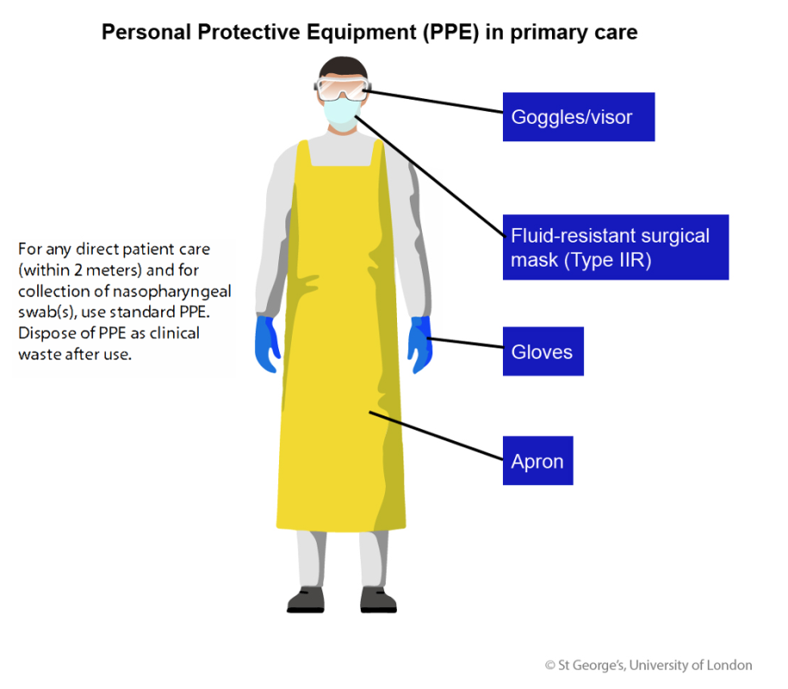
3M United Kingdom Plc, who are part of the British Safety Industry Federation (BSiF), are one of the major competitors I am competing against. Being part of the BSiF membership organisation gives organisations in the PPE industry access to extended client lists of workers in the NHS and key workers. Therefore I will apply to join the BSiF as it will provide me with lists of people working in the medical field that I can advertise and sell my products to.
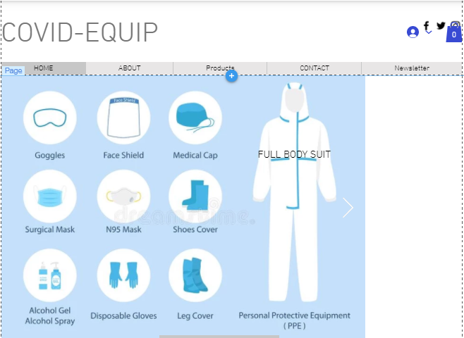

Figure 2

Figure 3

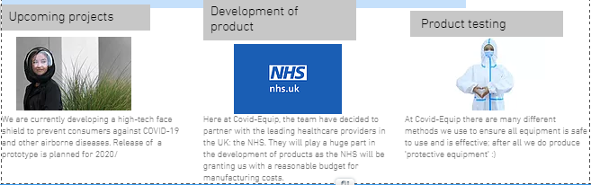

Figure 4

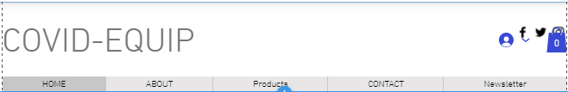
Figure 5

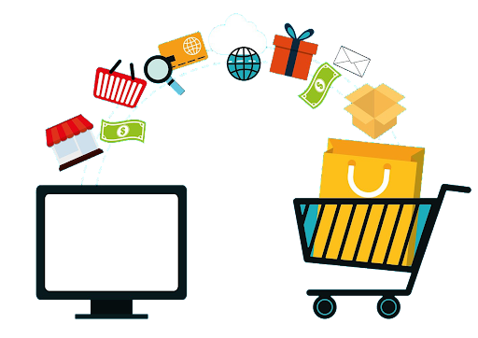
Section 2 – E-commerce

Figure 6
The main platform I will be selling my bodysuit through is a website I created on wix.com. the website is easy to navigate and has a simple layout, allowing consumers to use the website with little difficulty. The website has a concise description of the bodysuit which is attached to clear images of the bodysuit. Furthermore, there will be review of that consumers have left of the product, so customers can see what others thought of the bodysuit. These reviews will also be useful for me as they provide feedback on what is positive and negative about the bodysuit, allowing me to form methods to constantly make improvements to the product. My website will also have a live 24 hour chat service where customers are directed to one of my staff, and can bring up any concerns or queries they may have. We will try to give our customers the best feedback an answer their questions as best as we can.
If customers decide they want to purchase the bodysuit, they can do so by adding the product to their basket and continuing to checkout. Once they are at this stage, they have two options; continue as a guest or make an account. When continuing as guest, the customer must enter all important details such as their name, contact number, email address, home address and payment details. These details must be re entered every single time the customer makes a purchase on the website. Making an account makes transactions easier for the customer as they only have to enter all of their details when they initially make the account. After the first purchase, they will only need to enter their payment details to complete their transactions as other details have been saved securely to their account.
All transactions, both PayPal and credit/debit, will be completed securely as I have set up and implemented Secure Sockets Layer Encryption. However in the case of the customer buying a product through the use of the ‘guest’ feature, payment information will have to be typed with the use of drop down menus for whatever is possible.
In regards to the Paypal payments, ‘Paypal payments standard’ will be implemented, ensuring that the site of payment for a transaction through paypal will load up, allowing the person to enter their details and make the purchase. At the website they will have to enter their Paypal username and password, which shall allow them to use an already connected debit/credit account to pay for purchases. Once the payment had been made and processed, the purchaser will be emailed to a linked email with an order reference number. This order reference number will be useful if there are any issues with the product.
However customers who decide to make a purchase from a guest account, they will be prompted to manually input their details such as their card number etc. Once the transaction has been completed, the bank which the card is connected to, will send a confirmation email to the purchaser’s email confirming that the bank transfer has been complete. There will also be another email sent by the company to confirm that the transaction has been made, with the order reference number, which again will be useful if there are any issues in regards to the product.
Despite Paypal being fairly secure and allowing for quick simple transactions, it still remains to be not as popular as traditional debit and credit card payment methods. This can be seen as Debit cards make up 36% of all online payments and credit cards making up 47% respectively, whereas Payapl transactions only take up 19%. Furthermore credit and debit cards have a 0.3% to 1% merchant fee,, whereas Paypal has a much higher merchant fee of 2.9%. .
Furthermore online payments have many pros which are advantageous in comparison to non-online payment methods (manual) as there they are much quicker and easier to process than manual payment methods such as using cheques, as well as online payment methods reducing the labour costs.
Due to the receiving of personal data of the customers by the company, and the laws that are implemented in protecting the persona data of citizens, I will ensure to follow the GDPR. The GDPR is the General Data Protection Regulation act and it means that all personal data and information collected by the company will only be collected for the purpose of completing transactions of purchases. This data will not be sold and will be kept protected, private and confidential.
Furthermore a range of the products will also be sold on the website: amazon.com This is because Amazon is the world’s leading e-commerce, with an estimated worth of $386 billion. To do this I must chose a pro-selling plan which requires a monthly fee of £25 as a business expense. I will then use Seller Central, which is web interface, allowing me to personally order my listings and set pricing of certain products directly onto Amazon. Furthermore this will allow me to be updated and alerted on all product reviews, enabling me to have a constant form of constructive criticism. This selling of my products on the Amazon website will continue for quite some time, with exact details of each product including the total amount of available items left in stock.

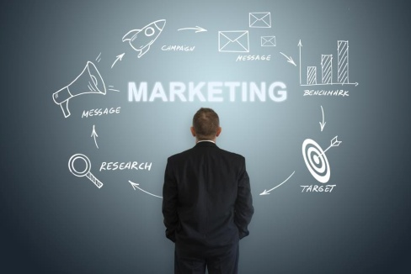
Section 3- Marketing


Figure 7 Figure 8

A key part of selling a product is marketing it correctly to a specific target audience and therefore I will utilise social media to promote each individual product. Many of these platforms will incude Instagram (shopping section), Facebook (marketplace) etc. Facebook specifically allows for me to specify sexes, locations and even certain jobs that I would like to heavily promote my product to. Furthermore the use of certain words known as key words can be entered into facebook to allow for my product to be suggested more often. Also, the platform Facebook specifically send an advertiser, such as myself, giving advice on how to improve marketing of their products.
In addition to this I will utilise Facebook’s ads objectives which are what I want a potential customer to do once they have seen my advertisement. The first step is referred to as conversion where the aim is for a person to be intrigued, and thus enticed, to visit the company website upon viewing the add, and then hopefully purchasing a product. This will be directly linked to the list of available products on the website as Facebook will have access to recently bought products and the details of how many products were sold and at what cost.
The maximum price I am willing to spend on advertising via Faceook and their management of advertisements will be £4 per day, totalling to £1344 per annum. By ensuring that facebok manages my advertisements, it allows me to spend more time on the development of products and dealing with the financial aspect of the company. There is a feature on both instagram and Facebook titled ‘business account’; by choosing the option of having a business account I can begin to advertise my product through the use of posts, stories with captions which reveal details about the product itself. Furthermore I could personally message social media influencers and celebrities to post promotional stories and posts about a specific product, which would be done via an exchange of money for the product to be promoted. As the general population on Instagram follow and are influenced by many popular users, this method of marketing will allow me to entice more customers to the products. Links to the website will be provide with every promotional post and in the descriptional ‘bio’ of the business account.
A lot of people have short attention spans and so the promotional content must be considered both interesting and intriguing. This can be done by the utilisation of key words on facebook, and hashtags on Instagram. This will allow the product to be marketed towards the target audience as well as being able to meet trends if trending hashtags and keywords are used. This will increase the customer engagement and have a knock on effect of increased sales. Despite social media marketing being rather tedious and hands-on, and sometimes expensive when influencers are paid to promote the products, it remains as one of the most rewarding and effective methods for marketing in this day and age.
A more traditional method of marketing is known as email marketing, which my company will also do. This process will include the company sending emails to a customer after they have given permission for us to do so by checking box when inserting payment details or signing up to a newsletter via the website. Furthermore email campaigns through social media platforms such as Facebook and Instagram will be made use of. This will provide me with a list of emails via the personal data collection under the GDPR, which can be used for further marketing. The emails could also be collected and used for constructive criticism allowing for feedback on products such as product reviews. Furthermore customers subscribed to certain newsletters could receive discounts based on loyalty towards the company; this is often referred to as a loyalty scheme. All of this would be considered a medium costing high ROI channel.
There is also a very effective technique of marketing known as engine marketing which is the use of transferring a certain amount of money to advertisers so that adverts promoting a certain product can be placed on popular search engines such as Google, Internet explorer , Yahoo and Bing. Clicking the advertisement could lead to a direct link to the website, and so provide more potential sales for our products. This is not very expensive and thus it has a low cost with medium ROI.
This is all falls under the umbrella term ‘digital marketing’ which is very advantageous considering that it is a less hands on way of promoting products that usually require a low/medium cost as investment and often provide medium/high ROI. This allows for an easy access around the world in terms of promoting a product, as opposed to marketing via a billboard etc, and a much quicker response to product marketing.
Finally, promoting via speaking to potential customers, either through communicating whilst handing out leaflets in a busy city centre, or via customers speaking to other customers after being interested and pleased with a product of some sort. This can also be referred to as word of mouth and can spread quickly for a local target audience but on a large scale, digital marketing is much better.
Also my products are available to people that are legal adults (18 in the UK),and therefore they own a payment card such as credit or debit card. There will be bulk sales to private healthcare workers nd the NHS is the main target.

Conclusion
Due to the recent Covid-19 pandemic, the product has a high demand and therefore I expect it to be a success. This will be successfully completed through the utilisation of many different forms of marketing, mainly focusing on digital marketing, such as using the social media platforms Instagram and Facebook to entice my target audience into purchasing products. Furthemore this provides consumer engagement through reviews and general product ratings which allows the company to take constructive criticism and develop a better product and provide better customer service. This all put together increases the likelihood of sales.

Reference list

Allassignmentexperts.com. 2021. ASDA CASE STUDY – STRATEGIC BUSINESS ANALYSIS: DEVELOPING A PLAN FOR GROWTH – All Assignment Experts | Blog. [online] Available at: <httpshttps://allassignmentexperts.com/blog/asda-case-study-strategic-business-analysis-developing-a-plan-for-growth/> [Accessed 16 July 2021].
Analytico. 2021. The Three Purposes of Marketing - Analytico. [online] Available at: <https://www.analytico.ca/three-purposes-marketing/> [Accessed 11 July 2021].
Clipart-library.com. 2021. Free E-Commerce Cliparts, Download Free E-Commerce Cliparts png images, Free ClipArts on Clipart Library. [online] Available at: <http://clipart-library.com/e-commerce-cliparts.html> [Accessed 14 July 2021].
Covid Innovations. 2021. Covid Innovations. [online] Available at: <https://www.covidinnovations.com/> [Accessed 7 July 2021].
FutureLearn. 2021. Personal protective equipment (PPE) for staff. [online] Available at: <https://www.futurelearn.com/info/courses/managing-covid-19-in-primary-care/0/steps/74815 > [Accessed 6 July 2021].
Hse.gov.uk. 2021. Personal Protective Equipment (PPE). [online] Available at: <https://www.hse.gov.uk/toolbox/ppe.htm> [Accessed 6 July 2021].
Hubspot.com. 2021. Facebook Marketing: The Ultimate Guide. [online] Available at: <https://www.hubspot.com/facebook-marketing> [Accessed 10 July 2021].
Hubspot.com. 2021. Instagram Marketing: The Ultimate Guide. [online] Available at: <https://www.hubspot.com/instagram-marketing> [Accessed 10 July 2021].
Managementstudyguide.com. 2021. Strategic Management - Meaning and Important Concepts. [online] Available at: https://www.managementstudyguide.com/strategic-management.htm [Accessed 7 July 2021]
Media Marketing & Management Dashboard. 2021. Facebook Marketing in 2021: How to Use Facebook for Business. [online] Available at: <https://blog.hootsuite.com/facebook-marketing-tips/> [Accessed 7 July 2021].
Media Marketing & Management Dashboard. 2021. The 21 Best Instagram Marketing Tips for 2021 (Cheat Sheet). [online] Available at: <https://blog.hootsuite.com/instagram-marketing/> [Accessed 7 July 2021].
Newfold.wigan.sch.uk. 2021. Orrell Newfold Community Primary - Covid -19 Documents. [online] Available at: <https://www.newfold.wigan.sch.uk/home/covid-19-documents > [Accessed 11 July 2021].
Oxfordlearnersdictionaries.com. 2021. innovation noun - Definition, pictures, pronunciation and usage notes | Oxford Advanced Learner's Dictionary at OxfordLearnersDictionaries.com. [online] Available at: <https://www.oxfordlearnersdictionaries.com/definition/english/innovation> [Accessed 15 July 2021].
Paypal.com. 2021. PayPal for Business | Merchant Services | PayPal UK. [online] Available at: <https://www.paypal.com/uk/business > [Accessed 13 July 2021].
PPE.ORG. 2021. Types of Personal Protective Equipment (PPE). [online] Available at: <https://www.ppe.org/types-of-personal-protective-equipment-ppe/ [Accessed 9 July 2021].
SHP - Health and Safety News, Legislation, PPE, CPD and Resources. 2021. PPE: Complete guide to Personal Protective Equipment | SHP. [online] Available at: https://www.shponline.co.uk/ppe-personal-protective-equipment/ [Accessed 7 July 2021]
The Royal College of Nursing. 2021. PPE and COVID-19 | Royal College of Nursing. [online] Available at: <https://www.rcn.org.uk/get-help/rcn-advice/personal-protective-equipment-ppe-and-covid-19> [Accessed 14 July 2021].https://www.rcn.org.uk/get-help/rcn-advice/personal-protective-equipment-ppe-and-covid-19
Wordstream.com. 2021. 7 Ways to Use Facebook for Marketing. [online] Available at: <https://www.wordstream.com/blog/ws/2013/04/15/facebook-marketing> [Accessed 4 July 2021].
Yotpo. 2021. 10 Customer Engagement Strategies You Should Be Using. [online] Available at: https://www.yotpo.com/resources/the-indispensable-list-of-new-customer-engagement-strategies/ [Accessed 9 July 2021].

Website:
Mashudali2.wixsite.com. 2021. [online] Available at:].<https://mashudali2.wixsite.com/my-site-3> [Accessed 13 July 2021]

