BMIH6007

International Meetings Management for the Hotel Industry
Student Name: Mariana Burcea
Student ID: 2128501
Lecture Name: Kathryn Flynn

Introduction
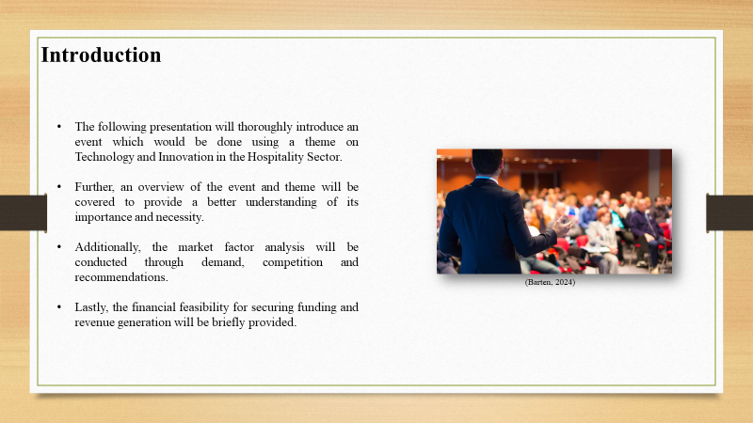
The following presentation will thoroughly introduce an event which would be done using a theme on Technology and Innovation in the Hospitality Sector. Further, an overview of the event and theme will be covered to provide a better understanding of its importance and necessity. Additionally, the market factor analysis will be conducted through demand, competition and recommendations. Moreover, the evaluation of operational factors will be performed for the venue, staff and ambience. Lastly, the financial feasibility for securing funding and revenue generation will be briefly provided.

Event Overview
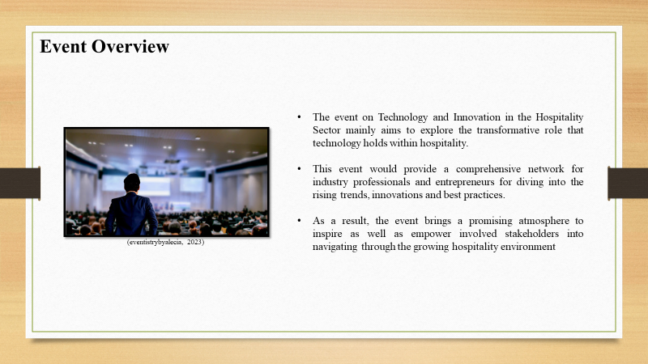
The event on Technology and Innovation in the Hospitality Sector mainly aims to explore the transformative role that technology holds within hospitality. This event would provide a comprehensive network for industry professionals and entrepreneurs for diving into the rising trends, innovations and best practices. Thus, using strategic networking opportunities and workshops, attendees will be able to acquire better knowledge regarding the growing technology for leveraging guest experiences and optimise operations. As a result, the event brings a promising atmosphere to inspire as well as empower involved stakeholders into navigating through the growing hospitality environment by fostering collaboration and innovation.

Theme
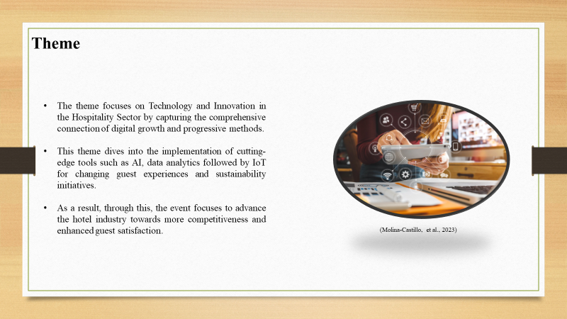
The theme focuses on Technology and Innovation in the Hospitality Sector by capturing the comprehensive connection of digital growth and progressive methods that reshape hospitality operations. This theme dives into the implementation of cutting-edge tools such as AI, data analytics followed by IoT for changing guest experiences and sustainability initiatives (Barten, 2024). Hence, beginning from personalised interactions with guests using virtual services to optimised management of resources using smart systems, the theme highlights the growth of seamless technological adaptations (Molina-Castillo, et al., 2023). As a result, through this, the event focuses to advance the hotel industry towards more competitiveness and enhanced guest satisfaction in a fast-growing technological environment.

Market Factor analysis
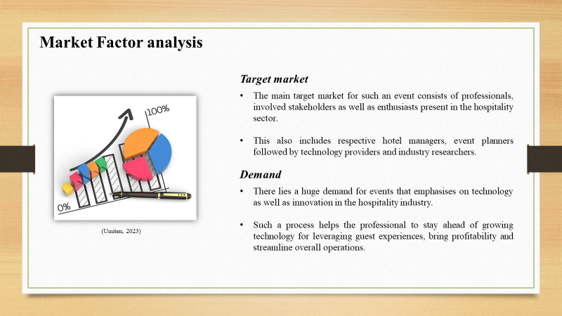
Target market - The main target market for such an event consists of professionals, involved stakeholders as well as enthusiasts present in the hospitality sector. This also includes respective hotel managers, event planners followed by technology providers and industry researchers. Moreover, this process goes beyond the people who are interested in the connection of technology and hospitality like learners, academics or entrepreneurs that are seeking innovative strategies.
Demand - There lies a huge demand for events that emphasises on technology as well as innovation in the hospitality industry. Since this sector goes through fast paced digital transformation, involved stakeholders always seek for insights related to growing trends and disruptive technological solutions. Such a process helps the professional to stay ahead of growing technology for leveraging guest experiences, bring profitability and streamline overall operations. Along with that, learners or researchers engage themselves in exploring the current developments that shape the potential of hospitality (Umiten, 2023).
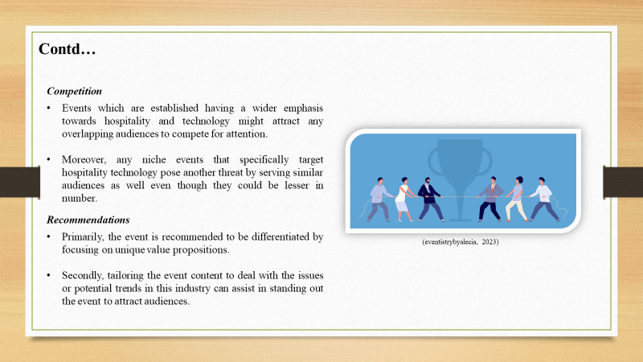
Competition - Even when there is huge demand, there lies competition which the event can face from similar sector gatherings, trade shows followed by conferences. Events which are established having a wider emphasis towards hospitality and technology might attract any overlapping audiences to compete for attention. Moreover, any niche events that specifically target hospitality technology pose another threat by serving similar audiences as well even though they could be lesser in number.
Recommendations - There are different ways these issues could be mitigated. Primarily, the event is recommended to be differentiated by focusing on unique value propositions like deeper exploration of particular technologies and exclusive networking opportunities (eventistrybyalecia, 2023). Secondly, tailoring the event content to deal with the issues or potential trends in this industry can assist in standing out the event to attract audiences. Thirdly, strategic partnerships with specific industry associations, influential stakeholders followed by technology providers can help in leveraging visibility and credibility. This would make this event become more appealing to the intended audience. Lastly, enhancing digital advertising networks, targeted campaigns and engaging content in social media can assist in properly promoting the event to reach more attendees.
Overall, even though the target market for this theme is quite diverse and includes different industry stakeholders, there is a higher need for these gatherings. Even then, competition needs to be navigated from previous events to differentiate the offerings for attracting and retaining audiences properly. All of these processes can effectively position the event as a premier platform to explore the connection of technology with hospitality.

Operational factors evaluation
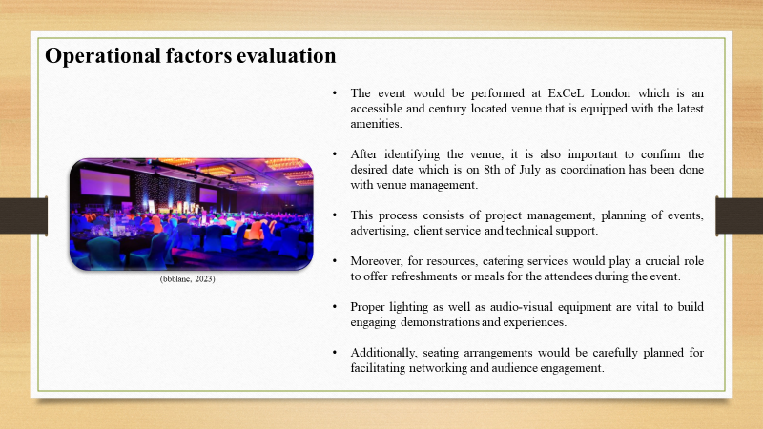
Venue - Selecting a suitable venue is vital as the event needs sufficient space which would accommodate different activities that includes presentations, workshops and networking sessions. Therefore, the event would be performed at ExCeL London which is an accessible and century located venue that is equipped with the latest amenities needed to host a technology-based event. Moreover, considerations like parking facilities and transportation links for the convenience of attendees are also present in the venue. After identifying the venue, it is also important to confirm the desired date which is on 8th of July as coordination has been done with venue management which ensured compatibility with the schedule. This date is quite flexible as accommodation for any unforeseen issues and logistical problems has been considered beforehand. Getting access to the suitability of the venue mainly includes evaluation of its capacity and layout where the space is required to include smooth event flow consisting of designated areas for presentations and exhibitions. Thus, sufficient audio-visual equipment, internet connectivity and lighting systems have been selected for supporting the presentation and demonstration properly (excel, 2024).
Staff - Event employees will need a wide skill set for handling different elements of the event properly. This process consists of project management, planning of events, advertising, client service and technical support. Furthermore, proper communication and problem-solving are vital to coordinate logistics and deal with any needs of attendees to ensure a seamless experience. Moreover, for resources, catering services would play a crucial role to offer refreshments or meals for the attendees during the event. As a result, collaborating with reputable vendors for offering wide menus to cater to various dietary needs would enhance the complete guest experience.
Ambience - Proper lighting as well as audio-visual equipment are vital to build engaging demonstrations and experiences. Therefore, investing in premium quality equipment as well as professional technical support systems would ensure effective sound and visual quality to leverage the effect of keynote speeches and panel discussions. Additionally, seating arrangements would be carefully planned for facilitating networking and audience engagement. Hence, comfortable seating would be provided along with networking areas and transparent signage to bring a positive experience among attendees (bbblanc, 2023).
Ultimately, proper planning combined with giving attention to operational aspects are vital to execute the event successfully. Through the venue securing, finding desired skills and distributing sufficient resources, the event would build an engaging experience that would be memorable for attendees to ensure smooth execution and efficiency.

Financial feasibility study
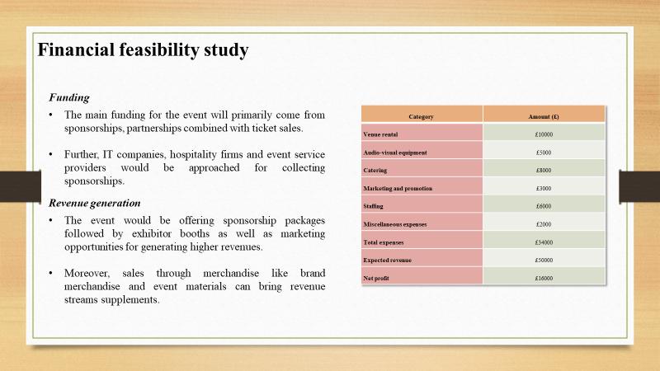
Financial planning is the pillar for the event to find success which comes with expenses, predicted revenues, funding sources and profit generation methods.

Income and Expenditure table
Category | Amount (£)
Venue rental | £10000
Audio-visual equipment | £5000
Catering | £8000
Marketing and promotion | £3000
Staffing | £6000
Miscellaneous expenses | £2000
Total expenses | £34000
Expected revenue | £50000
Net profit | £16000

Funding - The main funding for the event will primarily come from sponsorships, partnerships combined with ticket sales. Further, IT companies, hospitality firms and event service providers would be approached for collecting sponsorships to offer an effective branding process as well as exposure for financial assistance. Along with that, ticket sales consisting of various packages having different access levels or benefits would offer revenue generation. Lastly, partnerships with respective industry associations with educational institutions can help in securing funding and assistance (socialtables, 2023).
Revenue generation - The event would be offering sponsorship packages followed by exhibitor booths as well as marketing opportunities for generating higher revenues. Moreover, sales through merchandise like brand merchandise and event materials can bring revenue streams supplements. As a result, by widening income sources to deploy proper revenue generation methods, the event focuses to ensure effective financial viability to bring higher profitability.

Conclusion
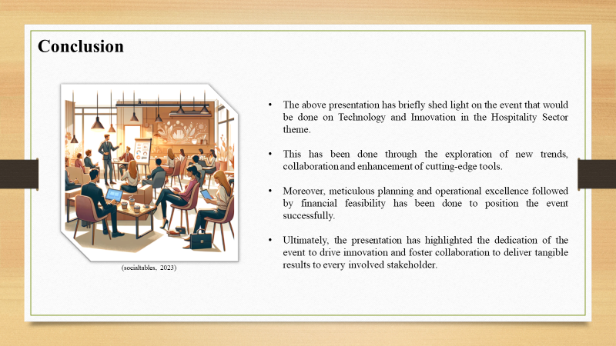
The above presentation has briefly shed light on the event that would be done on Technology and Innovation in the Hospitality Sector theme. This has been done through the exploration of new trends, collaboration and enhancement of cutting-edge tools to empower industry professionals and entrepreneurs. Moreover, meticulous planning and operational excellence followed by financial feasibility has been done to position the event successfully as a premium platform to push the sector towards more competitiveness. Ultimately, the presentation has highlighted the dedication of the event to drive innovation and foster collaboration to deliver tangible results to every involved stakeholder.

References
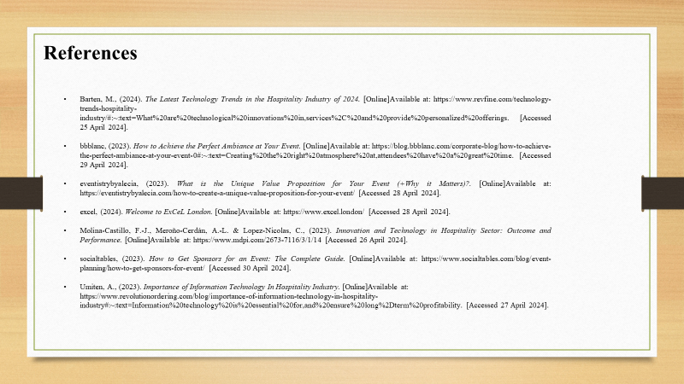
Barten, M., (2024). The Latest Technology Trends in the Hospitality Industry of 2024. [Online]Available at: https://www.revfine.com/technology-trends-hospitality-industry/#:~:text=What%20are%20technological%20innovations%20in,services%2C%20and%20provide%20personalized%20offerings. [Accessed 25 April 2024].
bbblanc, (2023). How to Achieve the Perfect Ambiance at Your Event. [Online]Available at: https://blog.bbblanc.com/corporate-blog/how-to-achieve-the-perfect-ambiance-at-your-event-0#:~:text=Creating%20the%20right%20atmosphere%20at,attendees%20have%20a%20great%20time. [Accessed 29 April 2024].
eventistrybyalecia, (2023). What is the Unique Value Proposition for Your Event (+Why it Matters)?. [Online]Available at: https://eventistrybyalecia.com/how-to-create-a-unique-value-proposition-for-your-event/ [Accessed 28 April 2024].
excel, (2024). Welcome to ExCeL London. [Online]Available at: https://www.excel.london/ [Accessed 28 April 2024].
Molina-Castillo, F.-J., Meroño-Cerdán, A.-L. & Lopez-Nicolas, C., (2023). Innovation and Technology in Hospitality Sector: Outcome and Performance. [Online]Available at: https://www.mdpi.com/2673-7116/3/1/14 [Accessed 26 April 2024].
socialtables, (2023). How to Get Sponsors for an Event: The Complete Guide. [Online]Available at: https://www.socialtables.com/blog/event-planning/how-to-get-sponsors-for-event/ [Accessed 30 April 2024].
Umiten, A., (2023). Importance of Information Technology In Hospitality Industry. [Online]Available at: https://www.revolutionordering.com/blog/importance-of-information-technology-in-hospitality-industry#:~:text=Information%20technology%20is%20essential%20for,and%20ensure%20long%2Dterm%20profitability. [Accessed 27 April 2024].

