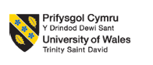
Student name: | VINCENT CIBWABWA | Student ID number: | 2321532
Programme: | BA (Hons) Leadership and Management Skills in the Workplace
Module: | Research Methods for Business
Module code: | LCLM6004 | Contribution to Overall Module Assessment (%): | 50%
Module Leaders: | Dr Rameses Manalang  Dr Olu Adegbite | Internal Verifier: | Md Kalam  Samuel Ofori
Assignment Title: | ▪ Component 2 –  Practical (Oral)  Academic Discussion  (Individual) | Word count (or equivalent): | Duration:  20 minutes discussion
Submission deadline: | Interviews w/c: 10/08/2026 | Return date of provisional marks & written feedback: | Friday, September  11, 2026

The Impact of Corporate Social Responsibility on Brand Image: A Study of Tesco

Table of Contents
Business Problem Statement 1
Research Aims and Questions 3
Aim 3
Questions 3
Literature Review 6
Methodology 9
Business and Practical Implications 12
Reference 14

Business Problem Statement
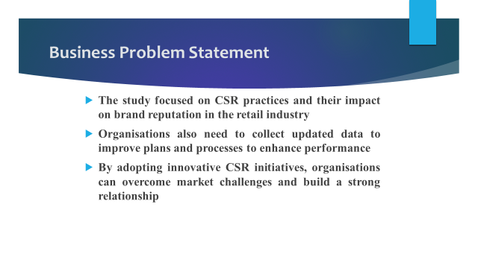
The study focused on CSR practices and their impact on brand reputation in the retail industry. This issue is relevant for the contemporary business context where it is necessary to enhance customer experience and overcome the intense market competitiveness. Organisations also need to collect updated data to improve plans and processes to enhance performance and brand credibility (Phan et al., 2021). By adopting innovative CSR initiatives, organisations can overcome market challenges and build a strong relationship of trust with customers and other stakeholders (Araújo et al., 2023). Besides, it contributes to the massive promotion of the brand to attain the most competitive benefits and expand the business areas.
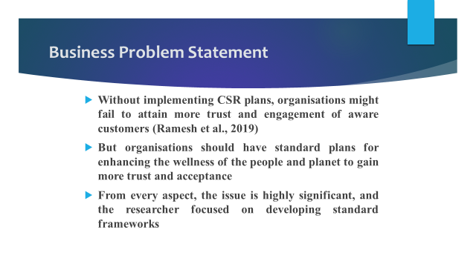
Without implementing CSR plans, organisations might fail to attain more trust and engagement of aware customers (Ramesh et al., 2019). So, it is possible to realise the significance of the issue for business organisations to improve performance continuously to become successful. But organisations should have standard plans for enhancing the wellness of the people and planet to gain more trust and acceptance from the target groups. For reasons of poor implementation strategies, lack of investment and organisational resistance, it is not possible to enhance brand reputation and image with strategic CSR plans (Al Mubarak et al., 2019). From every aspect, the issue is highly significant, and the researcher focused on developing standard frameworks to enable organisations to promote the brand through CSR practices.

Research Aims and Questions
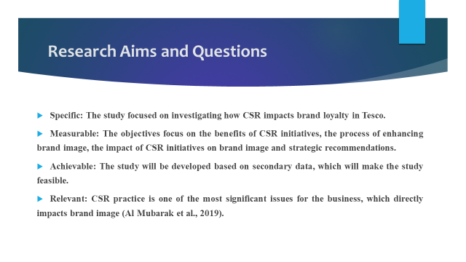
The aims and questions of the study are as follows-

Aim
The aim of the study is to examine how corporate social responsibility impacts the brand image in the retail sector.

Questions
The following questions will be answered through the study-
- What are the CSR plans of Tesco to increase customer trust?
- What are different initiatives of Tesco to enhance its brand image?
- How does CSR impact the brand image in Tesco?
- What are some strategic processes for Tesco to develop effective CSR plans for enhancing brand image?
The aims and questions are SMART, which can be possible to understand from the following discussion.
SMART Analysis
Specific: The study focused on investigating how CSR impacts brand loyalty in Tesco.
Measurable: The objectives focus on the benefits of CSR initiatives, the process of enhancing brand image, the impact of CSR initiatives on brand image and strategic recommendations.
Achievable: The study will be developed based on secondary data, which will make the study feasible.
Relevant: CSR practice is one of the most significant issues for the business, which directly impacts brand image (Al Mubarak et al., 2019).
Time-bound: The study will be concluded within the focused time frame with the most credible results.
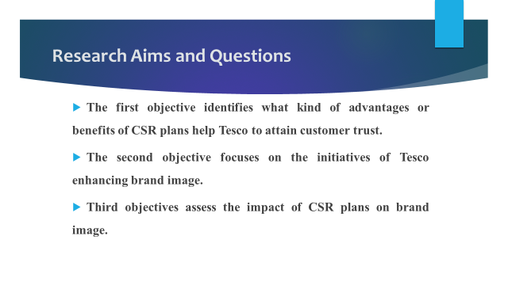
The objectives of the study are as follows-
- To unveil the CSR plans of Tesco to increase customer trust.
- To evaluate different initiatives of Tesco to enhance its brand image.
- To examine the impact of CSR on the brand image in Tesco.
- To recommend some strategic processes for Tesco to develop effective CSR plans for enhancing brand image.
Each of the objectives presents the problem of the research which are explored here.
The first objective identifies what kind of advantages or benefits of CSR plans help Tesco to attain customer trust. The second objective focuses on the initiatives of Tesco enhancing brand image. Third objectives assess the impact of CSR plans on brand image. The fourth objective develops practical recommendations for Tesco to enhance brand image. These objectives are clearly aligned with the contemporary business issues and provide a logical pathway for solving the issues.

Literature Review
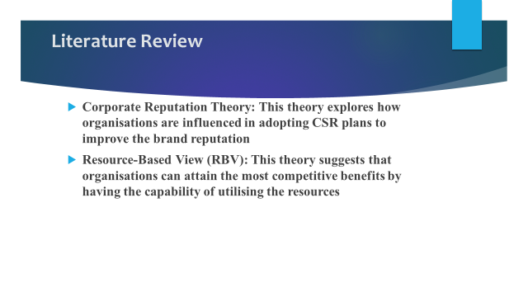
The study focuses on the following theories or models which are explored here.
Corporate Reputation Theory
This theory explores how organisations are influenced in adopting CSR plans to improve the brand reputation. This framework aligns with this study, and it was possible to explore the impact of CSR plans on brand reputation and credibility. Due to the intensive competition in the global market, it is necessary to bring about the necessary change in work plans and processes, which is possible by adopting innovative and standard CSR initiatives (Mahmood and Bashir, 2020).
Resource-Based View (RBV)
This theory suggests that organisations can attain the most competitive benefits by having the capability of utilising the resources. The implication of CSR plans can enable organisations to attain more customer engagement and satisfaction, for which it is consider as one of the most valuable assets for organisations (Çataldaş and Yalçınkaya, 2025). It is possible to improve the plans and processes to avoid potential challenges to reach the targets (Le, 2023). The organisations can collect the most up-to-date data from the focus groups through the CSR plans for faster decision-making and making the brand more credible to a wider number of customers (Nguyen-Viet et al., 2024).
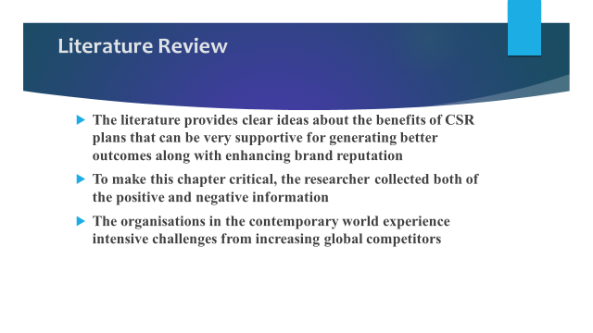
The literature provides clear ideas about the benefits of CSR plans that can be very supportive for generating better outcomes along with enhancing brand reputation. In some studies, the authors argued about CSR plans’ benefits and highlighted that for the development of CSR plans, organisations need to spend time, and it is costlier for implementation, which can be the reason for poorer financial performance. To make this chapter critical, the researcher collected both of the positive and negative information about CSR plans. The effectiveness of organisations in using CSR plans reduces the cost and makes the brand familiar (Attaran, Phan et al., 2021)). But failing to produce effective strategies for CSR practice, it is not possible to overcome the limitations for producing better results (Turner, 2024). It is also necessary to have a skilled and experienced workforce for operating their tasks in a standard way for the enhancement of the wellness of the people and planet to gain the trust of the customers (Araújo et al., 2023). The organisations in the contemporary world experience intensive challenges from increasing global competitors, which can be overcome with effective CSR initiatives. For the critical review of the existing studies, it was also possible to understand how organisations can improve employee morale, value and loyalty through the implementation of CSR plans to become successful. It is possible to make the employees more focused and collaborative to use the digital tools appropriately for the enhancement of organisational performance (Turner, 2024).
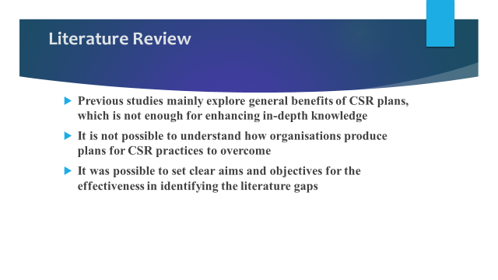
Previous studies mainly explore general benefits of CSR plans, which is not enough for enhancing in-depth knowledge about the topic and becoming motivated for practical implementation. Besides, the existing studies provide limited evidence about the relationship between CSR plans and brand image. It is not possible to understand how organisations produce plans for CSR practices to overcome the potential challenges for getting higher customer engagement and building trust. The researcher will be able to develop the study in a more structured way for the identification of the literature gaps. It was possible to set clear aims and objectives for the effectiveness in identifying the literature gaps that contribute to making the study more credible and providing a better understanding. The study will contribute to filling the identified gaps and supporting business organisations to produce strategic plans for CSR practice to increase customer engagement and brand image.

Methodology
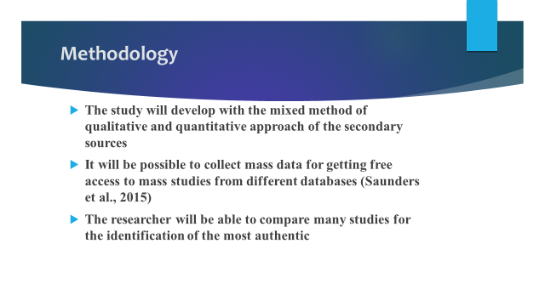
The study will develop with the mixed method of qualitative and quantitative approach of the secondary sources. The data will be collected from the existing literature, articles and books of credible publications. The researcher proposes this approach to avoid relevant challenges in developing studies with the existing knowledge. It will be possible to collect mass data for getting free access to mass studies from different databases (Saunders et al., 2015). It will be possible to reduce the cost for getting the chance of collecting data without investing any amount. Besides, it will not require spending more time collecting necessary data with the combination of a mixed approach. The researcher will be able to compare many studies for the identification of the most authentic and realistic data to generate the best results.
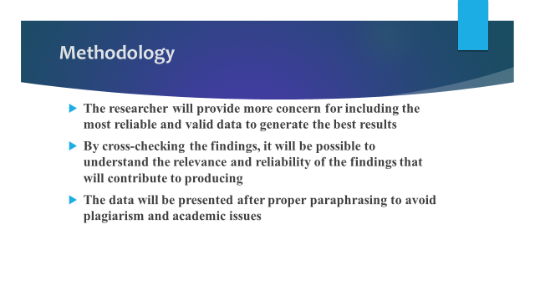
The researcher will provide more concern for including the most reliable and valid data to generate the best results. Peer-reviewed academic journals will be selected for this study to collect realistic and credible data to obtain the fixed objectives (Igwenagu, 2016). The studies published most recently will be selected for critical analysis and included properly. By cross-checking the findings, it will be possible to understand the relevance and reliability of the findings that will contribute to producing the best results. By selecting studies focused on corporate social responsibility and brand image, the researcher will ensure the validity of the findings. The studies will be selected from the most recognised academic databases to ensure higher validity. The data will be presented after proper paraphrasing to avoid plagiarism and academic issues. Proper citations and references will also be included in the study to ensure higher reliability and accuracy.
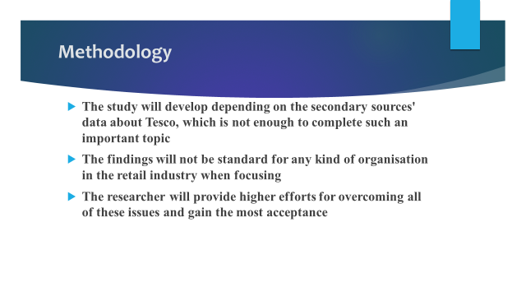
The study will develop depending on the secondary sources' data about Tesco, which is not enough to complete such an important topic. Secondary sources will not be enough for collecting confidential data for understanding the actual scenario of Tesco. The publication biases of the secondary sources will also create complications in producing the most credible results (Easterby-Smith et al., 2015). The findings will not be standard for any kind of organisation in the retail industry when focusing on the case of Tesco. These limitations of the study will contribute to reducing the credibility of the research outcomes. The researcher will provide higher efforts for overcoming all of these issues and gain the most acceptance from the readers.

Business and Practical Implications
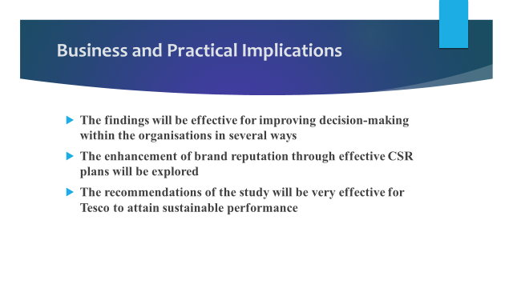
The findings will be effective for improving decision-making within the organisations in several ways. It will be possible to develop standard and effective strategies for CSR practice and make the brand more familiar. The results will enable the organisations to increase customer engagement and retention to generate higher sales and revenues. The enhancement of brand reputation through effective CSR plans will be explored with a realistic example that will enable the readers to take necessary initiatives for the wellness of their organisation. The findings will also enhance organisational efficiency for attaining higher customer engagement and enhance the competitive power. Moreover, the findings will allow to produce evidence based decision for practising CSR for avoiding any relevant challenge for enhancing the overall performance. The recommendations of the study will be very effective for Tesco to attain sustainable performance with the implementation of standard CSR plans.
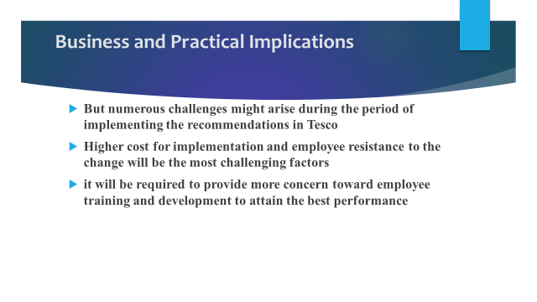
But numerous challenges might arise during the period of implementing the recommendations in Tesco. Higher cost for implementation and employee resistance to the change will be the most challenging factors. Besides, the lack of employee knowledge about the importance of enhancing the wellness of others systematically will also be a massive factor for the successful implementation of the plans and making the brand more trusted by the target groups. But Tesco will be able to overcome them by producing standard budget plans as it has financial stability. Besides, it will be required to provide more concern toward employee training and development to attain the best performance from everyone to generate higher productivity for the successful implementation of CSR plans.

Reference
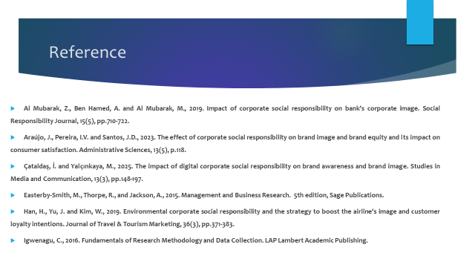
Al Mubarak, Z., Ben Hamed, A. and Al Mubarak, M., 2019. Impact of corporate social responsibility on bank’s corporate image. Social Responsibility Journal, 15(5), pp.710-722.
Araújo, J., Pereira, I.V. and Santos, J.D., 2023. The effect of corporate social responsibility on brand image and brand equity and its impact on consumer satisfaction. Administrative Sciences, 13(5), p.118.
Çataldaş, İ. and Yalçınkaya, M., 2025. The impact of digital corporate social responsibility on brand awareness and brand image. Studies in Media and Communication, 13(3), pp.148-197.
Easterby-Smith, M., Thorpe, R., and Jackson, A., 2015. Management and Business Research. 5th edition, Sage Publications.
Han, H., Yu, J. and Kim, W., 2019. Environmental corporate social responsibility and the strategy to boost the airline’s image and customer loyalty intentions. Journal of Travel & Tourism Marketing, 36(3), pp.371-383.
Igwenagu, C., 2016. Fundamentals of Research Methodology and Data Collection. LAP Lambert Academic Publishing.
Le, T.T., 2023. Corporate social responsibility and SMEs' performance: mediating role of corporate image, corporate reputation and customer loyalty. International Journal of Emerging Markets, 18(10), pp.4565-4590.
Mahmood, A. and Bashir, J., 2020. How does corporate social responsibility transform brand reputation into brand equity? Economic and noneconomic perspectives of CSR. International journal of engineering business management, 12, p.1847979020927547.
Nguyen-Viet, B., Tran, C.T. and Ngo, H.T.K., 2024. Corporate social responsibility and behavioral intentions in an emerging market: The mediating roles of green brand image and green trust. Cleaner and Responsible Consumption, 12, p.100170.
Phan, C.X., Le, L.V., Duong, D. and Phan, T.C., 2021. The impact of corporate social responsibility on brand image: A case study in Vietnam. The Journal of Asian Finance, Economics and Business, 8(4), pp.423-431.
Ramesh, K., Saha, R., Goswami, S., Sekar and Dahiya, R., 2019. Consumer's response to CSR activities: Mediating role of brand image and brand attitude. Corporate social responsibility and environmental management, 26(2), pp.377-387.
Saunders, M., Lewis, P., Thornhill, A. and Bristow, A., 2015. Understanding Research Philosophy and Approaches to Theory Development.

