University of Wales Trinity Saint David

Wales Institute of Science & Art


Project Planning
(ACHA5012/ACMA5007)

Cara Williams
2401134
23 | November | 2025
2287 Words

Table of Contents
Table of Contents 2
Table of Tables 3
Table of Figures 3
Abbreviation Table 3
1. Introduction 3
2. Roles and Responsibilities 5
2.1 Aerodynamics 5
2.2 Suspension Kinematics 5
2.3 Data Analysis and Simulation 5
2.4 Individual Team Member Roles and Responsibilities 6
2.4.1 Jason Taberner 6
2.4.2 Kiera Ryman 6
2.4.3 Evan Arthur 6
2.4.4 Ethan Davies 6
2.4.5 Louis Dunstan 6
2.4.6 Will Davies 7
2.4.7 Noah Newman 7
2.5 My Roles and Responsibilities 8
2.5.2 Individual Task Breakdown 9
2.5.3 Individual Specialist Equipment Required 10
2.5.4 Individual Bill of Materials 11
3. Overall Project Tasks and Schedule 12
4. Project Milestones and Gateway Objectives 13
5. Risk Identification and Risk Mitigation 13
6. Project Scheduling and Gantt Chart Development 13

Table of Tables
Table 1- Scoring Table 20
Table 2 - Students Organised Scoring Card 20

Table of Figures
Figure 1 - Individual Gantt Chart 14
Figure 2- Students Scoring Card 20
Figure 3 - Evidence of turbulent flow in sidepod region. 22
Figure 4 - Image depicting turbulent flow in cockpit. 22

Abbreviation Table
Abbreviation | Meaning
- UWTSD  - S2N OG  - S2N B  - S2 UW  - CFD  - FEA  - CoP  - CL  - CD  - SMART  - WBS  - RACI | - University of Wales Trinity Saint David  - Sports 2000 Original Bodywork  - Sports 2000 New Bodywork with Iley Developments (Splitter, Rear Deck Extensions and Airbox Upgrades)  - Sports 200 University of Wales (students redesign)  - Computational Fluid Dynamics  - Finite Element Analysis  - Centre of Pressure  - Coefficient of Lift  - Coefficient of Drag  - Specific, Measurable, Achievable, Relevant and Time-bound  - Work Breakdown Structure  - Responsible, Accountable, Consulted, Informed

Introduction
This report provides a detailed account of the planning and organisation undertaken for my Level 5 group project. It outlines the project objectives, scope, and success criteria while demonstrating the structured approach adopted by the team to ensure effective project management. Particular attention is given to my individual contribution, describing my specific tasks, responsibilities, and the methods applied to support the successful delivery and performance of the project.
The group project focuses on improving the aerodynamic performance of the University’s MCR racing car (#40) through a complete redesign of its existing aerodynamic package. The project aims to enhance the vehicle’s overall efficiency and stability by reducing aerodynamic drag, increasing downforce and decreas the overall pitch sensitivity resulting in improved cornering performance and lap times. SMART objectives will be used to define tasks clearly and track progress, with success evaluated against the performance parameters established within these objectives.

Roles and Responsibilities

2.1 Aerodynamics
The aerodynamics team, which the student is a member of is tasked with reducing the coefficient of drag while maintaining or increasing the coefficient of downforce, ensuring the design remains within the target balance window. The current car configuration has proven to be pitch-sensitive, with drivers reporting poor drivability across a range of setups. The team’s objective is to develop a more balanced aerodynamic package that maximises downforce while minimising drag. This team is composed of Ethan, Noah, Cara, Louis, and Evan, with responsibilities divided respectively across the splitter, nosecone, and floors; front pontoons, pushrod covers and wishbone shrouds; midriff, sidepods and cockpit; roll hoop fairing and wing; and rear deck.

2.2 Suspension Kinematics
The suspension kinematics team is focused on designing, manufacturing, and evaluating the feasibility of adding droop stops to the current front and rear geometry. The component will be installed in conjunction with the S2N (b) bodywork, with data acquisition conducted trackside at Pembrey Circuit in late November. Subject to successful results, further testing will take place during the 2026 racing season. Competitors at the front of the field have already implemented and validated droop stops; their data show an increase in the outside tyre’s contact patch during cornering. The kinematics team will therefore undertake a full-scale design and testing programme for the droop stop system.

2.3 Data Analysis and Simulation
The data team is responsible for managing all data collection and simulation analysis tasks across the project. Their work includes creating a model of the car in VI-Grade and providing the group with a baseline to compare developments. This allows the team to run simulations in Simulink to estimate lap times and evaluate the direction of design changes. VI-Grade and Simulink are also utilised to support the kinematics team, enabling them to simulate and better understand their droop stop concepts. The data team’s results are interpreted and communicated to the suspension and aerodynamics teams, providing actionable insights that guide design improvements and verify optimised performance prior to track testing. Vehicle behaviour will be analysed using VI-Grade simulations to assess dynamic stability, handling response, and overall track performance.

2.4 Individual Team Member Roles and Responsibilities
A Work Breakdown Structure (WBS) is a hierarchal method of decomposing project deliverables into manageable work packages to support planning, scheduling, and coordination. The decomposition of the group's main deliverables into sub-deliverables was informed by academic sources. In particular, Cretu’s paper ‘Features of Implementing a Work Breakdown Structure in Multidisciplinary Projects’ outlines how an effective WBS requires clear cross–team co-ordination, deliverable alignment, and the avoidance of overlapping tasks. These principles guided the structure of the group’s own task breakdown, ensuring that each work package is distinct, logically organised and aligned to the overall project objectives which can be seen below.

2.4.1 Jason Taberner
Responsible for investigating droop stops and implementing them on the car. His role requires analysis of the car’s current performance and position on the track using MoTeC Software. He will investigate how droop stops will affect the car and whether they are plausible with the current aero package through data analysis and testing. He is also responsible for the manufacture and installation of droop stops on the car.

2.4.2 Kiera Ryman
Responsible for all data and simulation analysis tasks within the project. Her role involves the use of VI-Grade to simulate droop stop modifications and CFD developments using a virtual model that will be created using MoTeC software to compare real-world data to a previous baseline model.

2.4.3 Evan Arthur
Responsible for the rear deck and engine cover aerodynamics, ensuring smooth airflow from the cockpit/sidepods to the rear wing region. His design will aim to reduce current drag, manage airflow over the engine cover while maintaining aerodynamic balance across the whole car.

2.4.4 Ethan Davies
As Project Manager, he oversees the project’s objectives and coordination, while also contributing to the aerodynamics team. Establishing objectives and setting performance targets for each area of the group. Coordinating CFD analysis and design development. Ensuring tasks are delegated evenly, and deadlines are met accordingly.
He oversees the design and development of the splitter, floors & nosecone for the MCR. Using CAD & CFD analysis to optimise airflow to the rear of the car to activate the deck as well as reducing the overall pitch sensitivity. Collaborating closely with Noah & Cara to ensure integration and manufacturability.

2.4.5 Louis Dunstan
Responsible for designing and analysing the effects of introducing a downforce generating device over the roll hoop and its effects on the aerodynamic efficiency of the rear wing in different locations and mounting styles. This will be proved with the use of a CAD file in CFD. Using CFD he will assess the different styles to find a model that works best with other members’ designs to keep the overall balance and COP within tolerance.

2.4.6 Will Davies
Responsible for the investigation into front droop stops. Understanding how droop stops
work and understanding how car characteristics change with and without droop stops
during cornering. Investigating where they will be mounted and what type of design will be beneficial for performance. Also, with a critical link between suspension kinematics and
aerodynamic stability.

2.4.7 Noah Newman
Noah’s role focuses solely on the aerodynamic refinement on the front section of the car, which consists of, front pontoons, pushrod covers, and wishbone shrouds. The front components of the car are crucial to the aero-mechanical interaction, where suspension and aerodynamic efficiency are directly in contact. His responsibility is to improve the airflow around the front of the car using CFD simulations. His aim is to reduce drag and turbulence through improving designs, ensuring that the sidepods and rear deck receive smoother airflow while enhancing front-end stability and aerodynamic efficiency.

2.4.8 Team Responsibility Matrix
To ensure clarity of responsibilities across the team, a RACI matrix was developed. This framework supports structured task allocation by identifying ownership, authority and collaboration pathways for each work package. Using a RACI model is recognised as best practice in project management for reducing ambiguity, improving communication and supporting co-ordinated delivery across complex groups. This conclusion is supported by Brower et al. (2021), who show that the RACI model is an effective tool that can improve coordination and team effectiveness
Key for table: R - responsible | A - accountable | C - consulted | I - informed
Work Package | Ethan | Cara | Noah | Evan | Louis | Jason | Will | Kiera
Baseline CAD Sign-Off (All baseline runs complete) | R | A | A | A | A | I | I | C
Mesh Verification & CFD Setup | R | A | A | A | A | I | I | C
CFD Runs – S2N OG & S2N B | R | A | A | A | A | I | I | C
Aero Development – Splitter/Floor/Nose | R/A | C | C | I | I | I | I | C
Aero Development – Midriff/Sidepods/Cockpit | C | R/A | C | C | C | I | I | C
Aero Development – Front Components | C | C | R/A | C | C | I | I | C
Aero Development – Rear Deck / Engine Cover | I | C | I | R/A | C | I | I | C
Aero Development – Roll Hoop & Wing | I | I | I | C | R/A | I | I | C
Droop Stops – Investigation & Design | I | I | I | I | I | R/A | R/A | C
Droop Stop Testing (Forces, Movement) | I | I | I | I | I | R/A | R/A | C
VI-Grade Simulation | I | I | I | I | I | C | C | R/A
Aerodynamic Maps & Data Interpretation | R | A | A | A | A | I | I | C
S2N-UW Integration | R | A | A | A | A | I | I | C
S2N-UW Optimisation | R | A | A | A | A | I | I | C
Interim VIVA Preparation | R | R | R | R | R | R | R | R
Final VIVA Preparation | R | R | R | R | R | R | R | R

2.5 My Roles and Responsibilities
My role focuses on the design and development of the midriff, sidepods, and cockpit regions of the car. These areas are fundamental to managing airflow from the front to the rear and ensuring aerodynamic efficiency across the vehicle. I am responsible for refining these surfaces through CAD and CFD analysis to reduce drag, optimise airflow continuity, and ensure effective integration with surrounding components. This process requires close attention to how changes in surface geometry influence pressure distribution and overall vehicle balance. My work aims to deliver an aerodynamically efficient and manufacturable design that complements the wider aerodynamic package developed by other team members.
In relation to Belbin’s team role theory, my position aligns most closely with the ‘Implementer,’ ‘Team Worker,’ and ‘Completer’ roles. These traits reflect the precision, organisation, and perseverance required to translate conceptual aerodynamic ideas into validated designs. The role demands both independent problem-solving and collaboration with other aerodynamicists to maintain consistency across the full car model, ensuring that each component contributes effectively to the collective performance objectives. This is backed up by a self-perception quiz carried out in class, I received high scores on these 3 roles with improvement to be made in ‘co-ordinator’ areas this would include improvement in talent coaching, delegation and overall communication (See Appendix Figure 1 and Tables 1&2).
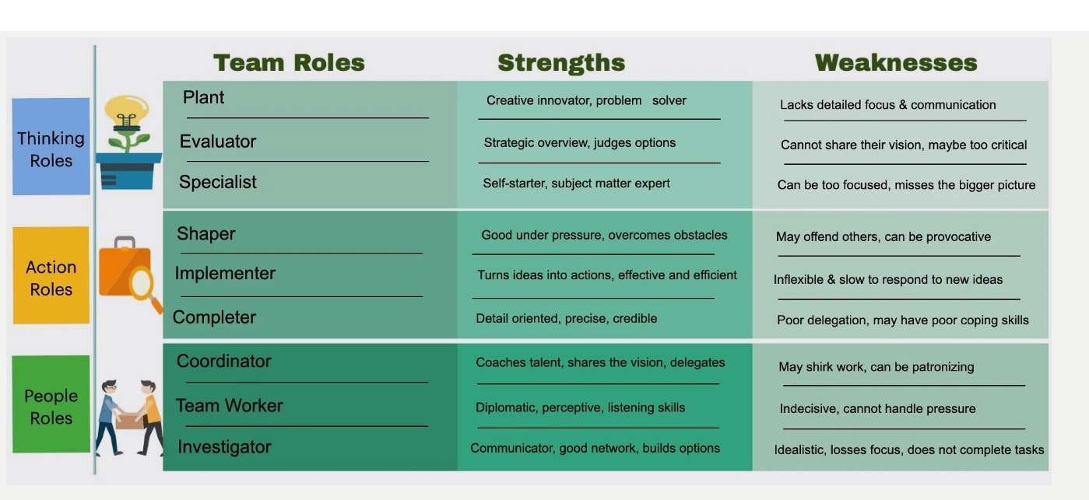
Figure 1 - Belbin's Model (Hector, 2024)

Individual Task Breakdown

Midriff and Cockpit
This section of the car was selected for development because the current midriff and cockpit geometry generates noticeable turbulence around the driver. This disturbed flow compromises the airflow feeding the rear deck and wing. By redesigning the midriff and cockpit surfaces, the aim is to stabilise the airflow in this region and deliver a cleaner, more controlled flow path over the driver and towards the rear of the car (See Appendix Figure 3). This area is being targeted for development to improve airflow delivery to the radiators while assessing how the surrounding geometry influences the flow towards the rear deck and rear pontoons.

Table 3 - Individual Task Breakdown
Task | Hours Taken to Perform Task | Task Deadline  (out of 28 weeks)
Validation and Verification of CFD Values (Mesh Study) | 30 | Week 2
CFD Runs S2N OG (Baseline and 3 Ride Height Changes) | 28 | Week 4
CFD Runs S2N B (Baseline and 3 Ride Height Changes) | 28 | Week 6
Aero Review of Midriff, Cockpit and Sidepod Regions (Individual Task) | 5 | Week 6
Collation of Results and Creation of Aero Maps | 5 | Week 6
Concept Creation for Individual Improving Target Regions | 40 | Week 8
Interim VIVA Preparation | 20 | Week 11
CFD Runs of Concepts | 40 | Week 11
S2N UW Integration | 60 | Week 16
S2N UW Integration Optimisation | 20 | Week 22
Final VIVA Preparation | 15 | Week 24
Grace Period for Unforeseeable Issues | N/A | Week 28
Total Hours | 291

SMART Objective Table (Midriff, Sidepods and Cockpit)

Table 4 - SMART Objective Table
Task | Specific | Measurable | Achievable | Relevant | Time-Bound / Gateway
Optimise Midriff, Cockpit and Sidepod Airflow | Improve surface geometry to reduce drag and stabilise airflow | Achieve 5% drag reduction from baseline CFD runs on S2N (b) model | Achievable through concept refinement and integration of all adjacent components | Directly contributes to improving the overall aerodynamic efficiency of the MCR | Complete Optimisation by week 10
Improve downstream flow to rear aero surfaces | Enhance airflow from sidepod region rearwards | Reduction in turbulent air created from sidepod measured through CFD velocity and streamline plots. (See appendix Figure 2) | Achievable using CFD to analyse the concepts’ ability to push cleaner air rearwards | Supports the overall team goal of overall car efficiency and balance | Demonstrate improved flow by week 10 (Gateway Objective)
Ensure integration of adjacent components | Modify geometry to remove clashes to maintain smooth transitions | No CAD conflicts notable while meeting our overall parameters of the project | Achievable through clear group communication and compromises between the team and data compromises e.g. more downforce but poor balance can be corrected for less downforce better balance | Ensures complete aero package functions cohesively and meets predefined parameters | Integration completed by Week 16 (Gateway Objective)

2.5.4 Individual Specialist Equipment Required

2.5.4.1 High Performance Computer
A computer with high computational power is essential to the project’s success. With a high-calibre system, CFD run times can be reduced to approximately five hours per run. Without access to such high-performance computers, completing the project within the required period would be unachievable.

2.5.4.2 Software Licensing
Ansys and SolidWorks are non-negotiables in this project; Ansys is a CFD solving application this allows us to run our MCR model in the virtual wind tunnel and SolidWorks is vital for digitising our concepts, the integration of my colleagues and I’s concepts and for ease in calculation our CoP values.

2.5.5 Individual Bill of Materials
Table 5 - Bill of Materials
Item | Quantity | Purpose | Cost  (£) | Lead Time (Weeks) | Source
High Peformance Computer | 1 | High Computational Power Reduces CFD Run Times. | Provided by University | 0 | UWTSD Computer Lab
ANSYS Software Licencing | 1 | CFD Solving Application | Provided by University | 0 | UWTSD
SolidWorks Licensing | 1 | 3D Design and Modelling | Provided by University | 0 | UWTSD
Prototyping Materials for Whole Car (Fibre Glass, Resin, Mould Materials etc.) | 1 | To Test the Final S2N UW Concept | £7,537.78 | 3 Weeks | Easy Composites
Prototyping Labour Costs  (£15 / hr doing 40 Hour Weeks) | 1 | To Test the Final S2N UW Concept | £6,000 | 10 Weeks | External Companies Amongst in House Manufacturing

2.5.6 Individual Gantt Chart
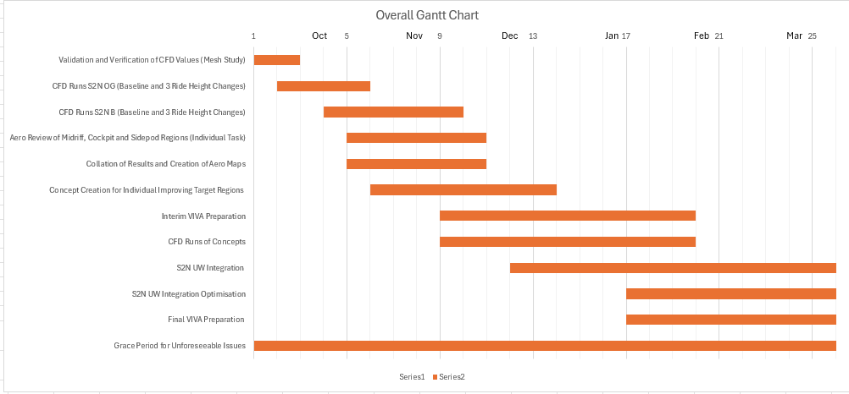
Figure 1 - Individual Gantt Chart

Overall Project Tasks and Schedule
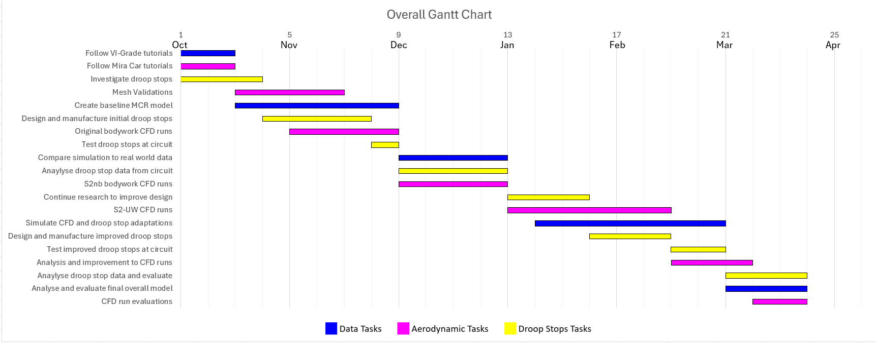
As a group we collated an overall list of tasks and the deadlines
Figure 2 - Overall Gantt Chart for Group
Table 7 - Overall Group Tasks
Tasks | Hours Required | Task Duration
Create aerodynamic maps using S2n bodywork runs | 28 hours | 2 weeks
Create aerodynamic maps using S2nb bodywork runs | 28 hours | 2 weeks
S2-UW CFD bodywork runs where sections of the car overlap | 30 hours | 3 weeks
Initial droop stops investigations | 20 hours | 3 weeks
Measurements of forces on droop stops | 5 hours | 1 weeks
Simulate droop stops in VI-Grade | 8 hours | 2 weeks
Analyse actuations due to droop stops in VI-Grade | 8 hours | 2 weeks
Simulate CFD alterations in VI-Grade | 50 hours | 4 weeks
Analyse and evaluate final model simulation | 10 hours | 2 weeks

Project Milestones and Gateway Objectives
Effective project planning requires clear checkpoints that allow the team to monitor progress and ensure deliverables meet the required standards. For this project, one milestone and one gateway has been selected to structure the workflow and assess the readiness for subsequent phases.
Stage | Description | Criteria | Deadline
Milestone  Baseline CAD Sign -off | Completion and approval of the initial CAD surfaces for the midriff, cockpit, and sidepod regions, enabling baseline CFD analysis to begin. No further geometry edits take place after this point to ensure consistency across simulations. | -CAD surfaces completed for assigned regions  - Packaging and design constraints satisfied  - Geometry suitable for meshing and baseline CFD | Week 6
Gateway – Improve downstream flow to rear aero surfaces | Formal assessment determining whether the aerodynamic development of the midriff, cockpit, and sidepod regions is ready to progress to full integration with other team members. | -5% drag reduction or more compared to baseline  - Improved airflow continuity to downstream components (rear deck, sidepod exit)  - No geometry clashes with adjacent aero regions  - Converged and stable CFD results with acceptable residual behaviour  -Validation against MoTeC or VI-Grade simulation data | Week 10

Risk Identification and Risk Mitigation
Effective project planning requires identifying potential risks that may affect delivery, quality, or timing. Three key risks relevant to the aerodynamic development of the midriff, cockpit, and sidepod regions have been identified, along with their potential impacts and mitigation strategies.

Risk | Likelihood | Impact | Consequence | Mitigation Strategy
CFD Non-Convergence or Mesh Instability | Medium | High | Delays optimisation; inaccurate force/flow data; inability to verify SMART and Gateway targets | Conduct early mesh sensitivity studies; use consistent meshing templates; monitor y+ and residual behaviour; perform coarse-mesh trial runs; maintain detailed simulation logs
Geometry Integration Conflicts with Adjacent Aero Regions | Medium | Medium–High | CAD redesign required; rework of CFD setup; delays to Gateway approval | Weekly integration checks with team; shared CAD assemblies; use alignment references for interfaces; maintain version-controlled CAD files; early communication of design changes
Software/Hardware Instability (SolidWorks, Fluent, VI-Grade) | Low–Medium | Medium | Loss of simulation progress; corrupted CAD or CFD files; reduced productivity | Maintain regular file backups; enable autosave; run overnight CFD with checkpoints; use stable software versions; coordinate workstation availability

Bibliography
Hector, L., 2024. Managing team diversity using role and behavior models - project skills mentor: Project skills mentor. [Online]
Available at: https://projectskillsmentor.com/user-journeys/how-belbin-roles-work-for-teams
[Accessed 22 November 2025].
Valentin George Cretu (2025) “Features of Implementing a Work Breakdown Structure in Multidisciplinary Projects”, Emerging Frontiers Library for The American Journal of Management and Economics Innovations, 7(8), pp. 106–114. Available at: https://emergingsociety.org/index.php/efltajmei/article/view/226 (Accessed: 22 November 2025).
Brower, H.H, Barbara J. Niklas, Michael A. Nader, Lindsay M. Trost and David P. Miller. (2021) ‘Creating effective academic research teams: Two tools borrowed from business practice’, Journal of Clinical and Translational Science, 5(1), p. e74. doi:10.1017/cts.2020.553.

Appendix
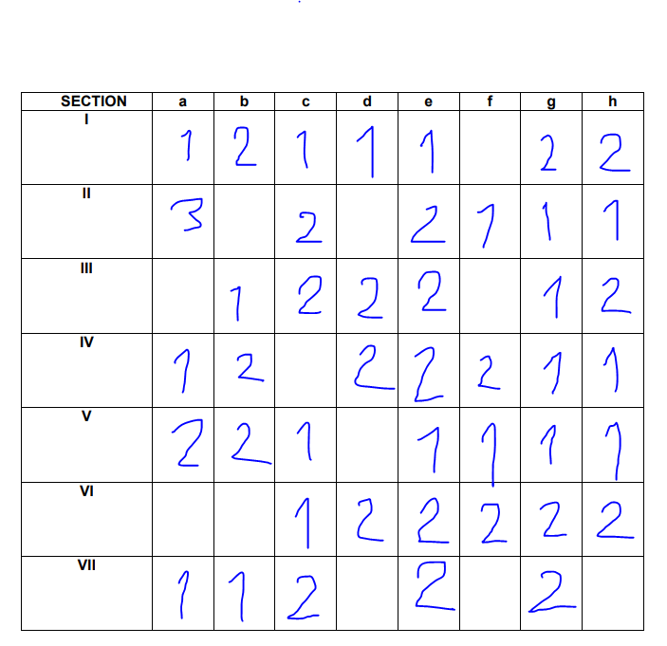
Figure 2- Students Scoring Card

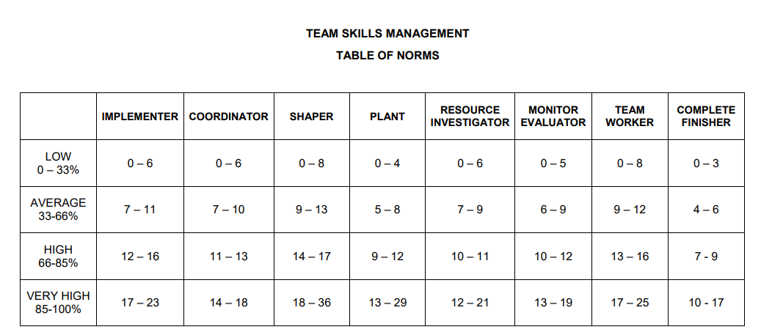
Table 1- Scoring Table
Table 2 - Students Organised Scoring Card
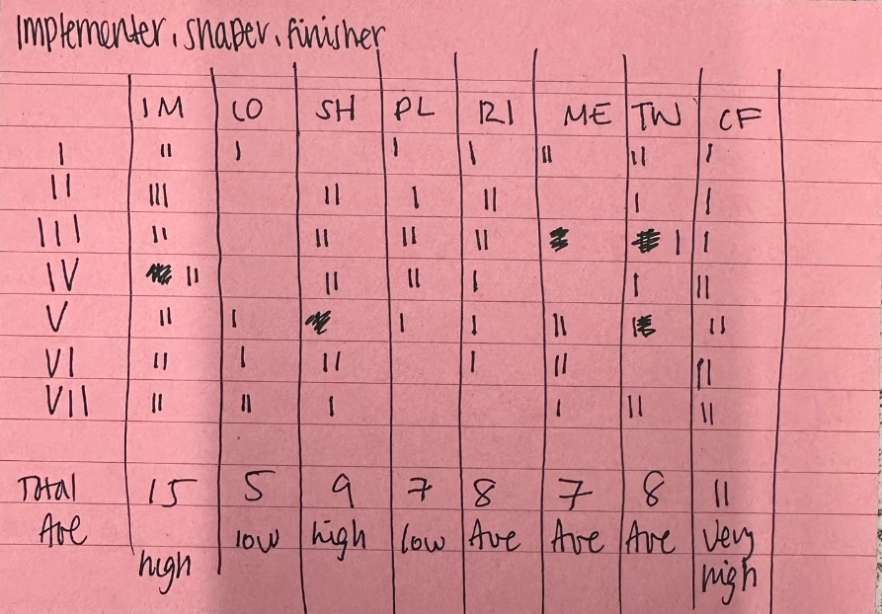

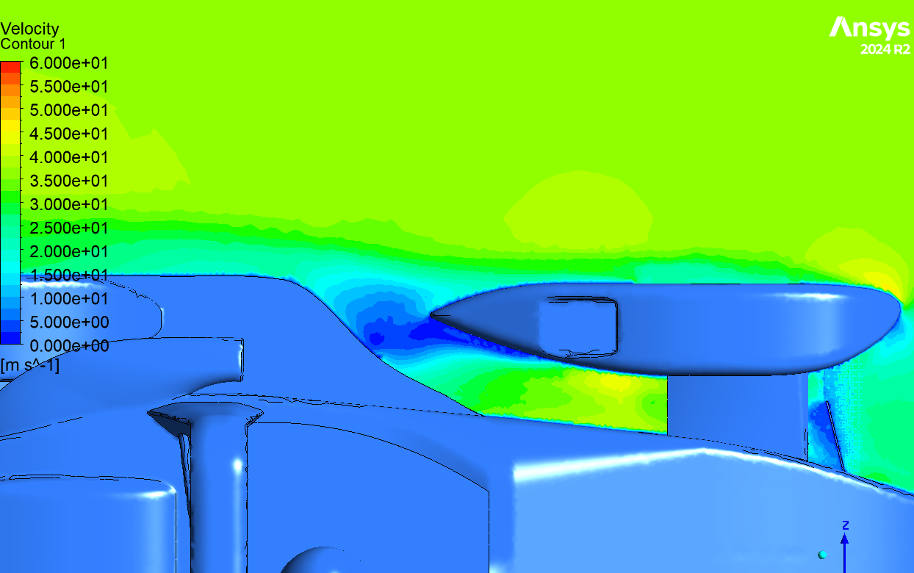
Figure 3 - Evidence of turbulent flow in sidepod region.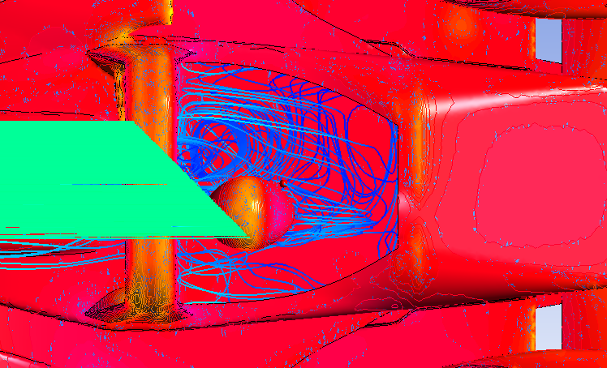
Figure 4 - Image depicting turbulent flow in cockpit.
.

