

Strategic Management (LCMB7003)

Strategic Analysis of Apple Inc.
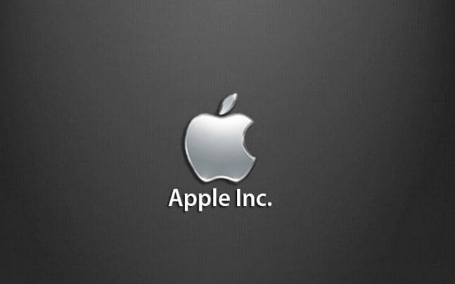

Student name: Sathwik Ramadugu
Student Number: 2223934

Table of Contents
Introduction 2
Background of Apple Inc. 2
Mission and objective of Apple Inc. 5
Macro environment analysis 6
PESTLE analysis 6
Micro environment analysis 9
Industry life cycle 9
Porter’s Industry five forces analysis 10
Internal analysis 12
Apple Inc. strategic resources and capabilities 13
Value chain analysis 14
Primary activities 14
Secondary activities 14
VRIO analysis of distinctive resources and capabilities 16
SWOT analysis 16
Strategies to sustain competitive advantage 18
Growth strategies 19
Green strategy and CSR 20
Conclusion 20
Recommendation 20
References 21

Introduction
The report has been taken forward with actionable proficiencies to analyse the competitive landscape of Apple Inc. through the effective and comprehensive PESTEL analysis , evaluating the external environment and providing an insight to the strategic recommendation with Porter’s generic strategy has been conducted the report constructed in order to provide recommendation and insight to the sustainability Apple’s competitive position within the rapidly evolving technology market.

Background of Apple Inc.
Apple Inc. engages with the designing, manufacturing and sale of the smartphones and other gadgets in the global market. The company has supported an international marketing framework with different products in the technology and gadget industry. For example, personal computers, tablets, wearable accessories and other varieties of technology based services are available (Cnn.com, 2021). In order to consider the international market with the geographical segments of a wide range. Apple has its operations available in America, greater China, Europe, and the rest of the Asia Pacific region (Apple.com, 2020). There are different segments within these geographical segments that includes north and south America, European countries as well as India, middle east and African countries (Apple.com, 2020). The products and services included within the geographical segment of the company are, iPhone, Mac, iPad, AirPods, Apple TV, Apple Watch, AppleCare, iCloud and others (Apple.com, 2023j).
Apart from these there are other services such as digital content stores, streaming services and licensing services and the founder of the company is Steven Paul Jobs in the year 1976, and having the main headquarter at California (Cnn.com, 2021). The company currently holds its shareholders values for mutual fund holders 29.70%, individual stakeholders 0.35% and the other institutes at 30.80% (Cnn.com, 2021). Currently the company has valued their human resources and have reached around 164 thousands of employees as estimated in the financial year of 2022 (Statista.com, 2023a).
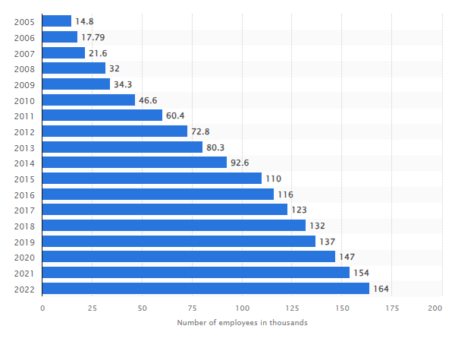
Figure 1: Number of employees at Apple Inc.
(Source: Statista.com, 2023a)
The company holds the world's 11th position in the largest company lists globally (Statista.com, 2023a). It has been estimated that with a global scale iPhone has generated more than half of the revenue for Apple Inc. in between the year 2013 and the year 2019 (Statista.com, 2023a). As estimated with the current status of the company’s employment opportunities have been increased at 6.49% in the year 2022 in respect to the previous year 2021 (Macrotrends.net, 2023).
Currently Apple Inc. is holding a powerful and flexible platform where the businesses have processed with certain services that helps in developing simple solutions with technologically emphasised and improved products (Apple.com, 2023a). Sales and engineering towards the fixation of jets and building skyscrapers is approaching with the apple developer platform given with the businesses to create powerful solutions (Apple.com, 2023a).
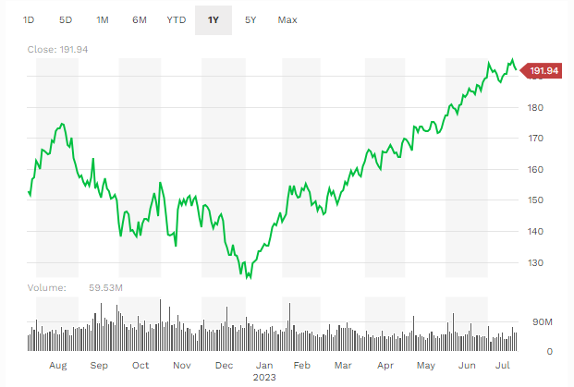
Figure 2: Stock price performance for Apple Inc.
(Source: Forbes.com, 2021)
The valuation has been depicted in the above graph; it has been estimated that with the stock performance data. The stock price performance has been identified to have a P/E ratio currently having a ratio of 32.63 (Forbes.com, 2021). Current dividend per share values at 0.92 and dividend yield at a value of 0.50% (Forbes.com, 2021). Company stock value price ranges at $3.02 trillion and that currently is having a diluted earnings per share (EPS), valued at 5.88 (Forbes.com, 2021).
Apple Inc. is majorly focus es in the key performance indicators (KPIs) in the global market. The KPIS has been unidentified for the current resources and capabilities evidently processed with the sustainable performance measurements and sustainable development practices. These are considered and identified as:
- Lifetime carbon benefit
- Renewable energy capacity (Apple.com, 2022).
These KPIS are majorly proceeds with the capabilities to use as a proceeding process and associated with the current KPIs identified for the company. There are considered as:
- Low carbon design
- Energy efficient
- Emissions abatement
- Renewable energy
- Carbon renewal (Apple.com, 2022).
In order to maintain the sustainable resources and retail with environmental sustainability requires resource allocation. These processes and identified with the allocation of the economic resources for each proceed with the category in a tidal allocation of $156.56 million of resources for the year 2022 (Apple.com, 2022).
In a financial statement of the company for the financial year 2023 ion a utterly base net income for the company estimated at $54158 million (Apple.com, 2023b). It decreases from the year 2022, with net income of $59640 million (Apple.com, 2023b). With the financial activities identified are the payments for taxes related to net share settlement, payments for dividends and dividend equivalent and repurchasing common stock and proceeds with the repayments of commercial paper (Apple.com, 2023b). Cash has been used in financing activities that increased from the previous financial year of 2022, in the year 2023, at having $61287 million (Apple.com, 2023b).

Mission and objective of Apple Inc.
Currently the company is having a value where it targets in inspiring the world that we share with everyone. A commitment has been leveraged within the world and that contributes to the effort to bring a passion in the best way (Apple.com, 2023c).
The mission of Apple Inc. has indicated as:
- Apple designs Mac, the best personal computers in the world along with the OS X, iLife, iWork and professional software (Apple.com, 2023c). Apple leads with the digital revolution with the reinvention of mobile phones and defines the future of mobile media and computing devices with iPad (Apple.com, 2023c).
The company is having a vision as well and that commits with the best personal computing experience in the world, to consider innovative hardware and software with internet offerings.

Macro environment analysis
The external environments consist of forces and factors within the organisational boundaries with approaching the influences in consideration with the organisational operations. In this case the external environment has direct and indirect facilitators that influence the organisational performances. Direct indirect influences have been focused and considered as the macro environment includes certain larger societal factors that affect the immediate environmental analysis categories with political, economic socio cultural, technological legal and environmental (PESTLE) analysis (Buye, 2021). The tool allows the assessment of the current environment within the external environment. To assess and process potential challenges based on the organisational premises to continuously scan the environment identify certain competitive advantages (Buye, 2021).

PESTLE analysis
Political: Current political contributions for the company are estimated to consider the interest of the company in regards with the private political preferences for individual executives. The evolution of the political contributions has been processed in order to consider the political influence for the company as well. In the year 2 021, Apple has made a $3500 contribution to the campaigns such as “Citizens for Great Cupertino District Schools” to support the campaign measures (Apple.com, 2021a). Political support with the campaign and services have been processed with the essential fund development to consider retention of high quality teachers and staff competitive compensation (Apple.com, 2021a). This ensures high quality fiscal solvency and provides support to the programs in order to contribute to the social and emotional wellness (Apple.com, 2021a).
Economical: Apple Inc. is currently having an increase in the costs from global logistics and rising employee salaries with a possibility to the consumers in putting off with the iPhone upgrade (Cnbc.com, 2022). China has shut down the Apple stores after the pandemic situation to the challenges and that costs a revenue hit by $8 billion (Cnbc.com, 2022). At the highest level the annual inflation rate in the US, Apple Inc. is having a sales inflation of 8.6% (Cnbc.com, 2022). Apple is having an average marginal value on the quarterly sales revenue at 43.7% (Cnbc.com, 2022). Where it tends to have a downfall in recent quarters and sales value with having an increased operating expenses, these expenses have been increased by 19% (Cnbc.com, 2022).
Socio cultural: Social and political implications have been used to personalise the content in order to which it states the increased preferences of personalisation applied within t7he synchronised opportunity for Apple Inc. (Bandy and Diakopoulos, 2020). The creation of news content involves subjective editorial choices based on logical reasoning and adherence to social values. It is influenced by the institutional training process that leads to the selection and presentation of trending and top stories (Bandy and Diakopoulos, 2020).
Technological: The technological market within the global approach valued at $61.3 billion in the year 2022 (Globenewswire.com, 2023). It is expected to reach $231 billion by the year 2032 and with a growing CAGR is slightly increased between the year 2023 to the year 2032, by 14.60% (Globenewswire.com, 2023). Wearable technology refers to electronic devices and products to be inserted directly to the body of the user and worn with the accessories.
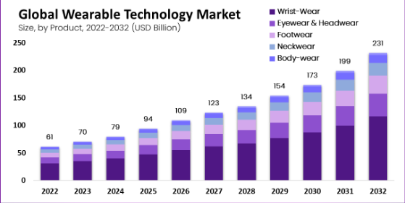
Figure 3: Global wearable technology market forecasted for the year 20232
(Source: Globenewswire.com, 2023)
Wrist wear products has a segment and generates a revenue of 5% of the share of sales revenue in the year 2022 (Globenewswire.com, 2023). With the application in consumer electronics, the application segment has dominated with the market having a market share and revenue of 25% estimated in the year 2022 (Globenewswire.com, 2023). In North America the dominating player has the highest revenue shares of 34% and has been powered with the microprocessors and transmitted with the help of the real world technological applications (Globenewswire.com, 2023). However, there are certain challenges identified to affect the technological growth in the market are:
- Increased geriatric population
- Rise of the prevalence of lifestyle disorder
- Supply chain disruption due to the pandemic
- Limited battery life (Globenewswire.com, 2023).
Legal: With a constructive legislative act the Lobbying Disclosure Act compilation has provided amended language from public laws and with several amendments. These amendments have been considered as the sections of 203, 204, 26, 211, 212 and 213 (United States Senate, 2023). Another way, the honest leadership and open government act (HLOGA) with section 203 amended in 2008 by July 30 (lda, 2022). These registrants have been processed and contributed within the report and that involves limiting organising and arranging and requesting with participation.
Environmental: Apple has provided and formed a new framework to target a goal to be achieved by the year 2030. The proof in the products and released a new framework shares with the environmental efforts around the environmental sustainable products and services. With renewable energy, efficiency and materials innovation are already having a significant impact in reducing the climate impact of the Apple products (Apple.com, 2023d).
Analysis
Potential opportunities: The potential contributions with opportunities from external environmental can be detected as:
- Political contributions to enhance policy making influences
- Technological market growth capitalising within the current market.
- Environmental efforts with sustainable and renewable energy to consider the opportunity in attracting environmentally conscious consumers with eco-friendly trends.
Potential threats: Apart from these, the potential threats to the company has been identified from the above discussion as:
- Rising employee salaries revenue hits die to store shutdowns at China and global logistics cost increases causes potential economic challenge to Apple Inc.
- Higher sales inflation rate leads to potential challenges in maintaining competitive pricing and affects consumer demand and brand loyalty.
- Challenges related to product innovation, supply chain disruption and limited battery life hinder the technological challenges and provide a dominant market for Apple Inc.

Micro environment analysis
Apart from the macro analysis , micro analysis is also based on having a detailed analysis and discussion over the internal strengths and weaknesses. In order to depict and identify the main competitive advantages within the company has been estimated and identified with the help of the effective micro-environmental analysis tools (Taqi, 2021). In order to process the effective decision making technique at an individual level within the brand. The industrial market formally follows with the basic analysis of the cost benefits analysis and that serves with several aspects within the current business environment (Hassania Rahou and Taqi, 2021).

Industry life cycle
As it becomes evident from the overall analysis of the industrial internal competitiveness is considered with the industry life cycle assessment. The assessment consists of five different stages with the market and size and follows with the high or emerging rivalry estimation. These stages are considered as development growth, shake-out, maturity and decline stage (Whittington, 2020). The life cycle assessment is publicly normalised to understand the internal strengths and weaknesses. The conferred as follows with different states and that includes, a comparison of the relative share of life cycle phases. Other than this identification of the largest sources approachable to each life cycle phase and states impact with the production of the component and subcomponents (Louis-Philippe_Jacquemotte-and-Hilty, 2020).
Market size | Development | Growth | Shakeout | Maturity | Decline
Typical five forces | Competitive rivalry | Supplier power | Buyer power | Growing threat of substitute s | Growth threat of new entrants
Table 1: Industry life cycle for Apple Inc.
(Source: (Whittington, 2020))
Apple is continually developing and innovating new products and services to meet the technology trends consumer demands. Apple experiences rapid growth and is fuelled with string product adaptation. The industry experience increased competition and consolidated as weak play in the competitive market to consider strong brand and innovation phase. Apple reaches a mature stage and market saturation and lower growth rates are common with product refinement and customer loyalty. In the decline stage the company mainly faces a decreased demand and dances disruptive chance, with emerging technologies consumer preferences remain relevant for Apple as well.

Porter’s Industry five forces analysis
The porter's five forces model is proposed to completed with the competitive advantages to consider the competitive advantages within particular industry. It leveraged with the five imperative forces within the industry considered with a modern theory based approach, it is widely known and accepted with the critical analysis to present within the framework is considered in a particular industry based analysis (Goyal, 2020).
Bargaining power of buyers: Brand awareness of Apple is at 32% and estimated among the consumers of the United States (Statista.com, 2023b). The survey has also been used to estimate the brand popularity at 55%m brand users at 49% (Statista.com, 2023b). Apart from the process the wearables users within the US, from Apple have created a buzz around the market at 57% in the current year of 2022 (Statista.com, 2023b).
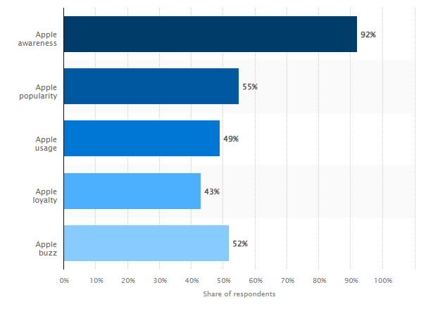
Figure 4: Brand Profile of Apple Inc.
(Source: (Statista.com, 2023b))
Therefore, as per the description of buyer power for Apple products is having a moderate impact within its internal operations, with a large customer base and a strong brand image. Those expected with the consumer influences and promotes the buying decision to approach continued innovation and improvement within the product development is necessary.
Bargaining power of supplier: Currently Apple Inc. is having a supply chain to consider a strong facility with approaching and meeting with the standards of human rights. In order to conduct and process with the supplier code of conduct required within the company that has been abiding by the health and safety, environmental standards and to respect the fundamental analysis within different standards. The company currently has 808 independent suppliers among more than 50 countries (Apple.com, 2023e). There is a consistent evaluation for the process and drives through effective accountability (Apple.com, 2023e). Therefore, the bargaining power of the supply Chinese processed and followed with having moderate to higher competitive advantages.
Threat of new entrants: There Is a threat of the new entrants in the tech industry that is relatively low in the current market, Apple’s entering into a technology based market requires significant investments in research and development, marketing and distribution. The established brands like Apple benefit from customer loyalty and the vast ecosystem of products and services have made a challenging situation for the new players to gain a significant market share quickly.
Threat of substitutes: For Apple products, android is the main competitive market process with a strong and high competitive advantage. The threat of substitutes is significant for Apple Inc. in the tech industry offering products and services to replace and compete with the Apple’s offerings. Therefore Apple have addressed a challenge by focusing on product differentiation, user experiences and building through the loyal customer base to manage an effective ecosystem.
Existing rivalry: Currently in the tech industry Apple specifically segments the operation and is having an intense competitive market. Apple faces competition from various well established companies. These include Samsung, Google, Microsoft and others (Globaldata.com, 2023). The competitive landscape is characterised by rapid technological advancements and aggressive marketing with constant product innovation. It strives within the company to maintain and follows with a competitive edge to upgrade its products and expansion of the services it also enhances the ecosystem in order to retail customers and attract new ones.
Analysis: Therefore, the evidence from the above discussion provides and indicates that Apple Inc. possesses competitive advantages in industrial units, it enjoys moderate buyer power to a strong brand and customer loyalty. The company’s responsible supply chain management grants it a moderate to high advantage over suppliers, the threat of new entrants is low in order to consider significant investment and an established customer base. However Apple faces a significant threat from substitutes and particularly within the android devices, despite intense rivalry the company’s focus on innovation, exceptional user experiences and a strong ecosystem enables it to maintain a leading position in the tech market. Overall Apple’s strategic approach helps in navigate within the industry challenges and sustain its competitive edge.

Internal analysis
The internal analysis refers to a designed business strategy to get a competitive advantage. It strategies with the analysis of the interaction between external and internal factors. These factors have been considered to focus on the internal resources and capabilities to maintain and identify the competitive advantages (Prieto-Sandoval, 2019). In order to define the current status it is identifiable with maintaining and guided with the resources and consists based on relevance with the assets capabilities, focused on the relevance of resources to sustain with the competitive advantage (Prieto-Sandoval, 2019).

Apple Inc. strategic resources and capabilities
The resources and capabilities for Apple Inc. contributes to a competitive advantage and position with the leading player in technology and gadget based industry. The brand equity, innovation, ecosystem integration and supply chain management enables the company to sustain growth and navigate with the challenges in the dynamic market.
Resources |  | Capabilities
Strong brand equity with high brand awareness (Statista.com, 2023b). | Brand value | Effective marketing design and customer experience management (Statista.com, 2023b).
Over 800 independent suppliers across 50 countries with responsible supply chain management (Apple.com, 2023e). | Supply chain | Efficient sourcing, production and delivery of its products.
Skilled and educated workforce with development and innovation in order to deliver high quality products and services (Bandy-and-Diakopoulos, 2020). | Human resources | Fosters through customer loyalty and enhances user experience.
Market capitalization over $3 trillion with substantial financial resources (Forbes.com, 2021). | Financial resources | New revolutionary products and user technology market with high performance gadgets (Globenewswire.com, 2023).
Table 2: Resources and capabilities of Apple Inc.
(Source: (Whittington, 2020))
These resources and capabilities have been identified for the company considered to process competitive advantages with the help of the VRIO framework.

Value chain analysis

Primary activities
Inbound logistics: More than 470 labour agencies have been identified present within the current supply chain market in southeast Asia (Apple.com, 2021b). The market is operating with higher risk mitigation and logistics suppliers have an global operational approach (Apple.com, 2021b).
Operations: With revolutionary precision and performance, the proposed approaches have considered joining within the current supply chain system. It is to continue with team sustainability and innovation considered to provide an immense scale of opportunity for the operational practices (Apple.com, 2023f).
Outbound logistics: Multi channel distribution strategies have created a significant role in approaching a better distribution strategy, with the retail stores and authorised resellers and online sales platforms have made and provide an access to the company’s services and services available within multiple devices (Apple.com, 2021b).
Marketing and sales: Marketing within the company have directed in consideration with the designers and engineers these are majorly processed its opportunity for collaborating with partners (Apple.com, 2023g). This promotes the product's vision and unites the team's wide range capabilities as well to ensure a passionate strengthening and commitments towards the current exponential market.
Services: The company is processed and follows with the increased trends within the entertainment process that increasingly focuses and processes both the best entertainment experiences mastered through the spatial audio (Apple.com, 2023h).

Secondary activities
Firm infrastructure: The current firm structure within Apple inc. have encouraged and processed the supporting functions such as finances, legal infrastructure and human resources. These all together focus on financial management and help in depicting the financial resources as well. These also handled the legal team and matters within the intellectual; property rights, compliances and regulations within different groups (Apple.com, 2023a).
Human resource management: The critical appraisal within the company's current operation helps in recognizing the significance of employees and drives through innovation and maintaining a competitive edge. It provides an aimed at practitioners with the designed leadership management to attract, d envelope and retain top talents (Apple.com, 2023a).
Technology development : Technology driven companies with strategic differences include a heavy research and development to innovate and bring a cultural edge, products and services to the market is necessary. Therefore, Apple has encouraged the decentralisation of certain practices focused in certain areas and development of the hardware, software, artificial intelligence and user experiences (Apple.com, 2023c).
Procurement: Within the current value chain analysis and the market for the company seen to have a company source with the raw materials and components with the help of the services om suppliers in order to support the manufacturing and operational benefits. It is to maintain the strategic relationship with key suppliers and to ensure a steady partnership or collaborative approach.
Analysis and evaluation of the competitive advantages: Apple Inc. possess with several key factors and competitive advantages that contributes and tensed to consider market leadership the company has a strong brand reputation and customer loyalty are vital factors that drives through the innovative and high quality products and creates a long lasting emotional connection within the customers, Apples relentless focus es in technological innovation enables with introducing a ground-breaking product and stay ahead of the rapidly evolving tech industry.
The integrated ecosystem within the company to provide a seamless user experience has been fostered through the customer retain and that makes it mostly challenging and to switch to the competitors, an efficient supply chain management ensures that timely and cost effective product delivery maintains a competitive edge. These have been personalised services in retail stores and an extensive online platform further enhances its competitiveness. Therefore the extension financial position of the company has invested in research and development with strategic acquisition. It has been consolidated with competitive positioning and any which leveraging strengths can be identified. It has been adaptable to changing market dynamics in order to sustain dominance as well..

VRIO analysis of distinctive resources and capabilities
Based on the resources and capabilities identified in the above secretion promotes competitive advantages with considering centre for the existing resources identified within the internal capabilities as well.
Resources/Capabilities | Value | Rarity | Inimitability | Organisational Support
Brand equity | Yes | Yes | Yes | Yes
Human resources | Yes | Yes | No | Yes
Financial resources | Yes | No | Yes | No
Supply chain | Yes | Yes | Yes | Yes
Table 3: VRIO framework
(Source: (Whittington, 2020))
As per the framework has been identified in this case Apple Inc, is considered with a characterisation of the substantial competitive framework with the help for the strengths and weaknesses. These are considered as a responsible supply chain to contribute and integrate with the seamless experiences in order to process with the substantial investment expertise and time making it a difficult for rivals and competitors. Therefore these have been reinforced to understand the competitive advantage gained by the company and analysis with the help of a crucial role in maintaining its market leadership position in the technology industry.

SWOT analysis
As per the resource, capabilities and the competitive embark it has been defined to contribute to the understanding of the regional strength and weaned offers with the opportunities and threats. These all together have gathered a certain database where the possible solutions the Apple have considered are based on the triangle model. This model includes cost, time and quality. These all together have been aligned by the company in order to grow customer in demand based and eco-friendly products in order to expand through the provided regulatory support and competitive advantages.
Strengths  - Strong brand reputation  - Technological innovation  - Integrated ecosystem  - Efficient supply chain  - Customer centric approach | Weaknesses  - High price  - Limited customization  - Highly dependent on the iPhone and other gathers.
Opportunities  - Sustainable renewable energy efficient product development (Globenewswire.com, 2023).  - Newly made policies (Louis-Philippe_Jacquemotte-and-Hilty, 2020). | Threats  - Economic changes  - Lack Of technology had long skill among employers (Cnbc.com, 2022).
Table 4: SWOT analysis
Therefore the analysis provides an insight to the strong brand reputation and technological innovations. It integrated with the ecosystem and that offers with string effective apply chain and customer centric approach that ensures with the effective premium pricing strategies and dependence on the iPhone sales limited customisations points. These contributes of the certain targets and respect with these a certain of risk assessments has been done for the current opportunities in the market, these opportunities and policies has been designed with the effective sustainable and renewables opportunity to encourage initiatives and that includes and targeted with the economic changes and defer from the scarcity of the skills with the technology. Therefore, the opportunities with the help of environmental sustainability is considered to carry a competitive advantage in the current position as well.

Strategies to sustain competitive advantage
In order to identify the strength from the above analysis in detail have provided an opportunity to this report on considering the sustainable competitive advantages. It has been processed with measuring techniques where the best strategic competitive advantage has been processed with porter’s generic strategies. The generic competitive strategies are considered with the three main kinds of strategies that can be applied into the different types of businesses (Ali-and-Anwar, 2021). There is evidence where leadership strategy has been differentiated with segments. The segmentation has been considered as to maintain the potential profitable approach in order to sell through the inquire products and potential profit marginalisation process (Ali-and-Anwar, 2021).
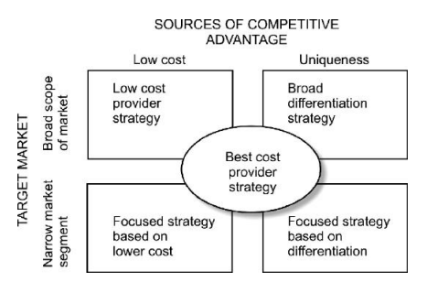
Figure 5: Porter’s generic strategies
(Source: (Ali-and-Anwar, 2021))
The competitive strategy within the business has been considered to process through the effective responses that mainly create a focus with the traditional generic strategies. It has been provisionally focus es in the probable generic competitive advantages that can co create a sustainable environment for the current selective approaches (Slavik, Hanak and Hudakova, 2020). The purpose of the model is to create a specific focus over the low cost strategy and differentiation strategy that informs with a certain phase of considering form performances (Islami, Mustafa and Topuzovska Latkovikj, 2020). In this case, based on the above analysis it can be identified that Apple Inc. is currently having a broad differentiation strategy. As it is evident that Apple is currently facing an unique approach to create innovative products and that includes with the brand loyalty and premium pricing is referred to align with the differentiation focus strategy. It caters with the customer centric approach and focuses on delivering an effective and seamless opportunity as well.

Growth strategies
In accordance with the evidence from the proportional and functional strategies of the company is having a benefit within the growth strategies. However, based on the external threats and internal weakness a better targeted market strategy can be identified and focused on the current selective approaches. These has been processed and flow with the formation of the effective strategic definition with the help of the Ansoff matrix.
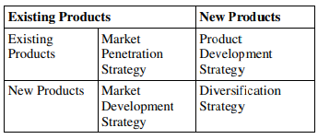
Figure 6: Ansoff matrix
(Source: Clarissia, 2020)
The Ansoff matrix includes four different strategic approaches where the current strengths and weaknesses for Apple can be approached to follow growth with the sustainable practices. The Ansoff matrix is having market penetration, market development, product development and diversification strategies (Clarissia, 2020). Therefore, a combination of market development and product development can be considered as the main growth strategic point to achieve success in the competitive market. These altogether grow with an interest in approaching toe strength such as technology based, environmental based opportunities to have a potential influence to the weakness that contributes as threats to the growth.

Green strategy and CSR
However, lastly the green strategy and the corporate social responsibilities (CSR) has been adopted by the company and has been recognised and delivered through potential opportunity with current market position. These have been identified as to bring a comprehensive conclusion to draw an effective recommendation for the future developments and sustainable competitive advantage cartoon practices. Specific competitive CSR positioning has been focused on ensuring environmental sustainability, promoting gender equality and women's empowerment, healthcare facilities, contributing to technology influences and financial assistance to the Non-governmental organisations (NGSOs) (Apple.com, 2023i).

Conclusion
Hence the report concludes in which it has been stated Apple Inc. possesses a strong brand equity, technological innovation and an integrator d ecosystem. Also it contributes to its market leaders growth and strategic focus on differentiation and sustainable practices. Therefore, it becomes evident that it helps in maintaining a competitive advantage edge through addressing challenges and seizing opportunities. Apple needs to and can continue with a successful dynamic techno industry with certain modifications in addition to the current condition of the company.

Recommendation
As per the above discussion it becomes evident that Apple Inc. needs to include a strategic management with considering the main strengths and weaknesses. Therefore it can be recommended that the company need to strategically manage:
- Political contributions
- Optimisation of costs
- Diversification revenue streams
- Foster inclusivity
- Investment in Research and development for wearables,
- Complying with legal standards
- Prioritisation of environmental sustainability and CSR initiatives are necessary.

References
Ali, B.J. and Anwar, G., 2021. Porter’s Generic Competitive Strategies and its influence on the Competitive Advantage. Ali, BJ, & Anwar, G.(2021). Porter’s Generic Competitive Strategies and its influence on the Competitive Advantage. International Journal of Advanced Engineering, Management and Science, 7(6), pp.42-51. https://papers.ssrn.com/sol3/papers.cfm?abstract_id=3863595
Apple.com (2020), Apple Services now available in more countries around the world, Available at: https://www.apple.com/newsroom/2020/04/apple-services-now-available-in-more-countries-around-the-world/ [accessed on: 22.07.2023]
Apple.com (2021a), Political Contributions – January 1, 2012 to date, Available at: https://s2.q4cdn.com/470004039/files/doc_downloads/advocacy/2014.04.03_Political_Contributions.pdf [accessed on: 22.07.2023]
Apple.com (2021b), People and Environment in Our Supply Chain, Available at: https://www.apple.com/supplier-responsibility/pdf/Apple_SR_2021_Progress_Report.pdf [accessed on: 22.07.2023]
Apple.com (2022), Annual Green Bond Impact Report, Available at: https://s2.q4cdn.com/470004039/files/doc_downloads/additional_reports/2023/apple_greenbond_report_fy2022.pdf [accessed on: 22.07.2023]
Apple.com (2023a), Apple makes business better, Available at: https://www.apple.com/in/business/enterprise/ [accessed on: 22.07.2023]
Apple.com (2023b), FY 23 Third Quarter Results, Available at: https://www.apple.com/newsroom/pdfs/FY23_Q2_Consolidated_Financial_Statements.pdf [accessed on: 22.07.2023]
Apple.com (2023c), values, Available at: https://www.apple.com/careers/in/shared-values.html [accessed on: 22.07.2023]
Apple.com (2023d), Apple announces major progress toward climate goals ahead of Earth Day, Available at: https://www.apple.com/newsroom/2023/04/apple-announces-major-progress-toward-climate-goals-ahead-of-earth-day/ [accessed on: 22.07.2023]
Apple.com (2023e), People and Environment in Our Supply Chain, Available at: https://www.apple.com/in/supplier-responsibility/pdf/Apple_SR_2023_Progress_Report.pdf [accessed on: 22.07.2023]
Apple.com (2023f), Build to the highest standards. Deliver on the highest expectations., Available at: https://www.apple.com/careers/us/operations-and-supply-chain.html [accessed on: 22.07.2023]
Apple.com (2023g), Marketing, Available at: https://www.apple.com/careers/us/marketing.html [accessed on: 22.07.2023] Available at: [accessed on: 22.07.2023]
Apple.com (2023h), Services, Available at: https://www.apple.com/in/services/ [accessed on: 22.07.2023]
Apple.com (2023i), Corporate Social Responsibility Policy of Apple India Private Limited, Available at: https://www.apple.com/in/legal/more-resources/docs/Apple-India-CSR-Policy.pdf [accessed on: 22.07.2023]
Apple.com (2023j), Service and support from the people who know your Apple products best, Available at: https://www.apple.com/in/support/products/ [accessed on: 22.07.2023]
Bandy, J. and Diakopoulos, N., 2020, May. Auditing news curation systems: A case study examining algorithmic and editorial logic in Apple News. In Proceedings of the International AAAI Conference on Web and Social Media (Vol. 14, pp. 36-47). https://aaai.org/ojs/index.php/ICWSM/article/view/7277
Buye, R., 2021. Critical examination of the PESTEL Analysis Model. Project: Action Research for Development. https://www.researchgate.net/profile/Ronald-Buye/publication/349506325_Critical_examination_of_the_PESTEL_Analysis_Model/links/6093f3fd92851c490fbd6e7e/Critical-examination-of-the-PESTEL-Analysis-Model
Clarissia, S.M.S., 2020. A study on Ansoff Matrix Technique: As a growth strategy and an adaptive learning technique adopted in the leading brand of products. BIMS Journal of Management, 18. https://bimskol.org/pdf/E-copy-BIMS-Journal-Management-Kolkata-Vol5-Issue-1-July-2020.pdf#page=26
Cnbc.com (2022), How inflation will affect Apple, Available at: https://www.cnbc.com/2022/07/01/wealthy-customers-will-help-apple-resist-the-effects-of-inflation.html [accessed on: 22.07.2023]
Cnn.com (2021), Company Description, Available at: https://money.cnn.com/quote/profile/profile.html?symb=AAPL [accessed on: 22.07.2023]
Forbes.com (2021), Apple, Available at: https://www.forbes.com/companies/apple/?sh=58b8abb15355 [accessed on: 22.07.2023]
Globaldata.com (2023), Apple Inc: Competitors, Available at: https://www.globaldata.com/company-profile/apple-inc/competitors/ [accessed on: 22.07.2023]
Globenewswire.com (2023), Wearable Technology Market Worth Over USD 231 Billion by 2032, At CAGR 14.60%, Available at: https://www.globenewswire.com/en/news-release/2023/03/13/2626170/0/en/Wearable-Technology-Market-Worth-Over-USD-231-Billion-by-2032-At-CAGR-14-60.html [accessed on: 22.07.2023]
Goyal, A., 2020. A critical analysis of Porter’s 5 forces model of competitive advantage. Goyal, A.(2021). A Critical Analysis of Porter’s, 5. https://papers.ssrn.com/sol3/papers.cfm?abstract_id=3765758
Hassania Rahou, E. and Taqi, A., 2021. Informal micro-enterprises: What impact does the business environment have on the decision of formalization?. In E3S Web of Conferences (Vol. 234, p. 00052). EDP Sciences. https://www.e3s-conferences.org/articles/e3sconf/abs/2021/10/e3sconf_icies2020_00052/e3sconf_icies2020_00052.html
Islami, X., Mustafa, N. and Topuzovska Latkovikj, M., 2020. Linking Porter’s generic strategies to firm performance. Future Business Journal, 6, pp.1-15. https://link.springer.com/article/10.1186/s43093-020-0009-1
lda (2022), Lobbying Disclosure Act (LDA) Reports, Available at: https://lda.senate.gov/system/public/ [accessed on: 22.07.2023]
Louis-Philippe, P.V.C., Jacquemotte, Q.E. and Hilty, L.M., 2020. Sources of variation in life cycle assessments of smartphones and tablet computers. Environmental Impact Assessment Review, 84, p.106416. https://www.sciencedirect.com/science/article/pii/S0195925519300642
Macrotrends.net (2023), Apple: Number of Employees 2010-2023, Available at: https://www.macrotrends.net/stocks/charts/AAPL/apple/number-of-employees#:~:text=Interactive%20chart%20of%20Apple%20(AAPL,a%204.76%25%20increase%20from%202020. [accessed on: 22.07.2023]
Prieto‐Sandoval, V., Jaca, C., Santos, J., Baumgartner, R.J. and Ormazabal, M., 2019. Key strategies, resources, and capabilities for implementing circular economy in industrial small and medium enterprises. Corporate Social Responsibility and Environmental Management, 26(6), pp.1473-1484. https://onlinelibrary.wiley.com/doi/abs/10.1002/csr.1761
Slavik, S., Hanak, R. and Hudakova, I.M., 2020. Natural and generic strategies of start-ups and their efficiency. Journal of Competitiveness, (2). https://www.researchgate.net/profile/Stefan-Slavik-2/publication/342686126_Natural_and_Generic_Strategies_of_Start-ups_and_Their_Efficiency/links/5f05cd07a6fdcc4ca455ed5f/Natural-and-Generic-Strategies-of-Start-ups-and-Their-Efficiency.pdf
Statista.com (2023b), Apple brand profile in the United States 2022, Available at: https://www.statista.com/forecasts/1335456/apple-wearables-brand-profile-in-the-united-states [accessed on: 22.07.2023]
Statista.com (2023a), Apple's number of employees in the fiscal years 2005 to 2022, Available at: https://www.statista.com/statistics/273439/number-of-employees-of-apple-since-2005/ [accessed on: 22.07.2023]
United States Senate (2023), Lobbying Disclosure Act of 1995, Available at: https://www.senate.gov/legislative/Lobbying/Lobby_Disclosure_Act/TOC.htm [accessed on: 22.07.2023]
Whittington, R., Angwin, D., Regnér, P., Johnson, G. and Scholes, K., 2020. Welcome to Exploring Strategy. https://www.pearson.com/pdhassets/9781292428741_sample.pdf

