
Constantin Ovidiu Strinu (2321711)
2321711@student.uwtsd.ac.uk
Module: ACCA6026 - Data Warehousing & Data Mining
Assignment: Component 1 - Data Warehousing
Lecturer: Rajeev Nath

Strategic Data Warehousing for NHS England
Consolidating Fragmented Healthcare Data to Enable Evidence-Based Decision-Making
Table of Contents
Task 1: Understanding the Case for a Data Warehouse (For the CEO and Board) 3
1.1 OLTP vs. Data Warehouse 3
1.2 Data Warehouse Architecture & ETL 3
1.3 Data Marts for Management Decision-Making 5
1.4 OLTP Normalisation vs. Data Warehouse Dimensional Modelling 6
Task 2: Star Schema Design and Implementation Plan 7
2.1 Source System Identification 7
2.2 Star Schema Design 8
2.3 Data Marts and Schema 10
2.4 ETL Plan 10
2.5 Data Quality & Governance 12
Conclusion 12
References 13

Figure 1 - Proposed NHS England data warehouse architecture and ETL flow. 4
Figure 2 - Star schema for NHS patient activity, illustrating facts and dimensions. 7
Figure 3 - Fact constellation for the NHS England data warehouse, showing master-data, metadata, and aggregate tables. 9

Table 1 - Simplified ETL plan by source system 11
Table 2 - ETL subsystem coverage by incremental load process (Phase 3). 11

Introduction and Purpose of this Report
NHS England manages one of the most complicated healthcare environments in the world, where enormous amounts of data on patients, treatment processes, workforces, and finances are created daily. Nevertheless, the current data cannot be accessed in real time due to being stored in separate operational systems such as electronic patient records (EPR) and patient administration systems (PAS). As a result, senior managers are deprived of the opportunity to have a consolidated picture of how the organization performs at any given moment in time. Such a situation is not just a mere speculation; NHS England has already recognized the issue in practice by starting the national roll-out of the Federated Data Platform (FDP) from April 2024. This infrastructure programme is aimed at linking separate trust-level systems to manage waiting list, discharge plans, and capacity in a consolidated way at a national level [1]. This report, produced as a consultant on external data warehouse implementation, will explain why NHS England needs an additional data warehouse instead of its transactional systems and provide a design and a strategy of its implementation (Task 1 and Task 2, respectively).

Task 1: Understanding the Case for a Data Warehouse (For the CEO and Board)

1.1 OLTP vs. Data Warehouse
NHS England uses OLTP systems in its routine work: EPR, PAS and workforce systems, collecting events in real time, recording a referral, changing the bed status, noting a shift. OLTP is based on a normalised relational model, which provides minimal redundancy of data and ensures instant application of every change, like a discharge, since operational people must see a single current version of reality [2]. This type of software provides transactional consistency and efficiency for single-record operations, but not analysis of millions of historical records.
Data warehousing is completely different in its nature. According to Inmon [3], data warehouse is a subject-oriented, integrated, time-variant, and non-volatile collection of data used for management decision-making. Unlike operational systems, a warehouse keeps history, and thus allows to compare, for instance, average length of stay over five years, or admission trends in certain regions: things that cannot be answered by OLTP, whose design is oriented to point queries [4]. While OLTP data is stored in dozens of separated silos, each trust has one PAS, each hospital has its EPR, data warehouse combines all these sources into one consistent database with shared definitions, e.g. one definition of "readmission".
Thus, for the Board, the advantage of a data warehouse investment is this: no matter what EPR or PAS will do, the same work in the same hospitals, it will add an analytical level to operational databases.

1.2 Data Warehouse Architecture & ETL
Data warehouses can be conceptualized as a pipeline process having four parts: sources, the place where extraction and transformation occur, the data warehouse itself, and the data marts and report generation tools that senior management looks at each day. This is illustrated by Figure 1 with reference to the NHS England systems.
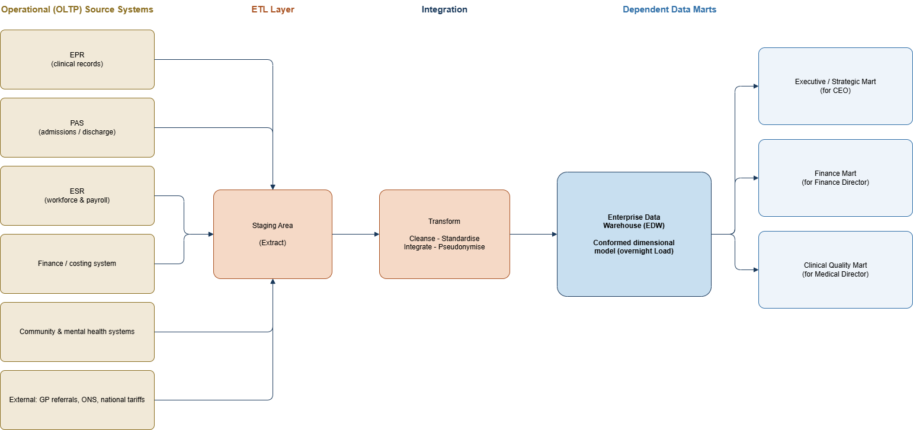
Figure 1 - Proposed NHS England data warehouse architecture and ETL flow.
The internal data sources of NHS England come in different categories as follows: the EPR and PAS provide data about patients and clinical activity; the Electronic Staff Record (ESR) provides data on shift patterns, agency use and sickness absence – a national workforce and payroll system for all NHS trusts [5]; financial and costing systems provide data on tariff-based income and expenditure; and community and mental health systems provide multi-agency longitudinal care record.
ETL processes transform data into usable information in NHS data warehouses in a reliable way by taking data from a replica of each operational database in an overnight operation or low-impact change data capture manner, such that clinicians using EPR or PAS during daytime never query tables which are being copied [6]. In the transformation process, which is done in an isolated staging area, the duplicate NHS numbers are removed, and the date formats, ICD-10 codes and patient identifiers are standardized and pseudonymised. The load phase finally writes the cleansed data into dimensional tables of the warehouse at nighttime when there is minimum clinical activity.
Concerning the delivery strategy, the authors recommend using the "bus architecture" of Kimball and Ross consisting of conformed dimensions and reuse of the Patient, Time and Hospital dimensions across all subject areas, rather than the top-down enterprise-wide solution of Inmon, since NHS England will be able to implement a working data mart in a matter of months for a region or directorate rather than years for the monolithic build [4].
To reassure the CEO of NHS in a direct way: the extraction process reads from a replica or a transaction-log copy of each source database but not from the live tables, which the clinicians and administrators update; thus, the ETL process does not lock any record or slow down any bedside screen. The transformation and loading take place in an infrastructure separate from the one in which the hospital operations take place in a designated overnight maintenance window according to NHS data volume expectations. Before the go-live, the warehouse will run in parallel with existing manual reporting for a period of trial for the leadership to be sure that figures match.

1.3 Data Marts for Management Decision-Making
In this case, the three key decision makers need the same data just from a different perspective, which is the exact purpose of the creation of dependent data marts – extracts of the same integrated warehouse but with a focus on a certain subject matter instead of independent databases with their own definitions [4].
For the Chief Executive, an Executive/Strategic data mart should have information about the Key Performance Indicators of the organisation: the RTT compliance on the national level, overall bed occupancy and patient flow bottlenecks per region, which are needed for trend dashboards from national to regional and down to trust level but not to patients.
For the Finance Director, a Finance data mart should have information about the cost per patient episode in comparison to the national tariff, budget versus actual spendings of trusts and directorates, agency staffing cost trends.
For the Medical Director, a Clinical Quality data mart should have readmission rates, mortality, patient safety incidents, and patient satisfaction segmented by specialty and hospital to check the quality of care.
As all three data marts are created from the same warehouse and use the same Time, Hospital/Region and Patient-cohorts dimensions, when the capacity problem of the Chief Executive arises for a particular region, it would match exactly with the costs that the Finance Director would see and the outcomes of the Medical Director in respect of that region: this "whose numbers are right" discussion that arises within organisations having independent departmental spreadsheets is deliberately avoided from the very beginning [4].
This reuse of the dimensions used in the warehouse is described by Kimball and Ross using the so-called bus matrix – a simple table that matches the subject areas (patient activity, finance, workforce) with the shared dimensions used by these subject areas [4]. For the NHS England it means, for instance, that when the CEO drills from the RTT national dashboard down to a particular region, then to a particular trust, and finally to a particular ward, the Finance Director can instantly drill into the same hierarchy and see the costs of that ward, while neither of directors needs to derive his own definition of "ward" or "trust".

1.4 OLTP Normalisation vs. Data Warehouse Dimensional Modelling
Systems such as PAS are normalized and generally achieve third normal form (3NF), where information like patient, ward, procedure, and staff data are spread over several interrelated tables in order to avoid redundancies such that when you update the patient address, for example, you only need to modify one row [7]. This ensures the integrity of data during transactional write operations, but analysing this information necessitates joining these several tables, which becomes difficult and time-consuming when there are millions of rows of data.
Dimensional modelling is the approach usually followed when building data warehouses. It involves deformalizing the data into a star schema, which consists of a single fact table containing the additive measures as well as several dimension tables containing textual attributes for filtering and grouping [8]. Figure 2 below shows a sample star schema of NHS patient activity. The fact table is named FACT_PatientActivity, and it contains all the measures while the dimension tables are DIM_Patient, DIM_Time, DIM_Treatment and DIM_Hospital.
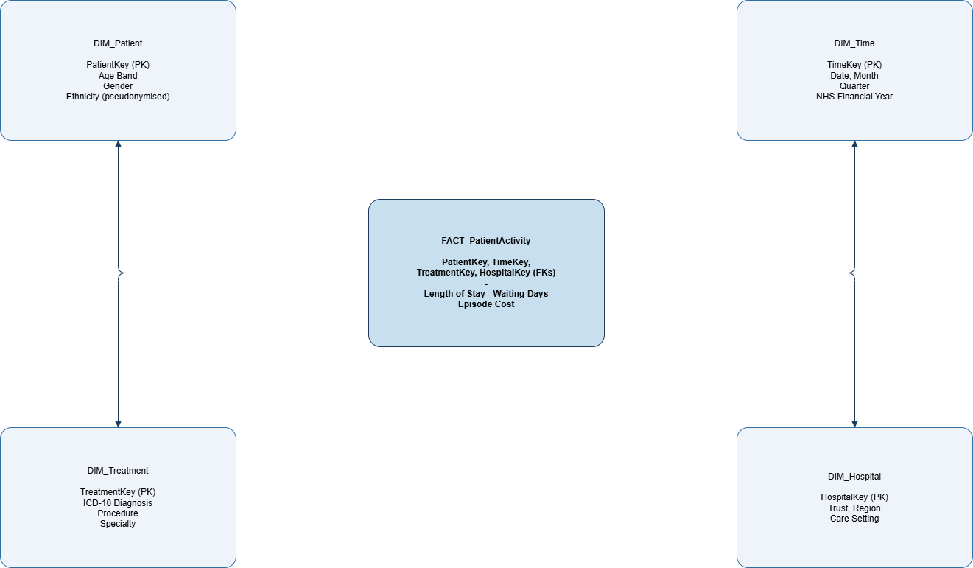
Figure 2 - Star schema for NHS patient activity, illustrating facts and dimensions.

The consequence of repeating the descriptive facts in each row is an intentional compromise: it gets rid of the complexity of join operations, making the query return within seconds instead of minutes and understandable to a manager, not just a database expert. Surrogate keys (and not the actual keys from the source system, such as a patient's id or the hospital's id) connect each fact row to the relevant dimensions, which also enables the data warehouse to keep track of how an attribute, like the hospital's region, evolves over time and thus does not break the historical reports. From the point of view of the IT Director, the difference lies in the intended use, not in the correctness of the model.

Task 2: Star Schema Design and Implementation Plan

2.1 Source System Identification
The source systems for NHS England’s data warehouse will include both internal and external sources. Internally: EPR and PAS provide patient demographic, admission, discharge, and ICD-10 diagnosis; the Electronic Staff Record (ESR) provides information on workforce that includes shift details, agency usage, and sickness absence [5]; finance and costing systems provide treatment costs and tariff income; and theatres, diagnostics, and community/mental health systems provide information on clinical activity outside the acute setting. Externally: GP referral information coded in SNOMED CT goes into PAS at the time of referral, while ONS population data and NHS England published reference costs and RTT waiting-time targets [9] help compare the performance of each region to the national level. Each of the sources provides data at a different refresh rate ranging from continuously updated clinical data to nationally produced figures monthly.

2.2 Star Schema Design
Following the four-step design methodology of Kimball and Ross as Business process → Grain → Dimensions → Facts, the first process is modelling of Patient Activity where the Grain is specified clearly as one row per complete patient episode. Every subsequent design decision flow from this one statement [4]. In this report, we propose a fact constellation i.e., multiple fact tables with conformed dimensions, instead of an isolated star, as the operational subject matter of NHS England spans across more than one related subject areas [8]. The two fact tables are illustrated in Figure 3. FACT_PatientEpisode is the transaction grain fact table which has one row per complete patient episode and contains additive measures viz. length of stay, waiting days, cost of the episode and bed days. FACT_MonthlyPerformance is an aggregate grain fact table with (month × hospital × specialty) grain that pre-computes the required metrics viz. RTT Compliance percentage, Bed Occupancy percentage, Readmission rate and Mortality index so that dashboard reports of executives are free from scanning millions of episode level rows each time the board opens a report [4].

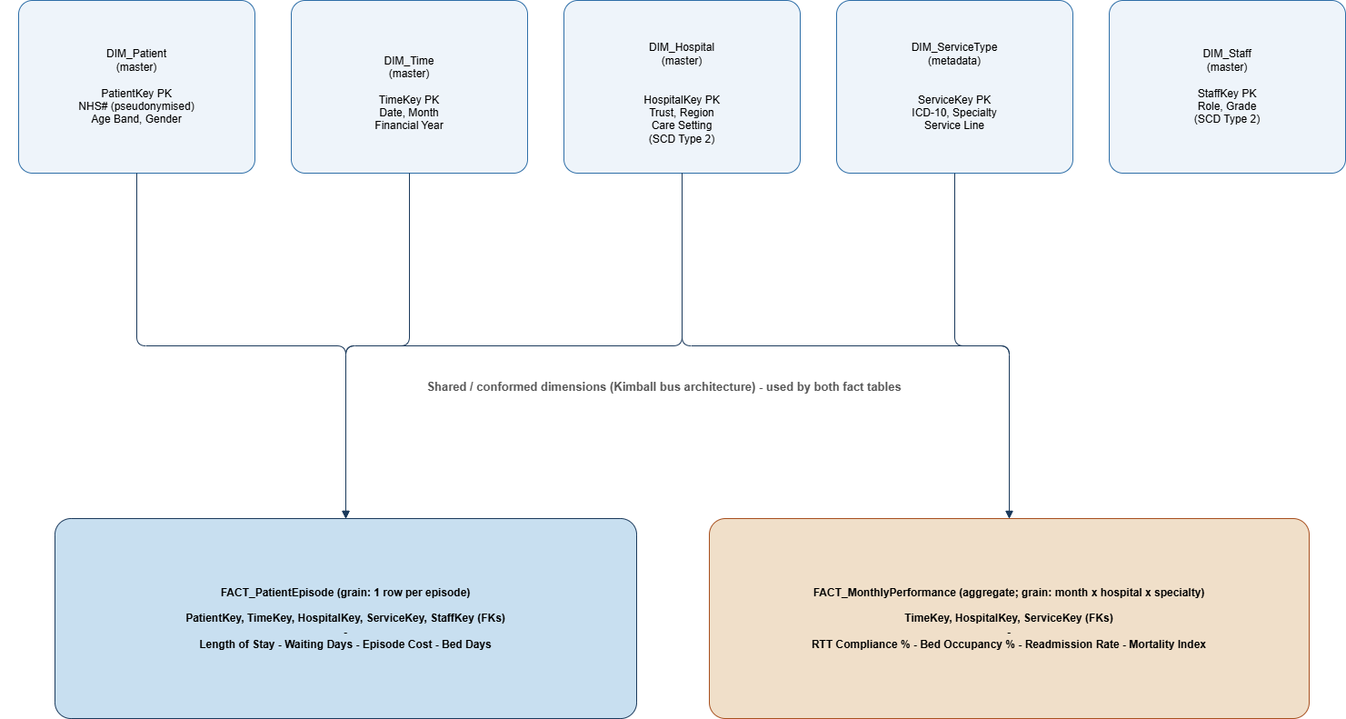
Figure 3 - Fact constellation for the NHS England data warehouse, showing master-data, metadata, and aggregate tables.
Both fact tables have the same five conformed dimensions, explicitly separated into master data and metadata as the brief requires. DIM_Patient and DIM_Staff are both master data dimensions that contain the two entities, crucial for the organization: patients, anonymized for their privacy, and staff members, who have role and grade. DIM_Hospital is also a master data dimension containing information about the trust, its region and the type of care delivered there. DIM_Time is a standard calendar dimension calibrated to the NHS fiscal year (from April to March). Finally, DIM_ServiceType is a metadata dimension: unlike other dimensions, it does not contain information about any real-life entities; instead, it contains codes that classify an activity, ICD-10 diagnostic categories, specialty, service line, allowing us to classify episodes based on “what kind of care”, rather than “who” or “where”.
Each of the dimensions is explicitly flat and denormalized, that is, consists of a single wide table without any sub-tables, because the performance and simplicity gain for user queries exceed the storage overhead created [8]. As hospitals can change and people can change their roles over time, DIM_Hospital and DIM_Staff should be implemented as Type 2 slowly changing dimensions: each time some tracked attribute of the record changes, a new row, with a new surrogate key, should be created so that past episodes could be still classified according to the organizational structure at the time of the episode occurrence [4]. The chosen constellation structure allows us to add a new fact table in the future, say, for workforce scheduling, and use existing Time, Hospital and Staff dimensions, which is the main reason for conformed bus architecture.

2.3 Data Marts and Schema
Three dependent data marts are proposed, each a filtered, subject-specific view of the constellation described in 2.2 and shown flowing from the warehouse in Figure 1, rather than a separately built database. The Finance data mart includes a FACT_FinancialActivity table (tariffs income, actual costs, budget variances) together with DIM_Time, DIM_Hospital, DIM_ServiceType and a mart-specific DIM_CostCentre table for analysis by the Finance Director. The Operations data mart includes a FACT_PatientFlow table (admissions, discharges, bed occupancy percentage, RTT waiting time days) with DIM_Time, DIM_Hospital and a mart-specific DIM_Ward table for capacity and flow monitoring. The Clinical Quality data mart includes a FACT_ClinicalOutcome table (readmission rate, mortality index, safety incidents, satisfaction score) with DIM_Time, DIM_Hospital and DIM_ServiceType for monitoring of standards by the Medical Director. Creating such data marts, rather than separate databases or a single combined mart, prevents the inconsistencies and duplication inherent in a spider-web-like “departmental extracts” approach warned about by Kimball and Ross [4].
Three marts instead of one big mart or multiple smaller ones is a deliberate trade-off, every mart maps directly to a current accountable role (Finance Director, Operations lead, Medical Director), so the owner and access control are obvious, but all three will still be using only FACT_PatientEpisode and FACT_MonthlyPerformance, so there is no need for separate ETL process per mart. Operations mart can produce a continuously updated daily aggregate on top of FACT_MonthlyPerformance, instead of recalculating bed occupancy each time based on the raw episodes, ensuring responsiveness of ward-level dashboard all day long.

2.4 ETL Plan
Table 1 summarises, for each warehouse table, where its data originates and the transformations ETL must apply before loading.

Table 1 - Simplified ETL plan by source system
Source System | Target Table(s) | Key Transformations
EPR / PAS | DIM_Patient, FACT_PatientEpisode | De-duplicate NHS numbers; pseudonymise identifiers; standardise ICD-10 codes and date formats
ESR (workforce) | DIM_Staff | Standardise role/grade codes; apply Type 2 SCD for role and trust changes
Finance / costing system | FACT_FinancialActivity | Standardise currency and cost units; aggregate transaction-level costs to episode grain; reconcile against national tariff
GP referral & national reference data | DIM_Time, aggregate benchmark tables | Validate against published NHS England statistics; aggregate to monthly grain

Table 2, adapted from Kimball and Caserta's ETL subsystem methodology [6], maps each incremental load process onto the ETL subsystems it touches during build and test.
Table 2 - ETL subsystem coverage by incremental load process (Phase 3).
Phase 3 — Develop Incremental Load Process | Extracting Data | Cleaning & Conforming | Delivering for Presentation | Managing the ETL Environment
Build and test the DIM_Patient, DIM_Staff and DIM_Hospital incremental load processes | X | X | X
Build and test the FACT_PatientEpisode incremental load process | X | X | X
Build and test the FACT_MonthlyPerformance aggregate table load |  |  | X
Design, build and test the ETL scheduling and automation |  | X | X | X

2.5 Data Quality & Governance
The quality of data needs to be evaluated based on accuracy, completeness, consistency, and timeliness [10]. Governance involves role-based access control that limits access to data marts only for authorized individuals, anonymization of patient identifiers, and adherence to Data Protection Act 2018, UK GDPR, and the principles outlined by the National Data Guardian Caldicott [11], [12]. Assurance is required to be provided yearly through NHS Data Security and Protection Toolkit [13] and a governance model like DAMA-DMBOK ensuring data ownership within all trusts contributing to the warehouse [14].

Conclusion
NHS England should adopt a Kimball-style dimensional data warehouse, developed incrementally around conformed Patient, Time, Hospital and Staff dimensions with dedicated data marts for the Chief Executive, Finance Director and Medical Director, without disrupting the EPR, PAS and ESR systems used in daily operations. This approach aligns with the ongoing Federated Data Platform rollout, demonstrating that the proposed architecture is practical and proven at NHS scale [1]. The techniques used throughout this report, including conformed dimensions, aggregate fact tables, Type 2 slowly changing dimensions and strong data governance, are also widely applied in industries such as retail, logistics and finance, making them valuable transferable skills.

References
[1] NHS England, “NHS Federated Data Platform,” NHS England, 2024. [Online]. Available: https://www.england.nhs.uk/digitaltechnology/nhs-federated-data-platform/
[2] S. Chaudhuri and U. Dayal, “An overview of data warehousing and OLAP technology,” ACM SIGMOD Record, vol. 26, no. 1, pp. 65–74, 1997.
[3] W. H. Inmon, Building the Data Warehouse, 4th ed. Indianapolis, IN, USA: Wiley, 2005.
[4] R. Kimball and M. Ross, The Data Warehouse Toolkit: The Definitive Guide to Dimensional Modeling, 3rd ed. Indianapolis, IN, USA: Wiley, 2013.
[5] NHS Business Services Authority, “Electronic Staff Record (ESR) Workforce Services,” NHSBSA, 2024. [Online]. Available: https://www.nhsbsa.nhs.uk/electronic-staff-record-esr-workforce-services
[6] R. Kimball and J. Caserta, The Data Warehouse ETL Toolkit: Practical Techniques for Extracting, Cleaning, Conforming, and Delivering Data. Indianapolis, IN, USA: Wiley, 2004.
[7] E. F. Codd, “A relational model of data for large shared data banks,” Communications of the ACM, vol. 13, no. 6, pp. 377–387, 1970.
[8] M. Golfarelli and S. Rizzi, Data Warehouse Design: Modern Principles and Methodologies. New York, NY, USA: McGraw-Hill, 2009.
[9] NHS England, “Statistics » Referral to Treatment (RTT) Waiting Times,” NHS England, 2024. [Online]. Available: https://www.england.nhs.uk/statistics/statistical-work-areas/rtt-waiting-times/
[10] R. Y. Wang and D. M. Strong, “Beyond accuracy: What data quality means to data consumers,” Journal of Management Information Systems, vol. 12, no. 4, pp. 5–33, 1996.
[11] UK Government, “Data Protection Act 2018,” legislation.gov.uk, 2018. [Online]. Available: https://www.legislation.gov.uk/ukpga/2018/12/contents
[12] National Data Guardian, “The Caldicott Principles,” GOV.UK, 2020. [Online]. Available: https://www.gov.uk/government/publications/the-caldicott-principles
[13] NHS England Digital, “Data Security and Protection Toolkit,” NHS England Digital, 2024. [Online]. Available: https://www.dsptoolkit.nhs.uk/
[14] DAMA International, DAMA-DMBOK: Data Management Body of Knowledge, 2nd ed. Basking Ridge, NJ, USA: Technics Publications, 2017.

