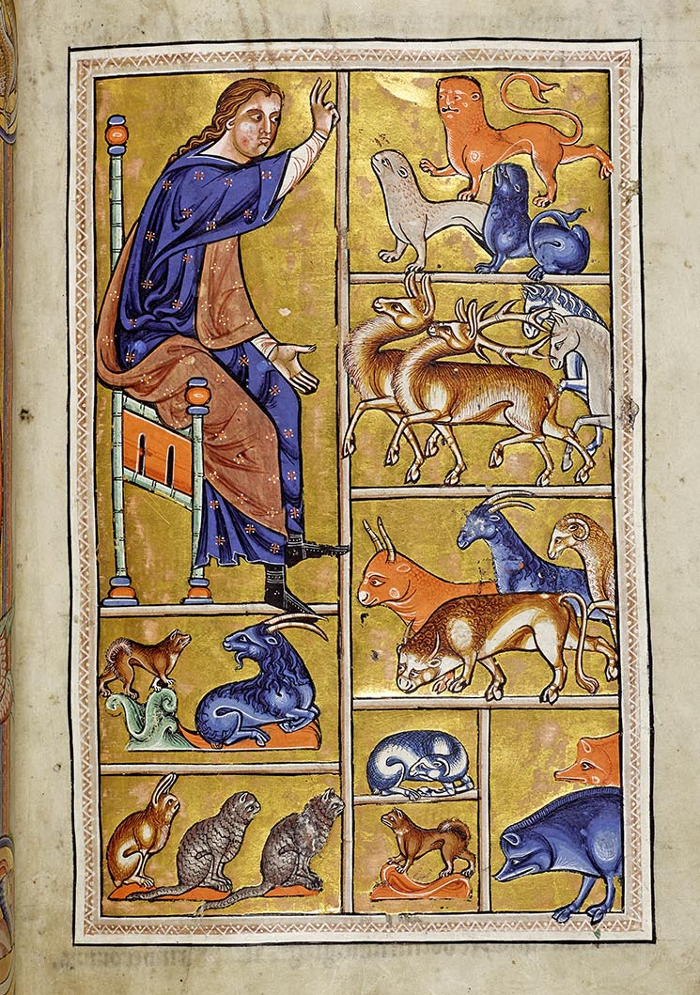
The above picture, hailing from the Aberdeen Bestiary and assumed to be illuminated around 1200, is titled “Adam Names The Animals” and is at the beginning of the Bestiary detailing Genesis and the creation of the world by God. The image depicts Adam in a very similar way to Jesus in a previous illumination, with the robes and the pose of blessing, and also akin to God’s creation of the animals previously, which gives the sense that the image may have been used by the artist to imply a similarity between God, Jesus and Adam, despite the latter two’s dichotomy of a scorned son and a loved one - a son who betrayed his father, the Creator, and one who only did him justice. Both Adam and Jesus are put on Earth to bring God’s actions to life, except Jesus is sent to be sacrificed for the sins that Adam committed initially. This pits them against each other, though the artist tells a narrative of a loving trinity of father and sons by crafting these images at the beginning of the bestiary in order. It reflects the idea that God loves all of his creations eternally, including the animals about to be named in the book.
In this scene, the Aberdeen Bestiary makes an effort to introduce the creation of all animals before going into detail about the individuals, with the book itself holding the same style as the Ashmole Bestiary, implying several things about the creation of the illuminations and the writings. Firstly, it can be noted that the Aberdeen Bestiary was never fully completed, giving modern historians an allowance to see the actual capability of the creation and the editing process used by the people putting it together. Secondly, while historians cannot exactly identify who made it, any manuscripts illuminated in the style similar to the two bestiaries have connections to Yorkshire and Lincolnshire in the late twelfth century, yet have no ties to specific monasteries – unlike the production of the Guthlac Roll, which has a specific style akin to stained glass windows, seemingly used in the window of the North Rose at Lincoln Cathedral, implying the artist of the Guthlac Roll may have produced the drawings in the Cambridge Bestiary. While the style cannot be attained to any specific person or group of people, it can be noted that the artist drew certain animals fictionalised in a sense – the top right animals are supposed to represent a lion, panther and leopard, the kind of animals that an English friar will likely never have seen in person before, making them appear as house cats but bigger, without their specific patterns and shorter ears. The bestiary itself also takes note of non-existent animals, such as dragons and satyrs, explaining their characteristics and mannerisms without a full understanding that they do not exist.
The illumination also depicts Adam clothed, which is interesting to note as the naming of the animals within the Bible would have taken place prior to Adam learning shame and therefore he would have been naked. The choice to draw him clothed reflects more of the opinions of the society at the time – the idea of any naked man drawn in a religious text, let alone the first man, would have been crude and frowned upon. Thus the recreation of Genesis changes his appearance and likeness, in order to not appear blasphemous. It is also worth noting that the images that are drawn sequentially at the beginning of the Aberdeen Bestiary are usually structured in the middle of most medieval bestiaries produced around this time – in fact, only six bestiaries do not follow this standard, two of which being Aberdeen and Ashmole. The two books are also found to be in common as two of the only bestiaries that copy the Aviarium in great detail, referring back to an Augustinian canon written in the mid-twelfth century.
Contextually this importance then highlights how the creator of these texts wished to portray Adam – as a holy man, the first man, the one who named the animals. It also shows the importance to which animals are given in the society and period at the time – with the power imbalance of man to animal it can be easy to misunderstand that certain animals were feared and revered, and in fact used to create the very parchment the illuminations were drawn upon. The choice of the animals is also very telling as to the narrative offered by the illuminator, as certain animals have been marked by historians as connections to the Devil, importantly the serpent, wolf, fox and raven for their conniving, mischievous and deceiving nature. The absence of these animals, replaced instead by a lion, stag, horses, rabbits and sheep, reveals the emphasis on holy animals that are more typically likened to God or his saints – the lion often representing Jesus, or God’s almighty strength, and similar is to be said for the others. The prey animals, such as the sheep and rabbits, may also represent the innocence of humanity and again Jesus himself, whilst also symbolising the peace of both predator and prey existing together in harmony prior to the Fall of Man. When Adam is naming them, they are not at each other’s throats, or escaping, or trembling in fear – rather they are bowing in reverence to their creator, who is giving them life in a way by giving them names and making them tangible through speech. In this manner, Adam not only parallels Jesus’ clothing from a previous illumination, but also God creating the animals.
The use of bright colour as well as the posing of Adam, the addition of lions and sheep, and the robes he is portrayed in, all add to the symbolism of a holy and good Adam, one who helped partake in the creation of animal kind, who can do no wrong. It is not only a reflection of the artist’s vision of Adam, but an effective introduction of an illuminated manuscript to the rest of the Aberdeen Bestiary.

Bibliography
Beal, Jane, ‘The Devil’s Threat in Medieval Bestiaries: Recognizing and Resisting Evil in the Dragon, Serpent, Wolf, Fox, Ape, Whale, Hawk, Partridge, and Raven’, Ítaca, no. 16 (2025), pp. 149–86, https://doi.org/10.14198/itaca.28809 [last accessed 6/12/25]
Aberdeen University Library MS 24, Aberdeen Bestiary, 2015, https://www.abdn.ac.uk/bestiary/ms24/f12v/ [last accessed 6/12/25]
Forrest, S.G. The Aberdeen Bestiary, Aberdeen University M.A.Dissertation, 1979.
Hassig D., Medieval Bestiaries, text, image, ideology, Cambridge 1995.

Aberdeen Bestiary, ed. Professor Jane Geddes, 2015, https://www.abdn.ac.uk/bestiary/ [last accessed 6/12/25]
F.4V¸ Aberdeen Bestiary
Ff. 2r, 2v.
The Patron Of MS 24, Project Background, Aberdeen Bestiary
A series of illustrations about the life of Saint Guthlac of Croyland.
Project Background, Aberdeen Bestiary
Willene Clark, The Medieval Book of Birds: Hugh of Fouilloy's Aviarium, Binghampton 1992, 73-85, 267-70,296-7.
Jane Beal, ‘The Devil’s Threat in Medieval Bestiaries: Recognizing and Resisting Evil in the Dragon, Serpent, Wolf, Fox, Ape, Whale, Hawk, Partridge, and Raven’, Ítaca, no. 16 (2025), pp. 149–86, doi:10.14198/itaca.28809

