Business Issues and the Context of HR

Report Title: The Evolving Role of HR in the Contemporary Business World

Name: Dayna James

CIPD Membership Number: 49165316

Date: 09th January 2019

Word count (max: 3900 words)

I declare that this assignment is my own work and that any information obtained from books and other sources have been appropriately referenced.

Signed Date 09th January 2019

Contents
1. Introduction ………………………………………………….………………….
2. Shaping HR Agenda ……………………………………..……………………
2.1. HR function ……………………………………………..……………………
2.2. HR Strategies …………………………………………..……………………
2.3. Insights and Solutions ………………………………………………………
3. Environmental Analysis ………………………………….……………………
3.1. PESTLE Analysis ……………………………………………………………
3.2. SWOT Analysis ………………………………………………………………
3.3. PRIMO-F ………………………………………………………….………….
3.4. Comparison of Environmental Analysis …………………..………………
4. Organisations Business Function – External and Internal Factors………
4.1. Government Policy - Externa…………………………………….…………
4.2. Demographic – External ……………………………………………………
4.3. Financial Health – Internal …………………………………………………
4.4. Communications – Internal ….………………………………………..……
5. Strategy Formulation and Implementation …………………………………
6. Business Performance …………………………………………….…………
6.1. Service Level Agreement ………………………………………….………
6.2. Key Performance Indicators ………………………………………….……
6.3. Forward Financial Plan ……………………………………………….……
7. Business Planning …………………………………………………………….
7.1. Competitive Information ……………………………………………...…….
7.2. Government Information …………………………………………………...
7.3. Financial Information ……………………………………………………….
7.4. Feedback …………………………………………………………………….

https://books.google.co.uk/books?id=rwjGDgAAQBAJ&pg=PA7&lpg=PA7&dq=Reilly+2000+late+1990’s+when+HR+leaders+realised+that+HR+admin+could+be+centralised&source=bl&ots=tlkRoF3Axx&sig=Cb9HO5RgItQ3w01T92ZTesrQwb4&hl=en&sa=X&ved=2ahUKEwizt_urltTfAhUhh1QKHSENB04Q6AEwAHoECAoQAQ#v=onepage&q=linear%20sequential&f=false ZEBRA BOOK

1. Introduction

The business world is constantly evolving, and the effects on an organisation can be significant if continuous improvement be ignored. The human resource management is a powerful tool in bringing in the success of the organisation (Zugno et al. 2013). It is internal as well as external factors that affect a business. The human resource has an impact on the functioning of the business (Zugno et al. 2013). This delegate paper will evaluate business issues, internal and external factors that affect organisations and the impact HR has on the business operations.

2. Shaping HR Agenda

As the world of work grows even more complex, diverse and ambiguous, the evolution and meaning of HR as changed. As technology, globalisation, skills shortages and the challenges workforce demographics add to the challenges facing business’s, HR must evolve and grow to play a greater part in developing organisations for the future.

In terms of HR, the key forces that shape the HR agenda explained by Taylor and Woodhams (2016) are that it gains an understanding of how organisations differ in terms of their objectives and the particular context in which they operate and is fundamental to the effective study of HRM. Today’s focus include modules of HR function, HR strategies, insights and solutions to support a business’s performance and its business accountability and ethics.

2.1. HR function

The human resource function has a bright future if it is managed and designed in a strategic manner. The objectives of the human resource management revolve around the effective utilization of the human resources, an optimum level of working relationships among the employees and the maximum individual development of the human resources (Armstrong & Taylor, 2014). The major functions of the human resource department consist of the planning, job analysis, recruitment, selection, orientation, training and development, performance appraisal, compensation and career planning (Salvendy, 2012).

David Ulrich’s (1997) ground breaking model of HRM services delivery spurred many senior HR leaders to restructure the delivery of their services to meet the challenges of changing national and international business conditions.
Ulrich model the “three legged stool” has been regarded by some of the best practice. Ulrich suggested that in a large organisation the HR function should be divided into three segments. The three segments or legs to the stool are explained as the following;
- Shared Services
- Centres of Expertise
- Business Partners.

Shared services which emerged in the late 1990’s when HR leaders realised that HR admin could be centralised (Reilly, 2000). A single but often relatively large unit handling all routine transactional services across the business.
Secondly, centres of expertise exist as repositories of key technical knowledge on resourcing, reward, employment relations, etc. and can develop policy while providing support to business units and to shared services.
Thirdly, business partners, in contrast, are individuals or small teams who work closely with the managers of business units on key initiatives and change management. This model is used even today because, though, it is not a perfect model, but it provides a good reference point for the HR framework (CIPD, 2016).

2.2. HR Strategies

A set of actions that are aimed at the integration of the organization’s culture, people as well as systems so that the organization can achieve its business goals, are known as HR strategy (Momin & Mishra, 2015). The approaches to HR strategy can demonstrated by the use of different methods. The methods used can be the best fit, best practice, horizontal and vertical integration and recourse-based view.

Best fit approach is in line with contingency theory. It emphasized that HR strategies should be congruent with the context and circumstances of the organisation. Best fit can be perceived in terms of vertical integration or alignment between organisations business and HR strategies.

The best fit approach is also subject to sever criticism. Firstly, Boxall and Purcell (2003) criticizes that in a changing business environment companies and their strategies are subject to multiple alternating contingences and that it is merely possible to adjust entire HR systems to new challenges frequently. Secondly, as companies move through their life-cycle HR practices have to be aligned which leads to an alternating treatment of employees which can have a demotivating effect and show inconsistency in corporate culture (Boxall and Purcell 2003) (UKEssays, 2013).

A best practice is a technique or methodology that, through experience and research, has proven to reliably lead to a desired result. A commitment to using the best practices in any field is a commitment to using all the knowledge and technology at one's disposal to ensure success.

Horizontal and vertical integration is the main characteristic of HR Strategy is its interaction with business strategy. HR strategies need to have external fit with business strategies and be vertically integrated with them. There needs to be horizontal integration with all aspects of HR strategy (internal fit). HR practices must support each other.

Recourse-based view strategy can be described as a management device used to assess the available amount of a business strategic assets. In essence, the recourse-based view is based on the idea that the effective and efficient application of all useful resources that the company can muster help determine its competitive advantage.

2.3. Insights and Solutions

REFERENCE - The human resource function leads the transformation process of many organizations towards a high performing, engaged, appropriate align and highly capable companies (Ulrich 2013). The HR function has gone through several transformations. The HR function has transformed from an operational role to a center service role (Ulrich 2013). CIPD online explains that in a world of increased reporting of corporate scandals, there is more recognition of the need to develop sustainable organisational practices that deliver a business’s long-term values, not only in terms of profit, but for the benefit of a range of stakeholders including people and wider society (CIPD, 2018).

In the current world of work, the ethical practice and accountability in an organisation included the application of ethical values, this means treating their employees fairly, honestly, openness and with integrity and should be the organisations behaviour in the day-to-day running.

3. Environmental Analysis

An environmental analysis is a strategic tool and can identify all external and internal elements which is affecting a business or an organisational performance. By analysing it can identify threats and opportunities for the business to help the business growth. The evaluations later translate into a decision-making process and helps align strategies with the organisational environment. It is critical that in today’s environment, the ever facing changes of every day work it is important that we analysis the impact these have on the organisation to promote growth.

3.1. PESTLE Analysis

A PESTLE analysis is an audit of six external influences on an organisation. These include the following;

- Political: Tax policy; environmental regulations; trade restrictions and reform; tariffs; political stability
- Economic: Economic growth/decline; interest, exchange, inflation and wage rates; minimum wage; working hours; unemployment (local and national); credit availability; cost of living
- Sociological: Cultural norms and expectations; health consciousness; population growth rates; age distribution; career attitudes; health and safety
- Technological: New technologies are continually emerging (for example, in the fields of robotics and artificial intelligence), and the rate of change itself is increasing. How will this affect the organisation’s products or services?
- Legal: Changes to legislation impacting employment, access to materials, quotas, resources, imports/exports, and taxation
- Environmental: Global warming and the increased need to switch to sustainable resources; ethical sourcing (both locally and nationally).

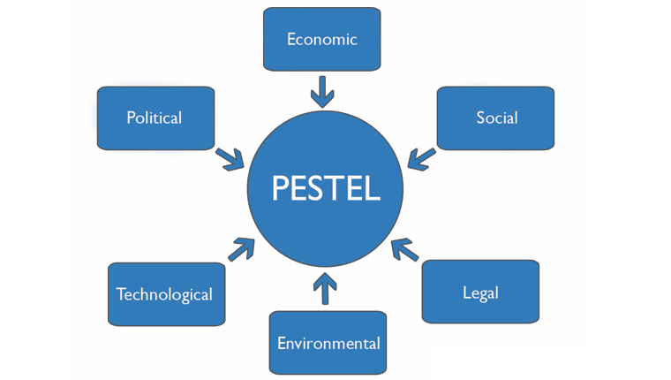

Figure 1: PESTLE Analysis Diagram

By analysing these factors, these gain insight and the bigger picture into the internal and external influences that impact organisations and how they are operating, business decisions and strategies. It allows HR professionals and senior managers to review the factors presented to identify an understanding what impacts and risks they have on the business. The gatherings inform their decisions allows to plan for change in terms of business growth or decline. It can benefit an organisation by highlighting the potential for additional cost implications as a result of change that any of the factors might have on the organisation. They prompt for further research and can be built into future organisational plans (CIPD, 2018).

The advantages and disadvantages of the PESTLE analysis as explained by CIPD online (2018) include the following;
Advantages | Disadvantages
- It’s a simple framework.  - It facilitates an understanding of the wider business environment.  - It encourages the development of external and strategic thinking.  - It can enable an organisation to anticipate future business threats and take action to avoid or minimise their impact.  - It can enable an organisation to spot business opportunities and exploit them fully. | - Some users (of a PESTLE analysis) oversimplify the amount of data used for decisions – it’s easy to use a limited selection of data.  - The risk of capturing too much data may lead to ‘paralysis by analysis’.  - The process needs to be undertaken on a regular basis to be effective.  - The pace of change makes it increasingly difficult to anticipate developments that may affect an organisation in the future.  - The data used may be based on assumptions that subsequently prove to be unfounded.
Table 1: Advantages and Disadvantages on PESTLE Analysis

3.2. SWOT Analysis

A SWOT analysis is a planning tool and is often used as part of a strategic or business planning process but can be useful in understanding an organisation or situation and decision-making for all sorts of situations. As explained by the CIPD (2015), “a SWOT analysis identifies information that is helpful in matching an organisation or group’s goals, programs, and capacities to the social environment in which it operates”.
The analysis involves stating the objective of the business and identifying the internal and external factors that are either supportive or unfavourable to achieving the objectives of the organisation.

SWOT analysis is explained below;
- Strengths: positive, tangible and intangible attributes, internal to an organisation and within the organisation’s control
- Weaknesses: internal factors within an organisation’s control that detract from the organisation’s ability to attain the desired goal. Which areas might the organisation improve?
- Opportunities: external attractive factors that represent the reason for an organisation to exist and develop. What opportunities exist in the environment, which will propel the organisation? Identify them by their ‘time frames’.
- Threats: external factors beyond the organisation’s control which could place the organisation mission or operation at risk. The organisation may benefit by having contingency plans to address them if they should occur. Classify them by their severity and probability of occurrence.

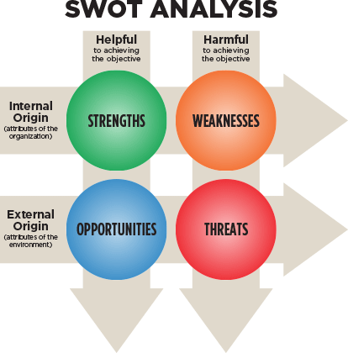

Figure 2: SWOT Analysis Diagram

It is important to note the strengths and weaknesses are intrinsic value-creating skills or assets, or the lack of these, relative to competitive forces. Opportunities and threats are external factors which are not created by the organisation, but emerge as a result of the competitive dynamics caused by future gaps in the market (CIPD, 2015).

Advantages | Disadvantages
- It is a simple four box framework.  - It facilitates an understanding of the strengths and weaknesses of the organisation.  - It encourages the development of strategic thinking.  - It enables a management team to focus on strengths and build opportunities.  - It can enable an organisation to anticipate future business threats and take action to avoid or minimise their impact.  - It can enable an organisation to spot business opportunities and exploit them fully.  - It is flexible. | - Some users over-simplify the amount of data used for decisions – it is easy to use scant data.  - To be effective this process needs to be undertaken on a regular basis.  - The best reviews require different people being involved, each having a different perspective.  - Access to quality internal data sources can be time consuming and politically difficult (especially in more complex organisations – parent company, etc).  - The pace of change makes it increasingly difficult to anticipate developments that may affect an organisation in the future.  - The risk of capturing too much data is that it may make it difficult to see the wood for the trees and lead to ‘paralysis by analysis’.  - The data used in the analysis may be based on assumptions that subsequently prove to be unfounded (good and bad).  - It lacks detailed structure, so key elements may get missed.
Table 2: Advantages and Disadvantages on SWOT Analysis

3.3. PRIMO-F

In the same way that PESTLE is used to add clarity to the internal factors that affect the organisation, PRIMO-F provides a consistent framework to look at strengths and weaknesses of the internal environment (CIPD, 2015).

The acronym PRIMO-F stands for:
- People: what do they do, do they have the skills the organisation needs?
- Resources: does the organisation have the right and adequate resources?

- Innovation: are new ideas important to us in all parts of the organisation?
- Marketing: how do they know what the organisation does?
- Operations: how is all this managed?
- Finance: what are the prices, costs and investments?
Figure 3: PRIMO-F Business Growth Model

Advantages | Disadvantages
- Helps analysis internal factors that impact the business  - Simple way to analysis strengths and weakness in a relevant area  - It can enable an organisation to anticipate future business threats and take action to avoid or minimise their impact. | - The pace of change makes it increasingly difficult to anticipate developments that may affect an organisation in the future.  - The data used may be based on assumptions that subsequently prove to be unfounded.  - Lack of consistent application  - Key issues are sometimes missed when using this analysis
Table 3: Advantages and Disadvantages on Primo-F Analysis

3.4. Comparison of Environmental Analysis

PRIMO-F provides the structure for SWOT analysis and PESTLE analysis provides the structure for SWOT. The PESTLE analysis is a technique used to understand the various external influences on a business. Whilst PESTLE analysis looks at 6 external factors that affect the business.
A SWOT analysis gives you a better insight into your internal and external business environment by analysing the four factors which looks at internal and external factors. The same way as PESTLE works, PRIMO-F looks into six internal factors that affect your business.

4. Organisations Business Function – External and Internal Factors

NPTCBC aims to help the county borough become a better place for people to live, learn and work, bring up families and enjoy their leisure activities. A place where everyone has an equal chance to get on in life. NPTCBC is committed to providing its employees with the best possible working standards. it is the council’s policy that no employee shall receive less favourable treatment than another and given equal opportunity to each employee. None shall be disadvantaged by conditions or requirements which cannot be justified.

4.1. Government Policy - External

NPTCBC are bound by statute. Our functions are set out in numerous Acts of Parliament written by law and passed by a legislative body. Many of our functions have associated legal duties which affect our policies and procedures both in organisational strategies and HR function.

It is a legal duty that we adhere to changes to Act’s passed by parliament. Failure to update our policies and procedures to be in line with the Act’s could result in fines, imprisonment, loss of reputation, loss of current or potential staff, down time and loss of productivity (Xenon Group, 2018).

4.2. Demographic - External

According to the Office for National Statistics (2018), in 2017 Neath Port Talbot was reported the eighth most populous local authority and the third most populous county borough. It was reported by City Population online (2018) that in 2017, the county of Neath Port Talbot had the population of 142,090 living in the borough. This is a significant increase to the reported amount of 139,812 people living in Neath Port Talbot in 2011. Given this, the increase in population will affect the local authority by having an increase in employment rates affecting our recruitment procedures.

4.3. Financial Health - Internal

NPTCBC is a public sector organisation and the financial health of the local authority is provided by the Welsh Assembly Government. NPTCBC relies on funding from the Welsh Assembly to maintain services. On the 09th October 2018, The Welsh Government published details of the Provisional Local Government Settlement for 2019/2020 (2018).

The settlement shows that funding of £4.214bn from the Welsh Government is to be granted to the Local Government. However, this is £12m or -0.3% less in comparison with the current year. This means that in terms of HR function by becoming more shared service based affecting staffing structures, cutting services and reviewing and identifying areas that savings can be made in line with the budget.

4.4. Communications - Internal

HR has an important role in the communication across its organisation when it comes to change. Effective communication within the business can have a number of benefits including effective leadership, Functional Implementation and Strategic Direction that is key to organisation success. When an HR manager communicates effectively with their staff, they represent a team with a consistent mission that can establish HR's credibility throughout the organisation. One of the uphill battles for HR managers is improving employee perception of HR, which for the most part has been likened to reporting to the principal's office for a reprimand. Many employees do not understand the functionality of HR and, even less, the purpose that an HR department serves, except when it comes to processing payroll (Mayhew, n.d.) .

5. Strategy Formulation and Implementation

The key stages to strategy formulation as explained (Higgins & Vincze, 1993) five stage model of strategic management for determining objectives and formulating strategy:
- Formulation of vision statement, mission statement and goals
- Determination of strategic objectives
- Formulation of strategies
- Implementation of strategies
- Evaluation and control of strategies

The model involves taking account of mission, internal and external analyses and assessment of organisation’s strengths, weaknesses, opportunities and threats (SWOT Analysis) to be able to inform a HR decision to improve the organisation.

Conducting this type of analysis will inform business decisions and formulate business’s vision statement, mission statement and goals / objectives. HR’s contribution in the vision and mission is to provide effective HRM by developing and implementing policies, programs and services that contribute to the organisations corporate and employee goals / objectives. Setting goals / objectives for succession planning to meet the set strategic objectives ensures that the organisation achieves its goals objectives. It is HR responsibility to work with other senior leaders and employees to implement the strategies for intended future direction. HR's role is to develop good-practice principles for the HR profession, and how HR can contribute to business performance (CIPD, n.d.).

5. Give some examples of how business performance can be evaluated, making reference to traditional and modern indicators. Make particular reference to the role of HR in business planning and change management with some examples to illustrate HR’s key role.
- Give 3 examples - KPIs, balanced scorecard, service level agreements or other examples. Traditional and modern indicators. Include different types of metrics and how these can be used, in particular HR metrics. Give examples of how HR contributes to business planning (providing insights - data, strategy and solutions) and in a change management agenda e.g. HR as a change agent (modelling and communicating the change, engaging others and providing support).

Traditional – Finance only
Modern – Methods cannot determine other indicators
http://www.cmj.bxb.ro/Article/CMJ_7_7.pdf

6. Business Performance – REFERENCE PAGE 30 LIZARD BOOK

NPTCBC is a public sector organisation, methods of measuring our performance can be evaluated by reviewing both qualitative and quantitative data.
Methods of measuring performance can be measured by the use of the “traditional” method of measuring performance by financial targets greater efficiency or efficiency savings and following management reforms by the “new” method of performance measures by the use of performance data, customer data and employee data both financial and non-financial.

Quinn (1980) explains that strategy is the pattern or plan that integrates an organisation’s major goals, policies and actions into a coherent whole. Quinn (1980) continues to explain that formal strategies contain 3 main elements and what tools are used for each approach:
- Rational / Classical
- Emergent / Logical Incrementalism
- Symbolic / Radical

Figure 2 explains the structure that NPTCBC gathers its data and how we report our performance. HR’s role in illustrating business planning and change management would be to provide data to inform decisions for strategic planning.

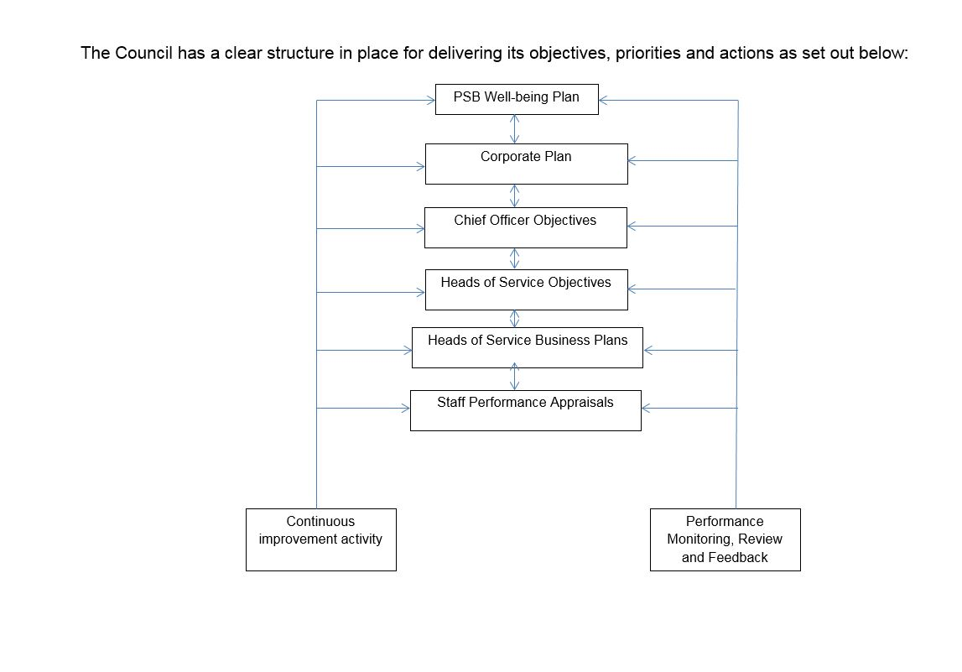
Figure 2 – Corporate Performance Management Framework Reporting Structure

6.1. Service Level Agreement

As you can see from the structure in figure 2, senior leaders of the authority set objectives that need to be met by each directorate. Senior leaders have the responsibility to report performance by using people metrics for each of their directorate that they are responsible for. This is collated by a number of continuous improvement activities and performance monitoring and review feedback i.e. staff turnover, percentage of response to positions and employee satisfaction. Senior leaders are to report the information that is collated from their directorate that is collated and included in the authorities corporate plan and business plans for each financial year. HR’s role in supporting this performance measure is to provide data in relation to staff turnover, recruitment data (percentage of responses from positions) and employee feedback in relation to employee satisfaction.

6.2. Key Performance Indicators

The Chief Executive requires each chief officer to demonstrate how they will maximise their collective contribution to the three wellbeing objectives and associated improvement priorities and in so doing embrace the sustainable development principle. The detail of this is articulated in the strategic priorities; through day to day service operations; supported by the corporate change programme, which, in turn, inform the priorities of teams and individuals.

Key performance indicators (KPI’s) are used to inform the authorities corporate plan.
KIP’s are reported quarterly and identify whether the authority are meeting the aims and objectives of the previous corporate plan. The corporate plan outlines all aims and objectives the authority is required to meet over the next 5 years. HR’s role in supporting this performance measure is to provide data in relation to the employees, as mentioned, in terms of sickness reporting and ensuring procedures are accurate.

6.3. Forward Financial Plan

NPTCBC is a public sector organisation. As a local authority and its financial status is controlled by the Welsh Assembly Government and therefore it is important that NPTCBC monitors its financial status cautiously. Forward financial planning is one method that NPTCBC uses to predict its financial status. The Financial Plan will outline each service area needs and what savings it needs to make over the next X years to achieve the required budget saving that Welsh Government has imposed on us. HR will assist in achieving the financial goals by monitoring sickness absence. Early intervention in sickness absence has proven to reduce the amount of sickness absence and also make effective financial savings. The HR team has a designated Sickness Taskforce Team who monitor sickness absence.

6. Explain how at least four different sources of business and contextual data that can be assessed and utilised for planning purposes e.g. internal information within the organisation including HR metrics, industry information e.g. trends in HR, competitive information, government information.
- HR metrics such as HR costs, responsiveness, issue management, recruitment, productivity etc and also industry information e.g. trends in HR (research), competitive information (eg salary), government information (eg reports on demographic trends). Include examples.

7. Business Planning

The process of business planning consists of a number of contextual data that is collated, assessed and utilised to inform a business’s decision and enables the business to plan strategically whether the data is qualitative data or quantative data sources. Sources that can be used to support the planning process are:

7.1. Competitive Information

Other organisations collect data on external competitors to weigh up the differences between them and allowing the organisation to determine what the other companies have an advantage to themselves. The data collected could be company sickness, pay rates, implementation of policies. As an example, NPTCBC may compare against other local authorities to determine whether we are able to implement other policies. NPTCBC will gather information from other local authorities policies to see if we can incorporate it into our policies. NPTCBC will also compare rates of pay and sickness absence statistics.

7.2. Government Information

Government data can be used as part of the planning process to monitor the differences from one period to another. It can be in terms of sickness statistics to identify trends which is required to be reported annually and is then compared each financial year. By reviewing this source, the authority can determine the financial cost implication that sickness absence has on the authority and can improve the amount of sickness reports by early intervention and issue management methods.

7.3. Financial Information

As discussed in 4.3, financial information can be used to monitor the financial health of the organisation. As NPTCBC is a public sector organisation, the financial income is granted by the Welsh Assembly Government annually.
Therefore, it is important that NPTCBC monitors the amount of expenditure and maximise services without exceeding the expenditure.

As financial data is mostly dealt with by the finance section within NPTCBC, in terms of HR the metrics used to assist in monitoring the amount of expenditure would be by monitoring adverts, post’s i.e. structures in terms of any new post’s/deletion or animation of post’s which is agreed via a personnel committee. If need be, voluntary redundancy schemes.

7.4. Feedback

Qualitative data such as feedback can be an excellent source of data use for planning purposes. Feedback from current and former employees i.e. exit questionnaire’s / interviews, employee s satisfaction surveys, focus groups, feedback from applicants in respect of the recruitment process, training evaluation and induction evaluation. To determine an accurate feedback, it will require to collate a numerous amount of the sources above to identify weakness areas.

Conclusion

The contemporary business world is a dynamic place where is the coexistence of the internal factors as well as external factors and HR play a vital role in balancing these effects. HR is required to coordinate with the business processes and implement suitable policies, ensuring we adhere to law, that are beneficial to the organisation and to contribute to the effectiveness of business’s performance. This delegate paper is beneficial for understanding the HR strategies and practices and how HR contribute to the environmental analysis both internally and externally.

References
Armstrong, M. & Taylor, S., 2014. Armstrong's handbook of human resource management practice. s.l.:Kogan Page Publishers.

Boxall, Peter; Purcell, John;, 2003. Strategy and Human Rescource Management. s.l.:s.n.
CIPD, 2015. SWOT analysis. [Online]
Available at: https://www.cipd.co.uk/knowledge/strategy/organisational-development/swot-analysis-factsheet
[Accessed 28 December 2018].

CIPD, 2016. Championing better work and working lives. 14 December.

CIPD, 2018. Ethical practice and the role of HR. [Online]
Available at: https://www.cipd.co.uk/knowledge/culture/ethics/role-hr-factsheet
[Accessed 5 January 2018].

CIPD, 2018. PESTLE analysis. [Online]
Available at: https://www.cipd.co.uk/knowledge/strategy/organisational-development/pestle-analysis-factsheet
[Accessed 28 December 2018].

CIPD, n.d. The HR Role. [Online]
Available at: https://www.cipd.co.uk/knowledge/strategy/hr
[Accessed 07 January 2018].

GOV, 2015. Wellbeing of Future Generations Act 2015, Wales: GOV.

Higgins, J. & Vincze, J., 1993. Strategic management: Concepts and cases. Chicago, IL.: Dryden Press,.

HR Guide.Com, 2018. HR Guide.Com. [Online]
Available at: https://hr-guide.com/HR/HR_Models_and_Theories.htm
[Accessed 04 January 2018].

Mayhew, R., n.d. What Are the Benefits of Effective Communication as a Human Resource Manager?. [Online]
Available at: https://work.chron.com/benefits-effective-communication-human-resource-manager-26562.html
[Accessed 07 January 2018].

Momin, W. & Mishra, K., 2015. HR Analytics as a Strategic Workforce Planning. Volume 4, pp. 258-260.

NEATH PORT TALBOT COUNTY BOROUGH COUNCIL, 2018. Provisional Local Government Settlement for 2019/2020 , Wales: NPTCBC.

Office for National Statistics, 2018. Population estimates for the UK, England and Wales, Scotland and Northern Ireland: mid-2017, s.l.: Office for National Statistics.
Population, C., 2018. City Population. [Online]
Available at: http://www.citypopulation.info/php/uk-parishes-wales.php?adm1id=W06000012
[Accessed 29 December 2018].

Quinn, J. B., 1980. Sloan Managing Strategic Change. 21(4), pp. 3-17.

Reilly, P., 2000. HR Shared Services and the realignment of HR. Brighton: University of Sussex, Institute of Employment Studies.

Salvendy, M., 2012. Handbook of human factors and ergonomics. s.l.:John Wiley & Sons.

UKEssays, 2013. Best Practice And Best Fit Approach In HRM Management Essay. [Online]
Available at: https://www.ukessays.com/essays/management/best-practice-and-best-fit-approach-in-hrm-management-essay.php#citethis
[Accessed 27 December 2018].

Ulrich, D., 1997. Human resource champions:the nect agenda for adding value and delivering results. Boston: MA: Harvard Businesss Review Press.

Woodhams, T. a., 2016. Studying Human Rescource Management. 2 ed. London: CIPD.

Xenon Group, 2018. 5 consequences of failing to comply with legislation. [Online]
Available at: http://www.xenongroup.co.uk/knowledge-centre/legislation/5-consequences-of-failing-to-comply-with-legislation
[Accessed 04 January 2018].

