Forex Trading Hub Website Report

Prepared by: Ionut Condrache
Student Number: 2211615
Course: BSc/HND Computing
Module: L4 - Introduction to Web and Database Concepts
Date: 12th January 2024

Contents
Introduction 3
Requirements 3
Implementation 3
Screenshots of Website Pages: 4
Validation Results: 6
Evaluation 7
Usability 7
Search Engine Optimization (SEO) 7
Accessibility 7
References 8
Appendices 8
HTML Code 8
CSS Code 10

Introduction

This report includes an overview and evaluation of the Forex Trading Hub website, which was created as part of the L4 Introduction to Web and Database Concepts program. The report discusses the website's aim, implementation details, validation results, and an assessment of usability, search engine optimization, and accessibility.

Requirements

Website Purpose and Audience:
The Forex Trading Hub website attempts to provide complete information about Forex trading. Its target audience consists of both novice and professional traders looking for educational information and tools to improve their trading knowledge.

Implementation

Screenshots of Website Pages:
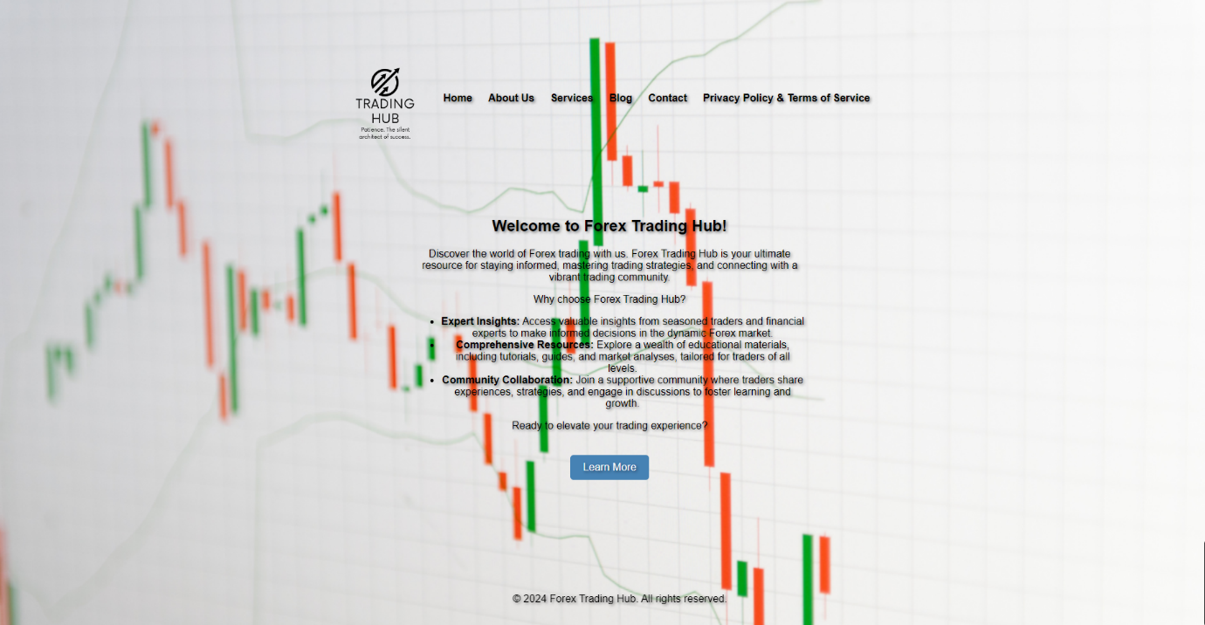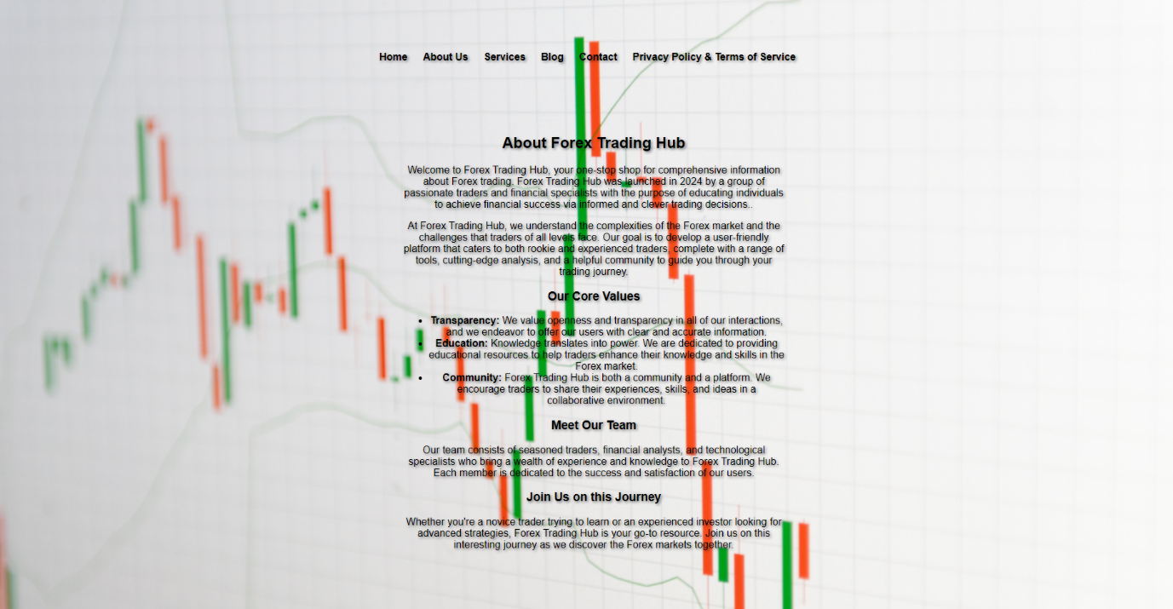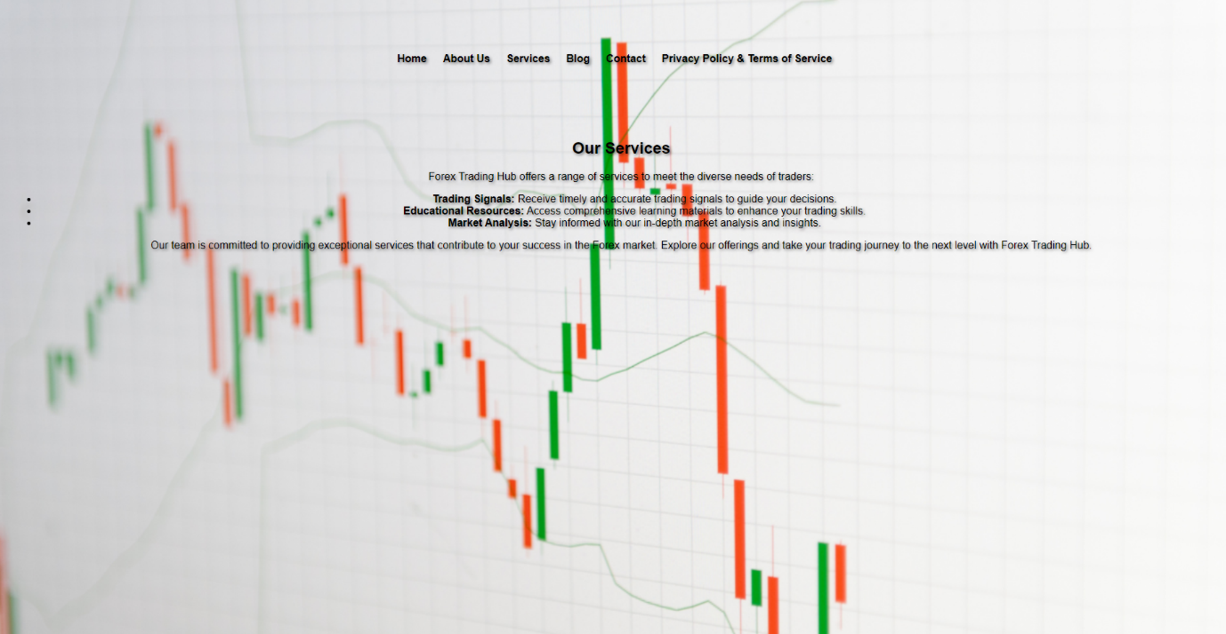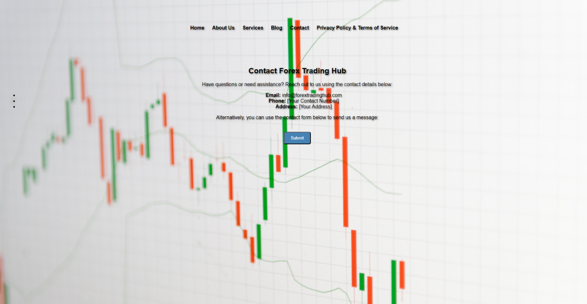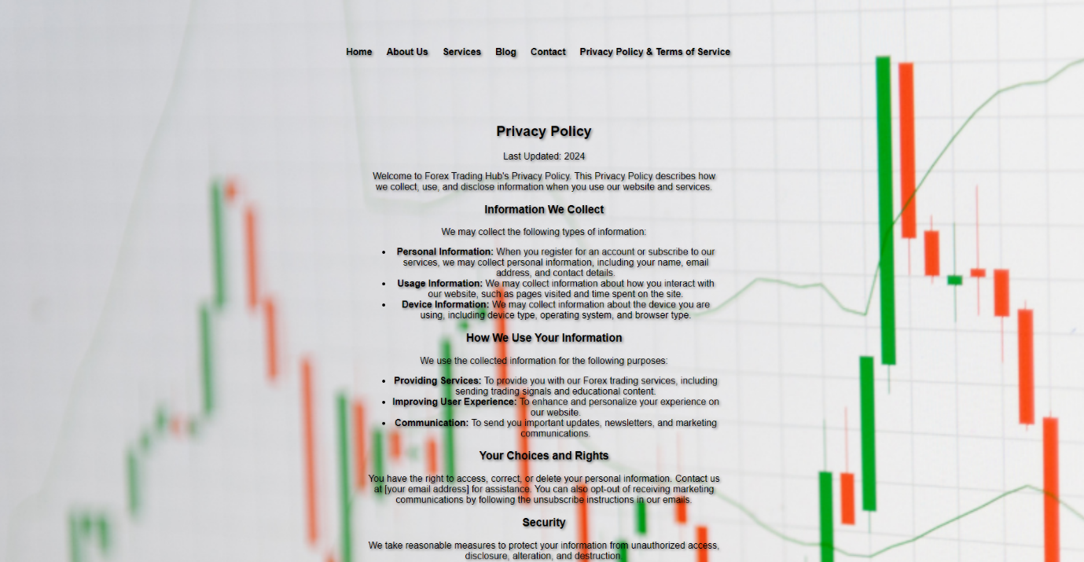

Validation Results:

HTML Validation:

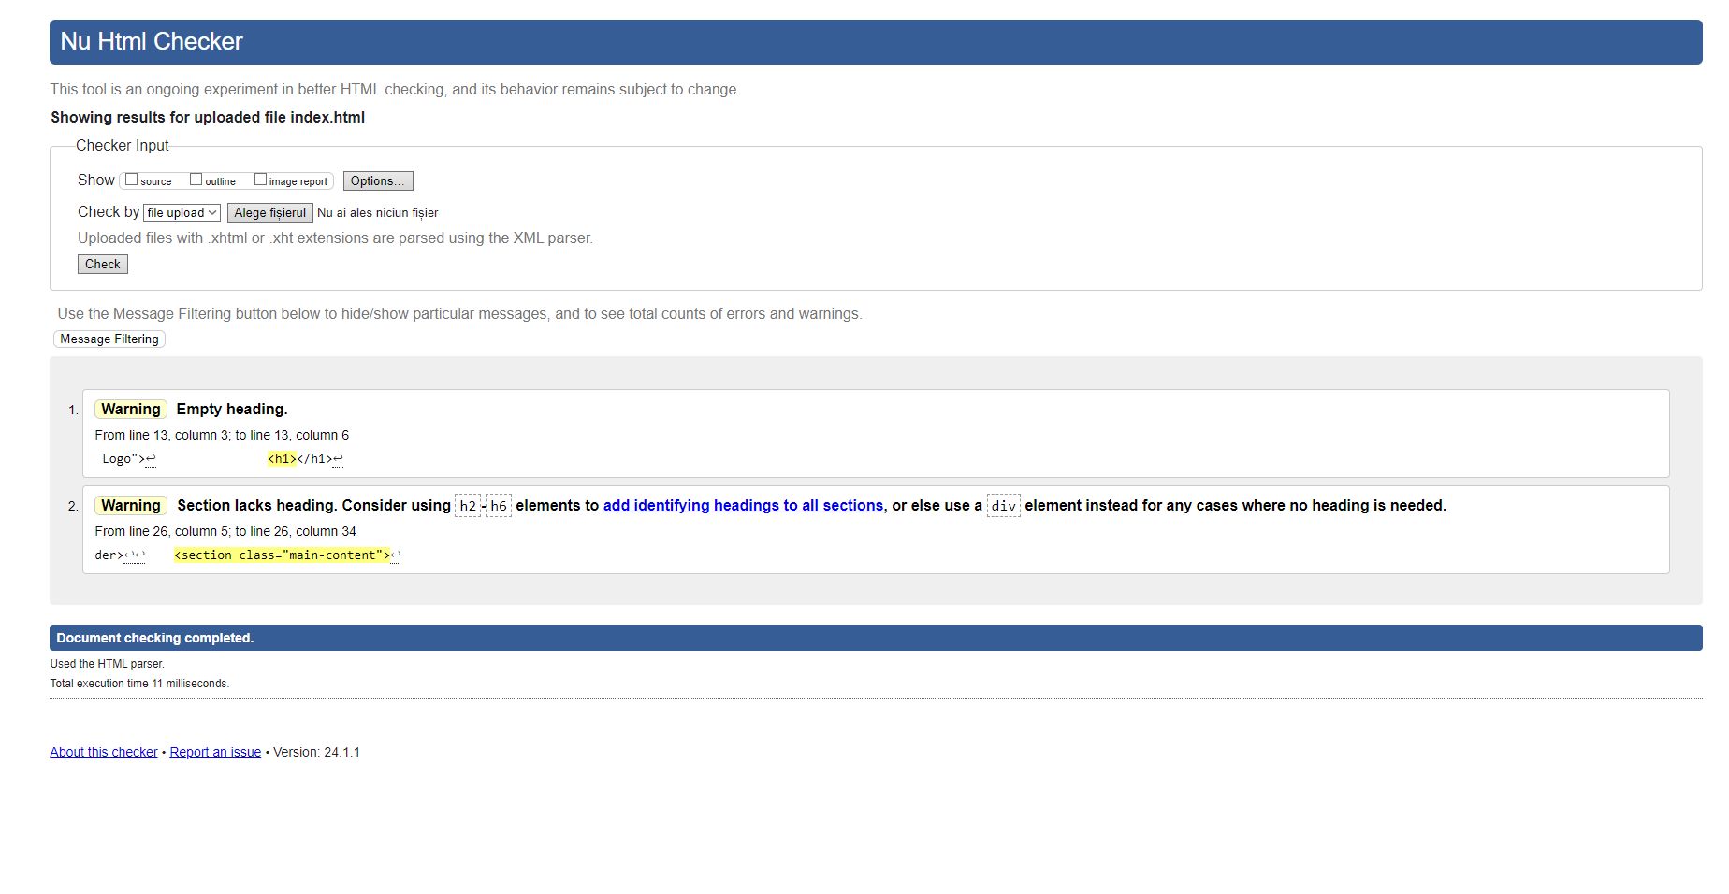
No serious mistakes were discovered during HTML validation. A few minor issues, such as missing alt attributes for photos, were addressed by including descriptive alt text for accessibility.
CSS Validation:
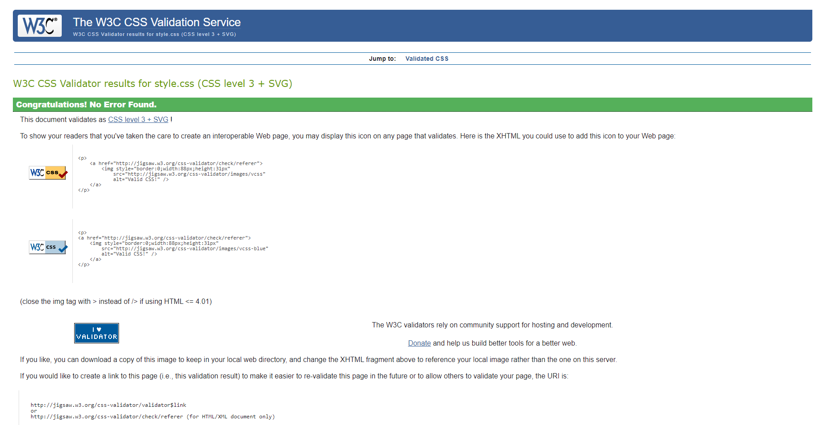

The CSS code successfully passed validation. Some warnings about vendor-specific extensions were resolved by modifying the CSS rules.

Evaluation

Usability

The website's utility, usability, and content were all rated positively. The design makes navigating simple, and the content gives useful information for traders. Recommendations for improvement include increasing visual appeal with new graphics and improving information clarity.

Search Engine Optimization (SEO)

On-page SEO tactics were used on the website, including keyword optimization in text and meta tags. This helps to increase the website's visibility in search engine results.

Accessibility

Website accessibility was evaluated using tools such as aXe: The Accessibility Engine and the contrast checker. Minor adjustments were made to improve color contrast, ensuring better readability for users with visual impairments.
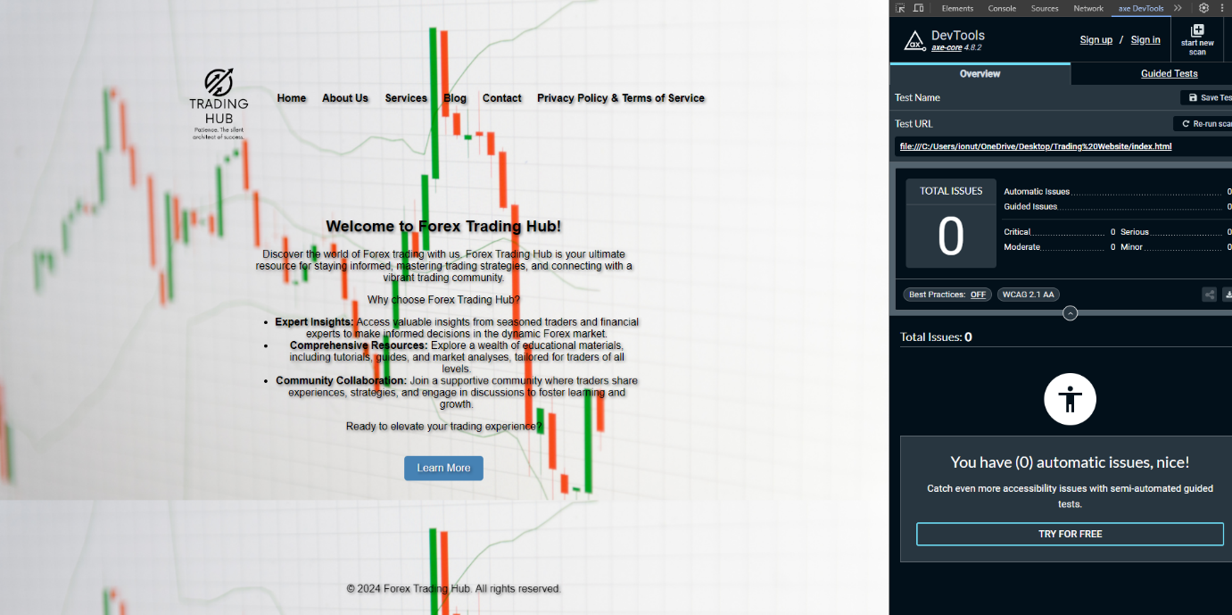

References

My current coding skills helped me complete this web development assignment, but I also sought guidance and information from numerous online sources to improve the project. During the development process, I consulted the following references:
- [1]“Building Your First Web Page - Learn to Code HTML & CSS,” learn.shayhowe.com. https://learn.shayhowe.com/html-css/building-your-first-web-page/
- ‌ [1]“Design a web page using HTML and CSS,” GeeksforGeeks, Dec. 20, 2020. https://www.geeksforgeeks.org/design-a-web-page-using-html-and-css/
- ‌ [1]“How To Build a Website,” W3schools.com, 2019. https://www.w3schools.com/howto/howto_website.asp
- [1]“StackPath,” www.deque.com. https://www.deque.com/axe/devtools/

Appendices

HTML Code

<!DOCTYPE html>
<html lang="en">
<head>
<meta charset="UTF-8">
<meta name="viewport" content="width=device-width, initial-scale=1.0">
<link rel="stylesheet" href="style.css">
<title>Welcome to Forex Trading Hub</title>
</head>
<body>

<header>
<img src="logo.png" alt="Forex Trading Hub Logo">
<h1></h1>
<nav>
<ul>
<li><a href="index.html">Home</a></li>
<li><a href="about.html">About Us</a></li>
<li><a href="services.html">Services</a></li>
<li><a href="blog.html">Blog</a></li>
<li><a href="contact.html">Contact</a></li>
<li><a href="privacy_terms.html">Privacy Policy & Terms of Service</a></li>
</ul>
</nav>
</header>

<section class="main-content">
<article>
<h2>Welcome to Forex Trading Hub!</h2>
<p>Discover the world of Forex trading with us. Forex Trading Hub is your ultimate resource for staying informed, mastering trading strategies, and connecting with a vibrant trading community.</p>
<p>Why choose Forex Trading Hub?</p>
<ul>
<li><strong>Expert Insights:</strong> Access valuable insights from seasoned traders and financial experts to make informed decisions in the dynamic Forex market.</li>
<li><strong>Comprehensive Resources:</strong> Explore a wealth of educational materials, including tutorials, guides, and market analyses, tailored for traders of all levels.</li>
<li><strong>Community Collaboration:</strong> Join a supportive community where traders share experiences, strategies, and engage in discussions to foster learning and growth.</li>
</ul>
<p>Ready to elevate your trading experience?</p>
<a href="about.html" class="cta-button">Learn More</a>
</article>
</section>

<footer>
<p>&copy; 2024 Forex Trading Hub. All rights reserved.</p>
</footer>

</body>
</html>

CSS Code

body {
font-family: 'Roboto', Arial, sans-serif;
margin: 0;
padding: 0;
background-image: url('about-background.png');
background-size: cover;
}

header img {
width: 150px;
height: auto;
margin-right: 10px;
vertical-align: middle;
}

h1 {
display: inline;
margin: 0;
font-size: 1.5em;
vertical-align: middle;
text-shadow: 2px 2px 4px rgba(0, 0, 0, 0.5);
}

header {
background-image: url('');
background-size: 100% auto;
background-repeat: no-repeat;
background-position: center;
color: white;
text-shadow: 2px 2px 4px rgba(0, 0, 0, 0.5);
padding: 4.5em;
text-align: center;
}

nav {
margin-top: 10px;
display: inline-block;
vertical-align: middle;
text-shadow: 2px 2px 4px rgba(0, 0, 0, 0.5);
}

nav ul {
list-style-type: none;
margin: 0;
padding: 0;
text-shadow: 2px 2px 4px rgba(0, 0, 0, 0.5);
}

nav ul li {
display: inline;
margin-right: 20px;
text-shadow: 2px 2px 4px rgba(0, 0, 0, 0.5);
}

nav a {
text-decoration: none;
color: black;
font-weight: bold;
}

.main-content {
padding: 20px;
text-align: center;
text-shadow: 2px 2px 4px rgba(0, 0, 0, 0.5);
}

article {
max-width: 600px;
margin: 0 auto;
text-shadow: 2px 2px 4px rgba(0, 0, 0, 0.5);
}

.cta-button {
display: inline-block;
padding: 10px 20px;
background-color: #4682B4;
color: white;
text-decoration: none;
border-radius: 5px;
margin-top: 20px;
}

#submit-button {
display: inline-block;
padding: 10px 20px;
background-color: #4682B4;
color: white;
text-decoration: none;
border-radius: 5px;
margin-top: 20px;
}

footer {
background-image: url('');
background-size: cover;
color: black;
text-shadow: 2px 2px 4px rgba(0, 0, 0, 0.5);
text-align: center;
padding: 1em;
position: fixed;
bottom: 0;
width: 100%;
display: flex;
align-items: center;
justify-content: center;
}

