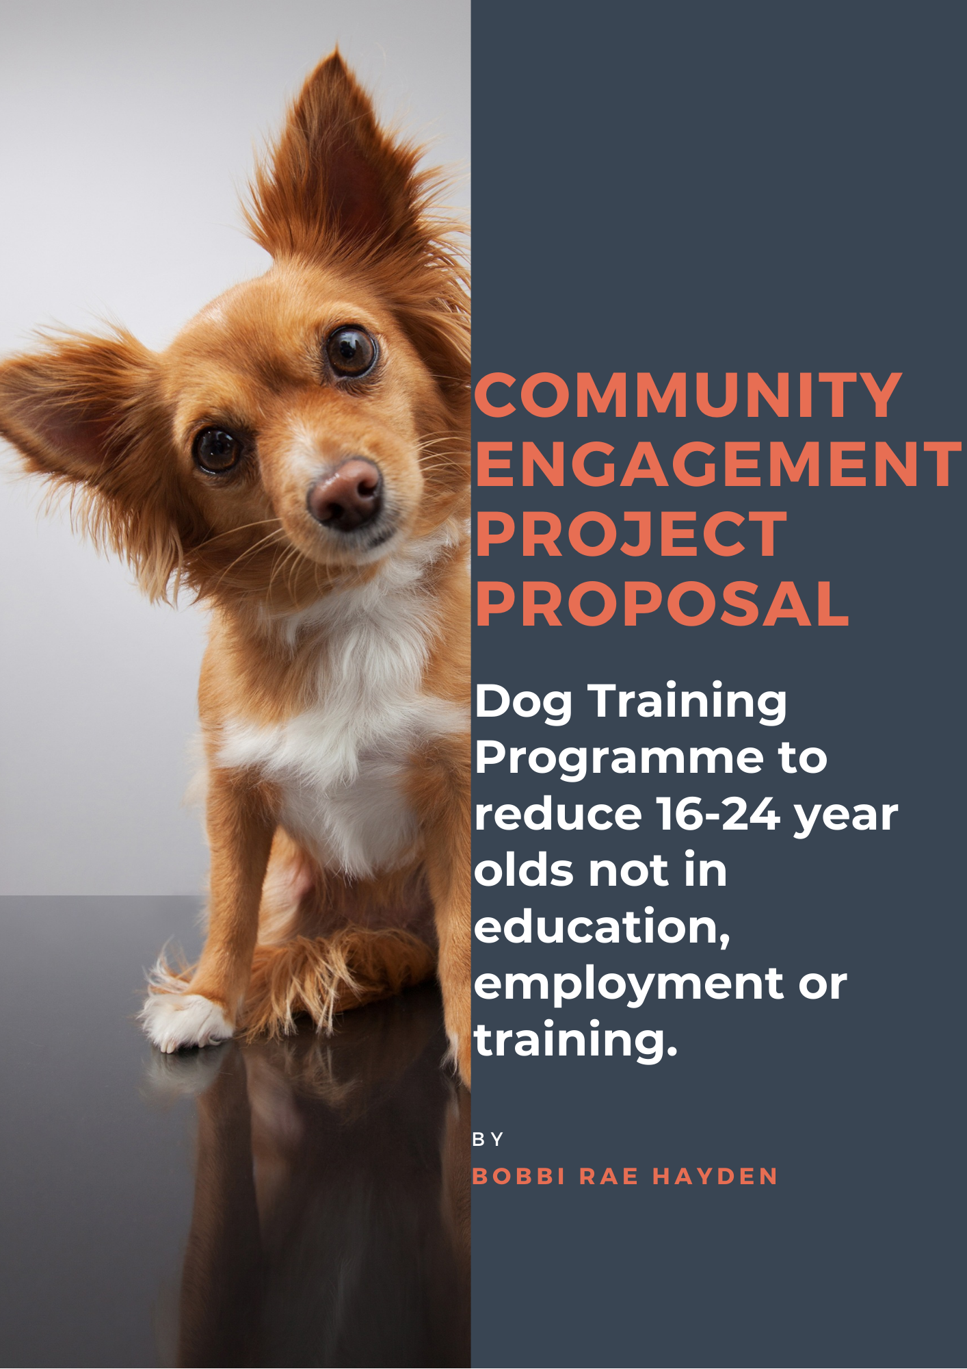
Table of Contents
Needs analysis 3
Community Engagement Project Proposal 6
Appendices 13
References 16

Needs analysis

This needs analysis is focused on the population in Swansea that are not in education, employment or training (NEET) and identifies what provisions are currently available to support these 16-24-year olds entering education, employment or training. With data to measure how effective these services are in supporting the diverse needs of those categorised as NEET, it allows any gaps to be identified that could negatively impact this group. With the evaluation of current provisions, considerations are made as to how the introduction of a dog training programme (DTP) could further reduce the amount of young people that are NEET in Swansea.

According to the Welsh Government (2020) 11.1% of 16-18-year olds and 15.7% of 19-24-year olds are NEET in Wales. There are 4.5% of people unemployed within Swansea, compared with 3.6% in Wales (Swansea Council, 2020). An accurate measurement as to how many 16-24-year olds are NEET in Swansea is to be published July 2021 which would allow further comparisons to be made (Swansea Council, 2019). Being out of work or education can often be due to limited or no qualifications, inexperience, insecure home environment, mental health issues, disability, substance misuse, and criminal history. Without exhausting the list of complex reasons as to why 16-24-year olds are NEET, it is acknowledged that an integrated approach and variety of services are required to successfully re-engage and fully support the diverse population NEET and prevent young people being NEET long term and marginalised from society (Welsh Government, 2009). Swansea currently has a variety of provisions available for individuals that are NEET, providing support in developing employability skills and opportunities of acquiring certification. This supports the Welsh Government’s (2018) goal of removing barriers to education and employment by providing opportunities of developing a stronger skills base. There are qualifications that can be gained through one provision in Swansea to support substance misuse awareness and money management, yet it is unclear as to whether these programmes effectively address the issues.

With many spending over 12 months NEET (Swansea, 2019), it makes it more likely that the individual neglects their mental health and well-being and becomes involved in crime (Welsh Government 2013). Therefore, it is vital that an appropriate intervention is available to re-engage this group and develop their skills, which will move them closer to education or employment. At the moment a range of support programmes are available for young people. These include school engagement and foundation learning programmes, financial advice and guidance and enterprise skills. Swansea Council are currently involved in the following projects; Communities for work, Cam Nesa, Cynnydd, Gower Landscape Partnership, Hafod Copperworks and Workways (Swansea Council 2020). These projects actively target 16-24-year olds, yet it is uncertain as to how these are currently running with Covid-19 restrictions. With expected rates of 16-24-years old NEET to increase due to Covid-19 (BITC, 2020), adequate provisions to support these people are required. Due to the pandemics negative effect on mental health, it is increasingly important to not only support these individuals to gain employment or enrol in education, but to effectively support their mental health also. With the combination of the current pandemic and it already being more likely for a person to be depressed when unemployed (Linn, Sandifer and Stein, 1985) there may be a gap in support.
According to the Welsh Government statistics (2019) (appendix 3) 12.2% of 16-18-year old males and 10% of 16-18-year old females are NEET, which have both increased by 0.7% and 0.4% respectively. 15.2% of 19-24-year old males are NEET, which decreased by 1.3%, yet there was in increase by 0.9% in female’s NEET, totalling 16.3%. These stats are consistent with previous years (Appendix 1), and clearly show that the level of young people NEET is increasing, suggesting additional interventions are required in reducing these statistics. Yet with only 2.7% of people NEET being school leavers (Swansea Council, 2019) which has been successfully reduced under the school engagement and foundation learning programme, it indicates that programmes should predominantly target those that are 18 and above, as this will have the greatest impact in terms of reducing the current statistics. With only 2.7% of 16-17-year olds being NEET, it has created a normative need of young people entering further education upon completion of compulsory schooling. Yet formal education is not suited to every person, therefore delivering a programme to facilitate learning outside of a traditional classroom and develop skills to gain employment is essential for individuals to gain access wider resources within society and gain employment opportunities (Welsh Government, 2013). Yet Swansea’s 7.9% of people without qualifications is in line with the national average and less than Wales’ 8.5%, suggesting that lack of qualifications is not the main reason as to why Swansea has higher numbers of people that are NEET. This is why the proposed DTP does not offer any formal qualification, only experiences that will develop the enjoyment of learning, growth in mindset and a range of skills, noted in the project proposal, that will support the reduction of 16-24-year olds that are NEET.

There are minimal provisions that help those that are NEET access practical skills, which has shown to be desired amongst young people (Natural England, 2013) yet ‘Tune into your potential’ is a music workshop available to 16-24-year olds with the aim to reduce NEET statistics by developing employability skills and support mental health and well-being through music across Swansea, Neath Port Talbot, Cardiff and Carmarthenshire. This project has found that participants have increased engagement as they are trying something new, which suggests that novel experiences are more likely to increase engagement within 16-24-year olds (Tune into your potential, 2021). Music is something everyone has access to in some form, yet may not understand. Therefore, this workshop educates participants as to ways in which they can incorporate their learning into their everyday life and how it can be applied to potential employment. A provision delivered by Careers Wales is ‘Jobs Growth Wales’ which provides 6 months paid work to 16-24-year olds (Careers Wales, 2020). For those that are NEET due to lack of qualifications or inexperience, this is an opportunity to develop experience working in a particular sector, which is often an essential requirement for employment. Yet, this is not a service which would be suitable to those that require mental health support or other aids. It could be a positive experience for 16-24-year old females in Swansea that are more likely to be NEET (Swansea Council, 2019). As it is more likely that a person will be NEET if they have a disability (Welsh Government, 2020) there are available provisions targeting individuals affected by work-limiting health conditions and disabilities, as well as those with care responsibilities and low or no skills. Workways+ will also offer one-to-one mentoring, support with job-seeking and interview skills, and the chance to gain new qualifications. By the age of 26 it is four times more likely that a person with a disability will be unemployed (Burchardt, 2005) therefore it is vital disabled 16-24-year olds NEET have access to adequate provisions to prevent long-term NEET. Changing Futures is a project aimed at disabled 16-24-year old’s NEET which supports the development of essential skills and offers aid work opportunities. According to Swansea Council (2019) 63% of 16-18-year olds NEET are currently categorised as ‘not available’, requiring specialist support to prepare them for employment or training. It is also identified that behavioural and emotional difficulties, lack of parental engagement and self-esteem are all core factors which act as a barrier to employment and training. There was a lack of accessible information as to how 16-24-year olds are supported with these influencing factors, yet is an area that could be addressed with the proposed community engagement project. As 49% of those claiming employment support allowance in Swansea reported mental health as the barrier to employment, it is evident that additional support is required (Swansea Council, 2019). The proposed DTP has connections to mental health advisors and counsellors to ensure the right provisions are available to those in need. Having access to this support team alongside working with dogs, actively closes the gap of mental health and well-being services available to those NEET. Currently there are no replications of the proposed project are available, yet there were many documentations of successful dog training programmes within prisons, which provides evidence as to how young people can benefit from working with dogs. There is a therapy dog programme available through CBSA in Llanelli, which is available to those who are NEET to develop their communication skills, increase confidence and engage in their community.

Individuals that are NEET commonly require support with writing CVs, applications and general ICT skills. In the DTP these are skills each person actively works towards and are detailed in the proposal. With reports of 86% of participants involved in a DTP noting their employability skills had increased, it is expected that the DTP proposed will also successfully engage and enhance their skills. (Leornardi et al, 2017). To ensure that every participant on the proposed community engagement project is able to express their needs, instead of an inaccurate perception of their needs being placed upon them, a wide-range of dog training opportunities will be available for the young people to choose from. It is expected that this percentage of young people NEET classed ‘not ready’ will be hard to reach, yet it is hoped that actively demonstrating advanced dog training activities available on the programme will be a novel incentive to engage. It is expected that those hard to reach will be more receptive to disclosing ways in which they could best be supported due to the therapeutic benefits of a dog, described within the proposal. It is expected that active engagement from stakeholders (parents, Job Centre, Local NEET provisions) will be required to ensure eligible participants can be contacted and enrolled.

The current statistics demonstrate that with the potential influx of young people NEET (BITC, 2020) Swansea has insufficient services available to adequately support the diverse needs of 16-24-year olds that are NEET. With Swansea’s unemployment rate being above the national average and 63% of 16-24-year olds being classed as ‘not ready’ for education or employment (Swansea Council,2019), it is evident that a programme is required that will not only develop employability skills, but address the mental health, well-being, and personal development of young people to ensure they are prepared for their future. There is a potential lack of meaningful activity for those that are disabled, which the DTP aims to provide. Therefore, with the combination of therapeutic benefits, alongside the skills gained from dog training, it is expected that the programme will reduce the number of 16-24-year olds NEET.

Community Engagement Project Proposal

As an alternative to the range of programmes already available to support the 16-24-year olds who are not in education, employment or training (NEET), a dog training programme (DTP) has been developed to re-engage and support the identified needs of this community. This project proposal details how this DTP is underpinned with relationship-centred and meaningful activities which will engage the young participants, develop essential employability skills, and inspire participants to actively seek learning opportunities throughout their life. With the aim to reduce NEET statistics, the benefits of interacting with dogs are explored, alongside what skills are developed through the DTP to successfully reduce how many 16-24-year olds are NEET.

As noted in the need’s analysis, Swansea has been successful in reducing the number of 16-24-year old’s that are NEET, suggesting that the current services available have been effective thus far. Yet as there has been an increase (appendix 2) it could suggest that current interventions are insufficient in consistently lowering the statistics. According to the Welsh Government (2013) the numbers have not been effectively reduced, due to failure in communication between agencies providing provisions, which would aid the holistic support of each young person. A survey delivered by the Welsh Government (2009) found that the majority of young people said they had remained NEET due to limited provision or opportunities available. This was acknowledged and lead to offering a wider choice of options as to how those that are NEET can enter education, employment or training. Yet without these provisions communicating, 16-24-year olds that are NEET may not receive the support they need to develop essential skills, which could lead to being categorised as long-term NEET. In some circumstances this DTP would not be appropriate, due to allergies, severe disabilities, cultural differences, fears etc. Therefore, having open communication with other projects would be vital to ensure 16-24-year olds can be signposted. However, if there are some people who feel unable to participate due to low confidence, fear, or cultural beliefs, it would be encouraged that the person engages with the employability skills and personal development aspects of the programme. As discussed later in this proposal, the dogs involved in the programme are from rescue centres, therefore if appropriate, other animals can be assessed and approved for the project enabling those unable to work with dogs, to work with other animals. The involvement of other animals is not expected to change the overall effectiveness of the programme as Perkins (2020) documented animals such as cats, birds and rabbits being registered therapy pets and offering therapeutic benefits. With DTP’s becoming widely recognised to be an effective engagement strategy that can meet the diverse needs within different communities, it could support positive behaviour change, and increase well-being and engagement in participants, resulting in participants pursuing opportunities in education and employment, or be closer to an employable status. (Leonardi et al, 2017). As mentioned in the need’s analysis, those that claim ESA are likely to have mental health issues. Therefore, with the increase of claimants (Welsh Government, 2020), it is essential that provisions can adequately address these needs. With the program’s core aims to increase educational engagement and employability, and support mental health and well-being, it is expected that the number of 16-24-year olds that are NEET will reduce. It is also expected that it will support at risk participants from further decreasing their employment opportunities through adverse behaviour. This is expected due to the therapeutic benefits of dogs.
The presence of and interaction with dogs is consistently proving to have therapeutic benefits in a wide-range of settings. Dog therapy programmes have been successful within schools, places of work, hospitals and care homes, to name a few. Centre of Building Social Action (CBSA) is a charity in Llanelli which has an on-going project that uses therapy dogs as catalysts for conversations between the young people and care home residents who are involved. In one example, a young college student participated to gain confidence and overcome social anxiety. Having access to therapy dogs introduced her to ways in which she can feel at ease whilst interacting with a range of people in different environments and found that she had the ability to learn new skills (CBSA,2021). It has been documented that being unemployed makes it more likely for a person to experience anxiety and depression (Linn, Sandifer and Stein, 1985), therefore the 16-24-year old’s who engage in the DTP will benefit from the dogs non-judgemental presence which can reduce stress, improve mood, increase confidence and positively impact anxiety (Beetz et al, 2012). There is a lack of research directly studying the effects of DTP’s for individuals that are NEET, yet DTP’s in prisons are widely documented and have therefore been used to support the evidence for this project. As noted by the department for education (2010), those who are NEET often have a history of offending and/or have behavioural issues which has been recognised as one of the factors as to why many of these individuals remain NEET. According to the Welsh Government (2013) not addressing NEET statistics can lead to premature death, neglect of well-being, involvement in criminal activity and substance misuse, and is said to cost approximately £2 billion across Wales. Therefore, it is vital that appropriate provision is available to those NEET and those at-risk of becoming NEET. If it’s the case that percentages of young people are NEET due to limited access to services that directly supports the mental health, well-being and personal development of those that have been involved in criminal activity or have experienced trauma that currently impacts their ability to engage in education or employment, then the participation in this DTP could be beneficial. This is because the programme has a holistic approach, which aims to engage the whole person, not just one aspect, such as their employability skills. Establishing a relationship with a dog can provide a safe space for a person to reconnect without fear of judgement (Beetz et al, 2012). As some dogs enrolled on the programme require training for behaviour problems, it could reflect an aspect of the young-person which has shown to increase a young person’s engagement in their own personal development and be more likely to address negative behaviours which act as a barrier to education or employment (Syzmanski, 2018). As those that are NEET are more likely to experience mental health issues, it is vital that these individuals receive support to develop effective strategies to care for their mental health and increase well-being. With a study revealing that dogs support people with or without mental health problems, the DTP is inclusive and will provide support to suit individual needs. Yet those with mental health problems are likely to benefit from increased ability to cope and improvement in mood (Beetz et al, 2012). With dogs fostering a calm learning environment, each young person will be able to engage in practising and developing new skills in an enjoyable way, which has shown to increase a sense of self-efficacy in DTP participants (Leonardi et al, 2017). With a lack of provisions delivering a therapeutic service, this could reduce the gap of 16-24-year olds that are NEET and currently categorised as ‘unavailable’ or ‘not ready’ for education or employment (Swansea Council, 2019).

This programme removes the traditional educational setting and classroom-based learning, enabling participants to learn new skills in an environment they feel comfortable in. This is an opportunity to learn and develop a greater understanding of learning and behaviour theories, practical dog training skills, alongside developing a range of transferable skills and using reflective practice to measure personal growth. As a practical learning experience, the participants are immersed in environments and learning that facilitates critical thinking and reflection. Critical thinking skills are essential in dog training

During the DTP participants are assisted in journaling their experience, documenting their learning and growth. Journal prompts, which are used to support the self-enquiry and reflection as to ways in which the skills gained in the programme support their future aspirations.

Every participant will be given the choice as to whether they will train a dog intended to be rehomed to a family home, an assistance dog intended for an individual requiring support with a disability, or train a dog who will work alongside the police or other organisation. This provides an element of autonomy to the participants, which is an essential component required for an individually to gain confidence in navigating their life. As noted in the needs analysis, those who are NEET are more likely to lack experience and employability skills such as CV writing (Welsh Government, 2018). In the DTP participants are supported in creating a profile of characteristics, a CV detailing the skills obtained and letter of recommendation for the dog they are training.

The DTP develops GRIT

Self-efficacy (Leonardi, 2017)

Emotion and behaviour management (Leonardi, 2017)
Motivation (Leonardi, 2017)

A participant of a DTP available in a Scottish prison expressed that by engaging in the programme and successfully training a dog and developing their skills was something they shared with family, which resulted in being a motivator in continuing their engagement. This sense of achievement and recognition from family can boost confidence and self-esteem, increasing the likelihood of engagement in employment or education.

Fosters emotional intelligence and behavioural competences
Increase physical activity and wellness

According to .. many that are out of work struggle with self-motivation as they are not actively engaging in goal orientated tasks. Working with animals can provide a purpose to wake up and

Upon completion of the programme, the participant will have enhanced their employability skills are developed the following:

The ability to train dogs using ethical, evidence-based methods.
An understanding of learning theory and behaviourism
Knowledge of canine communication and body language
An understanding of canine welfare
An understanding of (service dog regulation requrements )
An understanding of the science and practical applications of scent training, including medical detection and medical alert dogs.
A knowledge of olfactory physiology

Assessing body language
Engaging with wide range of members within community (residents, care workers, families)

Although some may pursue a career in dog training or similar, this DTP has been developed in a way that the participant is working on their own behaviour and skills, whilst training a dog.

Our participants will work with rescue dogs that require care and attention, which aims to provide a sense of purpose.

and will develop a growth mindset (Dweck, 201,,) which can identify unhelpful or destructive behaviour patterns, developing a plan and strategy to positively develop a new, more benefical behaviour

Dogs are mediators of social interaction – supporting the development of social cognition.

Once the role of the dog is established they are linked to one or two participants in the program. We have found that the role of the dog effects how the person

It is more likely that a person will be NEET if they have a disability (appendix 2) (Welsh Government, 2020), therefore, it could benefit the participant to engage in the learning of how to train an assistance dog. Assistance dogs can increase the independence of someone with a disability, increasing confidence and self-esteem, and reducing stress (Yamamoto and Hart, 2019), which could aid the individual in gaining employment. A registered assistance dog is trained to have at least three cues that are inaccessible for their handler, which can include but not limited to; the dog picking things up from the floor, turning lights on/off, opening doors and emptying the washing machine. Engaging the young person in learning a new skill that is constructive and rewarding could be an effective method in re-engaging themselves to apply the learning to their own life and ultimately engage within their community.

Although some disabled participants may be limited in how they can practically train a dog, they are an essential component to the training programme as dogs on the assistance dog training programme will need to be exposed to mobility equipment used by those who are disabled.

According to…. The average waiting list to have a dog professionally trained and registered as an assistance dog is …. Which suggests that developing the persons ability to train their own dog to perform useful behaviours could support the access of wider parts of their community, reducing the time their opportunity of gaining work or training. <<<< elaborate?? Social mobilisation

When training dogs it is vital that the dogs health and temperament are considered so that appropriate methods are used. This consideration could be reflected when the young person is learning something new

According to Dogs Trust (2020) there is an estimated 18.5 million dogs in the UK, which continues to increase, with many opting to rescue from Europe due to strict adoption rules within UK rescue centres. Dogs used on the programme will have been sourced from various rescue centres in South Wales and assessed as to whether they would be best suited to life as a pet dog, service dog or work alongside the police or other organisation.

This comes with the expectation of the dog behaving….. therefore delivering a programme that shares effective methods of training that can enhance the well-being of the owner is

The use of therapy dogs within educational settings is increasing, which is expanding the research on how this benefits participants of these programmes.

Why dogs. Why rescue dog
According to … the number of rescue dogs exceeded …
A combination of impulse purchases and lack of understanding of dogs lead to many being left at rescue centres.

Creating the dog training community engagement project therefore addresses the needs of those are are NEET aswell as reducing the number of dogs that would otherwise be euthanised or

Considering a dogs welfare needs has a potential of acting as a prompt for the young person to think about their own health and well-being needs

This suggests that animal-assisted interventions can support participants in developing their awareness in how they can contribute to their community

It has been noted that interacting with dogs increases ....

This is a skill that can be transferred to any task the individual engages in

Other benefits to the programme

Physical contact

If social distancing measures are still in place upon the delivery of this DTP the physical contact the participant has with the dog will….

Diverse needs group – neat population . important that a range of services that are available, so that these variety of needs are met.

Can be sign posted to academia / relationship is built

Dependent on the dogs needs and training requirements, the DTP can be physically demanding which could impact participation in some activities/exercises. Reasonable adjustment will be made for any person requiring additional support to enable them to participate. This however could be a barrier for some, which is why it is essential that a variety of intervention programmes are available.

Projects are predominantly funded by: European Social Fund, WGVA and The National Lottery Community Fund. WGVA have an Active Inclusion Fund that this project would be eligible form yet it is unclear as to whether funds are effected by Brexit or Covid-19.

To conclude, this DTP aims to holistically support each participant’s needs and address the complex barriers that limit education or employment opportunities. The programme is designed to be flexible as to how people engage, ensuring that each participant is involved in developing the skill relevant to their personal circumstances. With the therapeutic benefits of dogs, each person will have regular contact with therapy dogs which will …

This programme actively develops employability skills,

As this project has now been documented elsewhere, it will provide the opportunity of further researching the effects of … using dogs as a way to re-engage those that have been marginalised in society.

Appendices
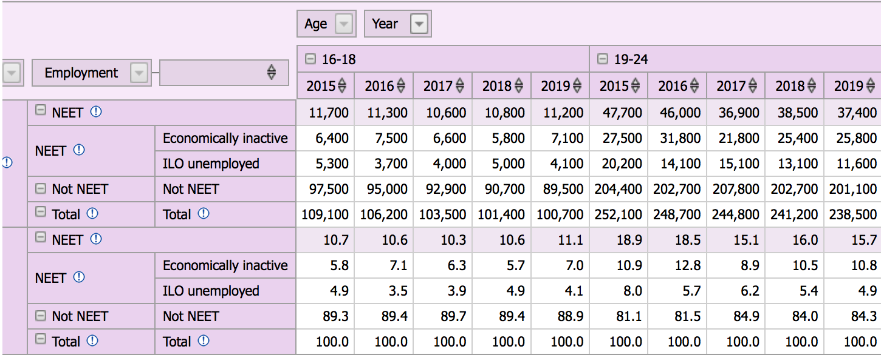

Appendix 1 (Welsh Government, 2019)

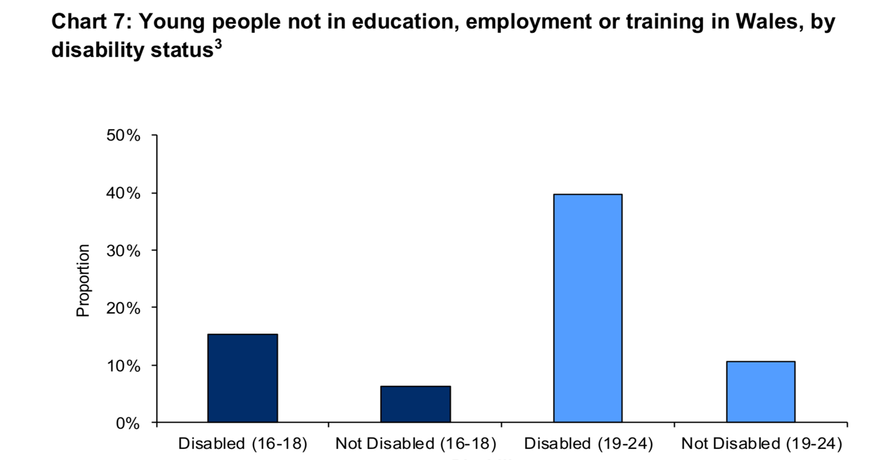
Appendix 2 - (Welsh Government, 2020)

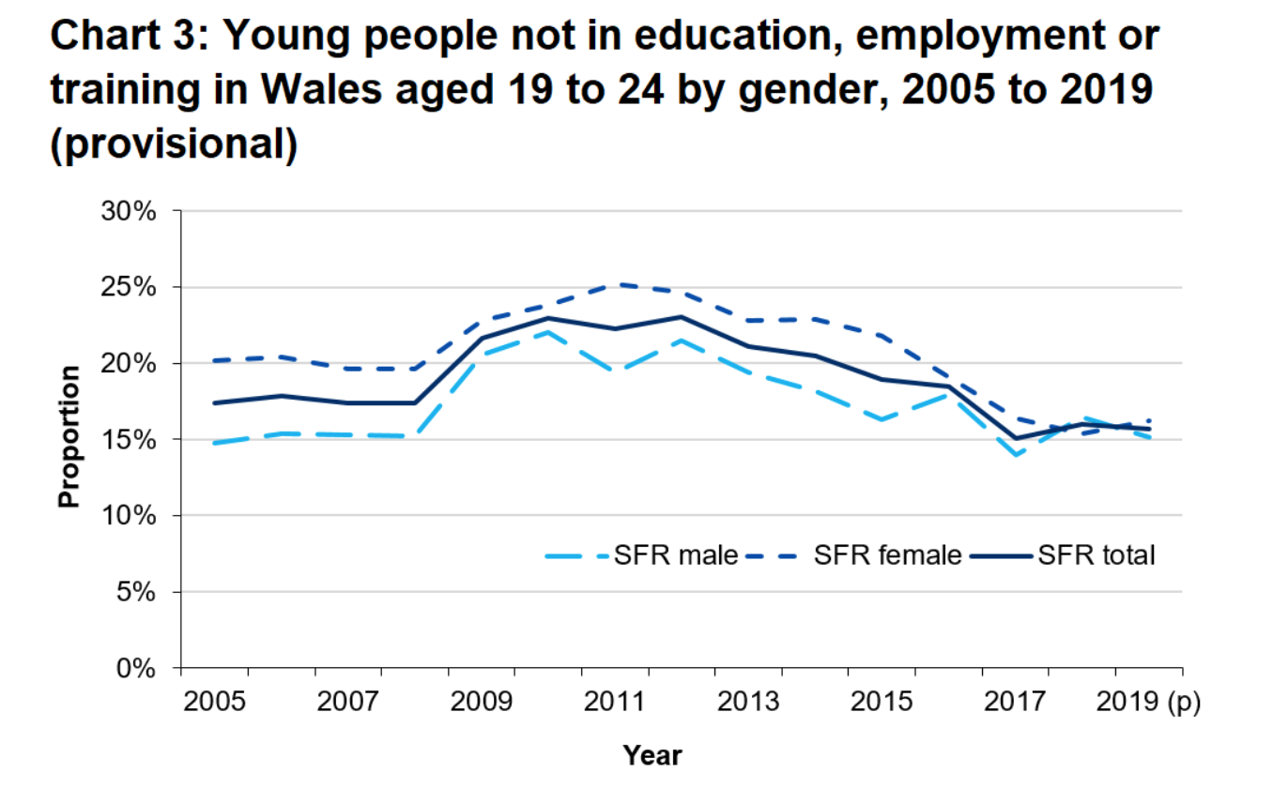
Appendix 3, (Welsh Government, 2020)

References

Acas. (2020) Work adjustments for mental health: a review of the evidence and guidance. Available at: https://www.acas.org.uk/work-adjustments-for-mental-health-a-review-of-the-evidence-and-guidance-html (Accessed 10 January 2021)
Business In The Community (BITC). (2020) Covid-19 and youth employment. Available at: https://www.bitc.org.uk/wp-content/uploads/2020/07/bitc-factsheet-employment-covid19andyouthemployment-june20.pdf (Acccessed 10 January 2021)

Beetz, A.Uvnas-Moberg, K. Julius, H. Kotrschal, K. (2012) ‘Psychosocial and psychophysiological effects of human-animal interactions: The possible role of oxytocin.’ Frontiers in Psychology. (3.234) pp.1-15 doi: 10.3389/fpsyg.2012.00234
Brunzell, T. Stoke, H. Waters, L. (2016) ‘Trauma-informed flexible learning: Classrooms that strengthen regulatory abilities. International Journal of child youth and family studies. 7(2). pp. 218-239 DOI: 10.18357/ijcyfs72201615719
Burchardt, T. (2005) The education and employment of disabled young people. The Policy Press:Bristol
Careers Wales. (2020) Jobs Growth Wales. Available at: https://careerswales.gov.wales/getting-a-job/jobs-growth-wales (Accessed 20 December 2020)

CBSA. (2021) Llinos’s story. Available at: https://cbsa.org.uk/our-projects/best-friends/llinoss-story/ (Accessed 10 January 2021)

Dogs Trust, 2020. Facts and figures. Available at: https://www.dogstrustdogschool.org.uk/facts-and-figures/ (Accessed 22 January 2021)

Yamamoto, M. Hart, L. (2019) ‘Professionally and self-trained service dog: benefits and challenges for partners with disabilities’ Frontiers in Veterinary Science. (6,179) pp. 1-15
DOI=10.3389/fvets.2019.00179

Leonardi, R. Buchanan-Smith, H. McIvor, G. Vick, S. (2017) ‘“You think you’re helping them, but they’re helping you too.”: Experiences of Scottish male young offenders participating in dog training program.’ INT J Environ Res public health. 14(8) DOI: 10.3390/ijerph14080945

Mercer, J. Gibson, K. Clayton, D. (2015) ‘The therapeutic potential of a prison-based animal programme in the UK. Journal of forensic practice. 17(1) pp. 43-54 DOI: 10.1108/JFP-09-2014-0031

Natural England. (2013) Changing young lives. Engaging NEET young people in the natural environment Available at: http://publications.naturalengland.org.uk/publication/10382390 (Accessed 22 January 2021)

Omerod. E. (2008). ‘Companion animals and offender rehabilitation – experiences from a prison therapeutic community in Scotland.’ Therapeutic Community. (29) pp. 285-296

Perkins. A. (2020) ‘The benefits of pet therapy.’ Nursing made incredibly easy. (18.1) pp.5-8
doi: 10.1097/01.NME.0000613652.69241.d7

Swansea Council. (2019) Barriers to employment and training are removed. Available at: https://www.swansea.gov.uk/article/30937/Barriers-to-employment-and-training-are-removed (Accessed 20 December 2020)

Swansea Council. (2020) European funding project management and support service. Available at: https://www.swansea.gov.uk/europeanfundingmanagementandsupport (Accessed 23 December 2020)

Swansea Council. (2020) Swansea Economic Profile. Available at: https://www.swansea.gov.uk/economicprofile (Accessed 20 December 2020)

Syzmanski, T. et al. (2018) ‘Dog Training Intervention Show Social-Cognitive Change in the Journal of incarcerated youth.’ Frontiers in Veterinary Science. (5) pp.302 https://doi.org/10.3389/fvets.2018.00302

Tune into your Potential. (2021) We can help you tune into your potential. Available at: http://intoyourpotential.co.uk (Accessed 10 January 2021)

WCVA (2021) Active Inclusion Fund. Available at: https://wcva.cymru/funding/active-inclusion-fund/ (Accessed 10 January 2021)

Welsh Government. (2009). Reducing the proportion of young people not in education, employment or training Wales. Available at: https://dera.ioe.ac.uk/10891/1/090430youngpeoplenotineduen.pdf (Accessed 20 December 2020)

Welsh Government. (2013) Youth engagement and progression framework. Available at: https://dera.ioe.ac.uk/18502/13/130930-ye-framework-implementation-plan-en_Redacted.pdf (Accessed 20 December 2020)

Welsh Government. (2018) Employability plan. Available at: https://gov.wales/sites/default/files/publications/2018-04/employability-plan.pdf (Accessed 28 December 2020 2020)

Welsh Government. (2019) Estimated 16-24 year olds not in education, training or employment by economic activity and age groups. Available at: https://statswales.gov.wales/Catalogue/Education-and-Skills/Post-16-Education-and-Training/Lifelong-Learning/Participation-of-Adults-and-Young-People/estimated1624neet-by-economicactivity-agegroup Accessed 23 December 2020)

Welsh Government. (2020). Young people not in education, employment or training (NEET): April 2019 to March 2020. Available at: https://gov.wales/young-people-not-education-employment-or-training-neet-april-2019-march-2020-html (Accessed 28 December 2020)

