

DIGITAL MARKETING

SUBJECT CODE : LCMB7010
LECTURER : AMITAVE BANIK
COURSE : MBA MARKETING MANAGEMENT
STUDENT NAME : BASIL SLEEBA
STUDENT NUMBER : 2131205

Table of Contents
Introduction to report 3
Part 1 3
Background of Vodafone 3
Vodafone and digital presence 4
Digital assets 6
Marketing Mix 7
Internal and external structural flow 11
ECRM in Vodafone 13
The information architecture of Vodafone 14
Sweet Spot 16
Part 2 18
Machine learning in Vodafone 18
How Artificial intelligence aids Vodafone in its Services 19
Segmentation 20
How machine learning is used in Vodafone to know its customers 21
How machine learning Maximises ROI 22
Conclusion ……………………………………………………………………………………………23

References 24

Introduction to report
Online marketing is considered a vital practice of promoting products or services through some significant digital media or channels, for example, search engines, social media, email, and websites. It is substantial for companies since it offers a cost-effective method to meet a huge base of customers, establish brand awareness, as well as engender leads and sales. This report purposes to judgmentally assess and examine how Vodafone Plc, a multinational telecommunications company, is characterised digitally as well as how it makes a practice of digital marketing within the media in addition to wider social scope. Vodafone is one of the top retail businesses which deals with various services to consumers internationally, both in-store and virtually. Part 1 of this report will emphasise Vodafone's digital assets, especially its website, to deliver a suggestion of the balance between internal as well as external communication structural flows, and information architecture, besides effective strategies, including promotions for its telecommunication services. By examining Vodafone's digital existence, this report will provide insights into how retail companies can control digital marketing on the way to reaching and involve with consumers in today's ever-evolving digital landscape. In part 2, this report will elaborate on how machine learning in digital marketing works for maximising Return on Investment.

Part 1

Background of Vodafone
Vodafone is a British multinational telecommunications corporation, with its main office in London. This company started its journey in 1984 as Racal Telecom Limited that was a subsidiary firm of Racal Electronics plc. Thereafter, in 1991, it was entirely demerged from Racal Electronics and started its’ journey as an independent corporation, Vodafone Group plc (Vodafone, 2023a).
Vodafone has developed expressively over the years executing some notable acquisitions and partnerships with other companies. For instance, in 2000, this FTSE 100 Index-listed telecommunication business made the largest takeover deal with Germany's Mannesmann AG (Kumar and Kumar, 2019). This deal marked Vodafone's entrance into the European market in addition to making it the largest mobile telecommunications company in the international market.
Today, Vodafone Plc is one of the world's most significant mobile communications service providers, functioning in 22 nations and connected with 300 million consumers. The company deals with a range of mobile, fixed-line, as well as broadband services to both consumer and business clients (Vodafone, 2023b). It has also expanded its portfolio to include Internet of Things (IoT) services, cloud computing, and digital advertising.

Vodafone and digital presence
As a globally present retail business, Vodafone proficiently employs digital marketing as well as other online assets to introduce its products and services to the wider consumer base. The plus point of a sturdy digital presence makes it easy for Vodafone to leverage some significant marketing channels, comprising social media, search engines, as well as email marketing and that minimise the distance between the corporation and the customer. The business's website, www.vodafone.com, functions as its primary digital asset, presenting a user-friendly design with flawless navigation and an instinctive layout that eases effortless customer involvement. Besides, the company website also presents personalized content based on consumers' comforts, locality, and usage patterns (Vodafone, 2023c). Vodafone uses a combination of paid policies to endorse its products and services, with a strong social media existence on platforms for example Facebook, Twitter, Instagram, and LinkedIn. This approach not only enables Vodafone to engage with its customers but also creates a scope of sharing corporation news and updates, as well as introducing new its products or services. Furthermore, Vodafone employs email marketing campaigns, intending to introduce personalized offers, promotions, and product suggestions to its consumers (Vodafone, 2022a).

Campaigns & Events
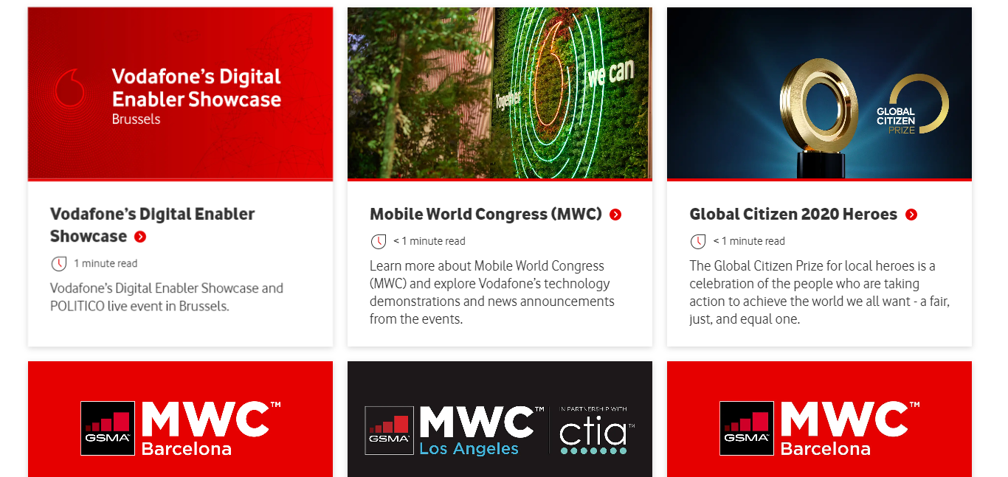
(Vodafone, 2022a)
Products and services in the retail and online market
The importance of products and services in the retail and online markets has dramatically surged in the current situation. The COVID-19 pandemic forced many industries to resume their physical stores and for that reason, online selling trends have surged. Retail companies which relied solely on in-store sales have had to rapidly familiarise themselves with online market practices to survive in the market (Merritt and Zhao, 2022).
In the retail market, companies have had to carry out new safety measures to confirm the safety of their consumers and staff. This has resulted in variations in how products or services are launched in the market and sold, with many trades presenting scopes of contactless payment in addition to home delivery options (Feng and Ho, 2021).
Vodafone is a prominent competitor in the telecommunications sector, delivering a diverse range of products and services for both individual users and corporate customers. Its product or service range covers mobile as well as fixed-line services, internet of Things (IoT) solutions, cloud and hosting services, as well as unified communications. Vodafone's mobile services comprise voice plans, data plans, international roaming, and smartphone device sales, while its fixed-line feature broadband internet, home phone, and TV services. Vodafone's IoT services provide corporate smart solutions to link and cope with their instruments and machines securely, in addition to its cloud as well as hosting services deliver scalable as well as security infrastructure for handling applications plus data competently (Vodafone, 2023d). Moreover, Vodafone's unified communications facilities permit companies to assimilate their voice, messaging, and collaboration tools into a particular platform, increasing output, teamwork, and cost lessening. By placing attention on innovation as well as technology, Vodafone remains competitive in the fast-fluctuating telecommunications landscape.

Digital assets
Vodafone depends on a change of digital assets to join with consumers and deliver its products as well as services. One of its key digital assets is its website, which is a portal to use Vodafone's offerings, comprising product info, data plans, promotions, as well as customer support. Furthermore, Vodafone's mobile application is a precious asset which authorises consumers to handle their accounts, pay bills, and seek support. Vodafone's social media presence is also a noteworthy digital asset, with active accounts on numerous common platforms, in which it presents news and updates and interrelates with consumers. The corporation's Chabot’s are a pioneering method to deliver consumers with computerised care, that can aid mitigate their inquiries as well as report worries. Vodafone's online store is another vital digital asset, offering consumers a convenient mode to buy devices as well as plans. Generally, Vodafone's digital assets are vital to its consumer appointment and product delivery approach. By consuming a variety of digital channels, Vodafone purposes to deliver excellent support, introduce its products, as well as improve customer practices.
Digital assets of a company refer to its online properties which are employed to back its business actions, involve customers, and distribute its products as well as services. These assets can comprise a business's website, mobile application, social media networks, online store, Chabot’s, as well as other digital instruments and platforms.

Marketing Mix
The marketing mix, which is also called as 7 P's of marketing, is a set of crucial rudiments that corporations incorporate to launch and sell their products as well as services. Vodafone, as a telecommunications business, has established a marketing mix which is tailored to its sector as well as its target customer base. 7 P’s of the marketing mix for this company are discussed below-
1. Product
Vodafone's key products are mobile phone facilities, fixed-line facilities, IoT facilities, cloud & hosting services, as well as unified communications. This corporation provides a variety of plans as well as packages which indulge the demands of both individual customers as well as corporate customers. Vodafone's services or products are established to be technically innovative, dependable, as well as inexpensive (Vodafone, 2023e). This MNC also offers Smartphones from leading corporations for example Apple, Samsung, and Huawei. Vodafone's product approach is emphasised innovation along with differentiation, offering its consumers high-quality products or services which meet their actual needs.
Products and solutions
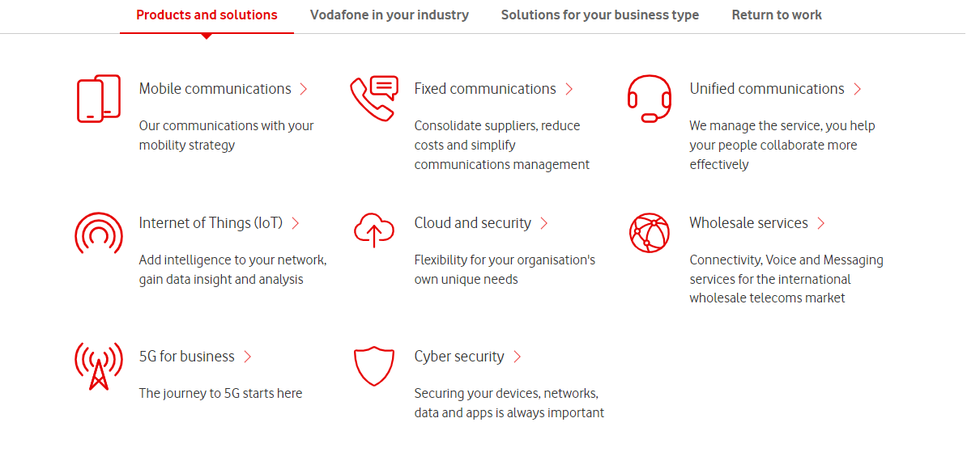
(Source: Vodafone, 2023e)
2. Price
Vodafone's pricing approach has emphasised an amalgamation of factors, comprising the competition level in the market, the price of providing its products and services, as well as customer demand. This corporation offers a variety of pricing strategies, containing prepaid as well as postpaid plans, with changing levels of internet data, voice, as well as messaging allowances. Vodafone also offers discounts on plans and presents to its consumers for incentivizing buying and maintaining customer loyalty (Vodafone, 2023f). The business's pricing strategy is designed to harmonise affordability as well as value for money with lucrativeness.
3. Place
Vodafone functions in numerous nations globally, serving a varied assortment of clients. This MNC has a robust retail occurrence, with brick-and-mortar stores situated in many countries, permitting clients to buy products as well as services and accept customer support. Furthermore, Vodafone offers its products or/and services online, via its website in addition to mobile applications (Vodafone. 2023g). The business's online presence sanctions it to reach broader viewers besides dealing with convenient self-service. Vodafone's distribution plan purposes to deliver its consumer's numerous channels for accessing its products as well as services.

Where Vodafone Operate
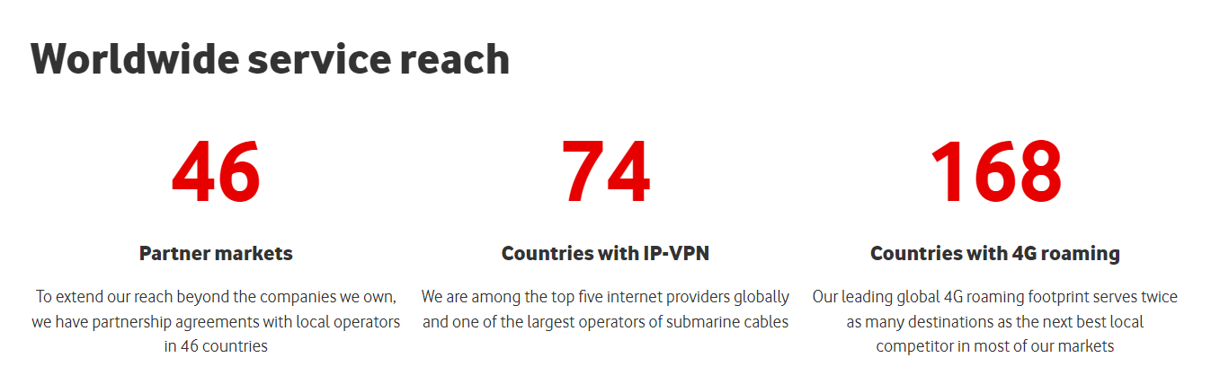
(Source: Vodafone. 2023g)
4. Promotion
Vodafone employs a variety of marketing channels for promoting its products as well as services. The company works with traditional advertising methods for example television, and print, besides outside advertising for meeting a broad customer base. Vodafone also works with digital channels for example social media, email marketing, and search engine publicity to reach as well as engage with its consumers (Vodafone. 2023h). The company's promotional policy is emphasised developing brand awareness, driving customer acquisition as well as retention, and strengthening its brand images of invention, dependability, and customer fulfilment.
In brief, Vodafone's marketing mix is designed to offer its consumers high-quality products as well as services which meet their demands at affordable values. The business's approach to the 4 P's of marketing highlights innovation, differentiation, and customer fulfilment. By engaging an inclusive marketing mix, Vodafone is well-positioned to flourish in an extremely competitive sector.
5. People
Vodafone has a huge workforce, comprising consumer service representatives, technical support team, sales personnel, in addition to management authorities. This company places a sturdy importance on worker growth in addition to offers training plans to benefit its employees form their skills as well as knowledge (Vodafone, 2023n). Vodafone always has the tendency to value diversity and inclusion, and endeavours to make a work environment in where each worker senses respected as well as supported.
6. Process
Vodafone deals with variation of products as well as services, containing mobile and fixed-line telephony, broadband internet, besides digital TV. This Plc has a updated sales procedure, with consumers able to buy or use products in addition to services from both online and in-store. Furthermore, Vodafone has a customer service procedure in place to manage customer queries and complaints, by the help of multiple channels of support accessible through phone, email, and live chat (Vodafone, 2023o).
7. Physical evidence
Vodafone has a sturdy brand appearance and is acknowledged internationally as a leading telecommunications corporation. This Plc company has a well-made website and app, offering customers with easy admittance to info and support. Vodafone functions retail stores in the global market, offering consumers with a physical location to acquire products as well as services and state to staff in person (Vodafone, 2023o).

Internal and external structural flow
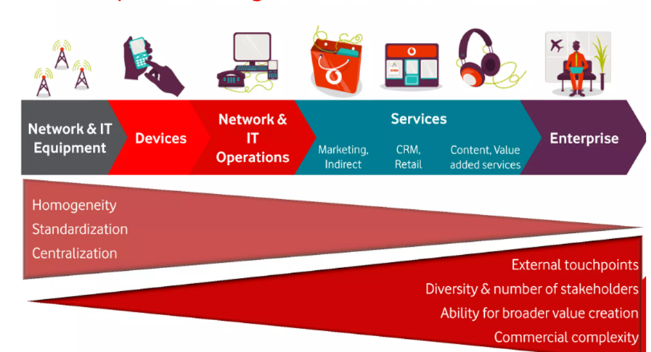
(Source: Slide Share, 2013)

Internal structural flow of Vodafone Plc
Vodafone Plc has a hierarchical structure with a flawless command chain. The company is directed by the Board of Directors, which is accountable for forming tactical trade decisions as well as overseeing the business's procedures. The Board of Directors is composed of non-executive directors, where the CEO, chairman and independent directors are the main strategists.
The Executive Committee is accountable for developing and executing the commerce's strategy and also handling the day-to-day processes. This is directed by the CEO as well as comprises senior executives answerable for key business segments like finance, marketing, technology, and human resources management. The Executive Committee initiates meeting frequently make a discussion on operational matters and execute tactical actions based on that (Vodafone, 2023b).
Each department within Vodafone has its own internal construction, with directors answerable for supervising the work of their squads. Communication within sections is enabled through daily-basis conferences as well as digital tools for instance email as well as instant messaging. This corporation also has an intranet, that acts as a central hub for worker resources, comprising company bulletin, and rules, besides training resources.
External structural flow of Vodafone Plc
Vodafone Plc functions in an extremely competitive as well as promptly fluctuating industry. This MNC's external structure is planned to maintain its tactical goals as well as confirm that it can retort rapidly to fluctuations in the industry.
Vodafone Plc has a decentralized organisational structure, with regional offices answerable for applying the corporation's policy in their particular industries. Each regional office has its own administration squad and is answerable for forming judgements regarding pricing, promotion, as well as sales in their region (Vodafone, 2023b).
Vodafone Plc also has a robust emphasis on corporate partnerships as well as alliances. The corporation has formed corporate strategic partnerships with other telecommunications corporations, technology businesses, as well as content providers to increase its offerings as well as penetrate the new marketplace. For instance, Vodafone has developed partnerships with Amazon Web Services and IBM for offering cloud services to its enterprise customers (Vodafone, 2020).
In summary, it can be concluded that Vodafone Plc has a flawless internal structure with a hierarchical command chain, directed by the Board of Directors as well as the Executive Committee. It is also a vital thing that each department in the corporation has its own internal structure, that facilities the way of maintaining collaborations between workers. Externally, Vodafone has a decentralized organisational structure with regional offices answerable for executing the business's policy in their particular marketplaces. The corporation also has strong attention on corporate partnerships and alliances, which eases market penetration and enhancement of brand reputation.

ECRM in Vodafone
ECRM refers to electronic customer relationship management that is highly beneficial for integrating all the web channels into the customer relationship strategy of an enterprise. The main purpose of incorporating this ECRM is to assist a corporation in linking marketing initiatives, sales and customer service. Hence, it can be claimed that ECRM offers a significant scope of bridging the gap between business, consumers and employees. This process combines software, hardware, processes, and management commitments to help implement company-wide CRM company tactics (ERM Solutions. 2022). Overall, the necessity of ECRM has been observed for all the corporates which have the aim of aligning business strategies with customer service support and this is crucial for expanding the scope of customer loyalty.
To stay in front in the telecommunication industry and hold its place as a market leader and Vodafone is now employing the ECRM (Electronic Customer Relationship Management) technology. Thus, it can be stated that Vodafone Plc is now getting some significant benefits in more customer acquisition.
As discussed above, ECRM is a technology which empowers corporations in administrating their consumer relations in a more well-organized as well as efficient approach. Not only this technology facilitates businesses to store consumer info but also makes it easier to utilise it to personalize their communications with clients which can be claimed as significant factors in customer service, and target market campaigns.
Vodafone is utilising ECRM technology to cope its communications with clients across multiple business channels, comprising email, social media, as well as Chabot. The use of ECRM benefits Vodafone in tracking customer connections across these trade channels, examining customer behaviour, in addition, to establish tailored marketing movements on the grounds of customer inclinations as well as interests.
One most significant illustration of how Vodafone is utilising the ECRM is through its "My Vodafone" application that is available on the play store. The application permits clients to administer their accounts, track their data usage, SMS usage and calling usage, and access consumer support (Vodafone. 2022d). Furthermore, the use of this application facilities the way of collecting how frequently consumers spend on the packages and what types of services customers are demanding from Vodafone. The entire information creates a crucial scope for the business in offering specialised offers for the customers and that platform is well-designed to promote this brand efficiently.
Vodafone is also utilising ECRM for making a great improvements in its customer service. By using the Chabot tools, Vodafone can offer its customers immediate support for common inquiries for example billing inquiries, network issues also service troubles. Chabot’s are accessible 24/7, and it has the efficiency of handling a high capacity of requirements, which aids to lessen waiting time for consumers (Choudhury, 2021).
In addition to that, Vodafone is utilising ECRM to investigate and scrutinise the different feedback from its customers and ease the way of service improvements too easily (Vodafone. 2022d). By employing social listening tools, Vodafone can observe social media channels for mentions of its brand as well as find customer sentiment. This crucial info can be used to foster customer service and mature targeted marketing drives.
Largely, Vodafone's utilisation of ECRM technology has allowed the corporation to deliver a more personalised as well as competent consumer service experience. By utilising data to comprehend customer behaviour as well as preferences, Vodafone can modify its services to suffice the actual necessities of individual consumers, which supports to progress of customer satisfaction as well as loyalty.

The information architecture of Vodafone
Information architecture is the procedure of systematising, arranging, and labelling content in a method which makes it easy to recognise and practice. Moreover, it aids trades by educating user involvement, creating it tranquil for consumers to navigate their websites or products, as well as fostering efficiency by restructuring information flow (Mollajan et al. 2023).

Website Structure
Vodafone's website structure is developed to offer consumers a seamless as well as easy-to-use experience that triggers brand value improvement. The homepage landscapes prominent calls-to-action, containing links to popular products, services, customer account login or the user log in, and customer support. The top navigation bar in the website consists of links to key pages, comprising mobile recharge plans, broadband service plans, in addition to TV (Vodafone, 2023J). The footer section of this website highlights some additional links to general company info, social media news, as well as legal policies.
Product Catalogue
Vodafone delivers an inclusive range of products as well as services, that include mobile plans, broadband plans, and TV, in addition to smart devices. The product catalogue is prepared into classes based on the type of amenities, creating it stress-free for consumers to discover what they are searching for (Vodafone, 2023m; Vodafone, 2023n; Vodafone, 2023k). Each product page comprises thorough facts regarding the service, comprising features, ratings, as well as contract terms.
Knowledge Base
Vodafone's knowledge base is the most valuable resource for its’ customers looking for support or responses to shared questions. The knowledge base is systematized into classes on the grounds of the service types, creating it tranquil for users to catch related info. The knowledge-based articles are too much well-written that one can easily comprehend, and the way of delivering consumers with step-by-step directions as well as helpful advice (Vodafone, 2023o). Furthermore, Vodafone established a community forum where consumers can enquire and respond to queries, delivering a self-help choice for those who favour it.

Internal Communication
Effective internal communication is vital for any type of trade, and Vodafone Plc is no exception. Vodafone practices a wide range of tools as well as technologies to enable communication among staff, comprising email, prompt messaging, as well as videoconferencing. This corporation also has an intranet, that essentially serves as a central hub for worker resources, with company news, rules, as well as training materials (Vodafone, 2023p). Vodafone's internal communication is established to foster teamwork as well as confirm that all staffs have the info they need to accomplish their work efficiently.
In conclusion, it can be said that Vodafone's information architecture is well-designed to offer users a seamless in addition to easy-to-use experience. The website structure is intuitive, and the product catalogue is well-organized, these two factors make the knowledge base a valuable resource for consumers who has the necessity of support. Furthermore, Vodafone's internal communication is very efficient, confirming that workers have the info they are essential to do their jobs efficiently. Overall, Vodafone's information architecture can be indicated as a key factor in the corporation's victory in addition to its capacity to encounter the requirements of its consumers and staff.

Sweet Spot
On the basis of the present market tendencies as well as Vodafone's strengths as well as competencies, the "sweet spot" for the corporation in the online as well as retail market could be in offering a unified, Omni channel experience for its consumers.
Vodafone has a robust international occurrence in both the online and retail industry, with its website as well as physical stores offering key touch points for purchaser engagement. By centring on delivering a unified experience across these channels, Vodafone can distinguish itself from other contestants and deliver a unique value proposition to its consumers.
To attain this, Vodafone could finance in technology which allows consumers to flawlessly move between online as well as offline channels. For instance, the corporation could adopt features for instance online appointment preparation for in-store consultations, or in-store pickup choices for online purchases. Vodafone could also practise data analytics to personalize the customer experience across channels, delivering targeted promotions and suggestions on the basis of customer liking as well as performance.
Furthermore, Vodafone could leverage its fortes in mobile technology and connectivity to offer advanced products as well as services which cater to the developing requirements of its consumers. This could comprise products for example connected devices, smart home keys, as well as mobile payment options.
By directing on delivering a seamless, Omni channel experience in addition to leveraging its fortes in mobile technology, this MNC can position itself as a frontrunner in the online as well as retail market as well as capture the courtesy of a wide range of clients.

(Source: Authors own creation)
Tele Formica
AT&T
Verizon
Orange Business
Individual customers
Corporate clients

Tele Formica
AT&T, Verizon
Orange Business

Unified, Omni channel experience

Part 2

Machine learning in Vodafone
Machine Learning (ML) is significantly recognised to be a subfield of “Artificial Intelligence” (AI), which majorly comprises training algorithms to inevitably learn the relationships along with patterns in data, and also to make pronouncements or predictions depending on that knowledge (Bajic et al. 2018). Fundamentally, “machine learning algorithms” are majorly structured to learn from data deprived of being overtly involuntary.
The procedure of machine learning characteristically includes quite a few steps, including feature selection, data preparation, training, testing and algorithm selection, At the time of the training session or phase, the algorithm is mostly fed with the input data and projected output, and it amends its interior parameters to enhance its performance (Li et al. 2017). After the algorithm has been competent, it can be employed for making decisions or predictions related to contemporary, or unobserved data. Machine learning is also utilised in an extensive variety of applications, such as speech recognition and image, normal language dispensation, recommendation systems, fraud detection, and many others (Dargan et al. 2020). The victory of machine learning depends heavily on the quantity along with the quality of the data utilised for training, and also the choice of suitable parameters and algorithms.
Vodafone, being one of the globe’s leading as well as extensive telecommunications corporations, has been utilising machine learning in the variability of customs to progress its business manoeuvres and services (Digital Initiative, 2018). Vodafone Group Plc obtains 313 million consumers across networks in near about 25 nations. As a result, the company Vodafone is distinctively placed to significantly leverage the hefty amounts of data at its disposal, especially IoT data and app usage, as distinct traffic patterns, to deploy machine learning across its customers (Digital Initiative, 2018).
One substantial area where machine learning has been predominantly beneficial for Vodafone is in consumer service (Vodafone, 2021a). By analysing extensive amounts of consumer data, machine learning algorithms can majorly be aided in recognising trends and patterns that can benefit Vodafone to better comprehend customer p references and needs. The mentioned factor can majorly lead to more efficient and personalised consumer service, along with more beleaguered marketing efforts. Another noteworthy area where Vodafone has utilised machine learning is in its network optimisation (Vodafone, 2017). By examining network performance data, machine learning algorithms can recognise areas where the network is undergoing glitches and advocate customs to mitigate those issues. The use of machine learning has led the company Vodafone to improve its network performance along with customer experience. The company Vodafone has also utilised machine learning in terms of detecting fraud. In terms of analysing extensive amounts of business data, machine learning algorithms have helped Vodafone to categorise anomalies and patterns that may perhaps direct towards fraudulent activity (Vodafone, 2022b). Moreover, Vodafone utilises machine learning languages to improve its operations as well as services. Certain instances include use of Pythons for conducting tasks like computer vision, predictive modelling and natural language processing. One major instance in the business of Vodafone comprises the usage of natural learning process (Vodafone, 2022d). Senior managers of the company Vodafone require to attend several meetings, so natural learning procedures majorly acts as a proposed AI-oriented solution that fully automates the entire process by default with the features like “Meeting Minutes Automation” and “Speech to Text”.

How Artificial intelligence aids Vodafone in its Services
“Artificial Intelligence” (AI), has been a critical part of Vodafone’s services, as AI majorly helps Vodafone to optimise its business operations, furnish more pleasant customer experience and also develop personalised experiences for each separate customer (Vodafone, 2022b). Moreover, the company has been able to leverage a hefty amount of data to foster its 5G network services. The segment below will majorly furnish quite a few ways in which AI has turned out to be beneficial for Vodafone:
- Personalised Customer Experiences - Vodafone significantly employs AI algorithms to interpret consumer data and develop personalised experiences for each one of them (Vodafone, 2021b). The procedure majorly comprises personalised product suggestions, customised marketing messages and targeted promotions, which are more probable to reverberate with each consumer.
- Improved Customer Service - Vodafone also utilises “AI-powered chatbots”, to administer its consumer’s inquiries and also to deliver quick and well-organised support (Vodafone, 2022c). This initiative will majorly help to dwindle the wait times of the customers and improve satisfaction.
- Network Optimisation - Vodafone also utilises AI algorithms to significantly improve its existing network infrastructure, so that customers enjoy its network’s excess capacity, reliability and speed (Vodafone, 2017). AI algorithms also aid in reducing network downtime and also certify that consumers partake in the unsurpassed conceivable experience.
- Fraud Detection - Vodafone utilises AI algorithms to dissuade as well as detect fraud. AI has majorly helped Vodafone to safeguard its consumers and also guaranteed that the consumers are not subject to imperilled to deceitful bustle.
Although Vodafone has received significant benefits from the from the usage of AI, but the company has also encountered major challenges while implementing machine learning. The machine learning models which the company has implemented relies extensively on data, in case the data is not available or of low quality, the models provide inaccurate results. The type of data that Vodafone uses is frequently dispersed across several systems and process becomes problematic to integrate and analyse. Machine learning models often tends to deliver biased outcomes in case not properly structured or trained. To mitigate the mentioned challenges Vodafone has joined with Google to introduce AI Booster, so that more scalable and faster solutions are obtained enhance customer loyalty and experience (Technology Magazine, 2022).

Segmentation
- Geographic Segmentation - The company Vodafone majorly segments or sections its market relying on the geographic location, which consents the corporation to accommodate the precise preferences and requirements of the consumers residing in distinct provinces. Presently the company administers its business in 21 nations and partakes in partner networks in near about 47 nations (Vodafone, 2023g). This has majorly helped the corporation to deliver its localised services and products to its consumers residing in distinct regions.
- Demographic Segmentation - The company Vodafone also sectors its market relying on demographic facets like the education echelon, income group and age group. For instance, Vodafone is majorly associated with offering diverse packages as well as plans separately for its business clients, families along with students, depending on their circumstances of requirements and preferences.
- Psychographic Segmentation - Vodafone also prioritises the values, beliefs and lifestyles of its consumers within the markets where the company is operating. Vodafone’s “value-added services”, such as cloud storage, mobile payments and entertainment are mostly intended to outfit the explicit preferences and needs of consumers with distinguishable interests and lifestyles (Vodafone, 2020).
- Behavioural Segmentation - Vodafone has also been heeded to segment its market relying on consumers’ behaviour, especially their convention patterns as well as adherence towards the brand. Vodafone bids promotions, loyalty programs and discounts to its consumers who utilise its service very often or who have been a customer of the corporation for many years.
- Business to Business (B2B) Segmentaion - Vodafone also prioritises the precise requirements along with the preferences of its commercial or business clients. The partakes in a separate global enterprise, whose “B2B” unit delivers “Information Technology” (IT) and telecommunication services to its clients existing in 150 nations (Vodafone, 2023i).

How machine learning is used in Vodafone to know its customers
Unlike many other business firms, Vodafone also utilises machine learning approaches to obtain clear insights into its consumers and furnish them with more pleasant services. Some of the ways that machine learning is utilised in Vodafone to know its consumers include:
- Market Intelligence - The machine learning algorithm is majorly utilised by Vodafone to demarcate trends and patterns and also to analyse consumer data. This mentioned factor majorly comprises demarcating which services and products are presently prevalent amongst certain consumer segments and tracking marketing messages to appeal to distinct groups.
- Customer Segmentation - As mentioned-above Vodafone utilises machine learning algorithms to segment ort sector customers relying on their behaviour, preferences and certain other facets. This initiative has helped the corporation to develop “targeted marketing campaigns”, that partake in the possibility to reverberate with every group (Vodafone, 2021c).
- Personalised Recommendations - Vodafone utilises machine learning algorithms to scrutinise consumer data and furnish personalised service and product recommendations. The procedure comprises suggesting such services and products that partake in the possibility to be of interest to each separate customer depending on their purchase and browsing history.
- Forecasting Decisions - A machine learning algorithm is also utilised by Vodafone to conjecture consumer demand and also to construct informed decisions regarding inventory administration, pricing strategy and other aspects. This initiative has majorly aided the corporation to improve its business manoeuvres and make sure that the corporation is able to come across consumers’ requirements in a timely and effective way.

How machine learning Maximises ROI
Machine Learning can majorly be a prevailing tool in the context of digital marketing and can also aid Vodafone to maximise its “Return on Investment” (ROI) by enhancing its marketing efforts and also enlightening it's empathetic associated with customer behaviour. Here are some ways that Vodafone utilise machine learning in digital marketing:
- Predictive Analysis - Vodafone can majorly utilise machine learning algorithms to investigate or examine consumer data and categorise patterns and trends that can assist to predict consumer behaviour. The mentioned hectare can majorly help Vodafone to improve its marketing efforts by pointing to the right customer, with accurate offers, at the exact time.
- Personalisation - By utilising machine learning to examine consumer data, Vodafone can develop personalised experiences for its consumers. This procedure may perhaps involve product or service suggestions, tailoring content, and delivering offers to separate consumers relying on their demographics, behaviours and preferences.
- Advertisement Targeting - ML algorithms can also scrutinise data to recognise the physical appearance of Vodafone's most valued customers. This factor will majorly aid Vodafone to target its advertising efforts persuasively and contact consumers who are willing to enjoy the services of Vodafone.
- Marketing automation - By utilising ML algorithms to systematize tedious marketing responsibilities, Vodafone will be able to diminish the volume of manual labour obligatory for digital marketing campaigns. Moreover, this factor can gradually help Vodafone to condense its expenses by enhancing the persuasiveness and efficiency of marketing efforts.

CONCLUSION
Vodafone has made significant investments in digital assets to enhance its marketing mix. The company has enhanced the structural flow both inside and outside the building to offer a seamless customer experience. Thanks to the usage of ECRM and information architecture, Vodafone has been able to further customise its offerings and target certain customer groups. Additionally, Vodafone has benefited from the integration of machine learning and artificial intelligence by being able to provide cutting-edge services, maximise ROI, and better understand its customers. By leveraging technology and data, Vodafone has solidified its position as a market leader in the telecoms industry and is well-positioned for ongoing success in the digital age.

References
Bajic, B., Cosic, I., Lazarevic, M., Sremcev, N. and Rikalovic, A., 2018. Machine learning techniques for smart manufacturing: Applications and challenges in industry 4.0. Department of Industrial Engineering and Management Novi Sad, Serbia, 29. https://onlinelibrary.wiley.com/doi/abs/10.1002/9781119792253.ch12
Choudhury, P. 2021. How Vodafone is using AI and chatbots to enhance customer experience. TechRepublic . [Online] Available at: <https://www.techrepublic.com/article/how-vodafone-is-using-ai-and-chatbots-to-enhance-customer-experience/> [Accessed on: 21st April 2023]
Dargan, S., Kumar, M., Ayyagari, M.R. and Kumar, G., 2020. A survey of deep learning and its applications: a new paradigm to machine learning. Archives of Computational Methods in Engineering, 27, pp.1071-1092. https://link.springer.com/article/10.1007/s11831-019-09344-w
Digital Initiative, 2018. Vodafone: leveraging Machine Learning in an (almost) 5G world. [Online] Available at: <https://d3.harvard.edu/platform-rctom/submission/vodafone-leveraging-machine-learning-in-an-almost-5g-world/> [Accessed on: 18th April 2023]
ERM Solutions. 2022. What is ECRM? [Online] Available at: <https://www.ermsolutions.com/resources/what-is-ecrm/> [Accessed on: 21st April 2023]
Feng, J. and Ho, H.C., 2021. Exploring young people's online food shopping behavior during the COVID-19 epidemic in China. New Normal and New Rules in International Trade, Economics and Marketing, pp.267-290. https://pesquisa.bvsalud.org/global-literature-on-novel-coronavirus-2019-ncov/resource/pt/covidwho-1573288
Kumar, B.R. and Kumar, B.R., 2019. Vodafone Acquisition of Mannesmann. Wealth Creation in the World’s Largest Mergers and Acquisitions: Integrated Case Studies, pp.17-29. https://link.springer.com/chapter/10.1007/978-3-030-02363-8_2
Li, J., Cheng, K., Wang, S., Morstatter, F., Trevino, R.P., Tang, J. and Liu, H., 2017. Feature selection: A data perspective. ACM computing surveys (CSUR), 50(6), pp.1-45. https://dl.acm.org/doi/abs/10.1145/3136625
Merritt, K. and Zhao, S., 2022. The power of live stream commerce: A case study of how live stream commerce can be utilised in the traditional British retailing sector. Journal of Open Innovation: Technology, Market, and Complexity, 8(2), p.71. https://www.mdpi.com/2199-8531/8/2/71/pdf
Mollajan, A., Iranmanesh, S.H. and TavakkoliMoghaddam, R., 2023. A systems approach to improve reliability of a contract by Modularising contract’s information flow architecture: a new contribution to risk mitigation in projects management. Enterprise Information Systems, 17(4), p.1971773. https://www.researchgate.net/profile/Ali-Mollajan/publication/356086147_A_systems_approach_to_improve_reliability_of_a_contract_by_Modularising_contract's_information_flow_architecture_a_new_contribution_to_risk_mitigation_in_projects_management/links/6411be6766f8522c38a87e76/A-systems-approach-to-improve-reliability-of-a-contract-by-Modularising-contracts-information-flow-architecture-a-new-contribution-to-risk-mitigation-in-projects-management.pdf
Vodafone, 2017. AI enabled augmented engineering increases network optimisation speed by over 45,000%. [Online] Available at: <https://www.vodafone.com/news/technology/ai-enabled-augmented-engineering-increases-network-optimisation> [Accessed on: 18th April 2023]
Side share, 2013. Group supply chain management. [Online] Available at: <https://pt.slideshare.net/CPOEvent/detlef-schultz-group-supply-chain-management-director-at-vodafone-procurement-company-scm-transformation-at-vodafone> [Accessed on: 18th April 2023]
Technology Magazine, 2022. Vodafone join forces with Google to launch AI Booster. [Online] Available at: <https://technologymagazine.com/ai-and-machine-learning/vodafone-join-forces-with-google-to-launch-ai-booster> [Accessed on: 18th April 2023]
Vodafone, 2020. Cloud Partners. [Online] Available at: <https://www.vodafone.com/business/cloud-and-hosting/cloud-partners> [Accessed on: 21st April 2023]
Vodafone, 2020. VAS – Value Added Services. [Online] Available at: <https://www.myvi.in/value-added-services> [Accessed on: 18th April 2023]
Vodafone, 2021a. Why leaders should be using AI in their businesses right now. [Online] Available at: <https://www.vodafone.com/business/news-and-insights/blog/gigabit-thinking/why-leaders-should-be-using-ai-in-their-businesses-right-now> [Accessed on: 18th April 2023]
Vodafone, 2021b. Personalising experiences – how customer segmentation helps. [Online] Available at: <https://www.vodafone.com/business/customer-experience/how-customer-segmentation-helps-to-personalise-experiences> [Accessed on: 18th April 2023]
Vodafone, 2021c. Personalising experiences – how customer segmentation helps. [Online] Available at: <https://www.vodafone.com/business/customer-experience/how-customer-segmentation-helps-to-personalise-experiences> [Accessed on: 18th April 2023]
Vodafone, 2022a. Campaigns & Events. [Online] Available at: <https://www.vodafone.com/news/campaigns-events > [Accessed on: 18th April 2023]
Vodafone, 2022b. Artificial Intelligence | AI helps keep our customers and businesses secure. [Online] Available at: <https://www.vodafone.com/about-vodafone/what-we-do/innovation/artificial-intelligence> [Accessed on: 18th April 2023]
Vodafone, 2022c. Vodafone and the University of Oxford tackle bias bots. [Online] Available at: <https://www.vodafone.com/news/technology-news/vodafone-university-oxford-tackle-bias-bots> [Accessed on: 18th April 2023]
Vodafone, 2022d. The Future Of Innovation through Artificial Intelligence And Machine Learning. [Online] Available at: <https://careers.vodafone.com/life-at-vodafone/projects-stories/the-future-of-innovation-through-artificial-intelligence-and-machine-learning/> [Accessed on: 18th April 2023]
Vodafone, 2023a. Company History. [Online] Available at: <https://n.vodafone.ie/aboutus/company/history.html> [Accessed on: 18th April 2023]
Vodafone, 2023b. Company History. [Online] Available at: <https://www.vodafone.com/about-vodafone/where-we-operate> [Accessed on: 18th April 2023]
Vodafone, 2023c. Company website. [Online] Available at: <www.vodafone.com> [Accessed on: 18th April 2023]
Vodafone, 2023d. Vodafone Business | Tailored IoT solutions. [Online] Available at: <https://www.vodafone.com/business/iot > [Accessed on: 18th April 2023]
Vodafone, 2023e. Products and services. [Online] Available at: <https://www.vodafone.com/business/products-and-services> [Accessed on: 18th April 2023]
Vodafone. 2023f. Pricing. [Online] Available at: <https://www.vodafone.com/business/pricing> [Accessed on: 18th April 2023]
Vodafone, 2023g. Where we operate. [Online] Available at: <https://www.vodafone.com/about/where-we-operate> [Accessed on: 18th April 2023]
Vodafone, 2023h. Promotions. [Online] Available at: <https://www.vodafone.com/business/promotions> [Accessed on: 18th April 2023]
Vodafone, 2023i. What we do. [Online] Available at: <https://www.vodafone.com/about-vodafone/what-we-do> [Accessed on: 18th April 2023]
Vodafone, 2023j. Our company. [Online] Available at: <https://www.vodafone.com/about-us/overview> [Accessed on: 21st April 2023]
Vodafone, 2023k. Mobile plans. [Online] Available at: <https://www.vodafone.com.au/plans/mobile-plans> [Accessed on: 21st April 2023]
Vodafone. 2023l. Broadband. [Online] Available at: <https://www.vodafone.com.au/broadband > [Accessed on: 21st April 2023]
Vodafone, 2023n. Smart devices. [Online] Available at: <https://www.vodafone.com.au/devices> [Accessed on: 21st April 2023]
Vodafone, 2023o. Help and support. [Online] Available at: <https://www.vodafone.com.au/support> [Accessed on: 21st April 2023]
Vodafone, 2023p. Community forum. [Online] Available at: <https://community.vodafone.com.au/> [Accessed on: 21st April 2023]
Vodafone. 2022d. Our strategy. [Online] Available at: <https://www.vodafone.com/who-we-are/our-strategy> [Accessed on: 21st April 2023]
Vodafone. 2023m. TV. [Online] Available at: <https://www.vodafone.com.au/tv> [Accessed on: 21st April 2023]
Vodafone, 2023n. Training and development. [Online] Available at: <https://www.vodafone.co.uk/cs/groups/public/documents/contentdocuments/vfcon072164.> [Accessed on: 21st April 2023]

