

DOF Sustainability Report: A Story of Three Climatic Outcomes
DOF ASA
16/10/2021
Kai Thompson

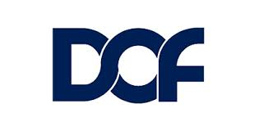

Contents
About this Project 3
Organisational Overview 4
Climate Risk Scenarios (CRS) Background & Assessment 5
Scenarios: A Story of Three Climatic Outcomes 7
Summary of CRS Risks and Opportunities 8
Analysis - Physical Risks 11
Analysis – Policies and Regulations 13
Analysis – Market and Technology 17
Analysis – Reputational Risk 22
Conclusion and Summary 25
Appendix A: Company Profile & 2020 Performance 27
Appendix B: IPCC Climate Scenarios 30
References 31

Table of figures:
Figure 1 DOF Company Profile 5
Figure 2 Climate Change Risk and Opportunities Source: (Task Force on Climate Related Financial Disclosures, 2017) 6
Figure 3 The Role of Scenarios in the Strategic Management Process Source (TFCD, 2020) 7
Figure 4 Exploratory vs Normative CSR Methodologies Source: (TFCD, 2020)) 7
Figure 5 Hypothetical Climate Scenarios (Stone, 2021) (Intergovernmental Panel on Climate Change, 2021) 8
Figure 6 Scenario Risk & Opportunities 11
Figure 7 Physical Risk Summary 12
Figure 8 Towing an Iceberg (Patowary, 2014) 13
Figure 9 Policy Scenarios 14
Figure 10 Climate Change Policies and Regulation Risks 14
Figure 11 Cross-industry partnerships & 2020 Integrated Annual Report (DOF ASA, 2020) 16
Figure 12 Sustainability Accolades (DOF ASA, 2021) 16
Figure 13 Market and technology risks 18
Figure 14 IMO GHG Reduction Solutions (International Maritime Organisation, 2019) 19
Figure 15 IMO Emission Goal Timescales 19
Figure 16 Oil and Gas Risk for Investors (Earley, 2015) 20
Figure 17 Offshore Wind Capacity, 2018 and 2040, Stated Policy Scenario (IEA, 2019) 21
Figure 18 Offshore Wind as a component of a Sustainable Development Scenario in 2040 (International Energy Agency, 2019) 22
Figure 19 DOF; Our Strategy (DOF ASA, 2020) 22
Figure 20 DOF Materiality Assessment 23
Figure 21 Stakeholder Reputational Risks 24
Figure 22 The brand paradox (Haidar, 2021) 25
Figure 23 DOF Value Chain 26
Figure 24 DOF Climate Change Risk Types 26
Figure 25 Building Resilience 27
Figure 26 Reducing Exposure 27
Figure 27 IPCC Climate Scenarios 31

About this Project

I have been engaged by DOF to undertake an evaluation of their organisational sustainability Profile. In doing so, this report shall appraise DOF’s exposure to three Climate Risk Scenarios and the organisations existing sustainability transition and adaption stategies.

The climate scenarios shall be interpreted into risks and opportunities within the areas of;
- Physical, climatic changes;
- Market Impact;
- The need for technology and digitalisation;
- Changes in policy and regulation; and
- Reputational risk.

Through this methodology, this Report seeks to identify and describe;
- Existing sustainability initiatives, practices and processes across DOF’s Value Chain;
- Key stakeholder interests concerning sustainability;
- DOF's relative position to peers in sustainability performance.

This report shall not make recommendations based upon the above. It is intended that future reports or plans shall be developed for this purpose.

Organisational Overview

DOF is considered a leading provider of ‘integrated subsea project and marine services’. DOF is unique in the industry as it both owns and operates its vessels and subsea equipment. Combined with its regional offices, DOF can deliver multi-discipline services globally from a single organisation.

A more comprehensive company profile and 2020 performance can be found in Appendix A.

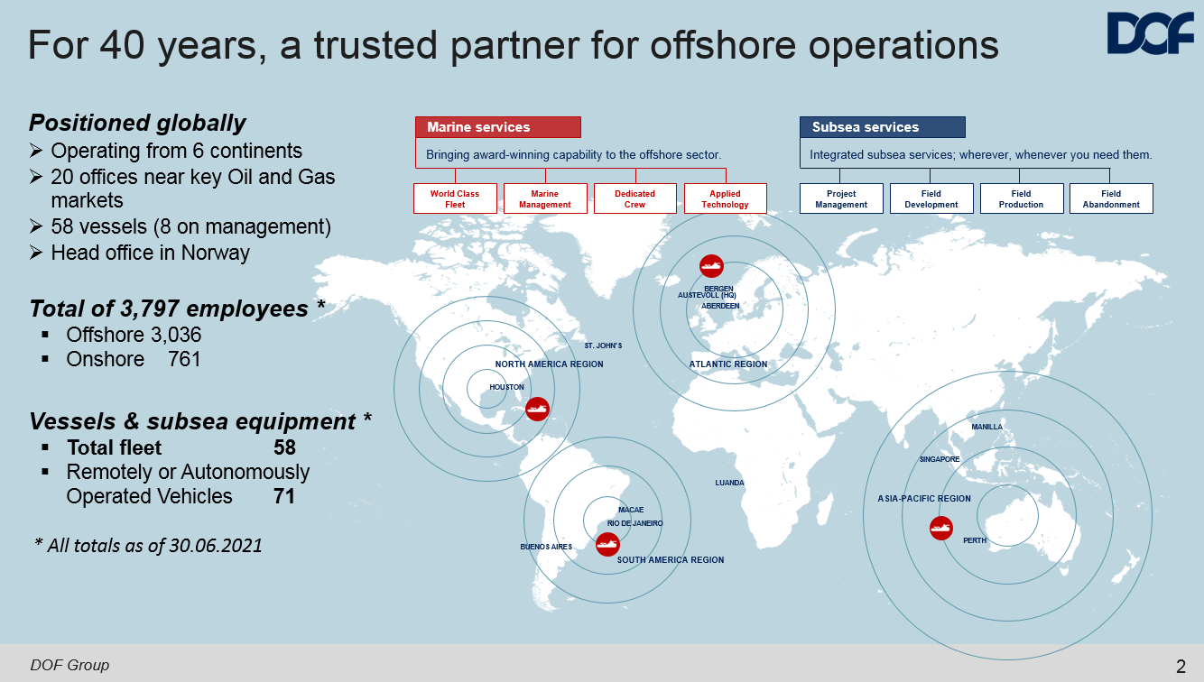

Figure 1 DOF Company Profile

Climate Risk Scenarios (CRS) Background & Assessment

The Task Force for Climate-Related Disclosures (TFCD) and International Monetary Fund (IMF) has made CRS assessments a key recommendation for business transparency and continuity in the financial sector (Task Force on Climate Related Financial Disclosures, 2017) (International Monetary Fund, 2021). A press release from the UK Government in October 2021 also indicates that this style of assessment shall become expected across other industries and the UK’s largest companies (GOV.UK, 2021).

For DOF, the requirement to perform or disclose CRS outcomes remains voluntary. Nevertheless, Climate Risk Scenarios (CRS) are a valuable method to guide existing policy and action towards future sustainable operations (Faure, et al., 2017) regardless of industry.

CRS methodologies present a range of sustainability impacts across diverse climate outcomes. DOF can use this information to interrogate plausible risks and opportunities to the organisation in an otherwise complex and uncertain topic like climate change (Acclimatise News, 2017). Figure 2 visualises some of the business continuity topics typically associated with climate change;

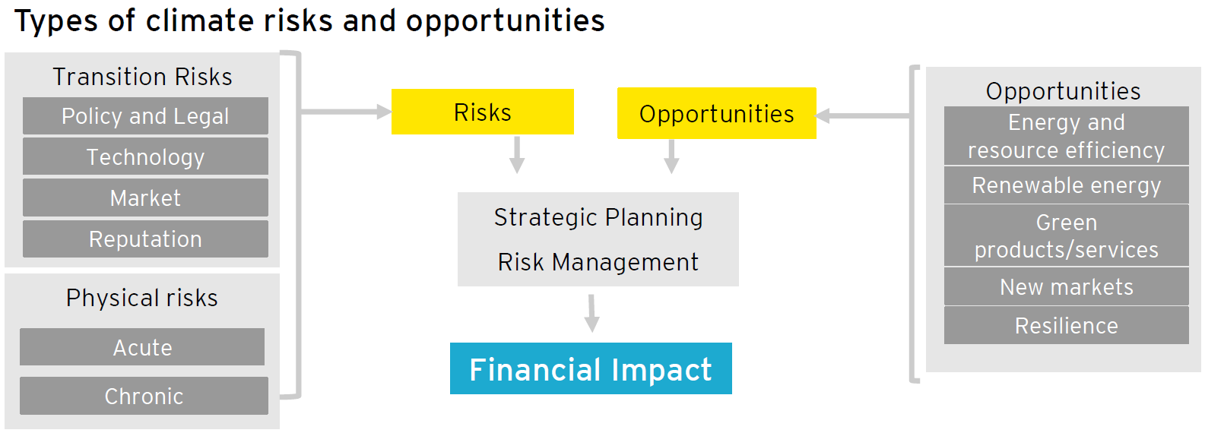

Figure 2 Climate Change Risk and Opportunities Source: (Task Force on Climate Related Financial Disclosures, 2017)

Using climate risk and opportunities to prompt longer-term strategic thinking will build business resilience around future climatic scenarios, as represented in Figure 3. This is particularly important for DOF and their current 'One DOF, for the Future' restructuring campaign (DOF ASA, 2020).

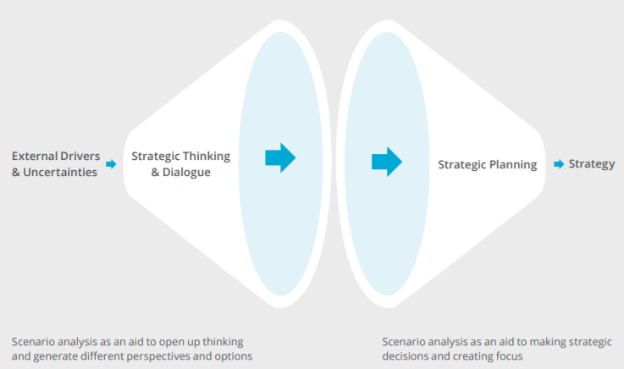
Figure 3 The Role of Scenarios in the Strategic Management Process Source (TFCD, 2020)

Methodology

Two main approaches can be applied to a CRS Assessment (Figure 4);

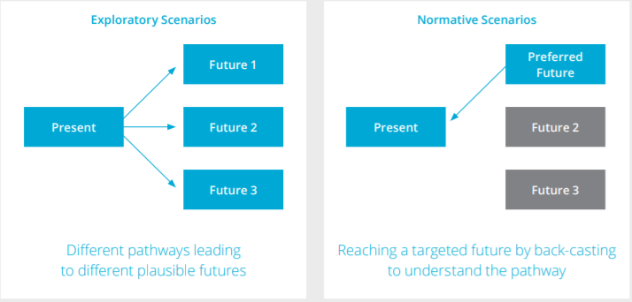
Figure 4 Exploratory vs Normative CSR Methodologies Source: (TFCD, 2020))
Based on TFCD's recommendations, this Report shall use an 'Exploratory' CRS approach to assess DOF's organisational and strategic resilience to climate change (TFCD, 2020).

Scenarios: A Story of Three Climatic Outcomes

This Report has adapted three scenarios (SSP1-1.9, SSP2-4.5 & SSP5-8.5) taken from the Intergovernmental Panel on Climate Change (IPCC) 6th Assessment Report (Intergovernmental Panel on Climate Change, 2021). See Appendix B for more detail.

For the purpose of this Report, Figure 5 builds upon IPCC’s science-based scenarios with an account of what the operating landscape may look for DOF like between 2030 – 2050.

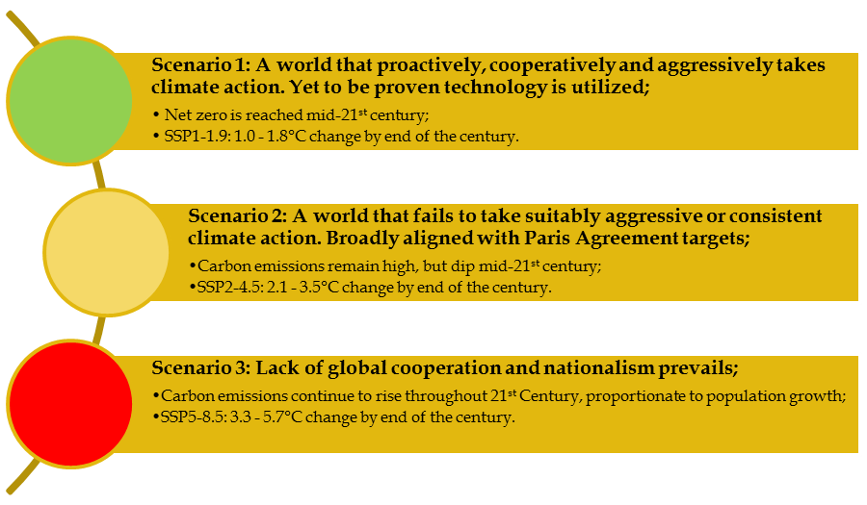
Figure 5 Hypothetical Climate Scenarios (Stone, 2021) (Intergovernmental Panel on Climate Change, 2021)

Summary of CRS Risks and Opportunities

Figure 6 maps out hypothetical CRS within the context of physical, political, market, technological and reputational risk and opportunities to DOF.

Rather than being comprehensive, this list is intended to provide a cross-section of risks and opportunities and form the basis for further discussion.

Figure 6 Scenario Risk & Opportunities

Analysis - Physical Risks

The IPCC 6th edition report outlines climatic changes to the physical environment that can be superimposed as risks or opportunities to DOF's business continuity. These are summarised below;

Risk: Extreme Weather

Opportunity: New transit routes and geographical locations for exploration

Risk: Frequency of climatic extremes

Risk: Sea level Rise

Opportunity: Leveraging the competitive advantage of modern fleet hardware

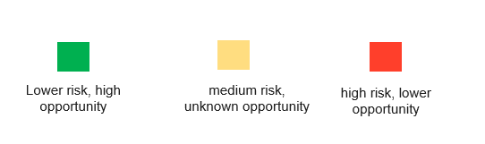
Figure 7 Physical Risk Summary

Fleet Modernity:

DOF's business model is based on modern vessels supporting offshore activities (DOF ASA, 2020). The modernity of the fleet and hardware mitigates some of the schedule risk associated with operations in inclement weather as the vessels can 'hold position' in rougher seas. DOF’s Vessels can operate in a wide weather window, decreasing 'downtime' by utilising existing dynamic positioning technology.

Regardless of this fact, if the frequency of extreme weather events increases, DOF's fleet will experience more weather-related interruption due to mandated operating limits. In response, clients seek to pass on this schedule risk through their supply chain by contractual means. This subsequently increases DOF's financial risk exposure. Compared to industry peers, DOF can leverage their modern hardware advantages as an attractive proposition for clients to mitigate weather-related downtime costs.

Operating costs and barriers to future work

Operational expenditure (OPEX) of the fleet will also increase if scenarios 2 and 3 become a reality. Vessels will burn more fuel holding position, transiting or waiting in rough seas, crew changes will become disrupted by weather events, and there will be increased frequency of asset damage in severe weather. In recognition of these risks, clients assess vessel operators' ability to mitigate these additional costs within project tendering and pre-qualification phases.

If DOF cannot regulate additional OPEX costs associated with climate change, they will be excluded and price themselves out of future projects.

New Markets and Opportunities

DOF's also operates a diverse fleet of vessels by design (DOF ASA, 2020). As such, the organisational impact is mitigated if a sector of the industry is impacted by climate change as vessels can move between regions and markets.

DOF's diverse fleet can already accommodate crew in thermal extremes through existing naval designs and accommodation facilities. Therefore, capital expenditure (CAPEX) on retrofitting systems to accommodate seafarers in climatic extremes should be comparatively lower than industry peers with older and less diverse fleets.
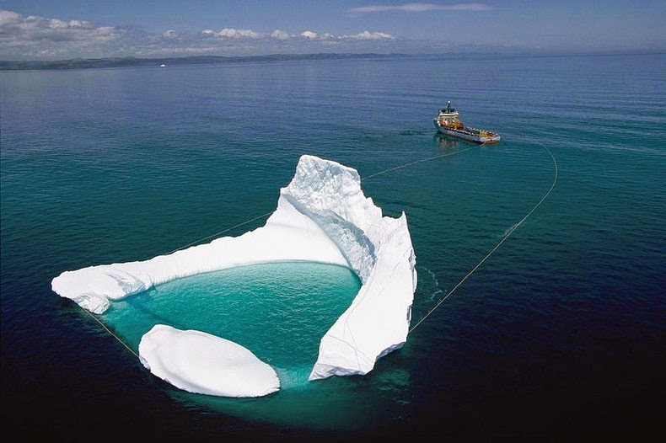
Furthermore, the diversity of vessels design allows DOF to seize new opportunities. For example, DOF has numerous 'Ice-Class' vessels that can be operated across icy sea routes. As Arctic and Antarctic regions open in scenarios 1 and 2, DOF could utilise existing vessels in these regions for new tasks. Such as, ice towing and clearing pathways for cargo shipping (Ghosh, 2021).

Figure 8 Towing an Iceberg (Patowary, 2014)

Analysis – Policies and Regulations

It is apparent within DOF’s 2020 Integrated Report that incumbent climate change policy and regulation changes present a material concern to DOF and its stakeholders (DOF ASA, 2020). This is exacerbated by the current void between industry commitments towards emission reduction and action (Climate Action Tracker, 2021) (Intergovernmental Panel on Climate Change, 2021). The unknown complexity, consistency, volume and demands of climate change policies across DOF's operational jurisdictions creates significant uncertainty and a transition risk for the organisation. Figure 9 demonstrates the variances in emission reduction targets, which could indirectly affect DOF.
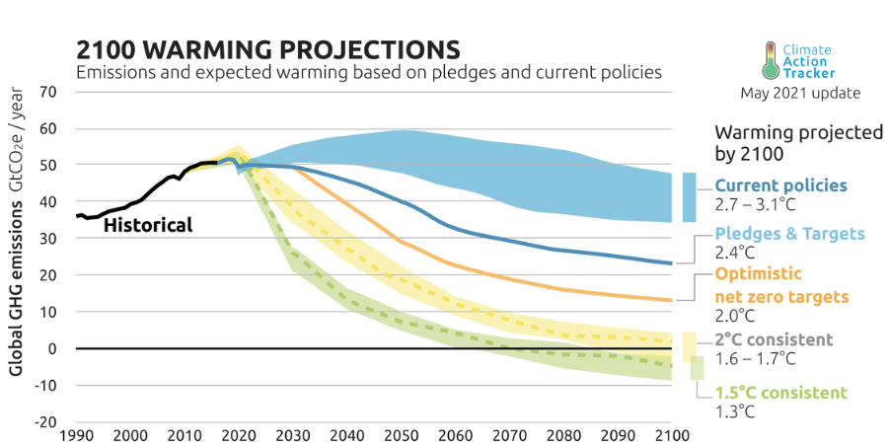

Figure 9 Policy Scenarios
Figure 10 applies some organisational context to Policy and Regulation CRS outcomes;

Risk: Enforced emission reduction targets

Risk: Pressure on industry to cease fossil fuel exploration and production

Risk: Implementation of fiscal policies to alter fossil fuel demand

Risk: ESG reporting, taxonomy and investor sentiment

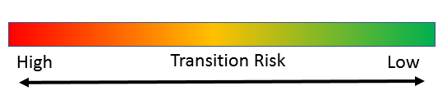
Figure 10 Climate Change Policies and Regulation Risks

Partnerships and Alliances

With little clarity over the future alignment of climate change policies, there is an inflexion point for the oil and gas industry. Either wait to conform or predict market demands and seek a competitive advantage beyond compliance (Steinberg, 2020).

To offset policy and regulation risk, DOF has formed strategic alliances in the industry. This has enabled them to;
- Establish an industry leading research and development project that has developed digitalisation technology, optimising fleet engine efficiency;
- Work with vessel classification societies to develop cutting-edge vessel efficiency management plans;
- Engage engineering consultants to investigate circular economy and perform ship lifecycle analysis;
- Form joint ventures with shore-based engineering companies to establish turnkey renewable energy products and services; and
- Place executive management team members within trade organisations to develop sustainability codes of practice the industry.

(DOF ASA, 2020)

These noncompetitive industry alliances are characterised by high interaction, low business conflict and shared interests in establishing transformative products or services. Working with partners to scale and replicate promising innovation, research, industry standards, DOF mitigates compliance risk by helping to define the industry benchmark. Peers in the industry waiting for coercive market pressures (or lack thereof in scenario 3) will have a low initial outlay of adaption costs but face higher financial exposure should Scenario 1, or 2 regulatory reforms come to fruition (Diakos & Bisisidis, 2020).

“These noncompetitive industry alliances are characterised by high interaction, low business conflict and shared interests in establishing transformative products or services.”

Voluntary Disclosures

Recognising evolving stakeholder expectations, DOF has also opted to disclose its sustainability performance through the Carbon Disclosure Project and Annual reports (Figure 11) (DOF ASA, 2020).

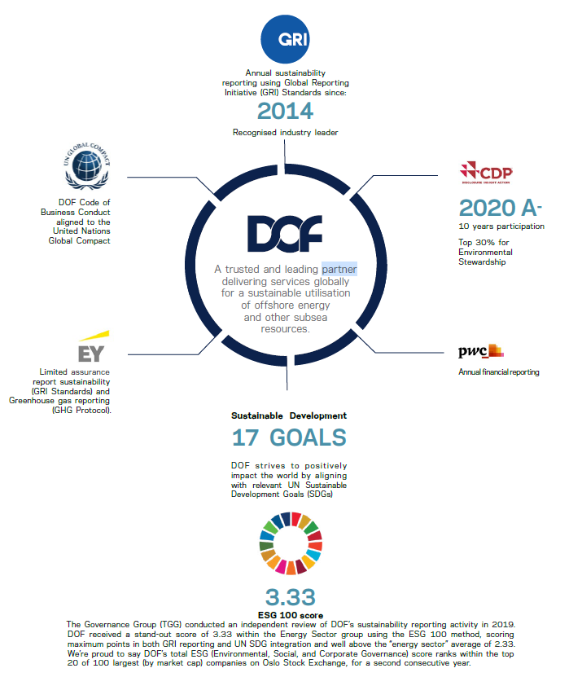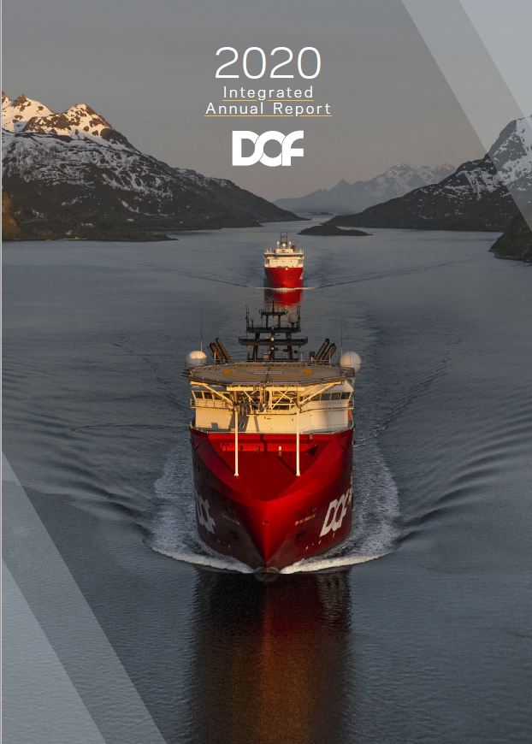

Figure 11 Cross-industry partnerships & 2020 Integrated Annual Report (DOF ASA, 2020)

Over 10 years of reporting, non-financial reporting programs have transitioned from the Health, Safety and Environmental Department to Financial, Governance, Risk and Compliance functions. Non-financial and financial material issues (such as climate change) are now considered and reported together, articulating to stakeholders the interconnectedness of the two factors within DOF’s business performance and strategy.

ESG Accolades

DOF’s maturity in non-financial reporting has also allowed them to become recognised as an industry segment leader;
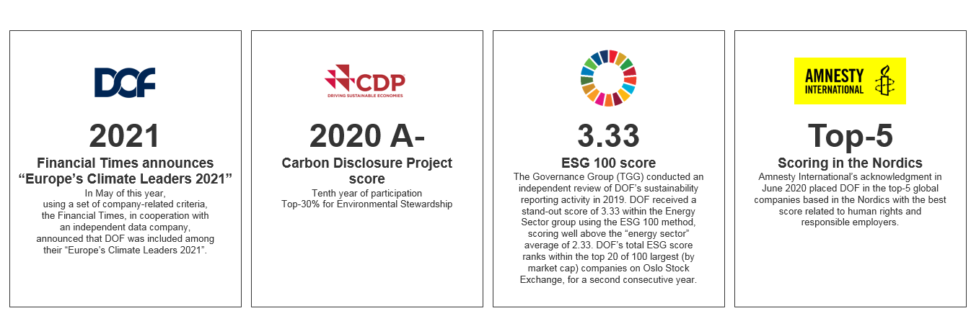
Figure 12 Sustainability Accolades (DOF ASA, 2021)

DOF has leveraged third-party sustainability accolades as a competitive differentiator for investors, clients and other stakeholders. Although this does not alter overall sentiment in the industry, it does make DOF a more attractive proposition within the market.

Analysis – Market and Technology

Risk: Alternative fuel and energy sources

Risk: Increased requirements on fleet for energy efficiency

Risk: Write-down of asset value

Opportunity: Development and commercial feasibility of emerging technologies

Opportunity: Diversification into new markets

Figure 13 Market and technology risks

The Technological Gap

Existing measures to reduce international shipping greenhouse gas emissions are primarily concerned with increasing the energy efficiency of vessels. The shipping industry will likely need to adopt alternative means of vessel propulsion to achieve more aggressive decarbonisation targets, as implied by Scenario 1 (OECD, 2018). Immediately, this presents a transition risk for DOF, as all existing vessels operate with Marine Gas Oil (MGO). However, this risk is shared by industry peers, as 82% of international shipping uses the same nonrenewable fuel source (International Maritime Organisation, 2021).

“The shipping industry will likely need to adopt alternative means of vessel propulsion to achieve more aggressive decarbonisation targets, as implied by Scenario 1” - OECD, 2018

IMO’s conservative emission reduction targets present less transition risk to DOF. Their emission reduction targets of 50% by 2050 are more aligned with Scenarios 2 or 3 but allow for a combination of ‘technological, operational innovation measures’ (International Maritime Organisation, 2019) (Figure 14). The more gradual implementation period gives time for DOF to incorporate unproven fuels and energy sources within their fleet (Figure 15).

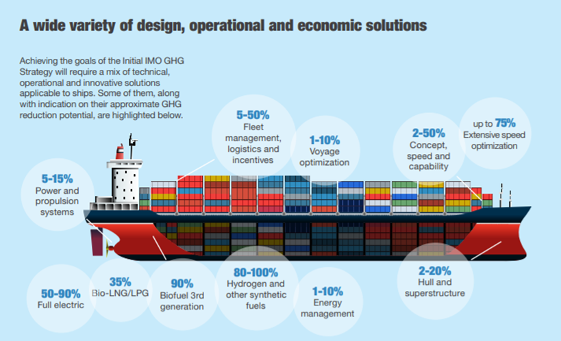

Figure 14 IMO GHG Reduction Solutions (International Maritime Organisation, 2019)
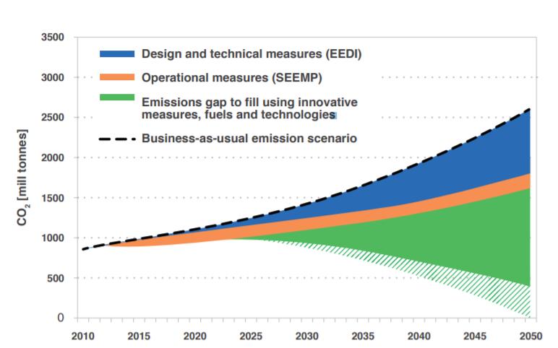
Figure 15 IMO Emission Goal Timescales

Stranded Assets

2020 was one of the worst years in history for the write-down of assets in the oil and gas industry, with almost USD 145billion in assets lost (Eaton, Colin, 2020). DOF faces similar financial risk in the form of stranded assets. Triggered by new technologies, regulatory or market changes, the lifespan of DOF’s fleet may prematurely end if it cannot remain economically viable (Market Forces, 2016).

DOF is particularly exposed to stranded assets because of the 30-year estimated ‘useful life’ of a vessel (DOF ASA, 2020) and high exposure to fossil fuel-related industries. Should there be a decisive move to a low-carbon economy, DOF’s assets will become stranded, having absorbed capital but unable to generate profit. With the implied energy transitions in Scenarios 1 and 2, company valuations in the industry could also be based upon reserves that cannot be extracted or used. This is known as the Carbon Bubble (Harvey, 2018), and could depreciate the value of principal energy companies by 40-60% (Ritchie & Dowlatabadi, 2015). This would have a knock-on effect for DOF, as most of its vessel utilisation comes from the same carbon-intensive clients and industry.

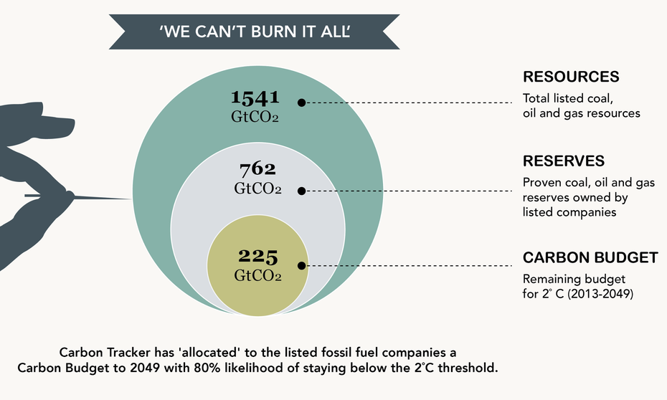
Figure 16 Oil and Gas Risk for Investors (Earley, 2015)

Alternative Market Opportunities

DOF has recently outlined six new strategic focus areas as part of their ‘One DOF for the Future’ campaign. One of which is to capitalise on growing demands in the offshore wind sector.

Within an aggressive ‘Sustainable Development Strategy’ such as Scenario 1, offshore wind could become the main component of the European energy mix in a short space of time;

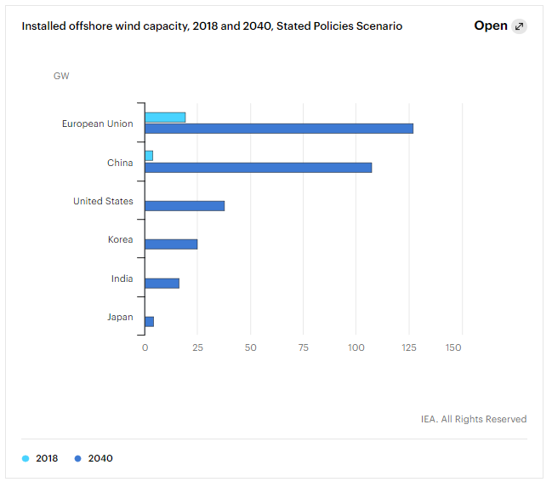

Figure 17 Offshore Wind Capacity, 2018 and 2040, Stated Policy Scenario (IEA, 2019)

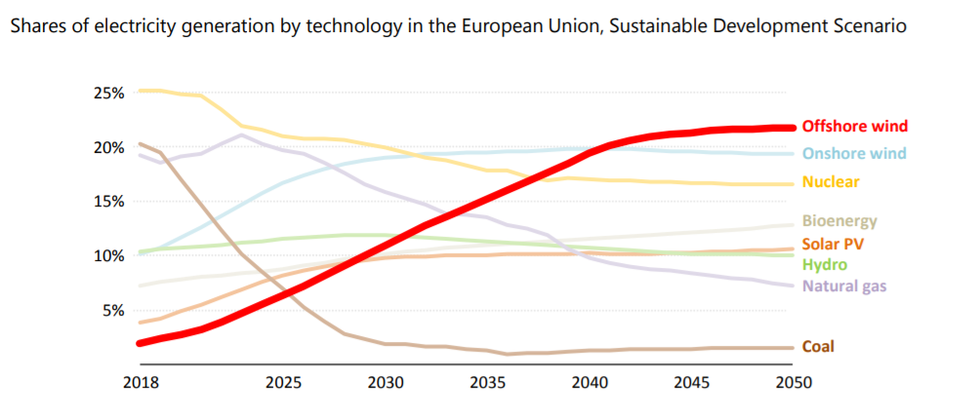
Figure 18 Offshore Wind as a component of a Sustainable Development Scenario in 2040 (International Energy Agency, 2019)
DOF’s diversification strategy recognises that despite some required CAPEX, it has few barriers to entry into the offshore renewable market. DOF already maintains a ‘cohort of asset, marine and subsea engineering competency in-house’ (DOF ASA, 2020) that can access opportunities in decarbonised markets. DOF actively seeks to use this type of diversification into ‘promising markets’ to manage its risk exposure within the changing landscape of oil and gas.

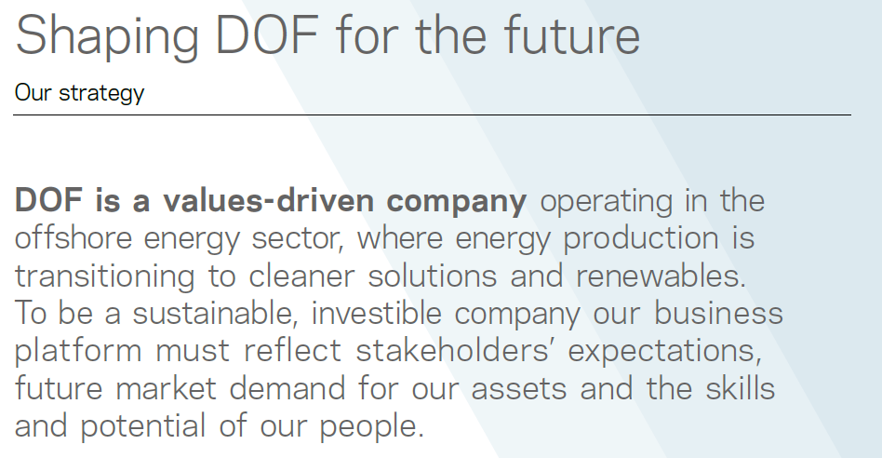
Figure 19 DOF; Our Strategy (DOF ASA, 2020)

Analysis – Reputational Risk

Reputational risk can be defined as;
“…any event that could damage stakeholders trust in and respect towards an organisation…” (OECD, 2020)

Within the 2020 Integrated Report, DOF identified ‘climate resilience’ and ‘climate impact’ as material concerns for their stakeholders Figure 20 (DOF ASA, 2020).

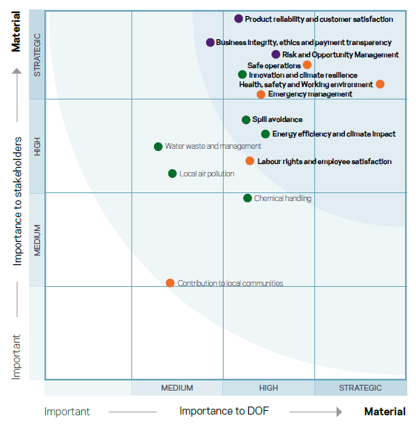
Figure 20 DOF Materiality Assessment

There is, therefore, significant exposure to reputational risk if stakeholder expectations related to climate change are not met. Figure 21 provides a sample of some strategically important stakeholders and examples of climate change expectations that may become the source of reputational risk;

Figure 21 Stakeholder Reputational Risks

Trust and Respect

As demonstrated in Figure 21, if the organisation loses the trust and respect of stakeholders, this can translate into a reputational risk for the organisation. As a result, DOF will become overlooked as an ‘integrated provider of subsea and marine solutions’ in favour of more virtuous organisations in the market. The impact is then seen on brand value, fragility and ultimately, financial performance.

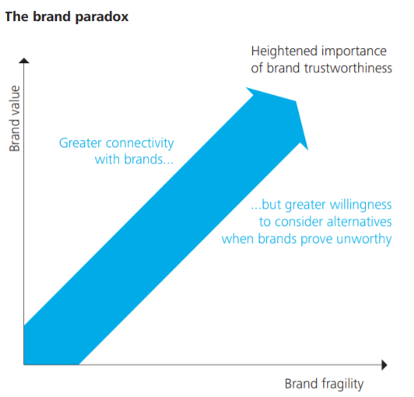
Figure 22 The brand paradox (Haidar, 2021)
Systems of governance within DOF seek to reduce the likelihood of stakeholder trust and respect being damaged. Reputational risks and opportunities are shaped in DOF’s best interests by promoting corporate values, robust governance and assurance processes, clear responsibilities and an emphasis on the triple bottom line in annual reports. This approach assures stakeholders that shared interests are being protected by DOF, and the potential for future reputational damage is mitigated by existing action.

Conclusion and Summary

The magnitude of climate change risk to DOF, its peers and the wider industry is high. Physical and transition risks associated with any of the applied CRS are vast and have the potential to disrupt every element of DOF’s Value Chain (Figure 23).

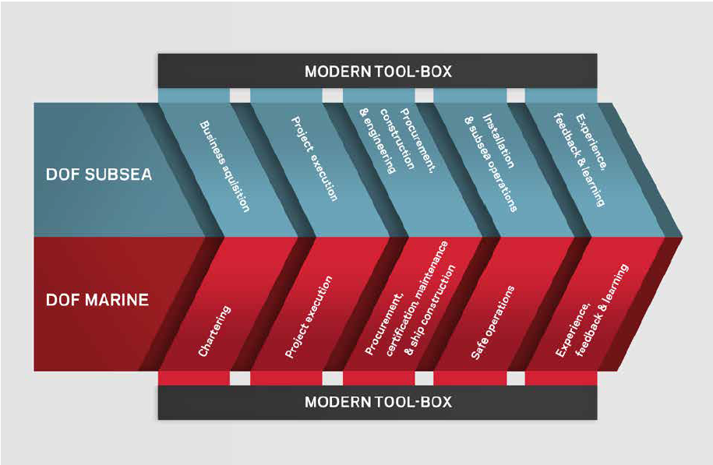
Figure 23 DOF Value Chain

This Report has illustrated some of DOF’s Climate Change vulnerabilities across the areas of:

Figure 24 DOF Climate Change Risk Types

As well as risk, climate change affords some opportunities to DOF.

This Report has outlined some sustainability initiatives, practices and processes DOF has deployed to manage climate change risk exposure and seize subsequent opportunities. This can be summarised into two areas;

Figure 25 Building Resilience
Figure 26 Reducing Exposure
Undoubtedly for DOF, the most daunting challenge is the decarbonisation of its fleet at the required scale and speed of ambitious climate risk scenarios. There is an evident technology gap for which neither DOF nor the wider industry have a commercially viable solution. This fact is at the centre of DOF’s sustainability problem and what DOF’s stakeholders are most concerned about. Regardless of other resilience-building or risk-reducing measures, DOF’s level of ‘sustainability performance’ will be ultimately defined by its speed and capability to transition its fleet away from fossil fuel dependency.
“Regardless of other resilience-building or risk-reducing measures, DOF’s level of ‘sustainability performance’ will be ultimately defined by its speed and capability to transition its fleet away from fossil fuel dependency”

Appendix A: Company Profile & 2020 Performance

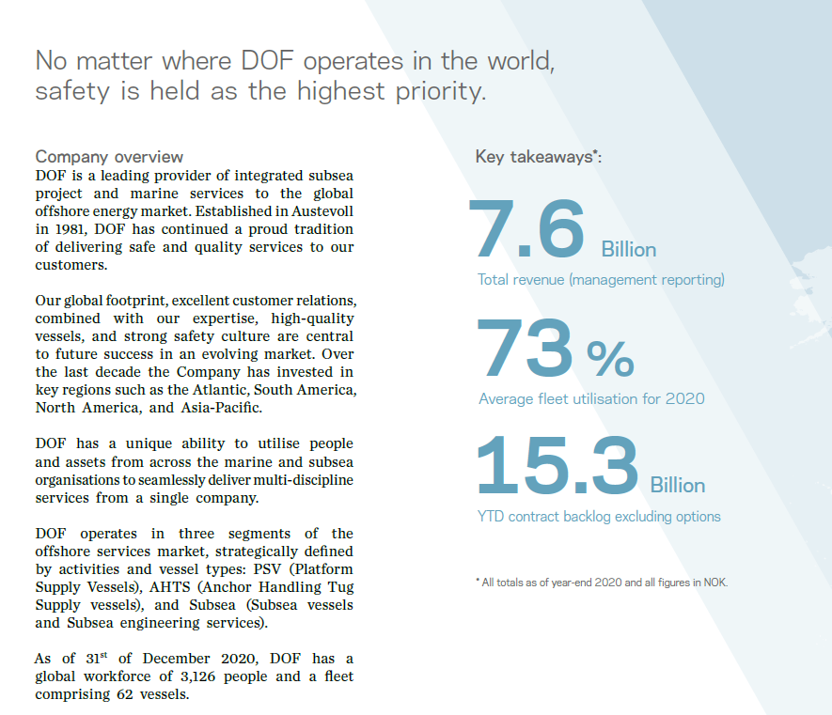
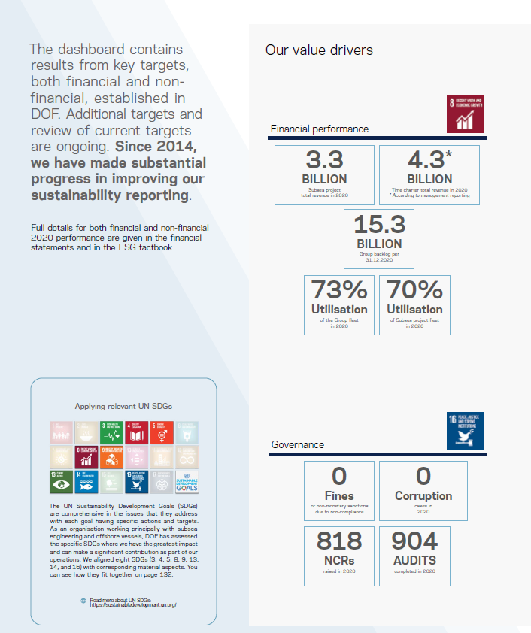

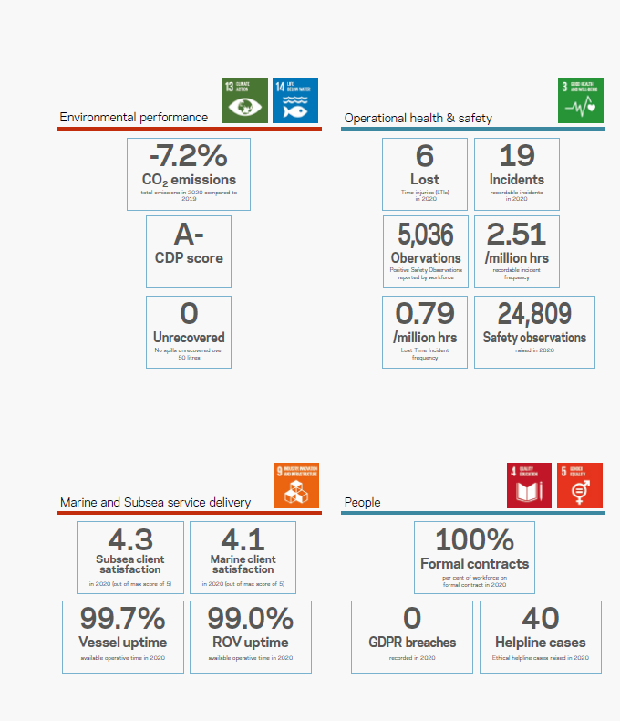

Appendix B: IPCC Climate Scenarios

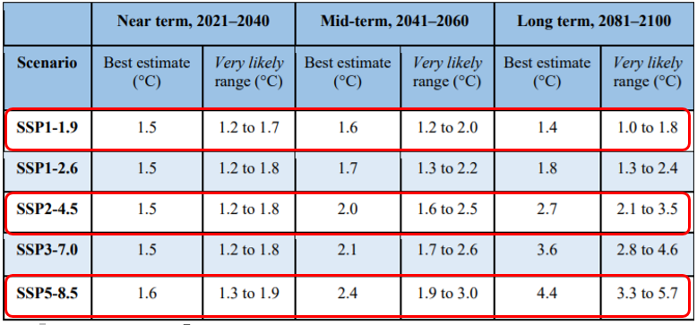
Figure 27 IPCC Climate Scenarios

References
Acclimatise News, 2017. Using scenarios in corporate disclosure of physical climate risk. [Online]
Available at: http://www.acclimatise.uk.com/2017/11/16/using-scenarios-in-corporate-disclosure-of-physical-climate-risk/
[Accessed 20 October 2021].
Climate Action Tracker, 2021. Addressing global warming. [Online]
Available at: https://climateactiontracker.org/global/temperatures/
[Accessed 23 October 2021].
Climate Action Tracker, 2021. International Shipping. [Online]
Available at: https://climateactiontracker.org/sectors/shipping/targets/
[Accessed 22 October 2021].
Cohen, A., 2019. What Will Our 2040 Energy Future Look Like?. [Online]
Available at: https://www.forbes.com/sites/arielcohen/2019/07/02/what-will-our-2040-energy-future-look-like/?sh=5528ea884433
[Accessed 22 October 2021].
Dasgupta, S., 2019. How the Ice Melting in the Arctic has Affected the Shipping Industry?. [Online]
Available at: https://www.marineinsight.com/environment/how-the-ice-melting-in-the-arctic-has-affected-the-shipping-industry/
[Accessed 22 October 2021].
Diakos, A. & Bisisidis, S., 2020. Financial risks stemming from climate change: “Challenging the degree of resilience into a constantly changing environment”. [Online]
Available at: https://www2.deloitte.com/gr/en/blog/risk-advisory/2020/financial-risks-stemming-from-climate-change.html
[Accessed 29 October 2021].
Dickson, D., Tilghman, N. & Bonny, T., 2020. The future of work in oil, gas and chemicals. [Online]
Available at: https://www2.deloitte.com/us/en/insights/industry/oil-and-gas/future-of-work-oil-and-gas-chemicals.html
[Accessed 1 November 2021].
DOF ASA, 2020. 2020 Integrated Report, Bergen: DOF ASA.
DOF ASA, 2021. Sustainability. [Online]
Available at: http://www.dofsubsea.com/investors/reports-and-results/
[Accessed 28 October 2021].
Doyle, D. H., 2021. A Short Guide to the EU’s Taxonomy Regulation. [Online]
Available at: https://www.spglobal.com/esg/insights/a-short-guide-to-the-eu-s-taxonomy-regulation
[Accessed 21 October 2021].
Earley, K., 2015. Carbon Tracker measures oil and coal risk for investors. [Online]
Available at: https://www.theguardian.com/sustainable-business/2015/apr/30/carbon-tracker-measures-oil-and-coal-risk-for-investors
[Accessed 30 October 2021].
Eaton, Colin, 2020. 2020 Was One of the Worst-Ever Years for Oil Write-Downs. [Online]
Available at: https://www.wsj.com/articles/2020-was-one-of-the-worst-ever-years-for-oil-write-downs-11609077600
[Accessed 30 October 2021].
Eaton, C. & McFarland, S., 2020. 2020 Was One of the Worst-Ever Years for Oil Write-Downs. [Online]
Available at: https://www.wsj.com/articles/2020-was-one-of-the-worst-ever-years-for-oil-write-downs-11609077600
[Accessed 23 October 2021].
EY, 2017. How can oil and gas fuel tomorrow as well as today?, s.l.: EY.
Faure, E. et al., 2017. Methods for assessing future scenarios from a sustainability perspective. European Journal of Futures Research, 5(17).
Femia, F. & Werrel, C., 2021. Agenda 2021: Prospects for Climate Security and Other Strategic Risks at the UN Security Council. [Online]
Available at: https://climateandsecurity.org/2021/02/agenda-2021-prospects-for-climate-security-and-other-strategic-risks-at-the-un-security-council/
[Accessed 22 October 2021].
Ghosh, S., 2021. Understanding Design of Ice Class Ships. [Online]
Available at: https://www.marineinsight.com/naval-architecture/design-of-ice-class-ships/
[Accessed 23 October 2021].
GOV.UK, 2021. UK to enshrine mandatory climate disclosures for largest companies in law. [Online]
Available at: https://www.gov.uk/government/news/uk-to-enshrine-mandatory-climate-disclosures-for-largest-companies-in-law
[Accessed 30 October 2021].
Haidar, C., 2021. Who’s trending what?, s.l.: Delloite.
Harvey, F., 2018. What is the carbon bubble and what will happen if it bursts?. [Online]
Available at: https://www.theguardian.com/environment/2018/jun/04/what-is-the-carbon-bubble-and-what-will-happen-if-it-bursts
[Accessed 30 October 2021].
IEA, 2019. Offshore Wind Outlook 2019. [Online]
Available at: https://www.iea.org/reports/offshore-wind-outlook-2019
[Accessed 30 October 2021].
IEA, 2021. Net Zero by 2050. [Online]
Available at: https://www.iea.org/reports/net-zero-by-2050
[Accessed 22 October 2021].
Intergovernmental Panel on Climate Change, 2021. Summary for Policymakers. In: Climate Change 2021: The Physical Science Basis, s.l.: Cambridge University Press.
International Energy Agency, 2019. Offshore Wind Outlook 2019, Copenhagen: IEA.
International Labour Organisation, 2018. The employment impact of climate change adaption, Geneva: ILO.
International Maritime Organisation, 2019. Initial IMO GHG Strategy. [Online]
Available at: https://wwwcdn.imo.org/localresources/en/MediaCentre/HotTopics/Documents/IMO%20ACTION%20TO%20REDUCE%20GHG%20EMISSIONS%20FROM%20INTERNATIONAL%20SHIPPING.pdf
[Accessed 30 October 2021].
International Maritime Organisation, 2021. Cutting GHG emissions from shipping - 10 years of mandatory rules. [Online]
Available at: https://www.imo.org/en/MediaCentre/PressBriefings/pages/DecadeOfGHGAction.aspx
[Accessed 21 October 2021].
International Monetary Fund, 2021. Working with its members, the IMF is managing the risks and opportunities of climate change, s.l.: IMF.
Market Forces, 2016. Stranded Assets. [Online]
Available at: https://www.marketforces.org.au/info/key-issues/stranded-assets/
[Accessed 30 October 2021].
Nelson, M., 2019. How climate change disclosures reveal business risks and opportunities. [Online]
Available at: https://www.ey.com/en_gl/assurance/climate-change-disclosures-revealing-risks-opportunities
[Accessed 22 October 2021].
Nelson, M., 2020. How can climate change disclosures protect reputation and value?. [Online]
Available at: https://www.ey.com/en_au/climate-change-sustainability-services/how-can-climate-change-disclosures-protect-reputation-and-value
[Accessed 1 November 2021].
Newell, P., 2008. Civil Society, Corporate Accountability and the Politics of Climate Change. Global Environmental Politics, Volume 8, pp. 122-153.
OECD, 2018. Decarbonising Maritime Transport: Pathways to zero-carbon shipping, Paris: OECD.
OECD, 2020. Forum on Tax Administration: Enhancing Reputational Risk Management, Paris: OECD.
Patowary, K., 2014. Towing Icebergs Away From Oil Platforms. [Online]
Available at: https://www.amusingplanet.com/2014/05/towing-icebergs-away-from-oil-platforms.html
[Accessed 23 October 2021].
Po, B., 2021. An ESG Reckoning Has Arrived For The Oil And Gas Industry. [Online]
Available at: https://www.forbes.com/sites/forbestechcouncil/2021/08/03/an-esg-reckoning-has-arrived-for-the-oil-and-gas-industry/?sh=3030981951fb
[Accessed 23 October 2021].
PWC, 2018. Getting started with climate scenario analysis. [Online]
Available at: https://www.pwc.co.uk/sustainability-climate-change/assets/pdf/getting-started-with-climate-scenario-analysis.pdf
[Accessed 29 October 2021].
Ritchie, J. & Dowlatabadi, H., 2015. Divest from the Carbon Bubble? Reviewing the Implications and Limitations of Fossil Fuel Divestment for Institutional Investors. Review of Economics & Finance, Volume 5, pp. 59-80.
Schmalensee, R. & Schoenbrod, D., 2021. Carbon Pricing Dashboard. [Online]
Available at: https://theconversation.com/the-oil-industry-says-it-might-support-a-carbon-tax-heres-why-that-could-be-good-for-producers-and-the-public-alike-156564
[Accessed 22 October 2021].
Steinberg, G., 2020. How a comprehensively sustainable approach reaches beyond compliance. [Online]
Available at: https://www.ey.com/en_gl/consulting/how-a-comprehensively-sustainable-approach-reaches-beyond-compliance
[Accessed 27 October 2021].
Stone, M., 2021. 5 possible climate futures—from the optimistic to the strange. [Online]
Available at: https://www.nationalgeographic.com/environment/article/5-possible-climate-futures-from-the-optimistic-to-the-strange?loggedin=true
[Accessed 23 October 2021].
Task Force on Climate Related Financial Disclosures, 2017. Recommendations of the task force on climate related financial disclosures, Switzerland: TCFD.
TFCD, 2020. Task Force on Climate Related Financial Disclosures: Guidance on Scenario Analysis for Non-Financial Companies, Switzerland: TFCD.
United Nations Environment Program , n.d. Fossil fuel subsidy reform. [Online]
Available at: https://www.unep.org/explore-topics/green-economy/what-we-do/economic-and-fiscal-policy/fiscal-policy/policy-analysis-3
[Accessed 22 October 2021].

