Introduction
The three words I have chosen are ‘Animation’, ‘Fantasy’ and ‘Belonging’. The reason I chose animation is because it has always been an integral part of my life; this is because animated shows have brought me up since I was a child. They have allowed to me connect and relate to new people of different backgrounds, allowing me to have a sense of belonging. Fantasy is another key part of my life as fantasy as it is tied with imagination and allowed me to create stories and designs that could not have been thought up otherwise. Finally, the reason I chose belonging is because it is a fundamental need that everyone should have fulfilled, and I feel that animation and fantasy are two topics that can be linked with belonging as they use belief systems and experiences as a way to create a unity within the story as well as in the real world.
Animation and fantasy go hand in hand, this is evident in the fact that many of the most popular and successful animated films and television shows are fantasy based. The Lord of the Rings is a fantasy-based novel which was later adapted into a successful live-action movie, animation with computer generated images were used and this allowed for the fantasy to become true. Animation and fantasy have always had the themes of friendship, kindness and family values, to name a few, this gives a sense of belonging, this transcends culture barriers. It is a very effective way of teaching children these key messages where more conventional forms of media wouldn’t appeal as much.
Animation
Animation, derived from the Lain word “anima” meaning soul or life, has come a long way from its early days of simple sketches. In the past, animation referred to the technique of creating moving images through hand drawn or stop motion methods.
Twenty-five thousand years ago, Early Modern Humans drew astounding drawings of animals they hunted. Their representation is accurate and superbly drawn. From early on, humans have had to need to show their experiences and imagination through drawing. Cave paintings were only the beginning. “Through all the centuries, artists continued to search for a medium for expression that would permit them to capture that elusive spark of life” (Thomas, Johnston, 1995, p. 1). In the 1800s, a new medium was born; motion picture cameras and the development of roll film, capable of projecting images, allowed for animation to be born. This medium allowed animators to break boundaries and make their dreams become reality and animators were not limited to just actions; emotions, feelings and inner fears could be portrayed using this form. ‘The Illusion of Life’ describes that live actors have an advantage as they can relate to and interact with others in the cast but with animation, animators have to come up with things out of thin air and have to consider how characters live, have chemistry and how they interact within their world.
“The years between 1981 and 1994 are considered the second Golden Age of animation” (Jones, Oliff, 2008, p. 8). In 1981, Walt Disney’s ‘The Fox and the Hound’ premiered. This was the last work of three animators from the ‘Nine Old Men’. Disney had named his key animators the ‘Nine Old Men’ after President Franklin Roosevelt’s Supreme Court’s nickname. Around this time, computer generated animation (CGA) was in its beginnings, just as the Nine Old Men were retiring. New artists such as Don Bluth, John Lasseter and Tim Burton were emerging with a new arsenal in their hands—CGA. Beginning the move to CGA, Disney created ‘The Black Cauldron’(1985), unfortunately, this movie made a financial loss at the box office, and they lost Don Bluth in the process.
2D animation fell into a slump until Roger Rabbit came onto the scene. Who Framed Roger Rabbit (1988) used 2D animation, Computer Generated Images (CGI) and visual effects to create what some might consider a masterpiece. Richard Williams (figure 1) was at the helm of the film—he was the creative mind—he directed and designed Roger Rabbit and Jessica Rabbit. Williams had begun animating at an early age—since he was 12 years old. When he grew up, he chose to turn to illustration and painting. He didn’t want to create art for rich industrialists’ wives and found the art world repulsive, but he didn’t know what the future had laid out for him or how arduous it would be. For his income, early on, he had to rely on TV commercials, which he despised initially. Richard Williams’ animation studio become a commercial powerhouse and created characters such as Tic-Tac breath mint detective. In order to complete his passion project ‘The Thief and the Cobbler’, Williams had to go through decades of work for hire, but in the end the animation was never completed.
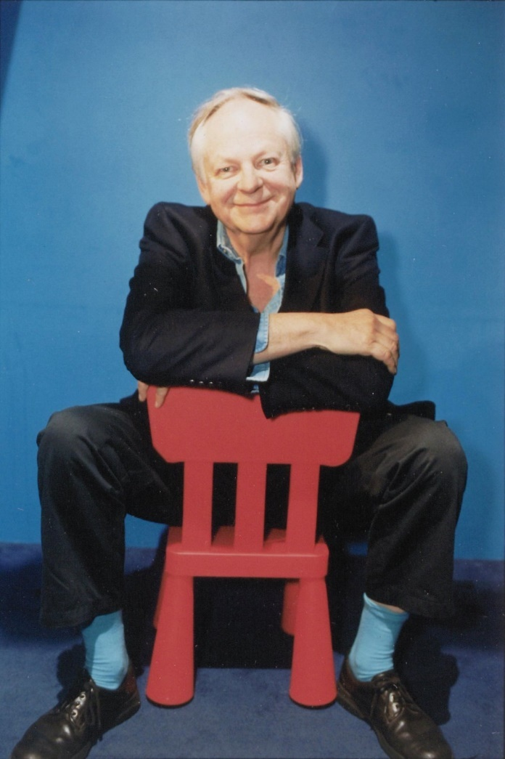
Figure 1
In 1984, restructuring in traditional animation studios brought about the first computer animated character—the Sexy Robot—used for a Superbowl commercial—this had a great impact on the film community but not as big of an impact as Toy Story (1995) the first well-known movie that was completely animated by CGI. Toy Story led the way for Pixar Studios to become a competitor to Disney, thus leading to Disney buying out Pixar and gutting its animators and skills to produce 3D films in Disney’s name. After that, using Pixar’s skills, they created Frozen (2013). Frozen was the highest grossing Disney animated movie of all time, before Frozen 2 (2019) came along, making $1.28 billion. CGA movies are now a prominent medium and has become the normal for the newer generation.
Fantasy
The word ‘fantasy’ is derived from the Greek word ‘phantasia’, which means imagination or appearance. This has been a key part of human nature since time began; it has allowed us to form a multitude of cultures, ideologies, beliefs and it could be argued that this is what makes us different from animals. In the past, fantasy referred to mythical tales and folklore but now with the emergence of new technology and digital media, fantasy has become a genre that encompasses various forms of artistic expression such as literature, film and animation.
In literature, fantasy has a rich history, dating back centuries. Works such as The Arabian Nights, The Odyssey and Pandora’s box are examples of early fantasy literature. These are only a few of the stories that have forged the way for new and more fantastical stories. ‘Lord of the Rings’ (2001) is a modern fantasy story that has continued to inspire readers and get them to use their imagination. J. R. R. Tolkien looked to Norse mythology when it came to naming creatures, place names and races. He used his imagination to create full, useable languages. For example, the elvish language is based on the Welsh Language. He thought up a large portion the story while he was in the trenches in World War One before he was taken back to the UK with trench fever. Tolkien wanted to replace religion with a world full of hope because of what he had experienced and how good can triumph over evil, instead of simply living in fear of what’s to come. In the movie CGI and practical effects are used, this might be why the movie’s visuals still hold up, to this day, even after 20 years. The motion capture technology they used to record Andy Serkis’ performance as Gollum pushed boundaries when it came to CGI. Balrog, another character in the movies was animated with CGI, it was very complicated to do so special effects were used in order to mask its imperfections. Lord of the Rings was one of the first (medieval) fantasy films that made money, it made over $870 million compared to its production cost of $93 million. The Lord of The Rings paved the way for other big budget fantasy films such as ‘The Lion, the Witch and the Wardrobe’ (2005).
Fantasy is one of the dominant modes of storytelling; it conveys our emotions, such as anxieties and longing. “Fantasy is a lie that speaks truth” (Attebery, 2022, p. 9–C1.P3). Attebery explains that fantasy tells truth in a subversive and more interesting ways. He talks about how fantasy can be true in three ways; it can be mythically true—true to traditional beliefs and narratives that have been long understood. The second way fantasy can be true is metaphorically—for example in The Lord of the Rings, the Hobbits are considered the weakest race, because of that they are able to save the world. This shows that no matter how seemingly insignificant you are, you can still make a big difference, if you’re willing to put your mind to it. Thirdly, fantasy can be structurally true; this could mean “the shape of the world, and especially the shape of change. Such change can be reflected in the grammar of the titles” (Attebery, 2022, p. 9–C1.P11).
Belonging
Belonging is a fundamental human need. In the past, ‘belonging’ may have been associated with someone’s class within a social hierarchy; poor people in the past would not have been able to relate to rich people as there was such a wealth disparity. In modern times, belonging and acceptance can be created with experiences such as TV shows or buying certain things such as name brand items like Gucci bags.
Maslow’s hierarchy of needs (figure 2), specifically the third tier, dictates that love and belonging is needed in order to have self-actualisation. “Humans are social creatures that crave interaction with others” (CFI, 2023). Humans need a sense of belonging as this decreases the chances of experiencing loneliness or depression. Friendship and family are two relationships that create a sense of belonging. Social ties that are associated with a sense of belonging help manage stress and other behavioural issues.
Maslow’s Hierarchy is useful to marketers because it gives a guide as to what needs should be met in order for a customer to do what they want, whether it be to buy something or do something. In advertising, images and portrayals of babies and puppies, for example, are used to evoke strong emotions like wanting to be attached and loved. These are subtle ways in which advertisers use the need for love and belonging to their advantage.
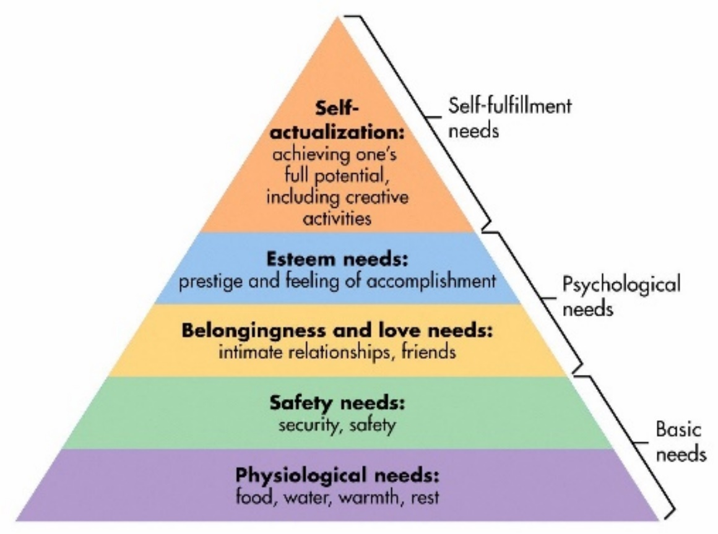
Figure 2
When we are born, we form an attachment to the caregivers—this is the first sense of belonging we experience, if at all—the beginning of our journey for belonging. Research has been conducted by John Bowlby (1958) and Mary Ainsworth on the attachment theory, it has shown that children that do not have a secure attachment to their mother in their early years of life are more likely to be affected in the future (Ainsworth, 1979, pp. 932-937)—they find it more difficult to form relationships in the future and therefore do not have as much of a sense of belonging as people who have a secure attachment.
A meta-analysis was conducted and came to the conclusion that belonging as a “feeling of value and respect derived from a reciprocal relationship … that is built on a foundation of shared experiences, beliefs or personal characteristics” (Mahar, Cobigo, Stuart, 2012, pp. 1026-1032). This shows us that a sense of belong is created and not something that can happen out of thin air.
Animation and fantasy, as an artistic expression, have played a role in exploring and depicting the themes of love and belonging through storytelling and visual elements. Animated movies like How to Train Your Dragon (2010), figure 3, also explores the theme of belonging. At the start of the movie, the main character wants nothing more than to fit into the Viking clan. One way he tries to fit in is by trying to kill a dragon, but he finds that he cannot do it. He finds his own way to create a rapport with the dragons, specifically Toothless, by having a mutual feeling about not belonging to their respective groups and accepting their differences. The animators used the way he looks—small and skinny, compared to the large and robust looking Vikings—and acts to create estrangement from the other characters. Instead of trying to fit in with the rest of the Vikings, Hiccup finds his own sense of belonging that changes the way other people think, thus leading to the other Vikings taking initiative to change and become like him, therefore leading to Hiccup’s love and belonging needs being met. Especially when he sacrifices himself, his needs are met by his caregiver—his father—as he finally accepts him.
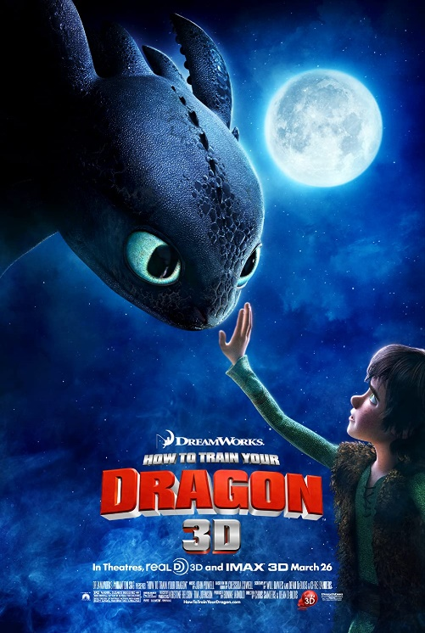
Figure 3
In conclusion, ‘animation’, ‘fantasy’ can be connected to create worlds can create a sense of community and ‘belonging’ for fans of various mediums such as films and literature. Animation provides a medium in which fantasy is explored. fantasy provides fantastical as well as more grounded elements that make animation more interesting and allow the audience to connect with it at a deeper level. One of the key elements of The Lord of The Rings trilogy that make it so popular is its combination of the fantastical and the real. It uses stunning visuals and an immersive story to draw you in, utilising realistic motivations and empathetic characters to make the story feel real enough that it could have happened. Belonging can also be created through the ‘fandom’ and community that surrounds it. The Harry Potter series by JK Rowling has created a vast and devoted fanbase through its books movies and spin off media. The magic world of Hogwarts and its characters allow fans to feel a sense of belonging to the wizarding world community, this is where they can interact with like-minded individuals. Animation and fantasy can also provide representation for minority groups, this can create a sense of belonging for those who feel marginalised. For example, Steven Universe, created by Rebecca Sugar, has been praised for its positive LGBTQ+ characters and themes. The show conveys themes of love, acceptance and inclusion. This creates a sense of belonging to the LGBTQ+ community as they share the same experiences and values. These three words are intertwined as they all provide a sense of community and belonging for the individuals who immersed themselves in these fictional worlds. Animation as a medium and fantasy as a genre can create devoted fan bases and provide representation for marginalised groups and create a community for those who feel isolated in real life.
Bibliography:
Acuna, K. (2020) Why Disney keeps remaking so many of its animated movies, Insider. Insider. Available at: https://www.insider.com/why-disney-keeps-remaking-animated-movies-2020-5
Ainsworth, M. S. (1979). Infant–mother attachment. American Psychologist
Attebery, B. (2022) Fantasy : how it works. First edition. Oxford, England: Oxford University Press.
Bretherton, I. (1992). ‘The origins of attachment theory: John Bowlby and Mary Ainsworth’.
Cavalier, S. (2011) The world history of animation. Berkeley: University of California Press.
CFI TEAM (2023) Maslow's hierarchy of needs, Corporate Finance Institute. Available at: https://corporatefinanceinstitute.com/resources/management/maslows-hierarchy-of-needs/
Garth, J. (no date) Tolkien fantasy was born in the trenches, Tolkien Fantasy was born in the trenches, by John Garth. Available at: https://johngarth.co.uk/php/tolkien_somme_standard.php
Hay, H. (2018) Disney to acquire Pixar, The Walt Disney Company. Available at: https://thewaltdisneycompany.com/disney-to-acquire-pixar/
Holmes, J. (2006) John Bowlby and Attachment Theory. First edition. Boca Raton, FL: Routledge.
Holzknecht, J. and Holzknecht, J. (2007) Maslow’s Hierarchy of Needs. Austin, TX: Castalia Media.
Jones, A. and Oliff, J. (2008) Thinking animation: bridging the gap between 2D and CG. Boston, Mass: Thomson Course Technology.
Mahar, A. Cobigo, V. Stuart, H. (2012) Conceptualizing belonging. Taylor & Francis Online.
Osmond, A. (2019) Richard Williams Obituary: A half-hidden animation master: Sight & sound, British Film Institute. Available at: https://www2.bfi.org.uk/news-opinion/sight-sound-magazine/comment/obituaries/richard-williams-animation-master-roger-rabbit-thief-cobbler
Published by Statista Research Department and Statista (2023) Lord of the rings: Production costs and global box office revenue 2017, Statista. Available at: https://www.statista.com/statistics/323463/lord-of-the-rings-films-production-costs-box-office-revenue/#:~:text=%27The%20Fellowship%20of%20the%20Ring%27%20was%20met%20with%20critical%20acclaim,just%2093%20million%20U.S.%20dollars.
Rowan, S. (2018) Harry Potter Fandom and Participatory Culture and the Social Value of an Architectural Icon. Palgrave Macmillan, Cham.
Theisen, A. (2022) Is a sense of belonging important?, Mayo Clinic Health System. Mayo Clinic Health System. Available at: https://www.mayoclinichealthsystem.org/hometown-health/speaking-of-health/is-having-a-sense-of-belonging-important#:~:text=The%20social%20ties%20that%20accompany,difficult%20times%20in%20our%20lives.
Thomas, F. and Johnston, O. (1995) The illusion of life: Disney animation. 1st Hyperion ed. New York: Hyperion.
Movies:
Frozen. 2013 [Film]. Jennifer Lee and Chris Buck. USA: Disney
How to Train Your Dragon. 2010 [Film]. Directed by Dean DeBlois and Chris Sanders. USA: Dreamworks Studios
Lord of the Rings. 2001 [Film]. Directed by Peter Jackson. New Zealand: New Line Cinema
Toy Story. 1995 [Film] John Lasseter. USA: Pixar
Images:
BFI National Archive (2019) Richard Williams, BFI. Available at: Osmond, A. (2019) Richard Williams Obituary: A half-hidden animation master: Sight & sound, British Film Institute. Available at: https://www2.bfi.org.uk/news-opinion/sight-sound-magazine/comment/obituaries/richard-williams-animation-master-roger-rabbit-thief-cobbler (Accessed: April 20, 2023). (Accessed: April 20, 2023).
Mcleod, S. (2023) Maslow's Hierarchy of Needs, Simply Psychology. Available at: https://www.simplypsychology.org/maslow.html (Accessed: April 20, 2023).
How to Train Your Dragon (2010) IMDB. Available at: https://www.imdb.com/title/tt0892769/mediaviewer/rm2210040832/?ref_=tt_ov_i.

