Critical Review

Joseph Long

3D Computer Animation
Scott Smith
30/04/2018

This essay is a critical review of my work and experiences within CG and the 3D Animation course with the focus on modelling and with reference to a few inspirations that helped along the way.

Hard surface modelling
When I university, I had little experience with creating any form of 3D work, but I had created a couple of 3D props prior to starting university as well as a 2D flash animation, but that’s about all the experience I had. Considering this, I was quite lost to begin with and hadn’t much of an idea what I wanted to do. Though I knew that I wanted to be a part of the CG or Games industry, I wanted to be a part of creating the stunning visuals seen throughout many of these platforms.
The first module was creative practice 1, in this the brief was to create a poster based on a novel/story. I was part of a group, that consisted of myself, Michal, Kane and Gareth. As a group we decided to create the poster based off of the sand man, we used many different sources and renditions of the sand man but the one that stood out the most was Neil Gaiman’s story. From this we decided what we would create which lead me to modelling my first part of a character and props that I also textured. As I wasn’t confident in using may and other 3D software along with two other group members we decided it was best for the most experienced of us who was Gareth, to create the assets that were the most important to the scene, such as the Sandman himself. However, I wished to push myself somewhat to improve my skills in 3D and to force myself to learn more about the software itself, so I volunteered to take up the modelling of the child’s head that would also feature within the poster along with some more complicated props for the scene.
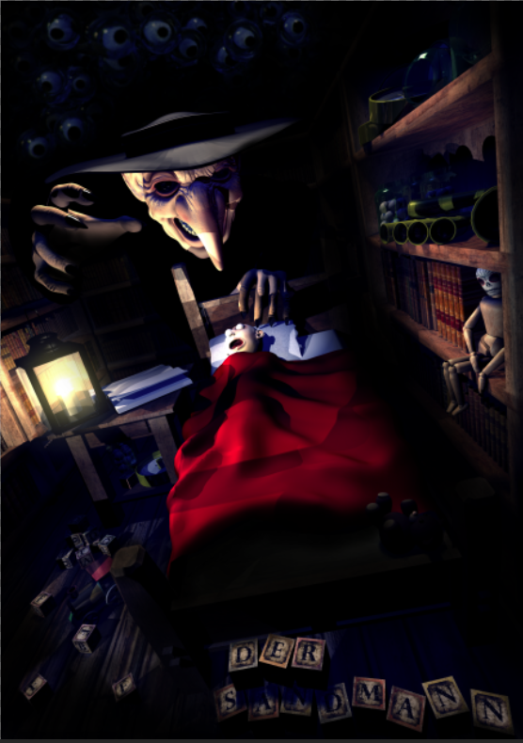

Modelling assets for this where I found my enjoyment for general modelling but was still unsure what career path I wanted to take specifically. However, there were plenty of assignments to make this possible to explore and discover what I had a passion for.
Production practice 2 took place in the second term, this also required us to be as a group however, we were grouped with the games course on this one, my group consisted of four. Another from my course and two from the games course. For the assignment itself, we set the project ourselves and our group decided that we wanted to create an animated introduction to a boss fight for a game.
During this time, I was interested in environmental modelling, so I was given the task of creating two environment sets one was an interior, this was where the battle was to take place and the other an exterior where the animation would start, showing our character enter the arena space. Creating the interior was relatively simple as it wasn’t complex, and it relied mainly on the textures, but the exterior was the hardest. I sculpted a glacier with a ribcage leading to the entrance, but when doing this I hadn’t considered issues that would take place concerning normal maps and UV’s, this was because at this point I hadn’t learnt much about them or anything about retopology. This meant I hadn’t created correct topology which was the root of a lot of problems I had later in the project such as being un able to UV the sculpt manually as there was just too many edge loops so I had to use Zbrush’s automatic unwrapping that created the best UV’s I could have got out of the topology, though this resulted in the UV seams being quite visible in the renders.
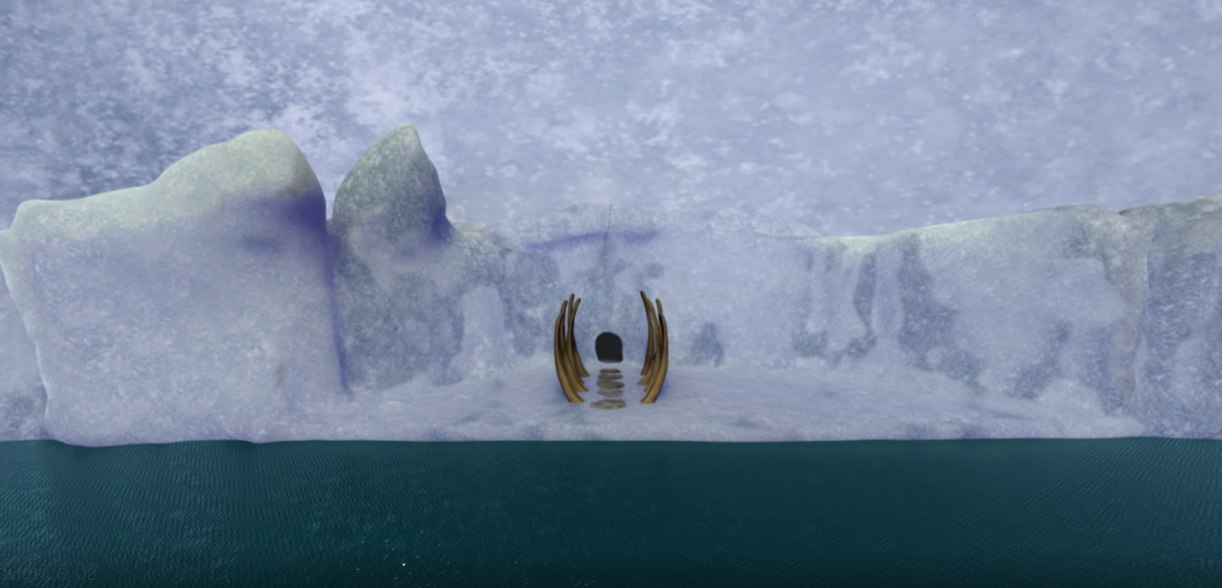
Though the project didn’t end how I or the group wished it too, a lot was learned from mistakes made which has helped develop my abilities in multiple aspects such as modelling and texturing, which introduced me to using substance painter that peaked my interest more in texturing as I enjoyed using the software with ease rather than struggling to find and paint good textures on on within other software such as mudbox which though it is fairly decent, it is quite a basic piece of software. Working on group assignments has given me valuable experience in being part of a team, the difficulties that can occur whilst trying to manage them and how to deal with these difficulties. However, not all issues can be solved and can sometimes depends a lot on who is part of that working group and their work ethics. As a result, improving upon my own work ethics has become an important aspect to increase employability and productivity, this is done through creating schedules, creating a decent work flow and constantly practicing skills that are needed for CG work, improving them and making myself more efficient.
There is one project that turned out quite well during my second year of university, this was due to the team working well with each other. The project was to create a sort of mind palace with basic information of the human bones that could be used to help educate someone, but the way we decided upon was to create it as a playable environment within UE4 so the user could have complete control over where they explored.
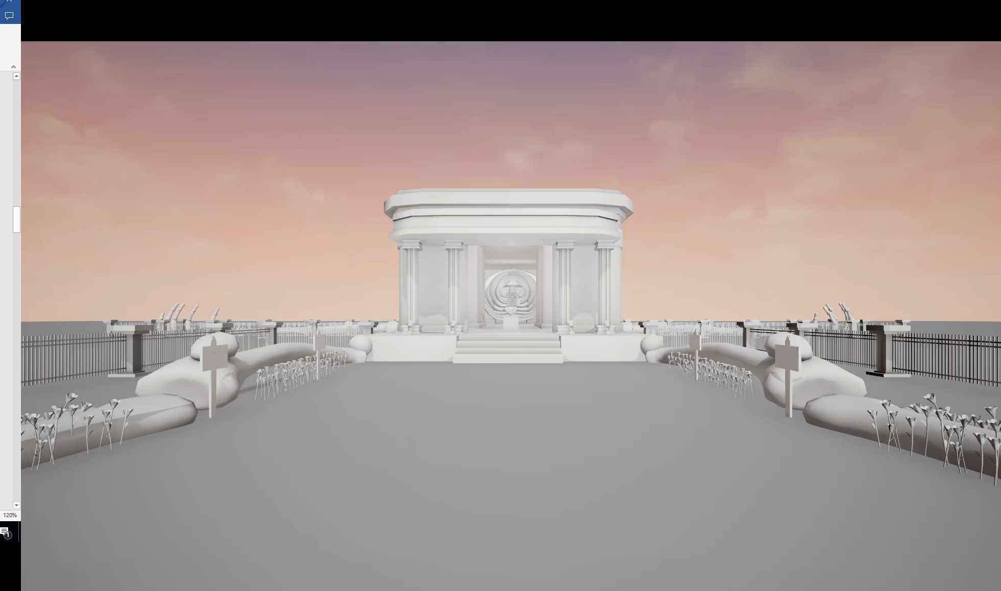
The initial intention was to design the game to be playable within VR however, we could not find access to any sort of VR kit making this difficult to do but we believe it can be used with a VR headset itself however there would be no motion controls and possibly no head tracking.
Using a game engine was a new challenge for myself as I was the person in charge of setting up the UE4 scene and setting as well as partaking in modelling accurate bones for the character such as the rib cage and arms. It was the first time I had working within UE4 which at first was daunting however, I had learned quickly how to navigate and how to make some changes to the code to enable or disable certain aspects and features of the engine. As there was a time restraint we didn’t have time to learn how to and set up a first-person camera that could be controlled with a controller, which pushed us to using a default camera that turned out to have a gun that fired large yellow balls. After finding this out it lead me down a rabbit hole which lead me to learn how to make some changes to the code, but that created errors as the game would still look for the gun. After getting some advice from a peer on the games course, I had gone back and learnt how to use the nodes within unreal that allowed a good amount of control to a user who doesn’t know how to code such as myself, which allowed me to disable the gun and the sounds it made whilst keeping the controllable camera.
Working within UE4 is where I learnt to push myself and take risks, if this wasn’t done and we stayed within the comfort zone of just using Maya then this small game wouldn’t have been made and the ideas of possible projects that myself and Matt, my other group member [at the time of the project] could work in in the future would not exist. The project has inspired me to want to work on more projects within game engines and VR and play around with what storied can be told through this technology as it brings the user a lot closer to the experience as they interact with it directly.
Being around many creative people has helped me push my own creative boundaries and improved not only my skills as an artist but also my story telling, through feedback and conversations with peers I have been able to think more creatively and understand more of what creates a good story. This has applied for both writing and visual storytelling, for example I now have better ideas of composition, character development and character motivation, all of which are important aspects of creating a visual story or a written one.

Organic modelling
The many issues that were encountered whilst working on all previous projects helped in avoiding them occurring again in later projects that could possibly cause a large amount of damage to progress and the visuals, especially when it came to create more complex work such as organic models.
At first, I hadn’t found much interest in organic modelling of any kind until receiving an assignment in the first year of university to model a character of our own design within Zbrush. Being influenced the film ‘Blade Runner’ (Scott, 1982) I designed a detective character with the cliché suit with a hat and trench coat to be modelled within Zbrush.

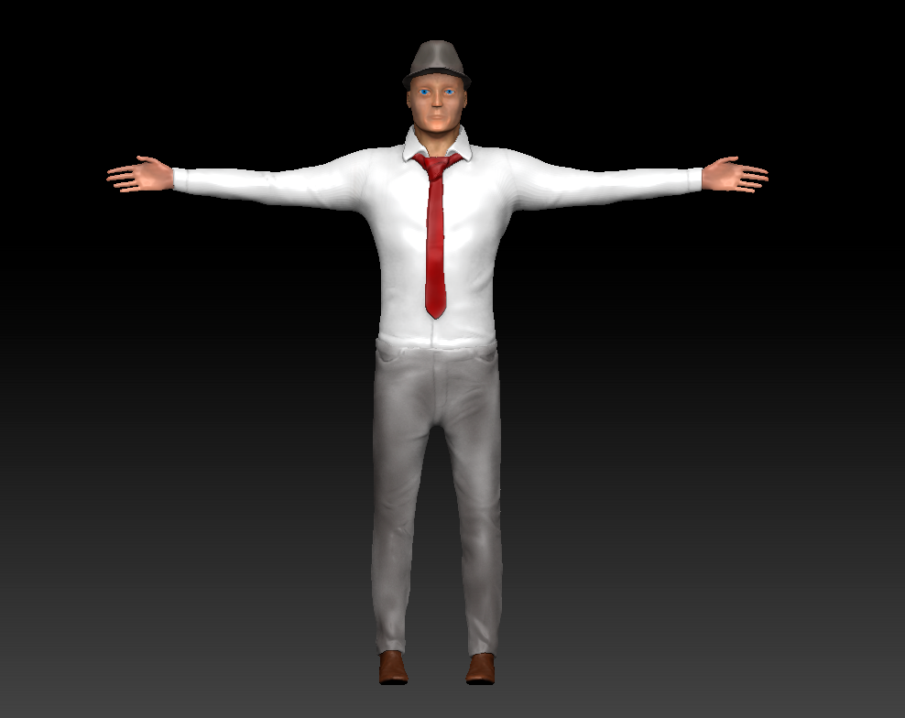

As seen the trench coat didn’t get modelled though it was attempted, I had yet to gain enough knowledge on how the coat would be modelled correctly this meant that modelling it caused too many issues to be able to be dealt with at the time as it was also running close to the submission date. Whilst modelling the characters body and clothes I ran into difficulties trying to create them to look somewhat real. This brought the realisation of the importance of using reference to enable higher detailed models as well as making the model look accurate such as muscle shape and placement as well as smaller details like where the seams are on clothes. Though it wasn’t put into practice very well with this first character, I learnt that even adding small details that may go unnoticed can make a character so much more interesting and alive.
The clothes were modelled though ‘extracting’ the mesh beneath by masking the desired areas, creating geometry that matched the area which I then modelled into the clothes. This was the way the class was advised to model clothes for our characters by the lecturer who handed out the assignment, however the task was also to rig and pose the character but to do this would have required the geometry underneath to be removed for this to work. This knowledge was found as when importation into maya was attempted the clothes and body were not able to be skinned to one rig at the same time, so instead the character was rigged and posed within Zbrush. For it to work within maya it would have required to simulate the cloth, something I have yet to experience due to time restraints on assignments, but this would be good to try out.
To texture this character and to keep it within Zbrush I decided that I was going to use poly painting. Though this is a good method of texturing it requires the mesh to have a large poly count to enable the texture to be of good quality. I had yet to learn how to reduce the poly count, so this was the best option at the time. This problem pushed me to learn more about retopologising when it came to model the character for my ‘3D Film making’ project titled ‘Fray’.

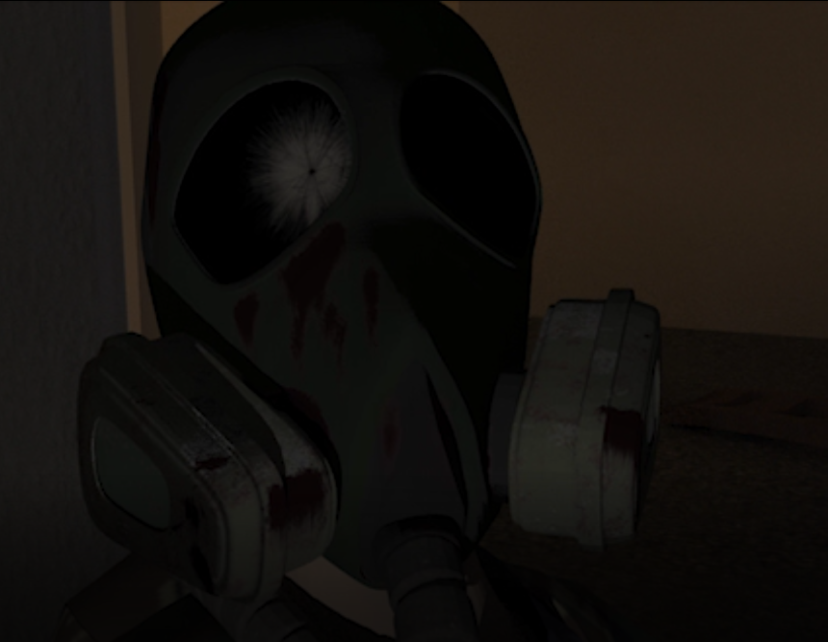

As the characters face/mask would have quite an extreme closeup I had to ensure the UV seams were hidden well to avoid being seen. Working on ‘Fray’ and an animation assignment lead to a few lessons learnt and helped me decide what career path I would like to take. Knowledge gained during the experience includes Zbrush skills. These were improved greatly through experimenting with the different tools to attempt to create styled models.
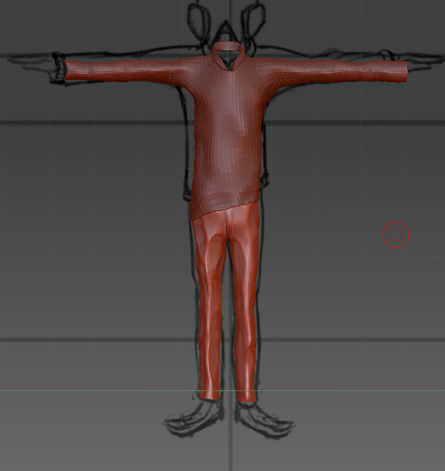

Looking back at this one, it looks a bit more appealing than the resulting model for what the character was however during the time of making the short, a realistic design was more desirable for myself. To create realistic looking clothing, I used a trial of Marvellous Designer, the result was as close as I could get it to what I wanted however, getting this into maya was a difficult task to which I then had to retop to create animatable geometry and to be able to UV it so normal maps could be made, vastly reducing the amount of poly’s too making the geometry much friendlier to maya.
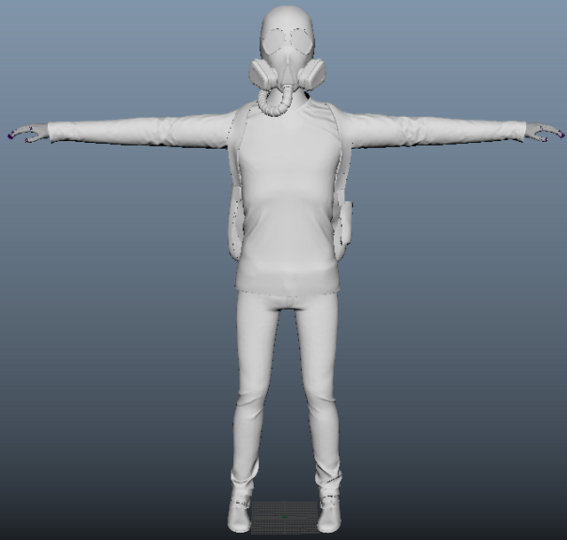

The final product wasn’t what I desired which is due to issue I had created myself, as seen the characters limbs were not correctly proportioned that resulted in making it not look like a child as well as causing some rigging issues. These issues cause during rigging as well as the time and effort put into making the rig pushed me away from rigging as it caused too much stress for something I didn’t enjoy doing. As my knowledge on rigging is limited the problems were seemingly happening for no reason, this is something I must improve on more to help on future projects even if it enables me to improve basic rigs then that will also improve the animation.
Around the time of the ‘Fray’ project the SAND event took place, this is when I had the chance to take part in a character sculpting master class with Ryan Morgan, an ex-student of the university who worked on ‘Guardians of the Galaxy’ (Gunn, 2014) someone who I took inspiration from. From talking with Ryan after the master class I understood better the importance of the many things that go into being a good character modeller, such as learning anatomy and strong poses as well as an idea how to gain some interest from industry professionals. This lead me onto wanting to be a character modeller for the major project, during which I had used skills I learnt from past experiences and the master class.
From the advice given to me I had learnt more of what the muscles on the human body should be shaped like, allowing the creation of a more accurate and realistic character. I was quite proud of the model, although a lot of the detail was lost during the process of creating normal maps due to some strange complications caused during using Zbrush to cut up the character geo so there would be just the parts of the character that was not covered by clothing to avoid rigging issues later as before hand the team had decided that simulating cloth would take too long to render for what we wanted.

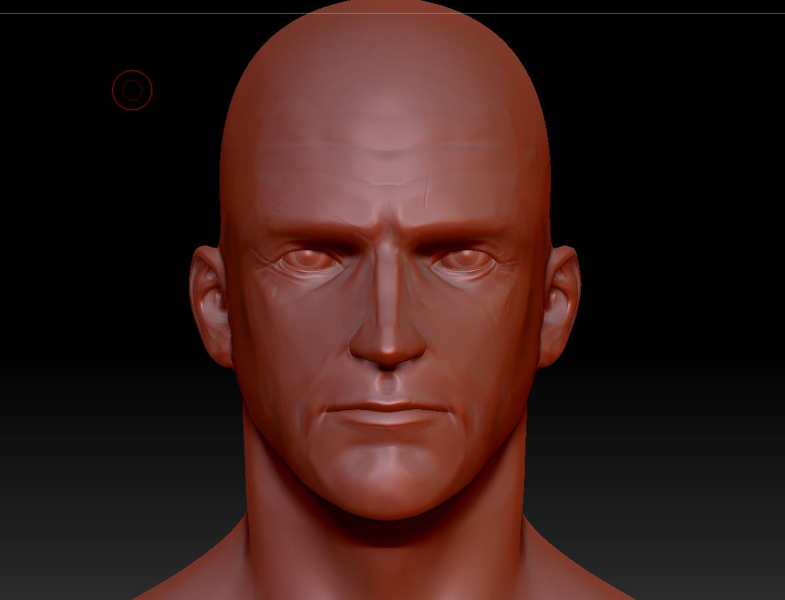
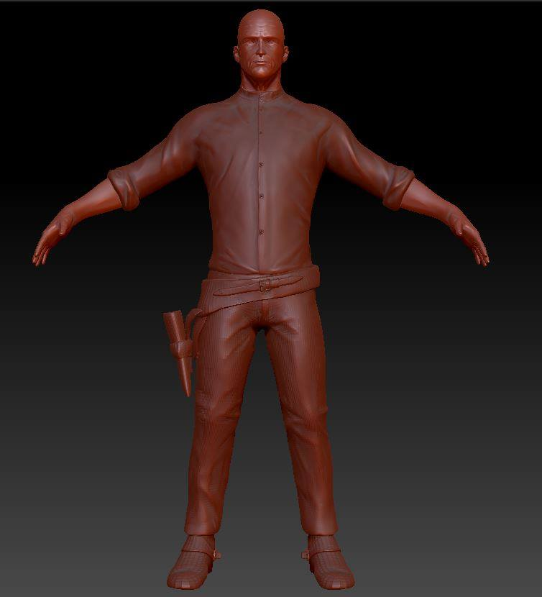
While sculpting there was an attempt to input some more character, trying to show he is older and experienced and almost tired of day to day life. Originally intended to suit the short I had written, based in the time that the west was coming to an end. When I began writing this story I was watching westerns and films alike, seeing the differences between a romanticised views of the west in films such as ‘Stagecoach’ (Ford,1939) and other Hollywood westerns however there was a difference between those and although still Hollywood, Quintin Tarantino’s films such as ‘The hateful Eight’ (2016) and ‘Django Unchained’ (2013) didn’t make a characters deaths a big deal, he made them dramatic but not a big deal to the story. Quintin had no problem killing off any character, this made me realise that death wouldn’t have been a big deal in the west so I wanted to write a story that emphasised that and how sudden it could be no matter who you are as well as the fact that there were no ‘good guys’, it was everyone for themselves.
The script and story became something I wanted to make and that is how pre-production came in as well as some good ideas flowing between myself and Sean, who was the only other group member at the time. After some time and some more added members to the group we were well on our way to creating the short, then a lecturer saw the animatic for the third time which was late into the project and had some issues with the lack of drama and excitement. The rest of the group agreed with this and I didn’t want to lose any marks which left little choice and ended up changing the story completely, and the story became something I didn’t wasn’t and was trying to do the opposite and not follow the usual convention for westerns and Hollywood films, though as the project went on I still had passion for it and liked it but still prefer if it was how it was written in the first place as did some peers. A valuable experience, that not everyone is going to like what you create but that doesn’t mean that it’s bad. Perhaps the original script and story will be revisited and revised later but the project has been enjoyable in most aspects, particularly modelling and animation in which I have applied and gained valuable skills such as now being able to create a good set of UV’s for a character by hand rather than just using an automatic unwrap which would usually lead to poor UV’s allowing seams to show and well as inconsistent texture resolution.
Overall the experiences gained through working on multiple CG projects has given me valuable lessons that have continued to improve my work, including problem solving skills and people skills, learning how to approach the issues and figuring out ways to solve them. Each project has lead me towards becoming a character modeller and animator although I have not been able to write about animation during this essay it is something I enjoy and have learnt just as much as character modelling.

References

Blade Runner. (1982). [film] Directed by R. Scott. United States: Warner Bros.
Django Unchained. (2013). [film] Directed by Q. Tarantino. Unites States: The Weinstein Company.
Guardians of the Galaxy. (2014). [film] Directed by J. Gunn. Hollywood: Marvel.
Stagecoach. (1937). [film] Directed by J. Ford. United States: United Artists.
The Hateful Eight. (2016). [film] Directed by Q. Tarantino. United States: The Weinstein Company.

