Level 5 Diploma in People management.
5C002 Evidence Based Practice
Q1. Evaluate the concept of evidence-based practice (EBP) and provide two examples of where Technivara could use it to ensure sound decision making in people practice (AC 1.1)
Evidence-based practice is a decision-making approach that relies on data, research, and analytics to support well-informed and balanced choices. ‘Evidence-based practice is about making decisions through the conscientious, explicit and judicious use of the best available evidence from multiple sources… to increase the likelihood of a favourable outcome’ (Eric Barends, Denise M. Rousseau., 2018) While experienced professionals may sometimes rely heavily on personal judgment, using evidence-based practice can help reduce bias by grounding decisions in carefully considered and validated information. According to CIPD, Factsheet, 2025 ‘Taking an evidence-based approach to decision-making can have a huge impact on the working lives of people in all sorts of organisations worldwide.’ The CIPD highlights how effective and important it is for people professionals to seek guidance and evidence when implementing a change or handling any HR related topic, well-grounded research in the form of evidence-based practice will provide a business with the knowledge and tools to get the best outcome.
It is important that HR professionals evaluate a variety of sources of evidence to weigh up the best decision. knowledge taken from insights from other businesses must be relevant. However, ‘each source of evidence has its merit and limitations, people professionals should carefully weigh the value of each part of the evidence before reaching a conclusion.’ (CIPD, Clare Mccarthy, 2025) One possible downfall is the resource in time needed to do evidence-based practice effectively, Although, ‘While evidence-based HR decision-making may sound time consuming, in the light of costs associated with non-effective decisions, a small-time investment before taking a decision may actually save costs’. (CIPD, Clare Mccarthy, 2025). Another benefit to using evidence based practice could be to gain bargaining power from senior management, ‘for senior leaders to fully understand what is happening in their organisations’ it can be ‘difficult to become a successful change manager relying on your personal experience alone’ (Denise M. Rousseau,2022) There are limitations ‘there is too much evidence’ ‘Much of the research is esoteric or obscure’ furthermore ‘people may select the evidence that confirms their own prejudices’ (Michael Armstrong, Stephen Taylor, 2020) it is essential Technivara uses a variety of methods and balance evidence. Using sources which are like the work Technivara does can be helpful.
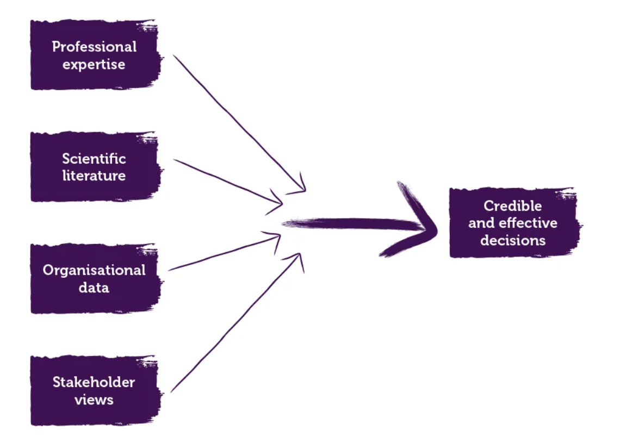

Fig 1. (CIPD, 2025) Evidence based HR. Make better decisions and step up your influence.
As you can see from FIG. 1 there are 4 main sources of evidence that people professionals could use.
An easy guide for HR professionals to follow when using evidence based practice is the ‘6 steps’
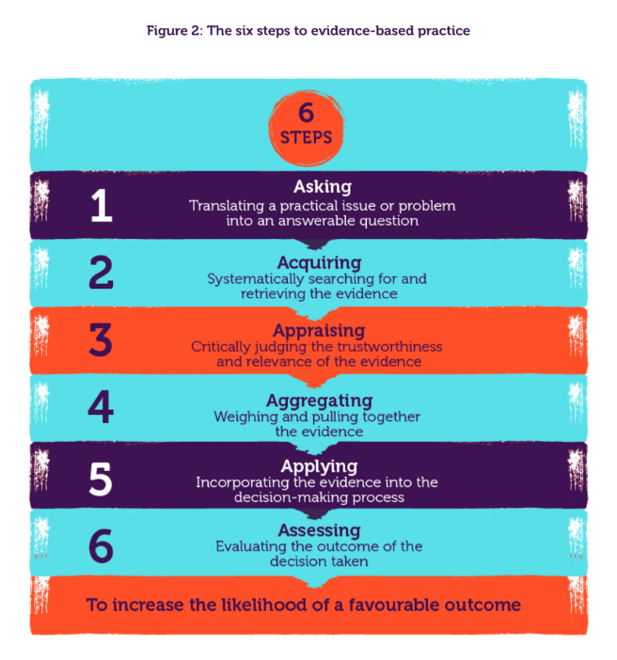
Fig 2. (CIPD, 2025)
Below are 2 examples of how Technivara could use evidence based practice.
- Employee surveys
Data from employee surveys, such as those on engagement, satisfaction or leadership feedback is a great example of evidence-based practice. By technivara doing a survey it can highlight an area that employees feel needs improving; by listening to employees and then acting on the information found it could reduce the turnover rate of employees. Using quantitative data to inform decisions. HR can implement focused initiatives depending upon the findings. However, ‘While surveys can reveal the ‘what’, qualitative analysis can shed light on the ‘why’ and ‘how’. (Maxine Williams, Harvard Business Review.) therefore, it is important to use both qualitative and quantitative evidence-based practice.
- Recruitment & Selection
Technivara could introduce structured interviews, skills evaluations, and predictive analytics to their hiring and selection processes. Technivara could benchmark which is another example of EBP. By evaluating their recruitment and selection processes against competitors. It is likely organisations are using AI which Technivara could implement. Many organisations are using AI to speed up and improve their recruitment and selection processes ‘Organisations are also increasingly reporting that technology has improved their candidates’ (Louise shaw, FCIPD, 2024) and sped up the recruitment process’ however, when benchmarking its important that Technivara keeps to the rhythm of its business, All businesses are different therefore ‘what one of them needs to do to be successful is different from what others need to do’ (Pfeffer,J and Sutton, R I, 2006)

Q2. Evaluate one appropriate analysis tool and one analysis method that Technivara might apply to recognise and diagnose issues, challenges and opportunities (AC 1.2)
Porter's Five Forces is a strategic analysis framework method tool designed by Michael Porter to assist organisations in analysing industry competitiveness externally and understanding the elements that influence profitability. Accessing five main focuses: Exisiting Rivalry, Bargaining power of buyers, bargaining power of suppliers, Threat of new entrants, and threat of substitutes. Porter (2008) argues that it is not the entry of new competitors but the threat of new entrants to the industry which drives competition and impacts the industry’s profitability. Technivara could use this to assess their internal competencies as well as external influencing workforce strategy, to improve. Porters fiver forces and porters value chain analysis aim is to add value to a business. Technivara could use the tools to do a deep dive into their whole business, from procurement to delivery of products it could streamline and assess solutions to the whole business using these methods ‘ For Porter its fundamentally about creating value, and about doing so differently from rivals’ (Magretta, J, 2011) Whereas, a SWOT Analysis tool includes a deep dive into an organisations internal and external Strengths, Weaknesses, Opportunities, and Threats. The analysis tool could be used before technivara managed a change or project. According to the CIPD advantages of this tool include how ‘It can enable an organisation to anticipate future business threats and take action to avoid or minimise their impact.’ And that ‘It encourages the development strategic thinking. One appropriate method that Technivara could use is questionnaires, Questionnaires are one of the most common methods for acquiring data in business research. Technivara could send out employee satisfaction and exit questionnaires to gain insight into the feelings and problems their employees come across ‘Employee surveys can be a quick and low-cost way to invite employee voice’ (CIPD,2025) using the responses to put changes into action and improve. ‘Employees are also often the best resource for spotting problems early and creating solutions.’ (Walden universities, 2025) one downfall of questionnaires is they often have a low response rate and therefore limited data, to increase response rate Technivara could include a prize for a participant. Technivara could also send out customer satisfaction questionnaires, using leading questions such as what do we do well? And what could we improve on. The customer satisfaction questionnaire can diagnose issues, challenges and opportunities for growth. However, ‘while the elements can appear deceptively simple and easy to apply, experience s’hows that to do a SWOT analysis that’s both effective and meaningful, requires time and a significant resource.’ (CIPD, 2025) ‘one criticism of planned strategy is that it develops a strategy on the basis of simplified and often incorrect assumptions about the external environment leading to a weak and ineffective strategy’ (Stephen, Taylor, Carol Woodhams, 2022)
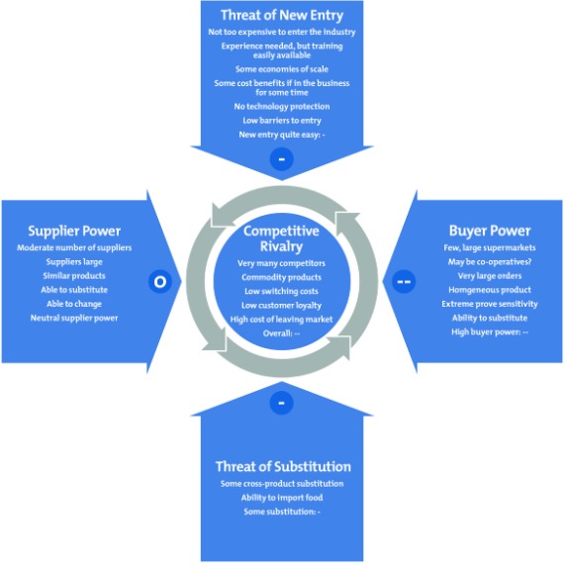

FIG 3. Porter S Five Forces Understanding Competitive Forces to Maximize Profitability Competitive Analysis Porter Competitive Intelligence.
Above Fig 3. Shows a diagram of porters 5 forces, Technivara can use this to stay competitive and stay market leaders in its field.
Q3. Explain the main principles of critical thinking including how these might apply to your own and others’ ideas to assist objectives and rational debate at Technivara (AC 1.3)
The main principals of critical thinking are analysis, evaluation, and interpretation of information that allows an individual to make solid, rational, and well-informed decisions.
Essential elements of critical thinking:
Analysis is the process of breaking down complex information into smaller elements to better understand it. Evaluation involves determining the credibility and significance of information sources.
Reasoning entails making logical links between evidence and conclusions.

Example in Human Resources:
If employee turnover is increasing, a good people professional critical thinker will not just conclude that "people are leaving for higher pay." They will assess the reasons for example...
doing surveys, analysing results, performing exit interviews to understand trends, and perform industry benchmarking. Effective critical thinking will allow to determine whether leadership, culture, or development opportunities play a role, by making bespoke questions that ask the appropriate questions to get the answers needed to bridge gaps and solve problems.
Before deciding on a solution, consider all possible reasons and test various theories, implementing changed based on evidence-based practice. To perform critical thinking on a topic Technivara must first decide on a course of action, critical thinking allows for the idea and potential outcome or negative effects or even how to do it all to come together. Critical thinking should be practical and rational with all elements considered before acting on a route ‘Practical rationality refers to the alignment between our desires or goals on the one hand, and our decisions and actions on the other. A decision is rational in this sense if it is consistent with achieving our goals’ (Stuart Hanscomb., 2023)

To assist objective and rational debate at Technivara critical thinking can be used by clarifying the issue by ensuring the problem or decision before arguing solutions, Evaluating evidence and considering different perspectives ‘ With so much information becoming available, many of which offer new ideas, new HR theories and approaches, it’s important that HR practitioners can evaluate whether what they read is valid, sound and unbiased.’ (CIPD, 2016)

Q4 Explain two decision-making processes that Technivara could apply to ensure that effective outcomes are achieved (AC 1.4)
There are many decision-making processes that Technivara could use to ensure effective outcomes are achieved such as the best fit model, future pacing, problem outcome frame, De bonos 6 thinking hats. Below two examples of decision-making processes are explained;
Edward De Bonos 6 thinking hats; Bono created a simple process to separate emotions from logic, creativity from information. Using parallel thinking it allows everyone involved to be heard. Below is the process of the 6 thinking hats; ‘The Six Thinking Hats is a technique characterized by using different thinking styles to analyze a problem or product’ Intal, G. L., Celestial, A. M., Medina, E. C., & San Juan, K. S. (2023) when people are wearing a different coloured hat, depending on the colour of the hat, it will correlate to how a group or person can think or behave while wearing the hat.
White hat thinking everyone thinks objectively on a subject. When wearing the white hat, you can not think emotionally. All thoughts and anything spoken must be about the facts on the subject and a decision must be formed using this.
Red thinking hat – everyone can talk openly about their emotions towards the subject.
Black hat – this is the cautious hat, the hat of survival – what to avoid and what to be careful of.
Yellow hat – Positive and constructive thinking, logical to dreams and visions
Green hat – this is the energy hat for new ideas and to improve.
Blue hat – thinking about thinking. This allows you to create an agenda this is for a chairperson or whoever may be in control of a meeting. Must be used at the beginning and end.
The 6 hats are simple and straightforward to apply. It helps remove unconscious bias and come to a balanced outcome that has been critically thought about. It encourages deeper consideration using several parallel perspectives. By using De Bonos 6 thinking hats in group participation one advantage is ‘engagement, leading to a feeling of ‘ownership’ of the decision’ (CMI, 2020) Technivara could use De Bonos 6 thinking hats when deciding on new processes and systems during the expansion of the group, it could increase engagement and reduce worries about the future of the business.

Problem-Outcome Frame is an NLP (Neuro-Linguistic Programming) model that describes two different perspectives on situations, problem outcome frame is a way of thinking which allows you to transport yourself into the future with positive solutions rather than the negatives and problems ‘the secret of NLP is that it removes any constraints on achievement and happiness and at the same time helps you build for the future’ (McDermott, I., & Jago, W., 2001)
Assess two different ethical perspectives including how these could be used at Technivara to inform and influence decision-making. (AC 1.5)
Utilitarianism is an ethical theory that determines right from wrong by focusing on the potential outcomes, it holds that the most ethical choice is the one that will produce the best outcome for the greatest number. “Utilitarianism is an influential ethical theory that judges actions by their consequences, seeking to maximize overall happiness and well-being” (Mill, 1861/1998) It is the most common approach to moral reasoning. One of the limitations of utilitarianism is that nobody can predict the future, can only predict what could happen, therefore it is difficult to know with certainty that there will be a positive or negative outcome. It is important that Technivara does not face burnout from employees going through the expansion of the business and that Technivara takes into account the wellbeing of all involved, using ethical perspectives utilitarianism can help Technivara cause unnecessary stress ‘Employers who do not manage stress and mental health issues risk low morale, high absence levels and high employee turnover’ (CIPD, 2024)
Technivara could use this theory in conjunction with workforce planning, often when a business expands or evolves businesses go through a restructure process there can be negative effects on individuals within the business, however by using utilitarianism in the planning stages before a restructure ‘the outcome should be the best for the majority reducing unfairness and promoting the business to be ethical ‘(strategic HRM) provides a framework linking people management and development practices to long-term business goals and outcomes.’ (CIPD, 2025, Strategic human resource management factsheet) If Technivara is to grow it will need to make strategic changes which sometimes could prove unethical this is where Utilitarianism could be used by technivara to measure any detrimental effects which in turn could have a long-lasting disadvantage on the business.
Deontological ethics is a duty-based ethical perspective. It states that activities are morally correct if they adhere to universal moral principles or duties, regardless of the consequences. In other words, Technivara should operate ethically because it is the right thing to do, not because it results in a desirable consequence, by using this theory it would remain a good business. Techinivara is expanding by applying ethical theories such as this would also contribute to good corporate social responsibility, this should be apparent throughout the business from how they treat their employees, to how they recycle, many often businesses expand and only see the value in profit not the value in good ethical practices. A deontological approach to business may cost more in the short term however, ethical treatment of employees and customers can help organizations mitigate risk (Canales 2010; Francis and Armstrong 2003). By performing ethically it will reduce the risk of unlawful activity therefore reducing the risk of ending up in court or employment tribunals.

Q6. Assess two different ways Technivara could measure financial and non-finanacial performance, providing one example of each
Technivara can measure its financial performance and non-financial performance using a variety of methods, it is very important for the progress of techinvara to assess its performance ‘performance is crucial in determining an organisations survival (Buchanan, 2019) While measuring is crucial it is important that Technivara analysis data to determine a plan for the businesses future, by regularly assessing its performance it will learn how to ride storms keeping the business afloat using knowledge from past events if performance drops, initiatives can be introduced to alleviate the negative effects on the business ‘ the process of acquiring knowledge through experience which leads to lasting change in behaviour’ (Buchanan, Huczynski, 2010)

Financial performance indicators include; income statements, cash flow statements, and balance sheets. A profit and loss statement is another financial measure which could be used to summarise a company's sales, expenditures, and expenses over a specific period to determine whether a business is profitable or losing money. For Technivara, this would provide a glimpse of financial performance and aid in identifying long-term patterns. It could take snapshots throughout the years to build a pattern. While also identifying how much money is available to invest in the expansion of the business. Profit and loss statements have limitations, such as the fact that they are historical documents that reflect what has happened but do not forecast future performance. However, ‘Profit is the main component of a company's wealth and reflects both the performance of the company and the firm's ability to reinvest or grant dividends.’ (Anca-Jarmila, 2017). Therefore, it is important to measure the profit Technivara is accruing furthermore the information found will determine the next steps for Technivaras expansion ‘Operating cash flow is a measure of how much cash the business has as a result of its operations. This measure could be positive, meaning cash is available to grow operations, or negative, meaning additional financing would be required to maintain current operations’ (Tim Stobierski, Havard business school)
Technivara can measure its non-financial performance which is just as valuable as financial success as they can emphasise qualitative outcomes that determine long-term success. Stakeholders happiness is a significant metric that is frequently measured via surveys, Net Promoter Score (NPS), or feedback data. Employers and customers are both examples of stakeholders, it is important that Technivara measures all stakeholders associated with the business to gain a balanced understanding of their non-financial performance; by measuring they can assess areas of improvement and the people team within the organisation can implement strategies to combat low scores. Surveys are a good example and easy to use, ‘to measure performance research into the performance which is being measured is needed, many research efforts include the use of some type of survey or questionnaire. (Byman, A, Bell and Harley, B, 2018)
Q7 Explain how people practices could add value at Technivara and identify two methods that might be used to measure the impact of these people practices (AC.3.2)
Attracting and retaining employees should be the backbone of human resource management; nevertheless, numerous initiatives are required to do this, ‘HR isn't just HR, but is about helping the business succeed through finding talent and leaders, and enhancing capabilities’ (Dave, Ulrich,. CIPD 2016) Technivara should include good practices in relation to welfare, learning and development, and fostering a fair and open opportunities environment. To be competitive, Technivaras people department must stay current with industry developments. People practices are impartial, which gives employees a sense of safety to speak freely. Current employment law and the introduction of the human rights bill coming into effect at the end of 2025 will see a need for more firms to use human resources with the relevant knowledge people professionals can effectively steer a business through strategic changes and growth, therefore adding value to the business.
‘The Employment Rights Bill is expected to become law later in 2025. This means important changes to employment law.’ ‘When it becomes law, the Bill will introduce additions and amendments to existing legislation, including the Employment Rights Act 1996’ (ACAS, 2025) .It is vital Technivaras people team understand any changes to employment rights and law. To stay lawfully abiding and reduce the risk of breaking the law which could result in costly employment tribunal cases for the business. This could mean people professionals need to update their policies to stay lawful This is another example of people practices adding value.
Improving Retention and Employee Engagement
Programs for training, development, and onboarding that are successful can lower turnover and increase work satisfaction. This guarantees that information is kept within the company and reduces recruitment expenses. Technivara could measure this by assessing the proportion of departing vs remaining employees offers unambiguous proof of the efficacy of HR tactics.
A decrease in voluntary turnover over the course of the following year would indicate a good impact if Technivara implemented new training and career development options. It is important that technivara uses methods to obtain this information, a good HR data system would be able to record this data for example If Technivara introduces new training and career development pathways, a reduction in voluntary turnover over the next year could suggest positive impact. Using data backed evidence could provide Technivara with hard evidence to measure if their practices are adding value to the business ‘A new era of data analytics should help HR’s cause and provide hard evidence.’ (M,Lewis., CIPD 2016)

Task 2

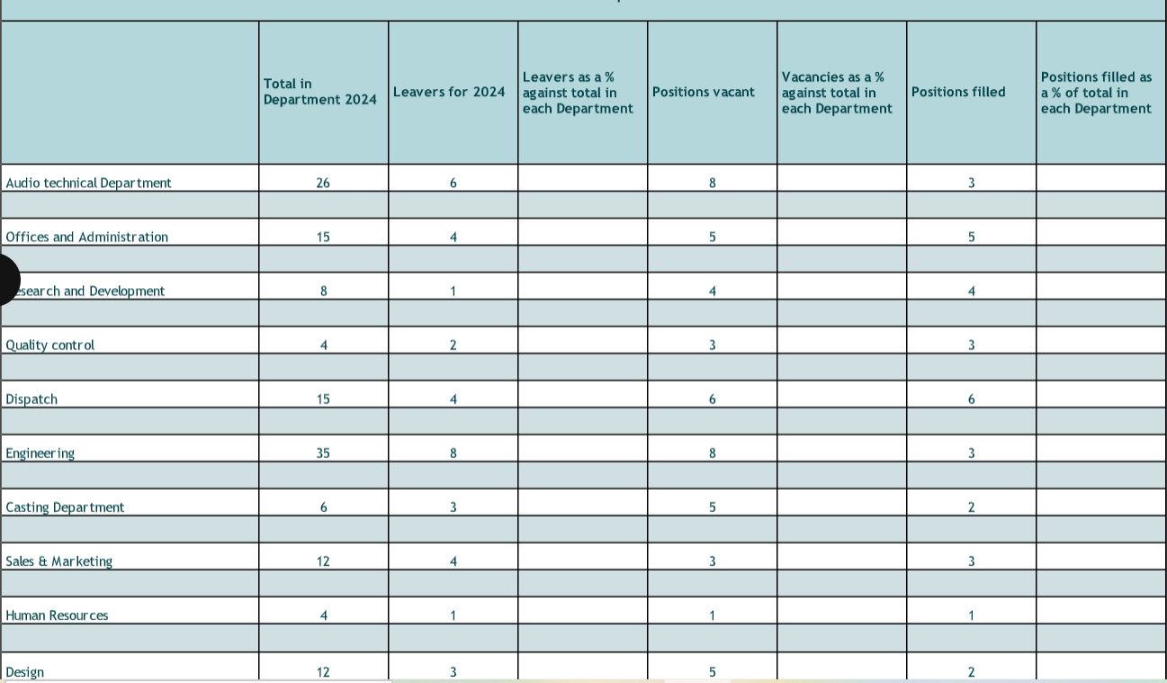

Q8. Table 1 shows Technivara’s turnover and recruitment data 2024. Sue has asked you to convert the data into percentages form, for each department to show:
- Leavers as a % of the total number of employees
- Vacancies as % of the total number of employees
- Positions filled as a % of the total number of employees (AC 2.1)

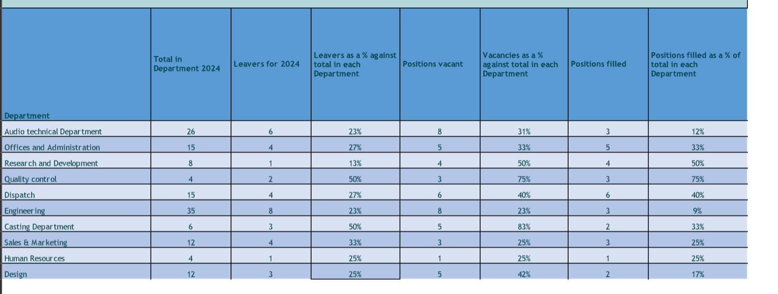
Table 1, Converted into percentages within the excel spreadsheet.
Question 8 - Calculations
Once you have entered the formulas then you may need to format to %
Leavers % formula: =[@[Leavers for 2024]]/[@[Total in Department 2024]]
Vacant % formula: =[@[Positions vacant]]/[@[Total in Department 2024]]
Position filled % formula: =[@[Positions filled]]/[@[Total in Department 2024]]

Q9 When you have completed Table 1. Present your findings using a minimum of three different types of diagrammatical forms (AC 2.2)

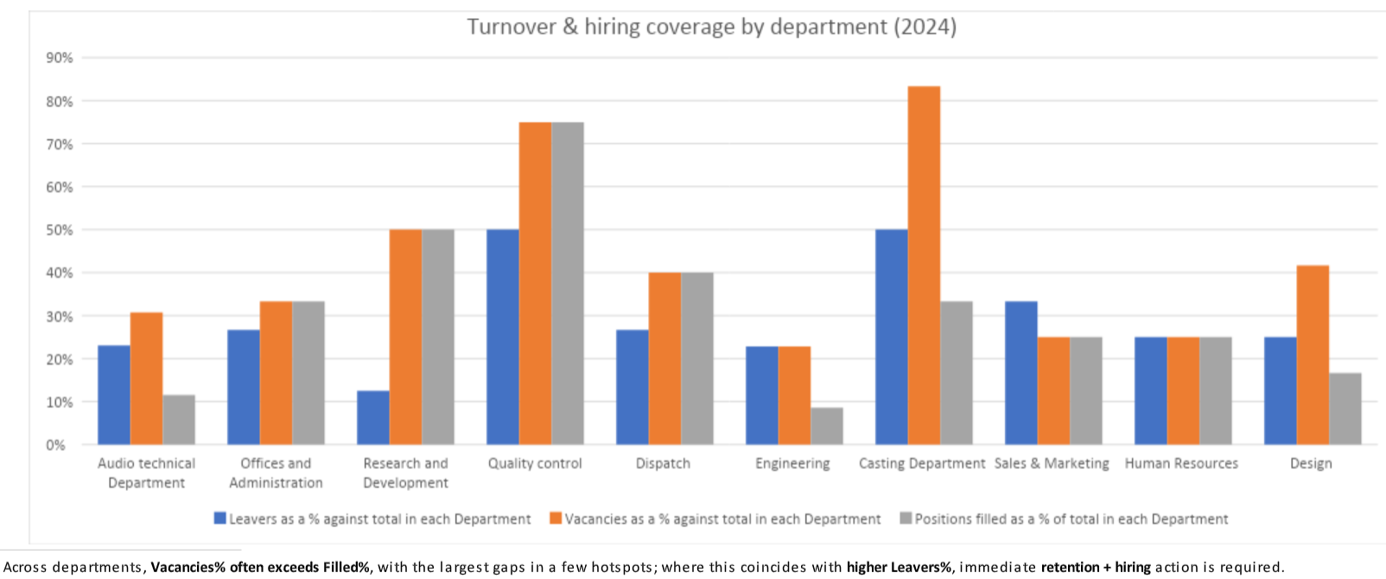
Above Graph and following graphs were made to digest the raw data from table 1. into visual data, which is easy to interpret and determine, the graph points out the departments which have the highest vacancies there is a correlation between high vacancies and leavers. It would be a good idea for the people team at Technivara’s to use data to show to the board to ensure they secure funding for recruitment and resource to alleviate negative effects on the business.
As you can also see from the Graph above human resources department is the only department which percentage of leavers, vacancies and positions filled is equal meaning there is no recruitment needs in this department.
As you can see the turnover of staff is 50% and over for casting department, quality control and research and development this highlights a huge issue for the business and needs an intervention.
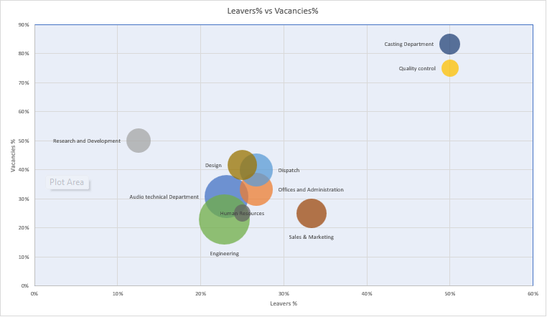
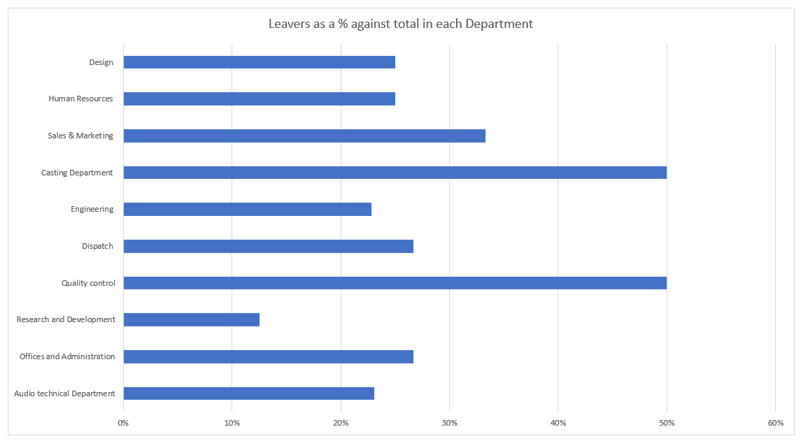
Q10. Table 2 contains evaluation feedback from 42 employees who attended a recent learning and development activity. Sue would like you to review the feedback and identity patterns, themes or trends that might be occurring and present recommendations based on your findings (A.C 2.3)
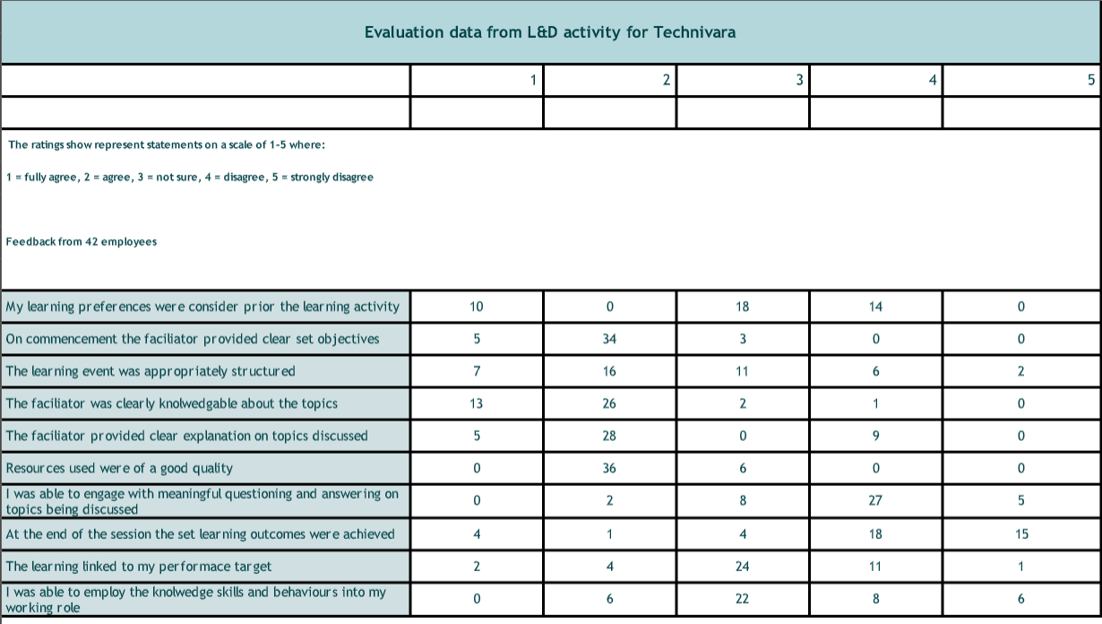
Table 2.
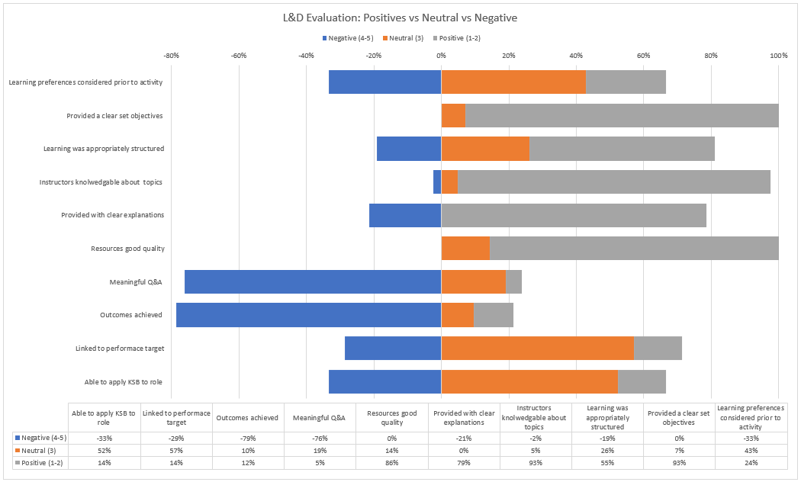
Table 2 converted into a diagrammatical graph to explain the positives, neutral and negative outcomes from the feedback of the learning and development activity.
Above is a graph to explain table 2.
To analyse the data provided I split the type of feedback answers into three categories; Negative, Neutral and Positive.
- Negative 4-5
- Neutral 3
- Positive 1-2
I then calculated the percentage share of each group per statement and created a graphical diverging 100% stacked bar.

Feedback has shown the delivery of lessons are strong, with positive feedback for teachers and materials. However, the outcomes achieved are weak and the programme is not sufficiently targeted or supported after the event. Suggesting the need for refresher sessions.

Positives
- Facilitator knowledge 93% positive
- Clear objectives at the start 93% positive
- Resources good quality 86% positive
- Clear explanations 79% positive
Negatives
- Meaningful Q&A/engagement ~79% negative
- Learning outcomes achieved ~79% negative
Findings
- There are capable facilitators and good training materials, however, the programme design doesn’t create enough practice, feedback and dialogue for learners to meet objectives.
- The pre-course admin and manager involvement is insufficient, so the content isn’t clearly tailored to role/line needs.
- Post-course transfer mechanisms (job aids, coached application, follow-ups) are limited. Learners leave without a clear idea of what is expected of them.
Recommendations

All administration stakeholders for the learning sessions sit down and discuss what outcomes need to be achieved. Goals should be role specific and could follow the SMART principles; Specific, Measurable, Achievable Relevant and Time Bound. According to Locke and Latham (2002), goals in a management environment are observable or quantifiable organisational results that must be accomplished within a given time frame. ‘Setting goals has a positive effect on performance, but this effect is far stronger when employees are able and willing to track their progress towards their objectives, rather than only review their achievement at the end of a project or year’ (Cioca, I. and Gifford, J. 2022) This refocus should coincide with the session’s outlines being rewritten to fit the agreed upon goals. If this isn't carried out then there could be training that is outdated and not role specific. Knowledge checks should be built into the training so that the trainer can measure if what they are teaching is being absorbed by the participants and identify anyone that may need a help learning, a questionnaire at the end of each learning outcome could make sure that what is being taught is being absorbed and learnt. Q&A and outcomes achieved received the most negative responses, there could be a correlation here, suggesting that the questions we’re not beneficial and therefore outcomes became negative.

Feedback questionnaire about the training is also a tool which could be used to see how effective the training was,

Individuals have different learning styles, it could be an idea that training incorporates different learning styles to deliver the training. There are many learning ‘modes’ that could be applied to teach employees new ways of working. Kolb (1984) suggest that there are four levels during which learning always occurs. The four learning phases, or stages, reveal a person's preferred method of learning. The person typically goes through every learning stage in a cycle. Reflective observation, abstract conceptualisation, active experimentation, and concrete experience all contribute to this cycle. By using theories such as the four-learning phase it could be used to create training that is effective.
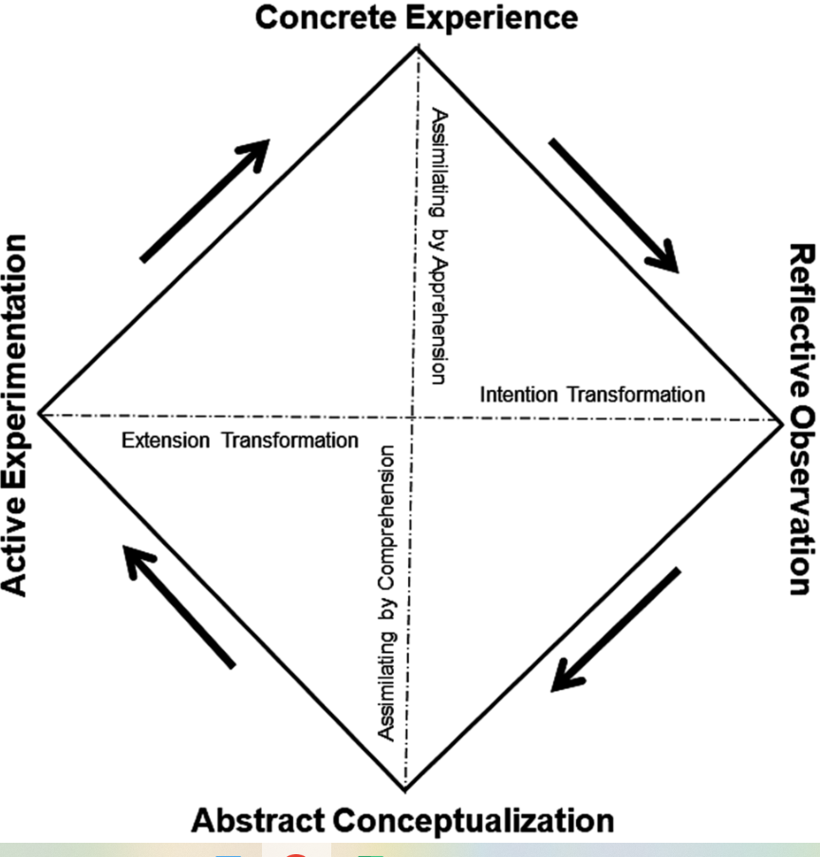
Fig 4. Experiential learning circle.

Trainers provide learning product owners with a completed session plan that meets the predefined session outlines. Lesson plans should highlight what the key learning points are and how they will be achieved throughout the session. The aim of this is to add more focus on what is supposed to be achieved. Part of the session plans will include highlighting what the goals of the session are at the start of the session, so participants know what to expect and then going through the session objectives at the end of the session with the participants. Time should be factored in for specific question and answer segments. This is something that came across as negative. We know that the trainers feedback is that they are knowledgeable so that would suggest that they just haven't given the participants the opportunity to ask the questions or have rushed in areas.

‘Learning and development is about creating the right culture and environment for individuals and organisations to learn and grow.’ (CIPD 2024) Successful learning and development initiatives have several advantages, including enhanced organisational culture and employee engagement through team building. It will be an expensive waste of time for the company and its employees if Technivara does not take action to enhance its training and development plans. Depending on L&D funds, training expenses can cost thousands of pounds. Employee productivity may also suffer because of time away from work for training and development. Employees may lose the time necessary to carry out their daily tasks, which could result in burnout.

References
ACAS, 2025. Employment rights bill [Date accessed 22/09/2025] https://www.acas.org.uk/employment-rights-bill
Anca-Jarmila, G. U. Ţ. Ă. (2017). The Financial Performance in a Company Illustrated with the Profit and Loss Account. Economics and Applied Informatics, (3), 201-108.
Buchanan, D A and Huczynski, A A (2019) organisational behaviour, 10th Ed. Harlow : Pearsons Education limited.
Buchanan, D and Huczynski, A (2010) organisational behaviour, 7th edn, Pearson education Ltd, Harlow.
Byman, A, Bell and Harley, B (2018) business research methods, 5th ed, oxford: Oxford university press
Canales, R. (2010). Rule bending, sociological citizenship, and organizational contestation in microfinance. Regulation and Governance, 5(1), 90–117.
Cioca, I. and Gifford, J.(2022) Performance feedback: an evidence review. Practice summary and recommendations. London: Chartered Institute of Personnel and Development.
CIPD 2024[DATE ACCESSED 22/09/2025].,https://www.cipd.org/uk/the-people-profession/the-profession-map/explore-the-profession-map/specialist-knowledge/learning-development/
CIPD, 2016) How to write a critical review. Date accessed 17/09/2025https://www.cipd.org/uk/learning/support-for-students/currently-studying/critical-review-writing/
CIPD, 2024) Stress and Wellbeing: UK employment law Date accessed 21/09/2025 https://www.cipd.org/uk/knowledge/employment-law/wellbeing-stress/
CIPD, 2025 Employee voice channels: Guide for people professionals [DATE ACCESSED 29/10/2025] https://www.cipd.org/uk/knowledge/guides/employee-voice-channels-guide-for-people-professionals/#eight-employee-voice-channels
CIPD, 2025) Swot analysis factsheet. Date accessed 17/09/2025 https://www.cipd.org/uk/knowledge/factsheets/swot-analysis-factsheet/#what-is-a-swot-analysis
CIPD, 2025, Strategic human resource management factsheet) DATE ACCESSED 20/09/2025 https://www.cipd.org/uk/knowledge/factsheets/strategic-hrm-factsheet/
CIPD, Clare Mccarthy, 2025) Date Accessed 17/09/2025
CIPD, Factsheet, 2025) Date Accessed 17/09/2025 https://www.cipd.org/uk/knowledge/factsheets/evidence-based-practice-factsheet/
CMI, 2020) DATE ACCESSED 20/09/2025 https://www.managers.org.uk/knowledge-and-insights/resource/decision-making/
Dave, Ulrich,. CIPD 2016) Analytics only work if you ask the right sort of questionshttps://www.cipd.org/uk/about/news-archive/ulrich-analytics/
Denise M. Rousseau, Steven ten Have, Evidence-based change management, Organizational Dynamics, Volume 51, Issue 3, 2022,100899, https://doi.org/10.1016/j.orgdyn.2022.100899.https://www.sciencedirect.com/science/article/pii/S0090261622000067)
Eric Barends, Denise M. Rousseau., 2018) Evidence based management, Kogan page, Evidence-Based Management (9780749483746) https://www.cipd.org/uk/knowledge/factsheets/evidence-based-practice-factsheet/#what-is-evidencebased-practice
Fig 1. (CIPD, 2025) Evidence based HR. Make better decisions and step up your influence.
Fig 2. (CIPD, 2025) https://www.cipd.org/uk/knowledge/guides/evidence-based-profession/

FIG 3. Porter S Five Forces Understanding Competitive Forces to Maximize Profitability Competitive Analysis Porter Competitive Intelligence. [Date accessed 16/09/2025] https://demodel.onrender.com/porters-five-forces-model.html
Fig 4. Experiential learning circle.[DATE ACCESSED 22/09/2025] https://www-igi-global-com.ezproxy.uwtsd.ac.uk/gateway/chapter/full-text-html/251750
https://www.cipd.org/uk/knowledge/bitesize-research/tackling-bias/
https://www.cipd.org/uk/knowledge/guides/evidence-based-profession/
https://www.cipd.org/uk/views-and-insights/thought-leadership/insight/evidence-based-hrm/
Intal, G. L., Celestial, A. M., Medina, E. C., & San Juan, K. S. (2023) Assessment of the Proposed pain management application using SWOT analysis and Six Thinking Hats. Proceedings of the 2023 7th International Conference on Software and E-Business, 14–19. DATE ACCESSED 20/09/2025 https://doi.org/10.1145/3641067.3641074
Kolb D. A. (1984). Experiential learning: experience as the source of learning and development. Englewood Cliffs, NJ: Prentice Hall.

LOCKE, E.A. and LATHAM, G.P. (2002) Building a practically useful theory of goal setting and task motivation: a 35-year odyssey. American Psychologist. Vol 57, No 9. pp705–17.
Louise shaw, FCIPD, 2024) Resource and planning report 2024 Date Accessed 17/09/2025 https://www.cipd.org/globalassets/media/knowledge/knowledge-hub/reports/2024-pdfs/8662-resource-and-talent-planning-2024-report-web.pdf
Magretta, J, 2011) Magretta, Joan. Understanding Michael Porter : The Essential Guide to Competition and Strategy, Harvard Business Review Press, 2011. ProQuest Ebook Central, https://ebookcentral.proquest.com/lib/trinity/detail.action?docID=5181983.
Matthew Lewis, Partner, Middle East and Africa, Boyden global executive search, does HR belong at board level. CIPD 2016 [DATE ACCESSED 21/09/2025]https://www.cipd.org/uk/about/news-archive/debate-hr-board-level/
Maxine Williams, Harvard Business Review.) November-December, Vol 95, No 6. pp 142–146.
McDermott, I., & Jago, W. (2001). The NLP Coach: A Comprehensive Guide to Personal Well-Being & Professional Success. Crown House Publishing.
Michael Armstrong, Stephen Taylor, 2020) 15th edition, Armstrong’s handbook of human resource management practice. pp 132-133
Mill, J. S. (1998). Utilitarianism (R. Crisp, Ed.). Oxford University Press. (Original work published 1861)
Pfeffer,J and Sutton, R I, 2006., Evidence based management, Havard Business Review, January, pp 62-74

Porter, M E. The five competitive forces that shape strategy Harvard Business Review Vol. 86, Iss. 1, (2008): pp 79
Stephen, Taylor, Carol Woodhams, 2022) p.p 47, Studying human resource management, CIPD 3rd edition, kogan page
Stuart Hanscomb., 2023.Critical thinking, second edition [Date accessed 17/09/2025]https://www.taylorfrancis.com/reader/read-online/9bca8e71-6e83-4f69-926c-c64b2edc7389/book/epub?context=ubx
Tim Stobierski, Havard business school online, DATE ACCESSED 21/09/2025 https://online.hbs.edu/blog/post/financial-performance-measures
Walden universities [DATE ACCESSED 29/10/2025] Employee surveys a few pros and cons https://www.waldenu.edu/programs/business/resource/employee-surveys-a-few-pros-and-cons

