UWTSD

Nathan Mackechnie

2116209

Structural & Fluid Analysis
Designing a Kiteboard: Fluid Flow Assessment
ACMA6010
Word Count: 3021
Executive Summary
Understanding fluid dynamics around the board is critical to controlling the board's characteristics. Reynolds number is a dimensionless value that plays a significant role in predicting the behaviour of fluid flow around objects. If the Reynolds number is low, fluid flow is laminar; when high, flow is turbulent, and intermediate, the flow is categorised as transitional. Estimations of the Reynolds number for the kiteboard produced a high Re, indicating turbulent flow across the board.
Boundary layers are formed when an object passes through a fluid. In this case, the kiteboard passes through the water. In a boundary layer, separation points can be observed where the fluid flow separates from the object, creating a wake, drag and reducing lift forces. Designers can delay separation by designing boards with no sharp edges and a smooth shape. Dimples may also be implemented along the board to create turbulent flow with higher kinetic energy and linear momentum than laminar flow. By delaying the separation point within the boundary layer, drag forces are reduced, and lift forces are increased, enhancing the efficiency and performance of the board.
Developments in kiteboards have seen material choices move from foam and wood to more durable, stronger and lightweight materials such as Carbon Fiber Reinforced Plastics. This material is a good choice for kiteboards, especially hydrofoil kiteboards, where boards must be highly stiff to allow the user to control the board from an elevated position. Vacuum-assisted resin transfer moulding is a suitable manufacturing method for producing Carbon Fiber Reinforced Plastic boards. This method utilises a vacuum bag to apply uniform pressure across the layered material, resulting in a high-quality, smooth finish.
Advancements in technology allow designers to predict fluid flow behaviours and capture valuable data using simulations. Computational flow dynamics software can be utilised to observe flow behaviour along with finite element analysis, which is a useful tool for observing the effect of the forces exerted on the board. Both serve as valuable tools in predicting behaviours of flows and forces on an object. With quick feedback, design changes can be easily made by running the simulations with the modifications made. It is highlighted that although costs can be saved by running multiple simulations without physical models, computational costs, including both hardware and software, can be extremely high.
Estimations of the three primary forces exerted on the board were made: drag, weight and wave impact.
Water tunnel testing is The chosen experiment for understanding fluid flow and the effect of the resultant forces on the board. This testing method involves submerging the object underwater; measurement instruments that have been calibrated are then fitted to the object to measure data such as flow velocity and pressure distribution and visualise flow. Setting up the experiment to match the environment the board will be used in and the simulation models, the data can then be used to validate the simulation models. Discrepancies are highlighted, which designers can analyse to modify the 3D model for more accurate real-world results.
Further research is recommended into alternative materials and manufacturing methods that may have different advantages than those discussed in the report. The importance of considering other forces, such as buoyancy, tensile, and impact forces, is highlighted. Further experiments are recommended, considering factors such as angle of attack. Wave tanks are also highlighted as suitable experiments for better understanding the board's behaviour in a realistic environment.

Table of contents
Table of contents 2
List of Figures 1
1. Introduction 2
2. Reynolds Number 2
2.1. Importance of Reynolds Number 3
2.2. Estimating Reynolds Number for the Kitesurf Board 4
3. Boundary Layer 4
4. The use of Carbon Fiber Reinforced Plastic 6
4.1. Developments of Kiteboards 6
4.2. Manufacturability 8
4.3. Performance implications of CFRP 8
5. Simulation of flows and forces. 9
5.1. Computational Fluid Dynamics 9
5.1.1. Direct Numerical Simulation 9
5.1.2. Large Eddy Simulation 10
5.2. Finite Element Analysis 10
5.3. Estimating Forces Exerted on the Kiteboard 11
5.3.1. Force of rider on board 12
5.3.2. Hydrodynamic Drag Force 12
5.3.3. Wave Impact Force 12
6. Prototype Testing and Data Acquisition 13
6.1. Hydrodynamic Testing 13
6.2.1. Data Acquisition 13
6.2.2. Comparison to Simulation Data 14
6.3. Experimental Procedure 14
7. Conclusion 15
8. Recommendations for further work 16
9. References 17

List of Figures
Figure 1- Illustration of Laminar, Transitional and Turbulent Flows (McGurk et al., 2020) 8
Figure 2 - Boundary layer diagram (Rainer, 2016) 10
Figure 3 – Steep Rocker Kiteboard Shape (Andric, 2023) 10
Figure 4 - Boundary flow of a smooth sphere compared with a golf ball (Libii, 2006) 11
Figure 5 - Hydrofoil Kiteboard (Surfertoday, 2024) 12
Figure 6 - Diagram of VARTM manufacturing method (Zitoune, 2014) 13
Figure 7 - FEA Nodes (ASR, 2019) 15
Figure 8 - SolidWorks FEA Simulation tool (Shih, 2017) 16
Figure 9 - Diagram of a Circulating Water Tunnel (Shi, 2019) 18
Figure 10 - Pitot tube used in a water pipe (Perabu, 2024) 19

Introduction
The design and performance of kiteboards are closely intertwined with advancements in materials science, manufacturing technologies, and fluid dynamics. This report explores the details that shape the development of kiteboards, with a strong emphasis on optimising aerodynamic and hydrodynamic characteristics. Key to this exploration is the selection of materials, including Carbon Fibre Reinforced Plastic (CFRP), and the application of advanced manufacturing techniques.
Understanding the interaction of fluid flow around the board and the resultant forces is crucial for enhancing its efficiency and manoeuvrability. Advances in technology now allow designers and engineers to model objects and run simulations to predict fluid flow dynamics accurately. This report investigates these considerations, assessing current practices, proposing innovations, and outlining pathways for future research and experimentation to push the boundaries of kiteboard design within high-performance sports equipment.

Reynolds Number
Reynolds number (Re) is a dimensionless quantity used in fluid mechanics to predict flow patterns in various fluid flow situations (NASA, 2012).
Reynolds number is defined as:
$Re = \frac{ρυL}{μ}$ (Equation 1 – Reynolds Number)
Where:
$ρ$ = Fluid Density ($Kg$/$m^{3}$)
$υ$= Relative Velocity (m/s)
L = Linear Dimension (m)
$μ$= Dynamic Viscosity (Pa$∙$s)
The Re concept is named after Osbourne Reynolds, a British innovator who discovered that this dimensionless parameter could predict a range of flow conditions. Predictions are made based on flow velocity, dynamic viscosity and fluid density parameters. When a flow transitions from one condition to the next, it is called a Critical Reynolds number. This value depends on whether the measured flow is internal or external (Cadence, 2022).

2.1. Importance of Reynolds Number
The Re is critical in determining flow conditions:
- Laminar Flow- smooth with fluid particles moving parallel, typically observed at lower Re values (Hussani, 2012).
- Transitional Flow – A flow type that is sensitive to disturbances; this is where flow alternates between laminar and turbulent, typically observed at intermediate Re values (Durst, 2008).
- Turbulent Flow - Random and mixed and typically occurs at higher Re values (Biswas and Eswaran, 2002).
These flow types are illustrated in Figure 1 below, showing the change in flow as it progresses.
Figure 1- Illustration of Laminar, Transitional and Turbulent Flows (McGurk et al., 2020)
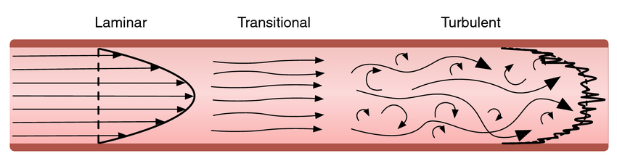
The Re is a crucial parameter for predicting flow behaviour. It is used to analyse flow in laboratory and simulation experiments, such as Computational Flow Dynamics (CFD).
In summary, Reynolds number calculations provide fundamental insights into various flow patterns and behaviours around objects. This understanding guides design decisions to optimise performance through strategies to manipulate drag and lift forces.

2.2. Estimating Reynolds Number for the Kitesurf Board
The Re value is expected to be high for this situation, indicating the turbulent flow. To estimate the Re value for the kitesurf board, the following assumptions must be made:
- $ρ$(Fluid Density of Seawater at 3.5°C) = 1030 Kg / $m^{3}$ (Science Learn Hub, 2010)
- $υ$(Relative Velocity of the board through water) = 9m/s (20mph) (Cawte, 2020)
- L (Linear Dimension) = 1.45m (Laurinaiyte, 2023)
- $μ$(Dynamic Viscosity of Seawater at 3.5°C) = 0.00089 Pa•s (Sharqawy, 2010)

Using equation 1 to calculate the Re;
$$Re = \frac{1030⋅9⋅1.45}{0.00089}$$
$∴$Re = 1.51028 x ${10}^{7}$
Therefore, as the Re value is high, it is evident that the flow around the fluid flow around the board is turbulent, which is expected for an object moving through water at high speeds. The high Re value is imperative for the board's performance, contributing to the overall pressure drag, stability, and manoeuvrability.

Boundary Layer
A boundary layer is formed when a solid object moves through a fluid, disturbing the surrounding molecules. For the Kiteboard, hydrodynamic forces are generated between the fluid and the object. The magnitude of these forces depends on several variables:
- Object velocity
- Object Shape
- Fluid Mass
- Fluid viscosity
- Fluid Compressibility (Benson, 2021)
Figure 2 - Boundary layer diagram (Rainer, 2016)
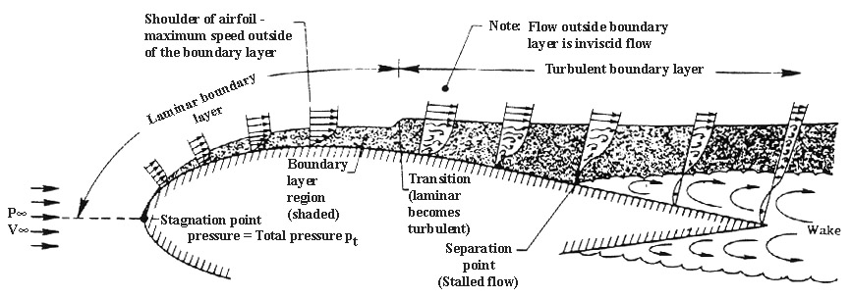
Figure 2 shows the formation of a boundary layer over an aerofoil (Eppler, 2012) shaped object. For the kiteboard, flow is likely initially laminar at the leading edge, transitioning to turbulent flow towards the rear of the board. When the fluid velocity decreases to zero (Stalled flow), fluid separation from the object occurs, creating areas of wake leading to higher levels of drag (Corke, 2024).
Sharp edges, roughness, and abrupt changes on the object's surface can cause separation. A turbulent boundary layer typically exhibits a delayed separation point due to mixing and energy displacement across the object (Schlichting and Gerstand, 2000). Delaying separation increases lift and reduces drag, fundamental properties determining a board's performance.
Figure 3 – Steep Rocker Kiteboard Shape (Andric, 2023)
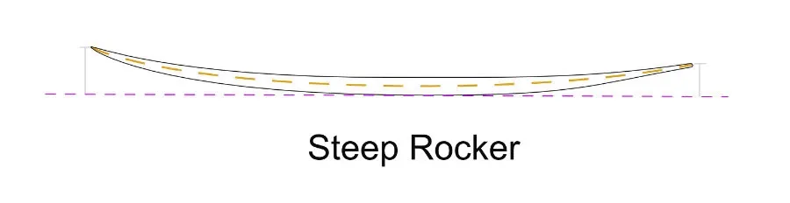
Personal preferences have resulted in many different shapes of kiteboards. For example, in Figure 3, the ‘Steep Rocker’ board has a high leading edge, creating a boundary layer beneath the board. The shape is curved with no sharp edges, delaying separation, reducing drag and increasing lift forces, allowing the user to easily lift from the water surface (Andric, 2023).
To delay separation and reduce wake, designers may also implement dimples on board sections to increase turbulent flow that observes higher kinetic energy and greater linear momentum than laminar flow. This design technique is illustrated in Figure 4.
Figure 4 - Boundary flow of a smooth sphere compared with a golf ball (Libii, 2006)
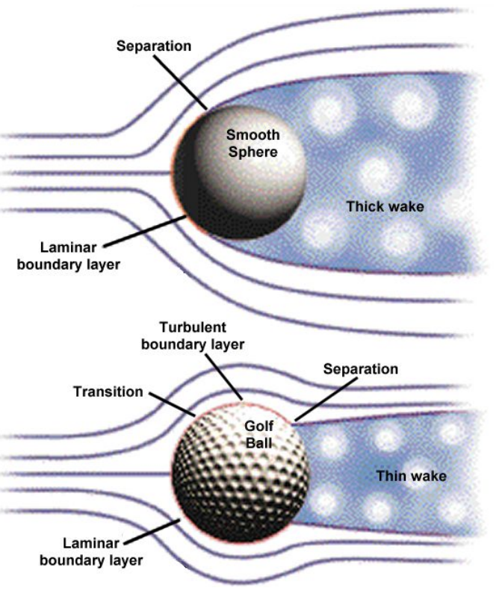
In summary, kiteboard designers must carefully consider boundary flow behaviour. Delaying the separation point along the board will decrease the wake size, reducing the drag forces and increasing the lift forces. Design techniques such as implementing dimples are viable solutions for further delaying separation by creating turbulent flow with higher KE and momentum.

The use of Carbon Fiber Reinforced Plastic
It is proposed that the kiteboard is made from Carbon Fiber Reinforced Plastic (CFRP), a composite material composed of carbon fibre and a polymer matrix, usually a thermoplastic such as polyester, epoxy or resin. Carbon fibre strands are bonded in a crystalline, three-dimensional arrangement with high strength and stiffness properties (Haka, 2023). The combination of polymers has advantages such as a reduction in cost, manufacturability, and so on. The following sections will discuss the historical developments of kiteboards and the use of CFRP.

4.1. Developments of Kiteboards
Kiteboarding is a sport that combines elements of surfing, windsurfing, and paragliding. Riders use a kite to harness wind forces to manoeuvre the board through the air and water. Popularity in the sport began in the 1990s when board designs were simple and often adapted from surfboards or wakeboards (Preszler, 2005).
Over time, board design has significantly changed, optimising the board to be specific to the sport. This involved creating lightweight, durable, and aerodynamic designs, enhancing the board's performance. This meant moving from wood, foam and fibreglass composites to more robust, lighter materials like carbon fibre and epoxy resins (Hapgood, 2015). The growing trend in sustainability has also impacted the materials used, pushing designers towards sustainable materials such as recycled plastics.
One of the most significant developments in kiteboards is the introduction of hydrofoil boards.
Figure 5 - Hydrofoil Kiteboard (Surfertoday, 2024)
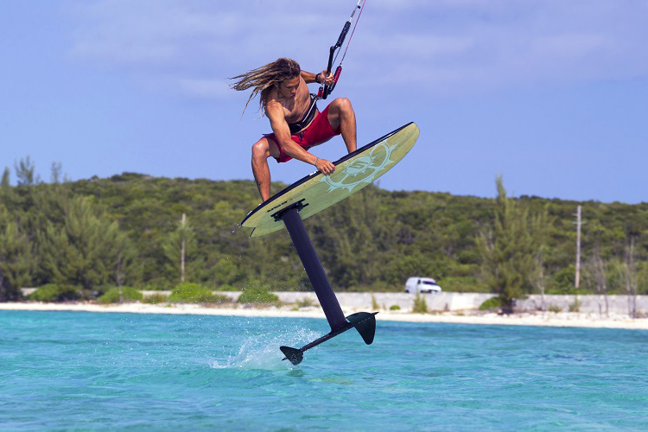
Figure 5 shows the hydrofoil attachment attached to the bottom of the board. As fluid runs over the hydrofoil, lift is generated, pushing the board out of the water and reducing drag. Appletree Surfboards (2022) highlights the importance of using carbon fibre for hydrofoil boards, as a stiff board is required to control the foil from the board.
Exploration of Nanotechnologies is a potential future avenue for further developing kiteboards. For example, graphene could be a suitable nanomaterial for the construction of the boards. Graphene is a sustainable material with a balanced combination of weight, strength and impact resistance (Bashir, Ikram and Maqsood, 2023).

4.2. Manufacturability
A suitable method would be Vacuum-Assisted Resin Transfer Moulding (VARTM).
Figure 6 - Diagram of VARTM manufacturing method (Zitoune, 2014)
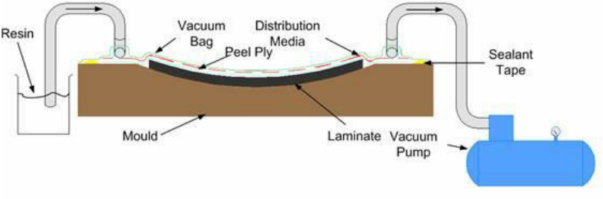
As shown in Figure 6, VARTM uses vacuum pressure and resin to produce CFRP components. A mould of the component is created where carbon fibre layers are layered, and resin is injected via ports. A positive vacuum pressure is created inside the sealed bag to apply uniform pressure across the mould. The mould is then removed, cured, and processed, ready for the user (Bhatt and Goe, 2017).
This process produces consistent quality through uniformed resin distribution using vacuum pressures, giving a smooth surface finish and reducing the need for post-processing. In terms of manufacturing cost, VARTM is typically a cost-effective process due to its low energy consumption and ease of automation (Shah and Chaudhary, 2020). Although there are many advantages to VARTM, Campbell (2010) highlights disadvantages that include slow production rates and high costs when it comes to creating complex moulds.

4.3. Performance implications of CFRP
CFRP obtains a high modulus of elasticity ranging from 150GPa – 300GPa (Henderson, 2019), this gives the board high stiffness, giving the user improved control and stability on the water. Control is also enhanced by having a lightweight board. A fundamental property of CFRP is its specific strength, which can exceed 3500Kn•m/Kg, making it high strength to resist the impact from waves but also extremely light per unit weight (Masuelli, 2022)
The resistance to impact also enhances the board's fatigue resistance, allowing it to retain its structural properties even after repetitive stress cycles. This is a significant benefit for the customer, ensuring the board they purchase is reliable and durable under demanding conditions. CFRP produces a smooth hydrophobic surface finish, making it an ideal composite choice for the board. A smooth finish on the board's surface delays the separation point, reducing drag and enhancing efficiency.
In summary, kiteboards have seen significant developments over the years, with significant advancements in the materials they are made from. CFRP, with its high strength-to-weight ratios, durability, and smooth surface, is an excellent choice for kiteboards, crucial for reducing drag forces. The VARTM method, with its ability to apply uniform pressure across the material, is a reliable and efficient choice for manufacturing kiteboards.

Simulation of flows and forces.
Optimising designs can be challenging. However, with the aid of computational methods, designers can easily simulate and analyse 3D models. The data accumulated from these simulations is essential for optimisation (Altair University, 2018). The following sections will discuss modelling techniques for simulating fluid flow and forces on the board.

5.1. Computational Fluid Dynamics
Advancements in technology enable designers and engineers to utilise computational methods to create digital models of objects and the surrounding flow to predict how the fluid interacts with the object (Lino, 2023).
Computational Fluid Dynamics (CFD) utilises a range of numerical techniques to simulate fluid flow around a component (Sharma, 2021). Direct Numerical Simulation (DNS) and Large Eddy Simulation (LES) are two primary techniques used in CDF. These modelling techniques will be discussed in the following section.

5.1.1. Direct Numerical Simulation
DNS uses full Navier-Stokes equations to capture all scales of motion, from the largest eddies to the smallest dissipative scales. The Navier-Stokes describe the motion of fluid substances, which are solved on a fine computational grid by DNS (Jiang and Lai, 2016). This method gives a fundamental understanding of turbulence with the highest accuracy of all other techniques, providing a detailed representation of fluid flow and turbulence (Geurts, 2022). Although highly accurate, Bernard (2019) highlights the high computational costs, which include hardware and software. DNS is typically only feasible for components experiencing low Reynolds number flows with simple geometries, making it ideal for studying fundamental fluid dynamics in controlled conditions. However, this specialisation significantly limits its flexibility for addressing complex engineering problems that involve high Reynolds number flows and intricate geometries typically found in real-world applications.

5.1.2. Large Eddy Simulation
LES resolves larger turbulence scales directly and models more minor dissipative scales using Sub-Grid Scale (SGS) models. Like DNS, LES utilises Navier-Stokes equations but solves them on a large cell computational grid, large enough to resolve larger turbulent eddies (Sagaut, 2006). This technique can model a range of fluid flow conditions, from transitional to turbulent flow types, providing a physical insight into the mechanisms driving turbulent flows (John, 2012). Much like DNS, computational costs are expensive, requiring significant computational resources. As finer grids are necessary to resolve larger eddies, simulation times are typically longer, demanding substantial computational resources. The results produced from LES can often be sensitive to grid resolution, increasing the risk of inaccuracies and reducing the reliability of the simulation (NASA, 2009).

5.2. Finite Element Analysis
Simulating forces' effect on a structure can be done with detail and reasonably quickly compared to laboratory-type experiments (Altair University, 2019). There are many methods of modelling forces on a structure, and the primary tool used is finite element analysis (FEA).
FEA, also referred to as Finite Element Method (FEM), is a numerical method which solves partial differential equations (PDE) on a defined domain (Altair University, 2019). FEA discretises a complex structure into finite-sized elements interconnected at discrete points known as nodes, as illustrated in Figure 7.
Figure 7 - FEA Nodes (ASR, 2019)
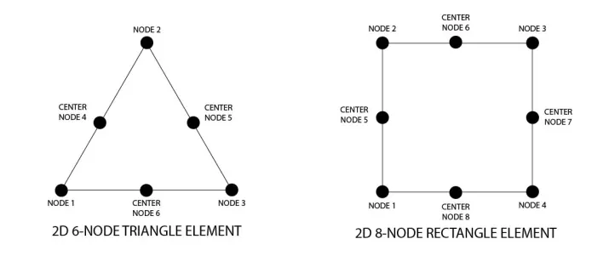
SolidWorks software offers an FEA tool for its users. This tool allows users to analyse their model and specific load conditions, collect data, and visualise the results.
Figure 8 - SolidWorks FEA Simulation tool (Shih, 2017)
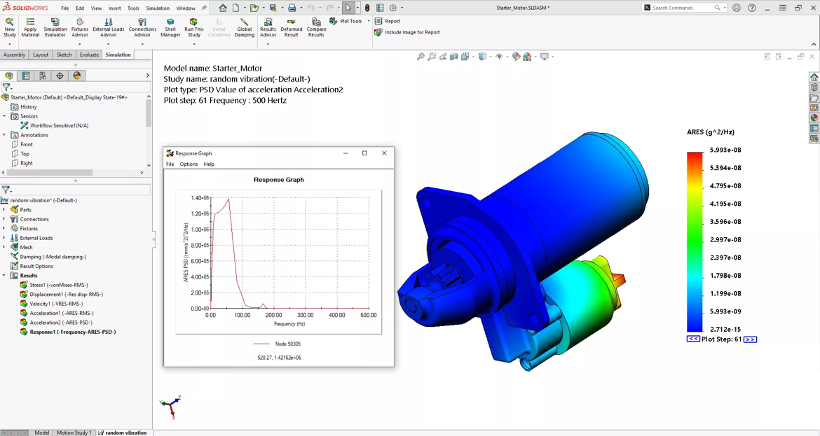
Forces can be applied to the model in various locations across the object, allowing designers to observe the effect of forces, visualising deformations and highlighting areas of concern, as depicted in Figure 8. However, much like CFD, FEA can be an expensive tool to use, requiring significant computing resources. A subscription to a software package such as SolidWorks can cost over £2500 per annum (pa), depending on the package (SolidWorks, 2023). On the other hand, costs can be saved over time, whereas expenses can be saved as the requirement to build physical models is obsolete.
In summary, simulation allows us to predict and analyse the behaviours of components under certain conditions. Understanding the advantages and disadvantages of CFD and FEA, such as the high setup costs associated with software like Autodesk CFD and SolidWorks, is crucial.

5.3. Estimating Forces Exerted on the Kiteboard
In this section, a selection of forces exerted on the kiteboard will be estimated. Understanding these forces is crucial as they directly impact the kiteboard's performance and stability.
When estimating the forces exerted on the kiteboard, assumptions must be made:
- Conditions are Steady-State
- Incompressible flow
- Uniform flow conditions
- Kiteboard is a rigid body
- The weight of the rider is 75Kg

5.3.1. Force of rider on board
$W=Mass of rider ⋅ Gravity$(Equation 2 – Weight force of rider)
$$W = 75Kg ⋅ 9.81 = 735.75N$$

$$∴L = \frac{1}{2 }⋅1030⋅9^{2}⋅0.5⋅0.6525 = 13,609.52N$$

5.3.2. Hydrodynamic Drag Force
$R = \frac{1}{2}⋅ρwater⋅v^{2}board⋅CD⋅Ab$ (Equation 3 – Hydrodynamic Drag Force)
Where,
- ρwater = air density (1030 kg/m³)
- Vboard= velocity of the board through the water (9m/s)
- CD = Drag coefficient of the board (0.05)
- Ab = Area of board (1.45m*0.45m)

$$∴R = \frac{1}{2}⋅1030⋅9^{2}⋅0.05⋅0.6525 = 1360.95N$$

5.3.3. Wave Impact Force
Assuming the board is stationary,
$Fwave= ρwater∙Ab∙Hwave∙V^{2}wave$ (Equation 4 – Wave Impact Force)
Where,
- ρwater = Air density (1030 kg/m³)
- Vwave= Velocity of wave (5m/s)
- Hwave= Height of Wave (2m)
- Ab = Area of board (1.45m*0.45m)

$∴Fwave=1030∙0.6525∙2∙5^{2}= 33,503.25N$

Prototype Testing and Data Acquisition
Laboratory testing using an accurate prototype is crucial in the validation process. The raw data obtained through the experiment can highlight discrepancies between theoretical models and actual performance. This experimental data is invaluable as it can enhance the simulations by adjusting the parameters to reflect real-world scenarios (Orlandi, 2012).

6.1. Hydrodynamic Testing
Hydrodynamic testing utilising a water tunnel will provide sufficient data on fluid flow and forces exerted upon the board. Alternative testing methods, such as aerodynamic wind tunnel testing, would also give an accurate fluid flow analysis (Hall, 2020). However, hydrodynamic testing offers a realistic analysis of the type of environment the board will be used in. Figure 9 shows a diagram of a typical water tunnel.
Figure 9 - Diagram of a Circulating Water Tunnel (Shi, 2019)
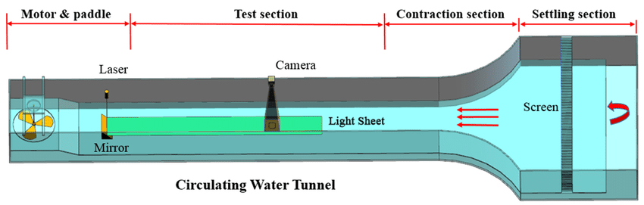

6.2.1. Data Acquisition
Pitot tubes will be used to measure stagnation pressure, which is then used to determine fluid flow velocity. These will be mounted to the object's external surface, facing the flow direction. Figure 10 below shows a diagram of a pitot tube used to analyse fluid flow velocity.
Figure 10 - Pitot tube used in a water pipe (Perabu, 2024)
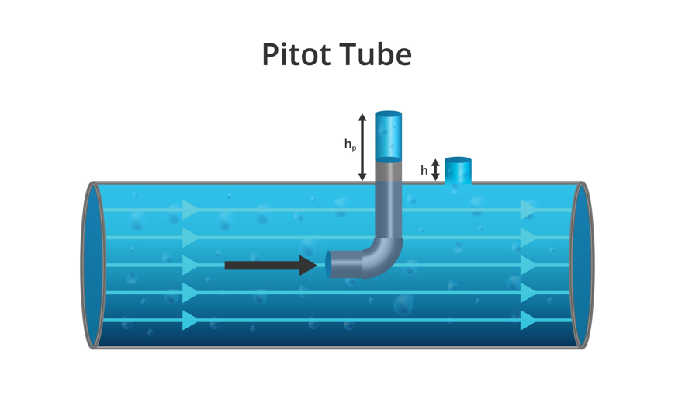
Digital Manometers will be used to measure pressure differentials across the object. This instrument will be flush mounted to the object's surface to minimise disturbances to the fluid flow (Tsiklis, 2012). Load sensors will be mounted to the leading edge of the board, providing data on the magnitude of the distributing forces, such as lift and drag (Yeow and Cheng, 2004). To visualise flow, the water will be seeded with small particles, and a particle image velocimetry (PIV) instrument will be used to illuminate the particles using a laser (Raffel et al., 2013). A camera will capture the simulation, allowing designers to watch a playback of the fluid behaviour. Before the experiment, instrumentation will be calibrated to ensure the data collected is reliable.

6.2.2. Comparison to Simulation Data
The findings from the experiment are presented with clear graphs, charts and tables. Data is compared to the simulation's models, highlighting discrepancies between theoretical and practical simulations. The simulations can then be modified to increase accuracy. Metrics such as root-mean-square error (RMSE) (Congalton and Green, 2008) can quantify the average magnitude of errors between the predicted and observed values, validating the predictions made by the simulations.

6.3. Experimental Procedure
The water tunnel will be calibrated to match the environment in which the board will be used; this includes factors such as density, temperature and flow velocity. This will involve conducting baseline measurements without the presence of the board. Density will be set at 1030 kg/$m^{3}$ a temperature of 3.5°C. Velocity will range from speeds of 7m/s up to 16m/s, giving a wide range of data for the fluid behaviour at low, average and extreme speeds. Yaw angle must be considered; tests will be run at a Yaw angle of 0° (Front on) and then at 10° to give a three-dimensional fluid flow over the board (Campagnolo et al., 2022). A prototype that meets the exact specifications of the 3D models is fully submerged in the tunnel, and the test is run under the above conditions. The test is then repeated for the different Yaw angles, providing a more comprehensive understanding of fluid flow and forces exerted on the board.

Conclusion
Re is a key value used to determine flow types, and calculations of the Re can be made to predict the flow behaviour around an object. Flow types can be categorised into turbulent, transitional, and laminar based on the calculated Re. A boundary layer is formed when fluid or air passes over an object. Understanding the formation of boundary layers around an object allows designers to implement design techniques such as dimples to control flow separation. Controlling separation is critical to the performance and efficiency of the board.
Initially, kiteboard designs were basic and manufactured from fibreglass, wood and foam. Manufacturing and material research developments have created opportunities for complex board designs with materials like carbon fibre and epoxy resins. Using CFRP for the board is viable for optimising performance, balancing strength and weight, and providing a high-quality finish and a rigid and durable board. VARTM proves to be a suitable method for producing quality boards out of CFRP and providing consistent quality. However, there are limitations to this method, such as a reduced production rate and high costs for complex moulds.
Many forces are exerted onto a kiteboard when in use; predictions can be made using approximate values. However, the results produced cannot be relied upon for accuracy. Simulating forces and fluid flow around a 3D model board using computational methods, such as CFD and FEA, provide a more accurate prediction. Simulation results can then be used to optimise the board's design. Simulations can then be run to test the modifications, providing quick feedback to the designer. However, considering the disadvantages of simulation methods, such as high computational costs, is essential.
Water tunnel testing is a suitable experiment for analysing fluid flow and associated forces. Various instruments, including pitot tubes, manometers, load sensors and PIV, capture essential data and visualise fluid flow around the board. Before the experiment, it is critical that all measurement devices are calibrated and that the tank matches the simulation data, ensuring the results are reliable and repeatable. The data captured can be analysed through statistical methods and used to validate the simulations using metrics such as RMSE.

Recommendations for further work
This report has several avenues for further exploration, including research and experimentation across various domains. Investigating alternative materials beyond CFRP will provide a broader perspective on suitable options for kiteboard construction, considering factors like strength, weight, durability, cost, and environmental impact. Additionally, research into alternative manufacturing methods, such as advanced 3D printing, will allow a comparison of advantages and disadvantages.
Force estimations were also limited to a small selection of forces. Further research into additional forces, such as buoyancy, tensile, and torsion forces, would be beneficial in providing more accurate predictions.
Further experimental testing considering factors such as angle of attack (AOA) will help collect data for the board's motions. It is also essential to research water tunnel testing further, understanding the limitations, such as temperature increases due to friction build-up between the fluid and tank wall, and further considerations, such as the impact of measurement devices on the fluid flow. In addition to water tunnel experiments, a wave tank should be considered to analyse forces such as wave impacts. A wave tank will provide an understanding of forces and fluid flow in the typical environment a kiteboard is used in.

References
Altair University. (2018). Practical Aspects of Structural Optimization. [Online]. Altair University. Available at: https://www.google.com/url?sa=t&rct=j&q=&esrc=s&source=web&cd=&ved=2ahUKEwjDi9S87NqFAxVsREEAHQbjAWUQFnoECBYQAQ&url=https [Accessed 19 June 2024].

Altair University. (2019). Practical Aspects Of Finite Element Simulation. [Online]. Altair University. Available at: https://www.advanced-eng.cz/wp-content/uploads/2019/11/eBook_Practical-Aspects-of-Finite-Element-Simulation.pdf [Accessed 19 June 2024].
Andric. (2023). Twin Tip Kiteboards: How different shapes and sizes affect the performance. [Online]. kitensurf. Available at: https://kitensurf.ae/twin-tip-kiteboards-how-different-shapes-and-sizes-affect-the-performance/ [Accessed 15 June 2024].

Appletree Surfboards. (2022). Carbon Fibre Vs Glass Fiber Kite Surfboards. [Online]. Appletreesurfboards.com. Available at: https://appletreesurfboards.com/carbon-fiber-vs-glass-fiber-kite-surfboards/ [Accessed 24 June 2024].

ASR. (2019). FEA Mesh Elements & Nodes Guide | Intro to FEA. [Online]. asrengineering. Available at: https://asrengineering.com/2019/09/23/fea-mesh-elements-nodes-guide-intro-to-fea/ [Accessed 19 June 2024].

Bashir, A., Ikram, M., Maqsood, A. (2023). Graphene A Wonder Material for Scientists and Engineers. [Online]. IntechOpen. Available at: https://www.google.co.uk/books/edition/Graphene/iX2_EAAAQBAJ?hl=en&gbpv=0 [Accessed 8 June 2024].

Benson, T. (2021). Boundary Layer. [Online]. NASA.gov. Available at: https://www.grc.nasa.gov/www/k-12/BGP/boundlay.html [Accessed 25 June 2024].

Bernard, P. (2019). Turbulent Fluid Flow. [Online]. Wiley. Available at: https://www.google.co.uk/books/edition/Turbulent_Fluid_Flow/tst-DwAAQBAJ?hl=en&gbpv=0 [Accessed 18 June 2024].

Bhatt, P,. Goe, A. (2017). Carbon Fibres: Production, Properties and Potential Use. Material Science Research India. 1(1). [Online]. Available at: https://www.materialsciencejournal.org/vol14no1/carbon-fibres-production-properties-and-potential-us [Accessed 16 June 2024].

Biswas, G., Eswaran, V. (2002). Turbulent Flows. [Online]. CRC Press. Available at: https://www.google.co.uk/books/edition/Turbulent_Flows/BBsdQPhrXugC?hl=en&gbpv=0 [Accessed 14 June 2024].

Cadence. (2022). What Is Reynolds Number and Why Is It Important?. [Online]. resources.system-analysis.cadence.com. Available at: https://resources.system-analysis.cadence.com/blog/msa2022-what-is-reynolds-number-and-why-is-it-imp [Accessed 24 June 2024].

Campagnolo, F., Castellani, F., Natili, F., Astolfi, D., Muhle, F. (2022). Wind Tunnel Testing of Yaw by Individual Pitch Control Applied to Wake Steering. [Online]. frontiersin. Available at: https://www.frontiersin.org/articles/10.3389/fenrg.2022.883889/full [Accessed 21 June 2024].

Campbell, F. (2010). Structural Composite Materials. [Online]. ASM International. Available at: https://www.google.co.uk/books/edition/Structural_Composite_Materials/D3Wta8e07t0C?hl=en&gbpv=0 [Accessed 16 June 2024].

Cawte, T. (2020). How Fast Can Kitesurfers Go?. [Online]. Thekitesurfcentre. Available at: https://www.thekitesurfcentre.com/news/how-fast-can-kitesurfers-go [Accessed 15 June 2024].

Chang, P. (2014). Separation of FLow. [Online]. Elsevier Science. Available at: https://www.google.co.uk/books/edition/Separation_of_Flow/nthQAwAAQBAJ?hl=en&gbpv=0 [Accessed 14 June 2024].

Congalton, R., Green, K. (2008). Assessing the Accuracy of Remotely Sensed Data. [Online]. CRC Press. Available at: https://www.google.co.uk/books/edition/Assessing_the_Accuracy_of_Remotely_Sense/T4zj2bnGldEC?hl=en&gbpv=0 [Accessed 25 June 2024].

Cummings, R,. Morton, S,. Mason, W,. McDaniel, D. (2015). Applied Computational Aerodynamics: A Modern Engineering Approach. [Online]. Cambridge University Press.. Available at: https://www.google.co.uk/books/edition/Applied_Computational_Aerodynamics/gwzUBwAAQBAJ?hl=en&gbpv=0 [Accessed 16 June 2024].

Durst, F. (2008). Fluid Mechanics. [Online]. Springer Berlin Heidelberg. Available at: https://www.google.co.uk/books/edition/Fluid_Mechanics/WTuHNxabGGQC?hl=en&gbpv=0 [Accessed 14 June 2024].

Eppler, R. (2012). Airfoil Design and Data. [Online]. Springer Berlin Heidelberg. Available at: https://www.google.co.uk/books/edition/Airfoil_Design_and_Data/JN55BgAAQBAJ?hl=en&gbpv=0 [Accessed 25 June 2024].

Geurts, B. (2022). Direct and Large-Eddy Simulation. [Online]. De Gruyter. Available at: https://www.google.co.uk/books/edition/Direct_and_Large_Eddy_Simulation/lEOmEAAAQBAJ?hl=en&gbpv=0 [Accessed 18 June 2024].

Haka, A. (2023). The History of Composite Materials in the 19th and 20th Centuries. [Online]. Springer Fachmedien Wiesbaden. Available at: https://www.google.co.uk/books/edition/Engineered_Stability/yPbJEAAAQBAJ?hl=en&gbpv=0 [Accessed 16 June 2024].

Hall, N. (2020). Closed Return Wind Tunnel. [Online]. NASA. Last Updated: 2021. Available at: https://www.grc.nasa.gov/www/k-12/airplane/tuncret.html l [Accessed 21 June 2024].

Hapgood, A. (2015). Kiteboarding, where it's at.... [Online]. Bloomsbury USA. Available at: https://www.google.co.uk/books/edition/Kiteboarding/H6_UAwAAQBAJ?hl=en&gbpv=0 [Accessed 23 June 2024].

Henderson, L. (2019). Carbon Fibers and Their Composite Materials. [Online]. MDPI AG. Available at: https://www.google.co.uk/books/edition/Carbon_Fibers_and_Their_Composite_Materi/7CujDwAAQBAJ?hl=en&gbpv=0 [Accessed 23 June 2024].

Hussaini, M. (2012). Natural Laminar Flow and Laminar Flow Control. [Online]. Springer New York. Available at: https://www.google.co.uk/books/edition/Natural_Laminar_Flow_and_Laminar_Flow_Co/i8fcBwAAQBAJ?hl=en&gbpv=0 [Accessed 14 June 2024].

IMechE. (2021). Composite Materials – Applications for the Future. [Online]. imeche.org. Available at: https://www.imeche.org/news/news-article/composite-materials-applications-for-the-future [Accessed 16 June 2024].

Jiang, X., Lai, C. (2016). Numerical Techniques for Direct and Large-Eddy Simulations. [Online]. CRC Press. Available at: https://www.google.co.uk/books/edition/Numerical_Techniques_for_Direct_and_Larg/sAkWn-dvtoAC?hl=en&gbpv=0 [Accessed 18 June 2024].

John, V. (2012). Large Eddy Simulation of Turbulent Incompressible Flows. [Online]. Springer Berlin Heidelberg. Available at: https://www.google.co.uk/books/edition/Large_Eddy_Simulation_of_Turbulent_Incom/fhH2CAAAQBAJ?hl=en&gbpv=0 [Accessed 18 June 2024].

Laurinaiyte, S. (2023). GUIDE TO KITEBOARDING. [Online]. True Sessions Ltd. Available at: https://www.google.co.uk/books/edition/thekitespot_com_GUIDE_TO_KITEBOARDING/O-_UEAAAQBAJ?hl=en&gbpv=0 [Accessed 15 June 2024].

Lino, M. (2023). Current and emerging deep-learning methods for the simulation of fluid dynamics. [Online]. royalsocietypublishing. Available at: https://royalsocietypublishing.org/doi/10.1098/rspa.2023.0058 [Accessed 16 June 2024].

Masuelli, M. (2022). Fiber-Reinforced Plastics. [Online]. IntechOpen. Available at: https://www.google.co.uk/books/edition/Fiber_Reinforced_Plastics/ONJuEAAAQBAJ?hl=en&gbpv=0 [Accessed 23 June 2024].

McGurk, K., Owen, B., Watson, W., Nethononda, R. (2020). Heritability of haemodynamics in the ascending aorta. [Online]. researchgate.com. Available at: https://www.researchgate.net/publication/344016445_Heritability_of_haemodynamics_in_the_ascending_ao [Accessed 26 June 2024].

NASA. (2012). Reynolds Number. [Online]. grc.nasa.gov. Available at: https://www.grc.nasa.gov/www/k-12/airplane/reynolds.html [Accessed 14 June 2024].

Orlandi, P. (2012). Fluid Flow Phenomena a Numerical Toolkit. [Online]. Springer Netherlands. Available at: https://www.google.co.uk/books/edition/Fluid_Flow_Phenomena/h0nvCAAAQBAJ?hl=en&gbpv=0 [Accessed 21 June 2024].

Perabu, H. (2024). Why you current pitot tube reading is not really accurate and representative?. [Online]. e8group.com. Available at: https://www.e8group.com.my/blog-1-1/why-you-current-pitot-tube-reading-is-not-really-accurate-and-re [Accessed 25 June 2024].

Rainer. (2016). Boundary Layer Separation and Pressure Drag. [Online]. Aerospaceengineering. Available at: https://aerospaceengineeringblog.com/boundary-layer-separation-and-pressure-drag/ [Accessed 15 June 2024].

Raffel, M., Wilert, E., Wereley, S., Kompenhans, J. (2013). Particle Image Velocimetry, A Practical Guide. [Online]. Kompenhans. Available at: https://www.google.co.uk/books/edition/Particle_Image_Velocimetry/v3r1CAAAQBAJ?hl=en&gbpv=0 [Accessed 21 June 2024].

Resolved Analytics. (2022). CAD-Embedded CFD Solution. [Online]. Resolvedanalytics.com. Available at: https://www.resolvedanalytics.com/theflux/comparing-cfd-software-part-1-cad-embedded-cfd#:~:text=Cur [Accessed 16 June 2024].

Sagaut, P. (2006). Large Eddy Simulation for Incompressible Flows. [Online]. Springer. Available at: https://www.google.co.uk/books/edition/Large_Eddy_Simulation_for_Incompressible/ODYiH6RNyoQC?hl=en&gbpv=0 [Accessed 18 June 2024].

Santhosh, S,. Qin, H,. Klose, BF,. Jacobs, GB,. Véte,l J,. Serra, M. (2023). Spike formation theory in three-dimensional flow separation. Journal of Fluid Mechanics. 1(1). [Online]. Available at: https://www.cambridge.org/core/journals/journal-of-fluid-mechanics/article/abs/spike-formation-theor [Accessed 15 June 2024].

Schlichting, H., Gersten, K. (2000). Boundary-layer theory. [Online]. Springer. Available at: https://www.google.co.uk/books/edition/Boundary_Layer_Theory/8YugVtom1y4C?hl=en&gbpv=0 [Accessed 15 June 2024].

Science Learn Hub. (2010). Ocean Desnity. [Online]. Sciencelearnhub.org. Available at: https://www.sciencelearn.org.nz/resources/687-ocean-density [Accessed 23 June 2024].

Shaari, K., Awang, M. (2014). Engineering Applications of Computational Fluid Dynamics. [Online]. Springer International Publishing. Available at: https://www.google.co.uk/books/edition/Engineering_Applications_of_Computationa/0DygBQAAQBAJ?hl=en&gbpv=0 [Accessed 16 June 2024].

Shah, M,. Chaudhary, V. (2020). PAPER • OPEN ACCESS Flow modeling and simulation study of vacuum assisted resin. [Online]. The Electrochemical Society. Available at: https://iopscience.iop.org/article/10.1088/1757-899X/872/1/012087/pdf [Accessed 16 June 2024].

Sharma, A. (2021). Introduction to Computational Fluid Dynamics. [Online]. Springer International Publishing. Available at: https://www.google.co.uk/books/edition/Introduction_to_Computational_Fluid_Dyna/LKM_EAAAQBAJ?hl=en&gbpv=0 [Accessed 16 June 2024].

Sharqawy, M. (2010). Thermophysical properties of seawater: a review of existing correlations and dat. [Online]. DSpace MIT. Available at: https://web.mit.edu/lienhard/www/papers/journal/Thermophysical_properties_of_seawater-DWT-16-354-2010.pdf#:~:text=URL%3A [Accessed 15 June 2024].

Shih, R. (2017). Introduction to Finite Element Analysis Using SOLIDWORKS Simulation 2017. [Online]. SDC Publications. Available at: https://www.google.co.uk/books/edition/Introduction_to_Finite_Element_Analysis/mBU9DgAAQBAJ?hl=en&gbpv=0 [Accessed 19 June 2024].

Shi, L. (2019). Effect of Incidence Angle on Entropy Generation in the Boundary Layers on the Blade Suction Surface in a Compressor Casc. [Online]. researchgate.net. Available at: https://www.researchgate.net/figure/Schematic-of-the-water-tunnel-and-particle-image-velocimetry-PIV [Accessed 26 June 2024].

Solidworks. (2023). Solidworks. [Online]. solidworks.com. Available at: https://www.solidworks.com/solution/3dexperience-solidworks-makers [Accessed 19 June 2024].

Surfertoday. (2019). Physics of kiteboard. [Online]. surfertoday.com. Available at: https://www.google.com/search?q=how+many+newtons+of+lift+does+a+kiteboard+have&sca_esv=b176e63ef7d8a [Accessed 19 June 2024].

Surfertoday. (2024). How to kite foil : Kiteboarding. [Online]. surfertoday..com Available at: https://www.surfertoday.com/kiteboarding/learn-how-to-kite-foil [Accessed 23 June 2024].

Tsiklis, D. (2012). Handbook of Techniques in High-Pressure Research and Engineering. [Online]. Springer US. Available at: https://www.google.co.uk/books/edition/Handbook_of_Techniques_in_High_Pressure/sXjSBwAAQBAJ?hl=en&gbpv=0 [Accessed 25 June 2024].

Yeow, K., Cheng, L. (2004). Hydrodynamics VI: Theory and Applications. [Online]. Taylor & Francis. Available at: https://www.google.co.uk/books/edition/Hydrodynamics_VI_Theory_and_Applications/Wc6SAwAAQBAJ?hl=en&gbpv=0 [Accessed 25 June 2024].

Zitoune, R. (2014). Sound and Vibration Damping Properties of Flax Fiber Reinforced Composites. [Online]. researchgate.net. Available at: https://www.researchgate.net/publication/271191552_Sound_and_Vibration_Damping_Properties_of_Flax_Fi [Accessed 24 June 2024].

