Digital Product Development (M5X01242)
Zuzanna Marika Kubicka
P149797
3D SCANNING AND PRINTING
Report

Introduction
In the report, I will explain how I have completed the tasks of scanning my feet and creating personalised insoles. During this work I have used following software; Autodesk Recap, Autodesk Meshmixer, Autodesk Fusion, SolidWorks and Cura. I have also used Ultimaker Original + as a 3D printing device. This report is also an explanation of problems which have occurred and how they have been solved.

Report
For my first step, I had to make a model of my feet. I have decided to use magnetic sand and plastic lunch box. I have stepped into the box with each of my feet individually. I have used my mobile phone camera, where I have turned off automatic ISO settings to make the photographs have higher quality.
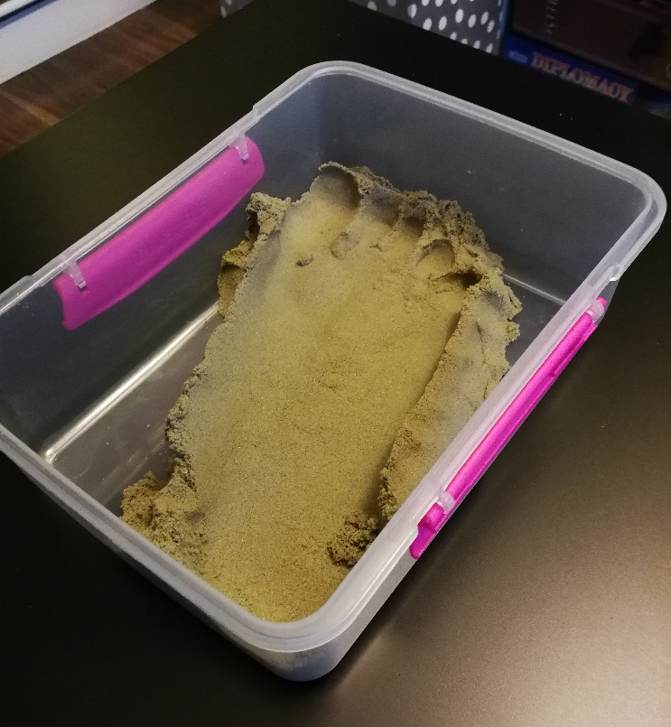
My second step was to go through taken photographs and delete the ones which were blurred or unclear and upload them to the photogrammetry software, in this case- Autodesk Recap.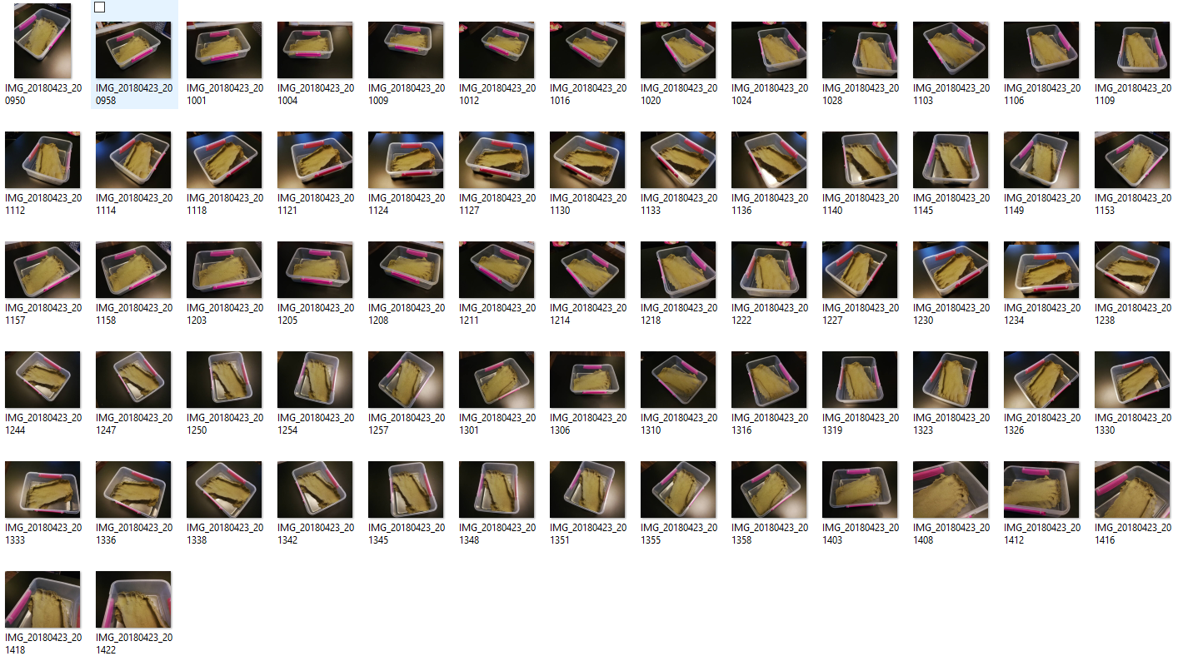

It took approximately 10 hours for the software to convert chosen photographs into a 3D model. When it finally converted I have added the measurements of my foot to the model.
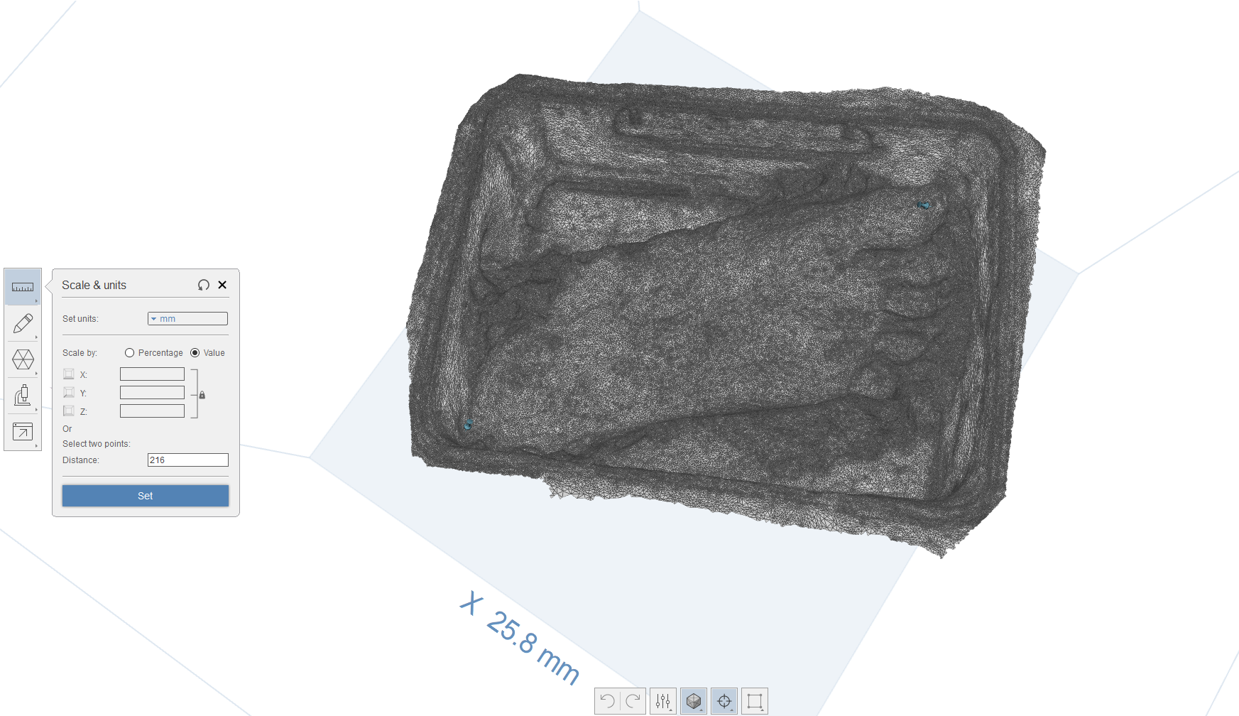

My next step was to smooth the surface of any unwanted parts and to crop any unwanted surfaces. I have used Autodesk Recap software Smoothing Tool to create a finished surface. 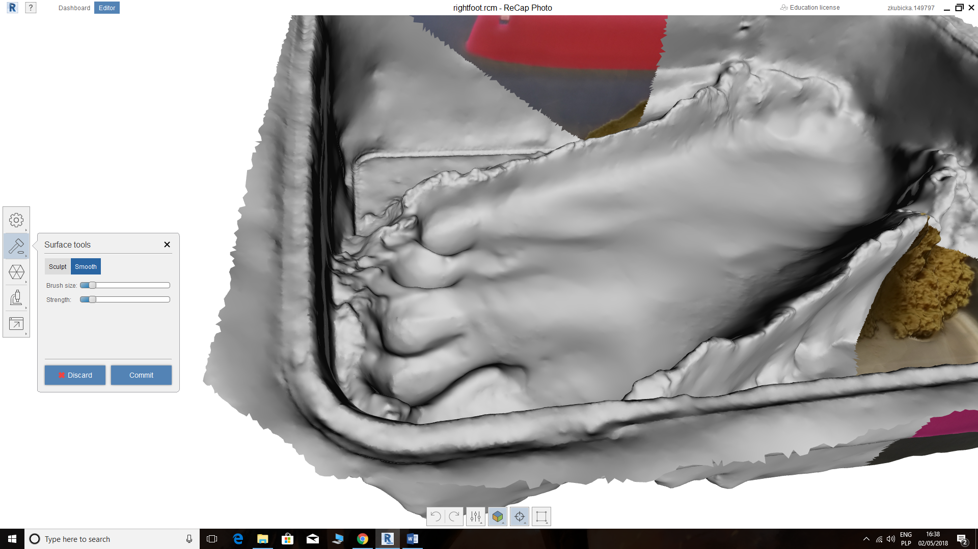

I have transferred my model from Autodesk Recap into Autodesk Meshmixer, to smooth and edit the model out of any bubbles, or parts which were not needed.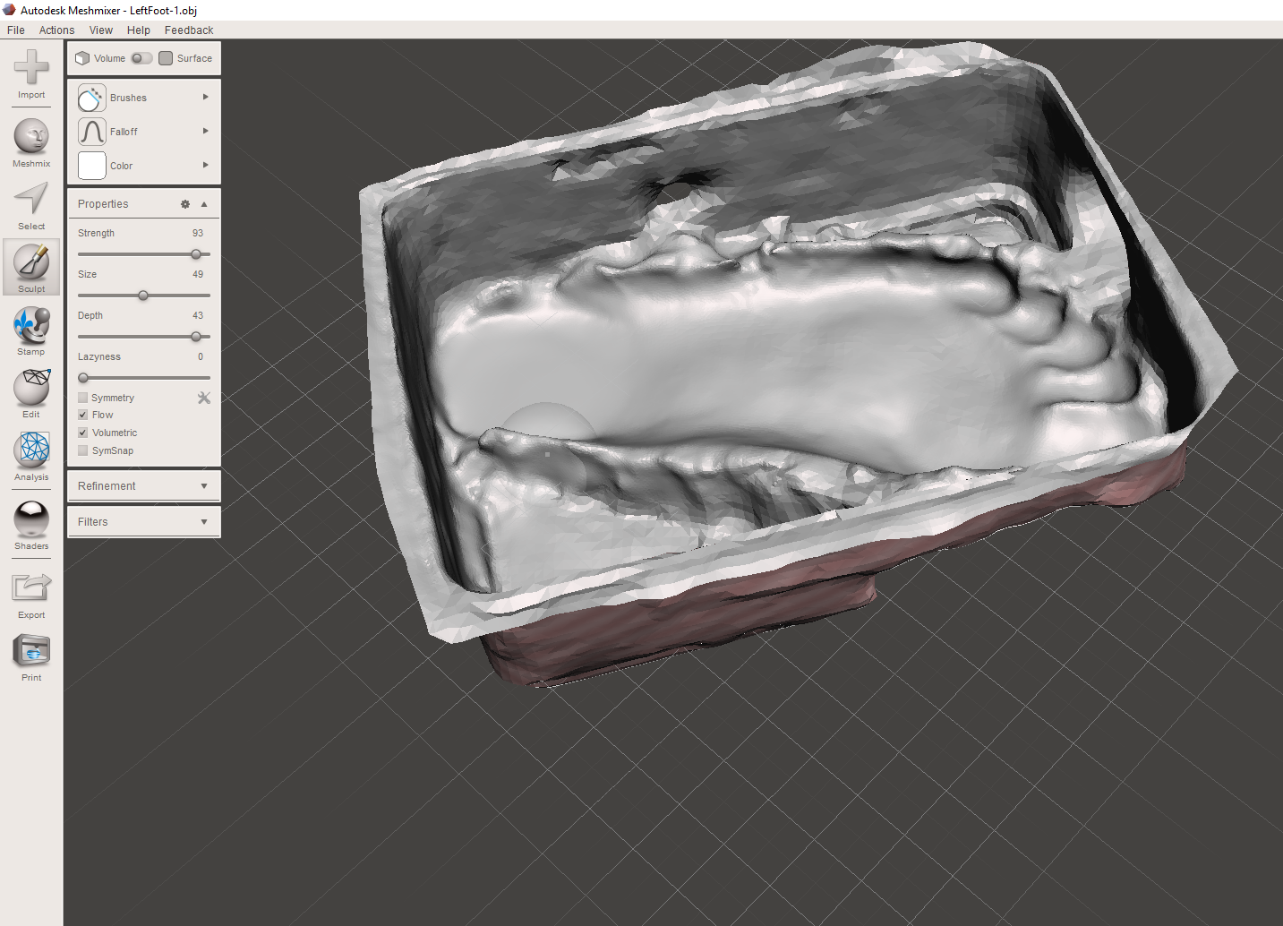
I have saved my file as QUAD mesh file and have exported it. In Fusion, I have imported my QUAD Mesh, and use converting function to convert mesh model into the T-Spline model. 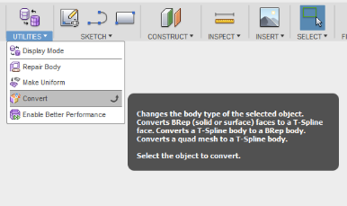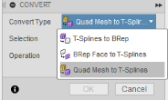
Before cutting my model, I had to edit faces using Fusion software to make some areas flatter. I have also made the edges more inline with each other, so there were no sharp corners.
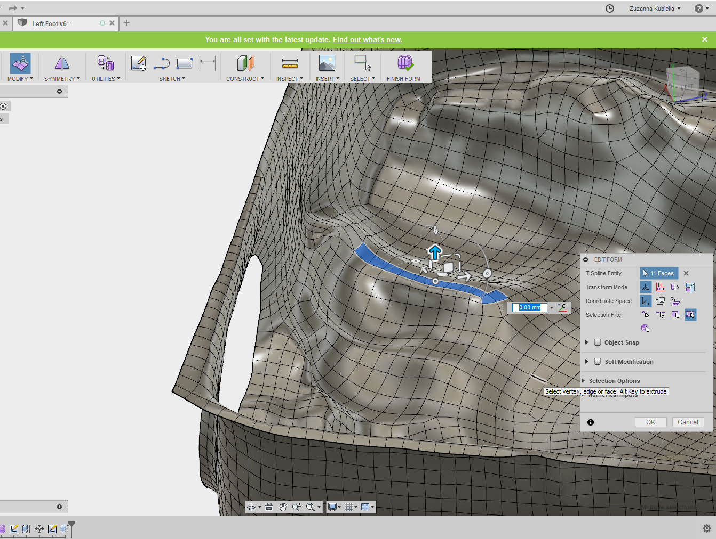
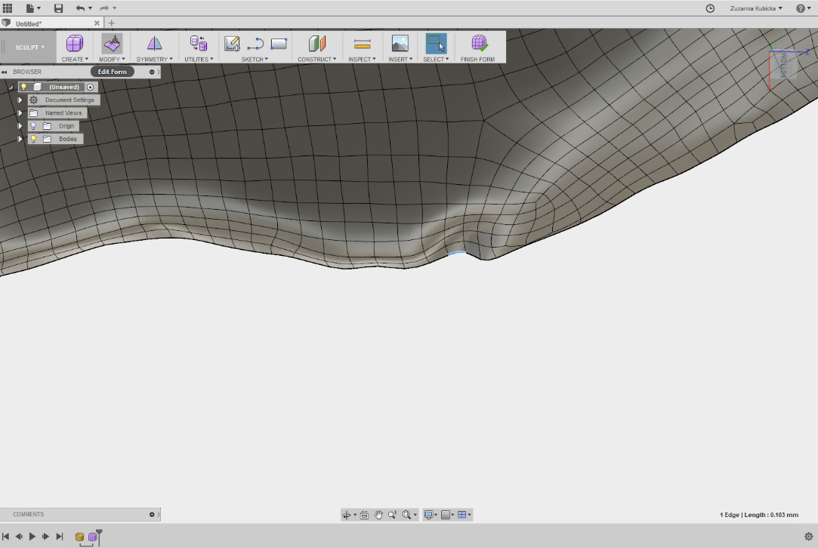
To create a model of the foot without the box, I have created an offset plane, on which I have produced an outline sketch of the foot inside the box. I have corrected the sketch by moving the points around.
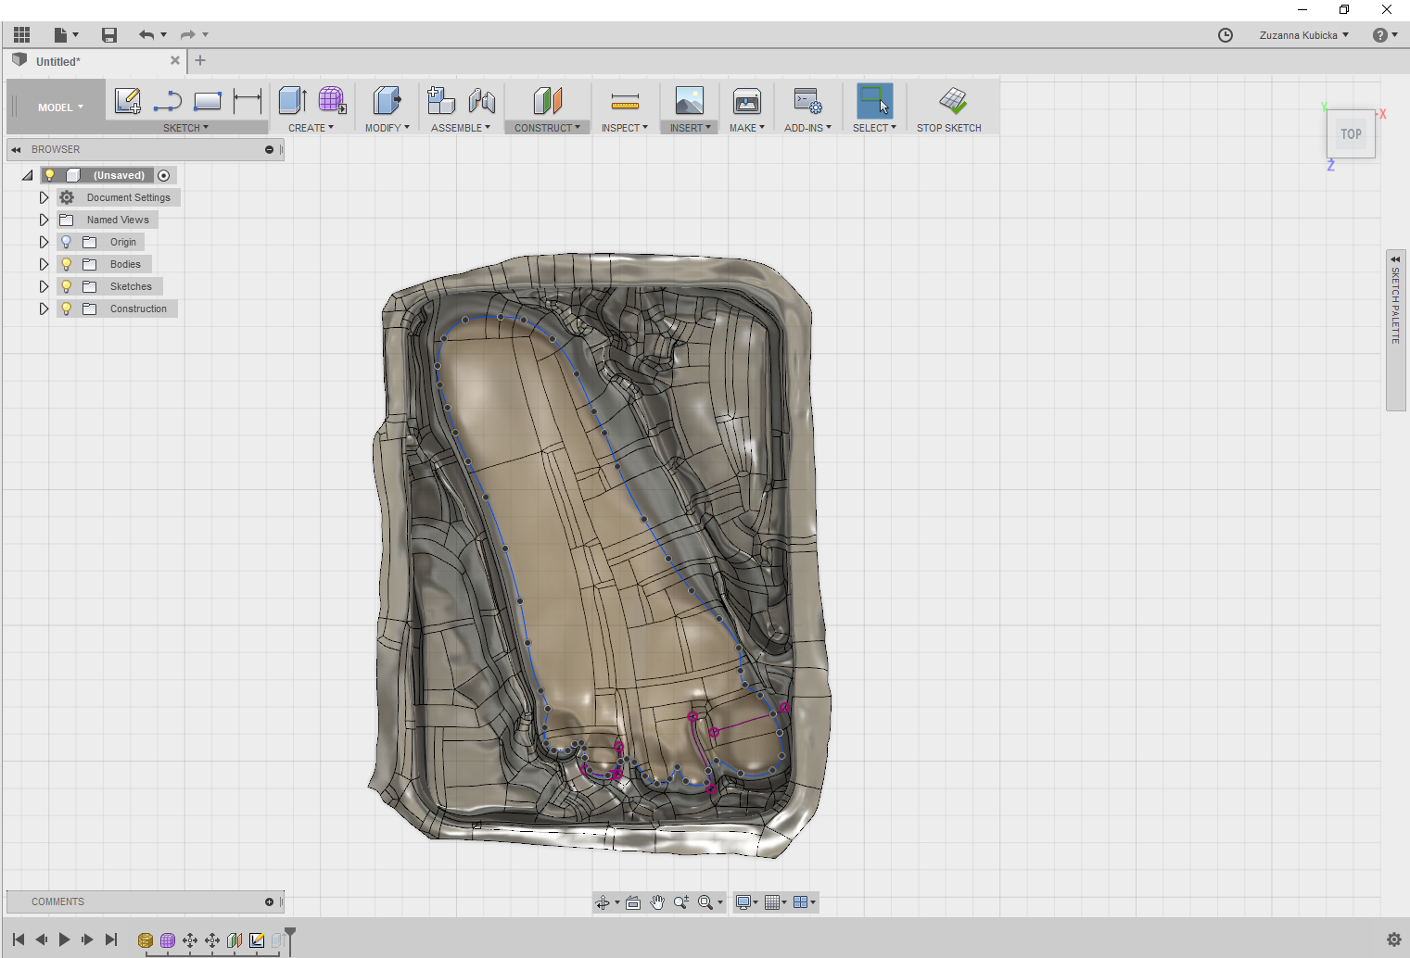

To cut out the unwanted surface of the box, I have used Extrude function in Fusion software. I have set the operation to Intersect so that only part of the model which fit into my sketch will left. 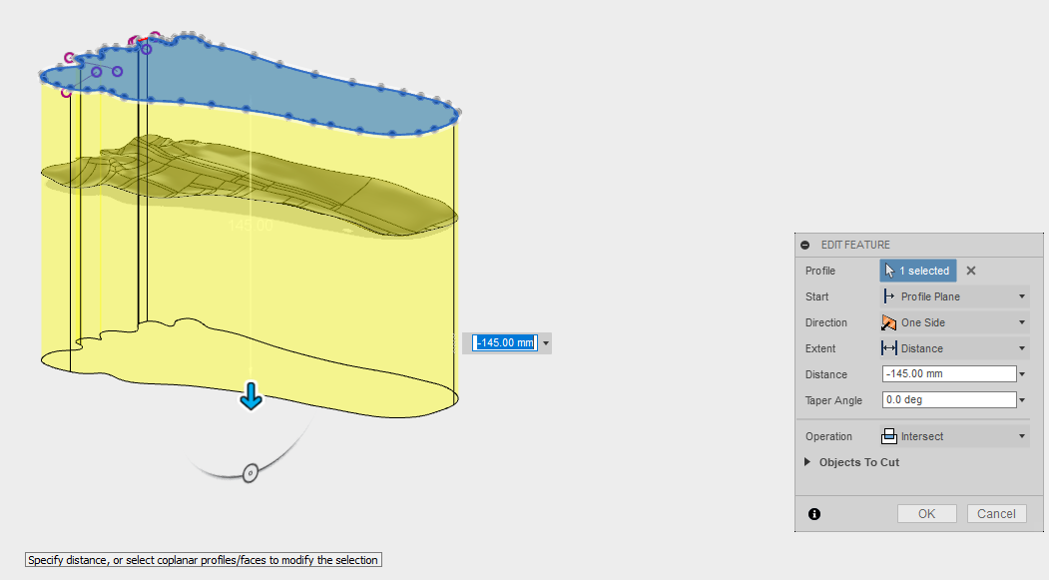

After extruding the sketch, I was left with the surface model, which needed a thickness. I have had a problem with adding thickness to the model in Fusion, so I had to export my model into STEP file, and I used another software called SolidWorks to resolve this problem. 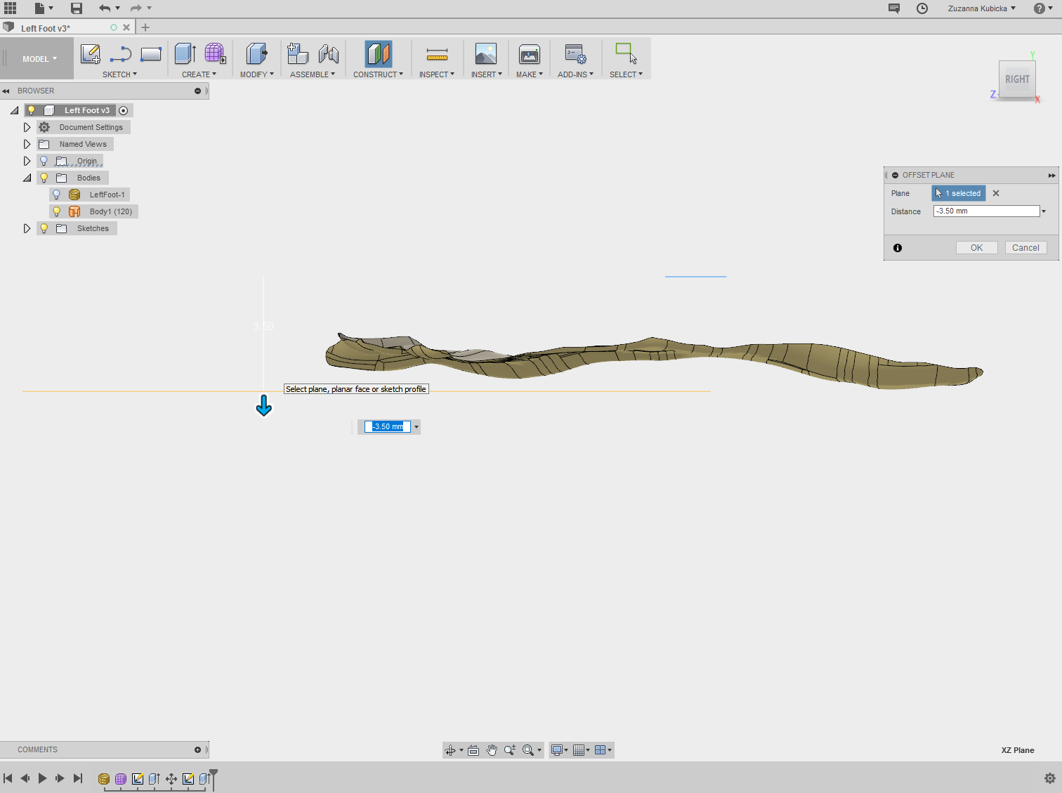
The software added thickness, but not enough, so I have decided to copy and paste the body three times and put them one on top of each other. I had then convert it again to STEP file and open it using SolidWorks.
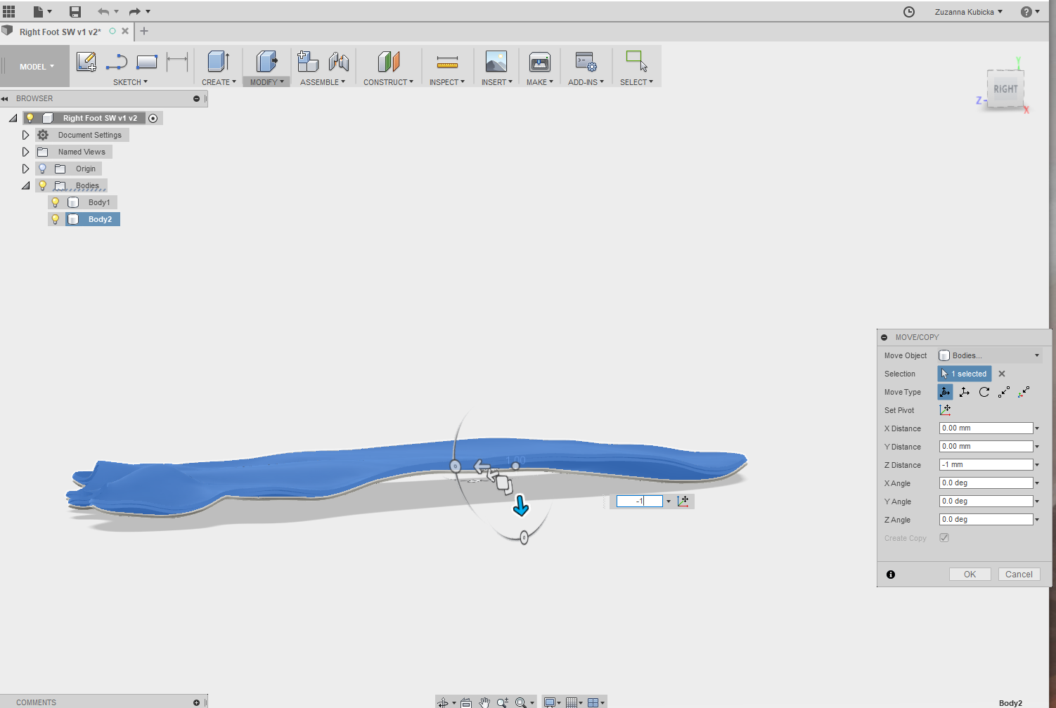

In SolidWorks, I have used Loft function to join three bodies, and some parts were hollow. Because the model was made in patches I had to loft each part individually.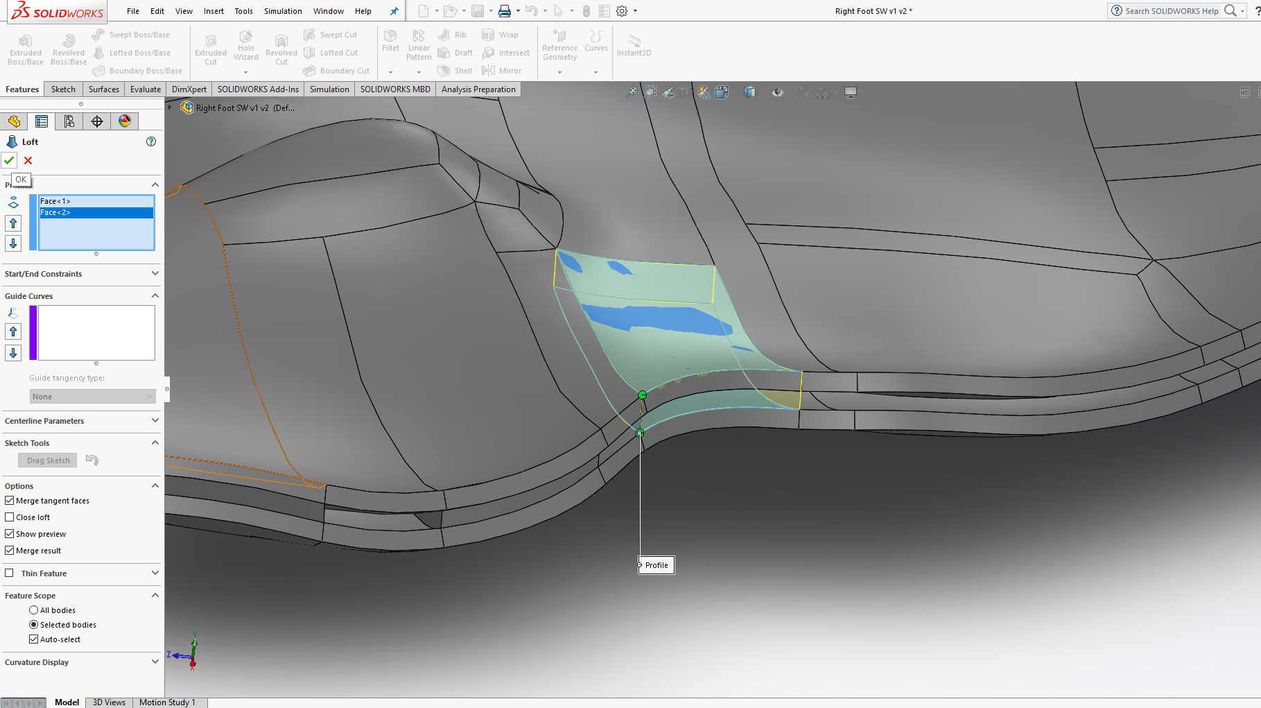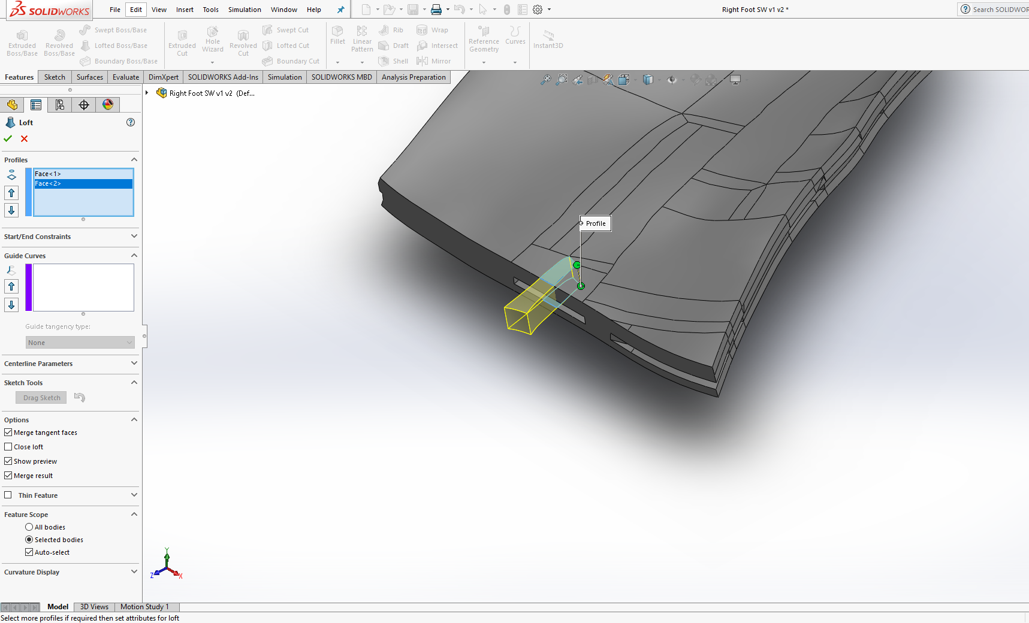
I have exported the model from SolidWorks into Fusion, and I have finished lofting the model using Fusion.
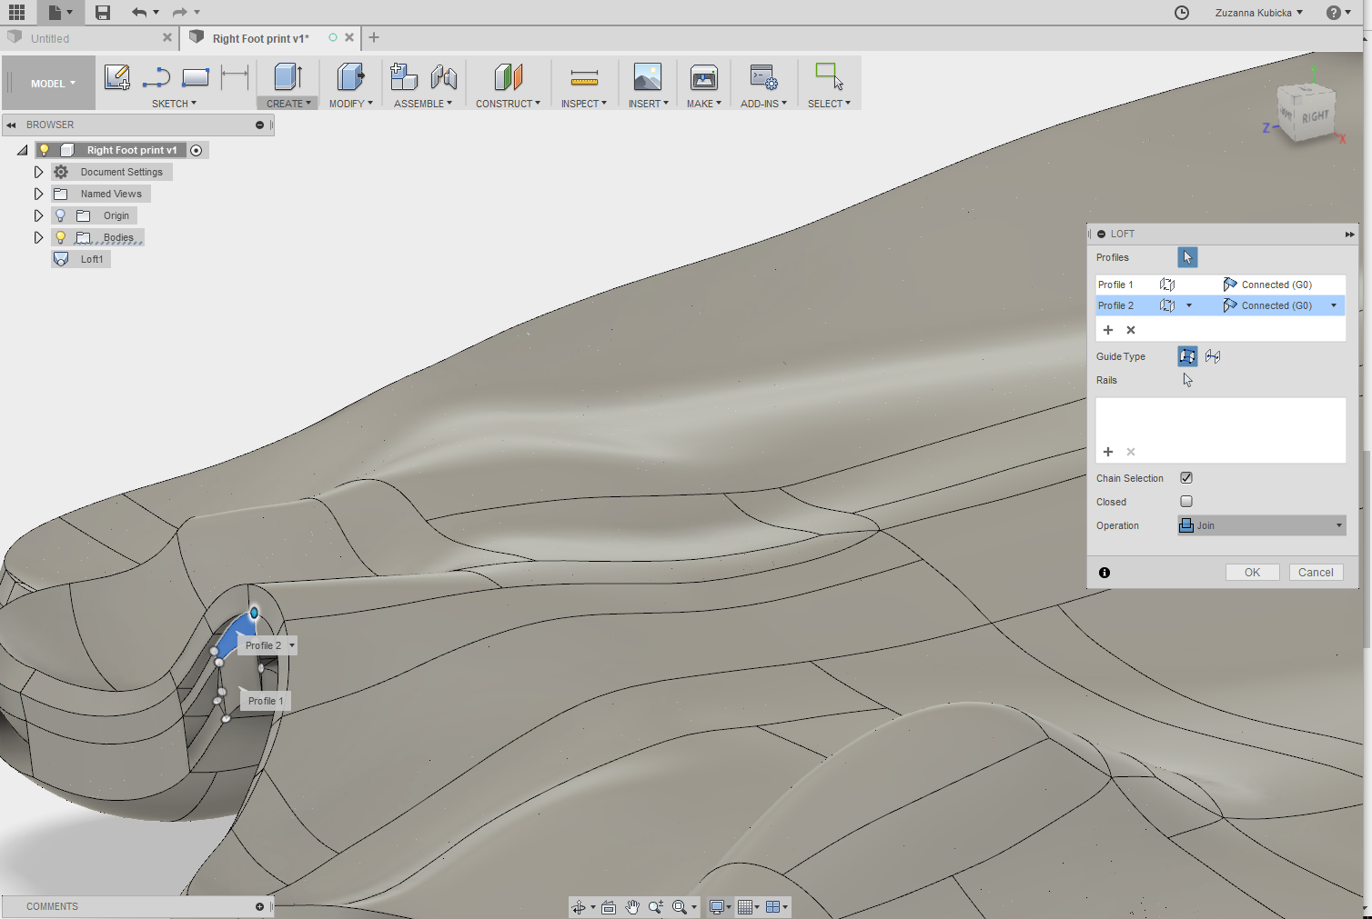
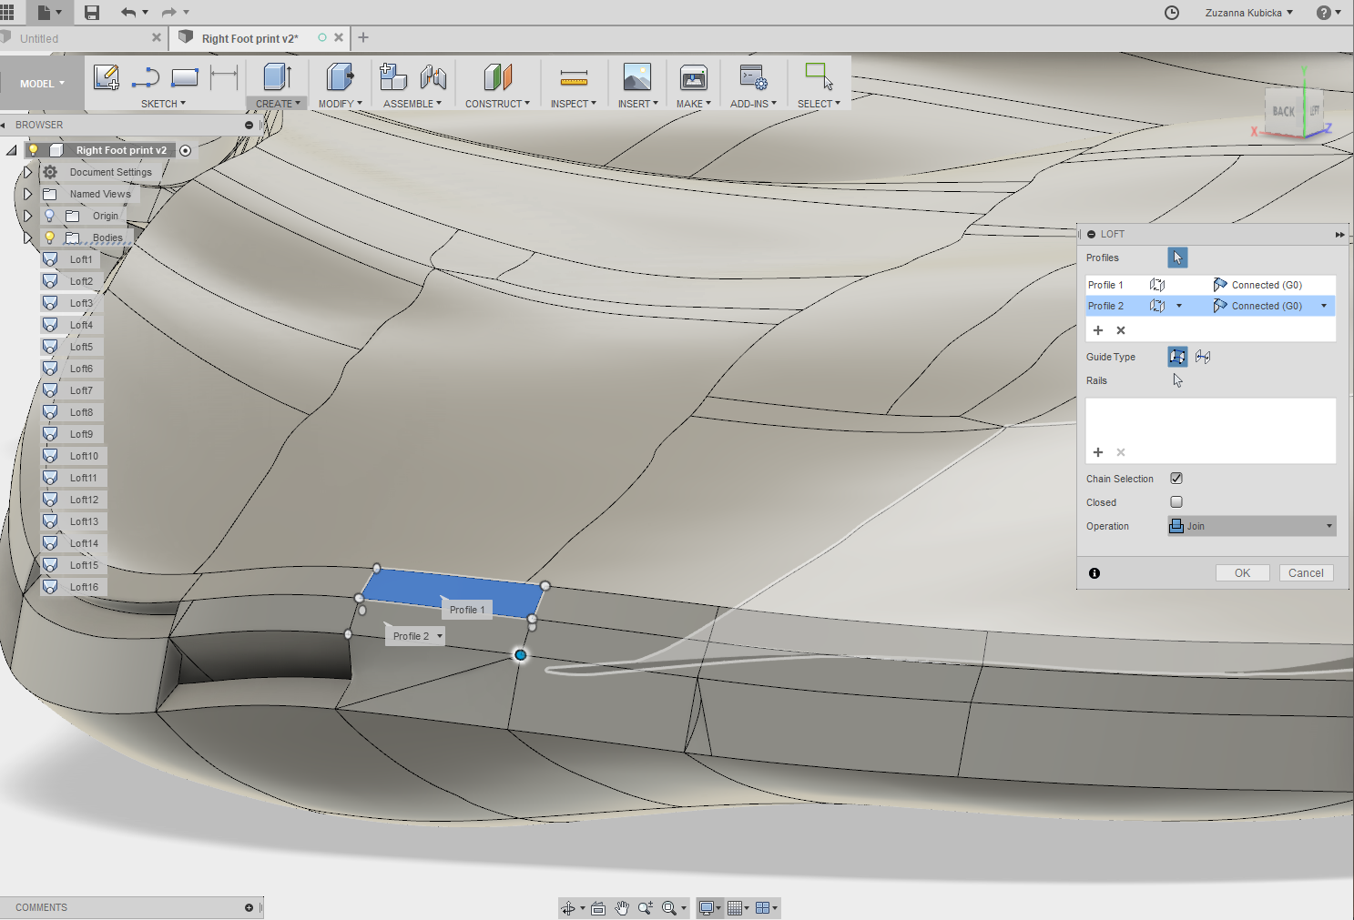
After finishing lofting, I have saved the file as STL ready for taking it to Cura.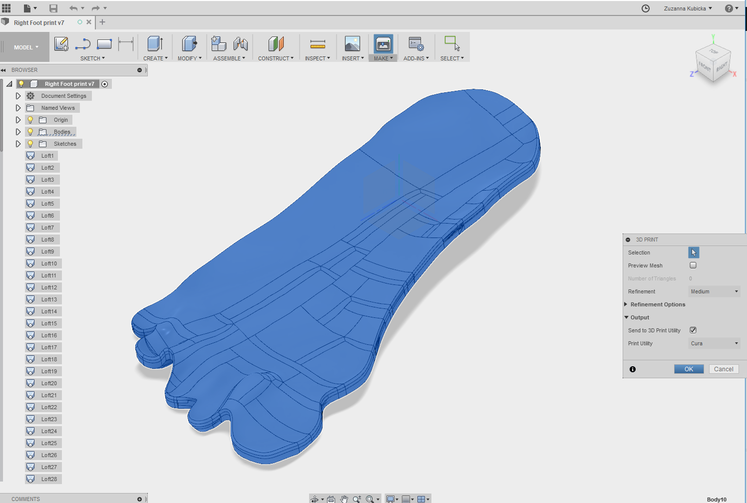
I have inserted saved STL file into Cura, but the size of the file was really big, and every time I tried to import the model into Cura it was crashing because of the size. After I have finally managed to save G CODE for printing, I saved my model into SD Card. 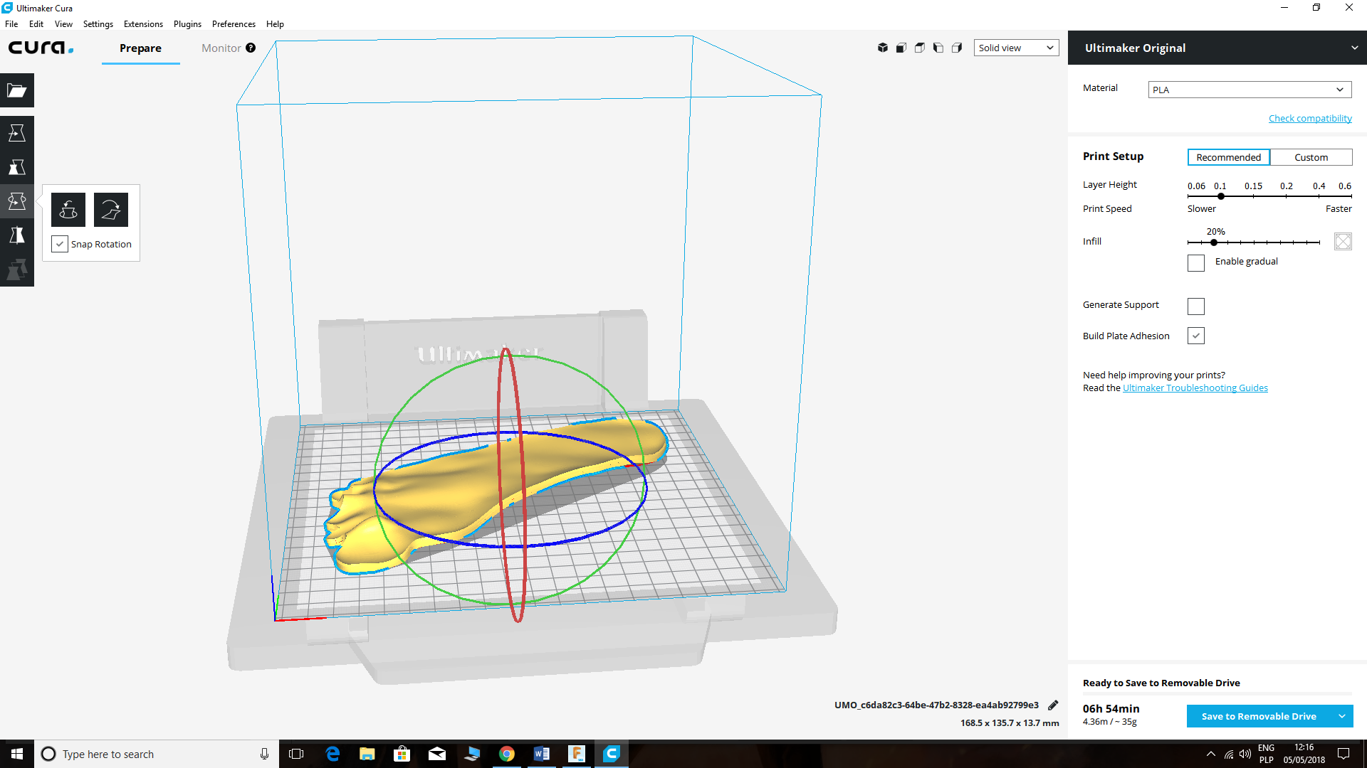

The SD card has been inserted into Ultimaker Original printer with a heated bed and set up for Auto Home. When the printer started to work, I found out that there is a problem with the model as it contained holes.

After discussing this with a tutor, I have decided to use Project function to project the edges of surface model and offset it by 1 mm.
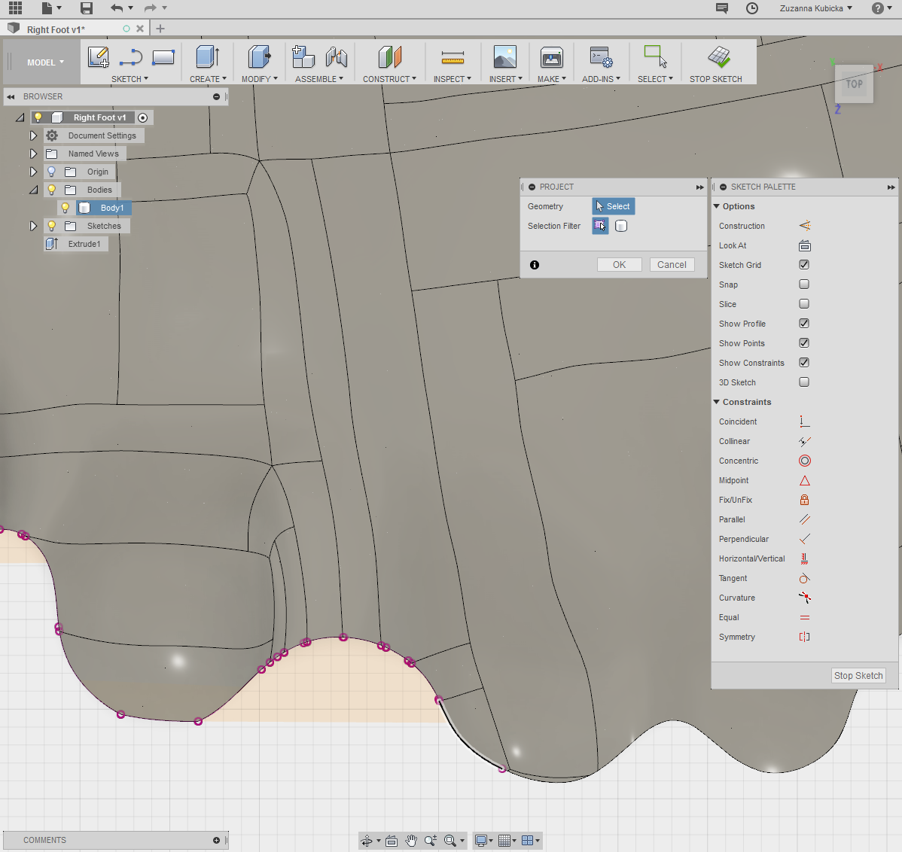
After offsetting and creating a new sketch, I have used extrude function where I have set up the distance To the object and joined extruded body to the surface model, which gave a solid, flat base, and curved, customised top. 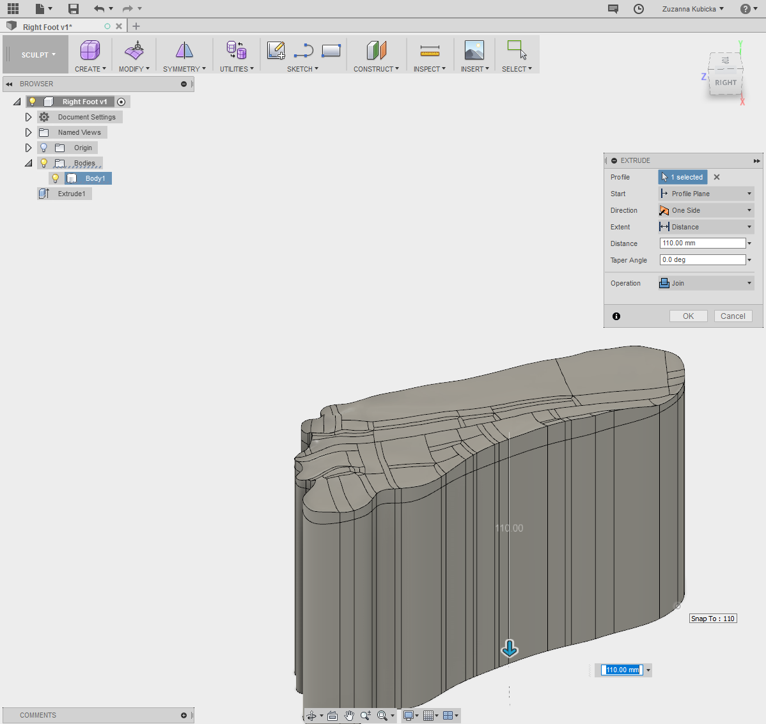

I have cut the bottom of the extruded part, to the size which I wanted, so that the sole would not be too thick, as well as not too thin. 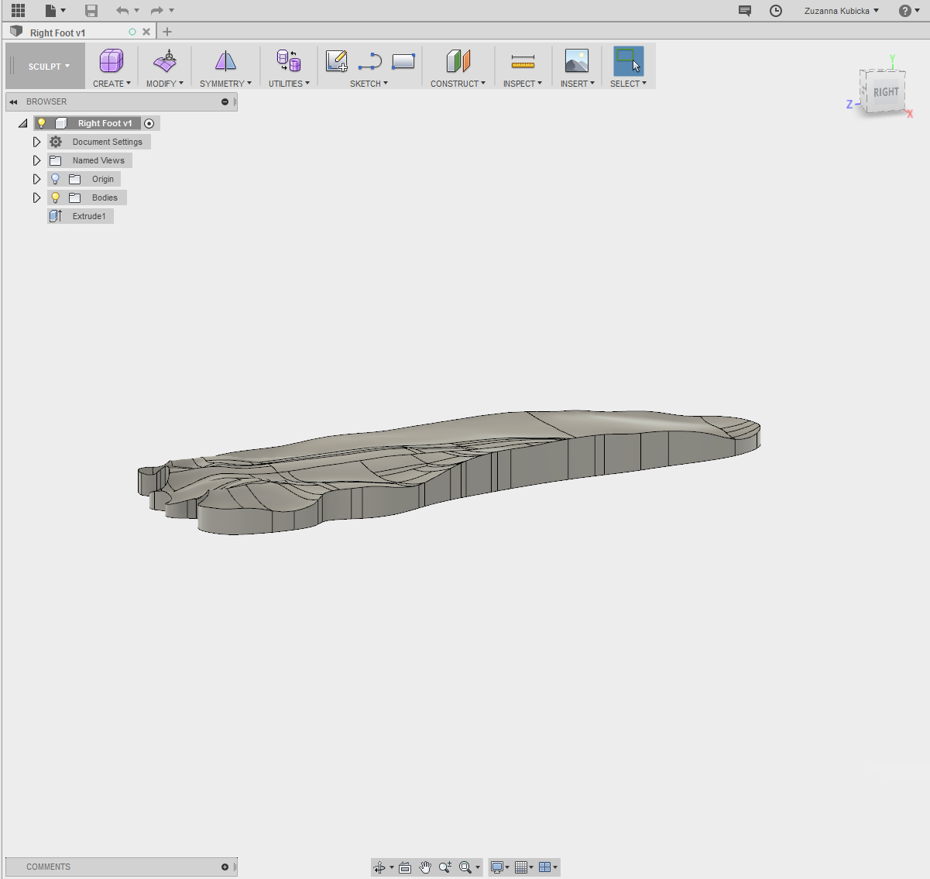
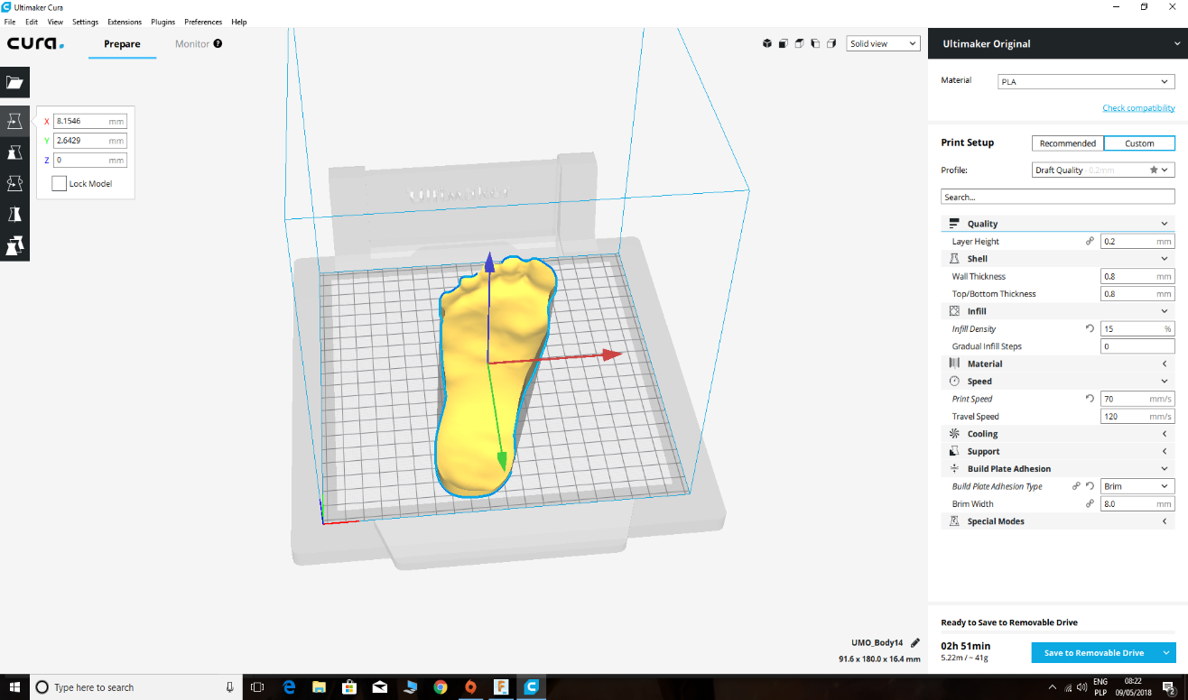
I have exported the body of the model as STL file and imported it into Cura. In Cura, I have modified some advanced settings. I have set up the infill for 15. The wall, top and bottom thickness were 0.8mm. I have also added build plate adhesion which was brim type. I did not add any support structures, as the bottom of the model was completely flat. The layer height was set up as 0.25mm. The printing time came to 2 hours and 35 minutes.
Conclusion
To conclude, I had some trouble while editing the model, especially with adding the thickness, as Fusion software kept crashing every time I tried to add thickness to the surface. There was a problem with the first sketch, which also made the size of the file very big. When I subtracted 1mm of this sketch and used extrude function to add flat bottom, it worked. The project gave me knowledge about using 3D printing machine, how to set it up, and which software the machine support. It also gave me a little bit more knowledge about file types, and photogrammetry option, which is very useful in modern days in design and manufacturing industry. I have learnt by the trial method, and also by asking questions, I have resolved the problem.

