Component 1 – Website Redesign for Online Business Presence
Student name | Taishee Khan
Student number | 2133060
Course title | BSc Applied Computing
Module name | Business and Web Management (ACCA5019)
Lecturer | Dr Mobolanle Bello
Assessment | Component 1
Submission Date | 23rd October

Contents
1.0 Introduction 3
2.0 WellCare Connect Website Redesign 3
2.1 Navigation, findability and emergency access 3
2.2 Visual Design, Branding and Trust 3
2.3 Accessibility 4
2.4 Booking Flow and Calls to Action 4
2.5 Performance 4
2.6 Personalisation and Telehealth 5
3.0 Responsive Design Implementation 5
3.1 Responsive Design 5
3.2 Implications of responsive design in e-commerce websites for improving user experience 5
3.3 Implications of responsive design in e-commerce websites for increasing mobile sales 5
4.0 Implementation Section 6
4.0.1 Moodboard Screenshot 6
4.0.2 Wireframe screenshots 6
4.0.3 Web design screenshots 10
4.1 Moodboard and Wireframe Design 16
4.1.1 Moodboard 16
4.1.2 Wireframe 16
5.0 Conclusion 17
6.0 References 18

1.0 Introduction
This report covers the UI/UX redesign of WellCare Connect, an online healthcare provider providing online scheduling, virtual care, digital prescriptions and access to medical records. It's intended to establish a new site design that makes it easier to use, accessible, trustworthy and converting, such as converting customers. Five main pages were considered (Home, Find a Doctor, Book Appointment, Virtual Care and Dashboard) and represented as a 'mood board', 'wireframes' and a prototype interactive 'Inkscape' (without live site). The methodology is user-centred: Auditing current issues, reading peer-reviewed literature, developing a mood board to establish a visual focus, wireframing layout and functionality, and constructing high fidelity prototype pages. The present problems and solutions are discussed in section 2. Responsive design for user experience and mobile sales are analysed in Section 3. Section 4 explains the implementation artefacts and how they were developed using the mood board and wireframes, and Section 5 presents the reflection. The report matters because patient retention depends on perceived usability and trust [1, 2], and a systematic, evidence-based design process reduces the risk of costly redevelopment and keeps the platform aligned with WellCare Connect's strategic objectives. All design decisions are therefore clearly tied to a business objective and to evidence.

2.0 WellCare Connect Website Redesign
The audit identifies interrelated issues of findability, visual credibility, accessibility, booking, performance and personalisation. These are discussed separately below, and then the solution adopted for the prototype. Evidence is primarily drawn from healthcare and e-commerce research and is therefore qualified where applicable:

2.1 Navigation, findability and emergency access
Current issues. Patients struggle to know where to go and find it difficult to locate specialist directories, telehealth services, and emergency contact numbers. Guo et al. found navigation and information design to be the most important factors determining perceived usability of shopping websites and thus satisfaction and loyalty [1]. In healthcare, the consequences are more significant because users may be sick or worried. Poor findability also negatively affects the specialist directory, which relies on users' ability to narrow choices by specialty, area, availability, and insurance.
Proposed solutions. One common 5-item navigation (Home, Find a Doctor, Book Appointment, Virtual Care, Dashboard), search, one search bar at the homepage (Find the Right Care), a filterable doctor directory, and a 24/7 Emergency Support panel with a one-tap call button. Red is used only for emergencies; it doesn't dilute urgency. On the Find a Doctor page, new filters for specialty, availability, gender, and insurance; list and map modes; sorting and rating; doctor cards with ratings; languages; consultation type; and more let patients compare doctors without leaving the page.

2.2 Visual Design, Branding and Trust
Current issues. Confidence levels are lowered by the old-fashioned appearance and inconsistent branding and trust-building features. In their study, Guo et al. identified that the major factors in determining satisfaction were the visual design, and the effect of this on satisfaction was found to be moderated by customer trust [1].
Proposed solutions. A single teal palette, a single typographic pairing, rounded components, and warm photography establish a contemporary, consistent identity (Figure 1). Trust cues are clinician portraits, ratings, availability badges, insurance information, a link to "Secure & Private" messaging, and links to privacy and terms in all footers. The subscription objective is supported by Sign Up and the footer "Subscribe to Updates". A stock-clinical visual style was not used because warm and human imagery is better suited to an empathetic brand, and the trade-off was the requirement to have authentic and diverse photography and consent for any real clinician images.

2.3 Accessibility
Current issues. Limited accessibility support. A scoping review of accessible health platforms identified common problems with the WCAG principles of perceivable, operable, understandable and robust content, and many studies were tested only to Level A or used only automated tools [3].
Proposed solutions. The prototype aims for WCAG AA compliance: at least 4.5:1 text contrast, icon-plus-text labels, large touch targets and consistent navigation. Although automated checks are available, we recommend manual testing with assistive technologies and real patients before development. Suggested development improvements include keyboard focus, alternative text for images, labels for form fields and captions or transcripts for video consultations.

2.4 Booking Flow and Calls to Action
Current issues. Booking flows are unclear and calls to action ineffective. Alfurayh et al. found that rescheduling appointments was the most-used patient-portal function and that satisfaction was linked to convenient login and clear information [4]. Simola et al. [2] discovered that the perceived usability of a system is more affected by negative experiences than by adding features, meaning that there is more to be gained from friction removal than friction addition.
Proposed solutions. The booking process becomes three steps (Date & Time, Patient Details, Confirmation) and a doctor profile, calendar, time slots and one "Continue" button. Primary actions are colored in solid teal, with outlined buttons being secondary actions. Progress indicators and an "at-a-glance" doctor profile contribute to reducing uncertainty, and an always visible "Back to Doctors" link ensures easy access to the correct way if you take a wrong turn.

2.5 Performance
Current issues. Slow loading negatively impacts the experience. Across 121 institutional homepages, mobile scores (mean 38.7) were significantly lower than desktop scores (mean 69.6), with first and largest contentful paint most influential [5]. A systematic review has been conducted to verify that load time, page size and response time are the key factors in the research of website performance [6].
Proposed solutions. The recommendations include compressed images, images loaded on demand, minimal scripts, a content delivery network, and performance budgets for first and largest contentful paint. These are design recommendations and not measured results, since the prototype is static.

2.6 Personalisation and Telehealth
Current issues. The platform has no customizations or reminders. A systematic review identified that personalised content, individualised push reminders, stable, user-friendly design and personal support have always been found to increase adherence with health apps [7], while behaviourally oriented reminders resulted in an increase in scheduling through a portal [8]. Experts have found that usefulness of telehealth to be good, although there are technical, connectivity, and training challenges [9].
Proposed solutions. The Dashboard provides an overview of appointments, prescriptions, records and messages and includes quick actions and reminders. The Virtual Care page incorporates a "When to Use Virtual Care?" guide, video, chat and consultation information, and a clear "Not for emergencies" warning to help less confident users. The measures reflect the three main objectives of patient engagement, trust and conversion – personalised reminders keep patients engaged and a clear telehealth path enhances access to care.

3.0 Responsive Design Implementation

3.1 Responsive Design
Responsive Web Design is a design approach that lets a single site render content fluidly across various screen sizes, rather than requiring multiple sites. [10] From 40 responsive websites, Li et al. identified six prevalent layouts and general, adaptable, and individual design factors that maintain interface consistency across devices. It includes card grids that flow from four columns to one, flexible navigation that becomes a menu and calendar and video panels. It's made possible by the core techniques of fluid grids, flexible images and media queries.

3.2 Implications of responsive design in e-commerce websites for improving user experience
Having the same consistency across devices lowers relearning, which correlates with the usability that Guo et al. showed to be a factor for satisfaction [1]. Patients can book on the phone while on the move and then book from their tablet when at home – the same navigation order and booking steps reduces the cognitive load. Experience is part of performance: mobile pages were significantly lower than desktop [5] – responsive images and thin layouts are a must. Reflowing is also useful for low vision or motor impaired users, but will need testing [3]. Most importantly, responsiveness isn't enough; a sub-optimal mobile layout simply reduces clutter on a desktop screen. The content needs to be prioritised mobile-first, with the emergency contact, search and booking options being listed first. Likewise, target touch targets should be at least 44px, forms should automatically activate mobile keyboards, and calendars should reflow without horizontal scrolling.

3.3 Implications of responsive design in e-commerce websites for increasing mobile sales
Wang and Choi determined that ease of use, system quality, interactivity and scarcity cues enhanced consumer engagement, thereby improving the intention to reuse mobile commerce [11]. WellCare Connect's "sales" are done bookings, virtual-visit starts and subscription enrollments. The most used feature of a portal is a booking flow that is easily usable, has a thumb-friendly interface and a sticky “Continue” button, which directly addresses the mobile conversion [4]. Reminders and a personalised dashboard can help engage people with the service and boost return visits – since a lifestyle or mental-health app is unlikely to keep people for more than 100 days after they sign up [12].

4.0 Implementation Section

4.0.1 Moodboard Screenshot
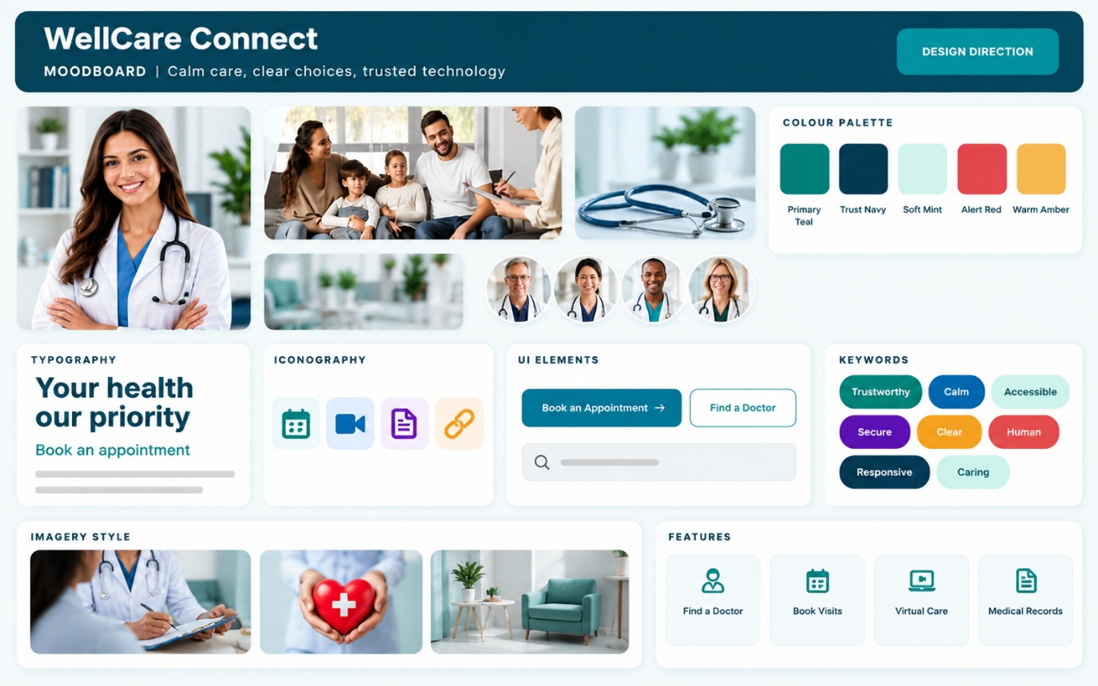
Figure 1: WellCare Connect mood board (palette, typography, imagery, iconography, UI components and keywords).

4.0.2 Wireframe screenshots

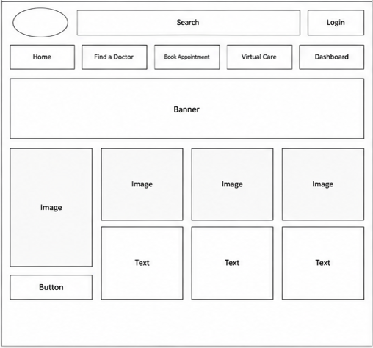
Figure 2: Homepage wireframe.

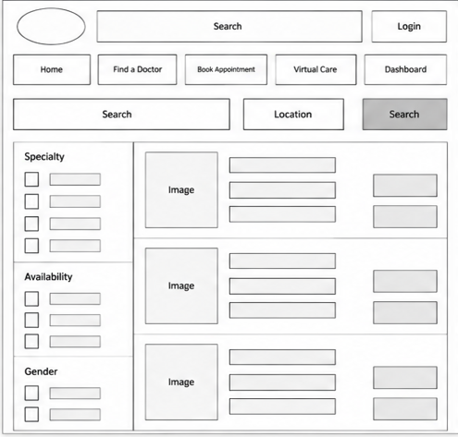

Figure 3: Find a doctor wireframe.

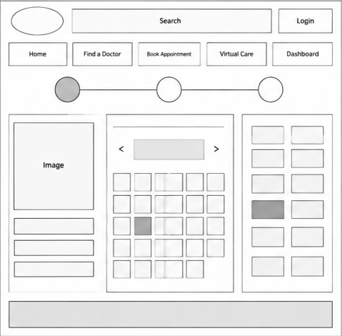

Figure 4: Book Appointment wireframe.

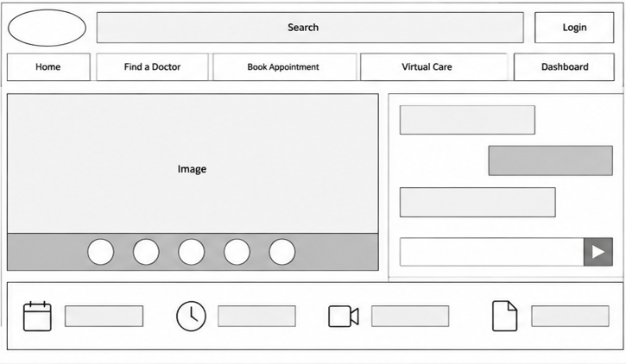
Figure 5: Virtual Care wireframe.
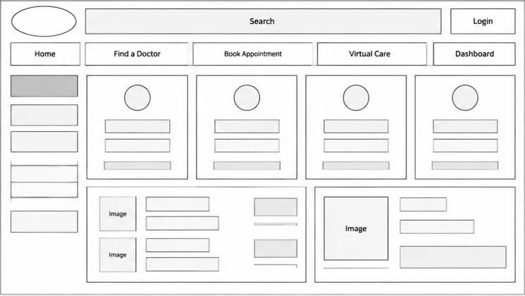

Figure 6: Dashboard wireframe.

4.0.3 Web design screenshots

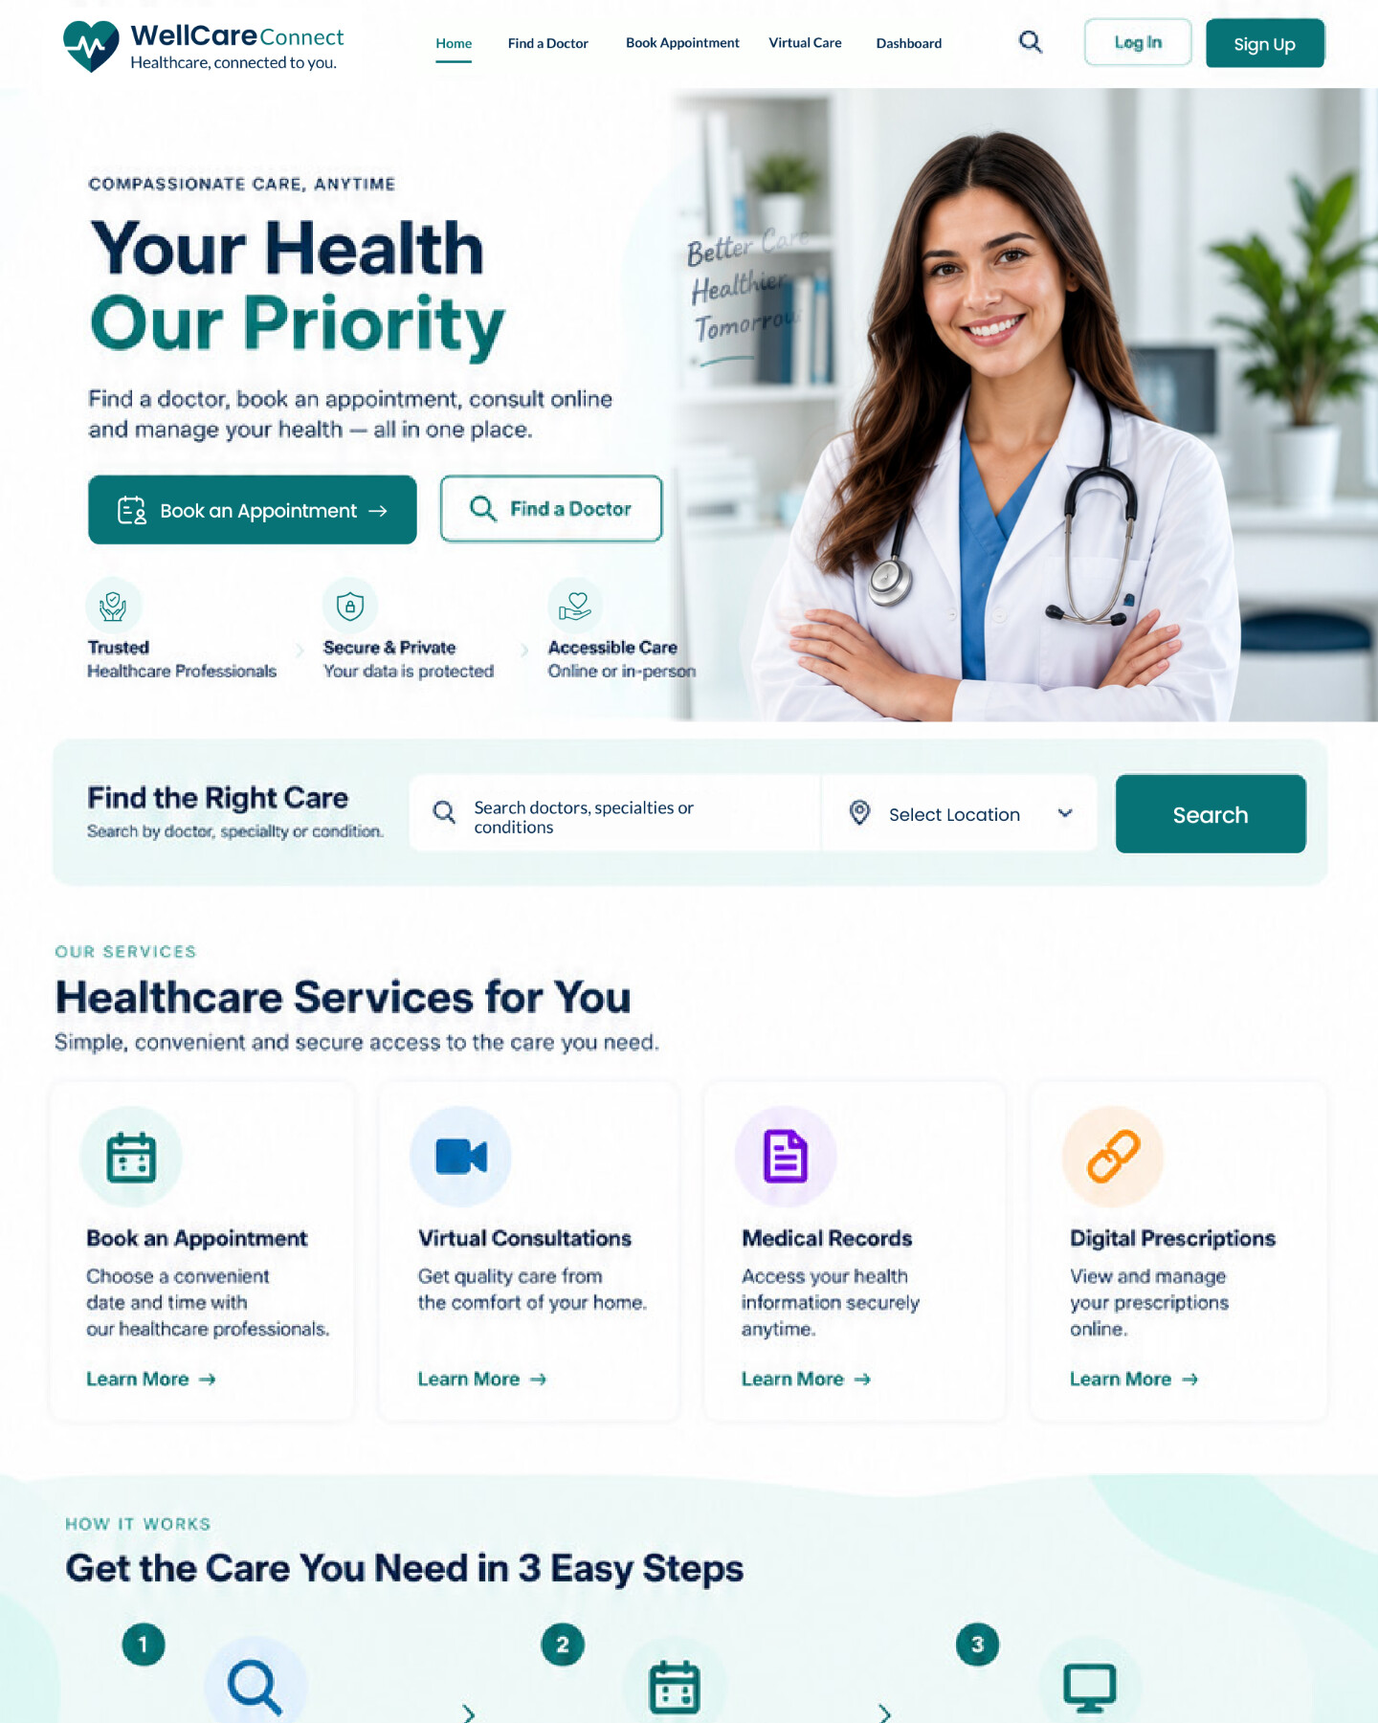

Figure 7: Homepage web design (part 1 of 2).
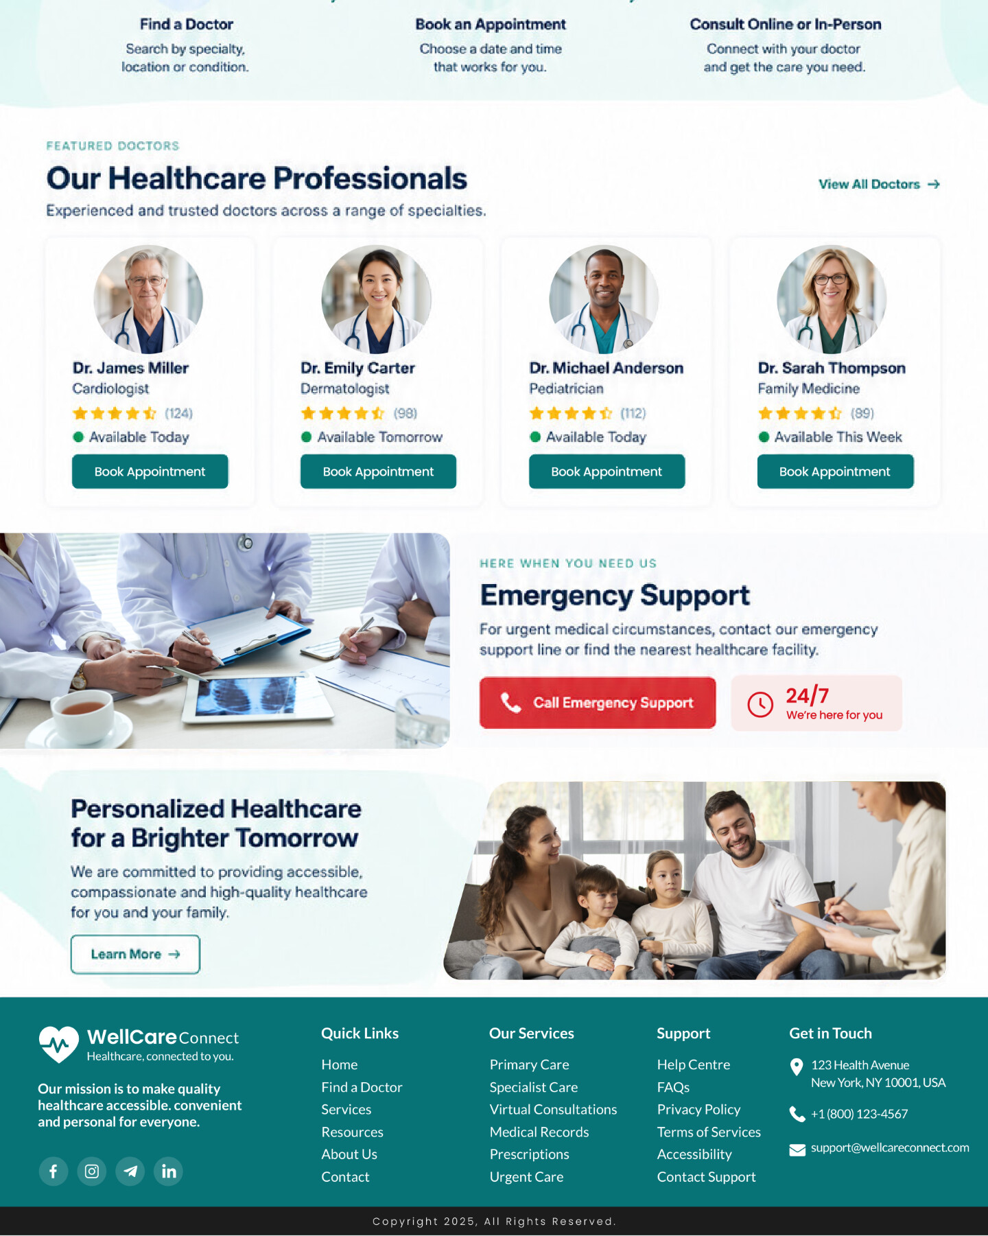
Figure 7 (continued): Homepage web design (part 2 of 2).
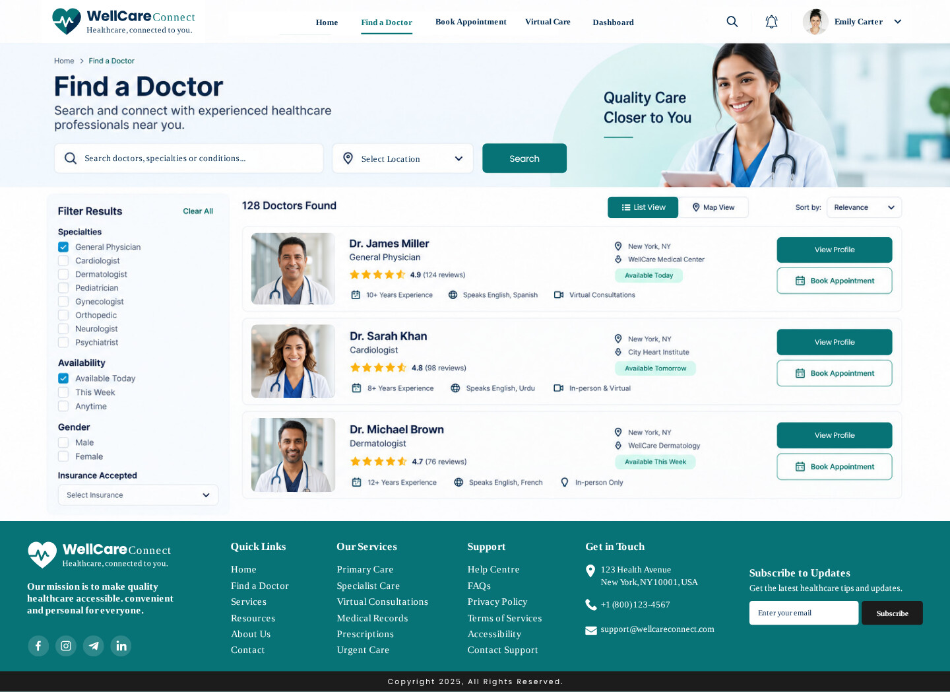
Figure 8: Find a Doctor web design.
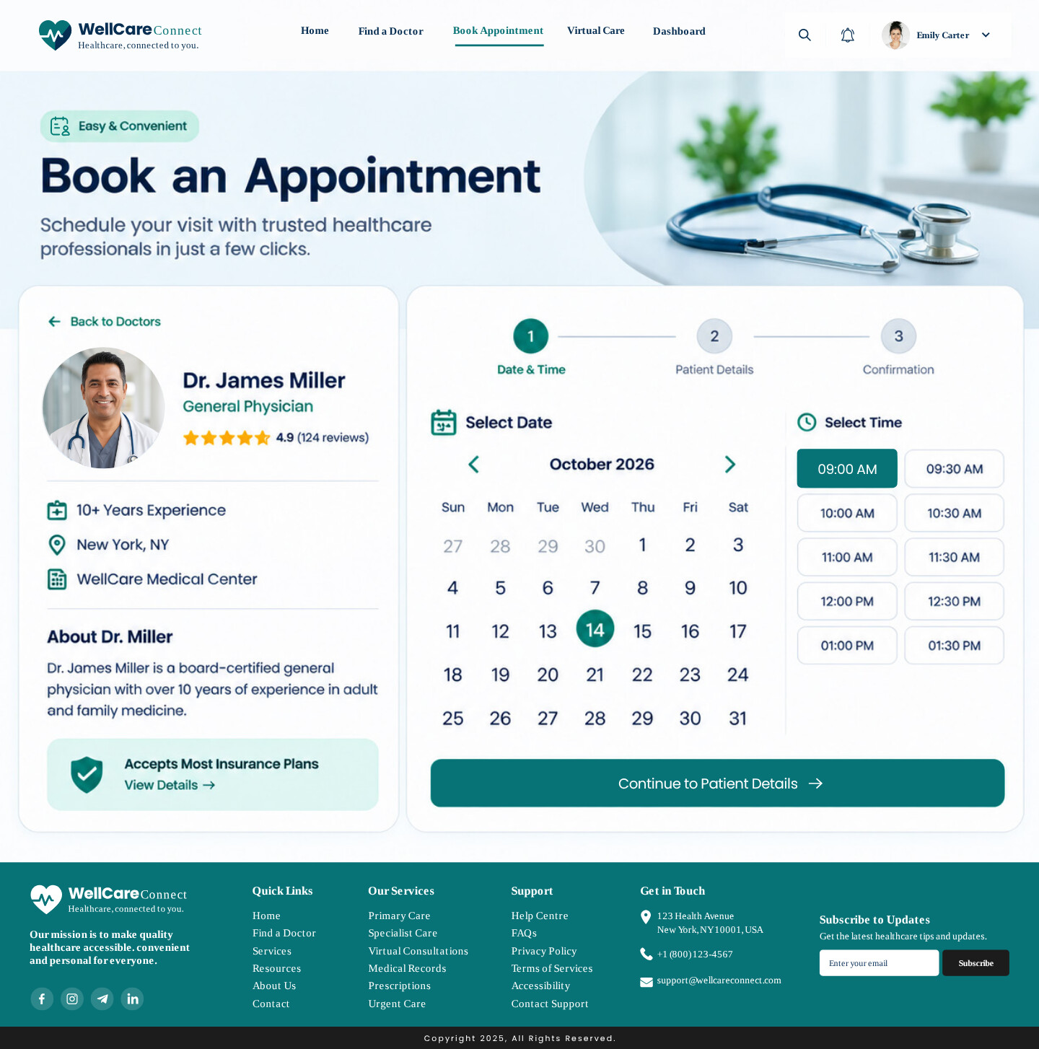
Figure 9: Book Appointment web design.
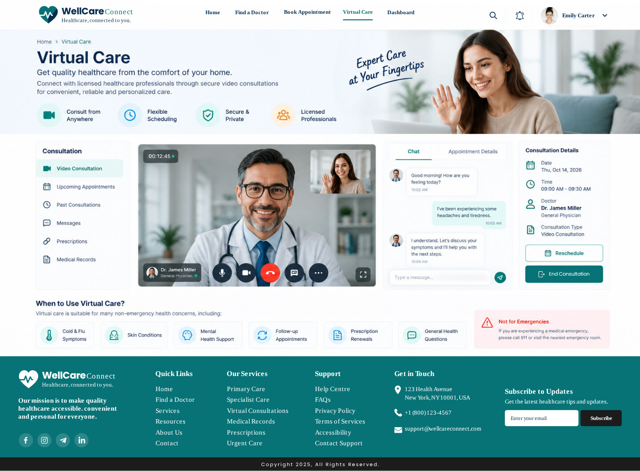
Figure 10: Virtual Care web design.
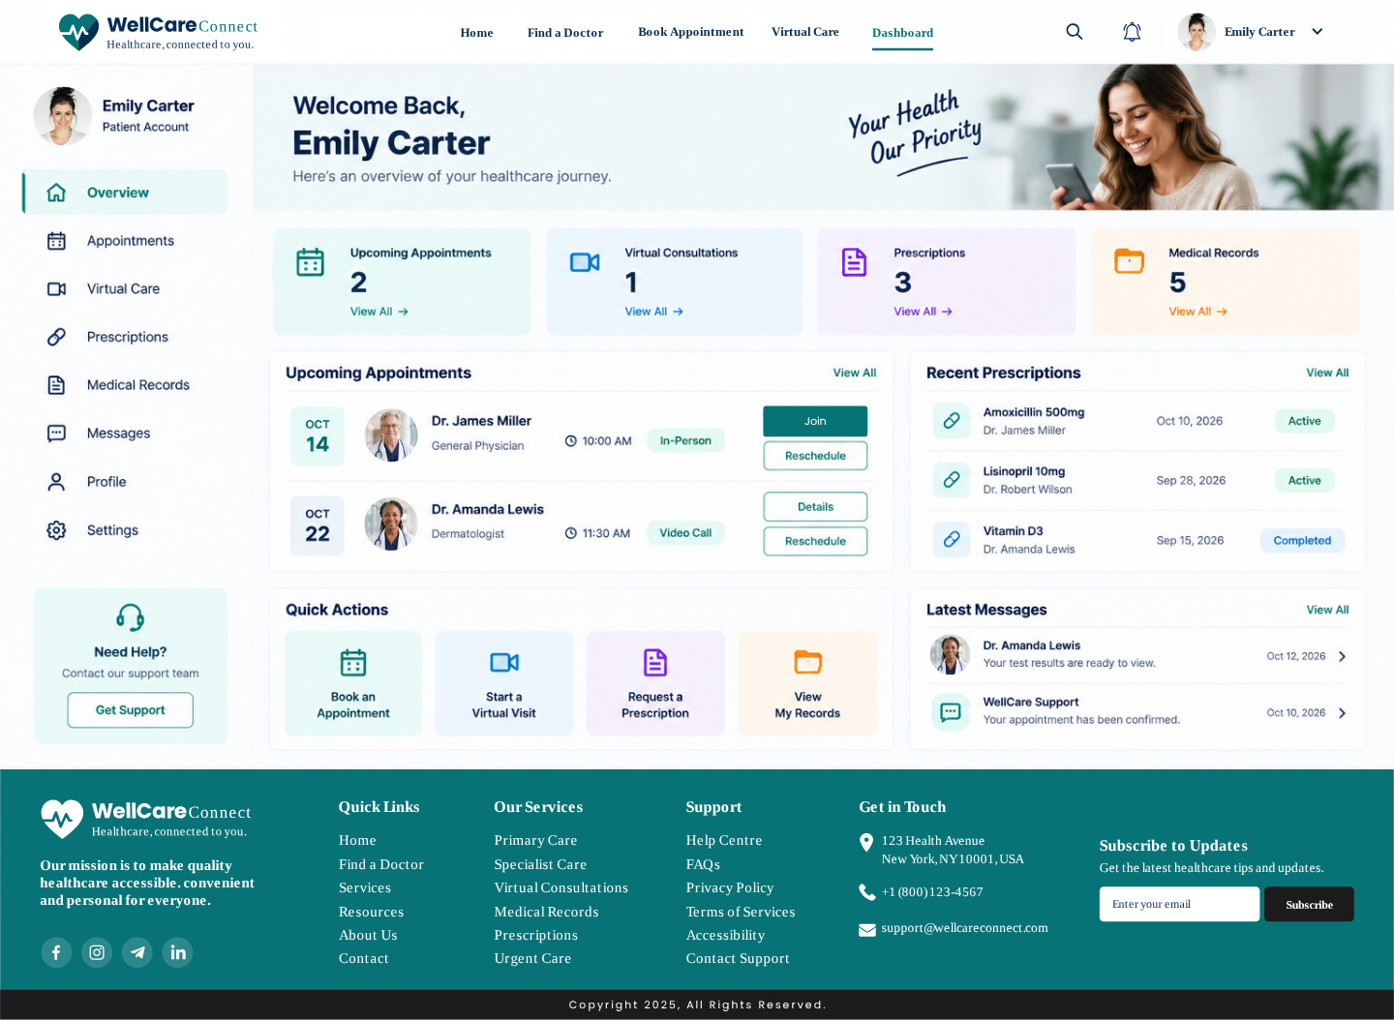
Figure 11: Dashboard web design.

4.1 Moodboard and Wireframe Design

4.1.1 Moodboard
Mood boards are collections of images, colours, and text that represent the desired "feel" or "mood" of a design and have been used to elicit and explore emotional responses [13]. They give stakeholders some opportunities to establish the tone before layouts, which helps to minimize subjective reworks.
The board was calm, trustworthy and human: teal and mint colors implying health and credibility, red for emergencies, rounded line icons in pastel circles, bright smiling photos of clinicians and families. These were then directly used on final pages as teal calls to action, a red Emergency Support button and circular doctor portraits. Often the visual language was motivated by satisfaction [1] and to create a harmonisation at an early stage in the process promised consistency over the five pages. The board thus became a reference, and all new parts were uniform in colour, imagery, and tone.

4.1.2 Wireframe
A wireframe is a low fidelity, greyscale, structural blueprint presentation, including layout, content hierarchy and functionality, but without colour or image, and therefore focusing on usability issues and not aesthetics. While the former study looked at replicas of products, low fidelity representations allow users to interact with and assess a design in the early stages and at a lower cost than a high fidelity [14].
The five wireframes (Figures 2-6) identified three key components and established the page structure prior to visual design: the persistent navigation and search-first homepage, the filter sidebar and list/map toggle on Find a Doctor, the three-step booking stepper, the three-panel Virtual Care layout, and the Dashboard with side menu, summary cards and quick actions. Separating structure from style early revealed issues, including the need for one key call to action per view, and it was clear the homepage needed visible emergency access. The same structure was also imported into the high-fidelity pages (Figures 7-11), and I added links to the various menu items in Inkscape. Even when the stakeholders reviewed the changes. The two artefacts together create a funnel from emotion to function to detail: the mood board is how it should feel; the wireframes are how it should work; the high-fidelity pages tie both together.

5.0 Conclusion
This project addressed reported issues of confusing navigation, outdated and inconsistent visuals, weak mobile support, limited accessibility, unclear booking, lack of trust cues, slow performance, and a lack of personalisation on the WellCare Connect website through structured research, a mood board, wireframes, and high-fidelity prototype pages. This creates a well-structured prototype covering 5 pages, with clear navigation, a rescue path, a 3-step booking process, a telehealth workspace, and a personalised dashboard with peer evidence. Certain restrictions should be acknowledged. The prototype is static, and as such, the performance and benefits in terms of accessibility and conversion are only hypotheses until they are tested with real patients, WCAG audits and A/B testing after launch. Many of the examples cited are e-commerce and app-based, which may not apply to healthcare. Future research should thus be conducted across a variety of patients, and security and privacy aspects should be included in the design process. Overall, the design aligns with WellCare Connect's business goals of engagement, trust, and conversion, and the UI/UX research, prototyping, and critical justification apply to web projects in professional settings.

6.0 References
[1] J. Guo, W. Zhang, and T. Xia, “Impact of shopping website design on customer satisfaction and loyalty: The mediating role of usability and the moderating role of trust,” Sustainability, vol. 15, no. 8, Art. no. 6347, Apr. 2023.
[2] S. Simola et al., “Patients’ experiences of a national patient portal and its usability: Cross-sectional survey study,” J. Med. Internet Res., vol. 25, Art. no. e45974, Jun. 2023.
[3] D. Ramírez-Saltos et al., “Enhancing sustainability through accessible health platforms: A scoping review,” Sustainability, vol. 15, no. 22, Art. no. 15916, Nov. 2023.
[4] G. H. Alfurayh, A. T. Alanazi, and H. S. Aldalham, “Feasibility of using patient portal to enhance patient engagement and patient-generated data in tertiary hospital,” Healthcare, vol. 13, no. 5, Art. no. 518, Feb. 2025.
[5] C. Xilogianni, F. R. Doukas, I. C. Drivas, and D. Kouis, “Speed matters: What to prioritize in optimization for faster websites,” Analytics, vol. 1, no. 2, pp. 175–192, Nov. 2022.
[6] M. Ghattas, S. Odeh, and A. M. Mora, “Predicting website performance: A systematic review of metrics, methods, and research gaps (2010–2024),” Computers, vol. 14, no. 10, Art. no. 446, Oct. 2025.
[7] R. Jakob et al., “Factors influencing adherence to mHealth apps for prevention or management of noncommunicable diseases: Systematic review,” J. Med. Internet Res., vol. 24, no. 5, Art. no. e35371, May 2022.
[8] S. Y. Liang et al., “Effects of behavioral economics–based messaging on appointment scheduling through patient portals and appointment completion: Observational study,” JMIR Hum. Factors, vol. 9, no. 1, Art. no. e34090, Mar. 2022.
[9] R. L. Goncalves et al., “Usability of telehealth systems for noncommunicable diseases in primary care from the COVID-19 pandemic onward: Systematic review,” J. Med. Internet Res., vol. 25, Art. no. e44209, Mar. 2023.
[10] W. Li, Y. Zhou, S. Luo, and Y. Dong, “Design factors to improve the consistency and sustainable user experience of responsive interface design,” Sustainability, vol. 14, no. 15, Art. no. 9131, Jul. 2022.
[11] M. Wang and J. Choi, “How web content types improve consumer engagement through scarcity and interactivity of mobile commerce?,” Sustainability, vol. 14, no. 9, Art. no. 4898, Apr. 2022.
[12] P. G. Kidman, R. G. Curtis, A. Watson, and C. A. Maher, “When and why adults abandon lifestyle behavior and mental health mobile apps: Scoping review,” J. Med. Internet Res., vol. 26, Art. no. e56897, Dec. 2024.
[13] H. M. Chang, L. Ivonin, M. Diaz, A. Catala, and M. Rauterberg, “Mood boards as a tool for studying emotions as building blocks of the collective unconscious,” in Proc. Int. Conf. Human-Computer Interaction, Cham, Switzerland: Springer, 2020, pp. 3–18.
[14] J. S. Joyner, A. Kong, J. Angelo, W. He, and M. Vaughn-Cooke, “Development of low-fidelity virtual replicas of products for usability testing,” Appl. Sci., vol. 12, no. 14, Art. no. 6937, Jul. 2022.

