

BA International Hotel Management
Management and Organizational Behavior
BMIH5004

A Case Study of Marriot International Hotel UK

Student Name: Adriana Mitran
Student ID: 1920087
Lecturer’s Name: Ben Chong
Word Count: 1967
Executive Summary
Marriott International is an American multinational that specialises in the hospitality and travel industry in the UK context. Moreover, Marriott is a reputed company with a customer-centred organisational culture that has helped strategically in terms of expansion. This report highly considered some of the key areas in which Marriott stepped into different businesses such as Europe growth, sustainability initiatives, digital transformation, and customer engagement. Moreover, this report also highlights that Marriot recently invested in a lot of technology-driven innovations like AI-enabled guest personalisation and enhanced cybersecurity for operational efficiency and customer experience. Furthermore, Marriott keeps its goals of sustainability by following the programs for net-zero carbon and smart energy systems while minimising waste, developing environmental partnerships, and optimises energy usage in hotels. Additionally, training and development remain the foundation for the employees to enhance their performance by taking part in leadership and diversity programs. Furthermore, enhancements are continually being made to loyalty programs with personalised rewards, travel advantages, and VIP experiences, including family travel packages. Therefore, Marriott keeps focusing on increasing digital services, building further sustainability measures, and improving employee engagement to maintain its competitive edge.
Table of Contents
1. Introduction 4
2. Organisation Structure, Culture and Goals 4
2.1 Orgnasational structure 4
2.2 Corporate Culture 6
2.3 Goals and Objectives 7
3. Recent change initiatives 8
3.1 Growth in Europe 8
3.2 Commitment Margins for Sustainability 8
3.3 Blocking illegal content on guest networks 9
3.4 Digital transformation and loyalty 9
3.5 Impact of Change Initiatives 9
4. Strategic direction 10
4.1 Short term goals 10
4.2 Long-term Goals 10
5. Recommendations 11
5.1 Technology Advancement and Innovation 11
5.2 Enhancing Sustainability 11
5.3 Continuing Education and Development for Employees 11
5.4 Customer Loyalty Programs Development 12
6. Conclusion 12
7. References 13

Introduction
This report aims to provide a vigorous insight into the Marriot International Hotel in the UK context. Moreover, the purpose of this report is to identify the market competition and recent new initiatives which enhance the operational activity of the Marriott Hotel (Marriott Hotels Limited, 2024). However, in this report, the organizational structure, culture, values, and goals have been incorporated effectively. Furthermore, Marriott Hotel was founded in the USA in the 19th century, and it has grown into one of the largest hospitality companies in the world that operates close to 8500 hotels in 138 countries (Marriott Hotels Limited, 2024). Nowadays, Marriort with a strong international reputation, innovation in many of its programs and customer-oriented, Marriott has been growing and adapting to market changes that may be averse to its leadership position. Furthermore, it provides an overview of the company's competitive positioning and long-range strategies.
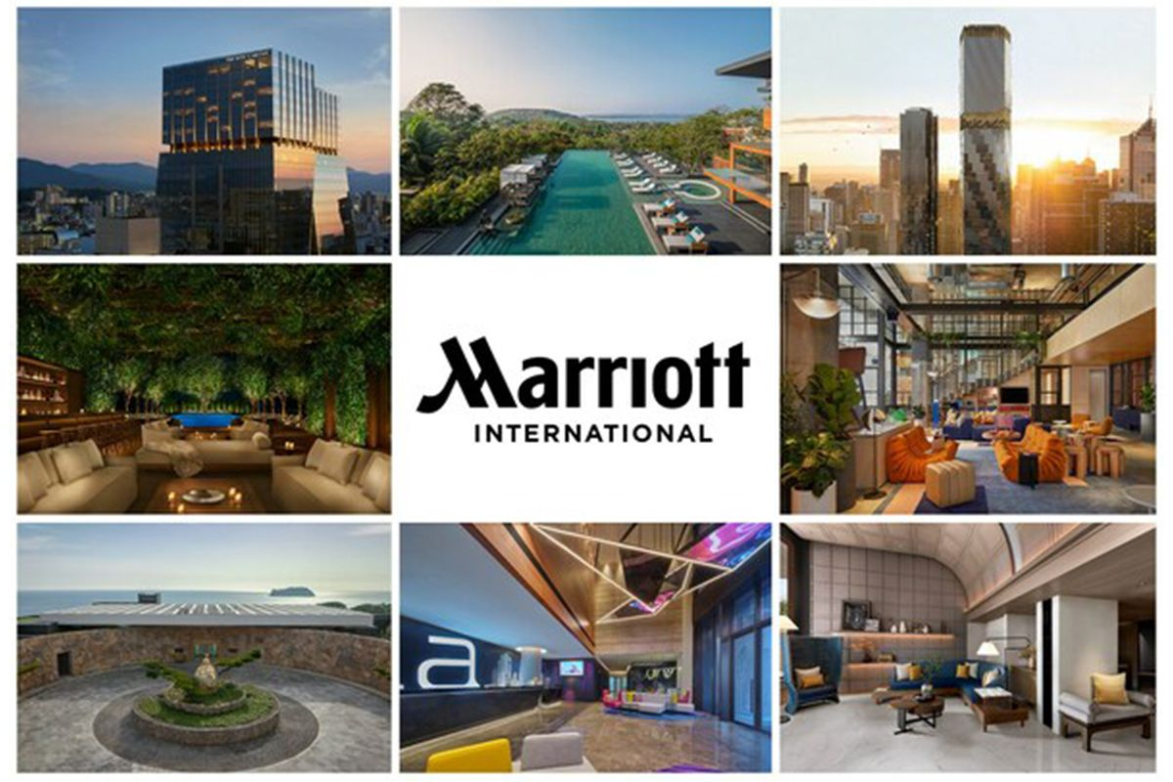
Figure 1: Marriott Hotel
(Source: Marriott Hotels Limited, 2024)

Organisation Structure, Culture and Goals

Orgnasational structure
The organisational chain provides a hierarchical structure which enhances the credibility of the hotel (González-Rodríguez et al., 2019). However, the corporate headquarters controls the global activities, and hotels owned by a franchise. Additionally, the local managers who report to one of the regional directors for management and communication efficiency, deal with individual hotels. However, within this organisational structure, all hotels uphold their service standards while allowing for minor local flexibility (Flood, 2023). On the other hand, Marriott has adopted some form of decentralised approach which includes the decision-making which is equally shared by corporate management and hotel managers. However, this increases the operational efficiency and responsiveness to market needs (González-Rodríguez et al., 2019).

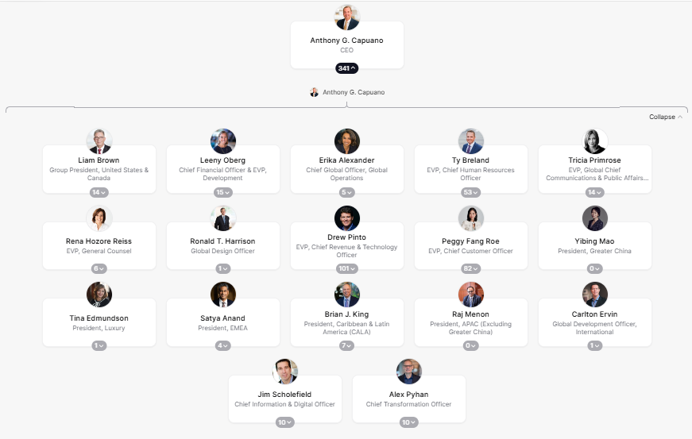
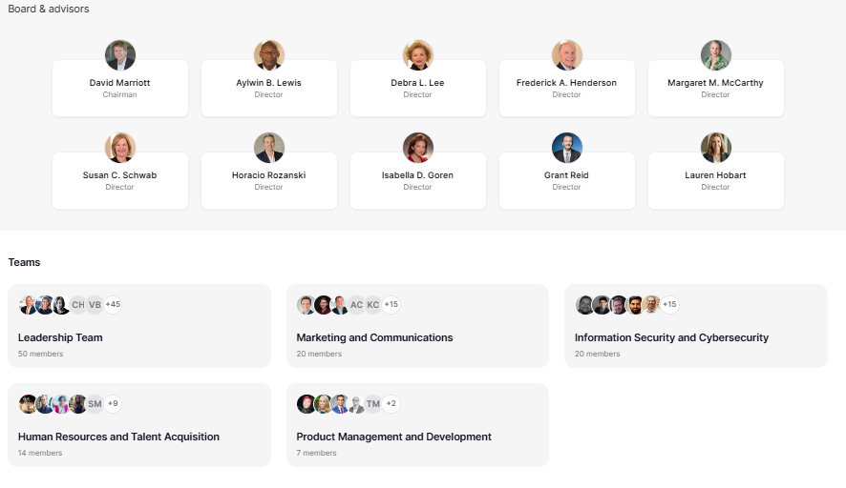
Figure 2: Organisational Structure of Marriot Hotel
(Source: Flood, 2023)

Corporate culture
In considering the Marriott cooperate culture five core values are highly integrated into the organisation. Additionally, this includes putting the people first, which shows that the Marriott hotel always puts their employees at the top of the priority and their satisfaction towards the job is incredibly important (Marriott International, 2024). Moreover, pursuing excellence at Marriot has been considered for its inclusive workplace, supporting its team diversity, and providing opportunities to excel in the competitive market. Therefore, by embracing the change initiates Marriot hires diverse individuals from diverse backgrounds and highly invests in the training and development programs (Flood, 2023). Furthermore, acting by integrating and serving the world by fostering the culture and providing a positive work environment which enhances employee retention and motivation. (Marriott International, 2024).
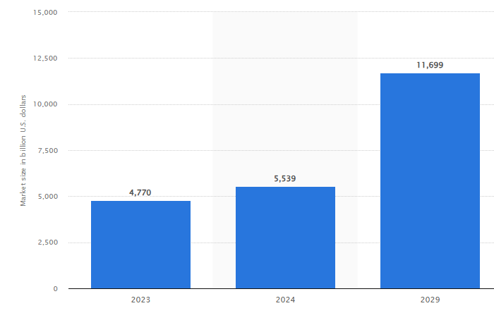
Figure 3: Market size of the hospitality industry worldwide in 2023.
(Source: Statista, 2024)

Goals and objectives
Marriott to grow its operation in international markets, and engage in sustainability, digital transformation, and customer loyalty (Bianco et al., 2023). Furthermore, the company intends to penetrate new markets by reducing its carbon footprint under eco-friendly measurements, including sustainability initiatives (Olekanma et al., 2024). Marriott has enhanced digital avenues by providing guests with mobile check-in and smart room technology (Bianco et al., 2023). At the hotel level, the core objectives revolve around quality service, maintaining high occupancy rates, and guest satisfaction (Marriott International, 2024). These strategic objectives help ensure that Marriott remains a global leader in the hospitality industry (Olekanma et al., 2024). As shown in (Figure 4), the net income of Marriott Hotel gradually increases from the year 2021 to 2023.
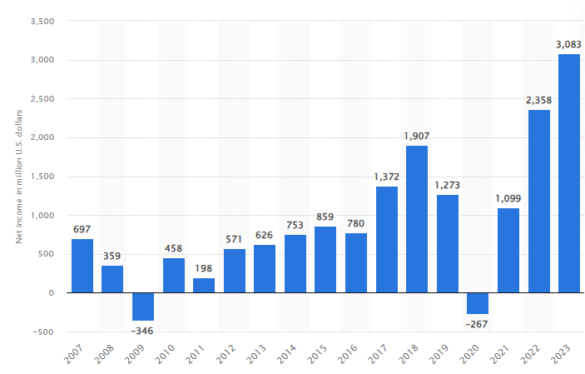
Figure 4: Net income of Marriott Hotel International
(Source: Statista, 2024)

Recent change initiatives

Growth in Europe
Marriott's growth expansion can be in terms of announcements about expanding plans in Europe for the next years adding about one hundred hotels and over 12,000 rooms by the end of 2026 (Marriott Hotel, 2024). Moreover, the conversion and adaptive reuse that is transforming old buildings into hotels. Therefore, the hotel expansion would bring Marriott closer to travellers across various preferences and support the general brand across the region (Eschenbrenner et al., 2023).

Commitment Margins for Sustainability
Marriott highly working on green accreditation as committed mostly to net-zero emissions, which provides a footprint (Apolloni et al., 2023). The company has experimented with environmentally sustainable practices operating hotels more energy-efficiently to conserve water and waste minimisation. Furthermore, the company is among those who consume renewable energy sources in many of their hotels to minimise some impacts of environmental degradation (Abdou et al., 2020).

Blocking illegal content on guest networks
Marriott has pioneered a humanitarian consideration by blocking child sexual abuse materials over its guest networks (Marriott International, 2024). Subsequently, this blocking mechanism has been enforced in close to 5,000 managed and franchised properties within the USA and Canada. Marriott's commitment to providing a safe and responsible atmosphere for its guests and employees (Marriott International, 2024). Furthermore, the company has augmented efforts beyond business and initiated various social activities within the locality to ensure anyone availing of their Internet services uses them appropriately (Armstrong and Taylor, 2023).

Digital transformation and loyalty
Marriot's investment in digital engagement increases exponential downloads of the Bonvoy app and thirty-one million new loyalty program members (Visser et al., 2021). Moreover, the Bonvoy app, in addition to check-in, room access keyless, and service requests, allows guests to be served without standing in line at the front desk (Harris et al., 2022). Moreover, Marriott's digital transformation endeavours to ensure a smooth and engaging stay for guests. Additionally, by provides Marriott with an intense competitive position in the market against its rivals (Harris et al., 2022).

Impact of Change Initiatives
The company continues to work hard to adjust to the changing times to give ever-more rewarding experiences to its customers and maintain sustainability in the long term (Busch et al., 2023). One of the major initiatives is the Hilton sustainability movement. Moreover, Marriott and Hilton are seeking to reduce their environmental footprint by introducing green measures aiming to reduce plastic waste, optimise energy consumption, and invest in renewable energy sources (Olekanma et al., 2024). In contrast, the company aims to achieve net-zero carbon emissions by 2050 and conduct its sustainability actions in all hotels (Olekanma et al., 2024).
In contradiction, Hilton has been going ahead with the introduction of an all-digital service concerning customer experience. According to Kumar (2021), customers may now check in, choose their room, and unlock their phone for door access via the Marriott app. Subsequently, the company is also using service robots for a limited clientele in selected hotels that can deliver room service and other customer services efficiently and conveniently (Kumar, 2021). On the one hand, Marriot's expansion across Asia and Africa is targeting developing economies with rising tourism trends (Fang, 2020). Moreover, Marriot employee training and development is another key area of concern. In contrast, continues investing in leadership training programs to prepare its employees for higher positions and motivation increases in a skilled workforce (Bianco et al., 2023).

Strategic direction

Short term goals
- The growth acceleration in Europe converts 15% of planned hotels into operational hotels in a 2-month time (Visser et al., 2021).
- Moreover, by hiring in the region by 10% in anticipation of the new hotel openings over the next 2 months.
- Furthermore, reducing the consumption of single-use plastics by half in all Marriott-managed hotels in 4 months (Bianco et al., 2023).
- Additionally, content blocking the inappropriate scale-up of the technology in 1,000 more properties in the next 3 months (Armstrong and Taylor, 2023).
- Digital Transformation and Loyalty Increase usage of the Marriott Bonvoy app by 20% in 3 months (Visser et al., 2021).

Long term goals
The long-term goals are thereby shifting the organisation's focus to further penetrate Europe and other emerging markets (Bianco et al., 2023). The organization plans to open one hundred new hotels in Europe, Asia, and Africa in the next six years, concentrating mostly on hotel conversions and adaptive reuse. In addition, Marriott plans to increase revenue from international markets by at least 20% through targeted marketing and partnerships over the next five years (Ramirez and George, 2019).
Moreover, by 2050, Marriott is committed to being net-zero for carbon emissions in all its endeavours (Jones, 2023). Moreover, Marriott will reduce energy and water consumption in its hotels by 30% by 2030 concerning the 2016 baseline. The timescale forecasts the renewable energy sources for 50 per cent of its properties (Jones, 2023). Furthermore, all single-use plastic products will thus be eliminated from hotels managed by Marriott (Ramirez and George, 2019). Furthermore, the digital transformation plan as far as Marriott is concerned focuses on how technology enhances guest experiences (Periasamy and Dinesh, 2024). Moreover, they plan to heavily invest in AI and automation for customised recommendations and seamless check-ins (Kumar, 2021). Moreover, by the year 2028, with the integration of smart room technology across all luxury properties, Marriott aims for 50% mobile app engagement (Ramirez and George, 2019). However, through additional partnerships with airlines, travel agencies, and luxury brands, the company expects membership in the loyalty program to rise by fifty million members by 2030 (Periasamy and Dinesh, 2024). Moreover, Marriott should lead the hospitality industry through strategies directed at global expansion, sustainability environmentalism, digital innovation, and client loyalty (Kumar, 2021).

Recommendations

Technology Advancement and Innovation
Marriott needed to dive into AI as it pertains to evolving personalised guest experiences, such as custom room preferences, and guest services like customised pre-check-in (Kumar, 2021). Moreover, digital payment modes, like cryptocurrency or contactless payments, must supplement convenient travel even for international travellers. Therefore, Marriott is also looking to enhance security through robust data encryption and multi-factor authentication mechanisms to secure customer data from cyber threats (Saoud and Romman, 2024).

Enhancing Sustainability
To continue to maintain a competitive edge as a leader in eco-hospitality, Marriott needs to be much bolder in carbon footprint targets, going up to 50% as much before 2035 (Saoud and Romman, 2024). Therefore, such technology needs to be utilised, including motion-sensor lighting, AI-based heating controls, and water conservation systems. Moreover, collaborating with environmental organisations will help Marriott adopt the best practices in sustainability towards international green systems (Eschenbrenner et al., 2023).

Continuing Education and Development for Employees
Leadership training should broaden to include more employee participants for higher management positions, to ensure a strong internal pipeline of talent (Kumar, 2021). Therefore, greater diversity and inclusion training ensures an inclusive workspace, which leads to increased satisfaction among employees (Charalampos Giousmpasoglou and Evangelia Marinakou, 2024). Marriott should also provide opportunities for career mobility through internal advancement and skill certification to retain top talent and keep attrition low (Eschenbrenner et al., 2023).

Customer Loyalty Program development
Reward personalisation on travels is much more applicable to high-end loyalty schemes (Saoud and Romman, 2024). This would include airlines and travel businesses finally pooling their discounted future flights and any otherwise special unique travel and premium packages as well. Moreover, such kind of VIP experience would lean towards a lot like priority early check-ins, private lounges, and exclusive concierge (Saoud and Romman, 2024).

Conclusion
Conclusively, this report highly emphasises Marriott International's democratic organisation structure, company culture, and strategic vision, which is already the leader of the game itself in global hospitality. Moreover, digital transformation is created throughout the whole industry like eco-friendliness and worldwide expansion, enabling them with long-term competitiveness. Moreover, continuous improvement in operational efficiency and experience for the customer through investing in AI and other digital technologies. Sustainability initiatives stretch worldwide for the company to meet environmental standards while appealing to eco-travellers (Kumar, 2021). Moreover, improvements in the employee training and development system would create a well-skilled and motivated workforce pool for delivering service up to the standards set by Marriott (Saoud and Romman, 2024). Furthermore, improvement and tailoring of the loyalty program enhance retention and engagement with the brand. Subsequently, Marriott should emerge with modern technologies and the changes in consumer expectations continuously.

References
Abdou, A.H., Hassan, T.H. and Dief, M.M.E. (2020). A Description of Green Hotel Practices and Their Role in Achieving Sustainable Development. Sustainability, [online] 12(22), p.9624. doi: https://doi.org/10.3390/su12229624.
Apolloni, M., Volgger, M. and Pforr, C. (2023). Analysis of accommodation providers’ carbon footprint in Australia: motivations and challenges. International Journal of Contemporary Hospitality Management. Doi: https://doi.org/10.1108/ijchm-09-2022-1183.
Armstrong, M. and Taylor, S. (2023). Armstrong’s Handbook of Human Resource Management Practice. [online] Google Books. Available at: https://books.google.com.pk/books?hl=en&lr=&id=3oChEAAAQBAJ&oi=fnd&pg=PP1&dq=Armstong [Accessed 25 Feb. 2025].
Bianco, S., Bernard, S. and Singal, M. (2023). The impact of sustainability certifications on performance and competitive action in hotels. International Journal of Hospitality Management, [online] 108, p.103379. doi: https://doi.org/10.1016/j.ijhm.2022.103379.
Busch, T., Barnett, M.L., Burritt, R., Cashore, B., R. Edward Freeman, Henriques, I., Husted, B.W., Rahul Panwar, Jonatan Pinkse, Schaltegger, S. and York, J. (2023). Moving beyond ‘the’ business case: How to make corporate sustainability work. Business Strategy and The Environment, 33(2). doi: https://doi.org/10.1002/bse.3514.
Charalampos Giousmpasoglou and Evangelia Marinakou (2024). Human Resources Management in Hotels. Springer eBooks, pp.129–158. Doi: https://doi.org/10.1007/978-3-031-52803-3_6.
Eschenbrenner, B., Zlatic, A., Bechtel, M., Collins, B., Straley, C. and Gubbels, G. (2023). Marriott International: A Managerial Strategic Audit. Honors Theses, University of Nebraska-Lincoln.
Fang, W.T. (2020). Future Tourism. Tourism in Emerging Economies, pp.267–295. doi: https://doi.org/10.1007/978-981-15-2463-9_11.
Flood, M. (2023). Marriott International Announces Organizational Structure and Executive Appointments. [online] Marriott International Newscenter (US). Available at: https://news.marriott.com/news/2023/02/24/marriott-international-announces-organizational-structure-and-executive-appointments.
González-Rodríguez, M.R., Martín-Samper, R.C., Köseoglu, M.A. and Okumus, F. (2019). Hotels’ corporate social responsibility practices, organizational culture, firm reputation, and performance. Journal of Sustainable Tourism, [online] 27(3), pp.398–419. doi: https://doi.org/10.1080/09669582.2019.1585441.
Harris, J.D., Snell, S.A. and Harrison, K. (2022). Marriott International: Hospitality’s Uncertain Future. [online] papers.ssrn.com. Available at: https://papers.ssrn.com/sol3/papers.cfm?abstract_id=4248262.
Jones, P. (2023). Towards Net-Zero Emissions in the Global Tourism Industry - Research Repository. Glos.ac.uk. [online] doi: https://eprints.glos.ac.uk/12354/1/12354-Jones-%282023%29-Towards-Net-Zero-Emissions-in%20the-Global-Tourism-Industry.pdf.
Kumar, P. (2021). Hospitality and Tourism Information Technology. USF M3 Publishing, LLC. Doi: https://doi.org/10.5038/9781732127593.
Marriott Hotels Limited (2024). MARRIOTT HOTELS LIMITED - Overview (free company information from Companies House). [online] find-and-update.company-information.service.gov.uk. Available at: https://find-and-update.company-information.service.gov.uk/company/01235583.
Marriott International (2024). Core Values and Heritage | Marriott International Corporate Values. [online] Marriott.com. Available at: https://www.marriott.com/culture-and-values/core-values.mi.
Olekanma, O., Rodrigo, L.S., Adu, D.A. and Gahir, B. (2024). Small‐ and medium‐sized enterprises’ carbon footprint reduction initiatives as a catalyst for green jobs: A systematic review and comprehensive business strategy agenda. Business strategy and the environment. Doi: https://doi.org/10.1002/bse.3846.
Periasamy, P., and Dinesh N. (2024). Leveraging Digital Transformation Technologies in the Hospitality Industry. Productivity Press eBooks, pp.151–165. doi: https://doi.org/10.4324/9781032688305-11.
Ramirez, A. and George, B. (2019). Plastic recycling and waste reduction in the hospitality industry: Current challenges and some potential solutions. Economics, Management and Sustainability, [online] 4(1), pp.6–20. Available at: https://cyberleninka.ru/article/n/plastic-recycling-and-waste-reduction-in-the-hospitality-industry-current-challenges-and-some-potential-solutions.
Saoud, L.S. and Romman, A.A. (2024). AI-Powered Chatbots in the Telecommunications Industry in the UAE: Studying the Factors Impacting Consumer Adoption. 2024 15th International Conference on Information and Communication Technology Convergence (ICTC), [online] pp.1549–1553. doi: https://doi.org/10.1109/ictc62082.2024.10827670.
Statista (2024). Marriott net income worldwide 2020. [online] Statista. Available at: https://www.statista.com/statistics/256252/net-income-of-marriott-international/.
Statista (2024). The global market size of the hospitality industry in 2020. [online] Statista. Available at: https://www.statista.com/statistics/1247012/global-market-size-of-the-hospitality-industry/.
Visser, M., Sikkenga, B. and Berry, M. (2021). Digital Marketing Fundamentals. [online] Google Books. Available at: https://books.google.com.pk/books?hl=en&lr=&id=xG8IEQAAQBAJ&oi=fnd&pg=PP1&dq=Marriott+investing+in+the+digital+engagement+increases+exponential+downloads+of+the+Bonvoy+app+and+31+million+new+loyalty+program+members&ots=pxG1mroO19&sig=tJt5h3jpSVCt-_DpApC2OdY2ZAI&redir_esc=y#v=onepage&q&f=false [Accessed 25 Feb. 2025].

