Workshop Skills Logbook

A.N. Apprentice
Student No: 1234567

L4 - Workshop Skills
ACDA4022
Electrical & Electronic Engineering Degree Apprenticeship

Introduction
The following lab report outlines the process followed to simulate, breadboard, and assemble a PCB for a non-inverting amplifier circuit shown in figure 1.
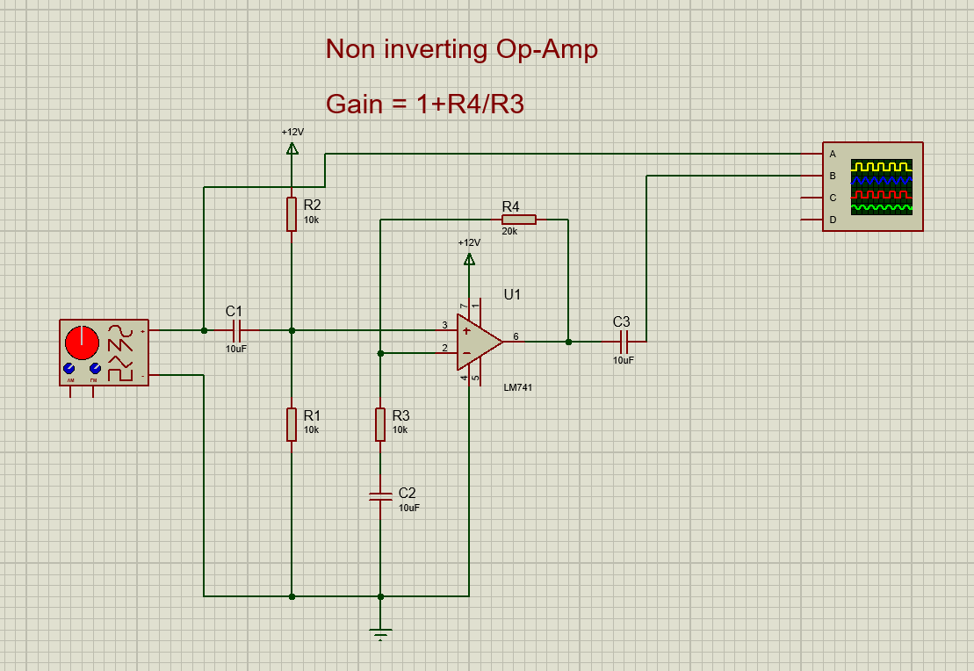
Figure 1: Schematic for a non-inverting amplifier with a gain of 3. The Circuit design was specified in the lab instructions, drawn in proteus.
When calculating the gain of this circuit, the standard formula is used:
$$A= \frac{V_{out}}{V_{in}}$$

Amplifier Circuit Simulation

Voltage measurements and gain calculations from proteus simulation
When the circuit shown above in figure 1 is simulated, the following table of values marking the gain of the circuit against frequency can be obtained:

It is shown in table 1 that the gain of the circuit is 3 for frequencies up to 10kHz. As higher frequencies are reached the gain begins to drop off, reaching a -3dB “half power” point at 250kHz (2.42mV). When multiplied by the gain of this circuit (3), this gives us a gain-bandwidth product (GBP) of 750kHz.

Frequency (Hz) | Output Voltage (mV) | Gain: |  | Frequency (Hz) | Output Voltage (mV) | Gain:
100 | 600 | 3 |  | 200 | 600 | 3
500 | 600 | 3 |  | 1k | 600 | 3
2k | 600 | 3 |  | 5k | 600 | 3
10k | 600 | 3 |  | 20k | 597.5 | 2.9875
50k | 593 | 2.96 |  | 100k | 575 | 2.875
200k | 487.5 | 2.43 |  | 500k | 230 | 1.15
200k | 487.5 | 2.43 |  | 300k | 370 | 1.85
200k | 487.5 | 2.43 |  | 250k | 427.5 | 2.1375
240k | 437.5 | 2.18 |  | 250k | 427.5 | 2.1375
Table 1: Results of proteus simulation showing the output voltage and gain of the amplifier circuit across a range of frequencies with a 200mV (peak to peak) input sine wave.

The LM741 Op-amp was then replaced with the TL071 Op-amp, and the same pattern is shown below in table 2, but with an increased “half power” point, now at 980kHz, resulting in an increased GBP of 2.94MHz.
Frequency (Hz) | Output voltage (mV) | Gain |  | Frequency (Hz) | Output voltage (mV) | Gain
100 | 597.5 | 2.9875 |  | 200 | 600 | 3
500 | 600 | 3 |  | 1k | 600 | 3
2k | 600 | 3 |  | 5k | 600 | 3
10k | 600 | 3 |  | 20k | 600 | 3
50k | 600 | 3 |  | 100k | 600 | 3
200k | 597.5 | 2.9875 |  | 500k | 535 | 2.675
1M | 420 | 2.1 |  | 2M | 262.5 | 1.3125
750k | 475 | 2.375 |  | 1M | 420 | 2.1
900k | 442.5 | 2.2125 |  | 1M | 420 | 2.1
950k | 430 | 2.15 |  | 1M | 420 | 2.1
970K | 427.5 | 2.1375 |  | 1M | 420 | 2.1
980K | 425 | 2.125 |  | 1M | 420 | 2.1
980k | 425 | 2.125 |  | 990k | 422.5 | 2.1125
Table 2: Results of the proteus simulation for the TL071 Op-amp showing the output voltage and gain of the amplifier circuit across a range of frequencies with a 200mV (peak to peak) input sine wave.

Gain/Frequency Graph of simulated proteus circuit
LM741 Op-Amp:
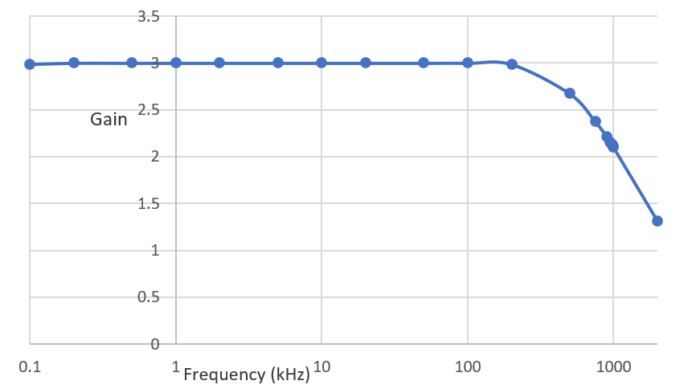
Figure 2: Graph of gain against frequency for the LM741 Amplifier circuit with a 200mV (peak to peak) input sine wave

TL071 Op-Amp:
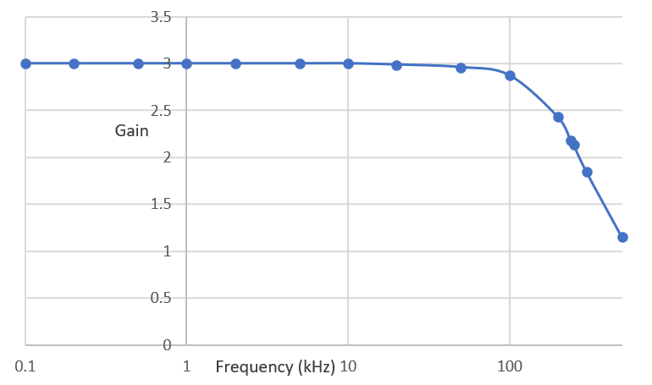
Figure 3: Graph of gain against frequency for the TL071 Amplifier circuit with a 200mV (peak to peak) input sine wave

Breadboarding the Amplifier Circuit
The circuit was then tested on a breadboard as described below.

Amplifier circuit on a breadboard
After the simulations had shown the circuit was producing the required gain of 3, it was then tested on a breadboard to make sure that the simulations reflected real world conditions.
Regrettably, longer wire connections were added rather than shorter ones that were kept tight to the board. This was because I didn’t realise automatic wire strippers were available at the time and had to strip longer lengths of wire to get a good enough grip to strip the end. If repeated, this would be a correction I would make so that the circuit wouldn’t look like a “rats’ nest”.
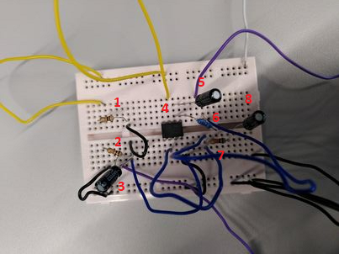
Figure 4: The LM741 Amplifier circuit assembled on a breadboard.
Figure 4 shows the LM741 amplifier circuit assembled on the breadboard. Note each component is identified in table 3 below.

Component No. | Component
1 | 10kΩ Resistor
2 | 10kΩ Resistor
3 | 10µF capacitor
4 | LM741 Op-Amp
5 | 10µF capacitor
6 | 20kΩ Resistor
7 | 10kΩ Resistor
8 | 10µF capacitor
Table 3: List of components assembled on breadboard for LM741 Amplifier circuit.

Testing details for breadboard amplifier circuit
When testing the breadboard circuit, the input was set to a 200mV sine wave of frequencies from 100Hz to 2MHz and the output was observed on an oscilloscope, with the gain being calculated.
The input waveform coming off the signal generator is connected to earth and the right leg of component 3 (DC blocking capacitor) allowing the signal to be fed to pin 2 of the IC.
The output waveform was observed from the right leg of component 5 (another DC blocking capacitor) which draws its signal from pin 6 of the IC.
Since the circuit was operating as expected it demonstrated an output sine wave of 600mV (peak to peak) up to

Voltage measurements and gain calculations from breadboard circuit
Frequency (Hz) | Output Voltage (mV) Peak to Peak | Gain
100 | 548 | 2.74
2k | 544 | 2.72
5k | 544 | 2.72
10k | 544 | 2.72
50k | 536 | 2.68
100k | 516 | 2.58
200k | 432 | 2.16
500k | 204 | 1.02
250k | 396 | 1.98
275k | 376 | 1.88
260k | 384 | 1.92
255k | 388 | 1.94
Table 4: Output voltage and gain recorded for the breadboard amplifier circuit.
Shown above in Table 4 is the output voltage and gain of the amplifier for the circuit on a breadboard, it is very similar to the simulated circuit with a -3dB point of 255kHz (compared to the 250kHz of the simulated circuit), but a slightly reduced gain from 3 to approximately 2.7 for frequency values below 50kHz, this can be explained by components behaving in a non-ideal way and slight variances in tolerances of the physical components.

Gain/Frequency Graph of breadboard circuit
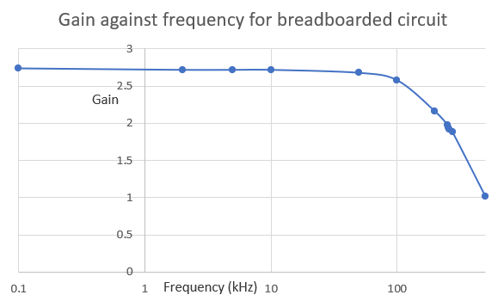
Figure 4: Graph of frequency against gain for the Op-amp amplifier circuit on the breadboard.

Amplifier PCB Construction

PCB Building and testing
The following photos and description outline the process that was followed to assemble and test the finished PCB amplifier circuit.
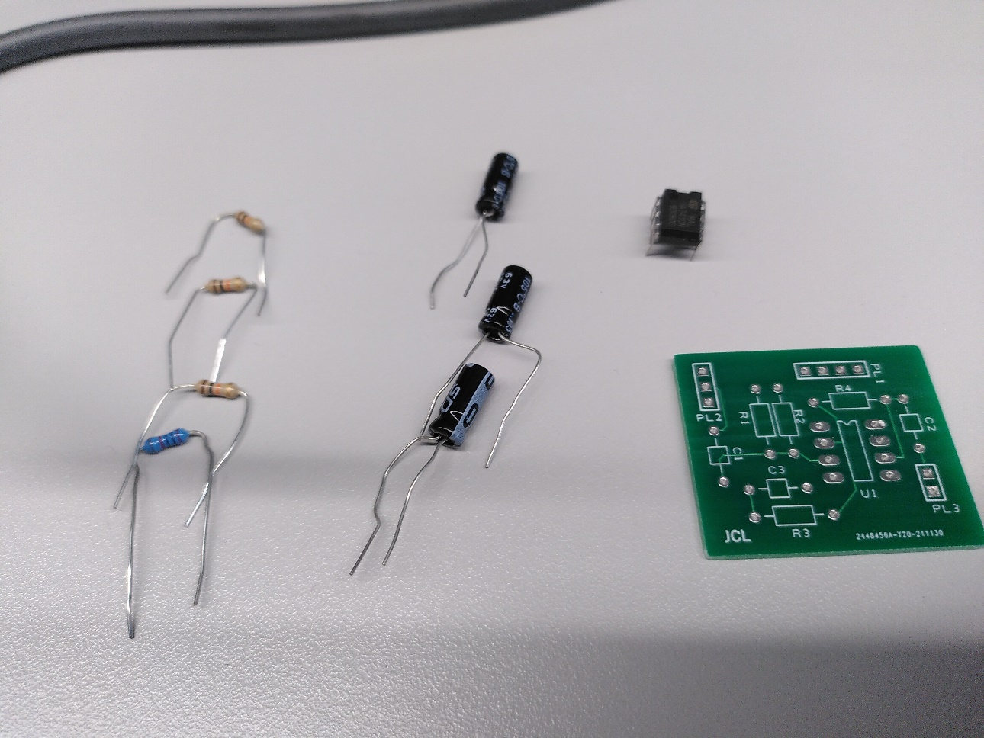
Fig 5: Taking inventory of components.
Before beginning the assembly of the PCB, each component was checked to ensure it was the correct value and the right quantity were available.

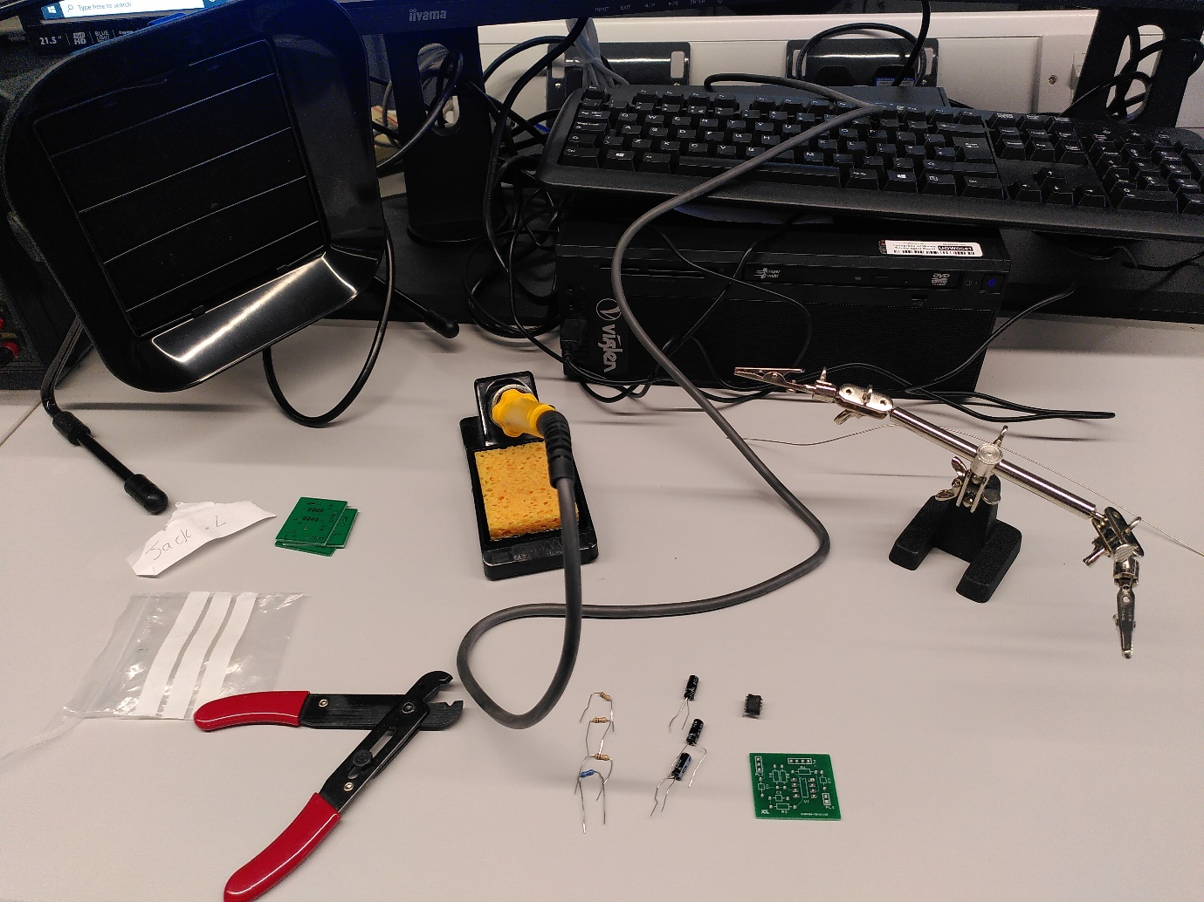
Fig 6: Setting up
The tools were set up appropriately with a tidy workspace, ensuring the soldering iron was tinned properly when it had finished heating up, stopping the tip from corroding. The extractor fan was turned on.
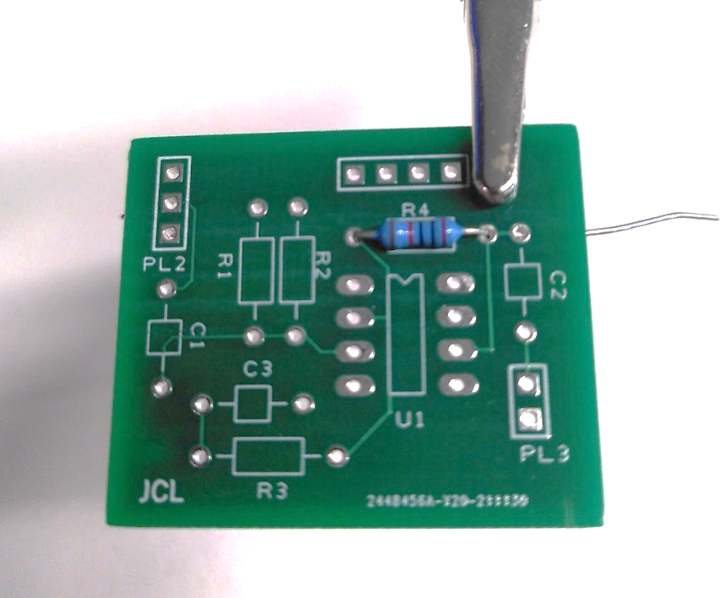
Fig 7: First component
The first components I soldered onto the board were the resistors as these are the hardest to accidentally damage when soldering other components onto the board.
I decided to start with the 20kΩ resistor as all other resistors were the same value, and therefore much harder to accidentally solder in the wrong place.
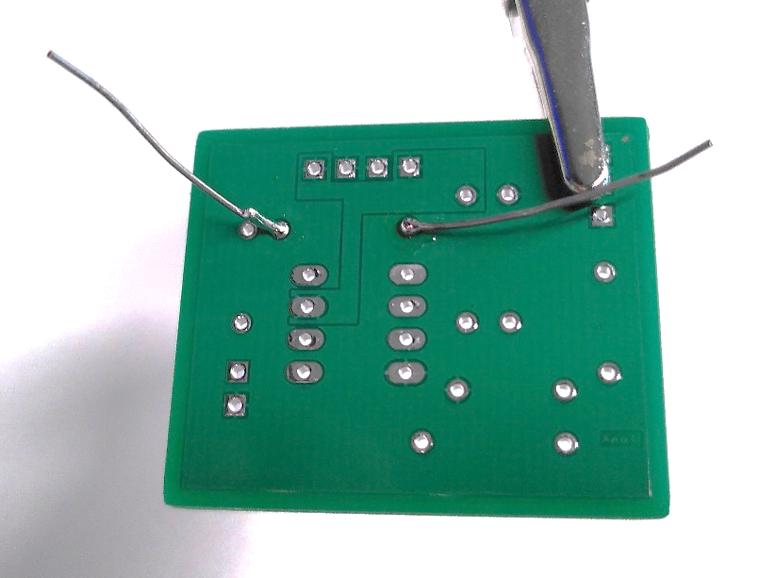
Fig 8: Reverse side
When soldering on the resistors, each leg would be inserted through the hole and bent sideways to keep it in position and tight to the board while being soldered.
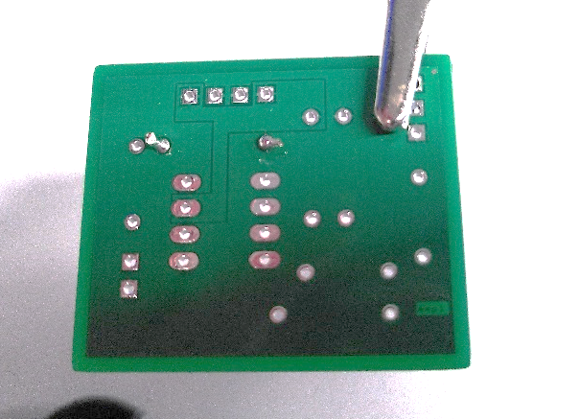
Fig 9: First resistor fixed in place with legs snipped.
When done soldering both legs and a secure connection had been confirmed, both legs were cut with flush snips to prevent electrical contacts with other components that could cause a short circuit.
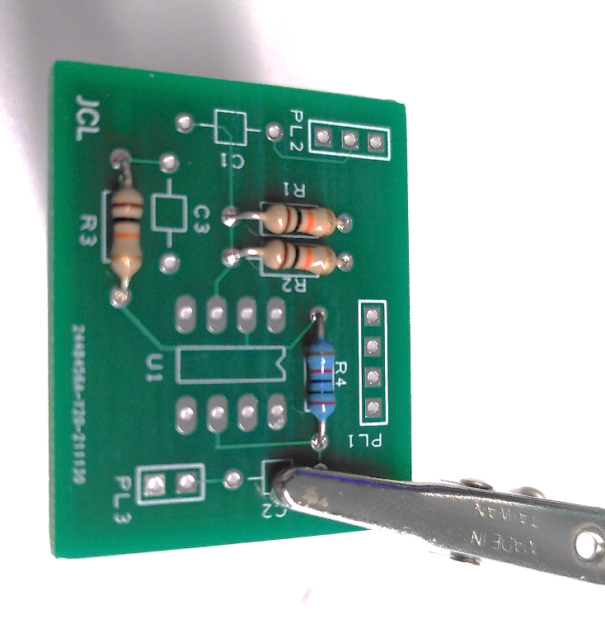
Fig. 10: All resistors assembled
The process was repeated for the three 10kΩ resistors as shown in figure 10 above.
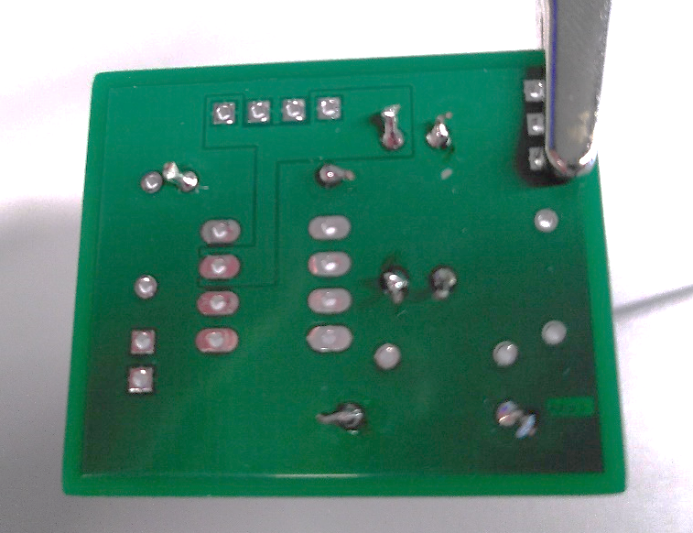
Fig.11: Reverse side of all four resistors.
The connections of each resistor were visually inspected and found to be appropriate.

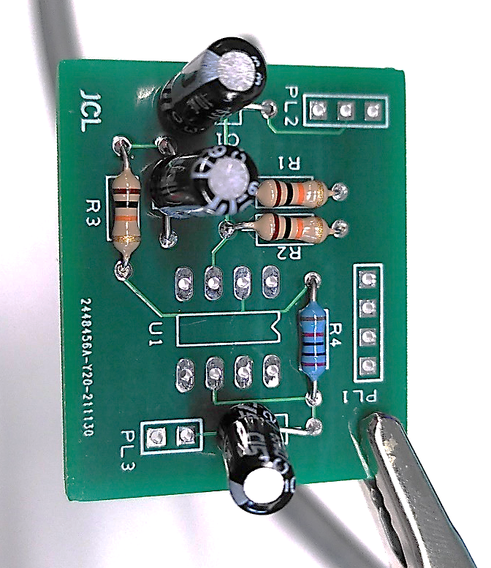
Fig. 12: Breadboard with capacitors assembled
The same process was followed for each of the three capacitors on the board. Note that two of them are soldered with incorrect polarity here, a mistake that wasn’t easy or tidy to fix. If this project were to be repeated, I would add a label onto the silkscreen of the PCB to indicate correct polarity.
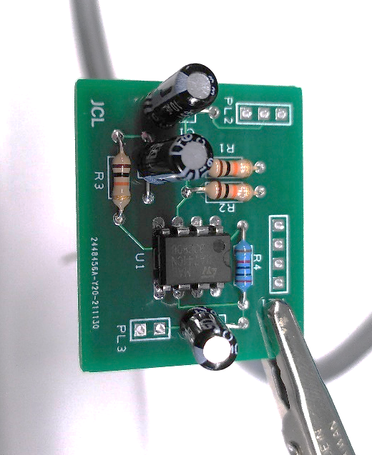
Fig. 13: Breadboard with IC added
Finally, the Op-amp was soldered in place, making sure that the notch and little circle were pointed at the top of the board, indicating pin 1 in the top left position. This was left till last as the Op-amp is the most sensitive component on the board and would have been easiest to damage accidentally while soldering other components. Trimming of the pins wasn’t necessary as they are much shorter than the legs of the other components on the board.

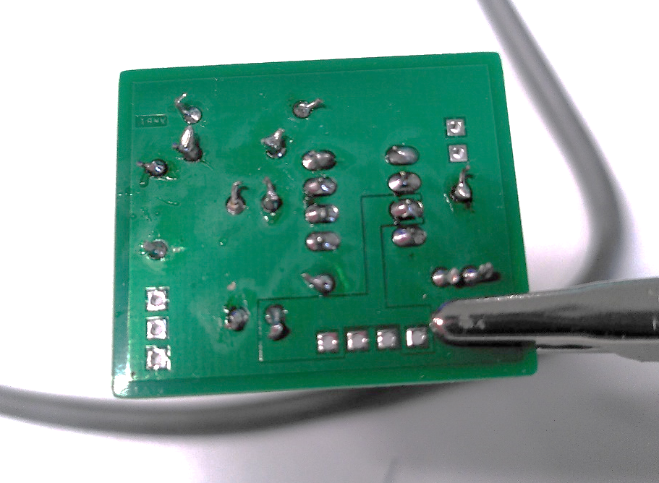
Fig.14: Rear connections of the board with everything assembled.

The PCB was then tested with a 200mV input sine waveform, and the output waveforms for different frequencies were recorded in table 5 below.
Frequency (Hz) |  | Output Voltage (mV Peak to Peak) | Frequency (Hz) |  | Output Voltage (mV peak to peak)
100 |  | 480 | 200 |  | 488
500 |  | 496 | 1k |  | 496
2k |  | 496 | 5k |  | 504
10k |  | 504 | 20k |  | 496
50k |  | 488 | 100k |  | 472
200k |  | 408 | 500k |  | 240
300k |  | 344 | 200k |  | 408
250k |  | 376 | 300k |  | 344
280k |  | 352 | 300k |  | 344
280k |  | 352 | 290k |  | 344
Tale 5: Test measurements for the assembled PCB amplifier circuit.
The data shown in table 5 is very similar to that of the breadboard and proteus simulation but with a slightly reduced gain, confirming the functionality of the circuit.
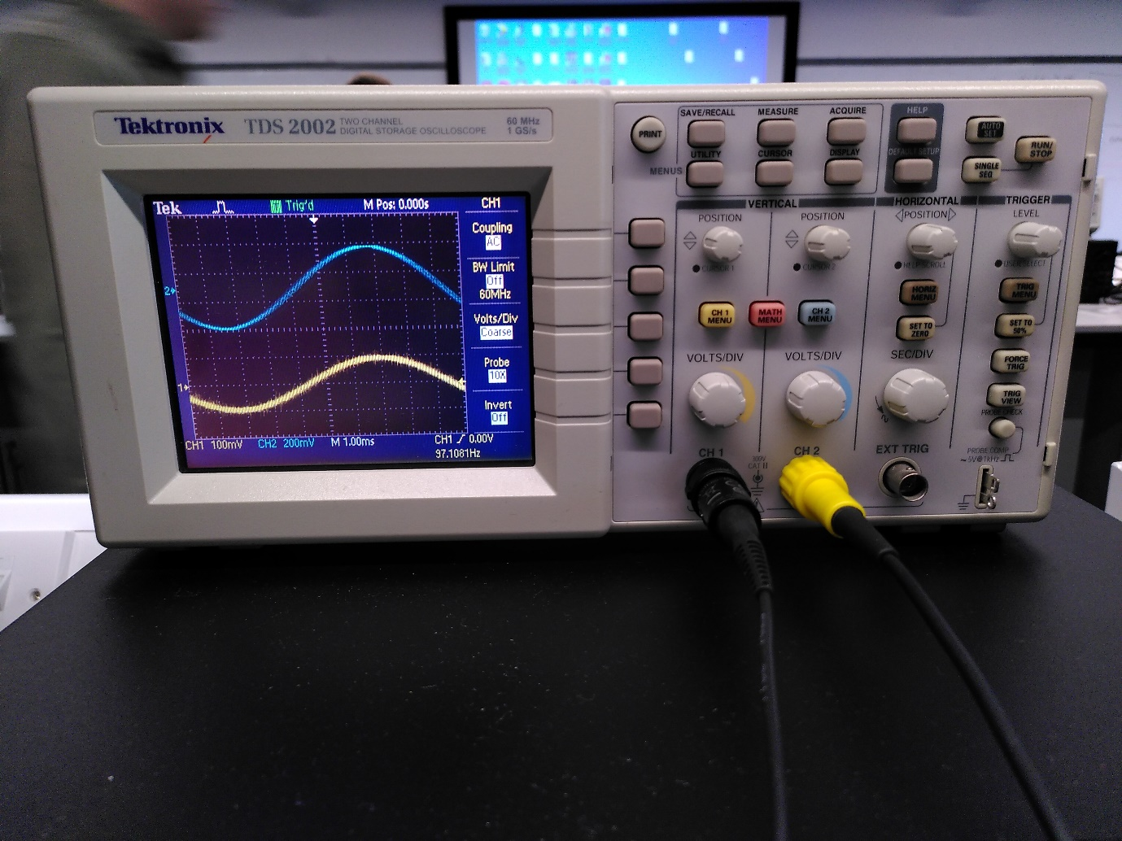
Fig 15: Finished circuit tested on an oscilloscope.
As shown in figure 15 above, the circuit was fed a 200mv peak to peak sine wave (channel 1, yellow) and outputted a 600mV sine wave (channel 2, blue). This is a gain of 3, as expected.

