Financial Management for the Hotel Industry
Student Name: Malanciuc Luminita
Student ID: 2211340
Module title:BMIH5007
Lecture:Tristan Hawkins

Table of Contents
Introduction 3
Financial Performance Comparison 4
Exploring the reasons for the reduced profitability of The Seacrest Lodge 7
Elucidating Turnaround Strategy of the Resort business to gain overall profit of the Business 9
Conclusion 13
References 14

Introduction
The Seacrest Lodge is a very reputed hotel business that provides services like restaurants, bars and other kinds of event facilities. The respective hotel is located in the picturesque coastline of the UK. Moreover, consumers' gatherings in the respective hotel are huge due to its refreshing relaxation and luxury staying experience as well. However, due to various external reasons, the overall revenue, room occupancy ratio and satisfaction level of customers are decreasing. The report will discuss the financial performance of The Seacrest Lodge including net income, assets, liabilities and expenses as well. Moreover, the report is prepared to highlight the core reasons for the declining rate of profit for the respective firm. The respective hotel is required to create efficient business development systems to enable the path of future success. Moreover, necessary turnaround strategies along with short-term goals and recommendations will be provided in the case study report as well.

Financial Performance Comparison
Balance sheets and income statements are known as important financial documents to examine financial performance. The financial performance of The Seacrest Lodge is provided below.
Comparison of Revenue, operational expenses and net income
The revenue of the respective hotel was £1,200,000 in the year 2021 however, the rate of revenue decreased to £1,100,000 in the year 2022 as well. For the next year of 2023, a huge decline of £950,000 was seen. It shows that the business is not successful in securing a good amount of revenue.
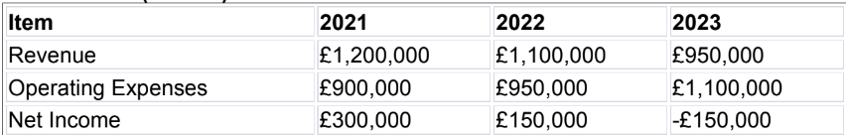
Figure: Seacrest Lodge’s income statement
On the other hand, the overall operational expenses of the firm were £900,000 in the year 2021 and it has seen a huge rise of £950,000 in the year 2022 and almost £1,100,000 in the year 2023 as well. It indicates that the business is unable to reduce its expenses due to various reasons. Low revenue and high operational expenses are creating huge challenges for the respective company. Additionally, the net income of the respective company has fallen from £300,000 in the year 2021 to almost £150,000 in the year 2022 as well. In the year 2023, the amount of income has come down to a negative figure of -£150,000 (Varelas and Apostolopoulos, 2020). After comparing the income statement of different years is very obvious that the rate of profit is declining hugely.
Comparison of Debt and equity
The balance sheet of The Seacrest Lodge has depicted that the respective business owns a liability of £1,530,000 in the year 2021 which was increased to almost £1,540,000 in the year 2022 as well. Moreover, in the year 2023, the amount was £1,550,000 and it indicates that the respective business can go bankrupt, if necessary, actions are not taken.
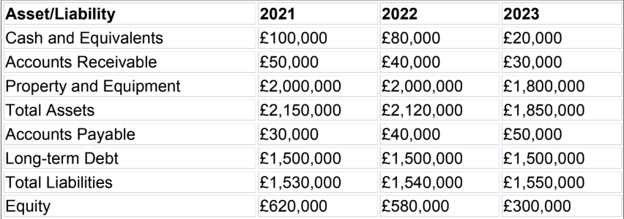
Figure: Seacrest Lodge’s balance sheet
On the other hand, the number of assets of the respective firm was decreasing hugely. The value of the asset has reduced from £2,150,000 to £2,120,000 in the period of 2021 to 2022 as well. Moreover, in the year 2023, the value of the asset was reduced to £1,850,000. It shows that the company is facing a huge internal struggle to maintain its daily operations.
Comparison of Room rate and occupancy rate
The room occupancy rate of the respective business has declined from almost • £260 in the year 2021 to almost £240 in the year 2022 as well (Lee et al., 2021). A huge declination of £210 was seen in the year 2023 as well. It indicates the business has a low number of sales.
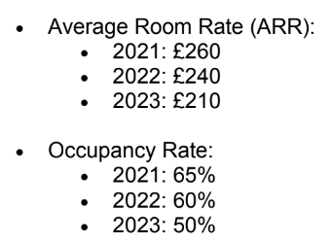
Figure: Seacrest Lodge’s average room rate and occupancy rate
Moreover, the average room rate of the respective business has also declined from 65% in the year 2021 to almost 60% in the year 2022 as well. In the next year, the room rate fell to almost 50%. It indicates that customers are taking a room despite very low prices. And, the business is unable to genera high profit due to low prices (Lee et al., 2021). The performance analysis has shown that the financial period of the business has declined hugely in different years.

Exploring the reasons for the reduced profitability of The Seacrest Lodge
High labour costs and shortage of workers
The UK is going through a huge crisis of high labour costs as many hotel businesses have to increase the daily wage by up to 10% to retain their employees. Hence, the operational costs of hotels are increasing rapidly (Abdou et al., 2020). Moreover, the Brexit agreement has also a huge contribution towards the huge amount of job vacancies in the tourism and hospitality sector of the UK. Moreover, without skilful workers like bartenders, chefs and cleaning people the daily operation cannot be completed. Hence, The Seacrest Lodge is facing a huge burden of business expenses due to the high cost of labour and a huge shortage of workers as well.
High operational cost due to inflation
The economic condition of the UK is not stable yet after the pandemic, however slow recovery was recovered. However, various international political events have also created a huge impact on the economy of the UK. The food price inflation has forced the hotel business of the UK to increase prices (Shi et al., 2021). On the other hand, the cost of living in the UK is also huge hence consumers are not spending money on leisure and tourism activity. Due to no sales and high food inflation, the business is forced to reduce its overall working hours. Moreover, food inflation is one of the reasons for reduced profitability in The Seacrest Lodge.
The increased price of energy
The energy prices of the UK have increased to more than 5% since the last year of 2022. Hence, the cost-of-living crisis is also affecting the general residents of the UK hugely. Various hotel businesses' overall operational expenditures are also increasing as well. Moreover, due to less amount of sales and high operational experience, the rate of profit for The Seacrest Lodge is declining (Marques and Pinho, 2021). Hence, increased energy prices are a real challenge for the respective business. Hence, the respective business has to make necessary planning for tackling the situation or else the prospect of the respective business will be destroyed (Lee et al., 2021).

Elucidating Turnaround Strategy of the Resort business to gain overall profit of the Business
Identifying business long-term and Short-term targets: The determination of the organisation's needs can be underlined with the objectives of the business in long-term and short-term analysis. The business needs to enhance their rate of workforce and it needs to include the trained workforce of the hospitality industry. The business also needs to align the business idea with the strategy and partner of the local business. Room modernisation and business margin revenue need to be underlined with the overall process of the talent acquisition programme for the business. For long-term business growth, the organisation needs appropriate loyal customers, trusted suppliers and investors to revive the growth of the business in the long run (Anderson and Arms, 2023).
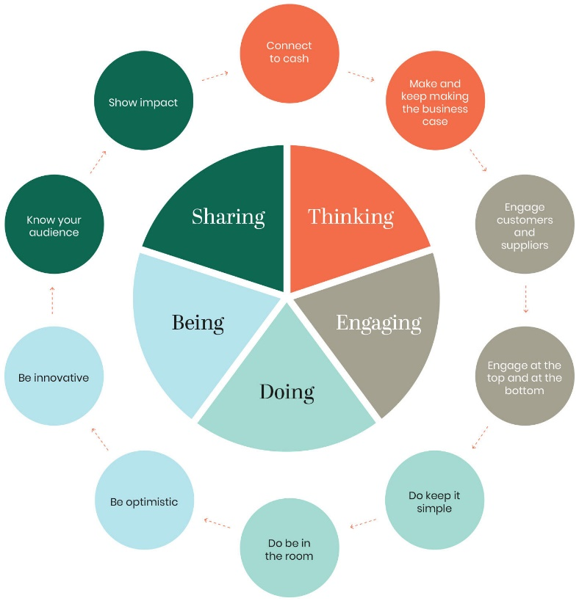
Figure: Steps to Enhance Business Profitability
Source: (Ferrarese et al., 2021)
Positioning and Rebranding
Brand Identity Revaluation Process: The research conducting the process of the market can be underlined with the contemporary perceptions of the consumers of the elucidated lodge. The brand image of the lodge needs to be revised based on the overall alignment with the sustainable practice of the business and the contemporary preferences of the travellers.
Exclusive Retreat Position: Unique features of the highlighted lodges can be underlined with a coastline that is a picturesque process, ambience sense, and customised services that make discerned guest experiences with a tranquil guest-seeking process (Ferrarese et al., 2021).
Enhancement of the overall experience of Guests
Upgrade renovation process: Room renovation investment, amenities of a modern hotel and furnishing of the hotel room based on comfortability. This can ensure the pampered treatment of the guests.
Customer Service Exception: Providing a warm welcome is the most needed skill of the hotel staff, customised staff service, including the needs of the guests overall exceeds the exception of the workforce (Anderson and Arms, 2023).
Unique Experiences: The resort can introduce customised experiences for visiting guests, for example, beachside yoga, guided jungle walks to feel nature and workshops to enhance culinary skills. These can underline the Seacrest Lodge's different perception to attract more guests.
Diverse Streams of Revenue
Wedding and Events: Leverage facilitated existing events, for example, corporate retreats, weddings, conferences and other social gatherings. The lodge can promote a venue that is idyllic to enhance revenue.
Local Partnerships: Nearby business collaboration, for example, providing adventure sports, creating packages with collaborations, and creating programmes for local artisans.
Seasonal Activities: Seasonal activities can be offered to the consumers based on the bonfires of the beach, night stargazing and bonfires of the beach (Sukawati et al., 2020).
Digital Transformation
Social Media and Access of Website: High-quality visuals and website revamping process in the website including familiar navigation access and capabilities of digital booking. Social media, maintaining daily presence on the platform social media including attractive posts makes the consumers interested in visiting the lodge.
Management of Reputation in Online Platform: Satisfied guest encouragement including positive leave reviews can address the overall feedback navigation and professional promotion of the websites.
Holiday Packages and Pricing
Dynamic Pricing: Room rate adjustment with seasons, demand overall special events. The lodge needs to have both premium price packages and economic holiday packages (Sukawati et al., 2020).
All-inclusive Packages: Bundle-appropriate packages including the creation of spa treatments, meals and overall activities. The guest process and cost savings need to be included in these highlighted options.
Financial Management
Cost Control: Regular expense review and recognising areas to reduce costs without quality compromising can make the business an attractive spot and help to review the overall control of the costs (Wolf, 2021).
Management of Cash Flow: Monitoring the flow of the cash including receivables and payable diligence can create the overall progress of the cash-flow management process. The business needs to look at the overall monetary flow.
Investment Prioritisation: Strategic fund allocation and initiatives for generating revenue can be underlined by attracting the stakeholders to invest more money within the business (Axhami et al., 2023).
Community Engagement
Local Involvement: Community events’ participation including local cause assistance and neighbouring business collaboration needs to be underlined to revive the growth of the business.
Eco-Friendly Practices: Initiatives for sustainability can embrace the appropriate initiatives based on the environment resonance process including travellers’ consciousness process.
Promotion including marketing
Target Advertising: Online advertisement usage, collaboration of the influencers and overall market of email to analyse the exclusive event access.
Loyalty Programme: Repeat visitor rewards with early check-ins and access to exclusive events can make the business more enhanced in the programme of loyalty (Sukawati et al., 2020).
Storytelling: The Lodge’s history needs to be shared with scenic beauty, and experiences of the guests and narrative cultivation can be underlined with the process of story-telling.
Holistic strategic implementation can reclaim the status of the Seacrest Lodge including sought-after destination status including the overall travellers’ attraction for the adventure and relaxation process, Creativity, dedication and lodge approach can be underlined with the thrive of the lodge.

Conclusion
This case study has elucidated that the lodge business with magnificent sea view suffers from business loss because of the sudden inflation rate, low-skilled workforces, attraction of the customers and less infrastructural management of the resort site. The discussion has elucidated the process to manage the business's high cost including the overall revival process of the business with multiple suggestions. Constant high-price demand with low service, including the country’s economic situation creates lots of hurdles for the business. The proposal aligns with the overall business strategy including the management of cash flow, proper process of promotion, and encouraging adventurous and sustainable activities to attract the consumers can make the business more popular among the consumers. Sustainable infrastructure with a diverse range of holiday packages can make the business gain profitability growth of the business.

References
Abdou, A.H., Hassan, T.H. and El Dief, M.M., (2020). A description of green hotel practices and their role in achieving sustainable development. Sustainability, 12(22), p.9624.
Anderson, M. and Arms, Z., (2023). Business improvement districts, class turf war and the strategic weaponisation of class monopoly rent. Urban Studies, 60(2), pp.238-255.
Axhami, M., Ndou, V., Milo, V. and Scorrano, P., (2023). Creating Value via the Circular Economy: Practices in the Tourism Sector. Administrative Sciences, 13(7), p.166.
Ferrarese, M., Loner, E. and Pulina, M., (2021). Demand, business profitability and competitiveness in the cableway system: A multidimensional framework. Research in Transportation Economics, 90, p.101041.
Lee, S.A. and Oh, H., (2021). Anthropomorphism and its implications for advertising hotel brands. Journal of Business Research, 129, pp.455-464.
Marques, J. and Pinho, M., (2021). Collaborative research to enhance a business tourism destination: A case study from Porto. Journal of Policy Research in Tourism, Leisure and Events, 13(2), pp.172-187.’
Shi, F., Shi, D., Weaver, D. and Samaniego Chavez, C.E., (2021). Adapt to not just survive but thrive: resilience strategies of five-star hotels at difficult times. International Journal of Contemporary Hospitality Management, 33(9), pp.2886-2906.
Sukawati, T.G.R., Riana, I.G., Rajiani, I. and Abbas, E.W., (2020). Managing corporate sustainability by revitalizing Balinese cultural identity. Polish Journal of Management Studies, 21(1), pp.382-393.
Varelas, S. and Apostolopoulos, N., (2020). The implementation of strategic management in Greek hospitality businesses in times of crisis. Sustainability, 12(17), p.7211.
Wolf, M., (2021). Community development initiatives as part of a tourism resort's CSR strategy: examination of a high-end luxury resort in the Maldives.

