A comparison of the marketing methods of two multinational brands
A comparison of the marketing methods of two multinational brands

Student: Bogdan-Ion Vidoi
Student ID: 2209545
Module Title: Marketing Essentials BMIH4005
Lecturer Name: Christopher Wilkin

Abstract
Customer satisfaction that returns in profit is the central aim of hospitality marketing (Kotler et al., 2017). In this essay it will be analyzed using different marketing models; like Bowman’s clock, the 4/7 Ps of marketing mix, the RACE framework, and it will be compared two known brands: Ritz Carlton and Premier Inn. At the end of the essay, it will be presented some recommendation to develop and enhance marketing activities that can positively impact future growth of the brands; taking into consideration the digital revolution impact on the hospitality market.

Introduction.
Marketing is the process by which businesses create value for clients and build strong relationships to receive profit in return (Kotler et al., 2017). So, the concept of exchange is central to the understanding of marketing (Bagozzi, 1978). Marketing communication incorporates three key elements: tools, media and messages (Fill, 2013). The role of marketing communication is to engage audiences in relevant conversations. The most important communication tools marketing employs include advertising, promotions, public relations, value-added approaches and personal selling(id.) Messages use a subtle blend of informative and emotional content about the brand to provoke the audience to think and behave in certain ways. Their scope is to generate cash flow and strategically develop relationships with a particular audience (Fill, 2013). Relationship marketing refers to building, maintaining, and developing strong relationships with clients and relevant stakeholders (Kotler et al., 2017).
In this essay, it will be discussed the marketing approach of two known brands: Ritz Carlton and Premier Inn. The first was chosen as the embodiment of excellent quality and service; the second as it is known for its accessibility and relatively low prices. These will be analysed using the 7Ps of the marketing mix, Bowman’s strategy clock framework and the RACE framework concerning their digital marketing approach.
Premier Inn is a British hotel chain. It has a relatively short history as it was established only in 1987 by Whitbread who was known before for its breweries and pubs.
The segmentation, targeting and position model
Branding is the process through which companies distinguish their offer from their competition by creating a distinctive name, packaging and design; by enhancing a core product with distinct value (Jobber, 2010). This augmented product facilitates customers to associate with the brand’s prestige and economy and thus ease the purchase decision (id). Brands affect perception (Jobber, 2010). The financial value of a company is greatly enhanced by the possession of strong brands (id). Customers trust strong brands as they are associated with quality certification (Jobber, 2010). The marketing task is to ensure that these associations are positive and reflect the positioning objectives of the company (id). Brand positioning consents a business to get a competitive advantage.
Market segmentation serves to target the market (Jobber, 2010). Next step is to develop a marketing strategy to clearly position the service (as shown in Figure 1).
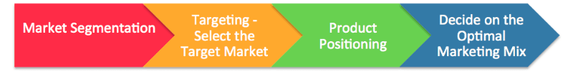
Figure 1.
There are four generic marketing strategies: undifferentiated marketing, differentiated, focused (niche) and customised marketing (id).
Ritz Carlton is positioned as a luxury hotels and resorts chain and offers high-class services at a premium (price strategy) to its customers. Their target market is the luxury segment: business executives, celebrities, athletes, and luxury travellers. According to Bowman’s strategy clock framework (Bowman & Faulkner, 1996), a marketing model that expands previous Porter’s model and explore how a product should be positioned to gain maximum competitive advantage, the Ritz-Carlton brand is positioned as focus differentiated in the classic/ distinctive luxury segment as it offers a sustainable competitive advantage at a premium price. The strategy results in high profit margins. Ritz is thus a business that competes on perceived value and has succeed in time to maintain its positioning in the segment.
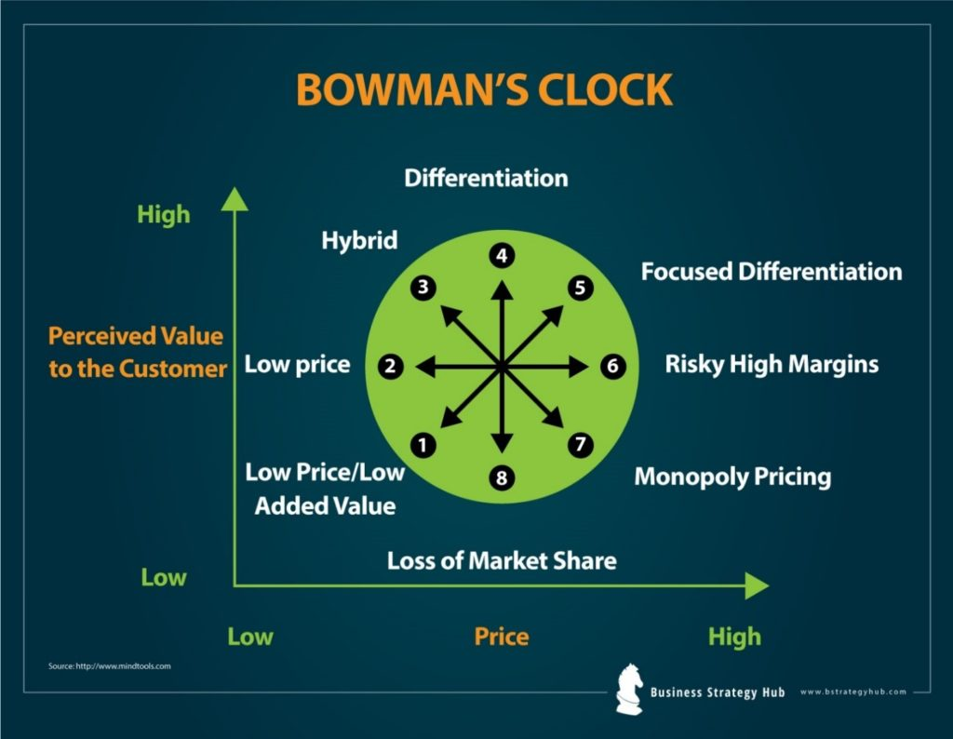
On the other hand, Premier Inn has a hybrid strategy, as consumers perceive some added value due to a blend of competitive low pricing and product differentiation. Premier Inn targets the family segment and is recognised as a budget segment in the UK. The hotel pricing strategy aims to provide customers great value for their money (Premier Inn, 2022).

Figure 2. Bowman's Strategy Clock
Source: Bowman & Faulkner, 1996 ; bstrategyhub.com
The marketing brand strategy and the 7Ps of the marketing mix
The total set of brands marketed by a company makes the product mix of that company. The management of brands is the key element of the product strategy. Successful brands develop a set of values superior to their rival ones (Jobber, 2010).
Next, it is discussed the marketing mix of the Ritz Carlton and the Premier’s Inn brands by looking at their 7Ps (Product, Price, Place, Promotion, People, Process and Physical evidence (Kotler, 2001)).
The Ritz-Carlton brand is the very centre of their marketing strategy promoted as "memories by the Ritz-Carlton". Storytelling is an essential part of creating a business model. The brand story is closely connected to brand identity. They promote their brand by telling stories about memorable customers’ experiences (Ritz Carlton, 2022). With 100 years of history, a strong credo and a business philosophy of tireless commitment to exceptional service, The Ritz-Carlton has been recognised as the gold standard of hospitality. The ‘credo’ of the hotel chain is that Ritz Carlton is ‘’a place where exceptional and genuine care and the comfort of our guests is our highest mission’’ as stated on their website.
Ritz Carlton’s marketing mix portfolio aims to ensure its customers have a memorable experience with them by offering the finest personal services and professional expertise in hospitality (Ritz Carlton, 2022). Ritz differentiates itself from its rivals through exceptional customer service and unparalleled hotel experiences. There is increased attention towards flowering, fine and best quality cuisine and other accessory facilities. They create a positive customer experience by being attentive to their clients’ unexpressed needs (Shoultz, 2016). Their marketing strategy wants to create customers for life (Ritz Carlton, 2022).
In contrast, the customers’ experience at Premier, as it can be drawn from rating sites like Trustpilot, shows mixed feelings regarding the services provided. Premier Inn offers different pricing options and different types of rooms for different customers, like family rooms with different options for kids (Premier Inn, 2022). Some customers complain that the hotel falls short of keeping its promise of cheap pricing as very few promotional rooms are available. Their hotels offer a bar and a restaurant on-site and are bike friendly. Though many of their rooms are spacious, and the interior comfortable, which attest to the excellent physical setting of Premier Inn, the clients do not find always all the necessary accessories, or they have to specially request them in contrast with Ritz customers.
The Ritz chain has premium locations in countries like Japan, China, India, Qatar, Morocco, Egypt, UK, Spain, Mexico, and Malaysia. Their location decisions are influenced by proximity to the airport or at the heart of a premium location offering stunning views.
Premier Inn operates mostly in the UK with over 800 hotels, and it is present in countries like United Arab Emirates, Qatar, Ireland, and Germany (Premier Inn, 2021).
The hospitality industry is unique as the employee are part of the product (Kotler et all, 2017). If the organisational culture does not support serving the clients, all marketing strategies will fail (id). A study enquired about the importance of business employees and internal marketing and found out that this is one of the top three determinants of a company’s performance (Chang, 2005).
Operating in the premium segment of the hospitality business, Ritz Carlton highly values its employees and trains them to impersonate the philosophy of the brand. Ritz-Carlton has successfully created a culture where employees instinctively meet the ‘unexpressed needs of their customers as they are ‘’fully empowered to create unique, memorable, and personal experiences for their guests through their own ideas’’ (Ritz Carlton, 2022).
Premier Inn also train thousands of young people through apprenticeships and work placements through their sustainability programme ‘Force for Good’, showing its pledge to corporate social responsibility (Whitbread, 2021). However, authors like Wickens (2021) recognise one third of their employees are paid the minimum wages and this leads to employee unsatisfaction.
Promotion strategy and Digital Marketing
Significant changes happen in customer-brand relationships due to digital technologies (Kotler et al., 2017). A technology executive stated, ‘’the pace of change is so rapid that the ability to change has now become a competitive advantage’’ (id., p.49) and this is something to pay attention to in a post covid society where everything was transformed by the digital impact. Now customers also influence companies’ behaviour (id.).
RACE (Chaffey, 2022) summarises the key activities that need to be managed in online marketing activities as part of the digital marketing strategy to engage the customers with the brand.
To (Plan) > Reach > Act > Convert > Engage
There is an initial phase of planning, which implies developing the digital strategy, setting objectives and planning. The planning must ensure that digital communications are aligned with the business and marketing strategy (Figure 3).
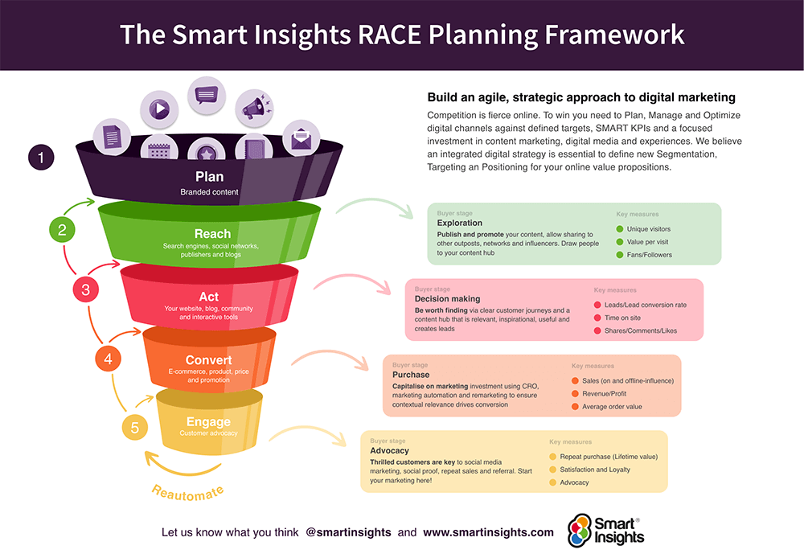
Figure 3
Source: smartinsights.com

Ritz Carlton’s marketing strategy highly relies on word of mouth to promote itself. Ritz targets the luxury segment also directly by email or accessing the luxury network, like travel magazines, or by hosting big events and conferences.
Through their online content strategy, Stories that Stay with You (Ritz Carlton, 2022), they illustrate how they go the extra mile to ensure an excellent stay for their guests They also have their app through which they provide holiday packages and offer reward points. The app allows guests to check in before arrival or reserve restaurants or halls, request different services and even check out. To be aware of their updates and activities, Ritz Carlton guests are advised to link their reward accounts with the app. The marketing strategy has identified several customer touch-points, where they continuously look to create value and emotional connection with their guests (like the three steps approach) (Ritz Carlton, 2022).
Promotion is the cornerstone of the marketing mix of Premier Inn (7Ps of Premier Inn). The hotel has invested a lot of money in advertising on different platforms, in print, digital & social media. It aimed to invest £20m into marketing this year, focusing especially on broadening its digital reach (Jefferson, 2021). It can be said from this marketing strategy that the chain understands the transformation the digital revolution brings and use it as a competitive advantage.
Premier Inn has a very simple and easy booking procedure (the process); all is done online. It is possible to book a room directly via the hotel’s website or app as well as from third-site partners like Booking.com and Lastminute.com or over the phone.

Conclusions and recommendations:
In a nutshell, the Ritz is associated with luxury, lavishing opulence, customer and employee satisfaction and prestige, positive memories and a strong emotional connection with the brand, while Premier Inn is associated with family holidays, weekend escapes or business trips at a good value but not such a great service to become memorable.
Ritz excels in quality service delivery, but some parts of the technology system must be redesigned to show their core values. The data obtained by employees from guests in the hotel should be converted into digital form and input into the system for future review and analysis. They can also use specific software and files created on computers to review guest expectancies and wishes (Beer 2003). Also, the hotel can meet the costs of creating its own comprehensive technology system to fit its demands (Cohen & Olsen 2013).
They should also have more benchmarking initiatives against competitors. It is not enough to only look internally to improve to meet the rising challenges. Benchmarking provides a broader perspective for further potential development and growth (Chang & Chen 2011).
Premier Inn should take serious steps to ensure fair wages for its employees to minimise the costs high turnover of personnel which are the most valuable assets in this industry. They should also take in the feedback from its customers to redesign and improve its services focusing more on quality and customer experience.
Both hotels must also build further on sustainability and green energy in the long term.
Also, both chains need to continue to allocate resources to promote their services online to reach the digital generation with new digital products and to create positive online experiences.

Reference List:
Bagozzi, R., 1978. Marketing as exchange: a theory of transactions in the marketplace, American Behavioural Science, 21(4), 257-61.
Beer, M. 2003. Why TQM programs do not persist: The role of management quality and implications for leading a TQM transformation, Decision Sciences, vol 34, no. 4, pp. 623-642.
Bowman, C. & Faulkner, D. O., 1996. Competitive and Corporate Strategy. 1st ed. Burr Ridge: Irwin Professional Publishing.
Chaffey D., 2022. The RACE Framework: A practical digital marketing strategy framework (smartinsights.com) [online] last access 02nd November 2022
Chang, J., 2005. From the inside out in Sales and marketing management p. 14.
Chang, P.-C. & Chen, S.-J. 2011. Crossing the level of employee’s performance: HPWS, affective commitment, human capital, and employee job performance in professional service organizations, The International Journal of Human Resource Management, vol 22, no. 4, pp. 883-901.
Cohen, J. F. & Olsen, K. 2013. The impacts of complementary information technology resources on the service-profit chain and competitive performance of South African hospitality firms, International Journal of Hospitality Management, vol 34, pp. 245-254.
Fill, C., 2013. Marketing Communications brands, experiences and participations, 6th ed. Harlow: Pearson
George, R.2021. Marketing Tourism and Hospitality, Concept and cases, London: Palgrave Macmillan
Harvard Business School 1999. The Ritz-Carlton: Using information systems to better serve the customer, Harvard Business School, pp. 1-30.
Jobber, D. 2010. Principles and Practice of Marketing, 6th ed. Berkshire: McGraw-Hill Higher Education
Kotler, P., Armstrong G., Saunders, J. & Wong, V. 2001. Principles of Marketing, 3rd ed. Harlow: Pearson Education Limited
Kotler, P., Bowen, J.T., Makens, J.C., Baloglu S., 2017. Marketing for Hospitality and Tourism Harlow: Pearson Education Limited
Schoultz, M., 2016. 8 Secrets to Learn from the Ritz-Carlton Marketing Strategy in < 8 Secrets to Learn from the Ritz-Carlton Marketing Strategy (digitalsparkmarketing.com) > [online] last access 12Th October 2022
Ritz Carlton 2022. Ritz Carlton Business Strategy - The Strategy Story [online] last access 12Th October 2022
Ritz Carlton 2022. About us. Web. < About (ritzcarlton.com)> last access 12Th October 2022
Sucher, S. J. & McManus, S. E. 2005, ‘The Ritz-Carlton Hotel Company’, Harvard Business School, 30 September 2005, pp. 1-30.
Jefferson, M., 2021. Premier Inn pins recovery hopes on marketing with ‘invest to win’ strategy, available at: https://www.marketingweek.com/premier-inn-recovery-marketing/ [online] last accessed 12Th October 2022
Premier Inn, 2021. About us, available at: https://www.premierinn.com/gb/en/why.html [online] last accessed 12Th October 2022
Trustpilot, 2021. Premier Inn, available at: Premier Inn Reviews | Read Customer Service Reviews of www.premierinn.com (trustpilot.com) [online] last accessed 12Th October 2022
Whitbread, 2021. About us, available at: About Us | Whitbread Careers [online] last accessed 12Th October 2022
Wickens, J. 2021. Premier Inn employees strike over living wage dispute, available at: Premier Inn employees strike over living wage dispute – Employee Benefits [online] last accessed 12Th October 2022

