A critical analysis of a heritage tourism site.
By Rhys Clark

Introductions
This essay should be a critical analysis revolving around a tourist site which is considered to have important ramifications around the heritage industry. Through the course of this essay the significance of the architecture and typology used in the Pitt Rivers museum shall be analysed and critically assessed in order to demonstrate how these particular aspects of the heritage industry relating to this site interact with and help to educate those that enter this site of heritage tourism.
First the analysis will look at the main building and how its structure helps visitors to this site observe and learn from the surroundings, not only from the exhibits and other exhibitions in the museum but also how the architecture draws the visitors’ attention to these exhibits and what implications this may have
The second objective is to look at the typology used in the museum and how, alongside the architecture of the museum, the perception of the building as an instrument of passive learning is subverted and the idea of the cabinet of curiosity is promoted instead. In other words, it can be seen as a tool of learning instead of as a collection of ‘mere objects’ which have been randomly collected by enthusiasts and hobbyists with no formal training. This tool of learning is a method by which curiosity of the everyday person is encouraged rather than being spoon fed information by those who ‘know better’.
The Pitt-rivers museum
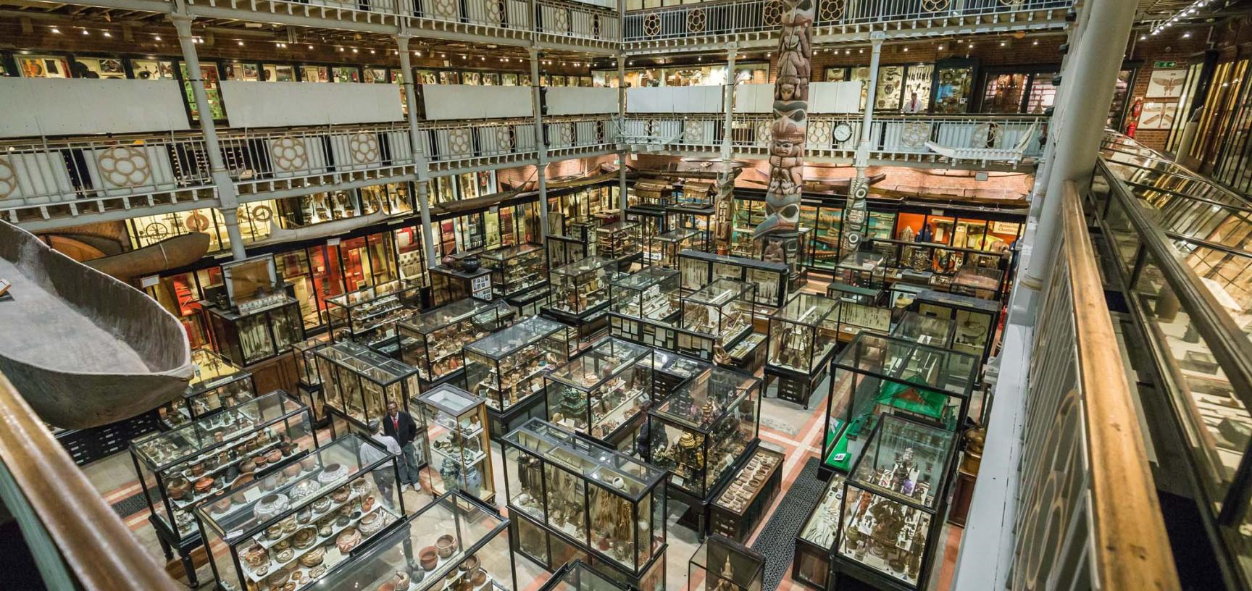
Pitt-rivers Museum (https://www.prm.ox.ac.uk/museum-court)
The Pitt-Rivers museum was founded by General Augustus Pitt River, who after retiring from the army, took part in many excavations. This resulted in a very large collection of anthropological and archaeological significance which was later donated to Oxford University, finally culminating in the Pitt-rivers museum. ‘Construction on the building began in the summer of 1885. It was the work of the Dublin-based architect T.N. Deane, whose father had provided the basic designs for the University Museum’ (Cousins, 1993:9). The purpose of this University, according to Backwoods, was ‘that a building should be provided to house the collection and not used for any other purpose; the second, that a person should be appointed to lecture on the subjects of the Museum.’ (Blackwood, 1970:10)
As can be seen above, the Pitt-River museum consists of 3 levels - a ground floor which mainly consists of fetishist items or items which are more symbolic in their usage, items that could be considered gifts all the way to shrunken heads and items of sympathetic magic. The second floor consists mainly of a diverse range of tools, such as those involved in the construction of a canoe, all the way to tools relating to surgery. The third and final level at the top of the museum displays weaponry and armour of various cultures and societies around the world.
The most striking thing about how these exhibits are displayed is that they blend in incredibly well with one another. So, as a visitor walks around the museum, going from bottom to top, that person can see, for example, how ceremonial fetish items blend in with practical everyday tools. One also may wonder how those tools, which one would consider everyday items, benign in their purpose, become lethal weapons of war and destruction. Their initial purpose becomes perverted, and vice versa, depending on the various paths that individuals may take to uncover their history’s.
How the Pitt-rivers museum uses the Panopticon as a form of architecture
First thing when talking about the architecture of the Pitt rivers museum is that in many ways it mimics certain aspects of the panopticon which started out life as an architectural concept designed to help in the discipline of convicts within the prison system. According to Foucault it was an ‘architecture that is no longer built simply to be seen…but to permit an internal, articulated and detailed control (Foucault 1977: 172). In effect, unlike previous architectures such as fortresses which commanded an unparalleled view of the surrounding area, or palaces which demanded that one look upon the building, a panopticon creates an unparalleled view of the area within a structure.
Foucault’s 1977 work makes a discussion referring to the 18th century penal system which is described as ‘a garden of the law that families would visit on a Sunday’ (Foucault, 1977: 111). The reason for this description is that at one point people went to prisons which the panopticon was originally designed for in order to absorb and observe the atmosphere and the people within these environments in order to understand and educate themselves on civic norms by learning from example what to do and what not to do. At this point in history the pseudoscience of phrenology was in vogue - a practice which judged other humans by the shape and various lumps and bumps upon the cranium. Later, the practice of going to prisons became less fashionable, and strangely enough, visiting museums became more socially acceptable. In particular, museums such as the natural History museum and the Pitt-rivers museum came into prominence showing off, ‘the ‘underdeveloped’ crania of the aboriginals at the Petersfield museum, for example, or the alleged peculiar crania of criminals’.(Bennet, 1995: 102-103).
Critically looking at this, the panopticon has something of a roundabout history. It was not specifically created for the museum, but rather was a piece of architecture that was developed and repurposed from the penal system as a method of observing people. It was then later used in order to promote the humanities and the heritage of other people, as can be seen in the Pitt-rivers museum. It should be mentioned that the Pitt Rivers museum is not a perfect example of a panopticon, as the purpose-built article would be circular whereas the structure of the Pitt Rivers museum is more architecturally square.
Typology
When discussing typology in reference to the Pitt rivers museum one was first understand what typology is and what it means in this circumstance in particular in the Pitt rivers case ‘the exhibits were arranged into a number of different series each of which, by means of the ,’typological method’ , depicted a particular developmental sequence’.(Bennett 1995 :199) All of this essentially meaning that a tool depending on its purpose is grouped together with other tools also performing a similar purpose but seeming to branch out from more simple designs to those off more complex and refined appearance, an example would be a stick developing into a spear developing into a halberd, listen analogy is developed but for the purpose of this explanation necessary to illustrate the point. it must also be commented that this methodology was used in the grouping of human bones with a slightly dated and racist ideology.
The people of The Pitt-rivers museum has since its inception been a place of anthropological curiosity grouping together objects according to Bennett group together objects ‘in accordance with the genetic and typological systems which group together all objects of a similar nature’ (Bennett 1995 : 79) From there it goes on to talk about how in the 18th century such systems of typology were there in order to extenuate the diversity of things such as inanimate objects all the way too human remains. This later changed however with the ideology surrounding Darwinian theory and the ideas surrounding this. Which the Pitt rivers museum coming in the later stages of the 19th century promoted in its display of human remains.
According to Blackwood 'The arrangement of large collections by subjects, with the areas in which objects are found as sub-groups within them, the original idea of General Pitt Rivers, sometimes displays the geographical variation of an art or industry’ (Blackwood, 1970: 14 - 16) this type of typography differs greatly with museums, such as the ‘Ashmolean’ in Oxford, Which looks at topographical areas and groups items according to their geographical location And time period rather than the purpose by which an object is used whereas the Pitt-rivers museum Use of typology allows people to know where the object is from in a very general manner with reference in the cases to which continent the artefact Being displayed comes from and numbers each item in order to get further information, that information has to be actively sought out in order to be gained and even then only cursory information is given.
This typological methodology has an obvious drawback in that a casual observer will not get the information right away and may find it annoying and inconvenient define the information that might otherwise be more easily be obtained, this however is incredibly difficult to do because of the scale of the collection found out the Pitt rivers museum and therefore would be impractical given the amount of staff is actually employed at the museum or even volunteering.
the positive side of this methodology is that it encourages curiosity the whole display and layout of the museum encourages one to look at mass of objects on display encouraging the observer from a distance to find out, to look and see what can be seen. This observation can be complemented by a comment on the Pitt rivers museum by Blackwood 'I enjoy coming here, because I always find something I haven't seen before.' (Blackwood, 1970:8) This little bit of personal Association with museum that she comments upon with the museum is extremely important as it shows that even with multiple viewings there is just too much to see in one sitting, this depending on the person that visits would encourage or will encourage multiple visits to the Pitt-rivers encouraging the curiosity encouraging the self-learning of the person viewing enabling and encouraging critical thought on the half of the viewer.
Overall the typology at the museum encourages multiple viewings of the same exhibits and encourages critical thought however on the other hand this may not appeal to a casual viewer.
The cabinet of curiosity and the Pitt-rivers
A cabinet of curiosity is essentially a collection of different objects and curiosities that enthusiast places decorously in a room war other space such as cabinet as the name would suggest according to Bennett in his work ‘The birth of the museum’ references ‘Cabinets de Curieux’, And comments on the 16th and 17th century collectors which made an effort to collect a variety of Artefacts. Not only this but it comments on the need of people to collect items In order for us to impress and be impressed by to ‘give free reign during its brief in interregnum, curiosity spontaneously fixed on all that was most rare and most inaccessible, most astonishing and most enigmatic.’(Pomian 1990: 77-8)
These characteristics exactly exhibited in the nature of the cabinet of curiosity is relevant here because a similar effect is created by the Pitt-rivers museum that would otherwise not be seen in another museum such as the Ashmolean or the Natural History Museum in London. The Ashmolean in particular, as has been alluded to earlier, Is more concerned about telling a story ordering its acquisitions depending on the histories and area in the world where's the Pitt rivers museum collects certain form of article and groups it according to its purpose and design, geographical importance is secondary, this is important because the affect that this has in the museum is very similar to a cabinet of curiosity, as it is grouping objects in an aesthetically pleasing manner which although not immediate is still logical promoting analytical thinking.
This non-linear form of teaching is alluded to in ‘The Museum of Lies: Incorrect facts or advancing knowledge of ancient Egypt?’ by Katarina Zinn who in her work talks about how the purpose of a museum is to teach an individual too think at least here in the modern day encouraging individuals to exercise areas of their mind which they may not necessarily have accessed in the past. According to Beatrix Blackwood '... [The Museum's] teaching activities [are] an integral part of the University Department of Ethnology and Prehistory [now School of Anthropology and Museum Ethnography].’ (Blackwood, 1970:14) In order to teach a person something new they must first be open to it and not as not everyone are the same different methodologies must be employed in order to teach and learn and this may not always be the case with simply telling someone a fact as although a fact may be considered true it could just as easily be proven false the point is an individual must learn to argue and analyse the so called fact first in order to have an informed opinion.
Conclusion
In conclusion Looking at the Pitt rivers museum critically the panopticon like architecture alongside the Pitt rivers use of typology create a symbiotic relationship making order out of chaos
The massive artefacts collected and on display at anyone given time requires that the typology display everything logically but also so that it is aesthetically pleasing encouraging people to come and view the collection. This positive is however countermanded as a person who may not be necessarily be as invested in the displays as someone else.
The architectural use of a panopticon like affect, allows people no matter where they are in the museum to be able to glimpse other displaces that maybe in the area on a different floor and encouraging people to think differently and seek out what can be seen within the museum.
Overall thanks to the symbiotic relationship between the architecture and typology within the museum a person can be both entertained and educated, Thanks to this inheritor of the ‘cabinet of curiosity’.

References
Bennett, T. 1995. Re-printed 1996. The birth of the museum history theory politics, London: Routledge, Taylor & Francis Group.
Blackwood, B. 1970, frontispiece. Oxford: Oxford University Pitt Rivers Museum. Oxford: Pitt-rivers museum.
Caulton, T. 1998. Hands-on exhibition managing interactive museums and science centres. London: Routledge, Taylor & Francis Group.
Cousins, J. 1993. Pitt Rivers Museum: A Souvenir Guide, Oxford: Oxford University Pitt Rivers Museum
Foucault, M. 1977. Discipline and punishment: The Birth of the Prison, London: Allen Lane.
Edited by knell, S J. MacLeod, S. Watson, S. 2007. Museum revolutions how museums change and are changed. London: Routledge, Taylor & Francis Group.
Labadi, S and Long, C. 2010 ‘Heritage and Globalisation’, London: Routledge, Taylor & Francis Group.
Pitt-rivers Museum 2019, New main court hire 2, Viewed 9th January 2020 . <https://www.prm.ox.ac.uk/museum-court>.
Pomian, K. 1990. Collectors and curiosities. Cambridge: polity press.
Edited by Selwyn, T. 1996. The tourist image myths and myth making in tourism, Chichester: John Wiley & Sons Ltd
Dion, M. & Editor Sheehy, C. J. 2006. Cabinet of curiosities: Mark Dion and the University as installation. Minneapolis: University of Minnesota Press.
Urry, J. 1990. The tourist gaze, leisure and travel in contemporary societies. London: SAGE Publication Lid.
Zinn, K, 2019. The Museum of Lies: Incorrect facts or advancing knowledge of ancient Egypt?, JOURNAL OF HISTORY AND CULTURES, Vol.10, pp165-190.

