Mohammed Manik Miah 1710290

Translate 24 Group Questionnaire and Results

This is market research for our translation business. Please take your time to fill our form.
- 1. Are you male or female? [male] [female] [other]
- 2. How old are you? [20-30] [30-50] [50-80+]
- 3. Have you ever faced difficulties in your everyday life due to having a language barrier? [ yes ] [ no ] [Other .........................]
- 4. Have you ever thought of hiring a professional translator to help you with your daily needs? [ yes ] [ no ] [Other .........................]
- 5. Would you consider making an appointment with a translator of your spoken language to help you with your doctors, hospital or any other appointments you may have? [ yes ] [ no ] [Other .........................]
- 6. Here at Transalte24 we are almost 25% cheaper than our competitors, we provide the same level of service, would that help you decide who you would choose? [ yes] [no ] [Other ..........................]
- 7. Would you like a translator to pick you up from your home or place of work and take you to your required appointment? [ yes] [ no ] [Other ..........................]
- 8. How will you rate us? ………….(1-5 : 1 means poor performance, 5 means excellent)
- 9. Will you use our services again? [yes] [no]
- 10. Will you recommend us to family and friends? [yes] [no]
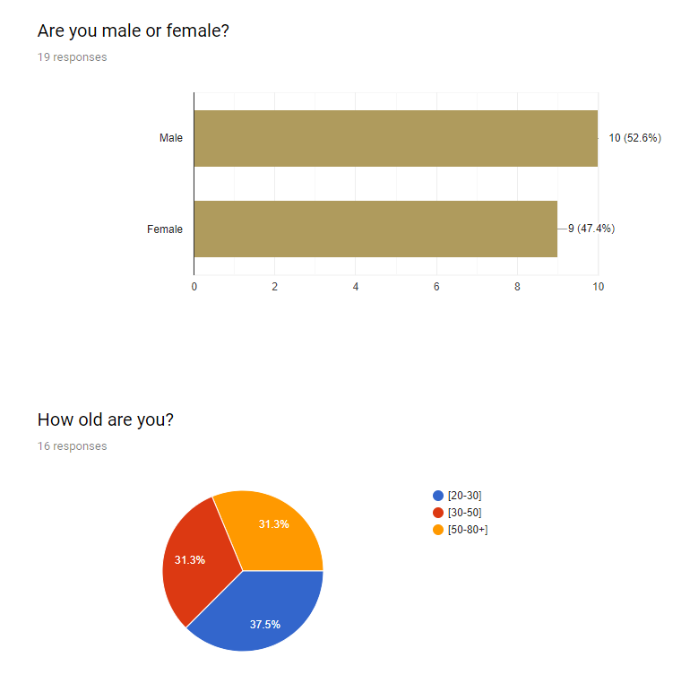
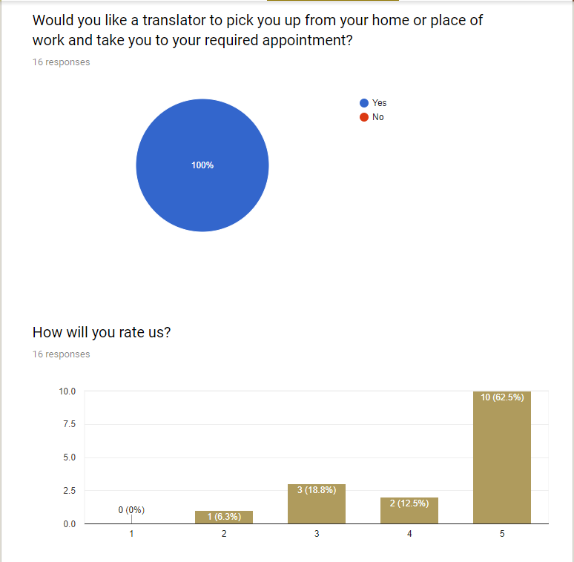

Website Development
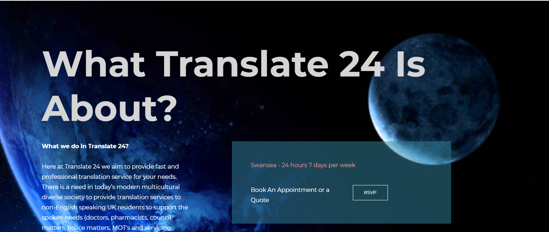
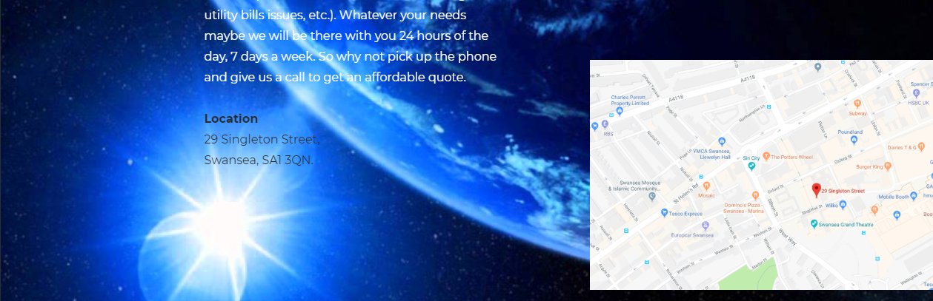

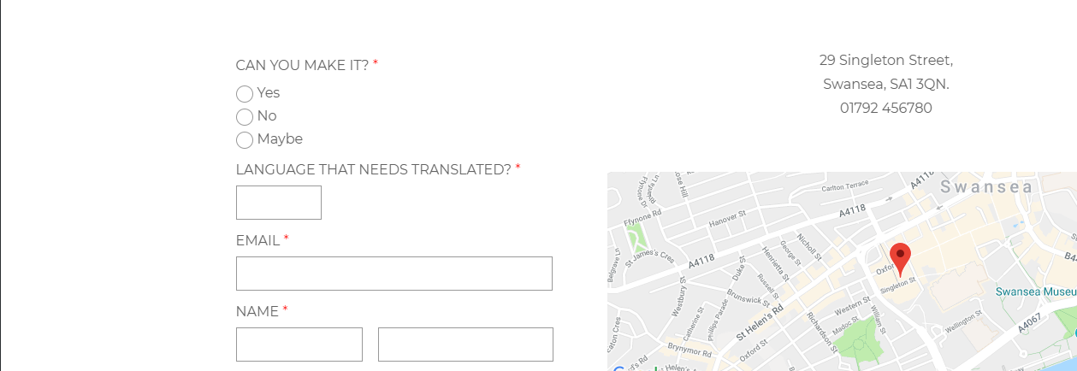

My part: link to emails, about us, personal bio and images etc.


