

2014507 - Cameron Dickson
Computational Methods
2D Diffusion Equation model using the Explicit Finite Difference Method
Dr Arnaud Marotin
29/01/2024

Table of Contents
Introduction to the problem under consideration 3
1. The constitutive equation of the problem 4
2. Numerical Method Chosen to discretise the governing equation 4
3. The initial boundary conditions and analytical solutions 5
4. Details of the Code 6
5. Analysis of the code 9
6. The Limitations of the model 12
7. Improvements to the model and future developments 13
8. Conclusion 14
9. References 15
10. Appendix 15

Introduction to the problem under consideration
The problem that is under consideration is that we have been tasked to calculate the temperature within a 2D aluminium plate through time. The calculations that need to be solved will be done by considering the region of interest. The region of interest which is the 2D aluminium plate will be covered by a uniform grid. The grid spacing is h = ∆𝑥 = ∆𝑦.
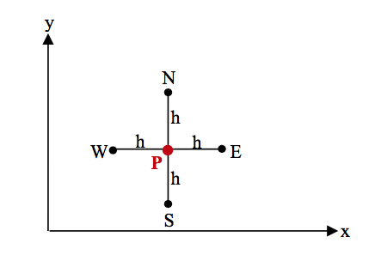Fig.1
The above image as stated as Fig.1 you can see the uniformed grid. The calculations will be based on the Explicit Finite Difference Method. The explicit finite difference method is where by using numerical techniques you can solve differential equations by assuming the derivatives. Within this problem it will be explicit as we can compute forward in time using quantities from the previous time steps that have been taken.
Mathematical Modelling is broken up into four types. These four types are statistical models, differential equations, dynamical systems and game theoretic models. The mathematical modelling we will use to solve this equation would be differential equations. By using this technique our purpose to get various approaches for modelling systems using these differential equations.
There are a lot of benefits with finite difference method and mathematical modelling. For example, using these types of numerical techniques you can achieve very precise results which will allow you to create extremely accurate assumptions of how a material or substance will act in the real world. Using these techniques it gives you a profound direction when solving a problem by following some simple rules. Like in our case to solve the problem that is given using coding and computers is very beneficial to perform calculations and many other functions for us that will decrease the time spent on the problem. It also reduces human error as long as the code or function you are using is correct then the results will be very precise and accurate. However there are many limitations when using mathematical modelling. Using these techniques can also be very hard to comprehend and can be very challenging if not fully understanding how to write or use these equations and formulas properly. That being the main limitation of using numerical and coded solution is that the data you use can maybe be inaccurate or not always available easily. This can then obscure your results that you might get. Using real world tests and solutions will allow you to see first hand how the material or substance reacts.

The constitutive equation of the problem

The heat equation is a partial differential equation that describes how temperature varies with time and space in a given region. It is fundamental in the field of heat transfer and is widely used in physics, engineering, and other scientific disciplines. The heat equation is important for understanding heat distribution and diffusion processes, providing understandings into things such as heat conduction, heat convection, and thermal radiation.

The heat equation that we have been given is shown below:

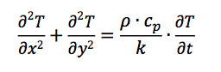

T – Temperature
$ρ$ - is the density of the material.
cp​ - is the specific heat capacity.
k - is the thermal conductivity.

$\frac{∂^{2}T}{{∂χ}^{2}}$ - is partial derivative for x

$\frac{∂^{2}T}{{∂y}^{2}}$ - is partial derivative for y

$\frac{∂T}{∂t}$ - is how the temperature varies over time

This equation describes how heat changes in a 2D region over time. The 2D results account for the temperature variations in the x and y directions, and the time-based result accounts for how temperature changes with time. The heat equation is a differential equation, and its solutions depend on the initial and boundary conditions of the system.

Crank, J. (1975). Ref.1

Numerical Method Chosen to discretise the governing equation

The following steps are part of the chosen numerical method for discretising the governing heat equation:

Taylor Series - For the first and second derivative, you use Taylor's series to create difference approximations. Taylor series is a mathematics concept that represents functions as an unlimited number of terms, where each term arises from the derivatives of those functions at different points in time.

Derivation of differences between Taylor's series are forward, backward, and central differences emerge. For the approximation of the 1st and 2nd derivative, these differences shall be used.

Explicit Finite Difference Scheme - Forward difference approximations shall be used to replace the temporal first derivative in the heat equation. Central difference approximations shall be substituted for the spatial second derivative of the heat equation.

Discretize the Spatial Domain - To discretize the spatial domain, by dividing the spatial area into a grid of discrete points. By doing this you will be able to capture the solution's behaviour in a precise way, grid spacing should be chosen that is often uniform.

Discretize the Temporal Domain - To discretize the temporal domain, by dividing the time interval according to a set of intermittent steps. In order to guarantee the stability of the solution a time frame should be chosen.

Derive Explicit Difference Finite Form – To do this you express a heat equation introducing Fourier’s Number. The Fourier number is a dimensionless parameter used in heat transfer analysis. The ratio between the rate of heat conduction in the solid and the rate at which heat is stored in the material due to thermal capacitance is defined.

A stability criterion will need to be established. In order to ensure that the solution is stable, the chosen time step and grid spacing should be in accordance with this criterion.

The initial boundary conditions and analytical solutions

For my code below are my initial boundary conditions:

Initial Domain Condition | 0˚C
North edge | 0˚C - 50˚C up to 4 and then 50˚C-0˚C from 4 to 6
East edge | 0˚C
South edge | 0˚C
West edge | 0˚C

The analytical solution means that I have to solve the heat equation with these initial boundary conditions. Since it is a complicated problem, mathematical methods may be used to find the solution. The solution I will use is by coding this and putting it into Matlab. For the numerical simulation of heat transfer, this code can be used to compare results with an analytical solution in order to verify that a numerical method is accurate.

Details of the Code

In Fig.2 that is stated below is the clearing functions. The CLC command is the first one to be used, it clears the Command window and produces a clearer display. Clear all will clear the command window, and the closing all function will close everything you see. In order to give the user a clear workspace, these three commands are commonly used at the beginning of any scripts.

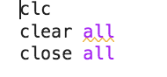
Fig.2

In fig.3 that is shown below. These properties are the foundation of the code and allowed for me to generate specific results related to the aluminium plate that was given in the assignemnt brief.

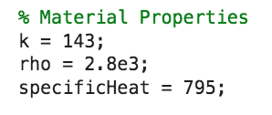Fig.3

In fig.4 that is shown below. This is the equation which is used to work out the thermal diffusivity. Thermal diffusivity is defined as the rate of temperature spread throughout a material.

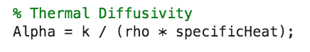Fig.4

In Fig.5 that is shown below. This is where I specified the plate dimensions that was given in the assignment brief.

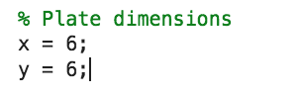Fig.5

In Fig.6 that is shown below. This allows the user to define a grid spacing that is specified. It also allows the user to provide a time step in seconds. The ‘msg’ that says grid spacing is not valid is so if the user puts in a grid spacing that is over the min or max value. This will flag up and make them enter a new grid spacing that is hopefully within the desired values.
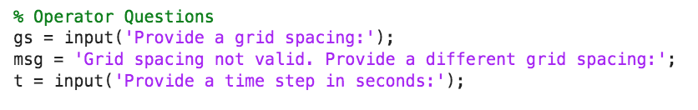

Fig.6

In Fig.7 that is shown below it displays the safeguarding inputs. These are used to ensure that user does not exceed a certain value. In this case the code is asking for the value to be less than the grid spacing but greater than 0. By adding this safeguarding you are ensuring that your grid spacing is divisible by the x/y dimensions. The while value is added to ensure that the operator meets the conditions of the text before allowing them to progress

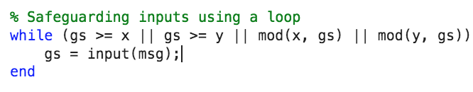Fig.7

In Fig.8 that is shown below. This is where I specified and wrote the code that defines the columns and rows. This is so the grid spacing does not start on either of the boundary conditions and the matrix is where it is set to 0 before the nodes are added later on.

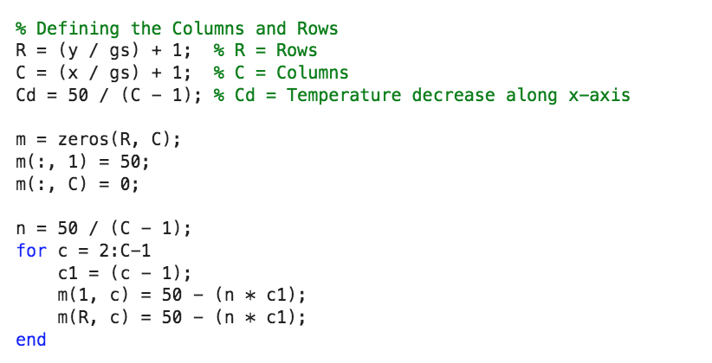Fig.8

In Fig.9 that is shown below. The max time step and stability criterion. The operator must enter a time step greater than 0 and less than the 'tmax' or the maximum timestep that the operator may be allowed to allow the fourier number to be less than 0.25, when using the 'while' function again. In view of the fact that a higher number may prove unstable, it is aimed at keeping the fourier number below 0.25. By doing this we are meeting the stability criterion by not allowing the operator to enter a significantly high timestep value.

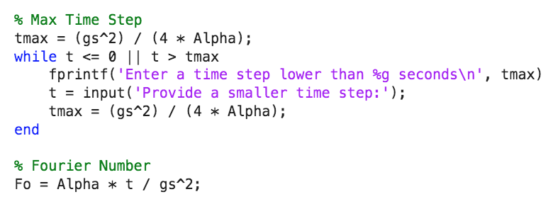Fig.9

In fig.10 that is shown below. The temp matrices is what represents the temperature distribution at the start on the plate. It then shows the temperature distribution across the plate with the correct time step that is set by the user.

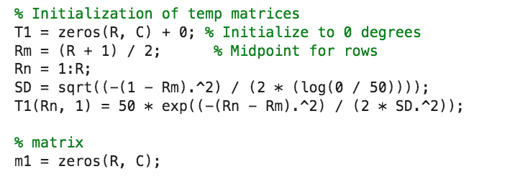Fig.10

In Fig.11 that us shown below. This is the calculation of the boundary conditions and how they will show and be plotted on my graph.

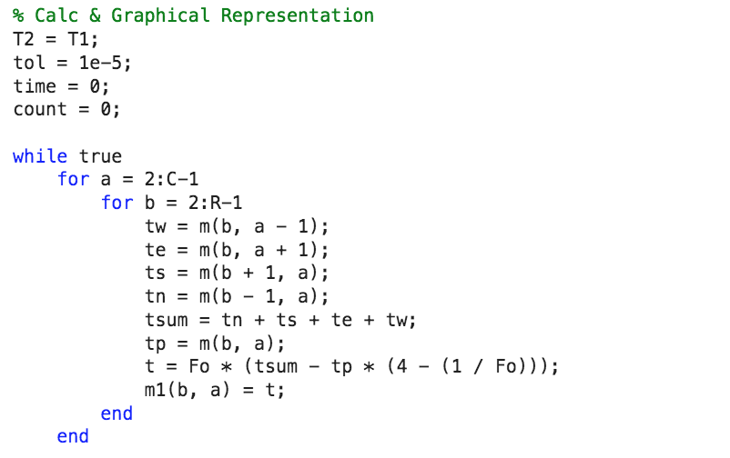Fig.11

In fig.12 shown below this is where my graph settings are coded in. Using the ‘contourf” function that uses 3D data and plots it into a 2D format. This is where I can set the colours and how the graph will look with the x and y axis labelled correctly.

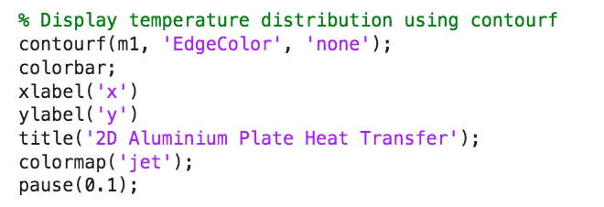Fig.12

In fig.13 shown below. This is the calculation for the Equilibrium time. This will calculate my results and then display it for me.

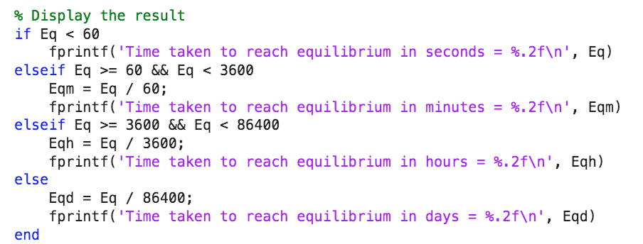Fig.13

Analysis of the code

Displayed in the tables below are the time in equilibrium results which have been based on the output of my code with changes of the Grid spacing and the Time step.
The changes created by changing these subjects are displayed below, each test is conducted with the plate dimensions of 6 x 6.

The table below the grid spacing will vary but the time step and tolerance will be fixed.

Grid spacing h | Time step (fixed) | Tolerance (fixed) | Thermal Equilibrium Time
3 | 150 | 0.001 | 2.07
2 | 150 | 0.001 | 1.69
1.5 | 150 | 0.001 | 0.88
1.2 | 150 | 0.001 | 0.65
1 | 150 | 0.001 | 0.43
0.75 | 150 | 0.001 | 0.25
0.5 | 150 | 0.001 | 0.11
0.25 | 150 | 0.001 | 0.03
0.2 | 150 | 0.001 | 0.02
From the table above you can see that as the grid spacing decreases in size the thermal equilibrium also decreases in time. This is what you’d expect. As the grid spacing gets smaller the thermal equilibrium time with a fixed time step will indeed reach that point quicker.

Grid spacing h (fixed) | Time step | Tolerance (fixed) | Thermal Equilibrium Time
2 | 2000 | 0.0001 | 0.02
2 | 1500 | 0.0001 | 0.03
2 | 1000 | 0.0001 | 0.07
2 | 800 | 0.0001 | 0.11
2 | 600 | 0.0001 | 0.18
2 | 400 | 0.0001 | 0.36
2 | 200 | 0.0001 | 1.09
2 | 100 | 0.0001 | 2.96
2 | 50 | 0.0001 | 6.08
2 | 25 | 0.0001 | 6.69
The table below is with a fixed grid spacing and a fixed tolerance but the time step will vary.

In the table above with a fixed grid spacing and a varied time step you’d expect to see a pattern or trend as you adjust them. In the results as I decreased the timestep and kept the grid spacing fixed the time it took to reach equilibrium got slower. This is what you’d expect as the time step is decreasing.

In my code I used a grid spacing of 0.5 and I changed the time step 3 times to show the differences of 3 different time steps. In fig.14 below I used grid spacing 0.5 and a timestep of 10. As you can see from this simulation it reached the thermal equilibrium very quickly and the temperature didn’t reach the middle of the plate.

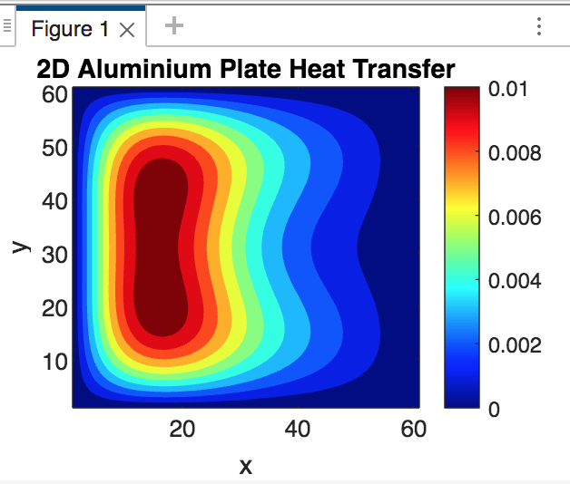Fig.14
In fig.15 that is shown below, I used the same grid spacing of 0.5 but changed my time step to 20. This should slow the time it takes to reach thermal equilibrium and you should see the heat displacement reach a more central position on the plate.

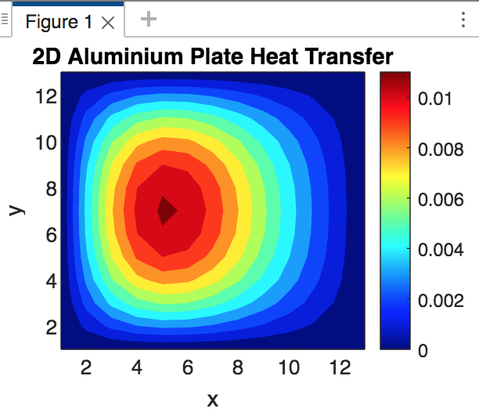Fig.15

In fig.16 that is shown below. I increased the timestep to 50 and kept my grid spacing to 0.5. This should allow a better reading and more accurate reading of the thermal equilibrium. This has allowed enough time for the heat to displace.

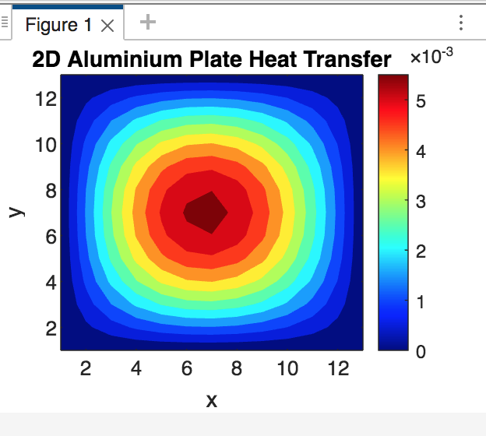Fig.16

Further analysis of my code concludes that these reading that I am getting are not what should be expected from the equation we were given. We should see the hottest part of the plate to the top right of the plate. As it is 50 degrees along the top boundary. On the graph that was shown in the assignment brief along the plate at the dimension 4 we should see the heat spike there. These results are due to my code not being correct. These are all problems with coding as human error can cause false readings and results you may not expect.

In regards to fig.16 as you can see due to my higher timestep I had a better result but it took longer to run the simulation compared to Fig.14 and Fig.15. This is explained by Gabo (2011) (Ref.2) as he came to the conclusion that “Smaller values of Time Step lead to a more accurate estimate of the integral, but it takes longer to evaluate.” Meaning that with a timestep of 50, the simulation will take longer, but the results will be more accurate.

The Limitations of the model

Some aspects to be addressed are the limitations of a numerical method and coding when using a simulation for heat transfer problems. Some of these limitations are stated below:

Roundoff errors - Numerical methods involve approximations, which can lead to roundoff errors affecting the representation of real numbers. These errors accumulate over many calculations it will impact the accuracy of the simulation.

Truncation error – By approximating we don’t use the true derivative. This will affect the heat equation which then introduces a truncation error. The truncation errors may be reduced by the use of different methods to get a more accurate result but these are costly to perform.

Complex geometry - Computational methods may be challenged by complex geometries. This will make it difficult to represent irregular shapes or complicated structures in an accurate way.

LeVeque, R. J. (2007). Ref.3

Modelling Thermal Equilibrium - Defining thermal equilibrium based on a minimum difference value between two temperature maps might oversimplify the physics. More strict criteria will need to be applied for the purpose of a true heat equilibrium.

Morton, K. W., & Mayers, D. F. (2005). Ref.4

To overcome these limitations you have to carefully consider the trade-offs between mathematical methods and real world physical systems.

Improvements to the model and future developments

The model could have a lot of improvements made to it. In order to achieve more accurate results, these improvements could be implemented. The code we used shows the technique of explicit finite difference methods, whereas the use of an implicit finite difference method would have been preferable. The implicit method can use a larger set of time periods. The stability criterion will not be required if a greater time interval is applied to the implicit method. The code will take more time to write, although it can achieve better accuracy by using an explicit method. For solving stiff equations with a finer mesh, the implicit method is more numerically stable.

Muzzaf Adak, 2020. Ref.5

Another example to be used to improve the model is Crank-Nicolson difference method. This could be used to improve the accuracy of our results. The Crank-Nicolson difference method which is primarily used for solving the heat equations. Below is the equation and how the Crank-Nicolson difference method works.
“The idea in the Crank-Nicolson scheme is to apply centred differences in space and time, combined with an average in time. We demand the PDE to be fulfilled at the spatial mesh points, but in between the points in the time mesh:
∂∂tu(xi,tn+12)=α∂2∂x2u(xi,tn+12) Ref.6

The advantages of this method is that it is stable as there is no restrictions on the sizes of the time or size of the mesh. It also produces positive solutions.

Another method for improvement would be finite element analysis or FEM, shows whether a product will break, wear out or work the way it was designed. It is named analysis, yet in the product development process it is used to predict what’s going to happen when the product is used. The problem areas that you could be looking to solve would be structural analysis, fluid flow and even heat transfer. Using your model or prototype you can simulate how these parts would actually perform In a real life environment. Using this technique you can prevent catastrophic failures and save time and resources making and test new parts constantly until you get the correct part.

Autodesk, 2020. Ref.7

Another method for improvement could be boundary element method, or BEM s an alternative numerical approach to solve linear partial differential equations if these can be formulated as integral equations i.e. in boundary integral form. The main application field for BEM in vehicle noise and vibration refinement is sound radiation simulation of engine, exhaust shell, etc. BEM could improve the model as it can make the numerical method a lot simpler to understand and achieve. The mesh formation because you have boundary conditions makes it easier for 3D models. It is also a very accurate method due to it being a lot simpler to achieve compared to FEM.

N. Hampl, 2010. Ref.8

The finite volume method or FVM could be another method to improve the model. FVM is a method for representing and evaluating partial differential equations in the form of algebraic equations. In FVM, volume integrals in a partial differential equation that contain a divergence term are converted to surface integrals, using the divergence theorem. A benefit when using FVM is you do not need to create a structured mesh. You will just need to use grid generation by dividing the domain in to distinct control volumes. Also FVM is more accurate than FEM.

Leveque, 2002 Ref.3

Conclusion

To conclude the Explicit Finite Method worked very well in giving me the results. However due to my code I believe that the results I obtained were not correct. Further analysis of my code concludes that these reading that I am getting are not what should be expected from the equation we were given. We should see the hottest part of the plate to the top right of the plate. As it is 50 degrees along the top boundary. However, these results are due to my code not being correct. These are all problems with coding as human error can cause false readings and results you may not expect. the results do not portray a highly accurate level of thermal diffusion across the plate. However, there are methods that could have been used that might have been more accurate or would have allowed us to work better and not have limited us to the tolerances, grid spacing and timestep. Using the Crack Nicolson method may allow for the results to be more accurate and I will lean more towards using this method as opposed to the implicit and explicit finite method.

References

- Ref 1. Crank, J. (1975). The Mathematics of Diffusion. Oxford University Press.
- Ref 2. Gabo. (2011), What does timestep stand for? Mathworks. Available at: https://uk.mathworks.com/matlabcentral/answers/22682-what-does-timestep-stand-for
- Ref 3. LeVeque, Randall. (2002). Finite Volume Methods for Hyperbolic Problems. Cambridge university press. Available at: https://www.cambridge.org/core/books/finite-volume-methods-for-hyperbolic-problems/97D5D1ACB1926DA1D4D52EAD6909E2B9
- Ref 4. Morton, K. W., & Mayers, D. F. (2005). Numerical Solution of Partial Differential Equations: An Introduction. Cambridge University Press.
- Ref 5. Adak, Muzzafa. (2020), Comaprison of Explicit and Implicit Finite Difference Schemes on Diffusion Equation. ResearchGate. Available at: https://www.researchgate.net/publication/340783624_Comparison_of_Explicit_and_Implicit_Finite_Difference_Schemes_on_Diffusion_Equation
- Ref 6. The 1D diffusion equation¶(no date) The 1D diffusion equation. Available at: http://hplgit.github.io/INF5620/doc/pub/H14/diffu/sphinx/._main_diffu001.html
- Ref 7. Autodesk. (2020), finitie element analysis software. Autodesk. Available at: https://www.autodesk.co.uk/solutions/finite-element-analysis#:~:text=Finite%20element%20analysis%20shows%20whether,when%20the%20product%20is%20used.
- Ref 8. Hampl, N. (2010). Advanced simulation techniques in vehicle noise and vibration refinement. Science direct. Available at: https://www.sciencedirect.com/topics/engineering/boundary-element-method#:~:text=The%20boundary%20element%20method%20(BEM,integral%20form)%20%5B4%5D.

Appendix

Code

clc
clear all
close all

% Material Properties
k = 143;
rho = 2.8e3;
specificHeat = 795;

% Thermal Diffusivity
Alpha = k / (rho * specificHeat);

% Plate dimensions
x = 6;
y = 6;

% Operator Questions
gs = input('Provide a grid spacing:');
msg = 'Grid spacing not valid. Provide a different grid spacing:';
t = input('Provide a time step in seconds:');

% Safeguarding inputs using a loop
while (gs >= x || gs >= y || mod(x, gs) || mod(y, gs))
gs = input(msg);
end

% Defining the Columns and Rows
R = (y / gs) + 1; % R = Rows
C = (x / gs) + 1; % C = Columns
Cd = 50 / (C - 1); % Cd = Temperature decrease along x-axis

m = zeros(R, C);
m(:, 1) = 50;
m(:, C) = 0;

n = 50 / (C - 1);
for c = 2:C-1
c1 = (c - 1);
m(1, c) = 50 - (n * c1);
m(R, c) = 50 - (n * c1);
end

% Max Time Step
tmax = (gs^2) / (4 * Alpha);
while t <= 0 || t > tmax
fprintf('Enter a time step lower than %g seconds\n', tmax)
t = input('Provide a smaller time step:');
tmax = (gs^2) / (4 * Alpha);
end

% Fourier Number
Fo = Alpha * t / gs^2;

% Initialization of temp matrices
T1 = zeros(R, C) + 0; % Initialize to 0 degrees
Rm = (R + 1) / 2; % Midpoint for rows
Rn = 1:R;
SD = sqrt((-(1 - Rm).^2) / (2 * (log(0 / 50))));
T1(Rn, 1) = 50 * exp((-(Rn - Rm).^2) / (2 * SD.^2));

% matrix
m1 = zeros(R, C);

% Graphical Representation
figure;

% Calc & Graphical Representation
T2 = T1;
tol = 1e-5;
time = 0;
count = 0;

while true
for a = 2:C-1
for b = 2:R-1
tw = m(b, a - 1);
te = m(b, a + 1);
ts = m(b + 1, a);
tn = m(b - 1, a);
tsum = tn + ts + te + tw;
tp = m(b, a);
t = Fo * (tsum - tp * (4 - (1 / Fo)));
m1(b, a) = t;
end
end

% Stability Criterion
if max(abs(m1(:) - m(:))) < tol
break;
end

m = m1; % Update the temperature matrix
count = count + 1;
end

% Thermal equilibrium time
Eq = count * t;

% Display temperature distribution using contourf
contourf(m1, 'EdgeColor', 'none');
colorbar;
xlabel('x')
ylabel('y')
title('2D Aluminium Plate Heat Transfer');
colormap('jet');
pause(0.1);

% Display the result
if Eq < 60
fprintf('Time taken to reach equilibrium in seconds = %.2f\n', Eq)
elseif Eq >= 60 && Eq < 3600
Eqm = Eq / 60;
fprintf('Time taken to reach equilibrium in minutes = %.2f\n', Eqm)
elseif Eq >= 3600 && Eq < 86400
Eqh = Eq / 3600;
fprintf('Time taken to reach equilibrium in hours = %.2f\n', Eqh)
else
Eqd = Eq / 86400;
fprintf('Time taken to reach equilibrium in days = %.2f\n', Eqd)
end

