Individual Academic Report – Life is Strange Episode 1: Chrysalis

Contents
Table of Contents
Title page 1
Contents 2
Introduction 3
Genre 4
Game flow 5
Intended demographic 6
Gameplay 7
Audio 8
Visual style 9
Game structure 10
Challenges 11
Replay value 12
Positive and negative aspects of the game 13
Bibliography 14

Introduction
Life is Strange, is a linear narrative game published by Square Enix [1], created by Unreal Engine [2] and developed by Don’t Nod studios [3] in January 2015. The game focuses on the choices you make; it shows the good and bad sides of the consequences of your actions. It has been available on every platform since its release in 2015 and has had a massive success since. It has won multiple awards, winning 3 different Game of the Year awards in 2015 [4].

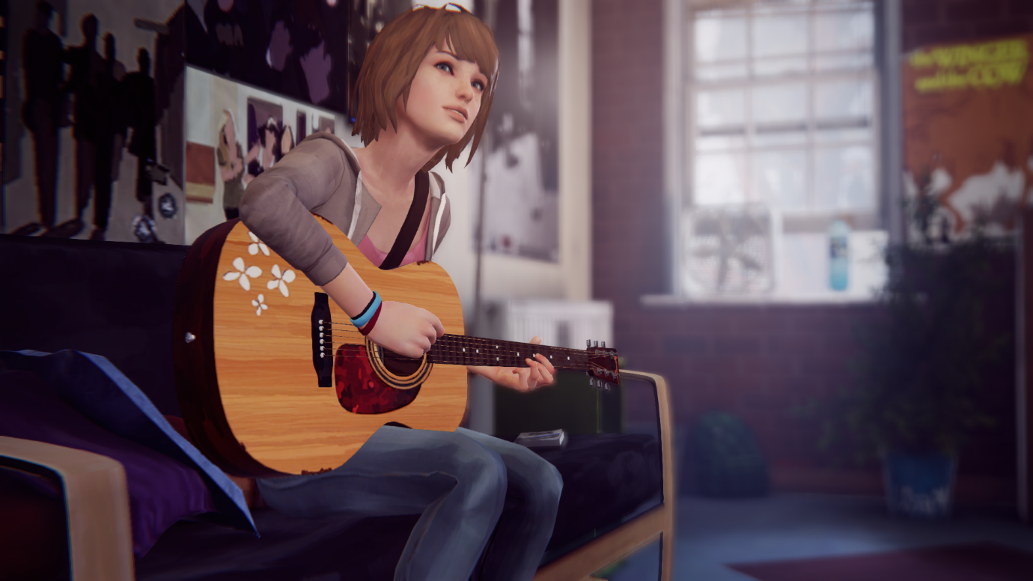
Screenshot of a cutscene in Life is Strange
Genre
The first chapter of Life is Strange; Chrysalis, shows an introduction to the journey of the main character, Max Caufield as she discovers she has the ability to rewind time for a short period. She explores these abilities as she is able to help prevent tragic events from happening as she reconnects with her childhood friend; Chloe Price and they journey through their teenage life. The first chapter introduces you to the story and the play style of the game, as the game is separated into 5 different chapters. The top three tags that describe Life is Strange on Steam [2] are “story rich”, “choices matter” and “great soundtrack”. These all highlight the main aspects of the game from the player’s experience.

Game flow
When loading up the game you are greeted with a shell menu screen and different options. The game has an auto save feature, which usually occurs after important decisions have been made and there is also an option to save during any time in game apart from during shell screens.
Saving a game at a point where the auto save has not been triggered and loading back in will cause a small opening scene for the area to play. This scene is un-skippable and after it is finished, Max walks into frame and repeats the objective.
The game is divided into interactable cutscenes and exploration in a small area. In order to progress, the player must interact with a certain object which triggers a cutscene. During these cutscenes, the player is often given multiple choices which will determine the direction the story progresses.

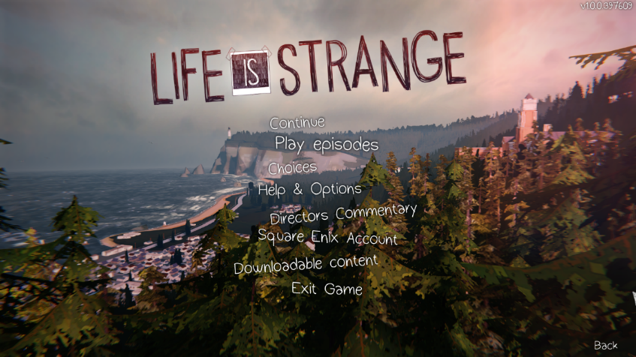
Screenshot of the main menu of Life is Strange
Intended demographic
The game is listed as a PEGI 16 and for mature audiences, due to some adult topics, drugs and violence used throughout the game [5].
Life is Strange has had a huge impact on the female audience and LGBT community side of the gaming community due to the female protagonist, Max and the supporting protagonist, Chloe. Max represents an awkward teenage girl experiencing high school and she is confident in who she is and takes pride in her interest of being a photographer. In contrast with Chloe who is rebellious and outgoing due to her complicate past. The storyline shows both aspects of their lives, with Max being privileged and Chloe being a non-privileged teenage girl.
The game is not specifically for boys or girls, but the female audience are drawn to the game due to Max and Chloe’s characters. They are both their own characters, and they are not driven by a love interest or go out of their way to do something out of character to impress someone. They live for themselves which the female audience find refreshing to see for female characters within games. However, there is not a specific target audience for the game, players that are interested in story games would be the intended demographic, no matter their gender or sexuality.
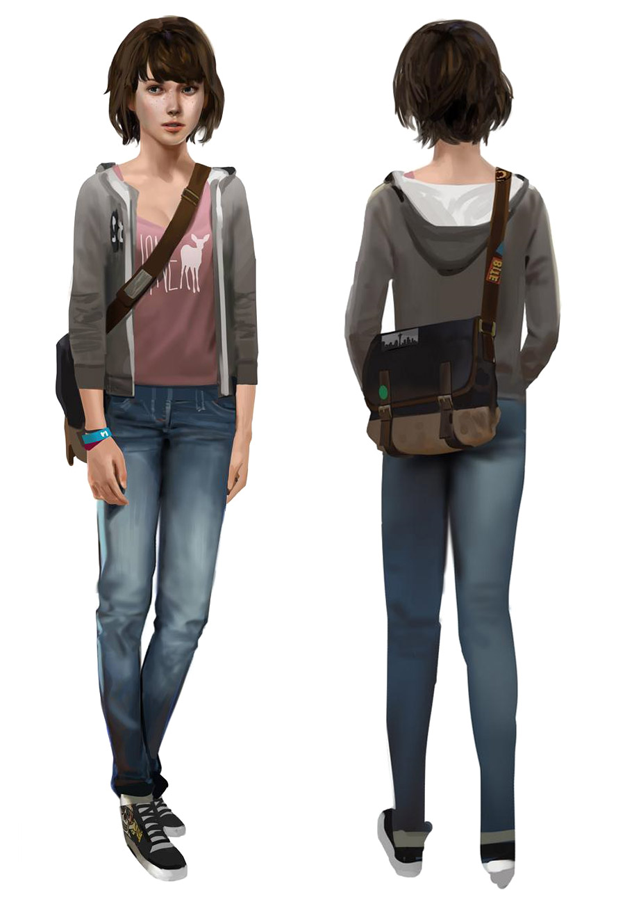

Front and back view of Max Caufield's concept design [6]
Gameplay
The gameplay consists of a third person view of Max; her movement is controlled with the controller on console and the keyboard and mouse on PC. With a controller, Max’s movement is controlled with the joysticks, one to move the camera around and the other to move Max around and the four buttons on the controller are used to interact with different objects and characters. The button on the back of the controller is to trigger Max’s time ability and to make her sprint. For PC, W, A, S, D keys are to control Max’s movement, and the mouse is to move the camera. Left click is to interact with objects and right click to rewind time. The gameplay is simple to do as it’s not a core part of the game and no quick combat is required.
After the cutscenes are finished, Max can observe her surroundings and interact with the objects around her, her movement is controlled by using the joystick and keyboard and mouse. These are relatively easy but interacting with different objects using a mouse is slightly difficult as you must hold the left click and drag the mouse to the direction of the interaction button. Max has a lot of internal monologues throughout the game, when interacting with different objects and when certain events happen, she says her opinions on them. This shows that although you play as Max and are in control of the choices she makes, she is her own character with her own opinions and thoughts.

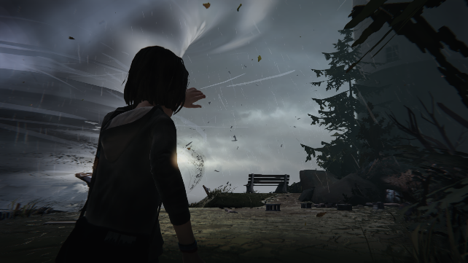
Screenshot of the opening scene in Life is Strange
Audio
When Max makes the wrong choice or decision, although it is clear by the character’s reaction, a butterfly symbol appears on the top left of the screen with text next to it that says, “this action will have consequences” after the interactable cutscene has finished. This is a reference to the “butterfly effect” theory [7] that originated from Edward Lorenz’s chaos theory [8], meaning that a small choice or mistake can have massive consequences. It plays a short sad tune to show that Max has made the wrong choice.
The game has a melodic soundtrack, the background music has a quiet tune playing that matches the overall aesthetic of the game. The soundtrack played throughout the game are original tracks by the French musician, Jonathan Morali [9]. The music is a calm melody that matches the artistic scenery in the game.
The only unoriginal song is played at the start of the game where Max’s journey with her rewinding abilities officially starts. The player can then move around the school halls to introduce the background characters and Max’s friends in her school. “To All of You” by Syd Matters [10] is triggered when Max leaves her classroom and puts her headphones as the player controls her around the school halls as she travels to the school bathroom.
When Max reaches the bathroom, the music fades out as a new cutscene starts and she meets Chloe Price for the first time from afar. This is where the first dangerous situation is shown in the game and where the music is silent to show how the game handles dramatic scenarios by creating more tension.

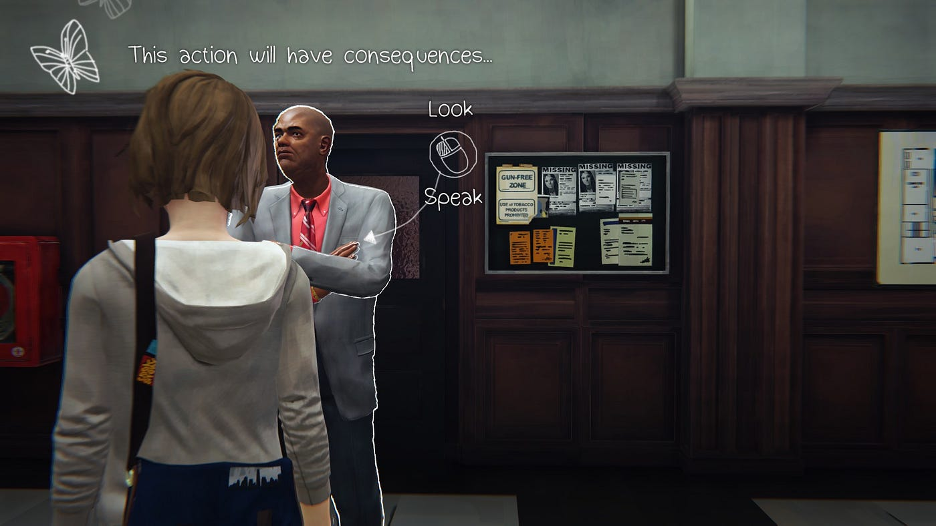
Example of the butterfly effect theory referenced in Life is Strange
Screenshot of the butterfly effect theory referenced in Life is Strange
Visual style
Everything in the game is 3D modelled and rendered with an oil painting finish. The style of the game is very artistic due to Max being a photography student and having art as her passion, the visual style of the game almost looks like the world through her eyes. The textured shading in the environment gives it an oil painting look, which matches Max’s artistic side as it shows the world through her eyes.
This style is consistent throughout the game, making the environments appealing to the eye. When Max interacts with a poster, the design is drawn with a sketchy and painted style. There is an option to read the writing on posters with the stylistic text in a readable font for players that struggle to read the text.
Motion capture was used to animate the character’s movement to make the movement smooth and appear realistic. The motion capture was shot by the French motion capture studio MocapLab [11].
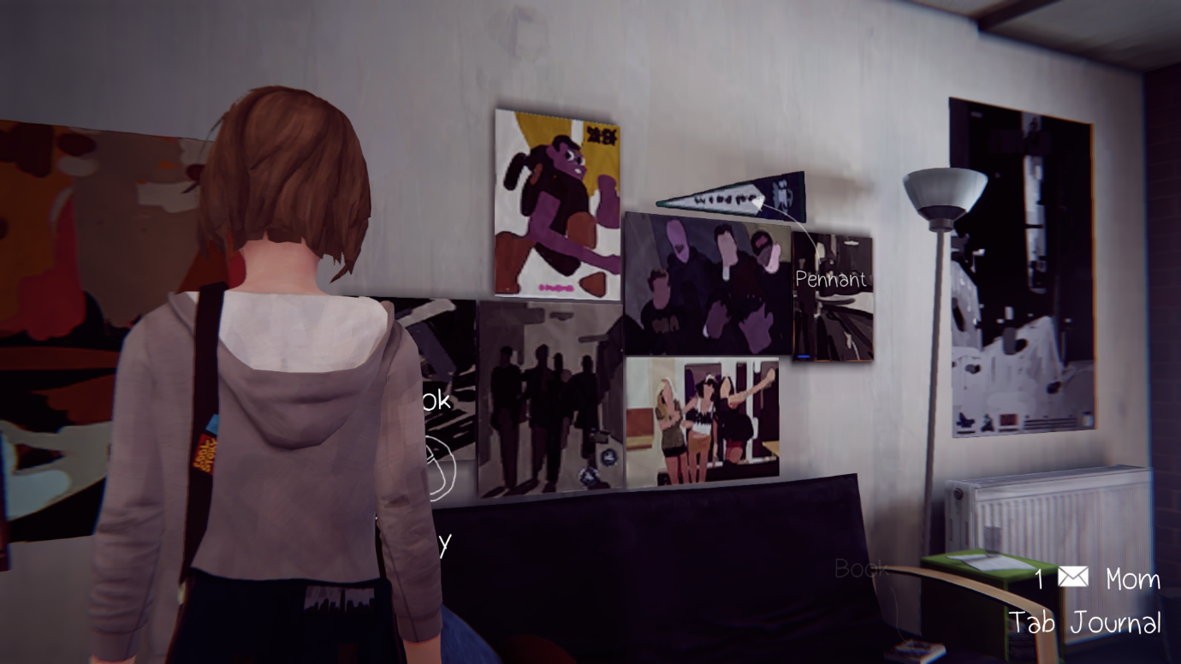
When video game characters have a realistic style to their models, their faces are usually scanned by an actor/actress to properly convey their expressions. However, the character designs in Life is Strange are completely original, which is why the character’s facial expressions do not show much expression. The character’s are carried by their voice acting and designs rather than facial animations, their mouth movements are slightly stiff when they talk which makes them out of sync when they are talking.
Example of the stylistic design of the environment in Life is Strange
Game structure (levels, life system, time-based, points-based, etc.)
When Max is speaking to the characters, there are often different options for what she can say or do. These options determine on different outcomes, if Max chooses the wrong option, she can rewind time which unlocks a new answer that she can use to save herself from saying the wrong thing. This is made clear by underlining the new option.
When Max explores different areas, there is no time limit or clues on how to progress. You’re free to explore the area and discover new things about the story and the characters. Max can interact with almost every object around her, and some objects trigger small cutscenes (e.g., Max interacting with her guitar triggers a skippable cutscene of her playing it). If Max tries to leave the area before completing the objective, she stops herself from leaving and reminds the player what they need to do to progress.
There is an option for Max to take photos of certain objects or scenarios to add to a collection. However, this does not add anything to the story or game, it is just to show that photography is a main part of Max’s character.

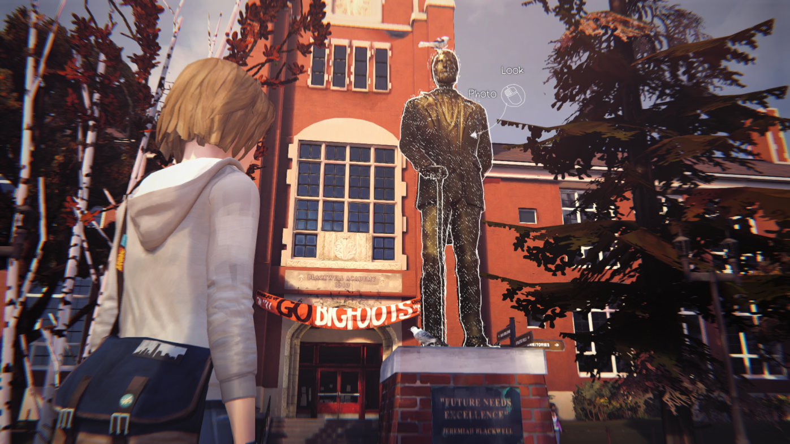
Screenshot of an interactable object in Life is Strange with the option to photograph it
Challenges
There is not a lot of challenge throughout the game, most of the gameplay includes interacting with an object or listening to dialogue for important information. There is not a time limit for many challenges as if Max is late to act, she can rewind time and stay in the correct position to prevent a tragic accident.
Most of the time it takes properly interacting with an object to unlock a clue for the story to progress. Throughout the first chapter, the puzzles are relatively simple to get the player used to how the puzzle system works in the game, interactable objects have a messy white outline around them and sketched dotted lines.
Some challenges throughout the game require the player to pay attention to their surroundings and what the character they’re speaking to is saying. Max will be given multiple choices and she must choose the right one otherwise the story cannot continue.
When the user goes idle, Max has some small animations she does. She awkwardly scratches her neck and looks around the area. After a certain amount of time, she repeats the objective to remind the player to get back to the game if they are away from their keyboard or simply just forgot what it is.

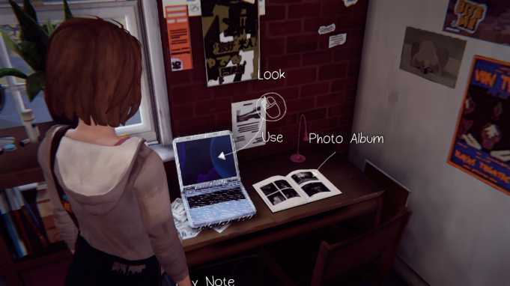
Screenshot of the interactive gameplay in Life is Strange
Replay Value
After completing the first chapter, there is a shell screen that shows you the percentage of the choices of other players globally which gives you the opportunity to replay the chapter to discover the alternative endings.
There are 3 different save files for the player, giving them the opportunity to replay and choose the alternative choices for the different endings. After completing the first chapter it shows you the percentage of what other players globally have chosen. This way you can easily replay the game with the option to collect more items or to experiment with different choices and explore different areas more.

Positive and Negative aspects of the game
Life is Strange has mainly positive reviews overall, with overwhelmingly positive reviews on Steam [2] to an 8.5 rating on IGN [12]. The player base favour the game for good reasons, players are mainly drawn to the story and the visual style of the game, along with the memorable cast and calming original soundtrack, the ability to interact with characters and objects even cutscenes makes the experience enjoyable and makes you feel as though you are a part of the story. The character voice acting also makes the experience feel more real, the voice acting feels natural and makes the characters appear like real people.
Although there is a lot of support on the game, there are also some negative aspects of it. The gameplay side of Life is Strange doesn’t have a lot of action in it and can be seen as easy to complete due to Max’s ability to rewind time making it easy to correct mistakes. Controlling Max can get uninteresting easily as she can only interact with objects and most objects do not add anything to the game and are only interactable for Max to share her opinions on them. Max’s movement is only limited to her walking and sprinting, but her sprinting doesn’t make her go very fast. Although this adds to the realism in the game, it can take a while for the player to get to different places, making the gameplay slow in comparison to the action in the story.

Bibliography
[1] Official website for Square Enix (2003, Apr. 1.) Square Enix [Online].
Available: Life is Strange

[2] Official website for Steam (2003, Sept. 12.) Life is Strange – Episode 1 [Online].
Available: Life is Strange - Episode 1 on Steam

[3] Official website for Don’t Nod studios (2008, May. 1.) Don’t Nod [Online].
Available: https://dont-nod.com/en/games/life-is-strange/

[4] Life is Strange Fandom Wikipedia (2004, Oct. 18.) Life is Strange Wiki [Online].
Available: https://life-is-strange.fandom.com/wiki/Life_is_Strange

[5] Official PEGI website (2003, Apr. 9.) PEGI Pan European Game Information [Online].
Available: https://pegi.info/search-pegi?q=life+is+strange+episode+1&op=Search&age%5B%5D=&descriptor%5B%5D=&publisher=&platform%5B%5D=&release_year%5B%5D=&page=1&form_build_id=form-kru20vTX13jv2KcgK4o4Mtk2YRENKwjWzKF1pJxHac8&form_id=pegi_search_form

[6] Life is Strange Fandom Wikipedia (2004, Oct. 18.) Life is Strange Wiki [Online].
Available: Maxine Caulfield | Life is Strange Wiki | Fandom

[7] O.Campbell (2025, Jun. 6.) The butterfly effect is a real phenomenon—but not how you think [Online].
Available: The butterfly effect is a real phenomenon—but not how you think | National Geographic

[8] Author Unknown (2025, Dec, 28.) Chaos Theory [Online].
Available: https://en.wikipedia.org/wiki/Chaos_theory

[9] Jonathan Morali Official “Jonathan Morali – Golden Hour” YouTube video (2020, Apr. 22.)
Available: https://youtu.be/7Ep_5rMWMKY?si=r4LpxNfjYyzxKtfe

[10] Syd Matters “To All of You” Song (2005, Apr. 1.)
Available: https://open.spotify.com/track/7yC7FWZz24L43brXzNpLWT?si=fbd97b4554b34456

[11] Author Unknown (2007) Don’t Nod – Life is Strange [Online]
Available : https://www.mocaplab.com/projects/dont-nod-life-is-strange

[12] Author Unknown (1996, Sep. 29) Life is Strange [Online]
Available: Life is Strange - IGN

