Network Programmability
Connor Michael Anthony Wilson
Student of University of Wales Trinity St David, Swansea, Wales
2011592@student.uwtsd.ac.uk



The start of the assignment investigating through the API available through the Github link provided. I decided that I wanted to make a program that listed different values for the most popular cryptocurrencies available this was because of the technology being relatively new and having relevance within the information technology field
The program is making use of RESTFUL API (Application programming interfaces. It enables companies or providers to be able to share their data with third parties which could be corporation business partners and internal departments in their companies. The API allows communication between the resources of the company and the program that is taking advantage of the technology. Most of the most popular web applications will make use of APIs currently. [1]
Firstly, decided that I wanted to make the program around listing the top 10 most popular cryptocurrencies available at the time of coding, so I went onto the Coin market cap website (https://coinmarketcap.com/). They include a chart that listed all the different cryptocurrencies in descending order with their name and how much they are currently worth in net total, etc. [2]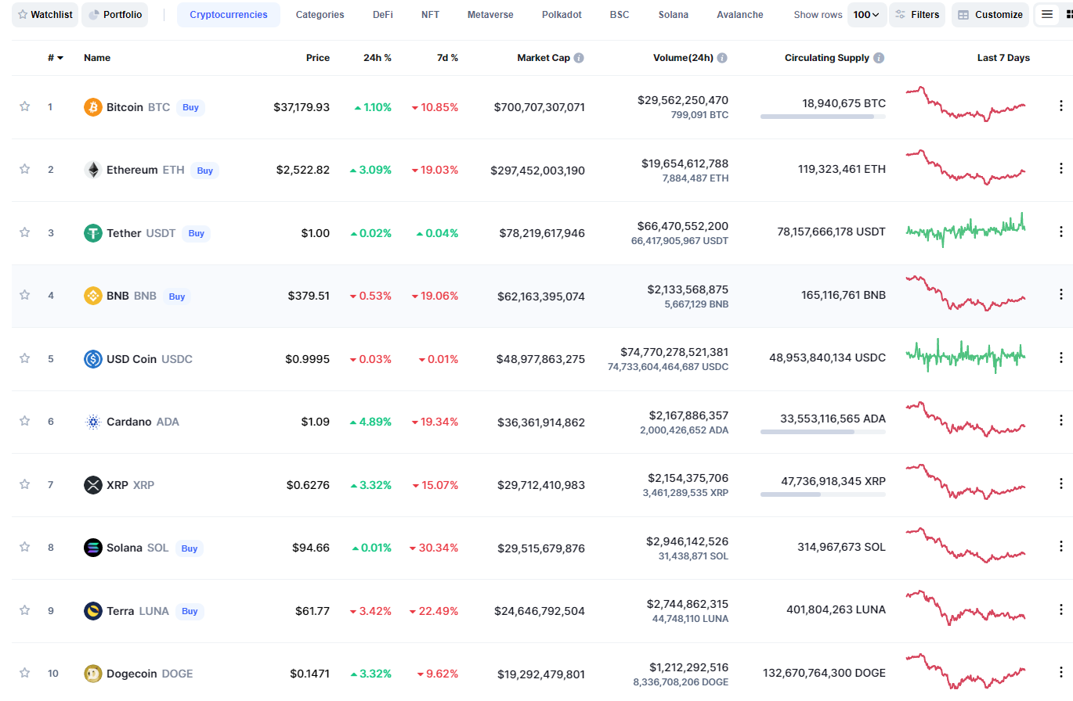
Figure 1 of the coinmarketcap the graph of coin markets [3]
At the beginning of my code, it prints a message with the available cryptocurrencies in the program which are shown in the screenshot below this is so that when the program is run the user is made aware of what inputs are available for them to select from.
The next line of code prints another message while asking for user input from the user and makes it so that the user input is only made to accept an integer value as the user is expected to respond with the numbers listed next to each cryptocurrency.
At this stage in the program, the user will input the number for the cryptocurrency that they would like to see the price of.
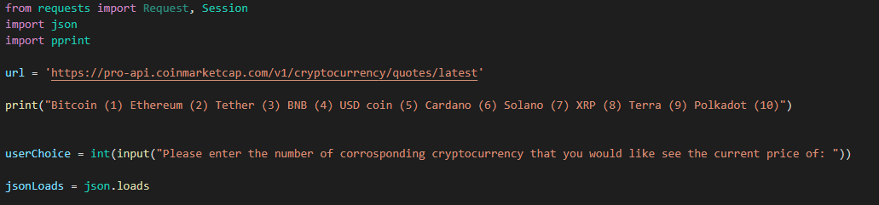
It also imports to say that use the import function within python to import the serval different libraries that my code will be making use of throughout. I use the JSON (JavaScript Object Notation) command as this is required to have the API work as it is reliant on JSON code to function correctly and will not work with just python code on its own.
pprint allows me to format some print statements when fetching the data from the API which allows the output to look cleaner and more professional rather than a block of code is printed by the program for the user to see.
I have then chosen to use if/elif statements for this program in retrospect and reflection it would have been better to make use of a while loop in this scenario as I think it would have made code implementation in the future easier and not only quicker. It can allow for less code in the program as each API call where fetches the value of the individual cryptocurrencies.
Have made so each of the cryptocurrencies and their corresponding values each have if/elif statement that if the value is equal to their corresponding number, then it will run through the code and print the value of the cryptocurrency.
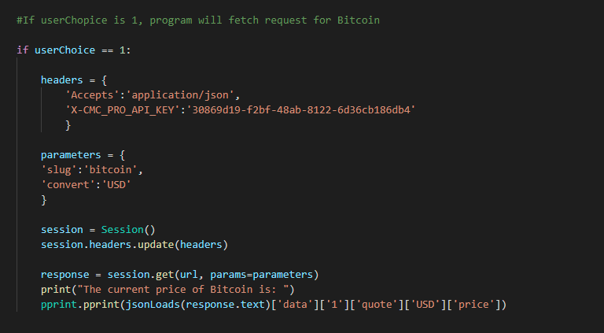

In the headers section of the code, I have made it so it accepts the code in JSON and then underneath I have inputted the API key for my account with the coin marketplace cap website so that it can retrieve the information from the coin market cap website.
In the parameters section of the code the slug uses retrieves the name of the cryptocurrency from the website on each if/elif statement I have declared the cryptocurrency individually for each of the different values. In retrospect, I have noticed another fault with my program here as cryptocurrency is very volatile like any currency market and the top 10 cryptocurrencies at the time of coding could be completely different the next day so to make the code more resilient and looking at the API documentation there is a feature that allows all of the cryptocracies to be printed. This can then be limited to the top 10 values at the present time for instance within the code this would make the program a lot more flexible as currently, it would need to be amended regularly to keep up with the trends that are in the market.
The next element is that it converts the value into USD other features that could have been included would have been to allow the user to make a choice of what currency that they would have preferred the program to print it into this making the program more accessible for users as they would have to then convert the USD value if they were living in another country.
Lastly, it prints a line for presentability which states what the price of the cryptocurrency currently is and then making use of the pprint library it formats the code block into presentable and professional results as it will display just the USD value of the cryptocurrency that is available through the printed result does print with a large number of decimal places so I should have used something that restricts the code to two decimal places for a more neat presentation.
Lastly, if I was to make any improvements to this code is I would include error catching into the code so that if the user enters anything other than a number in the range of 1-10 then it can produce an error and loop to the beginning again or after the result is given at the end when the user has chosen a value for the cryptocurrency then it can ask if they want to check the value of another cryptocurrency.

