Daniel Carlson (2001079)
Computer Forensics - ACCD5000 - DUE DATE: 26/04/2022
Synthesize a solution to a potential real-life scenario

Table of Contents
Task 1 – Research of Current Digital Forensic Tools 2
Introduction 2
The Sleuth Kit and Autopsy 2
FTK Forensic Toolkit/FTK Imager 2
CAINE 3
X-Ways Forensics 4
EnCase 4
Table of Comparison of Available Tools 5
Task 2 – Case study: Sabotage 6
Case Overview 6
Setup and Preparation 6
Initial Steps 7
Hash Detection and Verification 9
The decryption of Files 10
The integrity of Files 11
Report of Findings 11
Invoice of Services 12
Discussion of Case Study 14
Conclusion 14
References 15

Task 1 – Research of Current Digital Forensic Tools

Introduction
“Digital forensics is a branch of forensic science that focuses on identifying, acquiring, processing, analysing, and reporting data stored electronically.” [1] Digital forensic tools are used for all types of investigations in this modern era, from network investigation to complete system analysis. Digital forensics is now a crucial part of criminal and data investigation, and throughout the development of the industry, the evolution of the tools available has taken a significant upgrade. The concept used will never change within the industry, but the devices will continually change. There are numerous available tools, but some are better than others.

The Sleuth Kit and Autopsy
There are many different forensic tool kits available for system and host scanning, but the sleuth kit has been rated one of the best currently available software for professionals. A sleuth kit is a multi-functional tool. It contains many internal tools to help with forensic investigations, such as disk and system scanning and file system analysis. These within the tool will be carried out in a non-intrusive method. Therefore, it would ensure data and file stability and avoid any safety measures from forced access. The sleuth kit is mainly used for file system scanning and can analyse all disk images and recover any lost files.
The Sleuth Kit also comes with the GUI-based tool called Autopsy, and this tool works hand in hand with the sleuth kit tool and functions as a tool that gives the Graphic Interface to all the commands and functions available within the sleuth kit for the ease of use for the user. Both tools are free to download and are open-source tools; autopsy contains all the necessary tools required to analyse all types of drives and devices and includes tools such as keyword search, hashing and specific internal analysis tools such as Registry or Email.
The Autopsy Toolkit is the main downloadable software that is available for most platforms but is mainly used within the Windows Operating System. It includes many of the paid features within many other toolkits for free. It is the upgrade to the Sleuth Kit Forensic Investigation Command Prompt Tool and the replacement/free version of the premium service FTK Forensic Toolkit. As stated in [2]:
The Autopsy Forensic Browser empowers you to lead an advanced criminological examination. It is a graphical interface to The Sleuth Kit and different devices. Autopsy permits you to look at a hard drive or cell phone and recuperate proof from it.
It allows for numerous investigations to be undertaken and the support for any problems and information on the usage and features are all accessible and easy to read.

FTK Forensic Toolkit/FTK Imager
FTK is probably one of the most widely used toolkits by professionals within digital forensics. As stated by C. Dodt:
Developed by Access Data, FTK is one of the most admired software suites available to digital forensic professionals. FTK is intended to be a complete computer forensics solution. It gives investigators an aggregation of the most common forensic tools in one place. [3]
FTK allows professionals to use a range of tools within one software; it encloses all relevant and needed tools into one; it contains tools such as file decryption, malware detection and OCR, which converts images into readable text. The main disadvantage of FTK is that it’s a paid tool.
It is required to pay a premium for complete access, but there is a free trial available before a licence is needed for further use. FTK has been peer-reviewed and proven to be a dedicated and reliable go-to service for most professional digital forensics’ investigators. Many professionals are willing to go the extra mile to pay for this service due to its reliability and proof of professional outcomes.
Due to the success of FTK, there are parts of FTK that have been made free to use by the public, and one such tool is FTK Imager.
FTK Imager is open-source software used as “a data preview and imaging tool that lets you quickly assess electronic evidence to determine if further analysis with a forensic tool is warranted.” [4] FTK Imager is the first step to identify and investigate if further investigation is needed with more advances and detailed tools.
FTK Imager contains numerous drive and data recovery tools and image detection and restoration. The internal features of the application make it a desirable tool for many professionals. FTK Imager is widely renowned because it is one of the significant first steps undertaken in every investigative process. M. A. Talib [5]FTK Imager is a data preview and image processing tool that forensic investigators may use to evaluate digital evidence. A forensic toolkit (FTK) aids in the collection, storage, analysis, and dissemination of computer evidence. Forensic investigators do not work on the original files to protect and safeguard the integrity of the evidence.

CAINE
Other tools are specific to different Operating Systems, such as Linux or Raspberry Pie. CAINE is a tool designed to operate within the Linux environment. CAINE is one of many free tools available that professionals use to investigate Linux based systems. CAINE stands for Computer-Aided Investigative Environment. It aims to create a friendly GUI and an easy-access environment that all professionals would need during the four stages of the investigation. CAINE’s functions include anything from FTK Imager to file analysers/video convertors/players, network analysis tools and many more…
Caine is not an addon to the Linux OS. It is its specific environment and has a Windows live tool created for Windows investigations. CAINE is an open-source, free to use software that is available to download from the official website. The description of the entire program as specified by CAINE in [6]:
CAINE offers a complete forensic environment that integrates existing software tools as software modules and provides a friendly graphical interface.
- The main design objectives that CAINE aims to guarantee are the following:
- an interoperable environment that supports the digital investigator during the four phases of the digital investigation
- a user-friendly graphical interface
- user-friendly tools

X-Ways Forensics
X-Ways Forensics is another highly recommended digital forensic toolkit, as stated by X-Ways:
X-Ways Forensics is an advanced work environment for computer forensic examiners and our flagship product. X-Ways Forensics is more efficient to use after a while, by far not as resource-hungry, often runs much faster, finds deleted files and search hits that the competitors will miss, offers many features that the others lack. [7]
X-ways is a forensic toolkit that provides a massive array of different features and is widely used by professionals in digital forensic investigations. This toolkit offers many advantages to the operator within investigations, the number of features available is endless and contains both general forensic features as well as specific specialist features also. XWF is a windows-based application and will not be able to function on any other operating systems solo, but this does not say it can’t work with a little help, with the collaboration of additional software such as F-Response it can essentially function on any system it would connect to such as Solaris or AIX Operating Systems.
XWF is widely known for its excellence in the image and video compression and the creation of exceptional forensic images for basically every type of digital media available. Shavers [8] notes that XWF can build and maintain container files, which allow you to produce subsets of data for a variety of applications, in addition to producing forensic imagery from source devices. One example would be to give another examiner with a specific speciality a restricted and targeted collection of data.
There are a few drawbacks within XWF, the main drawback is that the toolkit is a paid service and does not offer a free trial for testing purposes. And the fact that the software is solely reliant on a USB dongle and will not be able to function without it, while this is a major disadvantage it can also be an advantage as the toolkit is easily removable and transportable without any problems.

EnCase
One of the best-paid services for Digital Forensics is named the OpenText EnCase Forensic Toolkit. The tool kit is a thoroughly proven and reviewed toolkit that is used highly within courts of justice within the investigations of digital crimes and evidence. As stated by [9] Many people regard Guidance Software's EnCase as being the industry standard software tool for digital forensics and media investigations. EnCase Forensic Edition has become the go-to forensic software tool for law enforcement, governmental institutions, and many schools and organisations.
EnCase provides numerous analysis and decryption tools and has been rated the 1st and most used software within modern organisations and by professionals within digital forensics. The EnCase Forensic toolkit has been evolving continuously since its creation in 1998, with the initial limitation of only being able to read specific file formats such as the FAT formats and the primary NTFS. But slowly, the updates continued to release, and the expandability and file range increased until it can handle nearly every single file format available now.
Of course, with each premium well, renowned software they are not perfect, and there are a few significant disadvantages to consider. EnCase is classed as the most expensive forensic tool available, which can cause individual investigators to lean toward a cheaper alternative option. Also, we EnCase update their software. It tends to cause compatibility issues with other forensic software. With all these updates, there can be a significant increase in the processing time; withes of data within the tool.

Table of Comparison of Available Tools
Software/  Toolkit | Operating System | Price | Features
The Sleuth Kit | Windows | Free | File System Tools, Volume System Tools, Image File Tools, Disk Tools, Sorting and Activity Tools.
Autopsy | Windows, Linux, OS X | Free | Registry Analysis, File Analysis Tools, Email Analysis Tools, Media and Playback, Detection and Extraction Tools, File Flagging, Android and Mobile support.
FTK Toolkit | Windows | Free Trial, then Licence required | Email Analysis, File Decryption, Web Viewer, Malware Detection(Cerberus), Conversion of Imagers to Text(OCR), Data Search and Investigation Tools, Memory Analysis and many more.
FTK Imager | Windows, Supports Command Line for MAC OS | Free | Creation of Images, Memory Capture, Decryption Tools, Image Mounting and Analysis tools, Encryption and Detection Tools and Hash Reporting.
CAINE | Windows, Linux (Main) | Free | Report Collection, Forensic Environment, Tool and Software Integration, Cloning, and Tool Centralisation, all listed tools above other than FTK.
X-Ways Forensics | Windows will work on others with assistance | Paid - £929 | Disk Cloning and Imaging, deleted files and directory viewing, File and Directory Cataloguing, Support for all file systems, File decryption, File and Text Conversion, Detection and Reporting Tools, Analysis Specialised Tools.
OpenText EnCase | Windows | Paid - £2,753 | File System Tools, Indexing Engine, Encryption and Decryption, Mobile Security Bypassing, Volume Shadow Copying, Extensibility, Easy reporting, Image Analysis Tools, Cloud services.
This table shows the comparison between each tool analysed within the document; We see the range of features varies based on the tool and that the paid version has a few more in-depth tools, but also CAINE has a considerable number of elements but is restricted to the Linux OS, with a reduced functionality within windows. We can see that most forensic toolkits are now created for the Windows Operating system, and many will only work within other operating systems if they are assisted by another tool.
We can see the variety and array of different features varying between the tools. We can observe that the paid toolkits contain a significantly greater variety of features than the freely available software. This table explains that even though the price for the toolkits does increase based on features, there are other options to access these features if the price is an issue.

Task 2 – Case study: Sabotage
This case study will briefly describe how a professional forensic investigator would do his day-to-day job. If lost, the recovery of highly confidential, important designs could cost the specific company millions. This task will show the steps undertaken to resolve this with a brief report of the conclusion and a full invoice of services after completion.

Case Overview
This investigation focuses on the recovery of important design image files that hold great importance to the success and future of the company CFC. It is required to investigate all drives on the designated PC, investigate all deleted files, and find the relevant file necessary to complete the required task. The first initial task is to use FTK Imager to examine the appropriate drives within the pc and attempt to recover any deleted files.

Setup and Preparation
Initially, the first step was to create a dedicated directory within the investigative machine where we would store all relevant forensic evidence discovered from the investigation.
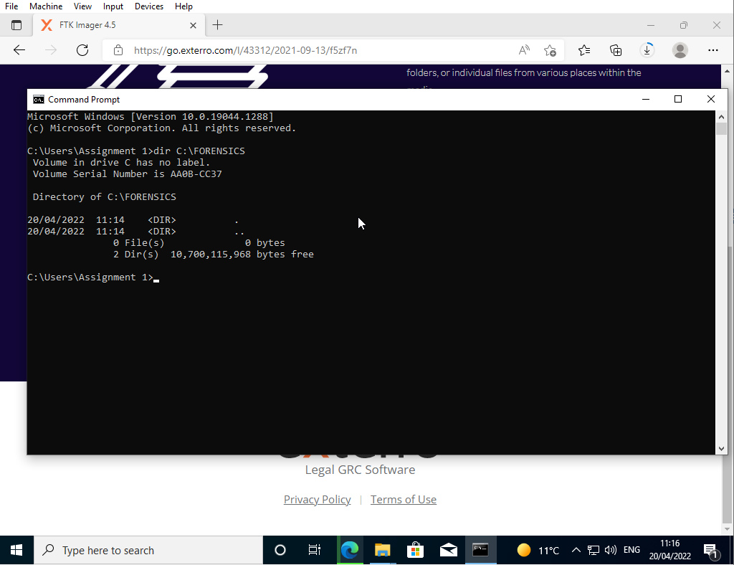

Creating a specified directory will allow us to store all relevant information to this case within a single drive for ease of investigation. This will enable us to export all the necessary files to one single location.

Initial Steps
The first significant step to undertake is recovering image files that have been deleted within the specified host. We can use FTK Imager to start this process and then identify if any further investigation is needed. With the initial FTK imager, we can recover any permanently deleted files by accessing a particular directory.
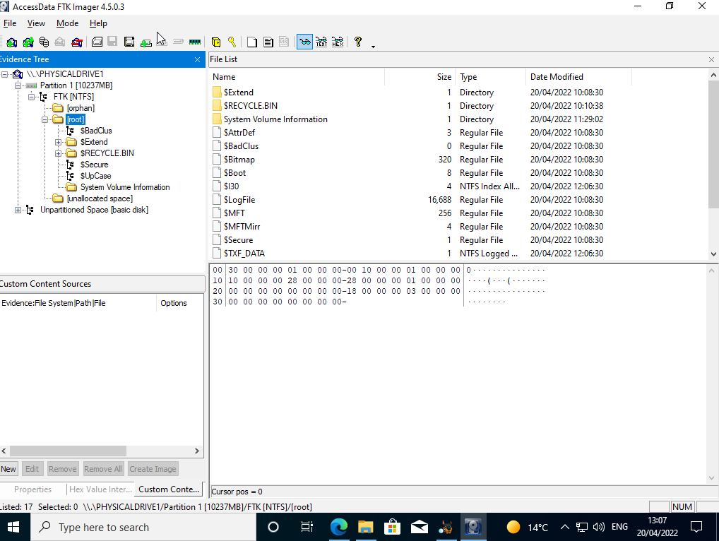

We use the FTK imager, select the targeted drive, in this case, the FTK Drive, and then investigate the saved and deleted partitions within the industry. This will allow us to recover any deleted images or text files within the drive.
We navigate to the $RECYCLE BIN folder that will show any recently/permanently deleted folders/files we would like to recover for the investigation.
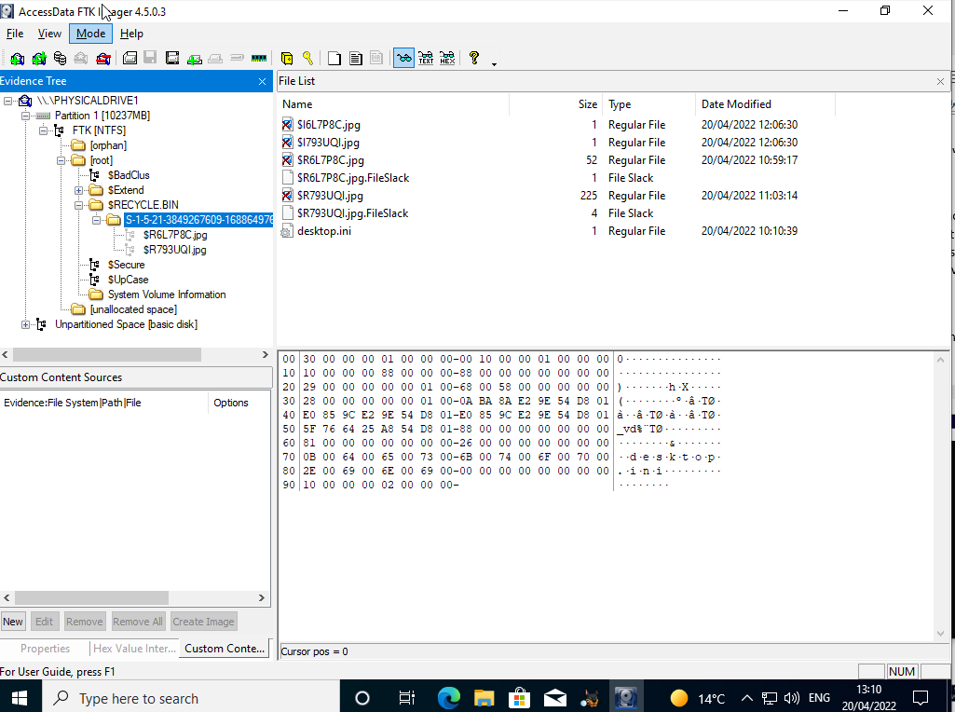

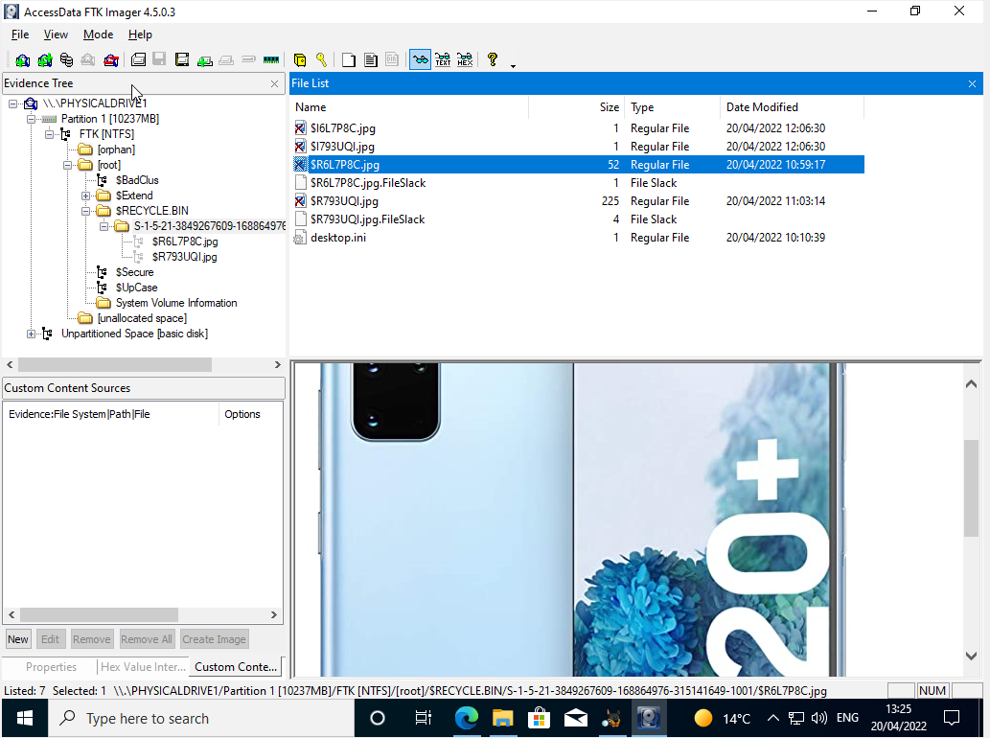
There are multiple deleted files within the file, including image files specific to this investigation. To recover them, it is necessary to extract the deleted files into the specifically created directory for the ito the inquiry below, the relevant image files will display within FTK Imager; therefore, only the required image files would need to be exported.

After successfully retrieving the files, it was identified that they had been encrypted, and the investigator did not have any access to the files. Therefore, decryption of the files will be necessary.
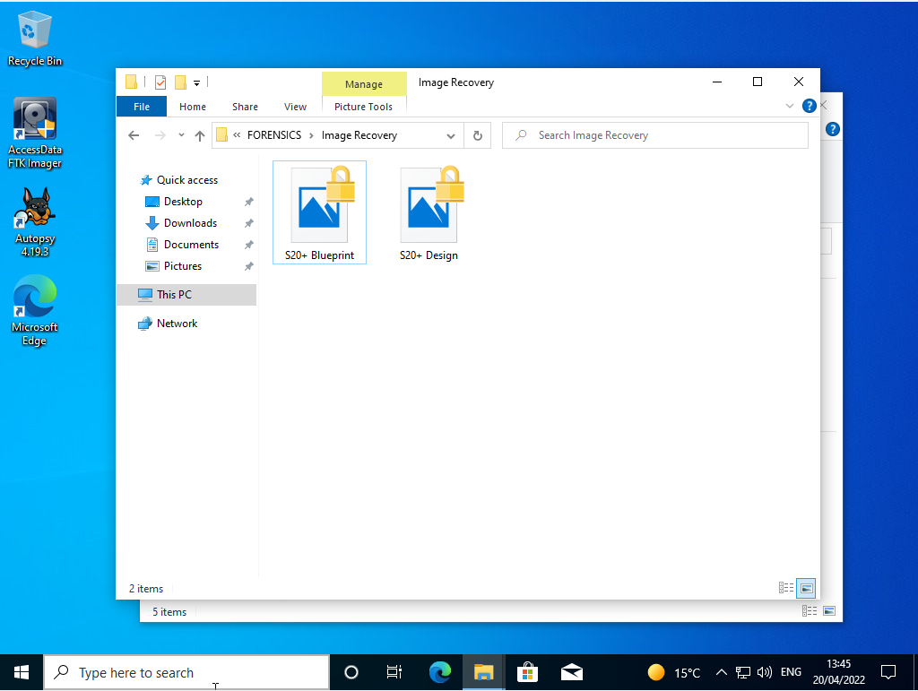

Hash Detection and Verification
Within the images is an MD5 hash that can verify if the decrypted images are the proper and correct images required for the case. Using FTK Imager we can extract the MD5 hash of the encrypted files and compare both encrypted and decrypted hashes by using the tool within the Autopsy Forensic Toolkit. As stated by D. Liu:

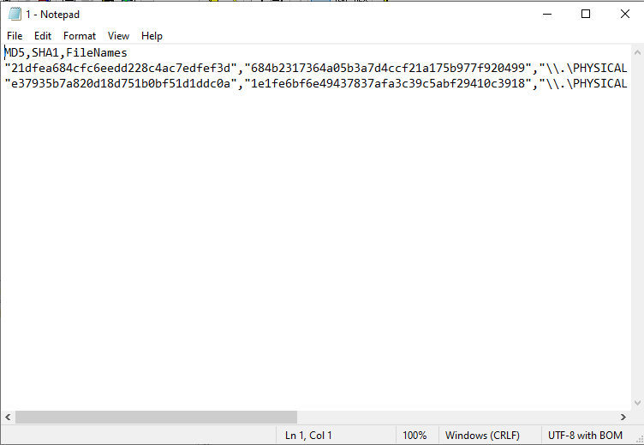

This is the extracted MD5 hash of both images requiring decryption. Now, these can be used to ensure that the correct image is now present within the Toolkit by using a new hash set and adding those specific hashes.
The creation of a new hash set allows us to specify what hashes to search for while analysing the files, making the identification and verification of the images more accessible and more accurate.
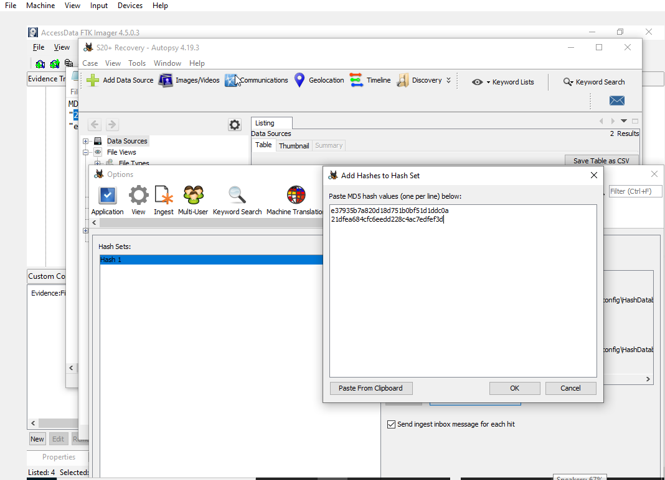
Using this hash system will allow the report generated at the end of the investigation to show if any of the drives and files scanned will contain any of the specified MD5 hashes collected.

Decryption of Files
The next major step undertaken within the investigation was to decrypt and analyse the specific image files recovered from the dive,, such as JPG image files. The Autopsy Forensic software can be used to identify and decrypt these files.
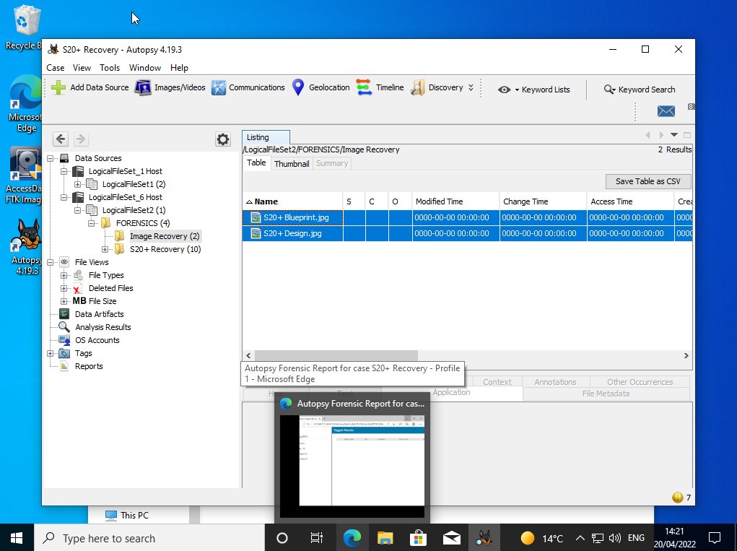

Using this software, the files were able to be decrypted/encryption key was found within the device, and the files were able to be accessed and recovered successfully. This has allowed the job to be completed and the relevant designs and blueprints discovered successfully without any loss or incident.
Both files were successfully extracted into a secure file and accessed to view their contents. This has shown the complete design and blueprint of the project to meet the case requirements.
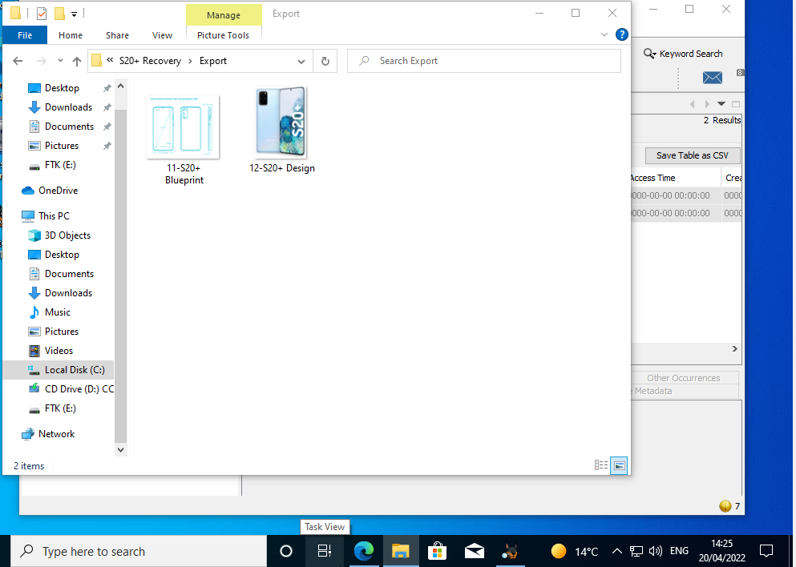

Integrity of Files
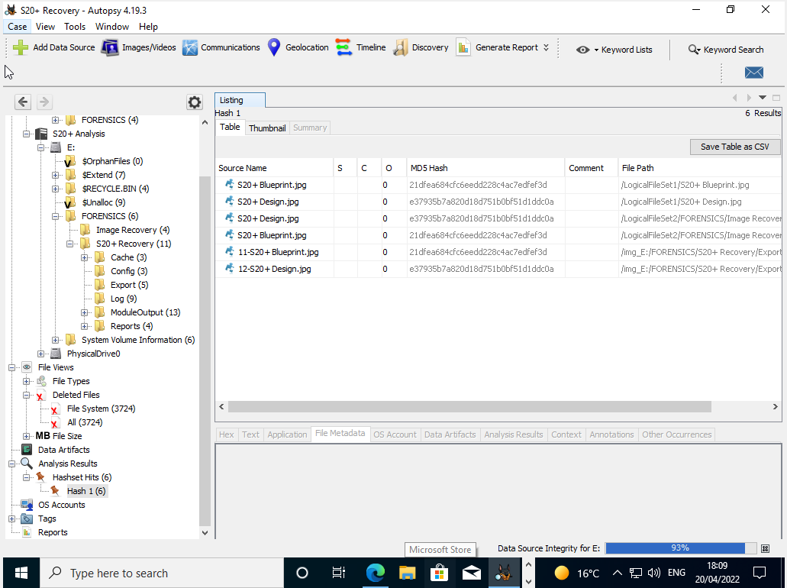
After successful decryption of the files, it is necessary to ensure that the stability and integrity of the files have not been compromised or changed in any way due to the initial processes. There is a function within the Autopsy toolkit to allow this to be checked. The process of Data Stability Checker.
The use of this tool will ensure that no important data will be lost and therefore it is one of the most essential tools to use within this investigation.

Report of Findings
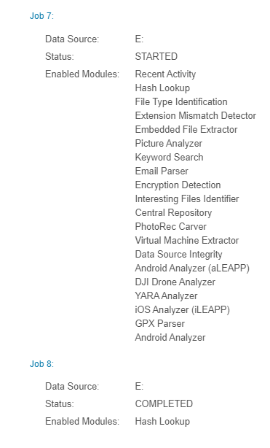
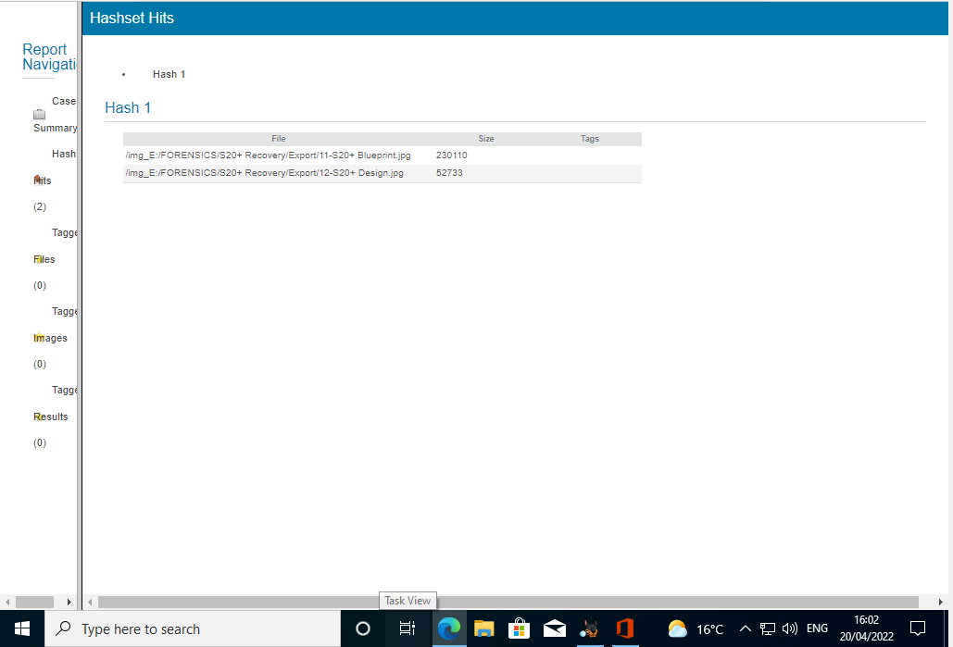
It was essential that after completing the case , a report was provided to show the steps and processes undertaken to meet this problem and recovery case. The report will show the versions discovered, all relevant information learned and any unknown information that appeared during the analysis and will allow the employer to see what processes were used in the investigation and what precisely the results/outcome of the study were.
The HTML generated report from the forensic tool software will ensure that everyone with relevant clearance could view the completed investigation and what processes were undertaken to complete this investigation and what was found and what if anything, failed. The report created this time showed the successful recognition of the two hashtags found with FTK imager within the successfully decrypted files; this indicated that no alteration had occurred within the file through the entire decryption process. The report also shows all tasks and areas undertaken throughout the investigation and what procedures were used. The report also shows the total size of the images and the root directory for the user to find the decrypted image.
The final part of the task/case scenario is to create a detailed invoice on the full price of the services undertaken to complete the investigation and recovery of the files according to the professional generated report. This will give the relevant pricing and service charges for the case to be completed.

Invoice of Services
Finally, it was essential to create a relevant invoice of the services undertaken throughout the investigation. This will then be presented/sent to the employer for payment of services to be processed according to the nature of the investigation. The invoice will include the personal service fee, all processes undertaken and cost of use such as electrical and software costs etc.
An invoice will explain in detail why the costs are what they are and exactly what process cost at what price. This will allow the employer to understand what exactly they are paying for, and it will allow Bob Lynch to receive payment for the services given. A sample invoice has been given below, this is a professionally created invoiced based on the job and scenario given within this task.
The invoice also included a service fee and 7.25% VAT according to the national invoice tax standards. In total, for this investigation and services, it will cost the employer Ms Dee Rod a total of £375.38 for the recovery of items.
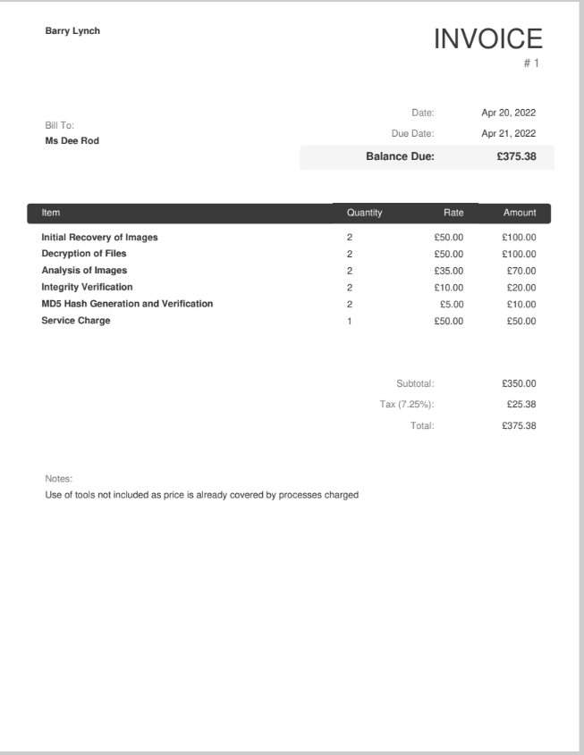

Discussion of Case Study
After the completion of this case study, it was clear to see the use of forensic tool within the recovery of important files is essential for the scenario to be completed. By using multiple tools throughout the investigation, it allowed smooth recovery of the case files without any major file corruption or conflicts. This ensured that no unnecessary problems occurred and allowed the scenario to be completed successfully. The use of the Autopsy Toolkit allowed the identification of the hidden encryption key within the host device and allowed the simple decryption of the targeted case images.
The report generated at the end of the scenario was a little problematic as the initial stage of image recovery was not included within the generated report, as it was undertaken using a different forensic tool (FTK Imager). This is a problem as the report would not contain every single aspect of what steps were taken during this case.
The final part of the study was an invoice of completed services. The invoice would underline everything that was done during the investigation and what prices the employer would have to pay for the completed services. It was also necessary to include a personal service fee and a specific amount of VAT based on the national standards. The invoice was then prepared ready to present to the scenario company for the scenario to be completed successfully.

Conclusion
Throughout this task, it has been presented about the importance of digital forensic toolkits within modern organisations and data recovery. The range of available toolkits to use is numerous and continuously evolving. For further, study it could be possible to use more extended means of research such as investigative software and professional opinions and research papers to further support the importance of forensic toolkits. The availability of these tools will allow for greater strides within digital forensics and enable us to further expand on the capabilities that the toolkits provide. We now understand that Digital Forensics is essential for success and, that the tools do evolve but the concept will always stay the same, the recovery and investigation will never change, only the method of doing it will and the array of available software will always seek to surpass limits and will forever be evolving to combat and adapt to the technological evolution of the modern age.

References

[1] | Interpol, “Digital Forensics,” [Online]. Available: https://www.interpol.int/en/How-we-work/Innovation/Digital-forensics#:~:text=Digital%20forensics%20is%20a%20branch,crucial%20for%20law%20enforcement%20investigations.. [Accessed 18 April 2022].
[2] | B. Subramanian, “An Overview of Autopsy: Open Source Digital Forensic Platform,” 14 May 2020. [Online]. Available: https://datascience.foundation/sciencewhitepaper/an-overview-of-autopsy-open-source-digital-forensic-platform-1. [Accessed 20 April 2022].
[3] | C. Dodt, “Computer forensics: FTK forensic toolkit overview,” [Online]. Available: https://resources.infosecinstitute.com/topic/computer-forensics-ftk-forensic-toolkit-overview/. [Accessed 18 April 2022].
[4] | Exterro, “FTK Imager,” [Online]. Available: https://www.exterro.com/ftk-imager#:~:text=FTK®%20Imager%20is%20a,(FTK®)%20is%20warranted.. [Accessed 18 April 2022].
[5] | M. A. Talib, “Towards early software reliability prediction for computer forensic tools (case study),” SpringerPlus, vol. 5, no. 1, p. 827, 2016.
[6] | CAINE, “CAINE,” [Online]. Available: https://www.caine-live.net/index.html. [Accessed 18 April 2022].
[7] | X-Ways, “X-Ways Forensics: Integrated Computer Forensics Software,” [Online]. Available: http://www.x-ways.net/forensics/. [Accessed 21 April 2022].
[8] | S. Brett and Z. Eric, “Chapter 2 - Case Management and Imaging,” in X-Ways Forensics Practitioner’s Guide, Syngress, 2014, pp. 15-43.
[9] | D. Kleiman, K. Cardwell, T. Clinton, M. Cross, M. Gregg, J. Varsalone and C. Wright, “Chapter 14 - Forensics Investigation Using EnCase,” in The Official CHFI Study Guide (Exam 312-49), Syngress, 2007, pp. 617-673.

