Lecturer: Julie Thomas
Word count: 2286
Report
Self-awareness in Modern Organisations

Rasa Vilimaite
2020471
AI Statement
I confirm that I have not presented any AI-generated materials as my own work.
I confirm that I have copies of my drafts, notes, and other resources I used, which I may be asked to provide in evidence

Executive summary
This report addresses the importance of self-awareness in personal and modern organisations' development by reviewing relevant literature and conducting personal reflection utilising Gibbs' Reflective Cycle (1988). The literature emphasises self-awareness as an important component of emotional intelligence (Goleman, 1995) and effective leadership (Ashkanasy and Daus, 2005), which influences decision-making, relationships, and resilience.

Using Gibbs' model, the reflection investigates personal responses to classroom obstacles, such as communication tasks and group work. Recognising judging tendencies, controlling emotional reactions, and cultivating empathy are some of the most important lessons. The study finishes with an action plan that emphasises continual contemplation, mindfulness, and soliciting feedback to improve self-awareness.

Table of Contents
1.0 Introduction 3
2.0 Main findings 4
2.1 Importance of self-awareness development in modern organisations 4
2.2 Concepts of challenges 6
2.3 Reflection using Gibbs reflective style 6
3.0 Conclusion 9
Personal development plan 10
Appendixes 11
Reference list 12

Introduction

As the business world continues to become increasingly fast-paced, self-awareness has emerged as an essential talent for effective management. Self-awareness refers to the state of being conscious of one's personality, emotions, motivations, and desires. The human touch is essential in both professional and personal relationships, and the changes in our modern, dynamic world impact all facets of society. As a result, managers are better able to comprehend the impact they have on individuals, make intelligent decisions, and stay authentic in leadership roles. In the article (Leadership, 2024), it says, “If you are self-aware, it means you have made”. A deficiency in self-awareness will invariably constrain the successful outcome of your actions. You will be incapable of effectively managing all the competing demands imposed upon you, nor will you be able to organise them to achieve optimal results.
We have moved away from the mechanical conceptions of business associated with the industrial revolution and early 20th-century authoritarian society, and the human element now plays a larger role in describing and understanding modern models of corporate complexity. Unconscious processes cannot be addressed and modified so long as they continue to be oblique, according to the author's experience (Goleman, 1995). Self-awareness, which is the cornerstone of emotional intelligence, is therefore an essential component in the process of illuminating our inner workings, which are typically obscured by our feelings and emotional states. In the turbulent sea of one's own emotions as well as the emotions of others, the person in charge requires a trustworthy signal of the correct direction to provide their entrusted workers with the ability to safely navigate to their intended destination.

2.0 Main findings

2.1 Importance of self-awareness development in modern organisations
Using Daniel Goleman’s Emotional Intelligence Quadrant (see appendix 1), the first is:
Self-awareness
It is a key part of emotional intelligence (EI), which is closely tied to becoming a good leader. Daniel Goleman (2002) says that leaders who are emotionally intelligent are better at managing relationships, settling disagreements, and motivating teams.
Having self-awareness means being "aware of both our mood and what we think about mood." According to the author (Goleman, 2002), it's also about being able to read and comprehend your own emotions and how they impact those around you. Know your feelings and the reasons behind them; it is self-awareness. When we have a better understanding of our emotions, we are better able to manage them and allow them to shape our interactions with others.
The following sequence leads to emotional awareness:
1. Feel the emotion
2. Acknowledge the feeling
3. Identify further information.
4. Accept feelings as they are.
5. Consider why the emotion is present in that moment. Consider any previous emotions. Consider its aim, whether it's to communicate, demonstrate, or instruct.
6. Act - express your opinions and feelings and take appropriate action if necessary.
7. Evaluate the response and identify key takeaways.
Self-awareness for managers must go beyond self-reflection and include social awareness, or knowing how other people see them. Even managers who mean well can seem distant or cold without this (Cecchi-Dimeglio, 2024).
Leadership emphasises the importance of authenticity. A self-aware manager is more capable of leading in alignment with both their personal values and those of the organisation. Avolio and Gardner (2005) assert that authentic leadership is predicated on self-awareness, integrity, the balanced assimilation of information, and an intrinsic moral perspective. However, (Ibarra (2015) says that authenticity must be properly maintained. Expressing "true feelings" incorrectly or firmly adhering to one's style without adaptability can result in perceived inflexibility or lack of professionalism in a variety of business circumstances.
Self-management
Self-management, also known as self-control, involves flexible control of one's actions, ideas, and emotions to achieve desired outcomes. Optimal self-regulation promotes well-being, self-efficacy, and connection with others. The author at Forbes (Cecchi-Dimeglio, 2024) and (McKee et al., 2023) says that it doesn't come naturally to become well self-managed and requires a lot of self-awareness, working together hand in hand. This means that organised feedback systems like 360-degree reviews, coaching, and reflective practices must be put in place. All of these require a lot of work and support from the organisation (Caza et al., 2020).
Social awareness
Social awareness is the skill of being able to effectively read other people's emotions and "read" circumstances. It's about being able to see things from other people's points of view by being able to feel and think what they are. The author (Boynton, 2021) says that it is possible to improve your ability to communicate successfully by increasing your social awareness of the emotions and responses of other people. One of the most significant practices of social awareness is to refrain from being judgmental. When engaging with troubled persons, it is instinctive to seek to comprehend the origins of their unpleasant feelings and responses; yet, our interpretations can frequently be erroneous. The author advocates for the practice of non-judgmental interpretations.
Additionally, exhibiting empathy as empathy denotes the cognitive and emotional mechanisms that connect individuals in diverse relationships, facilitating the sharing of experiences and comprehension of others (Eislinger, 2007).

Relationship Management
The skill of being able to handle one's feelings, other people's feelings, and the situation at hand in social situations. This quadrant brings the other three components together to make relationship management, which is the end result. If we know what the other three factors are, this will often go more smoothly.
Good managers must talk to people in ways that motivate, direct, and bring together people from different backgrounds. Self-awareness helps managers change their tone, body language, and messages to fit the scenario (Robbins & Judge, 2019).
While emotional intelligence is absolutely necessary, relying too heavily on reflection without taking any action might result in a state of passivity. It is necessary for self-awareness to result in changes in behaviour in order for it to be truly valuable (Channell, 2025).

2.2 Concepts of challenges
Academic, personal, and professional challenges frequently serve as accelerators for major learning and progress. When people meet a challenge, their reactions and reflections affect how much they learn and adapt. Two well-known theories for explaining this process are Kolb's Experiential Learning Theory (1984) and Gibbs' Reflective Cycle (1988). These models provide a methodical way to turn obstacles into opportunities for personal and professional growth.
Kolb (1984) defined learning as a cycle of concrete experience, reflecting observation, abstract conceptualisation, and active exploration. Concrete experience challenges frequently start with discomfort, failure, or uncertainty, prompting thought. Learning is centred on these challenges.
According to Kolb's paradigm, obstacles become transformative only when people reflect, assess, and act. Professional conflicts can either cause defensiveness or personal growth, depending on how they are handled. Kolb's theory crucially thinks that discomfort and challenges motivate learners to grow. However, people may fight this process, especially in stressful or emotional situations. The situation and the learner's readiness to engage are both challenges. Manson (2023), the author, also adds that suffering and hardship are necessary for us to feel like we've done something worthwhile and meaningful with our lives. This builds our sense of autonomy and self-worth, which are the foundations of a mentally healthy and happy person.

2.3 Reflection using Gibbs reflective style
Gibbs' Reflective Cycle (1988) provides an organised approach to personal growth, leading individuals through six stages: description, feelings, evaluation, analysis, conclusion, and action plan. This reflection looks at how spending time alone in nature has benefited my physical and mental health, raised my self-awareness, and improved my interpersonal relationships. It also includes insights on how habits such as getting enough sleep and pausing before reacting have improved my overall daily functioning and emotional management. My own reflection on challenges using the Gibbs reflective cycle:
Description
Over the last few months, I've been taking regular lonely walks along the beach and harbour near my home. These peaceful, scenic areas—open skies, rhythmic waves, and peaceful waters—became my escape from the responsibilities of my job and personal stress. During these walks, I frequently reflected on challenging talks at work and in my personal life. I reflected on how I had reacted in those circumstances, what I may have said differently, and how those interactions affected my relationships. I used this time not only to relax, but also to engage in serious self-reflection.
Feelings
At first, I felt a mixture of feelings. Being alone in nature made me feel at peace, but it also forced me to deal with feelings and thoughts that I hadn't worked through yet. I started to like being alone as I proceeded every evening. Walking barefoot on the sand or seeing the marina's calm helped me get back in touch with myself. I enjoy being by myself, with no noise, expectations, or interruptions. The longer I walked, the more I liked how clear it made me feel, both mentally and emotionally.
Evaluation
The walks had a significant beneficial influence on me. Physically, I became more active, which resulted in greater stamina and less stress. Research confirms these findings: "green exercise," such as walking in natural settings, has been associated with enhanced mood and physiological health (Pretty et al., 2007). Mentally, I got the insight to comprehend difficult topics, settle internal conflicts, and consider how I can communicate more effectively.
One recurring realisation was that I sometimes respond to others in ways that could be viewed as dismissive or judgmental, even when that is not my goal. The calm atmosphere of the beach allowed me to analyse these patterns without being defensive. I started practicing different responses: more empathic, patient, and less reactive. These observations helped my relationships by making me more conscious of how my words and tone affected others, both at work and at home.
Analysis
Spending time in nature allowed for critical self-awareness, which is an essential component of emotional intelligence (Goleman, 1995). Without interruptions, I could examine my emotional triggers and reconsider how I speak, particularly when stressed. I understood that when I'm weary or stressed, I'm prone to reacting or making assumptions, which can undermine trust and understanding in relationships.
I also found that self-regulation improved by being alone. Siegel (2007) says emotional resilience depends on the brain's ability to pause and reflect. Nature was perfect for this break. I practiced slowing down, questioning my assumptions, and imagining others' perspectives. I realised how sleep deprivation affected these reactions. Sleep deprivation made me irritable, and I misunderstood others' motives. Sleep is vital for emotional balance and social involvement (Walker, 2017).
Walking helped me restore balance. I learnt to pause emotionally and physically. Instead of reacting immediately, I took time to think. That small change—waiting before responding—was obvious. Discussions cooled, results improved, and I felt more connected. Control of myself.
Conclusion
Gibbs' Cycle has helped me see how much I appreciate being alone in nature. Not only does it help me get more exercise, but it also helps me think more clearly, become more self-aware, and build stronger relationships. Walking along the beach and marina has helped me figure out why I act the way I do, rethink how I react, and change how I talk to other people. By also making sure I get enough sleep and taking breaks in my communication, I have been able to better control my emotions and lower my stress levels. This has helped me find a healthier, more meaningful work-life balance.
Action Plan
Moving forward, I am planning to:
Continue to stroll alone along the beach/marina at least three times a week, allowing time for reflection and physical exertion.
Use mindful breathing or journaling during or after these walks to increase self-awareness.
Monitor my sleep habits to ensure that I get at least 7 hours per night, as bad sleep has a direct impact on my mood and communication.
To avoid impulsive reactions, practise "the pause" - taking a little minute before responding, particularly in tough situations.
Seek comments from close friends or colleagues to raise external awareness and hold yourself accountable for personal development goals.
By sticking to these routines, I hope to maintain a higher degree of emotional resilience, physical well-being, and interpersonal awareness.

3.0 Conclusion
Self-awareness is a key part of becoming a good leader in today's complicated and ever-changing economic world. It has an effect on many aspects of management, such as emotional intelligence, making decisions, communicating, and behaving ethically (Eurich, 2018; Welch, 2020). Self-aware managers are more likely to know what they're good at and what they're not, handle their feelings well, and be genuine in their leadership style, which helps build trust and team unity (George et al., 2021).
New research backs up the idea that self-awareness is very important for being a better leader. For example, McKee et al. (2023) say that being aware of yourself is important for controlling your emotions and being strong, especially in stressful situations. Self-awareness, on the other hand, does not happen on its own or by accident. It has to be grown on purpose by organised self-reflection, feedback systems, and coaching (Passmore et al., 2022). Self-insight is best promoted by tools like 360-degree feedback and reflective models like Gibbs' Reflective Cycle (Gibbs, 1988; Ibarra and Scoular, 2019).
In addition, self-awareness is most useful when it is backed up by other abilities, such as cultural intelligence, empathy, and active listening. If you don't take this comprehensive approach, it could turn into an idea that doesn't really work in the real world. So, organisations need to make places that encourage continuing learning and reflective practice so that leaders may keep changing and growing (Caza et al., 2020).
When self-awareness is purposefully fostered and supported, it leads to more flexible, moral, and successful leadership in relationships. This is becoming more and more important in today's diverse and changing business environments.

Personal development plan
Rasa Vilimaite
July 2025-December 2025

Objective | Actions | Resources | Success | Timeline
Submit final assignments and prepare for graduation | Plan a study schedule | University portal | All assignments submitted on time; graduation confirmed | July 2025
Reflect on your academic journey and plan your transition. | Write a reflection on key skills gained; create a LinkedIn profile or CV update. | Career service, LinkedIn | Completed updated CV and online profile | August 2025
Enrol in more advanced beauty courses | Research and register for accredited courses (e.g., lashes, skincare, brows) | Online learning platforms, local beauty academies | Complete 2–3 new certifications | August–December 2025
Grow an even bigger social media presence for business | Post content consistently; share before/after, tips, and client feedback | Instagram, Canva, scheduling apps | Increase in engagement, 200+ new followers | Ongoing (3x posts/week)
Improve client experience and services. | Create feedback forms, update the treatment list, and introduce a booking system. | Google Forms, Square, Calendly | Higher rebooking rates and client satisfaction | September–December 2025
Practice the Spanish and Arabic languages daily through apps | 15–30 mins of Duolingo or Memorise daily | Duolingo, flashcards, YouTube | Maintain a daily streak for 3+ months | Ongoing (July–December 2025)
Join a language exchange or tutor group. | Join an online conversation group (e.g., Tandem, iTalki) | Zoom, language exchange apps | One 30-minute conversation weekly | August–December 2025
Watch/listen to native content. | Watch TV shows, listen to podcasts, or music in both languages | Netflix, Spotify, YouTube | Understand basic conversations and improve pronunciation | August–December 2025
Walk 3–4 times per week in natural environments | Schedule beach/marina walks in calendar; track steps | Walking shoes, step counter, journal | 8,000–10,000 steps/day average; improved mood | July–December 2025
Reflect during or after nature time. | Keep a simple reflection journal after walks | Journal or app (e.g. Day One) | Weekly reflections written | Weekly (Ongoing)
Improve physical health and stamina. | Add gentle workouts (e.g., stretching, home fitness) | YouTube fitness channels, yoga mat | Noticeable increase in energy and flexibility | August–December 2025

Appendixes
1.
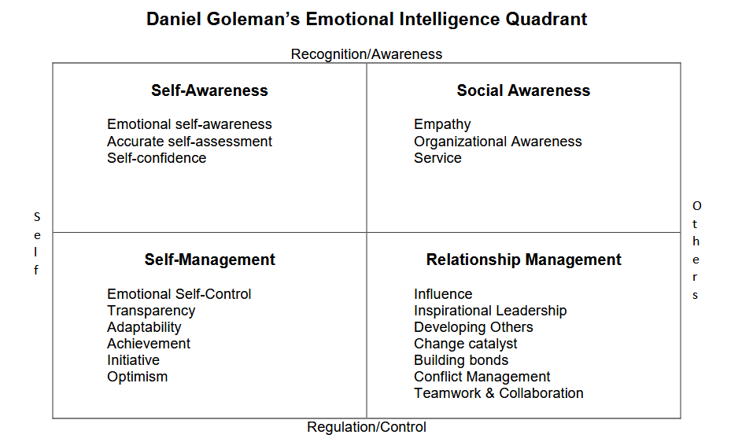.
2. Kolb's Learning Cycle
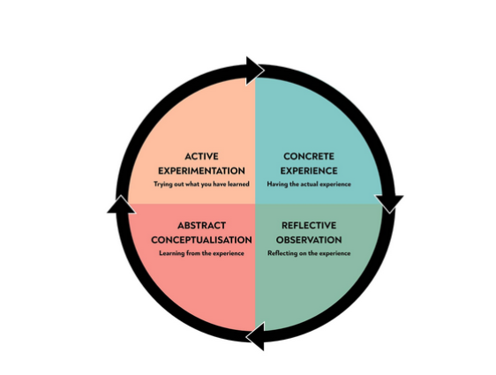

Reference list

