Production Progress
The model that I want to do is a witch’s hut that has been left for some time and the land has started to take over. I want it to be a basic hut that is in the middle of the garden with fence around it with a witch style hat for the roof design. I plan to use darker colours for the textures of the build.
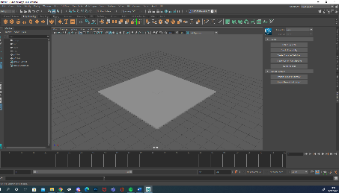
I started the build by placing a platform too build on that will become the garden later down the line of the build. It is an equal square, and the hut will be placed in the middle.

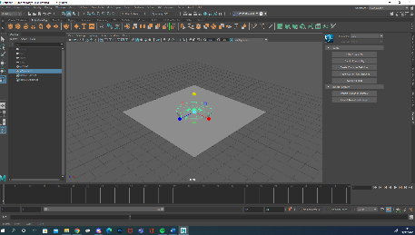

I have set down the base of the hut in the centre of the square. During this I was deciding for the hut to be a square or circler. After setting both up to see I decided on the circle design because I want to do a circular roof design for the roof.

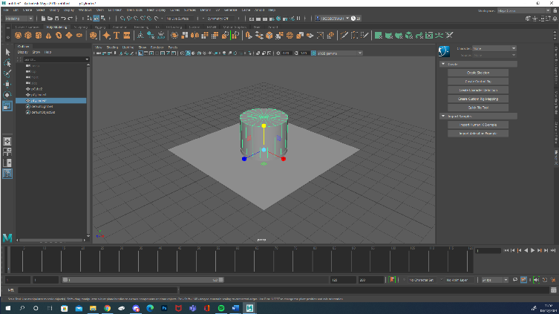

After that decision to make the building modular I built it up with a new shape to separate the base of the building with the structure.

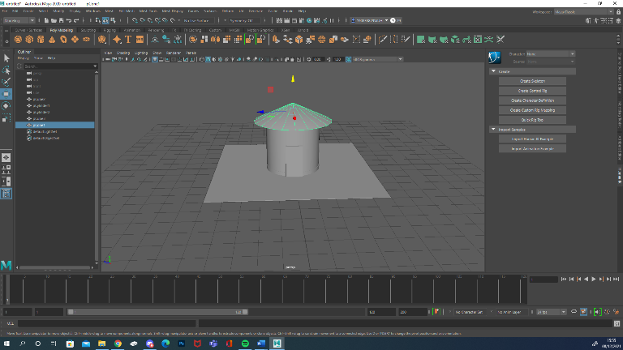

I then created the base of the roof and sized it to create a overhang on the hut.

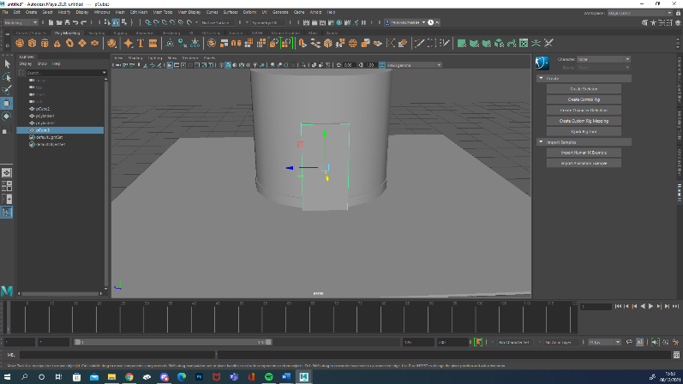

I created a new rectangular block where the door will be. This door will be textured as a door on the model.

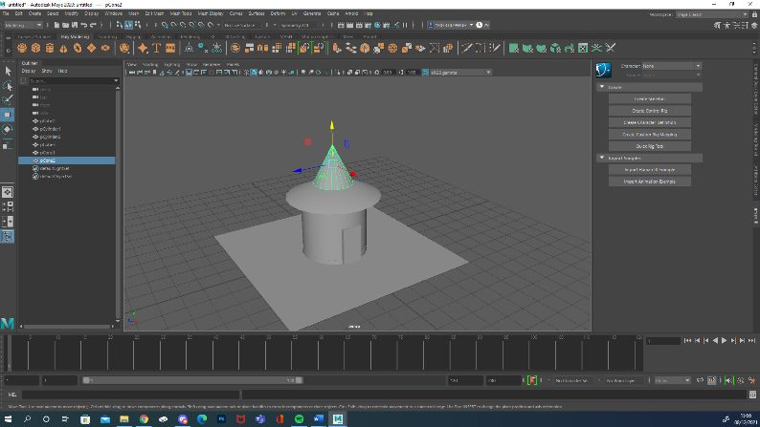

I have now placed the top of the roof on the lower part of the roof. It’s a cone shape that is centred to look more like a witch’s hat. I tried it angler with it leaning right but it wasn’t the look I wanted.
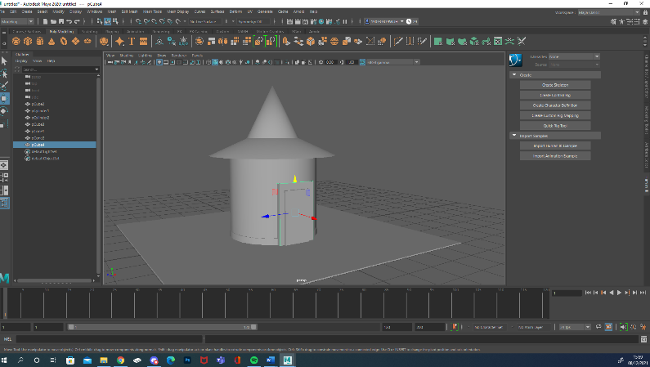

After doing the roof I looked back at the doorway and decided to make it stick out more to be more noticeable. I did this by adding another rectangle around the door and brought the door more out of the building.

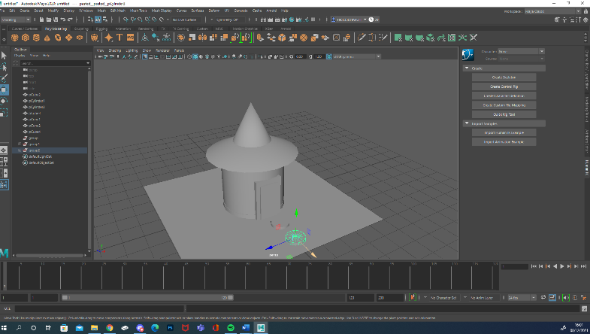
I then started out on the garden details. I created two circler pathway stones going from the doorway to the edge of the garden. This is where there was a gap between the fence.

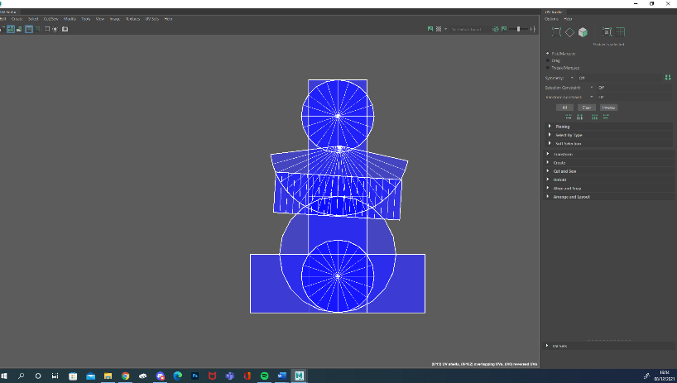
I now starting up the UV for the building and the surrounding area. I then clean it up as much as I could, but I couldn’t figure out how to separate them but now I can see what each object is.

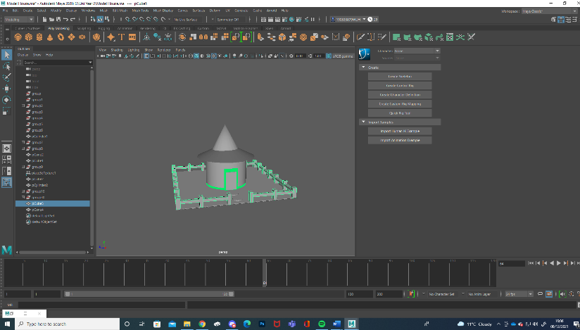
After I made sure that the UV was working, I started to build the fence around the border of the garden area. I did this by planting four rectangle posts, at each corner of the garden. After that I planted more fence posts between each of the corner posts around the square with a gap where the pathway is. I then put another rectangle though each of the pillars to connect them to make it more like a fence.
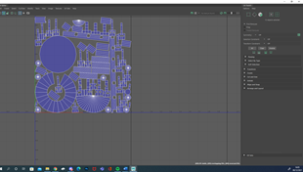

When I went into the UV for the model now it was a lot more complicated now. This is because each fence post has 6 faces, so it takes a lot of space. I had to clean it up to make sense of it. This is the best UV I could make but not everything is next to the correct object it is meant to be part of.

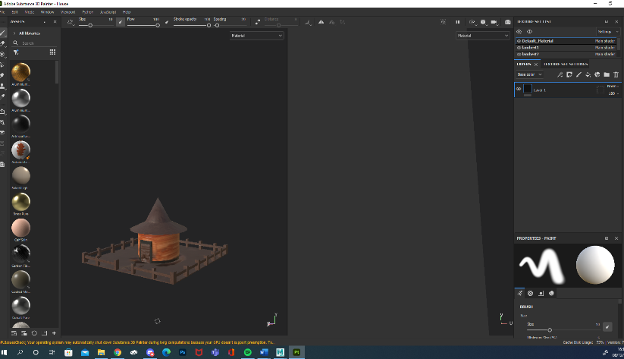
I then took my model into Adobe Substance to do some texturing. I did some colour mixing to decide what texture and colour each of the different parts of the model. I wanted the hut itself to stand out from the rest of the model, so I decide to use a brighter colour with everything else a darker shade.
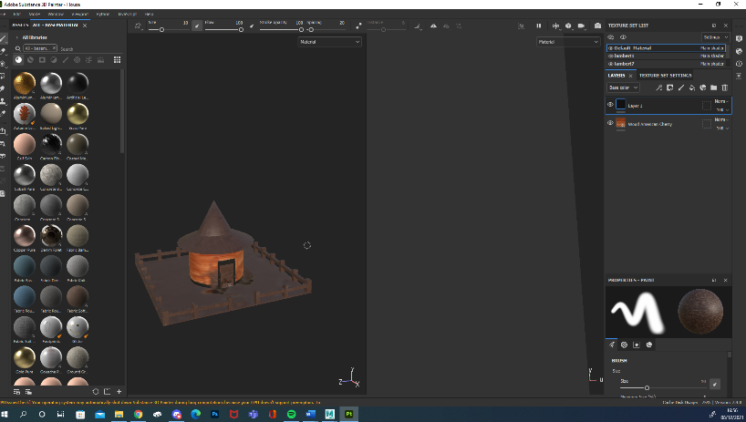

In the end I decide to use American cherry wood texture for the hut itself and used walnut wood for the darker tone I wanted for the roof to contrast the bright coloured hut. I also used the darker work for the door and the door frame.

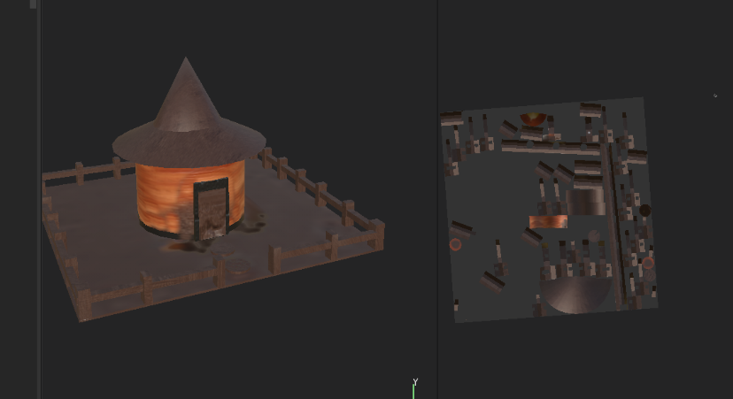
I also added the dark wood colour for the fences and used the dirt texture for the floor. When I was looking at it, I thought it looked a bit plain, so I decided to try to make it look a bit run down. I did this by changing the level of the ground at different point along with paint dirt on to and around the doorway to make it look overgrown and abandoned.

After looking at the model that I have textured in substance painter I want to say that I am disappointed in how it came out. I could get the detail to come out with the paint tool to make the building look withered. I will keep working on it but I am also going to texture the model in house with maya and compare the results to see which one I should use for the final model.
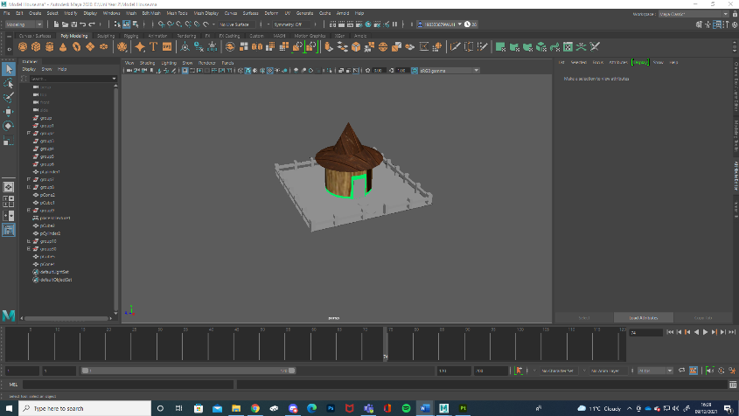
I also decided to have a go at texturing the house in Maya to see what it looks like and compare it to the substance painted one.
In the end I decided to carry on development with in maya because I feel like the textures turned out more that I liked it and removed the hassle of sending the painted UV back over to maya with a messy texturing.

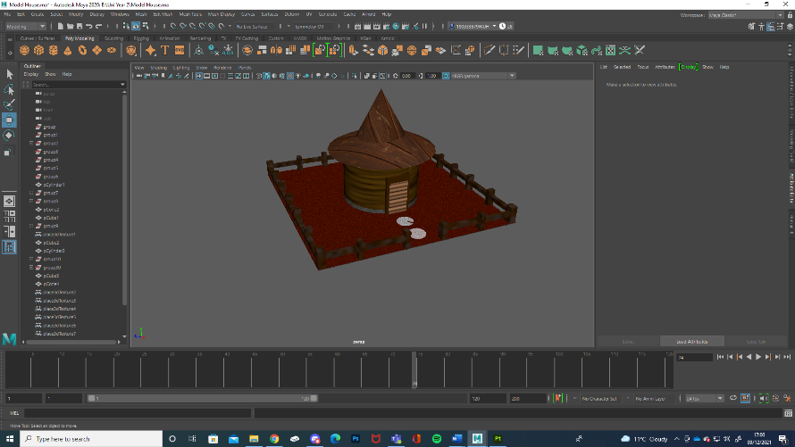
At this point I had textured the whole of the model within Maya. Looking at it I want to darken the fence a bit and add additional detail to the door.
I am also thinking and planning to add more to the garden area.

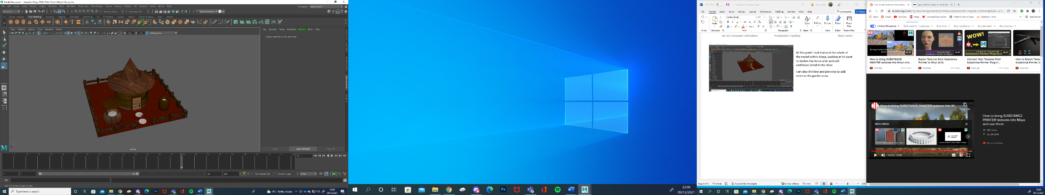
I have added more detail to the model including adding a door handle to the door, adding a barrel with water I it in the garden and adding a well in the garden with water in it as well. I have used different wood textures and colour shades on them.

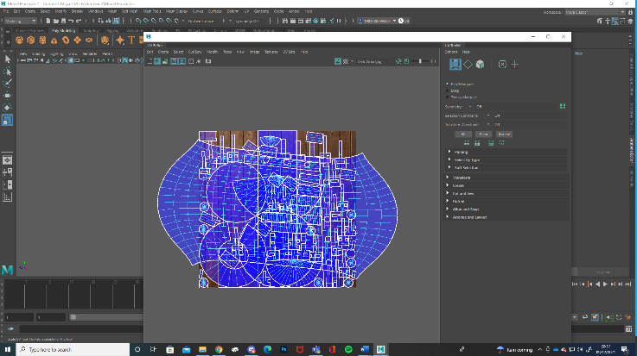
With all the new objects I have added to the model I went to look at the UV and it was a mess, with objects pilled on top of each other. This needs to be cleaned up.

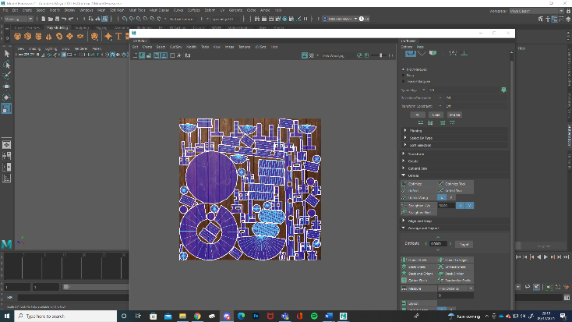

I cleaned up the UV of my model and made sure it was a clear UV map that all objects with in it can be clearly seen with textures matching correctly.

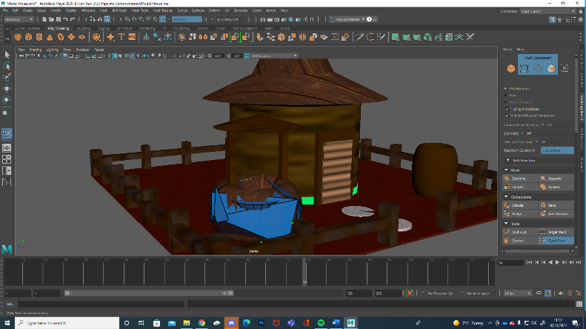
I have also retopologised the well in Maya and wrapped it around the well.



