James Gale
[Email address]
Name : James Gale
Module Name: ACCA4023
Student number:
Date: 09/12/2024

HNC Level 4

Contents
Introduction 2
Requirements 2
Implementation 2
Complete site images 2
Validation 4
Evaluation 5
Terms 5
Website usability 5
Accessibility 5
Search engine optimisation 6
Evaluation topics 6
Usefulness (usability and utility) 6
Search Engine Optimisation (SEO) 7
Accessibility 7
REFERENCEES FOR PICTURES AS WELL 8
References 8
Bibliography 9
Table of Figures 10
Appendices 11
Main Page HTML 11
Main Page CSS 18
News Page HTML 26
News Page CSS 29
Academy Page HTML 34
Academy Page CSS 37
Results Page HTML 42
Results Page CSS 44
Legends Page HTML 51
Legends Page CSS 54
Stats Page HTML 62
Stats Page CSS 67
Transfers Page HTML 71
Transfers Page CSS 74
History Page HTML 79
History Page CSS 81

Introduction
The report below discusses key parts of web design such as usability, accessibility and search engine optimisation in detail as well as discussing the site created. The site created is all based around Arsenal football club. Within the report there will be pictures displaying it, with the validation steps and an overall evaluation of it where ideas to improve are made.

Requirements
The Website is an Arsenal fan page dedicated to displaying up to date and relevant information regarding Arsenal football club. The subject and main topic is anything to do with Arsenal football club and its purpose is to display any up-to-date information and recent news, while also showing some of the history of the club and past players. The target audience of the site is anyone who supports or is interested in Arsenal as all the content is related to it.

Implementation

Complete site images
Below are the screen grabs of each page on the site.
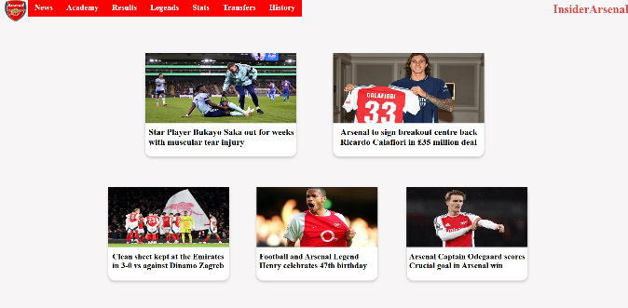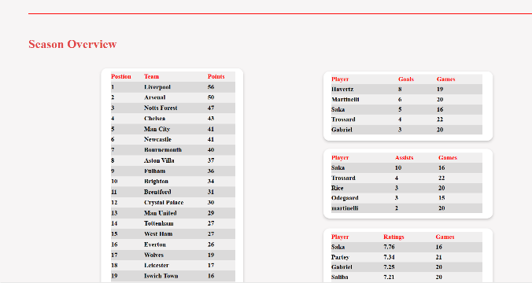
Figure 1 - Home page Figure 2 – Main page
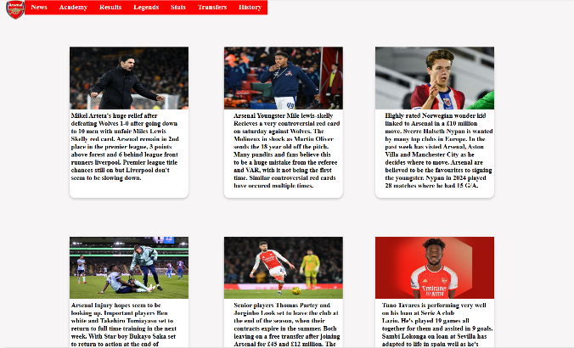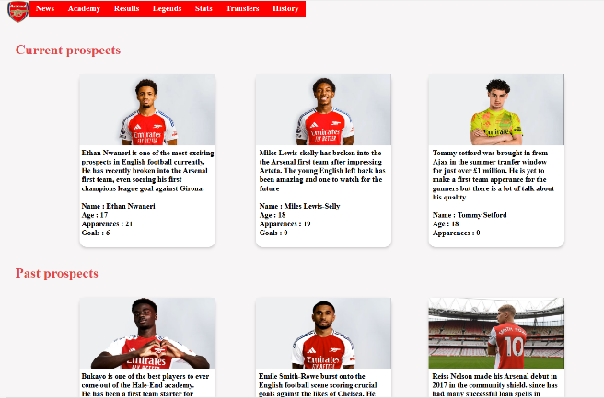
Figure 3 - News page Figure 4 - Academy Page

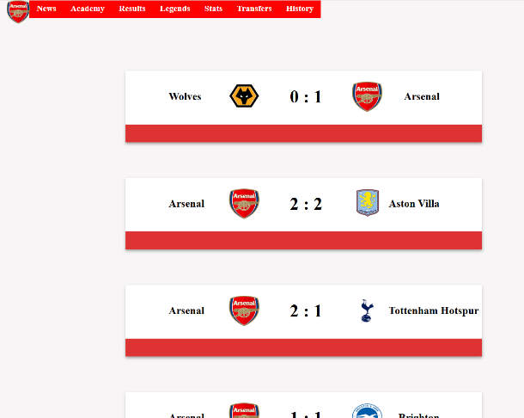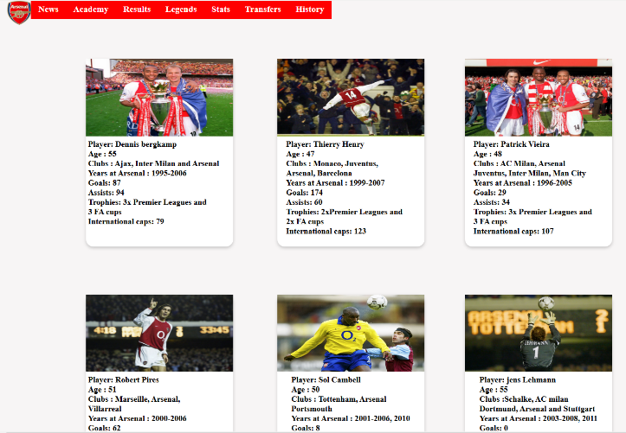
Figure 5 - Results page Figure 6- Legends page
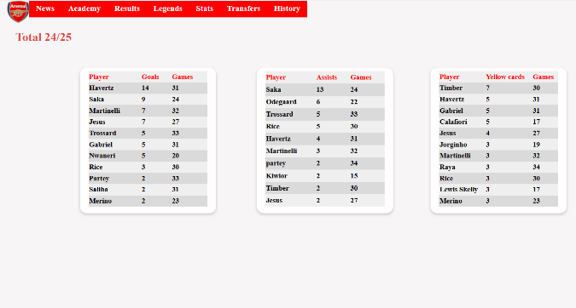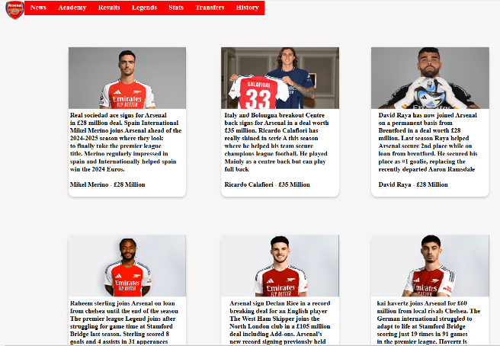
Figure 7 - Stats page Figure 8 - Transfers page
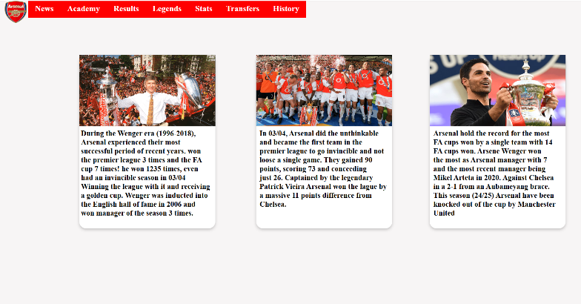
Figure 9 - History page

Validation
Validators were used to check if there were any errors on the main page HTML and CSS. With the main HTML page a few errors where found. One of these was on each <img> element, a bad value such as 210px was used where it expected just the value without the unit. To fix these errors, instead of using the px unit to size the images, just using values would remove them. Another error found was a table tag <table> was not closed, this was an easy fix where the closing tag was implemented in. There was also a warning where a <h1> tag was opened and used but it was empty with no content. To fix this, the unused <h1> tag was removed from the html. With the main page of the CSS, an error was found. On a flex box container, the align-items was used with a value of left. However, left is not actually an option for it and was not doing anything to the style. To fix this, it was simply removed. The other error found was a missing unit's error on some of the text styling. The value was entered for the size but a unit such as px or % was not assigned to it. To fix this, A unit was assigned to the value and had to change the value slightly to get the text in the correct position.
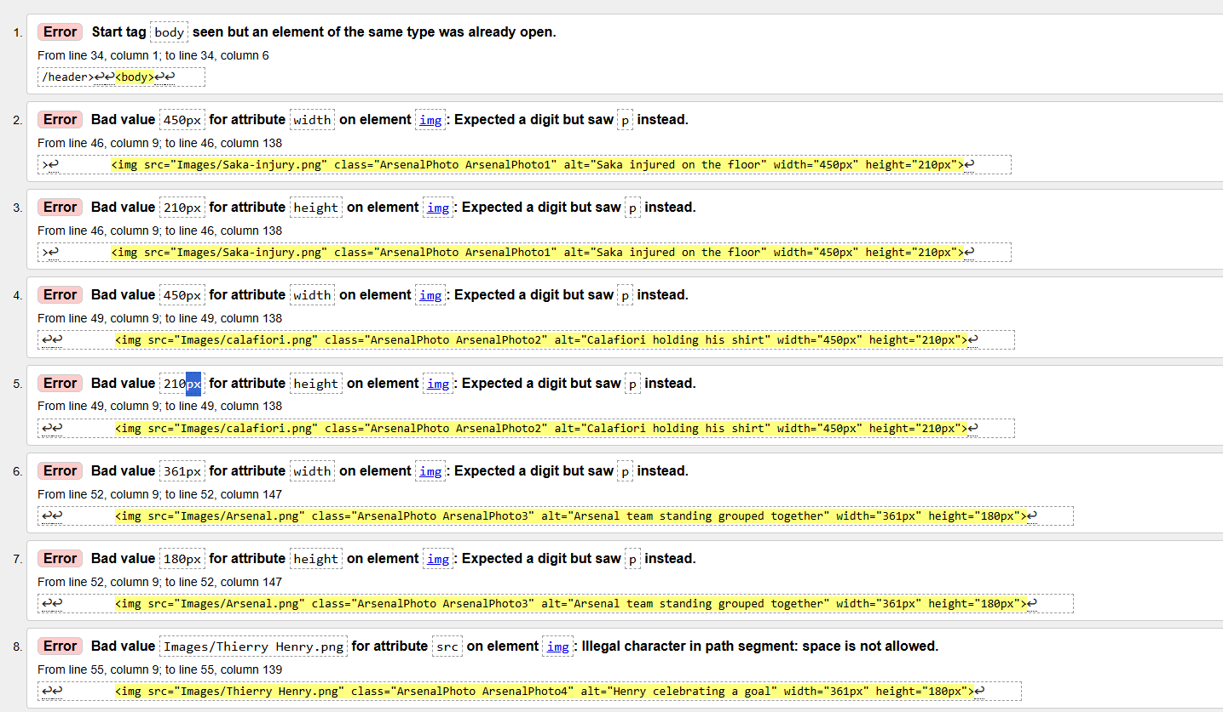
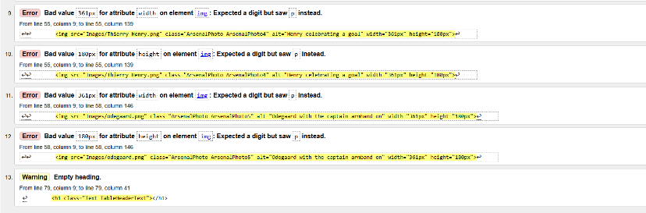
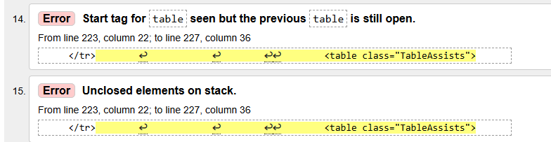
Figure 10 - Html Validation results
Figure 11- CSS Validation results

Evaluation

Terms

Website usability
Website usability is all about how easy it is for users to move around and access content on your site. You can perform different tests with users to understand how they navigate through the site and update it to improve user experience. “Usability is typically measured by having users attempt realistic tasks on an interface” [1]. You can get a good understanding of how useable your website is by “seeing what happens when users try to complete tasks” [1]. Within Web development, it’s critical the site is easy to use. If a user enters the site and struggles to access the content they require, they will simply close it and move onto a different one. There are five principles for website useability, availability, clarity, recognition, credibility and relevance. The availability “refers to how easy it is to access your website by the users” [2], this means users are able to access the site no matter which device or browsers they are using. The Clarity means when a user first visits the site, how quick and clear it is for them to access the information they want. If the site is unclear and hard to navigate, most of the time users will leave for a site that’s easier. The recognition part means how quick for a user to learn and recognise how to use the site, on a good site, users will typically take a few seconds to understand the layout and how to get the information they require. The credibility refers to how much the user trusts the information on the site. “Using high-quality, precise, relevant, and up-to-date information while integrating trust signals such as real users reviews, security badges, and social media proof” [2] will help gain the user trust and help improve the credibility. The final principle is Relevance, when users click on the site, the want to find the information they searched almost immediately otherwise they will move onto a different site. The user should be able to find the relevant information they want as soon as they enter the site to keep them engaged with the site.

Accessibility
Web Accessibility is all about allowing users to access the site no matter their device, browser, hardware or disability. “removing barriers that might prevent someone from using something, regardless of their access needs” [3] . Every website should have features that let all users access the site and view the content. “The power of the Web is in its universality. Access by everyone regardless of disability is an essential aspect” [4]. There are a lot of different methods that web developers can add to their site to make it more accessible for all users. A very common way is Alt tags (Alternative text), this is where you add some text to describe what the image is showing for users that may be blind and using a screen reader or users who have a poor internet connection/speed. An example could be you have an image of someone playing football, the alt text could read “a man playing football in a field”. Another way is users must be able to navigate around the site using just their keyboard. “Those with motor disabilities, rely on a keyboard rather than a mouse to navigate websites” [5]. The key part for keyboard navigation is users can navigate the entire site where they shouldn’t get stuck on any webpage. When their navigating, having “clear visual indicators showing which element currently has focus” [5] will help users understand where they currently are on the site. When the user presses ‘tab’, it should move between the different elements and when they click ‘enter’, it should go into the element they are on. It’s critical the tab order makes sense as users who navigate using only a keyboard rely on this order to navigate the site. Many users may have visual impairments, ensuring the colour contrast is acceptable may be the difference for them to be able to read the content. A website can be tested for the accessibility rating with tools such as W3C easy checks as well as the colour contrast score with a tool like colourcontrast.cc.

Search engine optimisation
Search engine optimisation is all about optimising users searches in hopes that the site will appear high up in their search results. When a user Googles something, depending on their search and how well optimised the site is, decides how high up it will show in the results. “The more relevant your keywords and content are to the user’s query and intent, the better chance your page has of ranking in a search engine’s results [6]. When implementing search engine optimisation, there are three different types being Technical, on-site and off-site. Technical optimisation is important to help boost the site in the search results and help users find it, it’s all about allowing search engines like Google to discover your site. If their unable to find it, users wont either. Sites are found by crawling, “Crawling is the discovery process in which search engines send out a team of robots (known as crawlers or spiders) to find new and updated content” [7]. If a site cannot be crawled, it will never be found. You need to ensure the site has a crawler site architecture which allows them to crawl through the site easily. Other technical SEO examples include having a mobile friendly design, having fast loading speed for pages and having good, structured data used throughout the html. On-page SEO is the most important type, “practice of optimizing elements on a website in order to rank higher and earn more relevant traffic from search engines” [8]. Some examples include having high quality content that users want to read and engage with, using high quality images with good alt-text to go with it and using good URLS throughout. The final type is off-page which is all about SEO away from the site such as advertising on other sites or having others mention the site on social media. All about trying to promote the site and gain more users through ways off the page.

Evaluation topics

Usefulness (usability and utility)
The website provides good utility and functionality, it provides users with what it was intended to. It shows the latest information on Arsenal football club with news, stats, tables etc. All links and buttons on the site work correctly and lead the user to the page they wanted. The performance of the site is fast and takes little time to load any page, apart from the ‘Legends’ page which take a bit more time to load due to the image sizes. To improve this, the use of more compressed or smaller file size images could be used to reduce loading time. Responsiveness is a key part of the functionality, unfortunately the site lacks this and could be improved. When changing resolution or browser size, all the elements stay in the correct location and do not move around. However, when users use a phone or small browser size, will have to scroll across/down for a while to view the site and will not look as intended, making it hard to view and use. To improve on this, media queries could be used where depending on the screen size, different CSS styles will be applied. If the screen size is a mobile, you could have max width set to 600px and have different styles for it. Usability is defined as “The ease with which a user can navigate and interact with a website” [9]. The usability and navigation of the site has been carefully thought out to ensure users have an easy time navigating around. Each page contains the same header / navigation menu with all the links. The user cannot get stuck as they can access any page from any page. Each button’s text is clear to what they are clicking on. The layout and design is fairly spread out with a lot of white space, making it look less crowded and easier for the user to read. Within the site, the same colour scheme is used with a same type of elements used in a similar layout to create a consistent feel throughout. To further improve the usability, adding a search bar feature to allow users to quickly find the information they are after rather than clicking through. A more readable text can be used as well to help improve the accessibility to help more users easily read the content displayed. “38% of people will stop engaging with a website if the content or layout are unattractive” [10] . The content of the site is all relevant, up to date and gathered from reputable and well-known sources. To improve the content, the pages could be expanded more to provide further information to users, for example clicking into a news story and having a separate page covering each one in more detail.

Search Engine Optimisation (SEO)
Search engine optimisation is the “process of getting traffic from free, organic, editorial, or natural search results in search engines” and “aims to improve your website’s position in search results pages” [11]. Search Engine Optimisation or SEO has been used throughout each page to help the site reach more users. Some of the on-page techniques used are Alt-text. This has been used on every image with a clear and easy to understand description of what is going on. This will allow search engines to better understand the page. All the content on the page is relevant, up to date and of high quality, easy to access and navigate through. This should keep users on the page for longer and not immediately click off. Then a little bit of technical SEO techniques has been used such as the site speed for loading is very fast, almost immediately loads upon clicking and all links on the page work well with no broken ones. To improve the SEO, the use of more descriptive tags such as <h1>, <p>, <strong> etc to make the site read better. The site is lacking in technical SEO techniques. Improving the accessibility for mobile devices to make it more mobile friendly would improve the ranking and ensuring the site is secure by using the https protocol.

Accessibility
Web site Accessibility contains four main principles, perceivable, operable, understandable and robust. Understandable means the users should be able to read all the content and be able to understand what it’s trying to say. The language used must not require a high level of understanding to read it. The robust principle means “Your website must effectively communicate information to all users, including users of assistive technologies, and remain compatible with evolving technologies and user needs” [12]. Alt text is used on each image with an accurate description to help users with screen readers understand. “Provide text alternatives for any non-text content so that it can be changed into other forms people need, such as large print, braille, speech, symbols or simpler language “ [13] . Alt-text fits into the first principle of perceivable where users must be able to understand all the elements of the page even if they can’t see or hear it. Keyboard accessibility means “All functionality of the content is operable through a keyboard interface without requiring specific timings for individual keystrokes” [13]. Within the site, your able to use the ‘tab’ key to move around the navigation elements and use the ‘enter’ key to click into them. This is used to help users who are unable to use the mouse to navigate around the site. This fits into the second principle of operable where all users must be able to operate and use the site as intended even without a mouse. The site also contains a responsive design where no matter the screen size, the content is still all readable and all the elements stay in the correct position. A colour contrast test was completed to see if the site met the WCAG standards. Unfortunately, with the colours used, it failed three and passed three. To further improve the accessibility, using colours that work better to help users with colour blindness read the content easier.
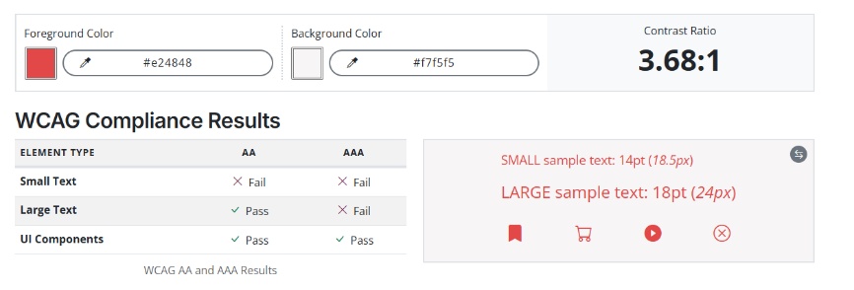
Figure 12 - Colour contrast results

References

[1] | J. Sauro, A Practical Guide to Measuring Usability, Denver: Jeff Sauro, 2010.
[2] | Ramotion, “Website Usability 101: Definition, Principles and Methods,” Ramotion, 17 4 2023. [Online]. Available: https://www.ramotion.com/blog/website-usability/#:~:text=Website%20usability%20is%20an%20essential,rather%20than%20the%20actual%20procedure.. [Accessed 10 1 2025].
[3] | A. Firth, Practical Web Inclusion and Accessibility: A Comprehensive Guide to Access Needs, bournemouth: Apress, 2019.
[4] | B. Newsnight, Interviewee, Sir Tim Berners-Lee on the World Wide Web. [Interview]. 2005 3 12.
[5] | J. Le, “How To Design An Accessible Website (A Complete Guide),” DreamHost, 14 2 2024. [Online]. Available: https://www.dreamhost.com/blog/make-your-website-accessible/. [Accessed 18 1 2025].
[6] | B. Clay, Search Engine Optimization All-in-One For Dummies, Simi Valley: For Dummies, 2015.
[7] | B. Muller, “How Search Engines Work: Crawling, Indexing, and Ranking,” Moz, 26 6 2024. [Online]. Available: https://moz.com/beginners-guide-to-seo/how-search-engines-operate#:~:text=Crawling%20is%20the%20discovery%20process,content%20is%20discovered%20by%20links.. [Accessed 18 1 2025].
[8] | C. Mmeje, “What Is On-Page SEO? How To Optimize A Page,” moz, 18 11 2024. [Online]. Available: https://moz.com/learn/seo/on-site-seo. [Accessed 27 1 2025].
[9] | A. Krysiak-Adamczyk, “Website Usability: The Ultimate Guide for 2025,” survicate, 16 1 2025. [Online]. Available: https://survicate.com/blog/website-usability/. [Accessed 23 1 2025].
[10] | sweor, “27 Eye-Opening Website Statistics: Is Your Website Costing You Clients?,” sweor, 6 3 2023. [Online]. Available: https://www.sweor.com/firstimpressions. [Accessed 6 3 2025].
[11] | C. Melinn, “What Is SEO And How Does It Work?,” digitalmarketinginstitute, 27 2 2024. [Online]. Available: https://digitalmarketinginstitute.com/blog/what-is-seo. [Accessed 28 1 2025].
[12] | wcag, “WCAG 101: Understanding the Web Content Accessibility Guidelines,” wcag, 9 10 2024. [Online]. Available: https://www.wcag.com/resource/what-is-wcag/. [Accessed 26 1 2025].
[13] | W3C, “Web Content Accessibility Guidelines (WCAG) 2.1,” W3C.org, 12 12 2024. [Online]. Available: https://www.w3.org/TR/WCAG21/#text-alternatives. [Accessed 25 1 2025].

Bibliography

[1] | J. Sauro, A Practical Guide to Measuring Usability, Denver: Jeff Sauro, 2010.
[2] | Ramotion, “Website Usability 101: Definition, Principles and Methods,” Ramotion, 17 4 2023. [Online]. Available: https://www.ramotion.com/blog/website-usability/#:~:text=Website%20usability%20is%20an%20essential,rather%20than%20the%20actual%20procedure.. [Accessed 10 1 2025].
[3] | A. Firth, Practical Web Inclusion and Accessibility: A Comprehensive Guide to Access Needs, bournemouth: Apress, 2019.
[4] | B. Newsnight, Interviewee, Sir Tim Berners-Lee on the World Wide Web. [Interview]. 2005 3 12.
[5] | J. Le, “How To Design An Accessible Website (A Complete Guide),” DreamHost, 14 2 2024. [Online]. Available: https://www.dreamhost.com/blog/make-your-website-accessible/. [Accessed 18 1 2025].
[6] | B. Clay, Search Engine Optimization All-in-One For Dummies, Simi Valley: For Dummies, 2015.
[7] | B. Muller, “How Search Engines Work: Crawling, Indexing, and Ranking,” Moz, 26 6 2024. [Online]. Available: https://moz.com/beginners-guide-to-seo/how-search-engines-operate#:~:text=Crawling%20is%20the%20discovery%20process,content%20is%20discovered%20by%20links.. [Accessed 18 1 2025].
[8] | C. Mmeje, “What Is On-Page SEO? How To Optimize A Page,” moz, 18 11 2024. [Online]. Available: https://moz.com/learn/seo/on-site-seo. [Accessed 27 1 2025].
[9] | A. Krysiak-Adamczyk, “Website Usability: The Ultimate Guide for 2025,” survicate, 16 1 2025. [Online]. Available: https://survicate.com/blog/website-usability/. [Accessed 23 1 2025].
[10] | sweor, “27 Eye-Opening Website Statistics: Is Your Website Costing You Clients?,” sweor, 6 3 2023. [Online]. Available: https://www.sweor.com/firstimpressions. [Accessed 6 3 2025].
[11] | C. Melinn, “What Is SEO And How Does It Work?,” digitalmarketinginstitute, 27 2 2024. [Online]. Available: https://digitalmarketinginstitute.com/blog/what-is-seo. [Accessed 28 1 2025].
[12] | wcag, “WCAG 101: Understanding the Web Content Accessibility Guidelines,” wcag, 9 10 2024. [Online]. Available: https://www.wcag.com/resource/what-is-wcag/. [Accessed 26 1 2025].
[13] | W3C, “Web Content Accessibility Guidelines (WCAG) 2.1,” W3C.org, 12 12 2024. [Online]. Available: https://www.w3.org/TR/WCAG21/#text-alternatives. [Accessed 25 1 2025].
[14] | 9. Team, “The principles of website usability,” 99designs, 15 01 2021. [Online]. Available: https://99designs.com/blog/web-digital/website-usability-principles/. [Accessed 3 1 2025].
[15] | S. Team, “11 Important Ways To Make Your Website Accessible,” Solve, 22 5 2024. [Online]. Available: https://solve.co.uk/web-design-tips/how-to-make-a-website-accessible/. [Accessed 3 1 2025].
[16] | D. Goodwin, “What Is SEO – Search Engine Optimization?,” searchengineland, 23 9 2024. [Online]. Available: https://searchengineland.com/guide/what-is-seo. [Accessed 4 1 2025].
[17] | R. Handley, “What Is SEO? An Intro to Search Engine Optimization,” semrush, 25 11 2024. [Online]. Available: https://www.semrush.com/blog/what-is-seo/. [Accessed 5 1 2025].
[18] | J. Sabilano, “Web Accessibility Features: Everyone Benefits From Inclusion,” userway, 24 1 2022. [Online]. Available: https://userway.org/blog/accessibility-features/. [Accessed 7 1 2025].
[19] | A. FC, “https://www.arsenal.com/,” [Online]. Available: https://www.arsenal.com/. [Accessed 20 1 2025].
[20] | B. News, “Football,” BBC, [Online]. Available: https://www.bbc.co.uk/sport/football. [Accessed 20 1 2025].

Table of Figures
Figure 1 - Home page Figure 2 – Main page 2
Figure 3 - News page Figure 4 - Academy Page 2
Figure 5 - Results page Figure 6- Legends page 3
Figure 7 - Stats page Figure 8 - Transfers page 3
Figure 9 - History page 3
Figure 10 - Html Validation results 4
Figure 11- CSS Validation results 4
Figure 12 - Colour contrast results 8

Appendices

Main Page HTML
<!DOCTYPE html>
<html lang="en">
<head>
<meta charset="UTF-8">
<meta name="viewport" content="width=device-width, initial-scale=1.0">
<link rel="stylesheet" href="MainPage.css">
<title>InsiderArsenal</title>
<!--
<link rel="preconnect" href="https://fonts.googleapis.com">
<link rel="preconnect" href="https://fonts.gstatic.com" crossorigin>
<link href="https://fonts.googleapis.com/css2?family=Roboto:ital,wght@0,100;0,300;0,400;0,500;0,700;0,900;1,100;1,300;1,400;1,500;1,700;1,900&display=swap" rel="stylesheet">
-->
</head>
<header>
<div class="HeaderContainer">
<!--The header buttons/links -->
<a href="News.html" class="button Page1">News </a>
<a href="Academy.html" class="button Page2">Academy </a>
<a href="Results.html" class="button Page3">Results </a>
<a href="Legends.html" class="button Page4">Legends </a>
<a href="Stats.html" class="button Page5">Stats </a>
<a href="Transfers.html" class="button Page6">Transfers </a>
<a href="History.html" class="button Page7">History </a>

</div>

<a href="MainPage.html" tabindex="1" role="link">
<img src="Images/Logo.png" class="Logo" alt="Description of the image" width="65" height="65">
</a>

</header>

<body>

<div class="MainContainer">

<div class="Text Title1">InsiderArsenal</div>

<!--rounded squares for text/images to go into -->
<div class="Rounded-Square Square1"> </div>
<div class="Rounded-Square Square2"> </div>
<div class="Rounded-Square Square3"> </div>
<div class="Rounded-Square Square4"> </div>
<div class="Rounded-Square Square5"> </div>

<!--Images and text for each rounded square -->
<img src="Images/Saka-injury.png" class="ArsenalPhoto ArsenalPhoto1" alt="Saka injured on the floor" width="450px" height="210px">
<h2 class="Text ArsenalPhoto1Text">Star Player Bukayo Saka out for weeks <br> with muscular tear injury</h2>

<img src="Images/calafiori.png" class="ArsenalPhoto ArsenalPhoto2" alt="Calafiori holding his shirt" width="450px" height="210px">
<h2 class="Text ArsenalPhoto2Text">Arsenal to sign breakout centre back <br>Ricardo Calafiori in £35 million deal </h2>

<img src="Images/Arsenal.png" class="ArsenalPhoto ArsenalPhoto3" alt="Arsenal team standing grouped together" width="361px" height="180px">
<h2 class="Text ArsenalPhoto3Text">Clean sheet kept at the Emirates <br>in 3-0 vs against Dinamo Zagreb </h2>

<img src="Images/Thierry Henry.png" class="ArsenalPhoto ArsenalPhoto4" alt="Henry celebrating a goal" width="361px" height="180px">
<h2 class="Text ArsenalPhoto4Text">Football and Arsenal Legend<br>Henry celebrates 47th birthday</h2>

<img src="Images/odegaard.png" class="ArsenalPhoto ArsenalPhoto5" alt="Odegaard with the captain armband on" width="361px" height="180px">
<h2 class="Text ArsenalPhoto5Text">Arsenal Captain Odegaard scores <br>Crucial goal in Arsenal win</h2>

</div>

<div class="TablesContainer">

<!--Small red line in between sections -->
<div class="Breaker"></div>

<!--Header to section -->
<h1 class="Header SeasonOverview">Season Overview</h1>

<!--rounded squares for text/images to go into -->
<div class="Rounded-Square Square6"> </div> <!--Premier League Table -->
<div class="Rounded-Square Square7"> </div> <!--Arsenal top scorers -->
<div class="Rounded-Square Square8"> </div> <!--Arsenal top assisters -->
<div class="Rounded-Square Square9"> </div> <!--Arsenal top -->

<h1 class="Text TableHeaderText"></h1> <!--Table header text -->

<!--Each table with the content within-->
<table class="tableMain">
<tr>
<th>Postion</th>
<th>Team</th>
<th>Points</th>
</tr>
<tr>
<td>1</td>
<td>Liverpool</td>
<td>56</td>
</tr>
<tr>
<td>2</td>
<td>Arsenal</td>
<td>50</td>
</tr>
<tr>
<td>3</td>
<td>Notts Forest</td>
<td>47</td>
</tr>
<tr>
<td>4</td>
<td>Chelsea</td>
<td>43</td>
</tr>
<tr>
<td>5</td>
<td>Man City</td>
<td>41</td>
</tr>
<tr>
<td>6</td>
<td>Newcastle</td>
<td>41</td>
</tr>
<tr>
<td>7</td>
<td>Bournemouth</td>
<td>40</td>
</tr>
<tr>
<td>8</td>
<td>Aston Villa</td>
<td>37</td>
</tr>
<tr>
<td>9</td>
<td>Fulham</td>
<td>36</td>
</tr>
<tr>
<td>10</td>
<td>Brighton</td>
<td>34</td>
</tr>
<tr>
<td>11</td>
<td>Brentford</td>
<td>31</td>
</tr>
<tr>
<td>12</td>
<td>Crystal Palace</td>
<td>30</td>
</tr>
<tr>
<td>13</td>
<td>Man United</td>
<td>29</td>
</tr>
<tr>
<td>14</td>
<td>Tottenham</td>
<td>27</td>
</tr>
<tr>
<td>15</td>
<td>West Ham</td>
<td>27</td>
</tr>
<tr>
<td>16</td>
<td>Everton</td>
<td>26</td>
</tr>
<tr>
<td>17</td>
<td>Wolves</td>
<td>19</td>
</tr>
<tr>
<td>18</td>
<td>Leicester</td>
<td>17</td>
</tr>
<tr>
<td>19</td>
<td>Iswich Town</td>
<td>16</td>
</tr>
<tr>
<td>20</td>
<td>Southampton</td>
<td>9</td>
</tr>
</table>

<table class="TableGoals">
<tr>
<th>Player</th>
<th>Goals</th>
<th>Games</th>
</tr>

<tr>
<td>Havertz</td>
<td>8</td>
<td>19</td>
</tr>

<tr>
<td>Martinelli</td>
<td>6</td>
<td>20</td>
</tr>
<tr>
<td>Saka</td>
<td>5</td>
<td>16</td>
</tr>
<tr>
<td>Trossard</td>
<td>4</td>
<td>22</td>
</tr>
<tr>
<td>Gabriel</td>
<td>3</td>
<td>20</td>
</tr>

</table>

<table class="TableAssists">
<tr>
<th>Player</th>
<th>Assists</th>
<th>Games</th>
</tr>

<tr>
<td>Saka</td>
<td>10</td>
<td>16</td>
</tr>

<tr>
<td>Trossard</td>
<td>4</td>
<td>22</td>
</tr>
<tr>
<td>Rice</td>
<td>3</td>
<td>20</td>
</tr>
<tr>
<td>Odegaard</td>
<td>3</td>
<td>15</td>
</tr>
<tr>
<td>martinelli</td>
<td>2</td>
<td>20</td>
</tr>

</table>

<table class="TableRatings">
<tr>
<th>Player</th>
<th>Ratings</th>
<th>Games</th>
</tr>

<tr>
<td>Saka</td>
<td>7.76</td>
<td>16</td>
</tr>

<tr>
<td>Partey</td>
<td>7.34</td>
<td>21</td>
</tr>
<tr>
<td>Gabriel</td>
<td>7.25</td>
<td>20</td>
</tr>
<tr>
<td>Saliba</td>
<td>7.21</td>
<td>20</td>
</tr>
<tr>
<td>Rice</td>
<td>7.19</td>
<td>20</td>
</tr>

</table>
</div>

</body>

Main Page CSS

/*for the body */
body {
background-color: rgb(247, 245, 245);
}
/*default Text format */
.Text {
position: absolute;
font-weight: bold;
font-family: "Roboto", serif;
text-align: center;
color: white;
z-index: 1;
}

/* Default Header format*/
.Header {
position: absolute;
font-weight: bold;
font-family: "Roboto", serif;
text-align: center;
color: white;
}

/*Header Container*/

.HeaderContainer {
display: flex;
position: relative;
width: 100%;
height: 50px;
margin-left: 80px;
margin-top: -10px;
}

/*Header button default format */
.button {
position: relative;
top: 2%;
padding: 10px 20px;
color: white;
font-family: "Roboto", serif;
font-size: 24px;
background-color: red;
border-width: 0;
font-weight: bold;
text-decoration: none;
}

/*Title text properties */
.Title1 {
color:rgb(226, 72, 72);
font-size: 35px;
right: 20px;
top: -40px;
}
/*Postion logo*/

.Logo {

position: absolute;
left: 1%;
top: 0.0%;

}

/* ***************************************************** */

/*Main container*/

.MainContainer {
position: relative;
width: 1890px;
height: 880px;
pointer-events: none;

}

/*Default format for the boxes/rounded squares.*/
.Rounded-Square {
position: absolute;
background-color: white;
border-radius: 20px;
box-shadow: 0 4px 8px rgba(0, 0, 0, 0.2);

}

/*Background squares with their postion and size*/

.Square1 {
height: 310px;
width: 450px;
top: 110px;
left: 430px;
}

.Square2 {
height: 310px;
width: 450px;
top: 110px;
right: 450px;
}
.Square3 {
height: 280px;
width: 360px;
top: 510px;
left: 320px;
}

.Square4 {
height: 280px;
width: 360px;
top: 510px;
left: 762px;
}

.Square5 {
height: 280px;
width: 360px;
top: 510px;
right: 320px;
}

/*Postion Arsenal photo's*/

.ArsenalPhoto {
position: absolute;
z-index: 1;

}

.ArsenalPhoto1 {
left: 430px;
top: 110px;
}

.ArsenalPhoto2 {
right: 450px;
top: 110px;
}

.ArsenalPhoto3 {
left: 320px;
top: 510px;
}

.ArsenalPhoto4 {
left: 761.5px;
top: 510px;
}

.ArsenalPhoto5 {
right: 320px;
top: 510px;
}

/*Positioning and properties for all Arsenal text */

.ArsenalPhoto1Text {
top: 310px;
left: 440px;
color: black;
font-size: 26px;
text-align: left;
}

.ArsenalPhoto2Text {
top: 310px;
right: 470px;
color: black;
font-size: 26px;
text-align: left;

}

.ArsenalPhoto3Text {
top: 685px;
left: 332px;
color: black;
font-size: 24px;
text-align: left;

}

.ArsenalPhoto4Text {
top: 685px;
left: 770px;
color: black;
font-size: 24px;
text-align: left;

}

.ArsenalPhoto5Text {
top: 685px;
right: 328px;
color: black;
font-size: 24px;
text-align: left;

}

/* ***************************************************** */

/*Table container*/

.TablesContainer {
position: relative;
width: 100%;
height: 1000px;
pointer-events: none;

}

/*Line breaker*/

.Breaker {
position: absolute;
bottom: 980px;
left: 100px;
background-color: red;
width: 90%;
height: 0.1%;
z-index: 30;
}

/*Header text for the Season Overview */
.SeasonOverview {
bottom: 830px;
left: 100px;
color: rgb(226, 72, 72);
font-size:40px;
}

/*Background squares with their postion and size*/
.Square6 {

bottom: 40px;
left: 340px;
height: 760px;
width: 470px;

}

.Square7 {

bottom: 40px;
left: 1075px;
height: 230px;
width: 560px;

}

.Square8 {

bottom: 303px;
left: 1075px;
height: 230px;
width: 560px;

}

.Square9 {
bottom: 560px;
left: 1075px;
height: 230px;
width: 560px;

}

/*Format for tables on main page with the positioning */
.tableMain {
position: absolute;
bottom: 60px;
left: 372px;
font-family: "Roboto", serif;
font-weight: bold;
font-size: 21px;
width: 412px;
height: 730px;
color: black;
border-collapse: collapse;
}

.TableGoals {
position: absolute;
bottom: 580px;
left: 1100px;
font-family: "Roboto", serif;
font-weight: bold;
font-size: 21px;
width: 500px;
height: 200px;
color: black;
border-collapse: collapse;

}

.TableAssists {
position: absolute;
bottom: 320px;
left: 1100px;
font-family: "Roboto", serif;
font-weight: bold;
font-size: 21px;
width: 500px;
height: 200px;
color: black;
border-collapse: collapse;

}

.TableRatings {
position: absolute;
bottom: 58px;
left: 1100px;
font-family: "Roboto", serif;
font-weight: bold;
font-size: 21px;
width: 500px;
height: 200px;
color: black;
border-collapse: collapse;

}

/*First row has red text*/

table tr:first-child {
text-align: left;
color: red;
}

/*Every Odd numbered line */
tbody tr:nth-child(even) {
background-color: rgb(219, 218, 218);
}

/*Every even numbered line */
tbody tr:nth-child(odd) {
background-color: rgb(240, 239, 239);
}

News Page HTML

<!DOCTYPE html>
<html lang="en">
<head>
<meta charset="UTF-8">
<meta name="viewport" content="width=device-width, initial-scale=1.0">
<link rel="stylesheet" href="News.css">
<title>InsiderArsenal</title>
<!--
<link rel="preconnect" href="https://fonts.googleapis.com">
<link rel="preconnect" href="https://fonts.gstatic.com" crossorigin>
<link href="https://fonts.googleapis.com/css2?family=Roboto:ital,wght@0,100;0,300;0,400;0,500;0,700;0,900;1,100;1,300;1,400;1,500;1,700;1,900&display=swap" rel="stylesheet">
-->
</head>
<header>
<div class="HeaderContainer">
<!--The header buttons/links -->
<a href="News.html" class="button Page1">News </a>
<a href="Academy.html" class="button Page2">Academy</a>
<a href="Results.html" class="button Page3">Results </a>
<a href="Legends.html" class="button Page4">Legends </a>
<a href="Stats.html" class="button Page5">Stats </a>
<a href="Transfers.html" class="button Page6">Transfers </a>
<a href="History.html" class="button Page7">History </a>
</div>

<h1 class="Header InsiderArsenal"></h1>
<a href="MainPage.html" tabindex="1" role="link">
<img src="Images/Logo.png" class="Logo" alt="Description of the image" width="65" height="65">
</a>
</header>

<body>

<div class="MainContainer">

<!--rounded squares for text/images to go into -->
<div class="Rounded-Square Square1"> </div>
<div class="Rounded-Square Square2"> </div>
<div class="Rounded-Square Square3"> </div>
<div class="Rounded-Square Square4"> </div>
<div class="Rounded-Square Square5"> </div>
<div class="Rounded-Square Square6"> </div>

<!--Images and text for each rounded square -->
<img src="Images/ArtetaShout.png" class="ArsenalPhoto ArsenalPhoto1" alt="Arteta celebrating win over Wolves" width="400px" height="210px">
<h2 class="Text ArsenalPhoto1Text">
Mikel Arteta's huge relief after <br>defeating Wolves
1-0 after going down<br> to 10 men with unfair Miles
Lewis<br> Skelly red card. Arsenal remain in 2nd <br>place
in the premier league, 3 points <br>above forest and 6 behind
league front<br> runners liverpool. Premier league title<br>
chances still on but Liverpool don't<br> seem to be slowing down.
</h2>

<img src="Images/MilesLewisSkelly.png" class="ArsenalPhoto ArsenalPhoto2" alt="Miles Lewis-Skelly walking out onto pitch" width="400px" height="210px">
<h2 class="Text ArsenalPhoto2Text">
Arsenal Youngster Mile lewis-skelly <br>
Recieves a very controversial red card <br>
on saturday against Wolves. The <br>Molineux
in shock as Martin Oliver <br>sends the 18 year
old off the pitch.<br> Many pundits and fans
believe this<br> to be a huge mistake from
the referee<br> and VAR, with it not being
the first<br> time. Similar controversial red cards <br>have
occured multiple times.

</h2>

<img src="Images/Nypan.png" class="ArsenalPhoto ArsenalPhoto3" alt="Nypan playing football" width="400px" height="210px">
<h2 class="Text ArsenalPhoto3Text">
Highly rated Norwegian wonder kid <br> linked to Arsenal
in a £10 million<br> move. Sverre Halseth Nypan is wanted<br>
by many top clubs in Europe. In the <br>past week has visted
Arsenal, Aston<br> Villa and Manchester City as he<br> decides where
to move. Arsenal are <br>believed to be the favourites to signing
<br>the youngster. Nypan in 2024 played<br> 28 matches where he had 15 G/A.
</h2>

<img src="Images/Saka-injury.png" class="ArsenalPhoto ArsenalPhoto4" alt="Injured Saka on the floor" width="400px" height="210px">
<h2 class="Text ArsenalPhoto4Text">
Arsenal Injury hopes seem to be <br>looking up. Important players
Ben <br>white and Takehiro Tomiayasu set to <br>return to full time
training in the next <br>week. With Star boy Bukayo Saka set<br> to return
to action at the end of <br>Feburary. Key players like Calafiori
<br> and Saliba have returned to the first <br>team after picking up
a small knock<br> the week before.

</h2>

<img src="Images/Jorginho.png" class="ArsenalPhoto ArsenalPhoto5" alt="Jorginho playing for Arsenal" width="400px" height="210px">
<h2 class="Text ArsenalPhoto5Text">
Senior players Thomas Partey and<br> Jorginho Look set to leave
the club at<br> the end of the season, when their<br> contracts expire
in the summer. Both <br> leaving on a free transfer after joining<br>
Arsenal for £45 and £12 million. The<br> two holding midfielders will
leave<br> massive gaps to fill for Mikel Arteta's<br> side. As the club
will need to sign <br> quality players to replace them.

</h2>

<img src="Images/Tavares.png" class="ArsenalPhoto ArsenalPhoto6" alt="Nuno Tavares headshot" width="400px" height="210px">
<h2 class="Text ArsenalPhoto6Text">
Tuno Tavares is performing very well <br> on his loan at
Serie A club <br> Lazio. He's played 19 games all<br> together
for them and assited in 9 goals.<br> Sambi Lokonga on loan at Sevilla
has <br> adapted to life in spain well as he's <br> played 14 matches
for the spanish club <br> and got himself 2 assists. Both players <br>
have buy clauses and will likely move <br>to the clubs
on a perminent basis.

</h2>

</div>

</body>

News Page CSS

/*for the body */
body {
background-color: rgb(247, 245, 245);
}
/*default Text format */
.Text {
position: absolute;
font-weight: bold;
font-family: "Roboto", serif;
text-align: center;
color: white;
z-index: 1;
}

/* Default Header format*/
.Header {
position: absolute;
font-weight: bold;
font-family: "Roboto", serif;
text-align: center;
color: white;
text-align: left;
}

.HeaderContainer {
display: flex;
position: relative;
align-items: left;
width: 100%;
height: 50px;
margin-left: 80px;
margin-top: -10px;
}

/*Header button default format */
.button {
position: relative;
top: 2%;
padding: 10px 20px;
color: white;
font-family: "Roboto", serif;
font-size: 24px;
background-color: red;
border-width: 0;
font-weight: bold;
text-decoration: none;
}

/*Postion logo*/

.Logo {

position: absolute;
left: 1%;
top: 0.0%;
}

/* ***************************************************** */

/*Main Container*/

.MainContainer {
position: relative;
width: 1890px;
height: 1300px;
pointer-events: none;

}

/*Default format for the boxes/rounded squares.*/
.Rounded-Square {
position: absolute;
background-color: white;
border-radius: 20px;
box-shadow: 0 4px 8px rgba(0, 0, 0, 0.2);

}

/*Background squares with their postion and size*/
.Square1 {
height: 510px;
width: 400px;
top: 110px;
left: 230px;
}

.Square2 {
height: 510px;
width: 400px;
top: 110px;
left: 750px;
}

.Square3 {
height: 510px;
width: 400px;
top: 110px;
right: 230px;
}

.Square4 {
height: 510px;
width: 400px;
top: 750px;
left: 230px;
}

.Square5 {
height: 510px;
width: 400px;
top: 750px;
left: 750px;
}

.Square6 {
height: 510px;
width: 400px;
top: 750px;
right: 230px;
}

/*Postion Arsenal photos*/

.ArsenalPhoto {
position: absolute;
z-index: 1;

}

.ArsenalPhoto1 {
left: 230px;
top: 110px;
}

.ArsenalPhoto2 {
left: 750px;
top: 110px;
}
.ArsenalPhoto3 {
right: 230px;
top: 110px;
}

.ArsenalPhoto4 {
left: 230px;
top: 750px;
}

.ArsenalPhoto5 {
left: 750px;
top: 750px;
}
.ArsenalPhoto6 {
right: 230px;
top: 750px;
}

/*Positioning and properties for all Arsenal text */

.ArsenalPhoto1Text {
top: 310px;
left: 235px;
color: black;
font-size: 22px;
text-align: left;
}

.ArsenalPhoto2Text {
top: 310px;
right: 750px;
color: black;
font-size: 22px;
text-align: left;

}

.ArsenalPhoto3Text {
top: 310px;
right: 235px;
color: black;
font-size: 22px;
text-align: left;
}

.ArsenalPhoto4Text {
top: 950px;
left: 235px;
color: black;
font-size: 22px;
text-align: left;
}

.ArsenalPhoto5Text {
top: 950px;
right: 750px;
color: black;
font-size: 22px;
text-align: left;

}

.ArsenalPhoto6Text {
top: 950px;
right: 235px;
color: black;
font-size: 22px;
text-align: left;

}

Academy Page HTML

<!DOCTYPE html>
<html lang="en">
<head>
<meta charset="UTF-8">
<meta name="viewport" content="width=device-width, initial-scale=1.0">
<link rel="stylesheet" href="Academy.css">
<title>InsiderArsenal</title>
<!--
<link rel="preconnect" href="https://fonts.googleapis.com">
<link rel="preconnect" href="https://fonts.gstatic.com" crossorigin>
<link href="https://fonts.googleapis.com/css2?family=Roboto:ital,wght@0,100;0,300;0,400;0,500;0,700;0,900;1,100;1,300;1,400;1,500;1,700;1,900&display=swap" rel="stylesheet">
-->
</head>
<header>
<div class="HeaderContainer">

<!--The header buttons/links -->

<a href="News.html" class="button Page1">News </a>
<a href="Academy.html" class="button Page2">Academy </a>
<a href="Results.html" class="button Page3">Results </a>
<a href="Legends.html" class="button Page4">Legends </a>
<a href="Stats.html" class="button Page5">Stats </a>
<a href="Transfers.html" class="button Page6">Transfers </a>
<a href="History.html" class="button Page7">History </a>
</div>

<h1 class="Header InsiderArsenal"></h1>
<a href="MainPage.html" tabindex="1" role="link" >
<!--TThe header logo and size -->
<img src="Images/Logo.png" class="Logo" alt="Description of the image" width="65" height="65">
</a>
</header>

<body>

<div class="MainContainer">

<!--Header text for the 2 sections -->
<h2 class="Text Header1">Current prospects</h2>
<h2 class="Text Header2">Past prospects</h2>

<!--rounded squares for text/images to go into -->
<div class="Rounded-Square Square1"> </div>
<div class="Rounded-Square Square2"> </div>
<div class="Rounded-Square Square3"> </div>
<div class="Rounded-Square Square4"> </div>
<div class="Rounded-Square Square5"> </div>
<div class="Rounded-Square Square6"> </div>

<!--Images and text for each rounded square -->

<img src="Images/Ethan Nwaneri.png" class="ArsenalPhoto ArsenalPhoto1" alt="Ethan Nwaneri headshot" width="400px" height="210px">
<h2 class="Text ArsenalPhoto1Text">
Ethan Nwaneri is one of the most exciting<br> prospects in English football currently.<br> He has recently
broken into the Arsenal<br> first team, even socring his first <br>champions league goal against Girona.<br><br>
Name : Ethan Nwaneri<br>
Age : 17<br>
Apparences : 21<br>
Goals : 6
</h2>

<img src="Images/Myles Lewis-Skelly.png" class="ArsenalPhoto ArsenalPhoto2" alt="Myles Lewis-Selly Headshot" width="400px" height="210px">
<h2 class="Text ArsenalPhoto2Text">
Miles Lewis-skelly has broken into the <br> the Arsenal first team after impressing <br>Arteta.
The young English left back has<br> been amazing and one to watch for the <br> future <br>
<br>
Name : Miles Lewis-Selly<br>
Age : 18<br>
Apparences : 19<br>
Goals : 0

</h2>

<img src="Images/Setford.png" class="ArsenalPhoto ArsenalPhoto3" alt="Tommy Setford Headshot" width="400px" height="210px">
<h2 class="Text ArsenalPhoto3Text">
Tommy setford was brought in from <br> Ajax in the summer tranfer window<br> for just
over £1 million. He is yet to <br> make a first team apperance for the <br> gunners
but there is a lot of talk about <br> his quality
<br><br>
Name : Tommy Setford<br>
Age : 18<br>
Apparences : 0<br>
</h2>

<img src="Images/BukayoSaka.png" class="ArsenalPhoto ArsenalPhoto4" alt="Bukayo Saka Headshot" width="400px" height="210px">
<h2 class="Text ArsenalPhoto4Text">
Bukayo is one of the best players to ever<br> come out of the Hale-End academy. <br> He has been a first team starter for <br>
over 3 seasons, helping Arsenal reach <br> new heights <br>

<br><br>
Name : Bukayo Saka<br>
Age : 23<br>
Apparences : 254<br>
Goals: 68
</h2>

<img src="Images/Nelson.png" class="ArsenalPhoto ArsenalPhoto5" alt="Reiss Nelson Headshot" width="400px" height="210px">
<h2 class="Text ArsenalPhoto5Text">
Emile Smith-Rowe burst onto the<br> English football scene scoring crucial<br> goals against the likes of Chelsea. He <br>
left in the 24/25 to join Fulham where <br> he has continued to impress. <br>

<br><br>
Name : Emile Smith-Rowe<br>
Age : 24<br>
Apparences : 115<br>
Goals: 18
</h2>

<img src="Images/esr.png" class="ArsenalPhoto ArsenalPhoto6" alt="Emile smith-rowe in the Emirates stadium" width="400px" height="210px">
<h2 class="Text ArsenalPhoto6Text">
Reiss Nelson made his Arsenal debut in<br> 2017 in the community shield. since has<br> had many successful loan spells in <br>Germany
and Netherlands. He played <br>a crucial role last season where Arsenal <br> finished 2nd in the League.
<br> <br>
Name : Reiss Nelson<br>
Age : 25<br>
Apparences : 90<br>
Goals : 8
</h2>

</div>

</body>

Academy Page CSS

/*for the body */
body {
background-color: rgb(247, 245, 245);
}
/*default Text format */
.Text {
position: absolute;
font-weight: bold;
font-family: "Roboto", serif;
text-align: center;
color: white;
z-index: 1;
}

/* Default Header format*/
.Header {
position: absolute;
font-weight: bold;
font-family: "Roboto", serif;
text-align: center;
color: white;
text-align: left;
}

/* Container for header*/

.HeaderContainer {
display: flex;
position: relative;
align-items: left;
width: 100%;
height: 50px;
margin-left: 80px;
margin-top: -10px;
}

/*Header button default format */
.button {
position: relative;
top: 2%;
padding: 10px 20px;
color: white;
font-family: "Roboto", serif;
font-size: 24px;
background-color: red;
border-width: 0;
font-weight: bold;
text-decoration: none;
}

/*Postion logo*/

.Logo {

position: absolute;
left: 1%;
top: 0.0%;
}

/* ***************************************************** */

/*Main container */
.MainContainer {
position: relative;
width: 1890px;
height: 1300px;
pointer-events: none;

}

/*Header postions, size and color*/
.Header1 {
color:rgb(226, 72, 72);
font-size: 40px;
left: 40px;
top: 40px;
}

.Header2 {
color:rgb(226, 72, 72);
font-size: 40px;
left: 40px;
top: 700px;
}

/*Default format for the boxes/rounded squares.*/
.Rounded-Square {
position: absolute;
background-color: white;
border-radius: 20px;
box-shadow: 0 4px 8px rgba(0, 0, 0, 0.2);

}

/*Background squares with their postion and size*/
.Square1 {
height: 510px;
width: 400px;
top: 170px;
left: 230px;
}

.Square2 {
height: 510px;
width: 400px;
top: 170px;
left: 750px;
}

.Square3 {
height: 510px;
width: 400px;
top: 170px;
right: 230px;
}

.Square4 {
height: 510px;
width: 400px;
top: 830px;
left: 230px;
}

.Square5 {
height: 510px;
width: 400px;
top: 830px;
left: 750px;
}

.Square6 {
height: 510px;
width: 400px;
top: 830px;
right: 230px;
}

/*Postioning all Arsenal photo's*/

.ArsenalPhoto {
position: absolute;
z-index: 1;

}

.ArsenalPhoto1 {
left: 230px;
top: 170px;
}

.ArsenalPhoto2 {
left: 750px;
top: 170px;
}
.ArsenalPhoto3 {
right: 230px;
top: 170px;
}

.ArsenalPhoto4 {
left: 230px;
top: 830px;
}

.ArsenalPhoto5 {
left: 750px;
top: 830px;
}
.ArsenalPhoto6 {
right: 230px;
top: 830px;
}

/*Postioning adn properties for Arsenal text */
.ArsenalPhoto1Text {
top: 370px;
left: 235px;
color: black;
font-size: 22px;
text-align: left;
}

.ArsenalPhoto2Text {
top: 370px;
left: 760px;
color: black;
font-size: 22px;
text-align: left;

}

.ArsenalPhoto3Text {
top: 370px;
right: 260px;
color: black;
font-size: 22px;
text-align: left;
}

.ArsenalPhoto4Text {
top: 1030px;
left: 235px;
color: black;
font-size: 22px;
text-align: left;
}

.ArsenalPhoto5Text {
top: 1030px;
right: 780px;
color: black;
font-size: 22px;
text-align: left;

}

.ArsenalPhoto6Text {
top: 1030px;
right: 250px;
color: black;
font-size: 22px;
text-align: left;
}

Results Page HTML

<!DOCTYPE html>
<html lang="en">
<head>
<meta charset="UTF-8">
<meta name="viewport" content="width=device-width, initial-scale=1.0">
<link rel="stylesheet" href="Results.css">
<title>InsiderArsenal</title>
<!--
<link rel="preconnect" href="https://fonts.googleapis.com">
<link rel="preconnect" href="https://fonts.gstatic.com" crossorigin>
<link href="https://fonts.googleapis.com/css2?family=Roboto:ital,wght@0,100;0,300;0,400;0,500;0,700;0,900;1,100;1,300;1,400;1,500;1,700;1,900&display=swap" rel="stylesheet">
-->
</head>
<header>
<div class="HeaderContainer">
<!--The header buttons/links -->
<a href="News.html" class="button Page1">News </a>
<a href="Academy.html" class="button Page2">Academy</a>
<a href="Results.html" class="button Page3">Results </a>
<a href="Legends.html" class="button Page4">Legends </a>
<a href="Stats.html" class="button Page5">Stats </a>
<a href="Transfers.html" class="button Page6">Transfers </a>
<a href="History.html" class="button Page7">History </a>
</div>

<h1 class="Header InsiderArsenal" ></h1>
<a href="MainPage.html" tabindex="1" role="link">
<img src="Images/Logo.png" class="Logo" alt="Description of the image" width="65" height="65">
</a>
</header>

<body>

<div class="MainContainer">

<!--rounded squares for text/images to go into -->
<div class="Rounded-Square Square1"> </div> <!--Header to section -->
<div class="Rounded-Square Square2"> </div> <!--Transfer picture -->
<div class="Rounded-Square Square3"> </div> <!--Result picture -->
<div class="Rounded-Square Square4"> </div> <!--Result picture -->
<div class="Rounded-Square Square5"> </div> <!--Result picture -->
<div class="Rounded-Square Square6"> </div> <!--Result picture -->
<div class="Rounded-Square Square7"> </div> <!--Result picture -->
<div class="Rounded-Square Square8"> </div> <!--Result picture -->

<!--Images and text for each rounded square -->
<img src="Images/wolves.png" class="MainLogo Logo1" alt="Wolves Logo" width="85" height="100">
<img src="Images/Logo.png" class="MainLogo Logo2" alt="Arsenal Logo" width="85" height="85">
<h2 class="ScoreText Score1">0 : 1</h2>
<h2 class="TeamText Team1">Wolves</h2>
<h2 class="TeamText Team2">Arsenal</h2>

<img src="Images/Logo.png" class="MainLogo Logo3" alt="Arsenal Logo" width="85" height="85">
<img src="Images/Villa.png" class="MainLogo Logo4" alt="Aston Villa Logo" width="85" height="100">
<h2 class="ScoreText Score2">2 : 2</h2>
<h2 class="TeamText Team3">Arsenal</h2>
<h2 class="TeamText Team4">Aston Villa</h2>

<img src="Images/Logo.png" class="MainLogo Logo5" alt="Arsenal Logo" width="85" height="85">
<img src="Images/tottenham.png" class="MainLogo Logo6" alt="Tottenham Hotspur Logo" width="85" height="85">
<h2 class="ScoreText Score3">2 : 1</h2>
<h2 class="TeamText Team5">Arsenal</h2>
<h2 class="TeamText Team6">Tottenham Hotspur</h2>

<img src="Images/Logo.png" class="MainLogo Logo7" alt="Arsenal Logo" width="85" height="85">
<img src="Images/brighton.png" class="MainLogo Logo8" alt="Brighton Logo" width="85" height="100">
<h2 class="ScoreText Score4">1 : 1</h2>
<h2 class="TeamText Team7">Arsenal</h2>
<h2 class="TeamText Team8">Brighton</h2>

</div>

</body>

Results Page CSS

/*for the body */
body {
background-color: rgb(247, 245, 245);
}
/*default Text format */
.Text {
position: absolute;
font-weight: bold;
font-family: "Roboto", serif;
text-align: center;
color: white;
z-index: 1;
}

/* Default Header format*/
.Header {
position: absolute;
font-weight: bold;
font-family: "Roboto", serif;
text-align: center;
color: white;
text-align: left;
}

.HeaderContainer {
display: flex;
position: relative;
align-items: left;
width: 100%;
height: 50px;
margin-left: 80px;
margin-top: -10px;
}

/*Header button default format */
.button {
position: relative;
top: 2%;
padding: 10px 20px;
color: white;
font-family: "Roboto", serif;
font-size: 24px;
background-color: red;
border-width: 0;
font-weight: bold;
text-decoration: none;
}

/*Postion logo*/

.Logo {

position: absolute;
left: 1%;
top: 0.0%;
}

/* ***************************************************** */

/* Main Container*/

.MainContainer {
position: relative;
width: 1890px;
height: 1300px;
pointer-events: none;

}

/*Default format for the boxes/rounded squares.*/
.Rounded-Square {
position: absolute;
background-color: white;
border-radius: 0px;
box-shadow: 0 4px 8px rgba(0, 0, 0, 0.2);

}

/*Background squares with their postion and size*/

.Square1 {
height: 200px;
width: 1000px;
top: 150px;
left: 350px;
}

.Square2 {
background-color: rgb(221, 51, 51);
border-radius: 0px;
height: 50px;
width: 1000px;
top: 300px;
left: 350px;
}

.Square3 {
height: 200px;
width: 1000px;
top: 450px;
left: 350px;
}

.Square4 {
background-color: rgb(221, 51, 51);
border-radius: 0px;
height: 50px;
width: 1000px;
top: 600px;
left: 350px;
}

.Square5 {
height: 200px;
width: 1000px;
top: 750px;
left: 350px;
}

.Square6 {
background-color: rgb(221, 51, 51);
border-radius: 0px;
height: 50px;
width: 1000px;
top: 900px;
left: 350px;
}

.Square7 {
height: 200px;
width: 1000px;
top: 1050px;
left: 350px;
}

.Square8 {
background-color: rgb(221, 51, 51);
border-radius: 0px;
height: 50px;
width: 1000px;
top: 1200px;
left: 350px;
}

/*Postion team Logo's*/

.MainLogo {
position: absolute;
}

.Logo1 {
top: 170px;
left: 640px;

}

.Logo2 {
top: 180px;
right: 820px;

}

.Logo3 {
top: 480px;
left: 640px;

}

.Logo4 {
top: 470px;
right: 820px;

}

.Logo5 {
top: 780px;
left: 640px;

}

.Logo6 {
top: 780px;
right: 820px;

}

.Logo7 {
top: 1080px;
left: 640px;

}

.Logo8 {
top: 1070px;
right: 820px;

}

/*Positioning and properties for all score text */

.ScoreText {
position: absolute;
font-weight: bold;
font-family: "Roboto", serif;
text-align: center;
font-size: 50px;
color: rgb(0, 0, 0);
z-index: 1;
}
.Score1 {
top: 150px;
left: 810px;
}
.Score2 {
top: 450px;
left: 810px;
}
.Score3 {
top: 750px;
left: 810px;
}
.Score4 {
top: 1050px;
left: 810px;
}

/*Positioning and properties for all team text */

.TeamText {
position: absolute;
font-weight: bold;
font-family: "Roboto", serif;
text-align: center;
font-size: 30px;
color: rgb(0, 0, 0);
z-index: 1;

}
.Team1 {
top: 180px;
left: 470px;
}
.Team2 {
top: 180px;
right: 660px;
}

.Team3 {
top: 480px;
left: 470px;
}
.Team4 {
top: 480px;
right: 660px;
}

.Team5 {
top: 780px;
left: 470px;
}
.Team6 {
top: 780px;
right: 550px;
}

.Team7 {
top: 1080px;
left: 470px;
}
.Team8 {
top: 1080px;
right: 660px;
}

Legends Page HTML

<!DOCTYPE html>
<html lang="en">
<head>
<meta charset="UTF-8">
<meta name="viewport" content="width=device-width, initial-scale=1.0">
<link rel="stylesheet" href="Legends.css">
<title>InsiderArsenal</title>
<!--
<link rel="preconnect" href="https://fonts.googleapis.com">
<link rel="preconnect" href="https://fonts.gstatic.com" crossorigin>
<link href="https://fonts.googleapis.com/css2?family=Roboto:ital,wght@0,100;0,300;0,400;0,500;0,700;0,900;1,100;1,300;1,400;1,500;1,700;1,900&display=swap" rel="stylesheet">
-->
</head>
<header>
<div class="HeaderContainer">
<!--The header buttons/links -->
<a href="News.html" class="button Page1">News </a>
<a href="Academy.html" class="button Page2">Academy </a>
<a href="Results.html" class="button Page3">Results </a>
<a href="Legends.html" class="button Page4">Legends </a>
<a href="Stats.html" class="button Page5">Stats </a>
<a href="Transfers.html" class="button Page6">Transfers </a>
<a href="History.html" class="button Page7">History </a>
</div>

<h1 class="Header InsiderArsenal"></h1>
<a href="MainPage.html" tabindex="1" role="link">
<!--Header logo with the size -->
<img src="Images/Logo.png" class="Logo" alt="Description of the image" width="65" height="65">
</a>
</header>

<body>

<div class="MainContainer">

<!--rounded squares for text/images to go into -->
<div class="Rounded-Square Square1"> </div> <!--Header to section -->
<div class="Rounded-Square Square2"> </div> <!--Transfer picture -->
<div class="Rounded-Square Square3"> </div> <!--Result picture -->
<div class="Rounded-Square Square4"> </div> <!--Header to section -->
<div class="Rounded-Square Square5"> </div> <!--Header to section -->
<div class="Rounded-Square Square6"> </div> <!--Header to section -->

<!--Images and text for each rounded square -->
<img src="Images/Bergkamp.png" class="ArsenalPhoto ArsenalPhoto1" alt="Dennis Bergkamp holding a trophy with Henry" width="400px" height="210px">
<h2 class="Text ArsenalPhoto1Text">
Player: Dennis bergkamp<br>
Age : 55<br>
Clubs : Ajax, Inter Milan and Arsenal<br>
Years at Arsenal : 1995-2006<br>
Goals: 87<br>
Assists: 94<br>
Trophies: 3x Premier Leagues and <br>3 FA cups <br>
International caps: 79<br>
</h2>

<img src="Images/Henry.png" class="ArsenalPhoto ArsenalPhoto2" alt="Thiery Henry celebrating a goal" width="400px" height="210px">
<h2 class="Text ArsenalPhoto2Text">
Player: Thierry Henry<br>
Age : 47<br>
Clubs : Monaco, Juventus, <br>Arsenal, Barcelona<br>
Years at Arsenal : 1999-2007<br>
Goals: 174<br>
Assists: 60<br>
Trophies: 2xPremier Leagues and<br> 2x FA cups<br>
International caps: 123<br>

</h2>

<img src="Images/Viera.png" class="ArsenalPhoto ArsenalPhoto3" alt="Patrick Viera holding Premier league trophy with teammates" width="400px" height="210px">
<h2 class="Text ArsenalPhoto3Text">
Player: Patrick Vieira<br>
Age : 48<br>
Clubs : AC Milan, Arsenal <br> Juventus, Inter Milan, Man City<br>
Years at Arsenal : 1996-2005<br>
Goals: 29<br>
Assists: 34<br>
Trophies: 3x Premier Leagues and<br> 3 FA cups <br>
International caps: 107<br>
</h2>

<img src="Images/Pires.png" class="ArsenalPhoto ArsenalPhoto4" alt="Robert Pires celebrating a goal" width="400px" height="210px">
<h2 class="Text ArsenalPhoto4Text">
Player: Robert Pires<br>
Age : 51<br>
Clubs : Marseille, Arsenal, <br> Villarreal<br>
Years at Arsenal : 2000-2006<br>
Goals: 62<br>
Assists: 61<br>
Trophies: 2xPremier Leagues and <br> 2x FA cups<br>
International caps: 79 <br>
</h2>

<img src="Images/Cambell.png" class="ArsenalPhoto ArsenalPhoto5" alt="Sol Cambell heading a football" width="400px" height="210px">
<h2 class="Text ArsenalPhoto5Text">
Player: Sol Cambell<br>
Age : 50<br>
Clubs : Tottenham, Arsenal <br> Portsmouth<br>
Years at Arsenal : 2001-2006, 2010<br>
Goals: 8<br>
Assists: 4<br>
Trophies: 2xPremier Leagues and <br> FA cups<br>
International caps: 73<br>
</h2>

<img src="Images/Lehman.png" class="ArsenalPhoto ArsenalPhoto6" alt="Jens Lehmann catching a ball" width="400px" height="210px">
<h2 class="Text ArsenalPhoto6Text">
Player: jens Lehmann<br>
Age : 55<br>
Clubs :Schalke, AC milan <br> Dortmund, Arsenal and Stuttgart <br>
Years at Arsenal : 2003-2008, 2011<br>
Goals: 0<br>
Assists: 0<br>
Trophies: 1xPremier League and <br>1x FA cup <br>
International caps: 61<br>
</h2>

</div>

</body>

Legends Page CSS

/*for the body */
body {
background-color: rgb(247, 245, 245);
}
/*default Text format */
.Text {
position: absolute;
font-weight: bold;
font-family: "Roboto", serif;
text-align: center;
color: white;
z-index: 1;
}

/* Default Header format*/
.Header {
position: absolute;
font-weight: bold;
font-family: "Roboto", serif;
text-align: center;
color: white;
}

/*Header Container*/

.HeaderContainer {
display: flex;
position: relative;
width: 100%;
height: 50px;
margin-left: 80px;
margin-top: -10px;
}

/*Header button default format */
.button {
position: relative;
top: 2%;
padding: 10px 20px;
color: white;
font-family: "Roboto", serif;
font-size: 24px;
background-color: red;
border-width: 0;
font-weight: bold;
text-decoration: none;
}

/*Title text properties */
.Title1 {
color:rgb(226, 72, 72);
font-size: 35px;
right: 20px;
top: -40px;
}
/*Postion logo*/

.Logo {

position: absolute;
left: 1%;
top: 0.0%;

}

/* ***************************************************** */

/*Main container*/

.MainContainer {
position: relative;
width: 1890px;
height: 880px;
pointer-events: none;

}

/*Default format for the boxes/rounded squares.*/
.Rounded-Square {
position: absolute;
background-color: white;
border-radius: 20px;
box-shadow: 0 4px 8px rgba(0, 0, 0, 0.2);

}

/*Background squares with their postion and size*/

.Square1 {
height: 310px;
width: 450px;
top: 110px;
left: 430px;
}

.Square2 {
height: 310px;
width: 450px;
top: 110px;
right: 450px;
}
.Square3 {
height: 280px;
width: 360px;
top: 510px;
left: 320px;
}

.Square4 {
height: 280px;
width: 360px;
top: 510px;
left: 762px;
}

.Square5 {
height: 280px;
width: 360px;
top: 510px;
right: 320px;
}

/*Postion Arsenal photo's*/

.ArsenalPhoto {
position: absolute;
z-index: 1;

}

.ArsenalPhoto1 {
left: 430px;
top: 110px;
}

.ArsenalPhoto2 {
right: 450px;
top: 110px;
}

.ArsenalPhoto3 {
left: 320px;
top: 510px;
}

.ArsenalPhoto4 {
left: 761.5px;
top: 510px;
}

.ArsenalPhoto5 {
right: 320px;
top: 510px;
}

/*Positioning and properties for all Arsenal text */

.ArsenalPhoto1Text {
top: 310px;
left: 440px;
color: black;
font-size: 26px;
text-align: left;
}

.ArsenalPhoto2Text {
top: 310px;
right: 470px;
color: black;
font-size: 26px;
text-align: left;

}

.ArsenalPhoto3Text {
top: 685px;
left: 332px;
color: black;
font-size: 24px;
text-align: left;

}

.ArsenalPhoto4Text {
top: 685px;
left: 770px;
color: black;
font-size: 24px;
text-align: left;

}

.ArsenalPhoto5Text {
top: 685px;
right: 328px;
color: black;
font-size: 24px;
text-align: left;

}

/* ***************************************************** */

/*Table container*/

.TablesContainer {
position: relative;
width: 100%;
height: 1000px;
pointer-events: none;

}

/*Line breaker*/

.Breaker {
position: absolute;
bottom: 980px;
left: 100px;
background-color: red;
width: 90%;
height: 0.1%;
z-index: 30;
}

/*Header text for the Season Overview */
.SeasonOverview {
bottom: 830px;
left: 100px;
color: rgb(226, 72, 72);
font-size:40px;
}

/*Background squares with their postion and size*/
.Square6 {

bottom: 40px;
left: 340px;
height: 760px;
width: 470px;

}

.Square7 {

bottom: 40px;
left: 1075px;
height: 230px;
width: 560px;

}

.Square8 {

bottom: 303px;
left: 1075px;
height: 230px;
width: 560px;

}

.Square9 {
bottom: 560px;
left: 1075px;
height: 230px;
width: 560px;

}

/*Format for tables on main page with the positioning */
.tableMain {
position: absolute;
bottom: 60px;
left: 372px;
font-family: "Roboto", serif;
font-weight: bold;
font-size: 21px;
width: 412px;
height: 730px;
color: black;
border-collapse: collapse;
}

.TableGoals {
position: absolute;
bottom: 580px;
left: 1100px;
font-family: "Roboto", serif;
font-weight: bold;
font-size: 21px;
width: 500px;
height: 200px;
color: black;
border-collapse: collapse;

}

.TableAssists {
position: absolute;
bottom: 320px;
left: 1100px;
font-family: "Roboto", serif;
font-weight: bold;
font-size: 21px;
width: 500px;
height: 200px;
color: black;
border-collapse: collapse;

}

.TableRatings {
position: absolute;
bottom: 58px;
left: 1100px;
font-family: "Roboto", serif;
font-weight: bold;
font-size: 21px;
width: 500px;
height: 200px;
color: black;
border-collapse: collapse;

}

/*First row has red text*/

table tr:first-child {
text-align: left;
color: red;
}

/*Every Odd numbered line */
tbody tr:nth-child(even) {
background-color: rgb(219, 218, 218);
}

/*Every even numbered line */
tbody tr:nth-child(odd) {
background-color: rgb(240, 239, 239);
}

Stats Page HTML

<!DOCTYPE html>
<html lang="en">
<head>
<meta charset="UTF-8">
<meta name="viewport" content="width=device-width, initial-scale=1.0">
<link rel="stylesheet" href="Stats.css">
<title>InsiderArsenal</title>
<!--
<link rel="preconnect" href="https://fonts.googleapis.com">
<link rel="preconnect" href="https://fonts.gstatic.com" crossorigin>
<link href="https://fonts.googleapis.com/css2?family=Roboto:ital,wght@0,100;0,300;0,400;0,500;0,700;0,900;1,100;1,300;1,400;1,500;1,700;1,900&display=swap" rel="stylesheet">
-->
</head>
<header>
<div class="HeaderContainer">
<!--The header buttons/links -->
<a href="News.html" class="button Page1">News </a>
<a href="Academy.html" class="button Page2">Academy</a>
<a href="Results.html" class="button Page3">Results </a>
<a href="Legends.html" class="button Page4">Legends </a>
<a href="Stats.html" class="button Page5">Stats </a>
<a href="Transfers.html" class="button Page6">Transfers </a>
<a href="History.html" class="button Page7">History </a>
</div>

<h1 class="Header InsiderArsenal"></h1>
<a href="MainPage.html" tabindex="1" role="link">
<img src="Images/Logo.png" class="Logo" alt="Description of the image" width="65" height="65">
</a>
</header>

<body>

<div class="MainContainer">

<!--rounded squares for text/images to go into -->
<div class="Rounded-Square Square1"> </div>
<div class="Rounded-Square Square2"> </div>
<div class="Rounded-Square Square3"> </div>

<!--tables with their content -->
<div class="Text StatText">Total 24/25</div>
<table class="TableGoals">
<tr>
<th>Player</th>
<th>Goals</th>
<th>Games</th>
</tr>

<tr>
<td>Havertz</td>
<td>14</td>
<td>31</td>
</tr>

<tr>
<td>Saka</td>
<td>9</td>
<td>24</td>
</tr>
<tr>
<td>Martinelli</td>
<td>7</td>
<td>32</td>
</tr>
<tr>
<td>Jesus</td>
<td>7</td>
<td>27</td>
</tr>
<tr>
<td>Trossard</td>
<td>5</td>
<td>33</td>
</tr>
<tr>
<td>Gabriel</td>
<td>5</td>
<td>31</td>
</tr>
<tr>
<td>Nwaneri</td>
<td>5</td>
<td>20</td>
</tr>
<tr>
<td>Rice</td>
<td>3</td>
<td>30</td>
</tr>
<tr>
<td>Partey</td>
<td>2</td>
<td>33</td>
</tr>
<tr>
<td>Saliba</td>
<td>2</td>
<td>31</td>
</tr>
<tr>
<td>Merino</td>
<td>2</td>
<td>23</td>
</tr>

</table>
<table class="TableAssists">
<tr>
<th>Player</th>
<th>Assists</th>
<th>Games</th>
</tr>

<tr>
<td>Saka</td>
<td>13</td>
<td>24</td>
</tr>

<tr>
<td>Odegaard</td>
<td>6</td>
<td>22</td>
</tr>
<tr>
<td>Trossard</td>
<td>5</td>
<td>33</td>
</tr>
<tr>
<td>Rice</td>
<td>5</td>
<td>30</td>
</tr>
<tr>
<td>Havertz</td>
<td>4</td>
<td>31</td>
</tr>
<tr>
<td>Martinelli</td>
<td>3</td>
<td>32</td>
</tr>
<tr>
<td>partey</td>
<td>2</td>
<td>34</td>
</tr>
<tr>
<td>Kiwior</td>
<td>2</td>
<td>15</td>
</tr>
<tr>
<td>Timber</td>
<td>2</td>
<td>30</td>
</tr>
<tr>
<td>Jesus</td>
<td>2</td>
<td>27</td>
</tr>

</table>

<table class="TableYellows">
<tr>
<th>Player</th>
<th>Yellow cards</th>
<th>Games</th>
</tr>

<tr>
<td>Timber</td>
<td>7</td>
<td>30</td>
</tr>

<tr>
<td>Havertz</td>
<td>5</td>
<td>31</td>
</tr>
<tr>
<td>Gabriel</td>
<td>5</td>
<td>31</td>
</tr>
<tr>
<td>Calafiori</td>
<td>5</td>
<td>17</td>
</tr>
<tr>
<td>Jesus</td>
<td>4</td>
<td>27</td>
</tr>
<tr>
<td>Jorginho</td>
<td>3</td>
<td>19</td>
</tr>
<tr>
<td>Martinelli</td>
<td>3</td>
<td>32</td>
</tr>
<tr>
<td>Raya</td>
<td>3</td>
<td>34</td>
</tr>
<tr>
<td>Rice</td>
<td>3</td>
<td>30</td>
</tr>
<tr>
<td>Lewis Skelly</td>
<td>3</td>
<td>17</td>
</tr>
<tr>
<td>Merino</td>
<td>3</td>
<td>23</td>
</tr>
</table>

</div>

</body>

Stats Page CSS

/*for the body */
body {
background-color: rgb(247, 245, 245);
}
/*default Text format */
.Text {
position: absolute;
font-weight: bold;
font-family: "Roboto", serif;
text-align: center;
color: white;
z-index: 1;
}

/* Default Header format*/
.Header {
position: absolute;
font-weight: bold;
font-family: "Roboto", serif;
text-align: center;
color: white;
text-align: left;
}

.HeaderContainer {
display: flex;
position: relative;
align-items: left;
width: 100%;
height: 50px;
margin-left: 80px;
margin-top: -10px;
}

/*Header button default format */
.button {
position: relative;
top: 2%;
padding: 10px 20px;
color: white;
font-family: "Roboto", serif;
font-size: 24px;
background-color: red;
border-width: 0;
font-weight: bold;
text-decoration: none;
}

/*Postion logo*/

.Logo {

position: absolute;
left: 1%;
top: 0.0%;
}

/* ***************************************************** */

/*Main container */

.MainContainer {
position: relative;
width: 1890px;
height: 1300px;
pointer-events: none;

}

.StatText {
color:rgb(226, 72, 72);
font-size: 35px;
left: 40px;
top: 40px;
}

/*Default format for the boxes/rounded squares.*/
.Rounded-Square {
position: absolute;
background-color: white;
border-radius: 20px;
box-shadow: 0 4px 8px rgba(0, 0, 0, 0.2);

}

/*Background squares with their postion and size*/

.Square1 {
height: 430px;
width: 400px;
top: 150px;
left: 230px;
}

.Square2 {
height: 430px;
width: 400px;
top: 150px;
left: 750px;
}

.Square3 {
height: 430px;
width: 400px;
top: 150px;
right: 230px;
}

/*Tables with the size and position*/

.TableGoals {
position: absolute;
top: 160px;
left: 255px;
font-family: "Roboto", serif;
font-weight: bold;
font-size: 21px;
width: 350px;
height: 400px;
color: black;
border-collapse: collapse;

}
.TableAssists {
position: absolute;
top: 160px;
left: 775px;
font-family: "Roboto", serif;
font-weight: bold;
font-size: 21px;
width: 350px;
height: 400px;
color: black;
border-collapse: collapse;

}

.TableYellows {
position: absolute;
top: 160px;
left: 1285px;
font-family: "Roboto", serif;
font-weight: bold;
font-size: 21px;
width: 350px;
height: 400px;
color: black;
border-collapse: collapse;

}

/*First row has red text*/

table tr:first-child {
text-align: left;
color: red;
}

/*Every Odd numbered line */
tbody tr:nth-child(even) {
background-color: rgb(219, 218, 218);
}

/*Every even numbered line */
tbody tr:nth-child(odd) {
background-color: rgb(240, 239, 239);
}

Transfers Page HTML

<!DOCTYPE html>
<html lang="en">
<head>
<meta charset="UTF-8">
<meta name="viewport" content="width=device-width, initial-scale=1.0">
<link rel="stylesheet" href="Transfers.css">
<title>InsiderArsenal</title>
<!--
<link rel="preconnect" href="https://fonts.googleapis.com">
<link rel="preconnect" href="https://fonts.gstatic.com" crossorigin>
<link href="https://fonts.googleapis.com/css2?family=Roboto:ital,wght@0,100;0,300;0,400;0,500;0,700;0,900;1,100;1,300;1,400;1,500;1,700;1,900&display=swap" rel="stylesheet">
-->
</head>
<header>
<div class="HeaderContainer">
<!--The header buttons/links -->
<a href="News.html" class="button Page1">News </a>
<a href="Academy.html" class="button Page2">Academy </a>
<a href="Results.html" class="button Page3">Results </a>
<a href="Legends.html" class="button Page4">Legends </a>
<a href="Stats.html" class="button Page5">Stats </a>
<a href="Transfers.html" class="button Page6">Transfers </a>
<a href="History.html" class="button Page7">History </a>
</div>

<h1 class="Header InsiderArsenal"></h1>
<a href="MainPage.html" tabindex="1" role="link">
<img src="Images/Logo.png" class="Logo" alt="Description of the image" width="65" height="65">
</a>
</header>

<body>

<div class="MainContainer">

<!--rounded squares for text/images to go into -->
<div class="Rounded-Square Square1"> </div> <!--Header to section -->
<div class="Rounded-Square Square2"> </div> <!--Transfer picture -->
<div class="Rounded-Square Square3"> </div> <!--Result picture -->
<div class="Rounded-Square Square4"> </div> <!--Header to section -->
<div class="Rounded-Square Square5"> </div> <!--Header to section -->
<div class="Rounded-Square Square6"> </div> <!--Header to section -->

<!--Images and text for each rounded square -->

<img src="Images/Merino.png" class="ArsenalPhoto ArsenalPhoto1" alt="Mikel Merino headshot" width="400px" height="210px">
<h2 class="Text ArsenalPhoto1Text">
Real sociedad ace signs for Arsenal<br> in £28 million
deal. Spain International <br> Mikel Merino joins Arsenal ahead of the <br> 2024-2025 season where they look <br> to finally take the premier league <br> title. Merino regularly impressed in <br>spain and Internationally helped spain <br> win the 2024 Euros.<br><br>
Mikel Merino - £28 Million

</h2>

<img src="Images/calafiori.png" class="ArsenalPhoto ArsenalPhoto2" alt="Ricardo Calafiori holding his shirt" width="400px" height="210px">
<h2 class="Text ArsenalPhoto2Text">
Italy and Bolongna breakout Centre<br> back signs for Arsenal in a deal worth<br> £35 million. Ricardo Calafiori has<br> really shined in serie A this
season<br> where he helped his team secure <br>
champions league football. He played <br>
Mainly as a centre back but can play <br>full
back<br><br>
Ricardo Calafiori - £35 Million

</h2>

<img src="Images/raya.png" class="ArsenalPhoto ArsenalPhoto3" alt="David Raya Headshot" width="400px" height="210px">
<h2 class="Text ArsenalPhoto3Text">
David Raya has now joined Arsenal <br> on a permanent
basis from<br> Brentford in a deal worth £28<br> million. Last season Raya helped <br>Arsenal secure 2nd place while on <br>loan from brentford. He secured his<br> place as #1 goalie, replacing the <br>
recently departed Aaron Ramsdale<br><br>
David Raya - £28 Million

</h2>

<img src="Images/Sterling.png" class="ArsenalPhoto ArsenalPhoto4" alt="Raheem Sterling Headshot" width="400px" height="210px">
<h2 class="Text ArsenalPhoto4Text">
Raheem sterling joins Arsenal on loan <br>
from chelsea until the end of the season<br>
The premier league Legend joins after <br>
struggling for game time at Stamford<br>
Bridge last season. Sterling scored 8 <br> goals
and 4 assists in 31 apperances <br>during the 2024-2025 season <br>
<br>
Raheem Sterling - Loan

</h2>

<img src="Images/Rice.png" class="ArsenalPhoto ArsenalPhoto5" alt="Declan Rice Headshot" width="400px" height="210px">
<h2 class="Text ArsenalPhoto5Text">
Arsenal sign Declan Rice in a record <br>
breaking deal for an English player <br>
The West Ham Skipper joins the <br>North London
club in a £105 million<br> deal including Add-ons.
Arsenal's <br>new record signing previously held <br>
by Nico Pepe when he joined for £72<br>
million <br><br>
Declan Rice - £105 Million

</h2>

<img src="Images/Havertz.png" class="ArsenalPhoto ArsenalPhoto6" alt="Kai Havertz Headshot" width="400px" height="210px">
<h2 class="Text ArsenalPhoto6Text">
kai havertz joins Arsenal for £60<br>million from
local rivals Chelsea. The<br> German international
struggled to <br>adapt to life at Stamford Bridge <br>scoring just 19 times in 91 games<br> in the premier league. Havertz is<br> expected to opertate in the number 9 <br> position this season for Arsenal <br>
<br>
Kai Havertz - £60 Million

</h2>

</div>

</body>

Transfers Page CSS

/*for the body */
body {
background-color: rgb(247, 245, 245);
}
/*default Text format */
.Text {
position: absolute;
font-weight: bold;
font-family: "Roboto", serif;
text-align: center;
color: white;
z-index: 1;
}

/* Default Header format*/
.Header {
position: absolute;
font-weight: bold;
font-family: "Roboto", serif;
text-align: center;
color: white;
text-align: left;
}

.HeaderContainer {
display: flex;
position: relative;
align-items: left;
width: 100%;
height: 50px;
margin-left: 80px;
margin-top: -10px;
}

/*Header button default format */
.button {
position: relative;
top: 2%;
padding: 10px 20px;
color: white;
font-family: "Roboto", serif;
font-size: 24px;
background-color: red;
border-width: 0;
font-weight: bold;
text-decoration: none;
}

/*Postion logo*/

.Logo {

position: absolute;
left: 1%;
top: 0.0%;
}

/* ***************************************************** */

/*Main container*/
.MainContainer {
position: relative;
width: 1890px;
height: 1300px;
pointer-events: none;

}

/*Default format for the boxes/rounded squares.*/
.Rounded-Square {
position: absolute;
background-color: white;
border-radius: 20px;
box-shadow: 0 4px 8px rgba(0, 0, 0, 0.2);

}

/*Background squares with their postion and size*/

.Square1 {
height: 510px;
width: 400px;
top: 110px;
left: 230px;
}

.Square2 {
height: 510px;
width: 400px;
top: 110px;
left: 750px;
}

.Square3 {
height: 510px;
width: 400px;
top: 110px;
right: 230px;
}

.Square4 {
height: 510px;
width: 400px;
top: 750px;
left: 230px;
}

.Square5 {
height: 510px;
width: 400px;
top: 750px;
left: 750px;
}

.Square6 {
height: 510px;
width: 400px;
top: 750px;
right: 230px;
}

/*Postion Arsenal photo's*/

.ArsenalPhoto {
position: absolute;
z-index: 1;

}

.ArsenalPhoto1 {
left: 230px;
top: 110px;
}

.ArsenalPhoto2 {
left: 750px;
top: 110px;
}
.ArsenalPhoto3 {
right: 230px;
top: 110px;
}

.ArsenalPhoto4 {
left: 230px;
top: 750px;
}

.ArsenalPhoto5 {
left: 750px;
top: 750px;
}
.ArsenalPhoto6 {
right: 230px;
top: 750px;
}

/*Positioning and properties for all Arsenal text */

.ArsenalPhoto1Text {
top: 310px;
left: 235px;
color: black;
font-size: 22px;
text-align: left;
}

.ArsenalPhoto2Text {
top: 310px;
left: 760px;
color: black;
font-size: 22px;
text-align: left;

}

.ArsenalPhoto3Text {
top: 310px;
right: 270px;
color: black;
font-size: 22px;
text-align: left;
}

.ArsenalPhoto4Text {
top: 950px;
left: 235px;
color: black;
font-size: 22px;
text-align: left;
}

.ArsenalPhoto5Text {
top: 950px;
right: 770px;
color: black;
font-size: 22px;
text-align: left;

}

.ArsenalPhoto6Text {
top: 950px;
right: 260px;
color: black;
font-size: 22px;
text-align: left;

}

History Page HTML

<!DOCTYPE html>
<html lang="en">
<head>
<meta charset="UTF-8">
<meta name="viewport" content="width=device-width, initial-scale=1.0">
<link rel="stylesheet" href="History.css">
<title>InsiderArsenal</title>
<!--
<link rel="preconnect" href="https://fonts.googleapis.com">
<link rel="preconnect" href="https://fonts.gstatic.com" crossorigin>
<link href="https://fonts.googleapis.com/css2?family=Roboto:ital,wght@0,100;0,300;0,400;0,500;0,700;0,900;1,100;1,300;1,400;1,500;1,700;1,900&display=swap" rel="stylesheet">
-->
</head>
<header>
<div class="HeaderContainer">
<!--The header buttons/links -->
<a href="News.html" class="button Page1">News </a>
<a href="Academy.html" class="button Page2">Academy </a>
<a href="Results.html" class="button Page3">Results </a>
<a href="Legends.html" class="button Page4">Legends </a>
<a href="Stats.html" class="button Page5">Stats </a>
<a href="Transfers.html" class="button Page6">Transfers </a>
<a href="History.html" class="button Page7">History </a>
</div>

<h1 class="Header InsiderArsenal"></h1>
<a href="MainPage.html" tabindex="1" role="link">
<!--TThe header logo and size -->
<img src="Images/Logo.png" class="Logo" alt="Description of the image" width="65" height="65">
</a>
</header>

<body>

<div class="MainContainer">

<!--rounded squares for text/images to go into -->
<div class="Rounded-Square Square1"> </div> <!--Header to section -->
<div class="Rounded-Square Square2"> </div> <!--Transfer picture -->
<div class="Rounded-Square Square3"> </div> <!--Result picture -->

<!--Images and text for each rounded square -->
<img src="Images/wenger-double.png" class="ArsenalPhoto ArsenalPhoto1" alt="Arsene Wenger Celebrating winning the double" width="400px" height="210px">
<h2 class="Text ArsenalPhoto1Text">
During the Wenger era (1996-2018),<br>Arsenal experienced their most<br> successful period of recent years. won<br> the premier league 3 times and the FA<br> cup 7 times! he won 1235 times, even <br> had an invincible season in 03/04 <br> Winning the league with it and receiving<br> a golden
cup. Wenger was inducted into <br> the English hall of fame in 2006 and <br> won manager of the season 3 times.
</h2>

<img src="Images/Invincibles.png" class="ArsenalPhoto ArsenalPhoto2" alt="03/04 team celebrating winning the premier league" width="400px" height="210px">
<h2 class="Text ArsenalPhoto2Text">
In 03/04, Arsenal did the unthinkable <br>
and became the first team in the<br> premier league
to go invincible and not <br> loose a single game.
They gained 90 <br>points, scoring 73 and conceeding<br> just 26. Captained by the legendary <br> Patrick Vieira Arsenal won the lague by <br>a massive 11 points difference from <br> Chelsea.

</h2>

<img src="Images/arteta-fa-cup.png" class="ArsenalPhoto ArsenalPhoto3" alt="Arteta holding FA cup trophy" width="400px" height="210px">
<h2 class="Text ArsenalPhoto3Text">
Arsenal hold the record for the most<br> FA cups won by a single team with 14 <br>
FA cups won. Arsene Wenger won <br>the most as Arsenal manager with 7 <br>
and the most recent manager being <br> Mikel Arteta in 2020. Against Chelsea<br>
in a 2-1 from an Aubameyang brace. <br>This season (24/25) Arsenal have been<br>
knocked out of the cup by Manchester <br>United<br>

</h2>

</div>

</body>

History Page CSS

/*for the body */
body {
background-color: rgb(247, 245, 245);
}
/*default Text format */
.Text {
position: absolute;
font-weight: bold;
font-family: "Roboto", serif;
text-align: center;
color: white;
z-index: 1;
}

/* Default Header format*/
.Header {
position: absolute;
font-weight: bold;
font-family: "Roboto", serif;
text-align: center;
color: white;
text-align: left;
}

/*Header Container */
.HeaderContainer {
display: flex;
position: relative;
align-items: left;
width: 100%;
height: 50px;
margin-left: 80px;
margin-top: -10px;
}

/*Header button default format */
.button {
position: relative;
top: 2%;
padding: 10px 20px;
color: white;
font-family: "Roboto", serif;
font-size: 24px;
background-color: red;
border-width: 0;
font-weight: bold;
text-decoration: none;
}

/*Postion logo*/

.Logo {

position: absolute;
left: 1%;
top: 0.0%;
}

/* ***************************************************** */

/*Main container*/
.MainContainer {
position: relative;
width: 1890px;
height: 1300px;
pointer-events: none;

}

/*Default format for the boxes/rounded squares.*/
.Rounded-Square {
position: absolute;
background-color: white;
border-radius: 20px;
box-shadow: 0 4px 8px rgba(0, 0, 0, 0.2);

}

/*Background squares with their postion and size*/
.Square1 {
height: 510px;
width: 400px;
top: 110px;
left: 230px;
}

.Square2 {
height: 510px;
width: 400px;
top: 110px;
left: 750px;
}

.Square3 {
height: 510px;
width: 400px;
top: 110px;
right: 230px;
}

/*Postion Arsenal photo's*/

.ArsenalPhoto {
position: absolute;
z-index: 1;

}

.ArsenalPhoto1 {
left: 230px;
top: 110px;
}

.ArsenalPhoto2 {
left: 750px;
top: 110px;
}
.ArsenalPhoto3 {
right: 230px;
top: 110px;
}

/*Positioning and properties for all Arsenal text */
.ArsenalPhoto1Text {
top: 310px;
left: 235px;
color: black;
font-size: 22px;
text-align: left;
}

.ArsenalPhoto2Text {
top: 310px;
left: 760px;
color: black;
font-size: 22px;
text-align: left;

}

.ArsenalPhoto3Text {
top: 310px;
right: 260px;
color: black;
font-size: 22px;
text-align: left;
}

