a. Using Table View

In this example, we will display some cafes in Swansea using a Table Ciew.

1. Set up a project in XCode. When loaded, delete the default View Controller. Replace with a Table View Controller.

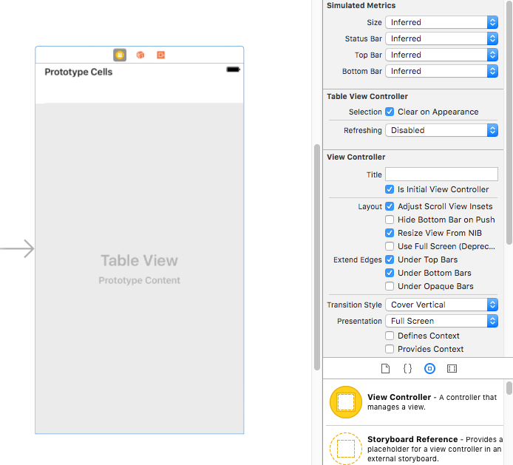

Set this new Table View controller so it is the initial view controller (look in Attributes Inspector)

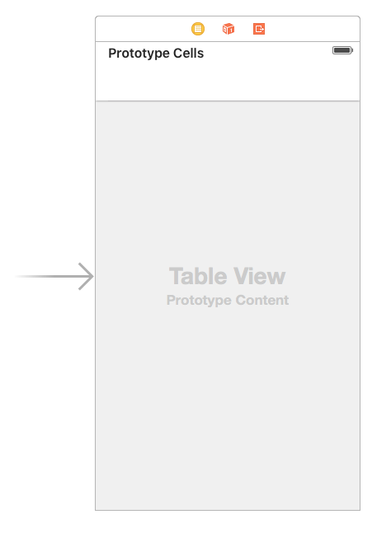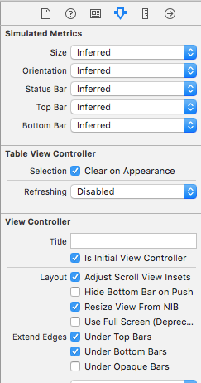
2. Create a new file – Cocoa Touch Class. We will use this to control our Table View Controller. Call it “CafeTableViewController”

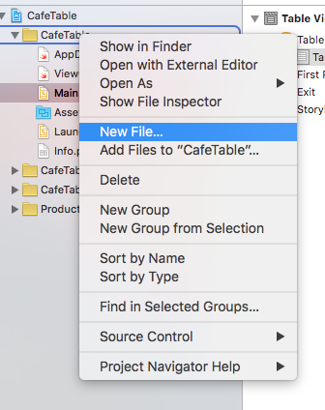

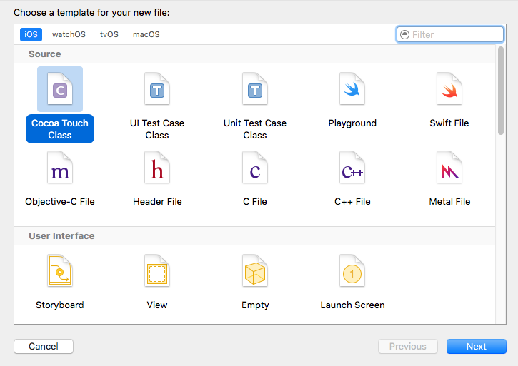

Set the subclass to be UITableViewController – our new controller will inherit the properties of the default UITableViewController (but we will also specify our own)

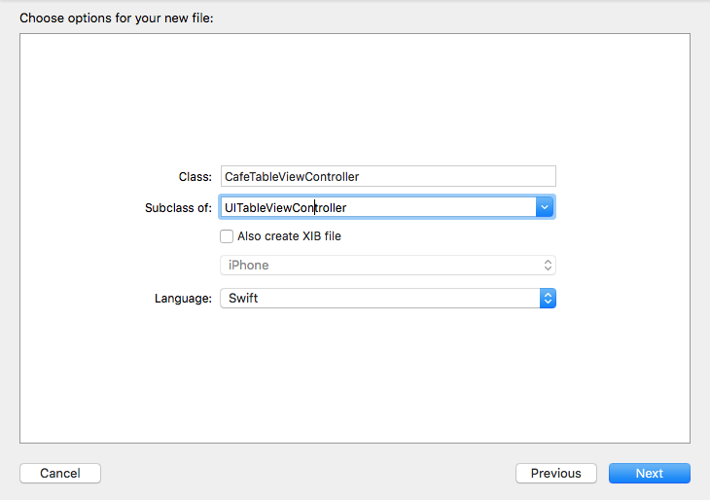

We have now got CafeTableViewController.swift file in our project.
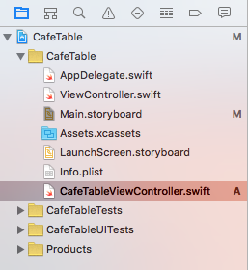

CafeTableViewController is a subclass of UITableViewController.

3. We now need to link the Table View Controller (on main.storyboard) to our CafeTableViewController class. Select the Table View on the storyboard, and then select CafeTableViewController as its class in the Identity Inspector.

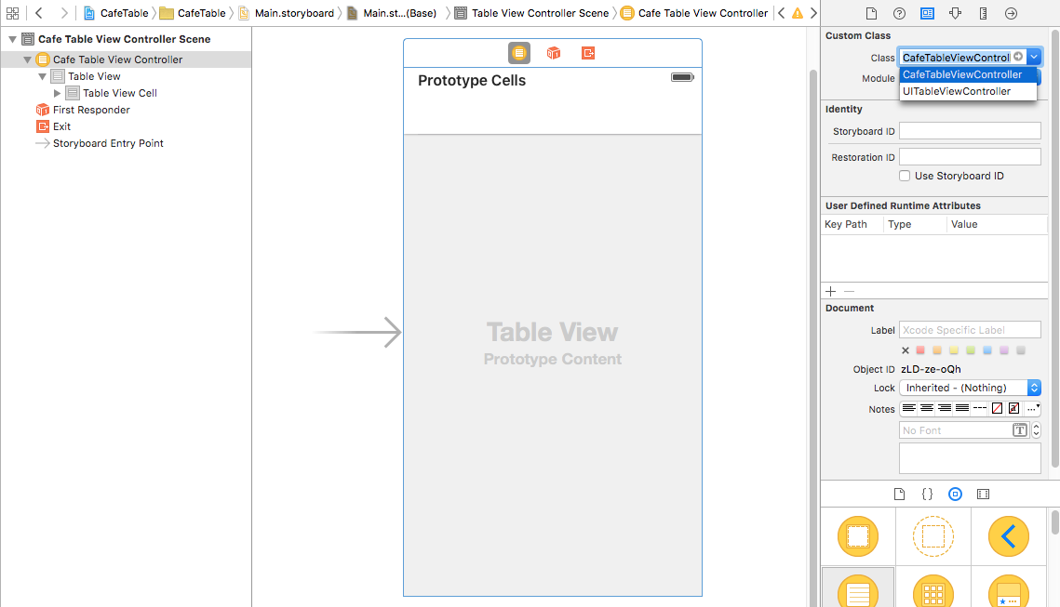

4. Select the Prototype Cell and change its style (in the Attributes Inspector) style to Basic and set Identifier as “Cell”. This will be our basic cell. (We will use the this cell's Identifier to set some custom properties shortly.)
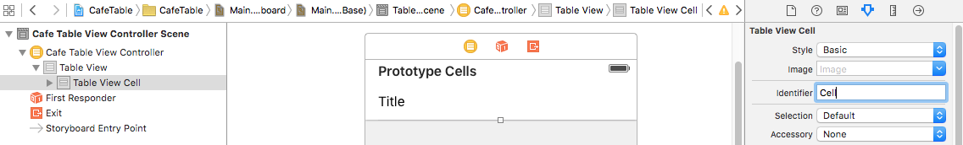

5. We would like to display some pictures with the cafes, so let’s put some pictures in our Assets folder.
Drag and drop some pictures into Assets.xcassets (set up New Image Set as required)
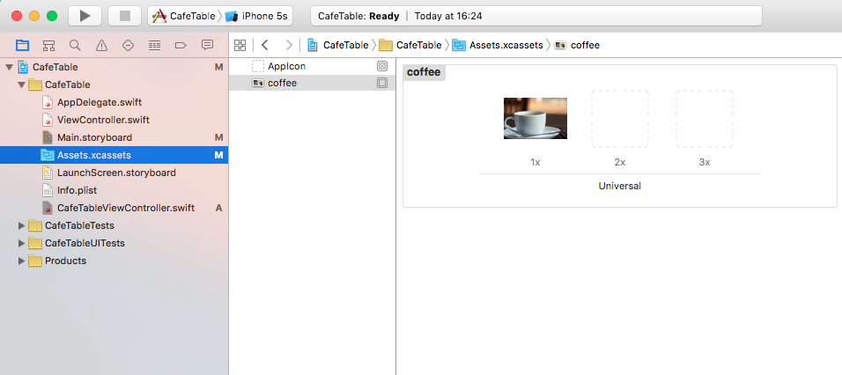
Note 1x 2x 3x – as we know, we can put different file sizes which will automatically select depending on the display being used to view the app eg low res iPhone/high res iPad
Let’s put a few different images/resolutions in:
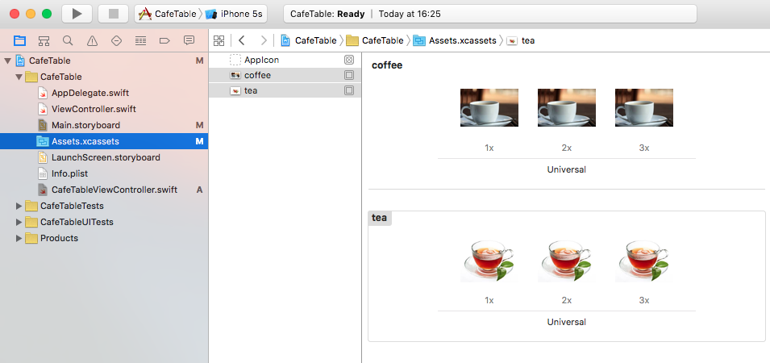

6. Now we need a list of the cafes in Swansea that we want to display.
Create an array of Cafes in CafeTableViewController.swift (called cafeNames)
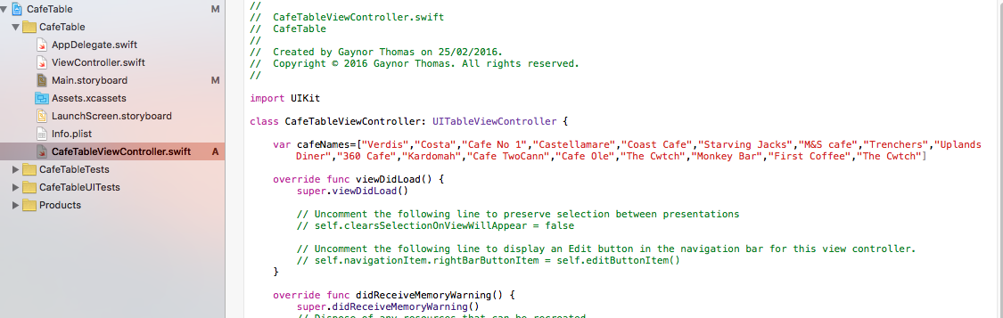

7. Although there is a default implementation for table rows and table cells (in the default UITableViewController class), we’re going to change it. This is so that a lot of memory is not wasted populating cells that are not currently on the screen. We will be putting cafes in cells and then scrolling through the m, so they will not all appear on the screen at the same time.

We are going to implement reusable cells. This means that the cells on screen are the only ones that exist. When we scroll, we will swap data in and out of these cells – this is a big saving on memory and makes our app more efficient.

Scroll down in CafeTableViewController.swift and you should see a commented out function as shown below:

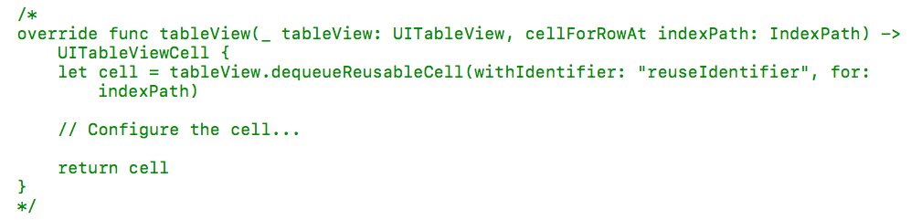

Uncomment this function. This function will implement Reusable Cells. We will link this to our Prototype Cell (we set the Identifier to "Cell" in the Attributes Inspector earlier)

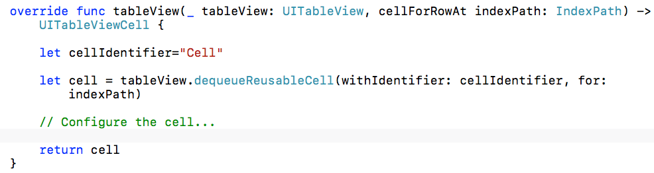
8. We will now add our data to the cell (NOTE: We are currently in Basic View for the cell, so there is only one textLabel and one imageView available)

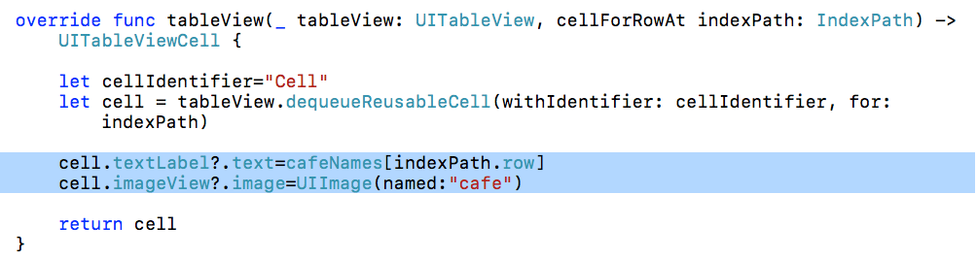

(*IMPORTANT) We also need to override the number of sections: (0 by default) Change the existing functions to have different returns:

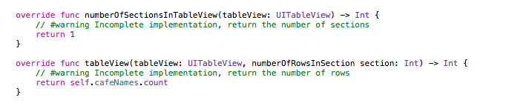

self.cafeNames.count is the number of cafes held in our array (currently 17)

9. Let’s run the program in the simulator:

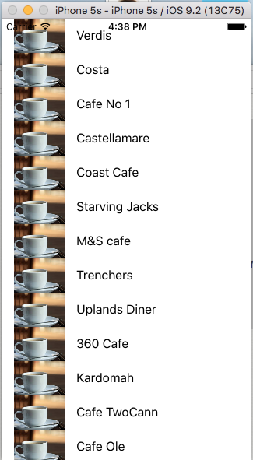

As you can see, all the cafes are listed along with a picture (albeit the same picture for all of them!)

10. Let’s make it so that each cafe has a different picture:
Add an array of pictures to CafeTableViewController.swift (these can be 17 different pictures, but I only have 2 pictures in my assets at the moment so I will reuse them a few times:

Change the imageView line in the reusable cell code function to use the array of images:

You should find that your cells are now reading the images from the array:



