

MSc Digital Transformation
for the Health and Care Professions
BMDS7005

How digitally mature is Powys Teaching Health Board’s Immunisation and Vaccination Service in delivering a person-centred digital vaccination journey?

Dissertation submitted in partial fulfilment of the award of
Master of Science in Digital Transformation for the Health and Care Professions

Catrin Elizabeth Herdman
2312284
5 May 2026

Acknowledgements

I would like to express my sincere gratitude to my supervisor for their invaluable guidance, constructive feedback, and ongoing support throughout the development of this dissertation. I am also grateful to colleagues within Powys Teaching Health Board’s Immunisation and Vaccination Service, whose contributions, participation, and shared insights were essential to the completion of this research.
I would like to thank all staff and external stakeholders who took part in the surveys and interviews, as well as those who facilitated access to data and supported my understanding of operational processes.
Finally, I extend my heartfelt thanks to my family for their encouragement, patience, and continued support throughout this journey.

Declaration

This work has not previously been accepted in substance for any degree and is not being concurrently submitted in candidature for any degree.

Signed

Date 5 May 2026

Use of Generative AI

RESEARCH | For this assessment, you can use Generative AI to support you in research, including searching for bibliography, using tools to summarise, compare and interrogate materials. | Yes ☒  No ☐
STRUCTURE | For this assessment, you can use Generative AI to support you in structuring your submission, including creating a draft argument structure, identifying parts and headings, etc. | Yes ☐  No ☒
PROOFREADING | For this assessment, you can use Generative AI to check your own text/creation for grammatical and syntactical mistakes, including rephrasing of your own work within specific standards. | Yes ☐  No ☒
WRITING | For this assessment, you can use Generative AI to create text for submission. | Yes ☐  No ☒
CREATIVE | For this assessment, you can use Generative AI to create creative materials, such as images. | Yes ☒  No ☐
PROGRAMMING | For this assessment, you can use Generative AI to create and check code. | Yes ☐  No ☒

Contents
1 Introduction 6
1.1 Project Aim and Research Objectives 7
2 Literature Review 9
2.1 Introduction 9
2.2 Study selection 9
2.3 Results of Literature Review 10
2.4 Digital Maturity Literature Review 11
2.5 Health Professional Digital Capabilities Frameworks Literature Review 15
2.6 Citizen Engagement Literature Review 17
2.7 Integrated Vaccination Record Literature Review 20
2.8 Conclusion 22
3 Methods 24
3.1 Introduction 24
3.2 Recruitment 25
3.3 Mixed Method Justification 25
3.4 Qualitative Method Justification 26
3.5 Ethics 27
3.6 Operationalisation of Digital Maturity Model 27
3.7 Conclusion 32
4 Results 33
4.1 Introduction 33
4.2 Research Objective One Results: Employees 35
4.3 Research Objective 2 Results: Process digitisation 55
4.4 Research Objective 3 Results: Citizen engagement 61
4.5 Research Objective 4 Results: Integration 71
4.6 Conclusion 75
5 Discussion 76
5.1 Introduction 76
5.2 Digital Competency 76
5.3 Process Digitisation 77
5.4 Citizen Engagement 78
5.5 Integration 79
5.6 Limitations 80
5.7 Conclusion 82
6 Conclusion 83
References 87
Appendices 92

1 Introduction

For centuries, humans have explored ways to protect each other against deadly diseases (World Health Organization, 2026). Some sources suggest practices, such as exposing healthy people to small box, were taking place as early as 200 BCE (World Health Organization, 2026). In 1885, rabies was successfully prevented through post-exposure vaccination, and in 1939, bacteriologists Pearl Kendrick and Grace Eldering demonstrate the efficacy of the pertussis (whooping cough) vaccine, reducing the rates at which children get sick from 15.1 per 100 children to 2.3 per 100 (World Health Organization, 2026). Between 1952 and 1955, Jonas Salk developed the first effective polio vaccine. By 1960, a second vaccine, developed by Albert Sabin, had been approved for use. This led to Czechoslovakia becoming the first country in the world to eliminate polio (World Health Organization, 2026).

Immunisation undoubtedly has a long history and the statement “vaccination saves lives” (Public Health Wales, 2024) has become a widely used statement in Wales, particularly after the global outbreak of coronavirus, which was officially declared as a pandemic on 11 March 2020 (World Health Organization, 2026). Eluned Morgan, First Minister of Wales, said “the COVID-19 vaccine programme is the biggest vaccination programme in NHS history; it has already saved thousands of lives” (Welsh Government, 2021). However, it is apparent this statement has become contentious with vaccine hesitancy becoming a global problem with low uptake being a “major threat” (Razai et al., 2021). Nonetheless, Public Health Wales (PHW), who are responsible for protecting and improving the health and well-being for the people of Wales, still emphasise vaccination is one of the most effective measures to safeguard our health and the well-being of children. PHW state vaccinations prevent many serious diseases and help maintain public health by reducing the spread of infections (Public Health Wales, 2024).

The coronavirus pandemic acted as a catalyst for transformative digital advancements within NHS Wales. Wales was the first, and initially only, region in the United Kingdom (UK) to create a digital vaccine management solution in response to the COVID-19 pandemic to manage, distribute and report of the COVID-19 vaccination programme (Digital Health and Care Wales, 2022). Consequently, the Welsh Government published the National Immunisation Framework (NIF) for Wales in October 2022, outlining its ambition to create a “person centred digital vaccination journey” (Government and Cymru, 2022). This strategic vision reinforces the continued prioritisation of immunisation and vaccination in Wales, whilst also highlighting the role of digital innovation in enhancing service delivery. The NIF promises to develop a “person-centred digital vaccination journey”, which is defined as an integrated vaccination record, digital consent processes, and enhanced functionality for booking, communication, and data recording (Government and Cymru, 2022). This dissertation reviews key elements of Powys Teaching Health Board (PTHB)’s Immunisation and Vaccination Service, in relation to the COVID-19 vaccination, and evaluates its delivery of a person-centred digital vaccination journey in line with the definition provided within the NIF.

1.1 Project Aim and Research Objectives

  - Project Aim
To review and evaluate how digitally mature PTHB’s Immunisation and Vaccination Service is in delivering a person-centred digital vaccination journey. A project plan was developed (Appendix A) to guide the research process and ensure that the following research objectives were achieved within the agreed MSc dissertation timeframe.

  - Research Objectives

The following research objectives have been established based on the NIF definition of a person-centred digital vaccination journey:

- Assess the digital competence of employees within PTHB’s Immunisation and Vaccination Service, including their ability to engage with digital tools.
This objective evaluates staff capability to support a person-centred digital vaccination journey. This includes exploring key elements such as awareness and use of digital systems in day-to-day service delivery.
- Evaluate the extent of process digitisation, focusing on booking systems, consent processes, communication channels, and data recording functionalities.
The objective examines the extent in which operational workflows, such as appointment booking, digital consent endorsement, communication mechanisms, and data capture, have been digitally embedded within routine internal processes.
- Explore citizen engagement mechanisms, particularly the effectiveness of digital communication in promoting vaccine uptake and how well citizens are engaged with around vaccination priorities.
The objective considers how digital platforms facilitate communication with service users, the accessibility and clarity of digital information, and the extent to which digital engagement supports uptake.
- Examine the integration and functionality of the Welsh Immunisation System (WIS) in supporting a unified and accessible digital vaccination record.
This objective focuses on how WIS contributes to an integrated digital vaccination record, assessing its usability, accessibility, and role in supporting safe, efficient, and coordinated vaccination delivery.
The definition of a person-centred digital vaccination journey provides the rationale for focusing on these four dimensions, as each objective represents an important component of delivering a digitally enabled immunisation and vaccination service. Although the digital competence of employees is not included within the NIF definition of a person-centred digital vaccination journey, wider literature recognised “successful digital transformation of health and care requires an appropriately skilled workforce” (Rimpiläinen, Bosnic and Savage, 2024). This is relevant in Wales, where the digital vaccine management solution, known as WIS, is used by employees across Health Boards, General Practice, Community Pharmacies and Public Health Wales to manage all stages of the vaccination journey (Digital Health and Care Wales, 2025). As WIS has been developed with “users at the heart of new designs”, this highlights the integral role employees across multidisciplinary settings play in managing different parts of the vaccination journey in Wales. Given this system-wide reliance on staff to operate WIS effectively (Digital Health and Care Wales, 2025), assessing how digitally competent employees are is both appropriate and necessary to meet the overall aim of the project.
The NIF identifies enhanced communication functionalities as a key component of digital service delivery. This dissertation incorporates this aspect within the scope of process digitisation but extends the analysis further by examining perceptions of how well-informed citizens are about vaccination priorities. However, collecting direct feedback from citizens will be out of scope due to time constraints. The focus of the citizen engagement evaluation is restricted to the opinions of stakeholders who play key roles in communication and engagement, such as PTHB’s internal communication and engagement team, Llais, who are an independent statutory body “give the people of Wales much more say in the planning and delivery of their health and social care services” (About Us | Llais, 2026), the Powys Association of Voluntary Organisations (PAVO), Powys County Council councillors, and Public and Patient Involvement (PPI) Groups of General Practices in Powys.

2 Literature Review

2.1 Introduction

The digital transformation of health and care began accelerating around 2016, but advanced significantly because of the COVID-19 pandemic (Morrison Ciarán et al., 2022). Digital maturity is an important consideration within this transformation, as it reflects an organisation’s ability, such as PTHB, to “digitise key tasks to better manage, predict, and sustain transformation from a clinical service and business provision perspective” (Phiri et al., 2023). Digital maturity models provide a structured means of measuring the capability and compatibility of IT systems to interface and interact both within and across organisations, which aligns with the research objectives of this project. The definition of a person-centred digital vaccination journey aligns closely with the parameters of a digital maturity framework, supporting reflection on the ability to “digitise key tasks” (Phiri et al., 2023).

Evaluation provides an opportunity for perspectives to be heard and considered, enabling stakeholders to explore whether meaningful improvement have been achieved (The Health Foundation, 2015). This dissertation therefore evaluates whether a person-centred digital vaccination journey has been achieved in Powys by exploring its digital maturity level and assessing four research objectives. To achieve this, a literature review was undertaken to examine existing research and widely used instruments across these areas, with a view to identifying those suitable for adoption in this dissertation.

2.2 Study selection
To ensure the relevance of the literature search results and reference records, clearly defined inclusion and exclusion criteria were applied. This approach enabled the dissertation to remain focused on the project’s scope and to identify sources directly aligned with the research objectives. The search strategy was developed using databases such as PubMed, alongside relevant websites, organisational publications, and citation tracking. This dissertation primarily examines the COVID-19 vaccination programme, as it acted as the catalyst for significant digital transformation within NHS Wales. Consequently, search terms were limited to literature published within the past five years. This timeframe reflects the period since the global outbreak of coronavirus was officially declared a pandemic (World Health Organization, 2026), thereby ensuring the literature reviewed is the most relevant. Other filters utilised were a requirement for the free full text document to be available within the language of English to mitigate significant exclusions during the screening phase. In line with the key dimensions of digital maturity within PTHB’s Immunisation and Vaccination Service, four separate literature reviews were conducted, each aligned with the research objectives and focused on a distinct area of digital maturity.

A summary of the search criteria for each area of interest and number of findings can be found within Table 1:

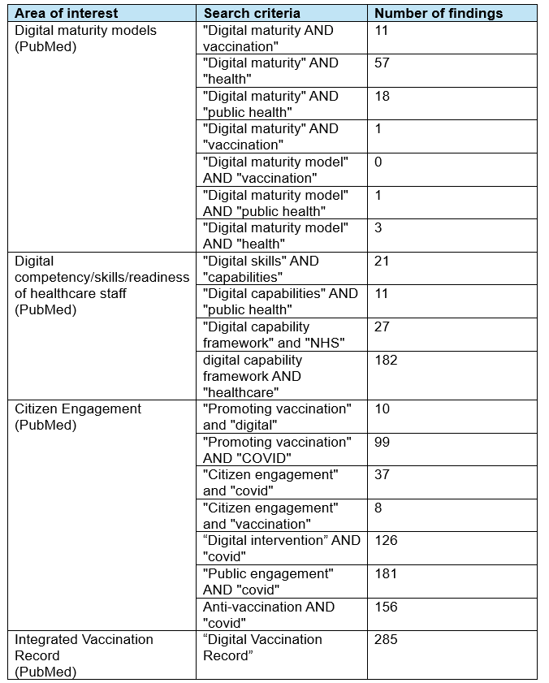
Table 1

2.3 Results of Literature Review
The search criteria yielded 1,046 records, with an additional 36 records identified through websites, organisations, and citation searching, covering the areas within scope where possible, as illustrated in the PRISMA diagram (Figure 1).
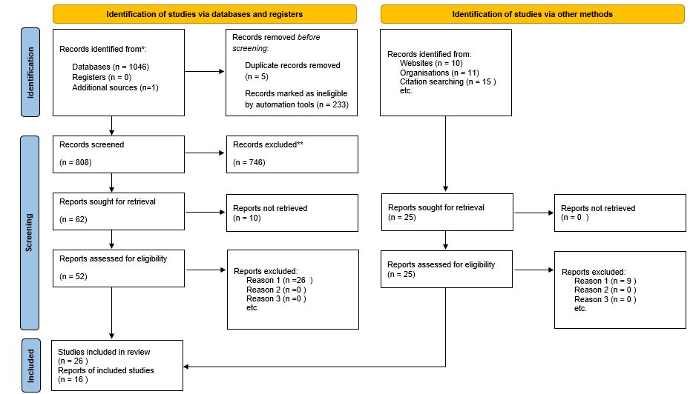
Figure 1
Process digitisation has been excluded from the literature review as this is unique to PTHB’s Immunisation and Vaccination Service and only documentation stored on the secure internal drive can be reviewed for this element of the dissertation. Nonetheless, research within the search criteria associated with digitally ready employees, citizen engagement, and an integrated vaccination record, which link with the other research objectives, was completed.

Following screening and duplication checks conducted with Mendeley Reference Manager automation tools, 833 records, including those identified through supplementary methods, met the inclusion criteria, as summarised in Table 1. Screened records which were irrelevant to the area of interest were immediately excluded. 22 reports were deemed eligible for digital maturity models, 10 for healthcare staff digital competency/skills/readiness, 23 for citizen engagement, and 22 for integrated vaccination records.

2.4 Digital Maturity Literature Review

One of the most widely used assessment tools is the Electronic Medical Record Adoption Model (EMRAM) (Van Poelgeest et al., 2017) developed by the Healthcare Information and Management Systems Society (HIMSS), a US-based organisation (Phiri et al., 2023). EMRAM provides a structured, stage-based framework for hospitals to measure digital health adoption, particularly focusing on electronic medical record systems. While widely used, EMRAM’s hospital-centric focus limits transferability to public health services, such as PTHB’s Immunisation and Vaccination Service.

The Digital Health Indicator (DHI), also developed by HIMSS, evaluates digital capability using outcome-focused metrics (Woods, Eden, Pearce, et al., 2022). Its focus on workforce, citizen engagement, and infrastructure aligns with three of the four research objectives, as Figure 2 demonstrates. However, the DHI extends to advanced digital innovations including analytics, AI, robotics, Internet of Things (IoT), and virtual reality, which does not align to the context of the public health service being evaluated.

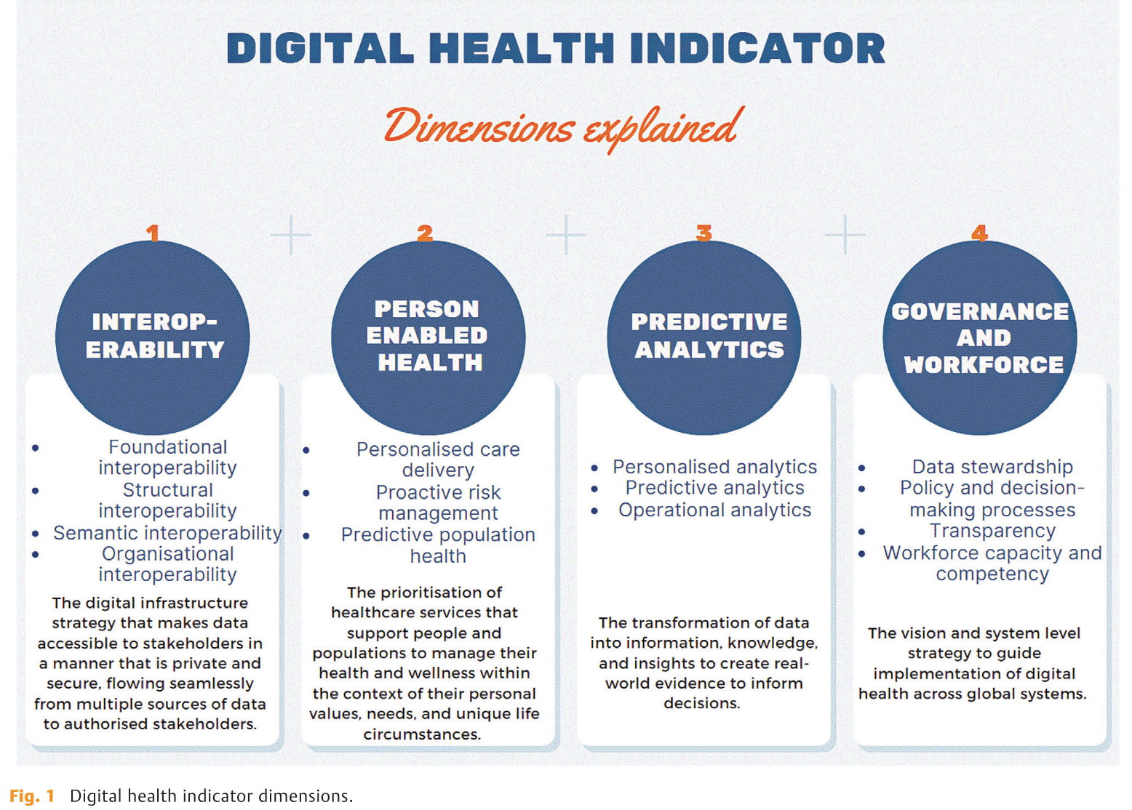
Figure 2

Within the UK context, NHS England has developed its own Digital Maturity Assessment (DMA), combining EMRAM components with additional measures of infrastructure, interoperability, and readiness (National Audit Office, 2020). While the DMA is promoted by NHS England to help providers and integrated care systems across England understand their level of digital maturity (NHS England, 2023), it largely overlooks human factors, such as employee digital competencies and citizen engagement, which are required for this dissertation.

The literature review demonstrates a range of digital maturity models, yet selecting an appropriate model for a given context remains challenging (Woods, Eden, Duncan, et al., 2022). Evidence-based methods to benchmark and assess model quality are limited, and large-scale evaluation of digital maturity across public health organisations is also limited (Woods, Eden, Pearce, et al., 2022).

However, systematic reviews of 27 unique maturity models highlight some correspondence to the research objectives of this dissertation, namely:
- People, Skills, & Behaviours
- Patient-centred care
- IT capability
- Interoperability
(Woods, Eden, Duncan, et al., 2022)

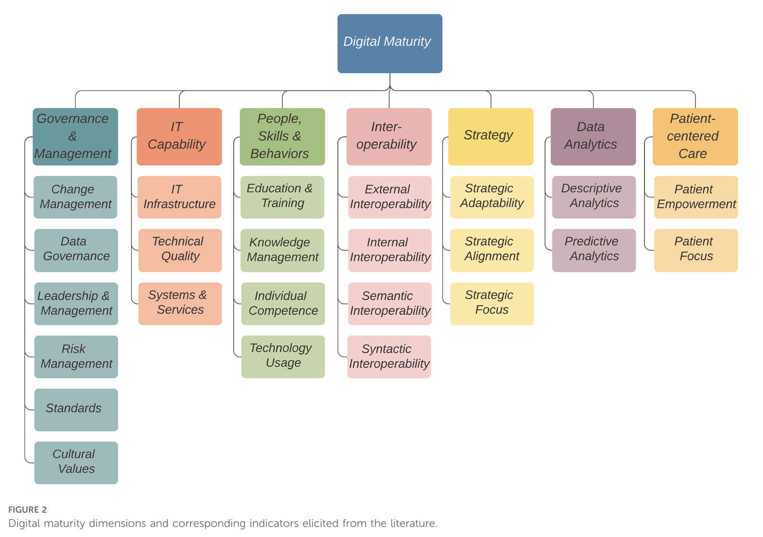
Figure 3

Figure 3 (Woods, Eden, Duncan, et al., 2022) summarizes all the dimensions of digital maturity from its findings.

Currently, no digital maturity model has been developed specifically for Immunisation and Vaccination Services. While EMRAM and the DHI are widely used approaches, they are either hospital-centric or overly focused on advanced technologies, beyond the scope of this research. Similarly, NHS England’s DMA, though contextually somewhat relevant, excludes key human and citizen-centred factors.

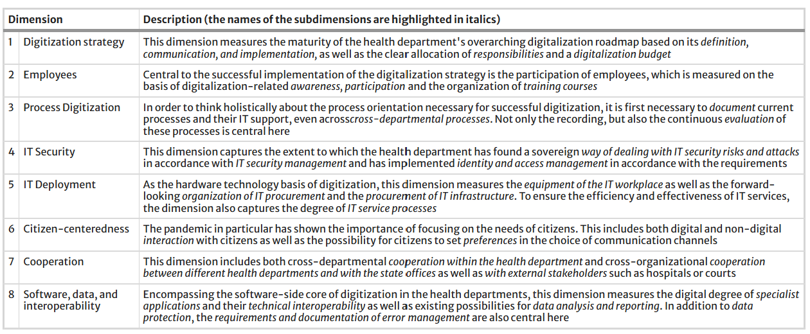
However, reviewing further literature discovered the German Health Authorities’ model. This maturity model, specifically for the digitisation of health offices, was developed between January 2021 and February 2022 and was funded by the German Federal Ministry of Health (Eymann et al., 2023). It has been applied since the beginning of 2022 with the aim of strengthening the digitisation of its Public Health Service (Eymann et al., 2023). This digital maturity model therefore offers a comprehensive public health-oriented framework, encompassing dimensions relevant to both technical infrastructure and human factors. These findings make it an arguably suitable and adaptable model for evaluating the digital maturity of PTHB’s Immunisation and Vaccination Service, as it allows alignment with the four research objectives of this dissertation:
Table 2
The German Health Authorities’ digital maturity model employs a five-level scale, where Grade 0 indicates a low level of digital maturity and Grade 4 represents a high level. To attain a specific level within a dimension or sub-dimension, at least 80% of the criteria for the level must be met. A criterion is considered met when it is answered as “applies” (Eymann et al., 2023). While locating detailed documentation to guide consistent application of this scoring scale has been challenging, it is possible to adapt this methodology for the research objectives of this dissertation, utilising the 80% benchmark and the “applies” rule. Further detail is provided in the Methods Chapter of this dissertation.

In conclusion, this review highlights the strengths and limitations of existing digital maturity models and justifies the adaptation of the German Public Health model for this dissertation. By focusing on the four research objectives, this approach ensures this dissertation utilises a robust framework for evaluating how digitally mature PTHB’s Immunisation and Vaccination Service is.

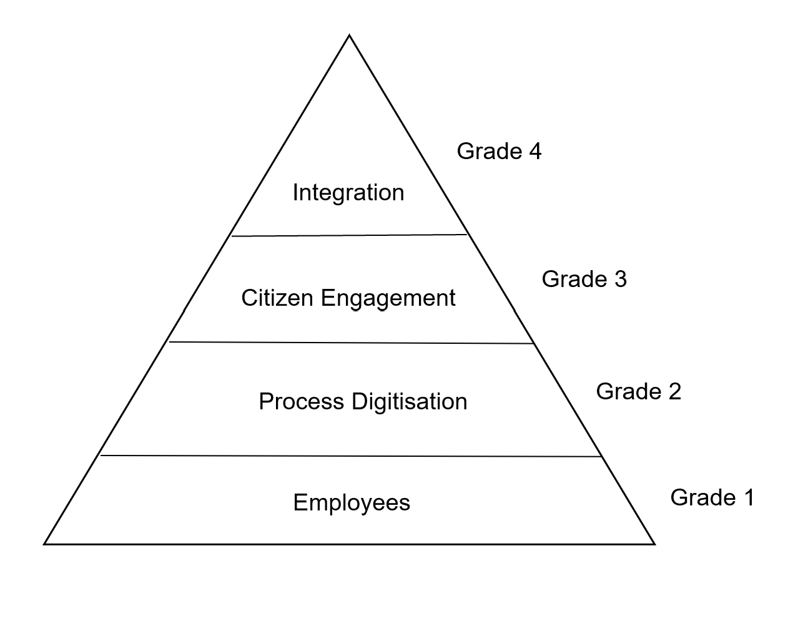
Figure 4

2.5 Health Professional Digital Capabilities Frameworks Literature Review

Digital technologies are becoming increasingly embedded in everyday life, and health services are no exception. There is often an assumption all healthcare professionals acquire the digital confidence and familiarity required to use technology effectively in their roles (Rimpiläinen, Bosnic and Savage Jamie, 2024). However, this assumption rarely reflects the reality of frontline practice. The Chief Executive Officer of the Digital Health & Care Innovation Centre emphasises healthcare workers must be supported to develop the digital skills required not only for their own efficiency but also to improve patient experience and support colleagues (Rimpiläinen, Bosnic and Savage Jamie, 2024). This underscores a growing recognition that digital capability is a fundamental component of professional competence rather than an optional skillset.

The literature indicates health systems around the world have acknowledged this need and are investing in digital capability frameworks to guide, structure, and support skill development among healthcare staff. The international review conducted in 2022 identified a surge in published frameworks designed to assess digital working, mirroring the broader rise in digital maturity models for organisations. The review screened 189 resources relating to terms such as digital literacy, digital competence, digital capability and digital skills, reflecting what the authors describe as a “messy domain” characterised by conceptual overlap, unclear boundaries, and a lack of standardised terminology (Rimpiläinen, Bosnic and Savage Jamie, 2024). The scale of the field is evident in the fact a simple Google search in 2023 for “digital health and skills” found nearly one billion results (Rimpiläinen, Bosnic and Savage Jamie, 2024).
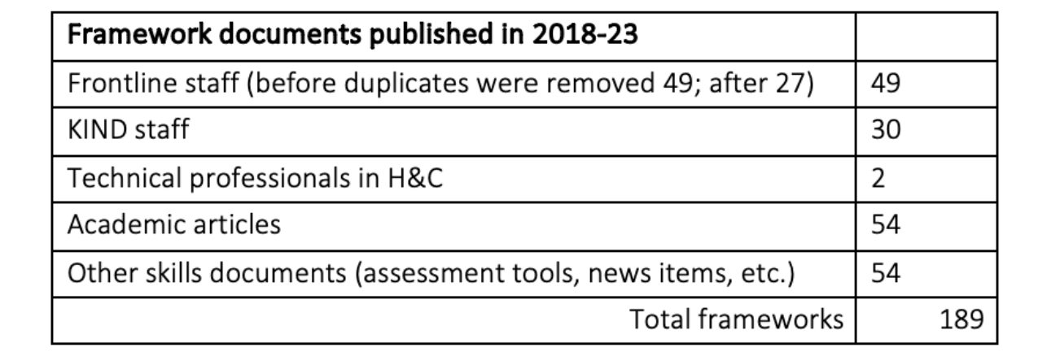
Table 3

Within this fragmented landscape, the UK stood out with 17 identified frameworks, 14 of which were directly targeted at health and care professionals, including frontline staff. However, the review also observed although “digital skills” is the most used phrase in everyday practice, none of the identified frameworks used this term in their title. For the purposes of this dissertation, the distinction between digital literacy and digital competency is particularly important. Digital literacy is typically defined as “the ability to use and understand digital technology and information to effectively participate in society” (Rimpiläinen, Bosnic and Savage Jamie, 2024). While this captures general population-level capabilities, it does not fully address digital behaviours required within a health service context. One objective of this dissertation includes assessing the competence and ability of staff within PTHB’s Immunisation and Vaccination Service to use operational digital tools integral to service delivery and a person-centred digital vaccination journey. This arguably aligns more closely with the concept of digital competency, defined as “having sufficient skills and capability to be efficient with digital processes and devices” (Ala-Mutka, 2011). Digital competency frameworks therefore offer more relevance for evaluating the functional, task-based, and role-specific skills required for delivering a digital vaccination journey.
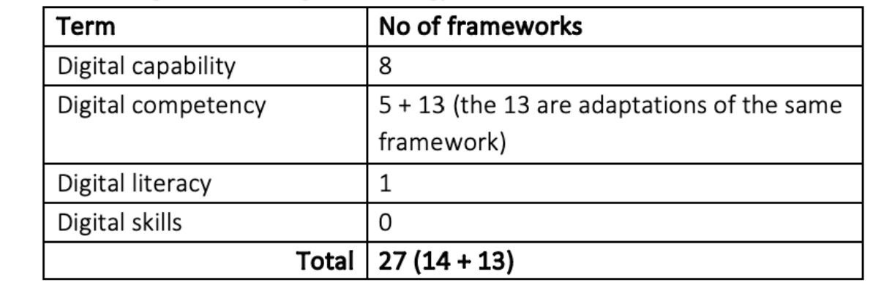
Table 4
From a Welsh perspective, Health Education and Improvement Wales (HEIW) developed the Digital Capability Framework for Healthcare in Wales, which provides a structured self-assessment tool to identify learning needs and guide training opportunities (Health Education and Improvement Wales, 2023). While the Welsh framework is highly relevant to Research Objective One, particularly due to its emphasis on Using Technology, its length of 54 questions exceeds what is feasible within the scope of this dissertation and presents a risk of reduced staff engagement due to survey burden.

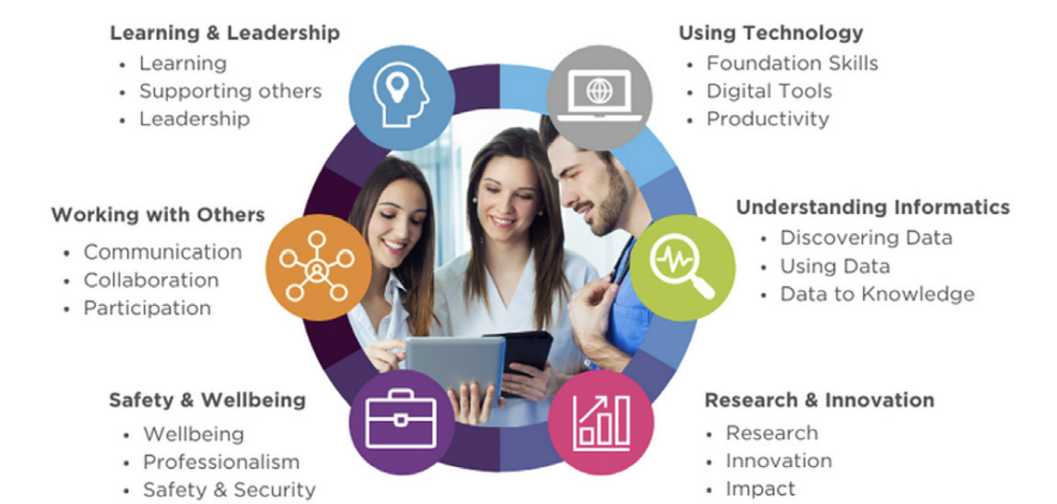
Figure 3
In summary, the literature demonstrates both the complexity and importance of digital capability in healthcare. The number of international frameworks discovered as part of this review underscores the urgent need to equip health professionals with the skills necessary to function effectively within increasingly digitalised services. For the evaluation of PTHB’s Immunisation and Vaccination Service, digital competency frameworks, rather than digital literacy models, provide the most appropriate foundation for assessing staff digital competence within a digitally enabled vaccination programme, informing the careful design of the survey.

2.6 Citizen Engagement Literature Review

The COVID-19 pandemic caused unprecedented health and economic disruption worldwide, affecting nearly all countries (World Health Organization, 2020). Public engagement relies heavily on trust and transparency, which are essential for securing sustained cooperation during health emergencies such as the COVID-19 pandemic (Bhatia, 2020). Existing literature has demonstrated technology-driven interventions were prioritised for engagement and communication purposes to achieve this (Bhatia, 2020). The pandemic thus accelerated the use of social media and digital technologies for its public health communication. Research shows these platforms played a central role in disseminating information and supporting vaccination campaigns, especially during the height of the pandemic (Zang et al., 2023). Information about vaccination throughout the pandemic was disseminated through multiple channels, including television, radio, social media, and community networks, illustrating the breadth of COVID-19 digital communication strategies (Pennisi, Genovese and Gianfredi, 2024).

COVID-19 information is accessible on the PTHB website where citizens can find details about the vaccine, the eligibility criteria, how citizens will receive their invitation and why people need the vaccine (Powys Teaching Health Board, 2024). Further information on the COVID-19 vaccination can be found on the PHW website (Public Health Wales, no date b) where citizens can also access leaflets. To support with citizen engagement, primary care providers have also facilitated solutions which align with local preferences and needs (Ratzan et al., 2021). In Powys, there are 16 General Practitioner (GP) practices (NHS 111 Wales, 2025), and following a review of each GP Practice website in Powys during November 2025, the following discoveries were found:

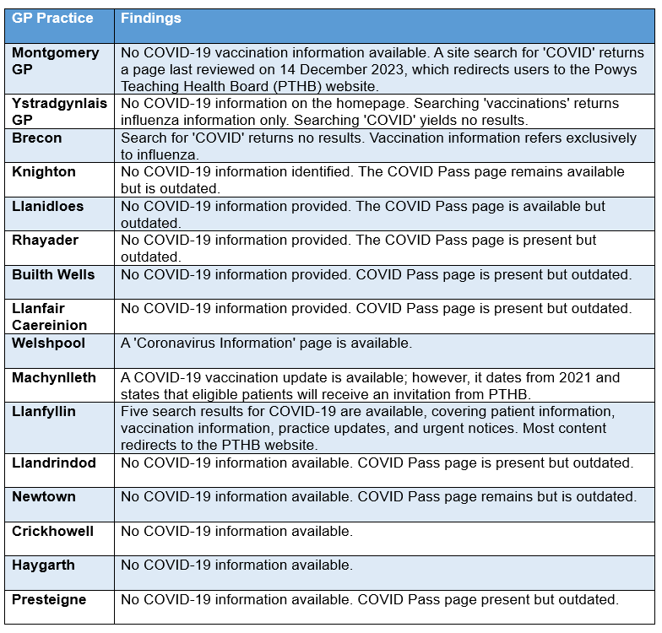
Table 5

These findings illustrate how widely utilised websites are for public health communication in 2025. Powys GP practices provide very limited vaccination information, despite the ongoing need to promote vaccine uptake for COVID-19 and other preventable diseases (Pennisi, Genovese and Gianfredi, 2024). Moreso, the establishment of collaborative relationships with local community leaders, such as primary care providers, has proven to be an effective strategy for enhancing access to and uptake of the COVID-19 (Scott et al., 2021). This highlights the importance of ensuring GP websites are kept up to date, as although the public health emergency of international concern for COVID-10 officially ended in May 2023 (Sarker et al., 2023), COVID-19 is still considered a very infectious respiratory disease and there are still two annual campaigns which take place annually in Wales (Powys Teaching Health Board, 2025b). Eligibility is for those at greater risk from the disease, including:

- People aged 75 and older
- Residents in care homes for older people; and
- Anyone aged six months and over who has a weakened immune system
(Powys Teaching Health Board, 2025b).

Unlike the early stages of the pandemic, when broadcast television dominated public attention, with average viewing time reaching 3.5 hours per person in December 2020 (Ofcom, 2020) and the Prime Minister’s announcement on 10 May 2020 becoming the most-watched programme of the year, public engagement with pandemic-related information has arguably declined. Powys GP website content validates this statement to some extent, although no comparison can be made with content on the website during the pandemic. This shift signals a reduced reliance on traditional mass media for health communication and raises concerns about the effectiveness of current strategies to sustain public awareness and compliance.

Further literature highlights public health engagement now faces compounded challenges, including restoring trust, addressing misinformation, and overcoming vaccine hesitancy (Pennisi, Genovese and Gianfredi, 2024). These issues have potentially diluted confidence in vaccines and influenced citizen perceptions and engagement. Information sources on social media played major roles in impacting individuals’ behaviours during the COVID-19 pandemic, including vaccination intention. Social media could be considered a “double-edged sword” leading to the dark side of social media usage, such as information overload, making it difficult for people to verify every single piece of information they saw and read (Honora, Wang and Chih, 2022).

The phrase ‘Vaccinations save lives’ is widely used to emphasise the benefits of immunisation (Pennisi, Genovese and Gianfredi, 2024). In May 2024, the World Health Organization reported global immunisation efforts over the past 50 years have saved approximately 154 million lives, equivalent to six lives every minute (Pavia et al., 2024a). However, it is apparent this statement has become contentious as a study conducted in 2021 showed the percentage of people willing to be vaccinated against COVID-19 in 79 of 117 countries were less than 70%, which made it very challenging to achieve herd immunity and elimination of COVID-19 outbreaks (Honora, Wang and Chih, 2022). Approximately 30 million doses were provided in 2021, which decreased to around 199,000 doses by May 2023 (European Centre for Disease Prevention and Control, 2023). It is therefore important to explore technology-driven interventions and the role they have played in vaccine hesitancy, as unlike other pandemics, the one significant and rapid change encountered during the COVID-19 pandemic is the use of digital media (Honora, Wang and Chih, 2022).

In addition to this, anti-vaccine activists, have used traditional communication methods, in addition to social media, to amplify vaccine-related mistruths about COVID-19 vaccines. These efforts arguably contributed to COVID-19 vaccine hesitancy (Carpiano et al., 2023). Before the pandemic, anti-vaccine messages focused on health concerns such as claims vaccines cause autism. Over time, these shifted toward arguments about personal freedom, medical choice, and parental rights (Carpiano et al., 2023). However, COVID-19 vaccine trails gave anti-vaccine activists opportunities to discredit the vaccine development and call the trials into question, spreading doubt among citizens less familiar with the process. During national vaccination rollouts, they highlighted stories of unsupported side-effects, conspiracy theories, and worked to undermine public confidence in vaccine safety. Using social media, they used sensationalism, outrage, and controversy as effective tools for generating audience attention and growing, engaging, or monetising a following. Key leaders such as politicians, wellness influencers, sport figures, celebrities, and even clinicians, scientists, and academics took visible roles in arguing the health-freedom perspective, while often spreading false and misleading claims about COVID-19 vaccine efficacy or safety using social media, accessible to citizens in Wales and Powys too.

With this context in mind, this literature review is particularly relevant to assessing the effectiveness of digital communication strategies in promoting vaccine uptake and to examining whether these approaches and perspectives align with those of local citizens.

2.7 Integrated Vaccination Record Literature Review

With the breakout of the COVID-19 pandemic, various digital tools which facilitate accessibility, efficiency, and effectiveness across healthcare systems toward vaccination programmes was implemented (Pavia et al., 2024) and the pandemic acted as a practical ground for the application of new digital health solutions. An increase in the implementation of Electronic Health Records (EHRs), “a source of real-world data” (Pavia et al., 2024), and advancements such as interoperability standards and integration with public health databases, has enabled seamless data sharing across healthcare systems. In Wales, there are several computing applications and online services to improve the everyday experiences of citizens and health and social care workforce in Wales, including (please note this may not be an exhaustive list):
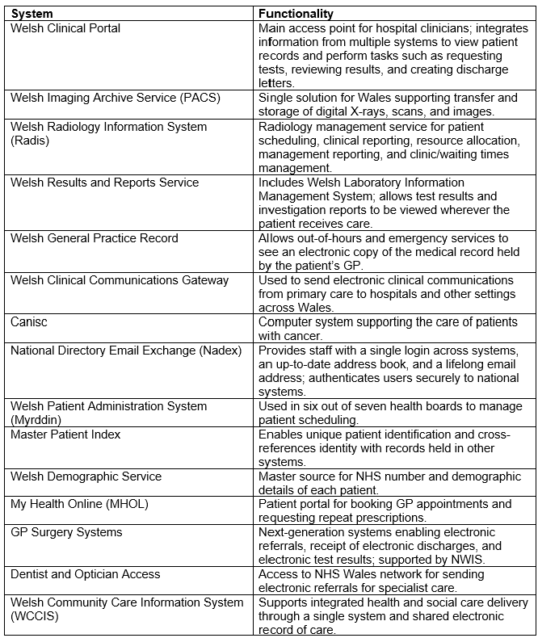
Table 6 (Informed Health and Care, 2015)
Immunisation Information Systems (IIS) are essential for safe and effective immunisation programmes (Brooks et al., 2024). Literature has confirmed several countries took a range of development approaches to immunisation systems, which presented challenging demands, with some countries adapting existing systems to be fit for purpose, whilst others implemented new ones (Brooks et al., 2024). During 2024, 188 of 194 WHO Member States took part in a questionnaire, with 155 responses to Immunisation information system IIS-related questions. Of the countries responded, more than 85% reported having all seven IIS functions in place for COVID-19 vaccines (Brooks et al., 2024).

From a Welsh perspective, WIS was developed and launched on 7 December 2020, just one day before the first COVID-19 vaccination was administered in Wales (Digital Health and Care Wales, 2025). WIS enabled regular and reliable reporting of vaccination figures every three hours to health boards, Public Health Wales, and Welsh Government, supporting rapid decision-making and accurate monitoring of vaccine uptake. The system stores patient demographic information, identifies who is eligible for vaccination, schedules appointments, creates letters for bookings and cancellations, records consultation results and vaccine details, and allows healthcare staff to enter data during service delivery (Digital Health and Care Wales, 2025). Within months of its implementation, Wales achieved one of the most successful vaccination campaigns globally (Digital Health and Care Wales, 2025).

NHS England similarly created RAVS, the Record and Vaccination Service, allowing healthcare professionals to record vaccinations, including COVID-19, more efficiently and effectively (Record a vaccination service - NHS England Digital, 2026). Community pharmacies can onboard RAVS, as well as hospital hubs, vaccination centres and Primary Care Networks (PCNs) (NHS England Digital, 2026b). Public Health Scotland have likewise implemented their Vaccine Management Tool, a web-based application allowing health and social care staff to record patient vaccination data at the point of care (Public Health Scotland, 2021). Ireland uses COVAX as its national electronic system for recording COVID-19 vaccinations. However, a fully integrated immunisation database for all vaccines is not yet in place, as the Schools Immunisation System operates alongside COVAX. According to the National Immunisation Office Strategic Plan (2024–2027), work on developing a comprehensive National Immunisation Information System is now underway, with COVAX serving as its foundation (Health Service Executive, 2024).

With the launch of WIS 2.0 during 2025, integration advancements mean the Welsh system can deliver data to the National Data Resource (NDR) and Clinical Data Repository (CDR), allowing it to be interoperable with other clinical systems. From September 2025, every vaccinator in Wales, including in GP surgeries, community pharmacies and health board vaccination centres, will use WIS to record vaccination administration (Digital Health and Care Wales, 2025). The enhanced WIS combines up-to-date demographic information with primary care data on risk factors to provide a secure, national view of vaccine eligibility across Wales. A colleague at Digital Health and Care Wales, said “WIS 2.0 gives Wales a single, modern immunisation system teams can trust at the point of care and at national scale. It is built around recognised standards, real-time data and practical workflows, so clinicians can spend more time with people and less time wrestling systems” (Digital Health and Care Wales, 2025).

In summary, this review highlights while Wales is making significant progress toward an integrated vaccination record as part of its person-centred digital vaccination journey, similar advancements are occurring across the UK and globally, reflecting a wider shift toward interoperable and accessible immunisation systems.

2.8 Conclusion

To conclude, this four-part literature review provides a comprehensive foundation for this dissertation by identifying widely used instruments and existing frameworks which can be adapted to evaluate the digital maturity of PTHB’s Immunisation and Vaccination Service in delivering a person-centred digital vaccination journey. While digital maturity models are widely implemented internationally, this review confirms the absence of a model specifically designed for Immunisation and Vaccination Services. In response, the German public health maturity model encompassing both technical infrastructure and human factors emerges as the most relevant and adaptable option for this dissertation, offering a suitable basis for assessing the digital maturity of PTHB’s Immunisation and Vaccination Service in delivering a person-centred digital vaccination journey.

Aligned with the first research objective, the literature identifies digital competency as a critical factor in assessing whether PTHB staff are sufficiently equipped to deliver a person-centred digital vaccination journey in Powys. For a digital vaccination journey to incorporate integrated vaccination records, digital consent processes, and enhanced booking and communication functionality, it is essential that staff feel confident in both their knowledge and use of the relevant systems and applications. Staff digital competency therefore represents a key consideration in assessing the service’s level of digital maturity.

While citizen engagement is not explicitly included in the NIF definition of a person-centred digital vaccination journey, this review confirms its importance. Evidence from the COVID-19 pandemic underscores the role of technology-driven interventions, particularly social media, in influencing vaccine uptake and shaping communication strategies. Citizen engagement therefore must be considered a key component of a person-centred digital vaccination journey as engagement and communication plays a big role in influencing uptake of the vaccine. It is thus important this dissertation explores mechanisms for effective engagement in Powys, including the impact of digital communication on uptake and alignment with citizens’ needs.

Finally, this review reinforces the pivotal role of Immunisation Information Systems in enabling integrated, data-driven vaccination strategies. WIS stands as the backbone of Wales’ digital vaccination ambition, underpinning the delivery of a unified, person-centred approach. Its integration capabilities must therefore be explored in further detail to help determine how digitally mature the entire vaccination journey in Powys really is.

3 Methods

3.1 Introduction

The literature review indicates that assessing the digital maturity of PTHB’s Immunisation and Vaccination Service requires drawing on established instruments and frameworks, appropriately adapted to align with the research objectives of this dissertation. This chapter outlines the research methods selected to address these objectives. As highlighted in the literature review, evaluating digital maturity requires consideration of multiple interrelated dimensions. For the purposes of this dissertation, these dimensions include employees, process digitisation, citizen engagement, and integration. Previous chapters have justified the inclusion of these areas, as they are directly linked to the concept of a person-centred digital vaccination journey that Wales seeks to achieve, and are consistent with established digital maturity models. Of the frameworks reviewed, the German Health Authorities’ Digital Maturity Model was identified as the closest fit to the scope of this dissertation, given its strong alignment with public health principles and its applicability to service-level digital maturity assessment.

The evaluation of PTHB’s digital maturity level, in respect of delivering a person-centred digital vaccination journey, therefore requires a combination of quantitative and qualitative methodologies, also known as mixed methods, which takes advantage of both strategies (Friedman, Wyatt and Ash, 2022) and is considered applicable to social and health disciplines (Creswell and Plano Clark, 2011). Mixed methods offer many advantages over a single method from a scientific perspective (Friedman, Wyatt and Ash, 2022), especially surveys to understand the views of the participants (Creswell & Plano Clark, 2011). However, mixed methods is not always the best method for every research objective (Creswell and Plano Clark, 2011), and as this chapter will clarify, some areas require the use of qualitative methods only.

In line with this approach, the evaluation of PTHB’s Immunisation and Vaccination Service utilises the German Health Authorities’ Digital Maturity Model as the overarching framework. Digital competency of employees, extent of process digitisation, digital citizen engagement and communication initiatives, and the integration and functionality of the Welsh Immunisation System (WIS) in supporting a digital vaccination record are explored using the methods outlined below:

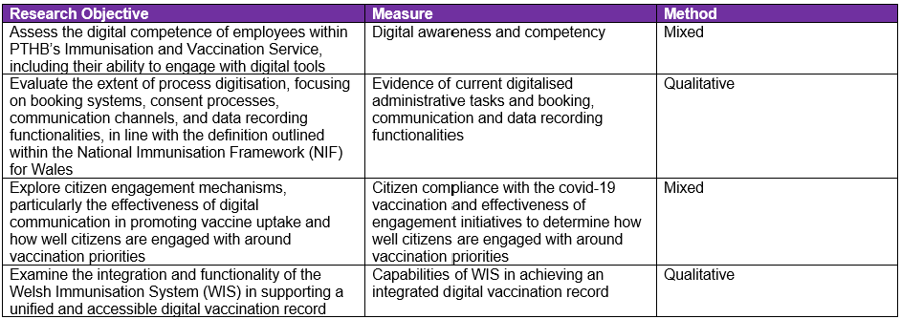
Table 7
This chapter details the rationale for method selection and describes the data collection, analysis and interpretation processes for each research objective.

3.2 Recruitment

Participants were recruited to complete surveys as part of the mixed-method approach outlined above. Recruitment for the digital competency survey focused on individuals working within PTHB’s Immunisation and Vaccination Service. Participants included both clinical and administrative staff, all of whom played an active role in the delivery and coordination of the Immunisation and Vaccination Service in Powys. The citizen engagement survey targeted those involved in supporting citizens with vaccination priorities. Citizen or patient involvement was deemed out of scope for this evaluation due to its focus on employees and stakeholders, operational processes, and integration capabilities rather than direct user feedback. As such, the surveys were designed to gather insights from staff whose roles directly influence or support vaccination delivery in Powys.

3.3 Mixed Method Justification

Two surveys were developed using Microsoft Forms (Appendices B and C). Appendix B assesses the digital awareness and competency of staff within the Immunisation and Vaccination Service, while Appendix C evaluates stakeholder perceptions of how effectively citizens are engaged with regarding vaccination priorities. Both surveys adopt a mixed methods approach by combining quantitative data to identify patterns and relationships among variables with qualitative data from free-text responses to provide richer insights and contextual understanding. The voices of the participants would not be directly heard in quantitative research (Creswell and Plano Clark, 2011), and as employees and citizens are the focus of two research objectives, it is important to ensure there are opportunities to strengthen the weaknesses quantitative research alone poses.

These surveys therefore collect, analyse and mix both quantitative and qualitative data in a single study (Creswell and Plano Clark, 2011). Analysis methods will include predominantly descriptive statistics to summarise the general nature of the data obtained (Leedy, 2020). These analyses will provide contextual insight into factors that may influence digital competence. As part of the citizen engagement evaluation, quantitative survey data will be considered alongside qualitative responses to explore attitudes toward information access, communication preferences, trust, and perceived effectiveness of communication, areas which arose within the literature review. This comparative analysis aims to identify themes that may have implications for future engagement and communication strategies within vaccination programmes. It was originally intended this dissertation would also analyse vaccination uptake by geographic area; however, this was not possible. Uptake figures at this level are not available for use outside official Public Health Wales reporting and therefore cannot be accessed or used for research purposes within this study. Similarly, it was hoped Short Message Service (SMS) delivery reports from GOV.UK Notify could be analysed for citizens with a registered mobile phone number; however, Digital Health and Care Wales (DHCW) confirmed this information cannot be shared for research purposes as it contains sensitive and confidential data, including personal mobile numbers.

Appendix B aligns with the ‘employees’ dimension of the chosen digital maturity model. A copy of this survey was shared with peers of the course for review, however, no suggested amendments for improvement were received. The survey was circulated via my student email address rather than my PTHB work account and remained open for a three-week period to 55 staff members. Only three members of staff was absent from work at the time the survey was circulated and was not due to return before the survey closed. It is acknowledged distributing the survey within my own department introduces a potential source of bias due to existing professional relationships. However, this risk was mitigated by ensuring participation was entirely anonymous, thereby reducing the likelihood respondents would feel identifiable or influenced in their responses.

Appendix C focuses on citizen engagement, particularly the effectiveness of communication mechanisms in promoting vaccine uptake and the extent to which citizens feel informed and involved in vaccination priorities. Citizen-centeredness is another dimension of the chosen digital maturity model. This survey aims to assess digital accessibility, inclusivity, effectiveness, trust, and collaboration, providing insight into how well Powys is utilising digital tools to inform and engage citizens and whether a truly person-centred digital vaccination journey is being delivered. The survey was circulated to four PPI Groups in Powys, Llais, Powys Association of Voluntary Organisations, one GP Patient Participation Group and three colleagues within the Communications and Engagement Department of PTHB. It was also recommended by the PTHB Communications and Engagement Department the survey be shared for inclusion in the Powys councillors’ bulletin. The survey was also circulated via email and was open for a three-week period.

3.4 Qualitative Method Justification

It is important to note “not all situations justify the use of mixed methods” (Creswell and Plano Clark, 2011). “There are times when qualitative research may be best” (Creswell and Plano Clark, 2011); therefore, a qualitative approach was adopted for the process digitisation and system integration objectives. These objectives required the collection of in-depth insights through observations, interviews, and document analysis. This approach enables a deeper understanding of the digital maturity of internal processes within PTHB, as well as the robustness of integration capabilities within WIS. It was therefore considered the most appropriate methodology for evaluating and examining these research objectives. Accordingly, the analysis methods comprised a review of relevant documentation, the graphical representation of operational processes using Business Process Model and Notation (BPMN) (Standards Development Organization, 2026), and the analysis of interview data.

3.5 Ethics

Prior to data collection, ethical and information governance considerations was addressed, and ethical approval was obtained (Appendix D). Participation in the study was entirely voluntary. No patient data was collected, and all participants were anonymised to ensure individual responses could not be identified. Data was collected and processed in accordance with GDPR requirements and the Data Protection Act (2018). All data was stored securely on a password-protected personal SharePoint area, accessible only to the researcher through the University of Trinity Saint David’s secure login system. Data will be retained only for the duration necessary to complete this project and will then be permanently deleted. These measures were implemented to ensure confidentiality, minimise risk, and maintain compliance with ethical and data governance standards.

3.6 Operationalisation of Digital Maturity Model

The chosen methodologies are transferable to the digital maturity model selected to determine how digitally mature PTHB’s Immunisation and Vaccination Service is in delivering a person-centred digital vaccination journey. In line with this, a scoring matrix was developed to operationalise the requirement at least 80% of the criteria for a given level must be met, as specified in the chosen digital maturity model (Eymann et al., 2023). The 80% threshold was selected as it provides some flexibility while still ensuring the proportion of criteria required is high enough to avoid overstating the service’s digital capability. Other digital maturity models, such as HIMSS EMRAM, similarly require 90% of criteria to be met before an organisation can be awarded a digital maturity stage. The report produced by the Ministerial Advisory Group evidences how organisations were only able to achieve Stage 1 when they met the required 90% criteria, and could not progress to higher stages until all prerequisite benchmarks had been fulfilled (Welsh Government, 2025):

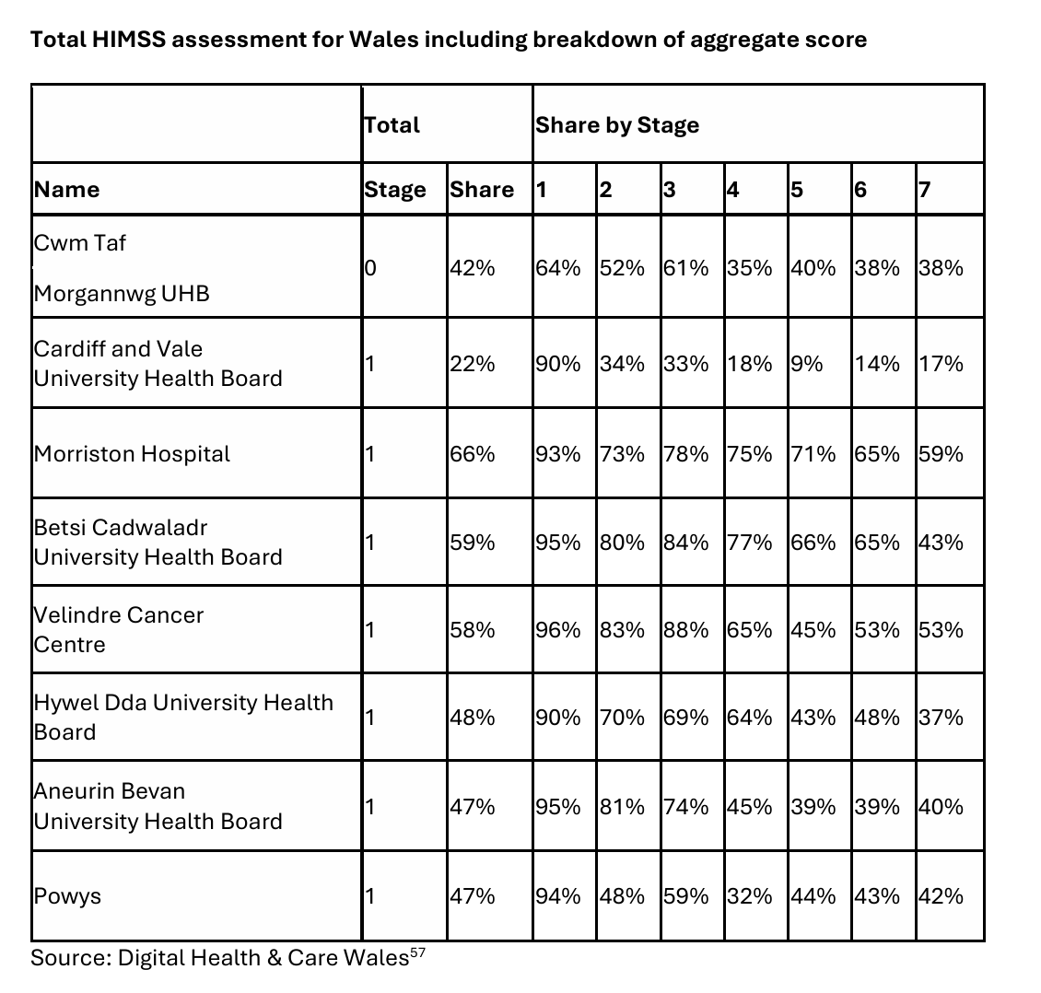
Table 8
Adopting an 80% benchmark arguably offers a fairer and more pragmatic approach than other widely used models, such as EMRAM, while still ensuring a robust level of digital maturity is achieved.

For survey items measured using Likert-type scales, responses indicating that the criterion had been met were classified as “applies,” while responses indicating a clear lack of endorsement were classified as “does not apply.” “Neutral” and “not applicable” responses were excluded from the denominator to ensure that calculations reflected only respondents who provided a clear evaluative judgement. For competency-based items, responses demonstrating sufficient ability to perform role-related digital tasks were categorised as “applies,” whereas responses indicating insufficient competence were categorised as “does not apply.” To generate a dimension-level digital maturity score, the proportion of criteria classified as “applies” was aggregated using a mean-based approach, producing a single maturity value for each dimension. All dimensions were weighted equally, ensuring that no single area disproportionately influenced the overall digital maturity score. This approach supports transparency, fairness, and replicability of the scoring method.

  - Employees scoring matrix

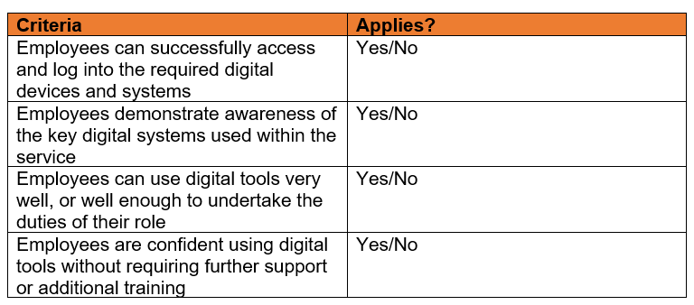
Table 9
The scoring matrix presented in Table 9 was selected due to its strong alignment with the employee-focused dimension of the chosen digital maturity framework, which specifically assesses levels of digital awareness, engagement, and participation. These indicators closely reflect the definition of digital competency identified in the literature review as “having sufficient skills and capability to be efficient with digital processes and devices” (Ala-Mutka, 2011). Importantly, this alignment ensures that the matrix moves beyond measuring general attitudes toward digital technology and instead captures the extent to which employees can engage meaningfully and effectively with core digital systems required for service delivery. This distinction is critical, as positive perceptions of digital tools alone are insufficient to demonstrate digital maturity in practice. Given the system-wide reliance on staff to operate WIS accurately and consistently (Digital Health and Care Wales, 2025), employee digital competence and engagement are fundamental to the safe, seamless, and efficient delivery of vaccination services. Staff capability in navigating digital workflows, recording vaccination data, and supporting digital interactions with citizens directly underpins the effectiveness of a person-centred digital vaccination journey. As such, the use of this scoring matrix is justified as an appropriate and robust mechanism for evaluating the employee dimension of digital maturity within PTHB’s Immunisation and Vaccination Service.

  - Process digitisation scoring matrix
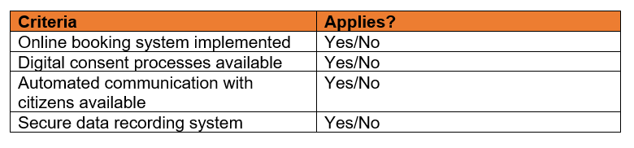
For components of the evaluation that utilise a purely qualitative methodology, such as organisational processes and WIS, a modified scoring matrix was developed. While retaining conceptual consistency with the overarching digital maturity framework, this matrix differs slightly to reflect the nature of the data collected, as surveys were not employed for these measures. In determining which elements within the process digitisation digital maturity dimension are classified as “applies,” the criteria set out within the NIF were utilised. To assess whether the process digitisation dimension met the threshold of 80% “applies,” key internal operational workflows, including booking, communication, and data recording systems, were evaluated. Where at least 80% of these operational elements were identified as implemented and functioning effectively, the criterion for this dimension was met. This approach is illustrated in a high-level format below.
Table 10

  - Citizen engagement scoring matrix
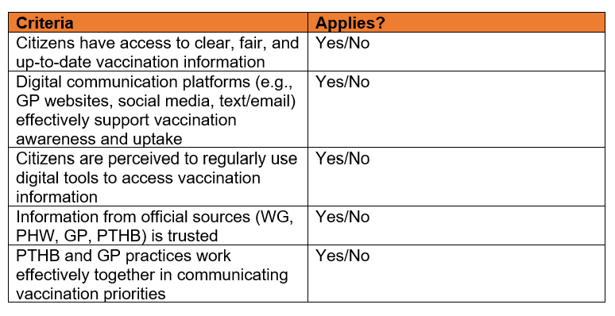
Table 11
Although the NIF definition of a person-centred digital vaccination journey refers only to enhanced functionality for communication, the chosen digital maturity matrix places strong emphasis on citizen-centredness, including the need to account for both digital and non-digital communication preferences (Table 2) (Eymann et al., 2023). This ensures the scoring criteria used for this dissertation reflect a broader and a more holistic understanding of engagement needs, rather than focusing narrowly on communication alone. As such, the criteria selected for this domain are aligned not only with the requirements of the citizen-centredness dimension of the digital maturity matrix itself, but also with the practical realities of delivering inclusive, person-centred vaccination services.

Existing literature reinforces the significance of communication within vaccination programmes. Digital platforms have been shown to play a central role in disseminating information, supporting appointment systems, and facilitating engagement during immunisation campaigns (Zang et al., 2023). However, the literature also highlights persistent challenges, including the need to rebuild trust, address misinformation, and mitigate vaccine hesitancy (Pennisi, Genovese and Gianfredi, 2024). These issues remain highly relevant to contemporary immunisation strategies and underscore the importance of evaluating how effectively communication, both digital and non-digital, is experienced by citizens. For these reasons, this dissertation includes an assessment of communication within Powys by integrating relevant questions into the developed survey. This approach ensures the scoring criteria used for this section remain aligned with both the expectations of the digital maturity matrix and the key themes emerging from current literature.

  - Integration scoring matrix

Although the NIF does not provide a formal definition of an integrated vaccination record, this dissertation adopts a working definition informed by the capabilities described for WIS 2.0; An integrated vaccination record is conceptualised as a single, unified immunisation system serves as a trusted source of vaccination data at the point of care and across national health services (Digital Health and Care Wales, 2025). It is designed to operate at scale and is built upon recognised interoperability standards, enabling real-time data exchange and practical workflows which support clinicians in delivering safe, efficient, and person-centred care (Digital Health and Care Wales, 2025). In line with this definition, the following core integration functionalities was assessed to determine whether the 80% “applies” threshold has been achieved:
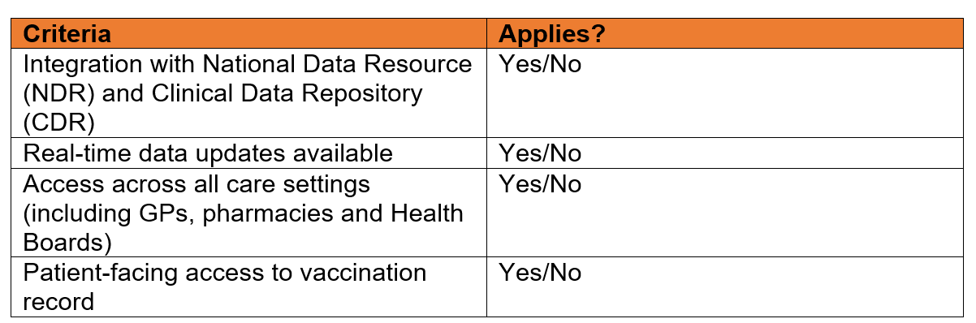
Table 12

3.7 Conclusion

This chapter has justified the research methods employed and explained their practical application in evaluating the digital maturity of PTHB’s Immunisation and Vaccination Service, as well as assessing the extent to which the service is equipped to deliver a person-centred digital vaccination journey.

A mixed methods approach was identified as the most appropriate methodology for two of the four digital maturity dimensions, enabling the collection of both quantitative and qualitative data within a single evaluative design. An embedded mixed methods approach was adopted whereby quantitative and qualitative data was collected concurrently through the same survey instrument and within the same timeframe. Open-ended questions were incorporated to allow participants to elaborate on their Likert-scale responses, thereby enriching the interpretation of quantitative findings and providing greater contextual depth (Leedy, 2020).

Qualitative methods, including document review, process mapping, and interview feedback, were essential for examining operational workflows underpinning the process digitisation and integration capability dimensions. These methods provided critical contextual insight into how digital processes function in practice, including the extent of digitisation within internal workflows and the level of integration achieved in maintaining a comprehensive digital vaccination record. Such depth of understanding could not have been adequately captured through quantitative measures.

This chapter has also detailed how the selected digital maturity framework was operationalised through the development of tailored scoring matrices and the application of an 80% “applies” threshold. This threshold is not only appropriate to the chosen model but is also comparable with widely used digital maturity instruments, such as HIMSS, which applies a 90% “applies” criterion. This structured and transparent approach ensures that both survey data and qualitative findings are translated consistently into digital maturity ratings across each dimension, in alignment with the National Infrastructure Framework, the existing literature, and the selected digital maturity model.

The following chapter presents the findings generated through these methods and outlines the digital maturity levels achieved across each of the assessed dimensions.

4 Results

4.1 Introduction

34 responses were received from employees of the Immunisation and Vaccination Service in PTHB for the digital competency survey (Appendix B), which aligns with the first research objective and ‘employees’ dimension of the chosen digital maturity assessment (Table 2). Responses were provided by male and female colleagues, as well as those who preferred not to disclose their gender. The sample included 14 administrative staff and 20 clinical staff, with ages ranging from under 25 to 60 and above.

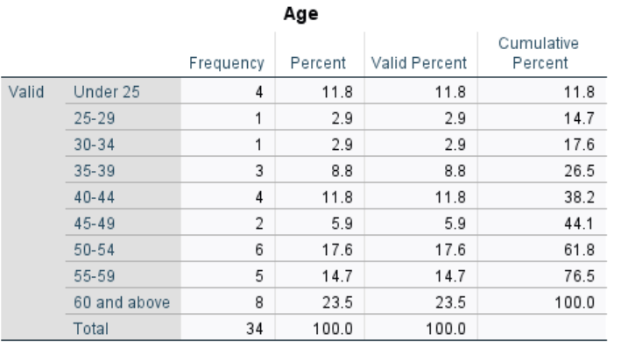

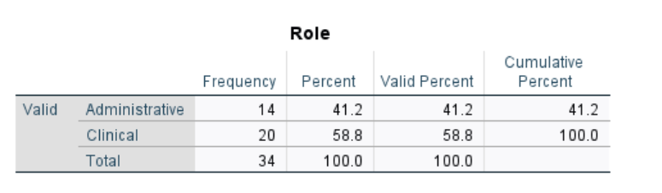
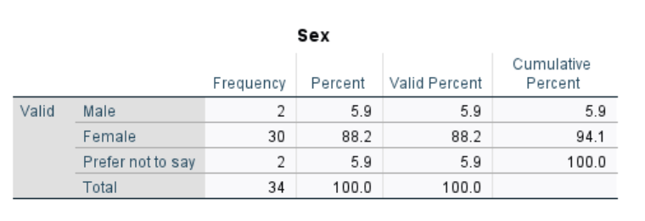

For the second research objective, a range of internal materials were examined, including best practice documents and WIS 2.0 user guides. In addition, direct observations were conducted of administrative staff carrying out routine internal processes. To supplement these findings, informal interviews were undertaken via email and Microsoft Teams with colleagues from DHCW and the PTHB Data and Analytics team.

The citizen engagement survey, as part of the third research objective, received 11 responses: six from PPI Groups, one from Llais, two from colleagues within the Communication and Engagement Department of PTHB, one from PAVO and one from a Powys councillor. Respondents were aged 50 and over (see Appendix C).

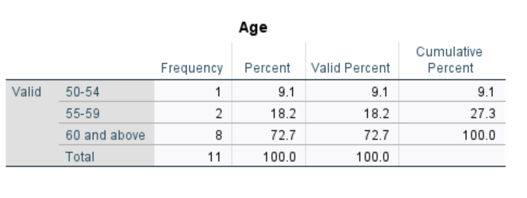
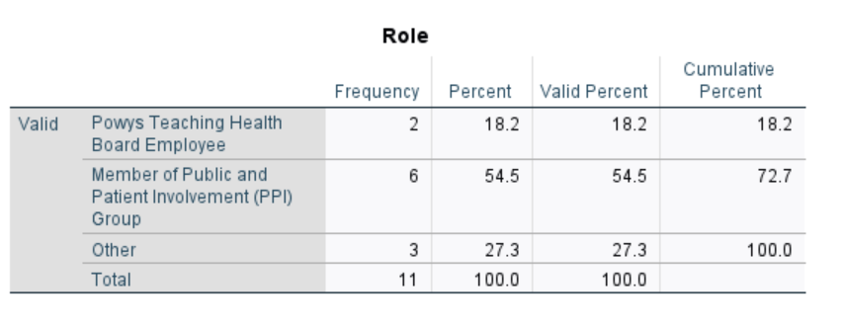
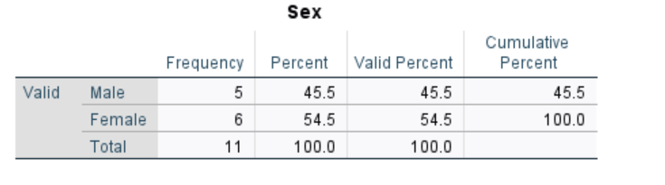

For evaluating the final research objective, results derived from undertaking informal interviews via email and Microsoft Teams with colleagues from DHCW and the PTHB Data and Analytics team to further understand the functionality and accessibility of an integrated digital vaccination record through the WIS.

4.2 Research Objective One Results: Employees

  - Quantitative results

SPSS software version 30.0 was used to generate descriptive statistics, including frequencies, percentages, and means, to summarise responses to the quantitative survey items. Responses marked as “neutral” and “not applicable to my role” were treated as missing values and excluded from percentage and mean calculations to avoid underestimating competence for role-specific systems. See Appendix E for full SPSS output.

For awareness and training questions, responses were coded as follows:

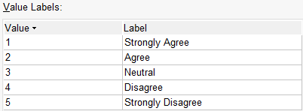

For usage items, responses were coded as:

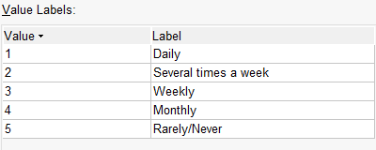

For competency-based questions, responses were coded as:

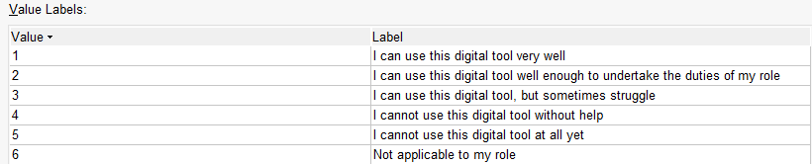

The mean score for awareness of logging into a device to access required digital tools was 1.26 (on a five-point scale where 1 = Strongly Agree), indicating responses were strongly clustered towards agreement. Mean awareness scores across the eight digital systems ranged from 1.15 for WIS to 3.15 for Power BI Dashboards, demonstrating variation in familiarity across systems. Lower awareness was also observed for the Digital Services Portal (mean = 2.71).

Usage patterns reflected similar variation. Mean usage scores indicated Microsoft Outlook, Microsoft Teams and WIS were the most frequently used systems, whereas Power BI Dashboards and the Digital Services Portal were used least frequently.

Competence ratings showed higher perceived competence for WIS, Microsoft Outlook, Microsoft Word and Microsoft Teams. In contrast, Power BI Dashboards demonstrated the lowest competence ratings, followed by the Digital Services Portal.

Responses regarding training needs further reflected this pattern. Respondents mostly disagreed they required further training for WIS, whereas agreement was highest for Power BI Dashboards, indicating a greater training need for this system.

Frequency distributions for each quantitative survey item were created using SPSS to support assessment against the digital maturity model. Responses were recoded into a binary format to determine whether each item met the predefined 80% “applies” threshold. Items coded as 1 = Applies represented respondents who demonstrated digital maturity for the criterion, while 2 = Does Not Apply, which indicated non-maturity. Responses that did not contribute to either category, specifically “Neutral” and “Not applicable to my role”, were treated as missing on SPSS and excluded from the percentage calculations to ensure the final proportions reflected only definitive responses. The resulting distribution of “Applies” and “Does Not Apply” classifications is summarised in Appendix F, with the detailed item-level frequencies presented below:

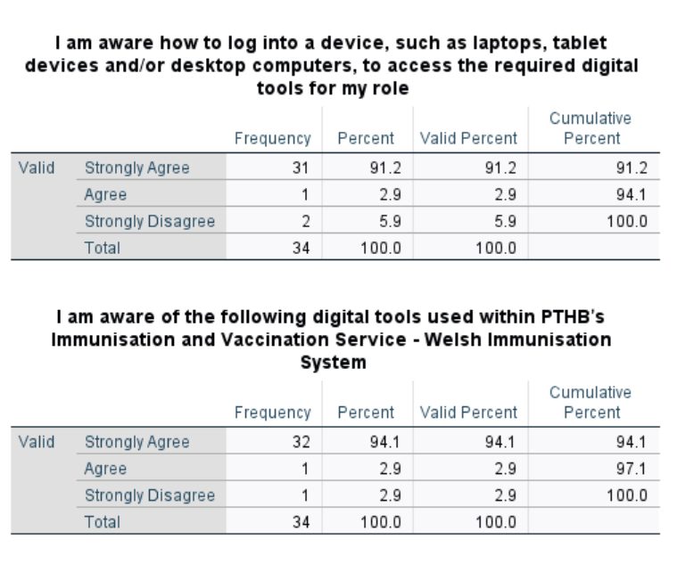
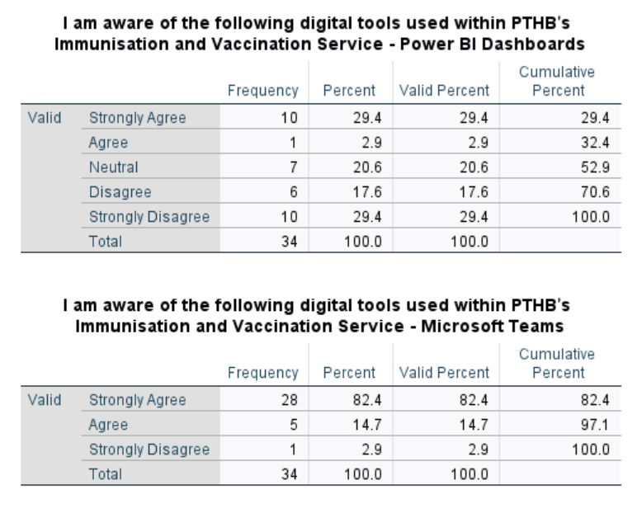
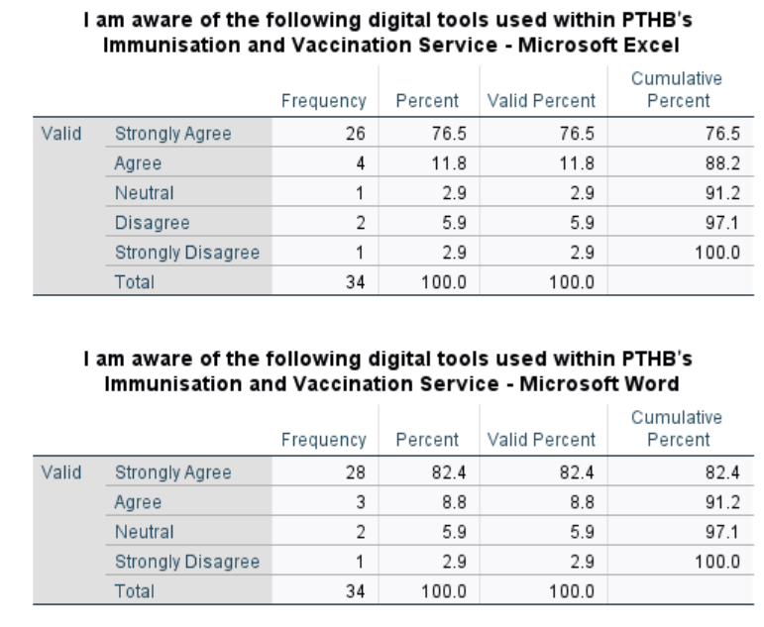
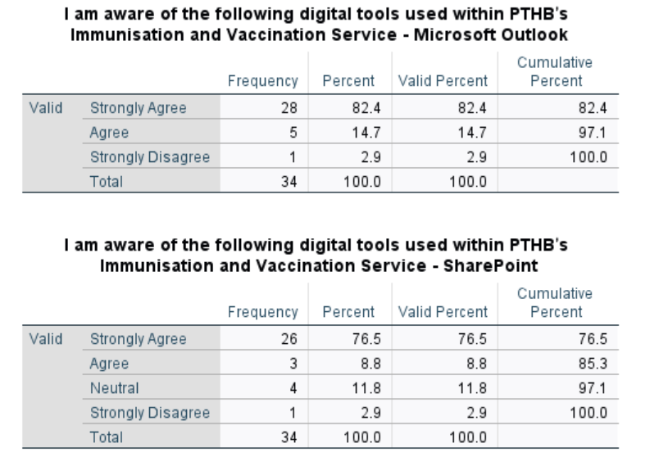
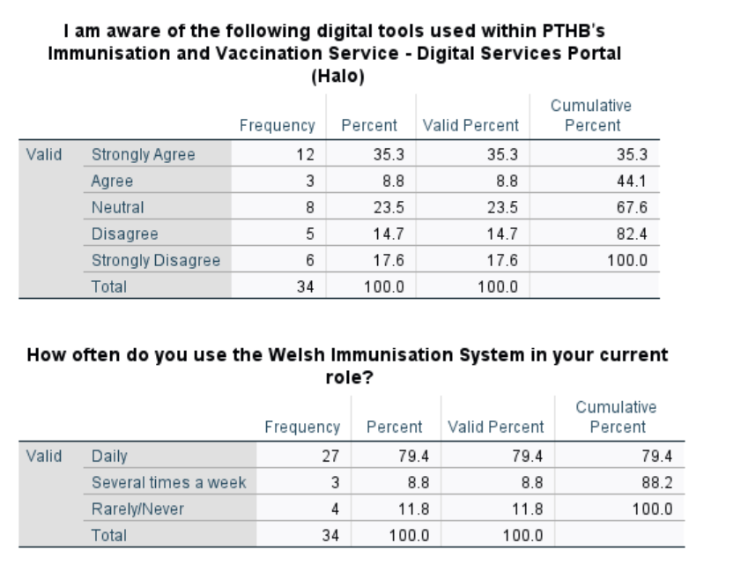
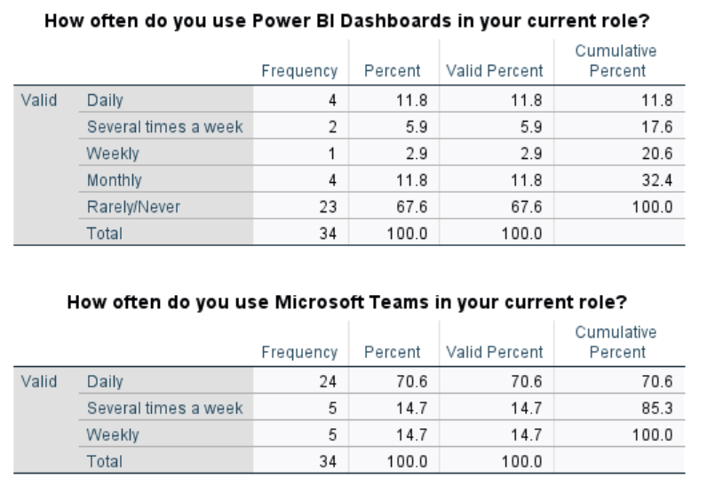
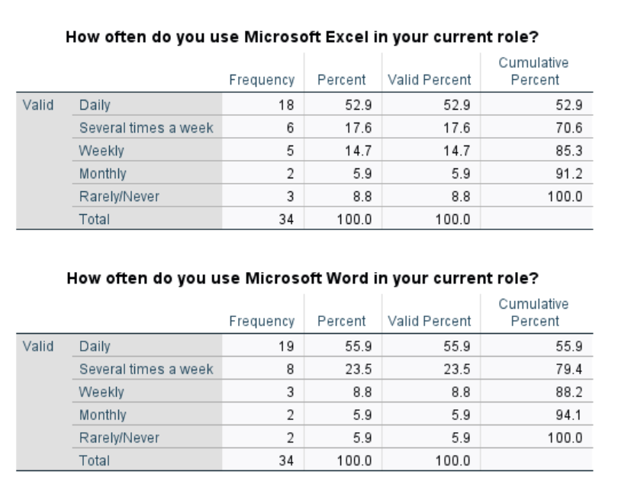
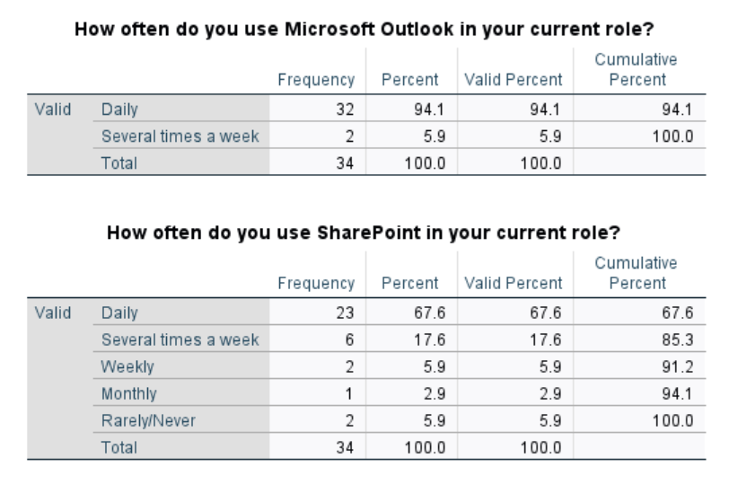
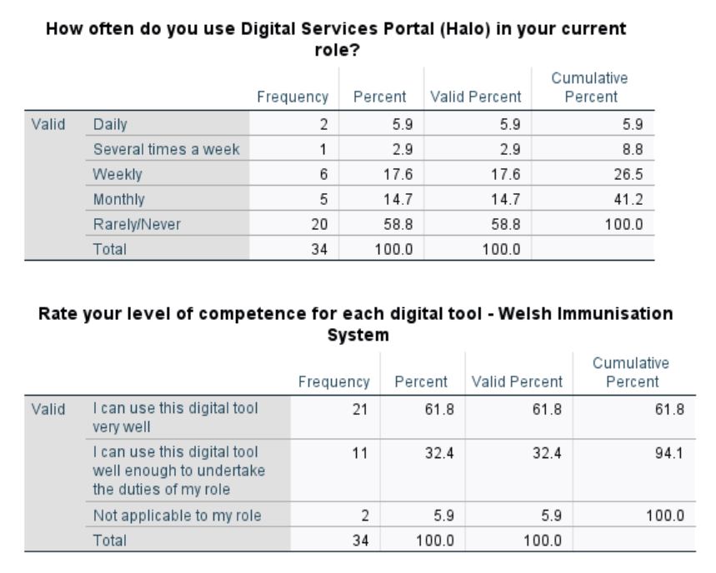
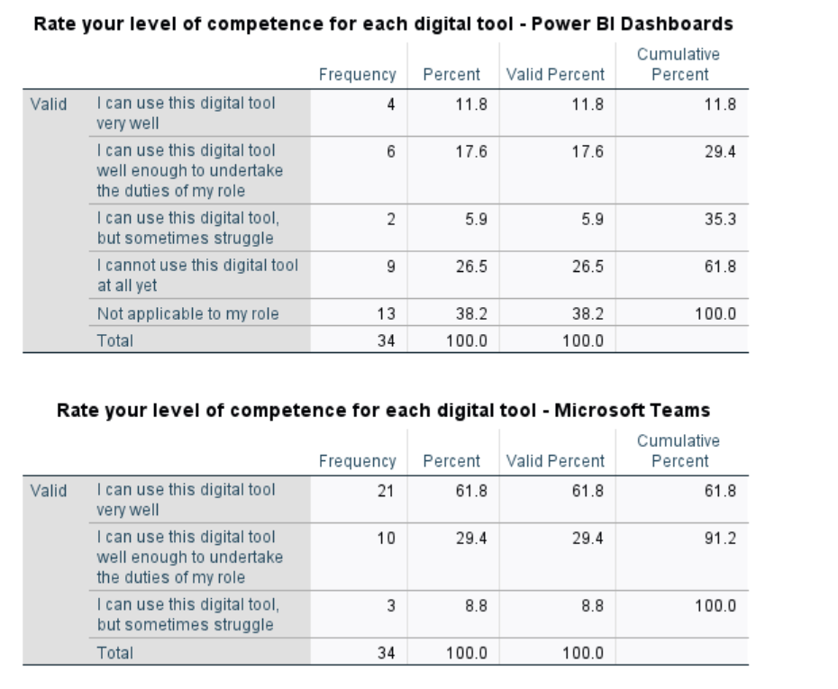
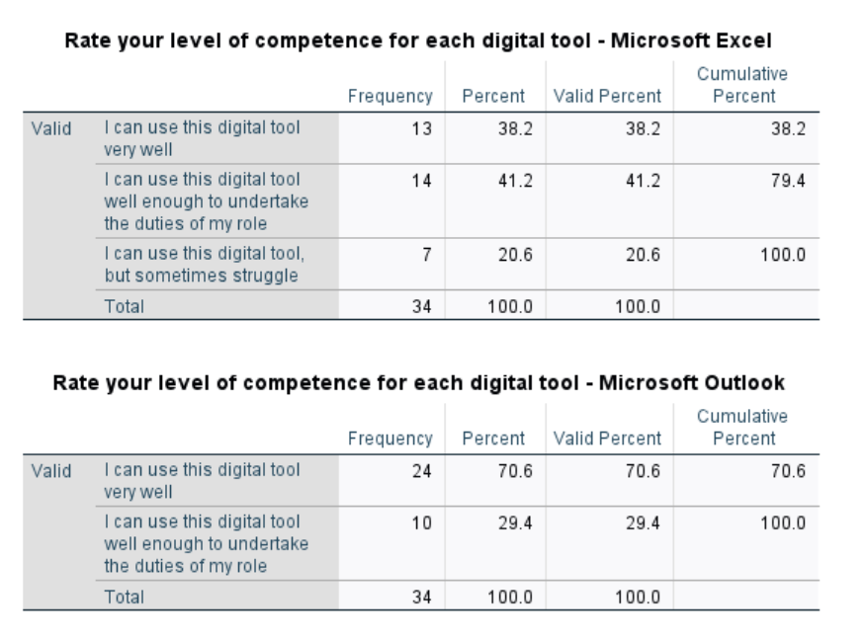
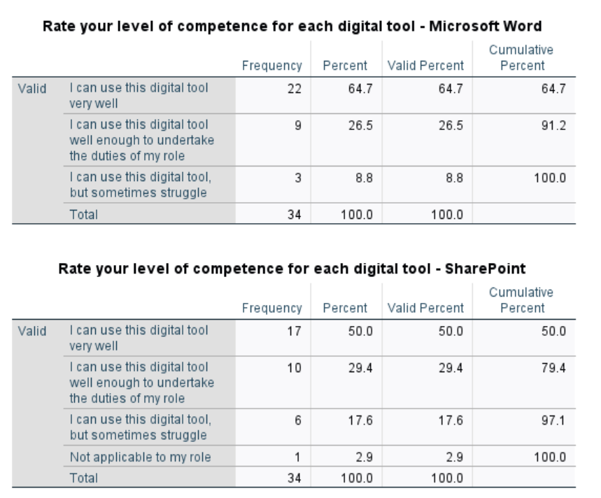
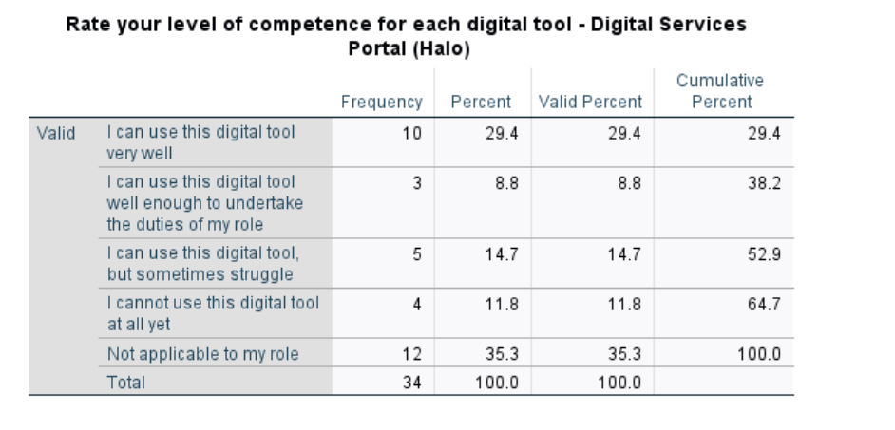
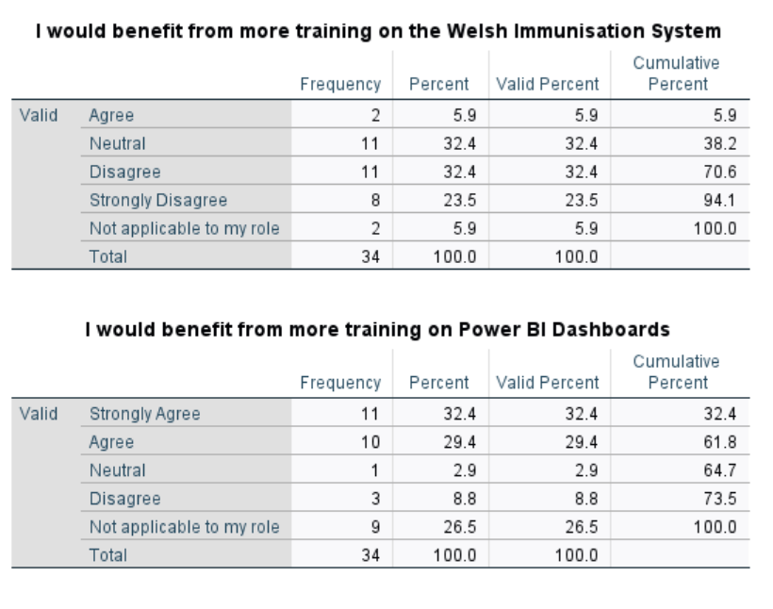
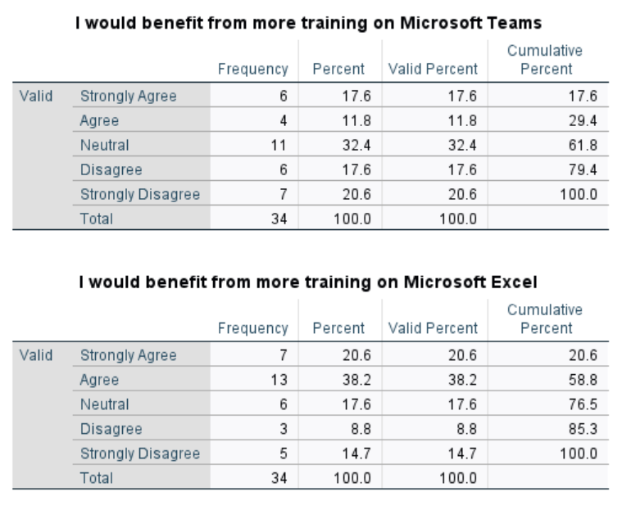
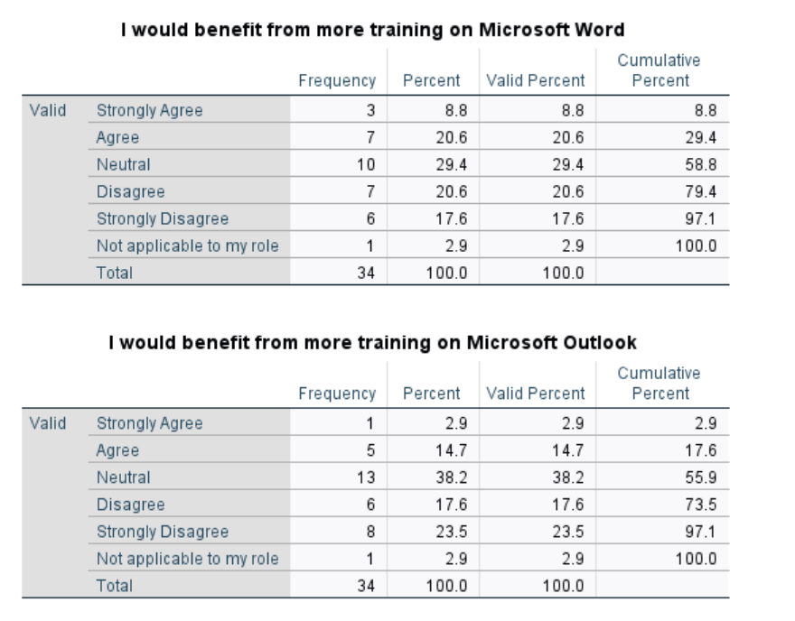
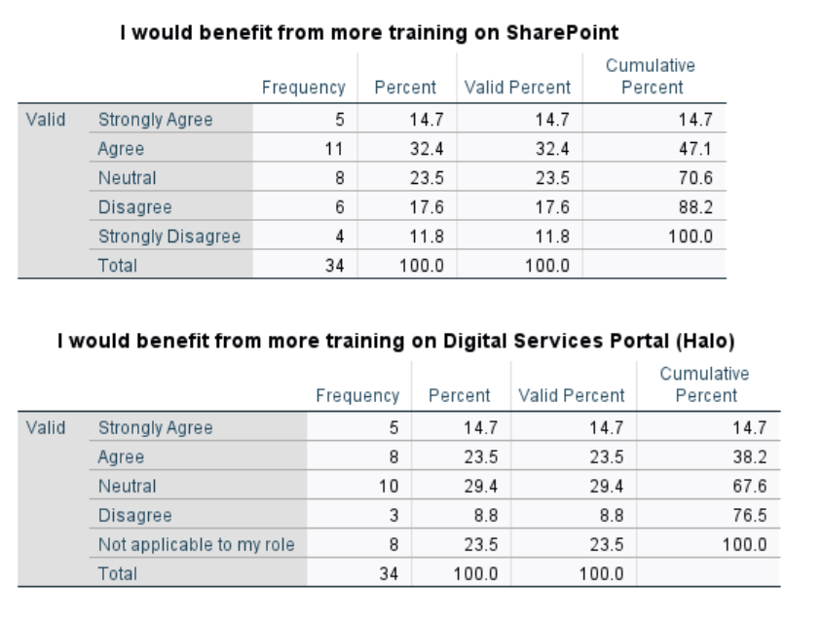
The results above highlight employees overall feel the most competent in WIS, followed by Microsoft Outlook and Word and feel less competent in Power BI Dashboards and the Digital Services Portal.

For each criterion, the overall percentage meeting the “applies” definition was calculated by grouping the number of responses classified as “applies”. This total was divided by the sum of valid and multiplied by 100. The resulting percentage provided a single criterion-level score for comparison against the 80% threshold. The results have been summarised within Table 10 below:

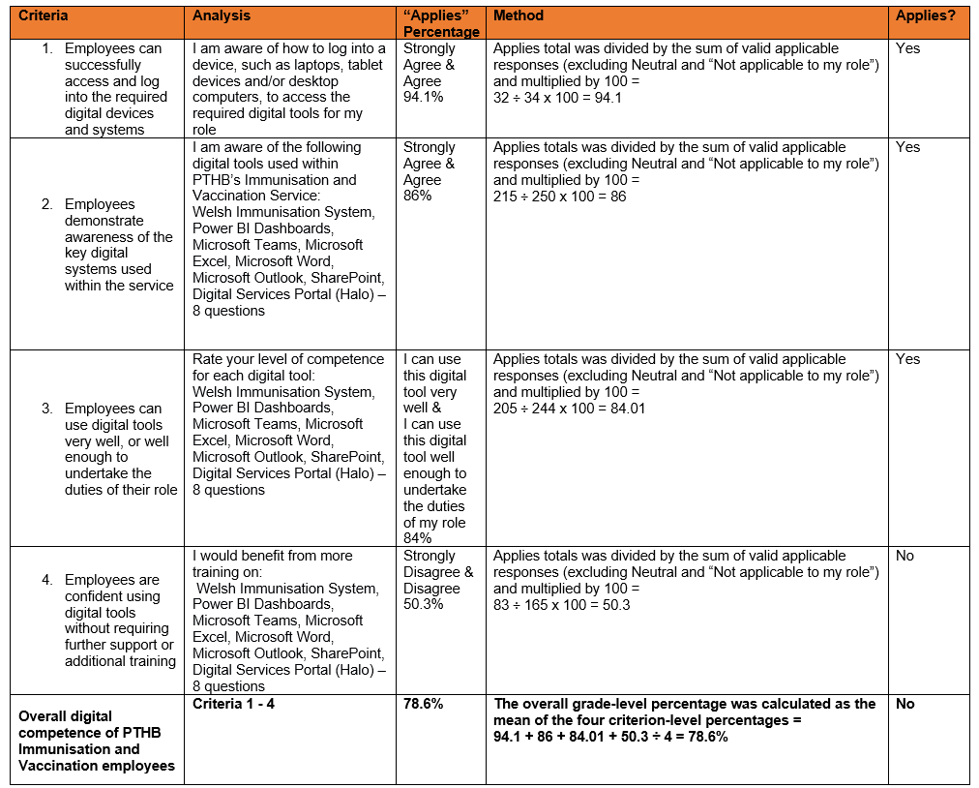
Table 13

These results have also been summarised into a bar chart, as below:
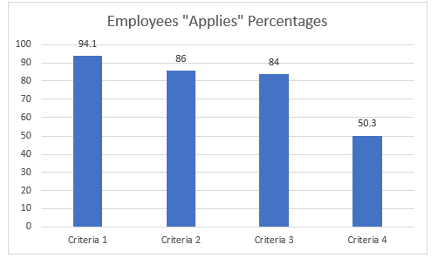
The bar chart suggests strong performance across criteria 1-3, with over 80% of respondents indicating these aspects of digital maturity apply to them. This suggests employees are generally very aware of digital tools, understand the key systems used in the service, and can use these tools very well, or well enough to undertake the duties of their role. However, criterion four shows a marked decline and slight contradiction, with just over half of respondents indicating they would benefit from additional training or support on the digital tools used within the service.

Correlation analysis was conducted to explore whether digital competency levels across the assessed digital tools were associated with age (Appendix G). The results identified statistically significant correlations, with p-values below the 0.05 significance threshold for WIS, Microsoft Word, and Microsoft Outlook. These tools were also those in which respondents reported the highest overall levels of confidence and competence. These findings indicate sufficient statistical evidence of a relationship between age and competency levels in these digital tools. The relationship trend is presented below:

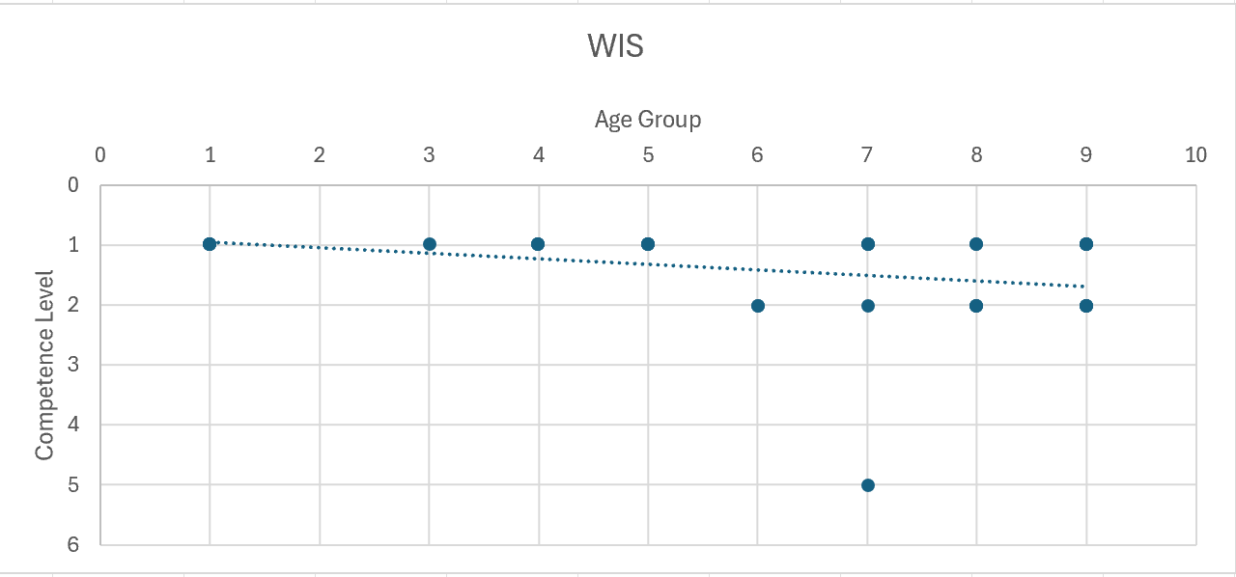
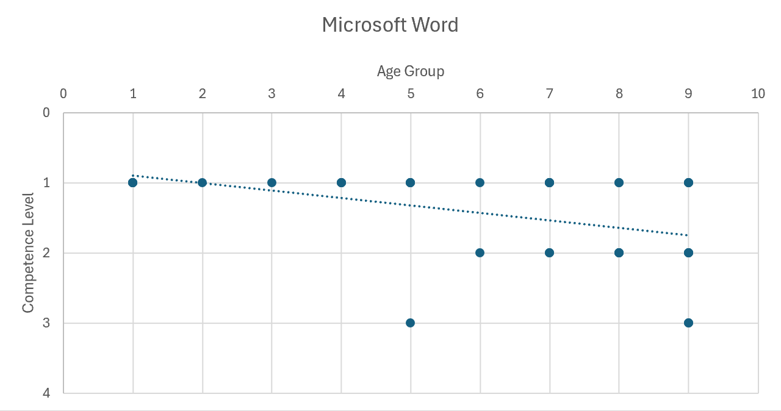
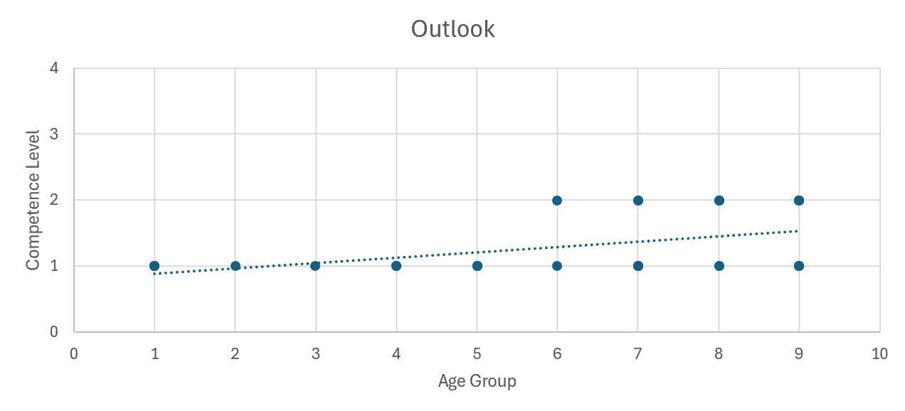

Below is clarification of the competency levels and age groups:
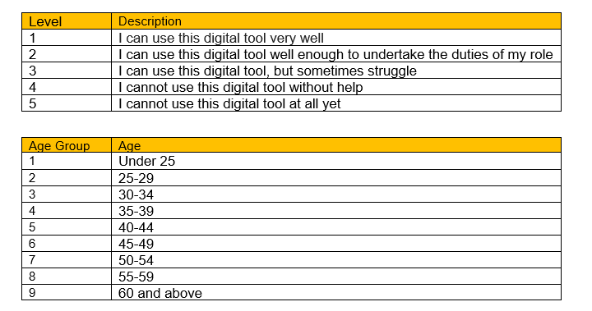

Graphical analysis indicates a general decline in digital competency among employees aged 40 and above. For both the Welsh Immunisation System (WIS) and Microsoft Outlook, competency levels remain broadly consistent across younger age groups, with responses largely clustered at higher competency levels. From approximately age 45 onwards, trendlines display a gradual downward slope, indicating diminishing competency with increasing age. A comparable pattern is observed for Microsoft Word. These visual trends align with the correlation analysis and support the presence of statistically significant, system-specific relationships between age and digital competency.
It should be noted that although 34 responses were included in the analysis for Microsoft Word and Microsoft Outlook, and 32 responses for WIS (with “not applicable to my role” responses excluded), the scatter plots display fewer visible data points due to overlapping values. Multiple respondents reported identical age and competency score combinations, and consequently, individual data points on the graphs represent clusters of respondents rather than single observations. This consolidation reflects the underlying distribution of the data and does not affect the validity of the analysis.
  - Qualitative results:
Qualitative data collected through the survey was analysed using thematic analysis, which provides deeper insight into the experiences and perspectives of participants, insights which cannot be fully captured through quantitative measures alone (Creswell and Plano Clark, 2011).
Three free-text questions were included in the survey:
- What problems do you have when using digital tools?
- What support would help you feel more skilled and confident when using digital tools?
- Are there any other digital tools or systems would help you in your role?
The findings from these questions are presented below:
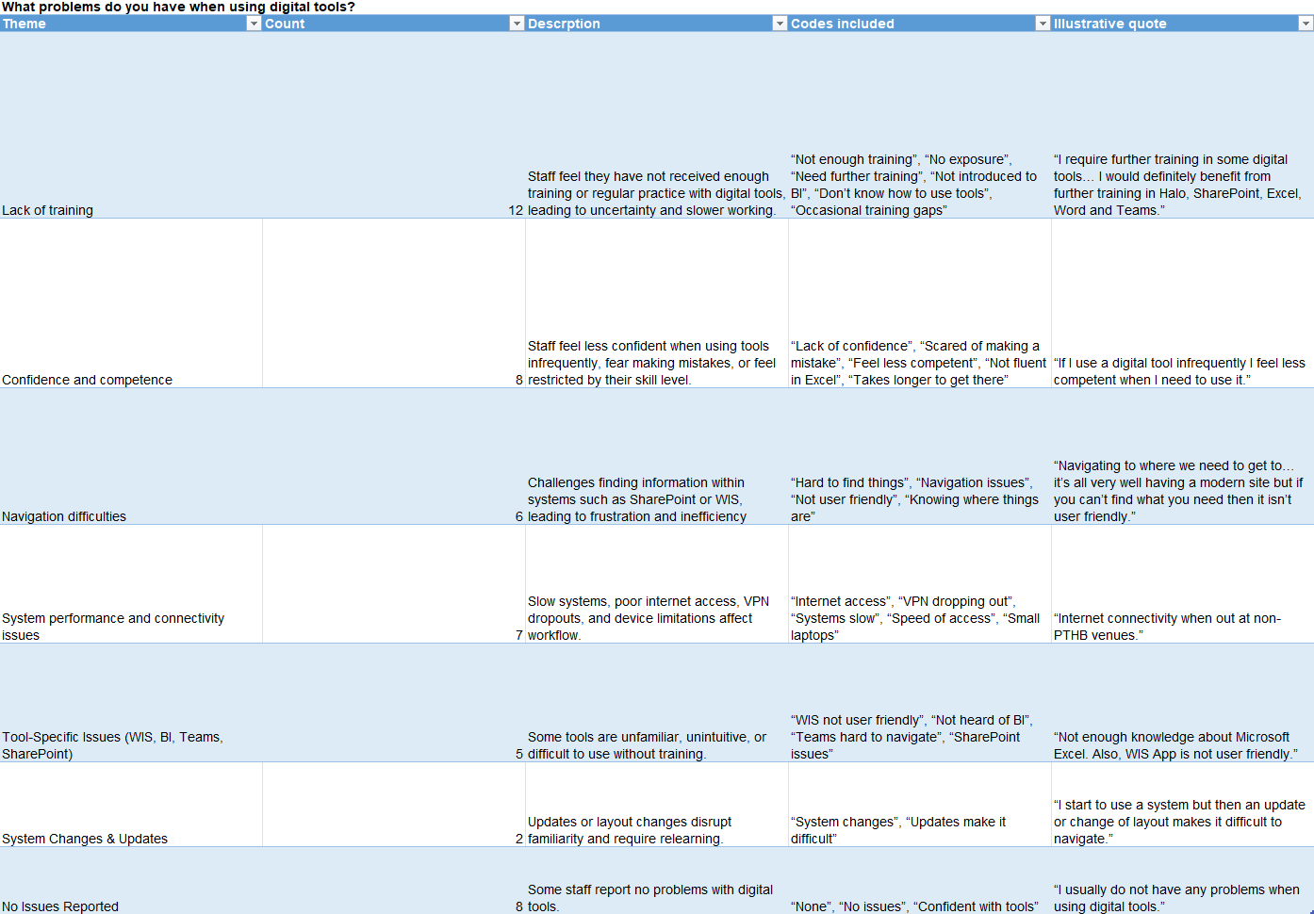
The most frequently reported issue experienced by employees when using digital tools was a lack of training. This qualitative theme aligns closely with the quantitative findings, where a substantial proportion of respondents agreed or strongly agreed they would benefit from additional training across multiple digital platforms.
Although descriptive statistics showed SharePoint was used frequently by employees, 17.6% of employees struggle to use it and 47.1% of colleagues feel they would benefit from additional training or support on this digital tool. The qualitative data further suggested a dip in competence for SharePoint is related to difficulties navigating the tool and inconsistencies within shared-drive folder structures.
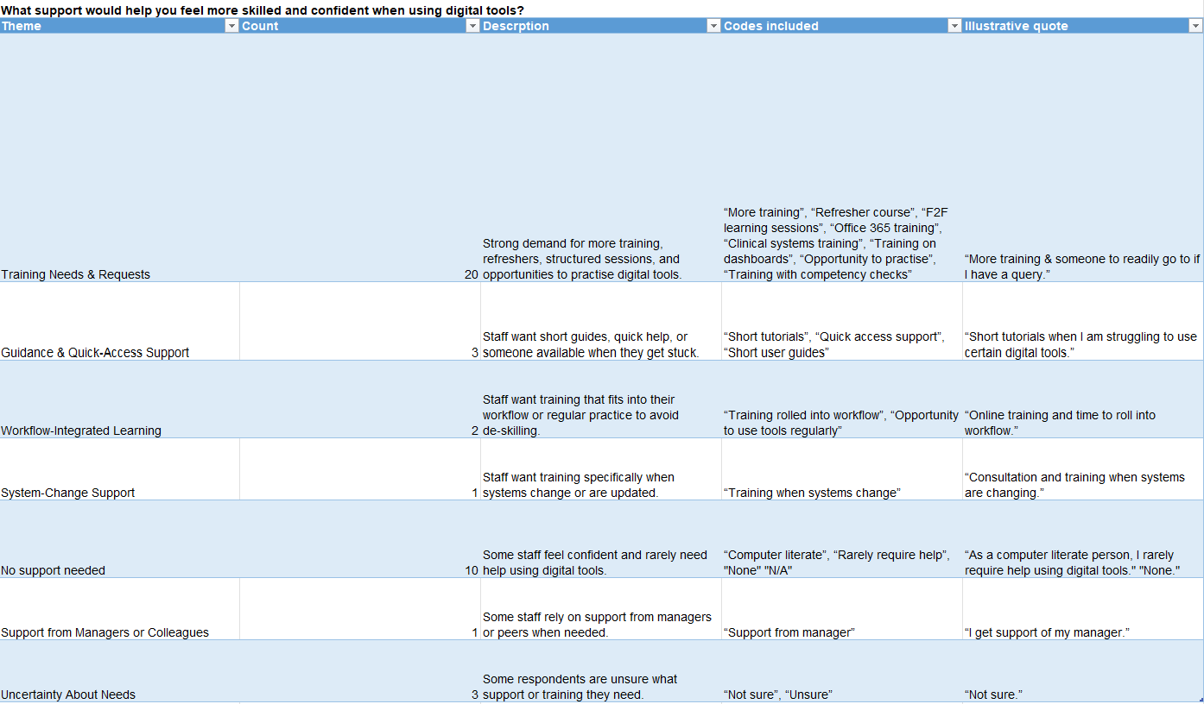

In terms of support required to help colleagues feel more confident using digital tools, training emerged again as the most frequently mentioned need, referenced by 58.8% of respondents. A further three respondents highlighted the importance of guidance documentation to reinforce training.

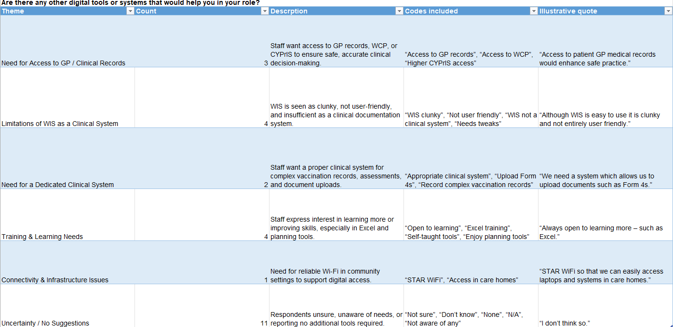
The quantitative results showed half the number of respondents strongly agreed or agreed they would benefit from additional training on 8 digital tools, which is strengthened by the findings within the qualitative results.

4.3 Research Objective 2 Results: Process digitisation

The findings relating to Research Objective Two are derived from qualitative methods, including observation of operational workflows, informal semi-structured interviews, and document review. Documentation reviewed included the WIS 2.0 User Guide and the Solution Architecture Document (SAD) provided by DCHW.

Workflow observations were carried out by observing the Immunisation and Vaccination Booking and Vaccination Centre Teams to evaluate the extent of process digitisation, focusing on booking systems, consent processes, communication channels, and data recording functionalities.

The results of the observations can be found below. Microsoft Visio was utilised to produce BPMN process flow maps to clearly demonstrate current operational workflows:

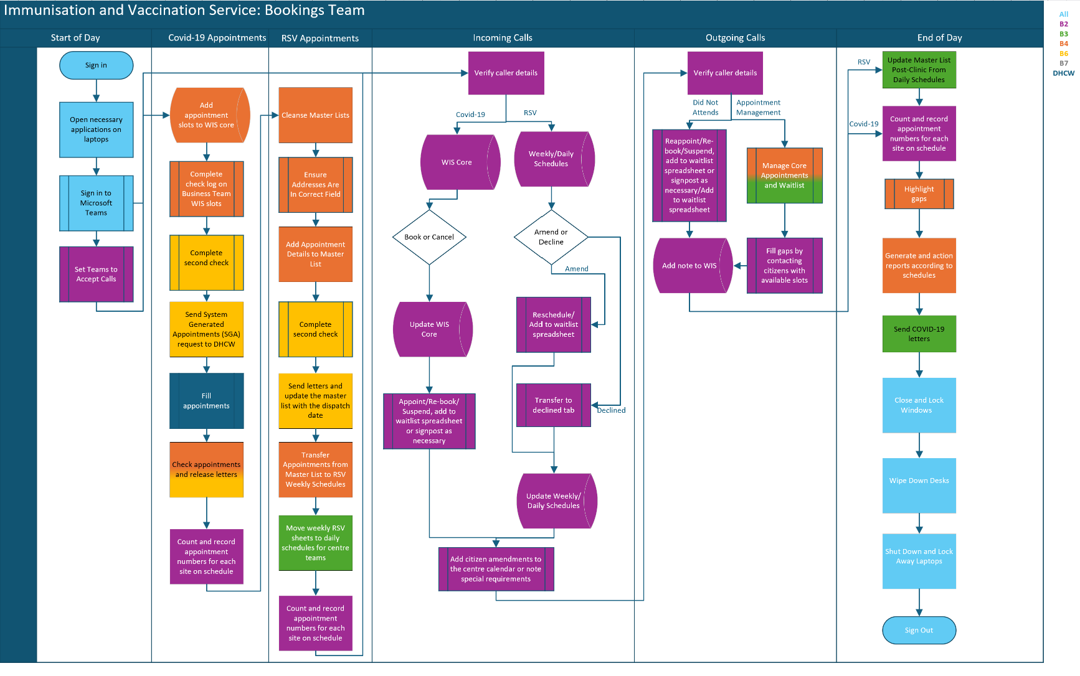
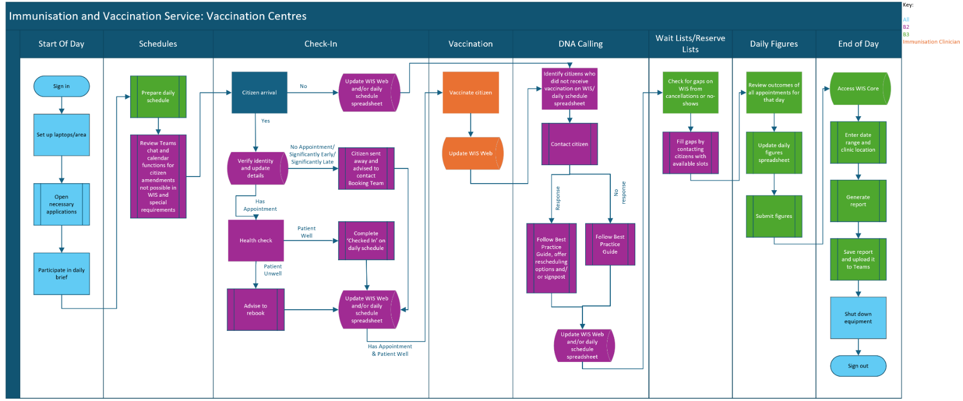
Figure 4
Figure 5

  - Online booking system
The above data flow maps evidence online booking systems have been implemented for COVID-19 appointments as these are completed by adding appointment slots onto WIS core and using System Generated Appointment (SGA) requests. This is completed using Notification Application Programming Interface (API), which is a system component to automatically send communication to patients, such as letters, when a vaccination appointment is booked or updated (Howe, 2025). All appointment amendments are also carried out by using WIS Core, the online booking system.
  - Digital consent processes
The Vaccination Centre data flow maps indicate WIS Web is used during the vaccination process, and the WIS User Guide confirms digital consent is mandatory during this part of the process:

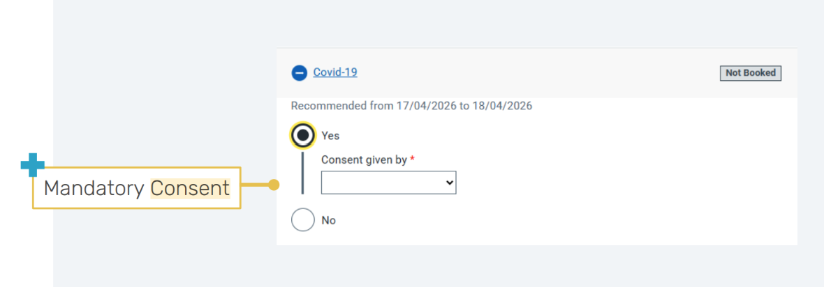
Figure 6
  - Automated communication with citizens
The SAD further confirms Notification API connects to Notify.Gov to use its existing messaging functions and works by securely passing information between systems. DHCW have 21 live services on Notify.Gov (GOV.UK Notify, no date), with PTHB being one of these services. Although it can be confirmed automated communication with citizens is available, a colleague from DHCW advised during an informal interview via Teams that SMS delivery reports “contain personal data (phone numbers and identifiers) and we do not have the appropriate Data Protection Impact Assessment coverage in space to share information”. Whilst observing the Booking Team, it was explained PTHB utilise the Notify.Gov service for sending SMS reminders for COVID-19 vaccination appointments. However, the effectiveness of these SMS reminders could not be evaluated within the scope of this dissertation, as direct citizen or patient involvement was considered out of scope for the evaluation.

  - Secure data recording system
In terms of a secure data recording system, the SAD confirms this criteria has been met as “the application relies on a combination of the National Active Directory for user authentication and employs a salt and pepper hashing algorithm on the user’s National Active Directory Exchange (NADEx) to generate a set of database credentials, ensuring secure user connections” (Howe, 2025). A high-level overview of this follows:
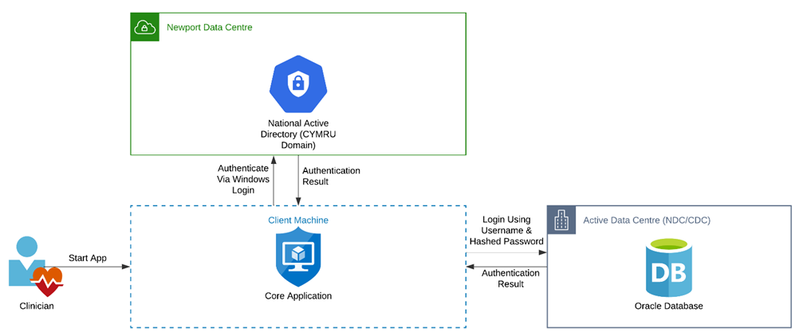
Figure 7
Overall, observational and documentary evidence indicates the COVID-19 vaccination pathway demonstrates a high level of process digitisation across booking, consent, communication, and data recording functions, consistent with the expectations outlined in the NIF. Digital systems are embedded within operational workflows, with automation supporting appointment generation and patient communication processes. However, minor governance and interoperability constraints remain. For example, restricted access to SMS delivery reporting means although automated communication functionality is in place, there is limited visibility regarding whether messages are successfully delivered and received, at what volume, and whether these are useful for citizens.

In accordance with the methodology for determining whether the process digitisation dimension meets the 80% “applies” threshold, the findings are summarised in Table 11 below:

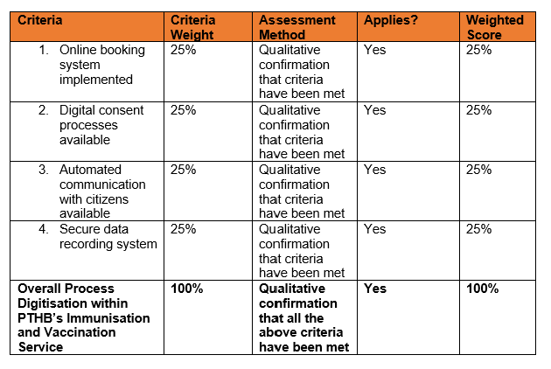
Table 14
Evaluation against the predefined assessment criteria demonstrates all required components are operational within the COVID-19 vaccination pathway. Each criterion is substantiated through observational and documentary evidence. Consequently, this dimension satisfies 100% of the specified requirements and exceeds the 80% applicability threshold, demonstrating full alignment with the digital maturity framework for process digitisation.

4.4 Research Objective 3 Results: Citizen engagement

  - Quantitative Results
SPSS software version 30.0 was used to analyse descriptive statistics, including frequencies, percentages, and means, to summarise responses to the quantitative survey items. Responses marked as “neutral” were treated as missing values and excluded from percentage and mean calculations to avoid distorting the results and to ensure the analysis reflected only respondents who expressed a definitive opinion. See Appendix H for full SPSS output.

Responses were coded as follows:

Information about COVID-19 vaccinations being shared clearly received a mean score of 2.60, indicating a general tendency toward agreement among respondents. Stronger agreement was observed for the importance of allowing citizens to choose how they receive vaccination information (mean = 1.82). Non-digital communication methods, such as posters, letters, and telephone calls, were also viewed highly favourably, reflected by a mean score of 1.64.

Trust in vaccination information from official sources (including the Welsh Government, Public Health Wales, GPs, and the Health Board) showed moderate agreement, with a mean of 2.60. However, expressed widespread disagreement that social media provides accurate and trustworthy information about COVID-19 vaccine safety, as indicated by the high mean score of 4.00.

Several items demonstrated more neutral response patterns. The statement assessing whether people know where to find clear and up-to-date vaccination information resulted in a mean score of 3.14, suggesting no clear consensus. Similarly, the clarity and usefulness of GP practice websites produced a neutral mean of 3.00. Perceptions of whether PTHB and GP practices work effectively together to promote vaccination also produced a mean of 3.14, indicating varied views on collaborative working. Respondents also tended to disagree that social media is the best way to communicate vaccination information, with this item generating a mean of 3.80.

SPSS was also used to generate frequency distributions for each quantitative survey item. Frequency analysis was helpful for assessing the level of digital maturity for this dimension and to determine whether the predefined 80% threshold for each indicator had been achieved. As outlined in the Methods chapter, responses were categorised as either “applies” or “does not apply” according to predefined criteria.
Classification as “applies” indicated respondents strongly agreed or agreed to statements which suggest citizens are engaged with well around vaccination priorities, which contributes towards the 80% benchmark required for the dimension. SPSS was used to recode responses into binary variables (1 = Applies; 2 = Does Not Apply). Responses falling outside the predefined criteria (Neutral) were treated as missing values and excluded from the denominator to ensure percentage calculations reflected only definitive responses. The “Applies” and “Does Not Apply” breakdown can be found in Appendix I. However, a detailed breakdown of responses for each Likert-scale item is provided below:

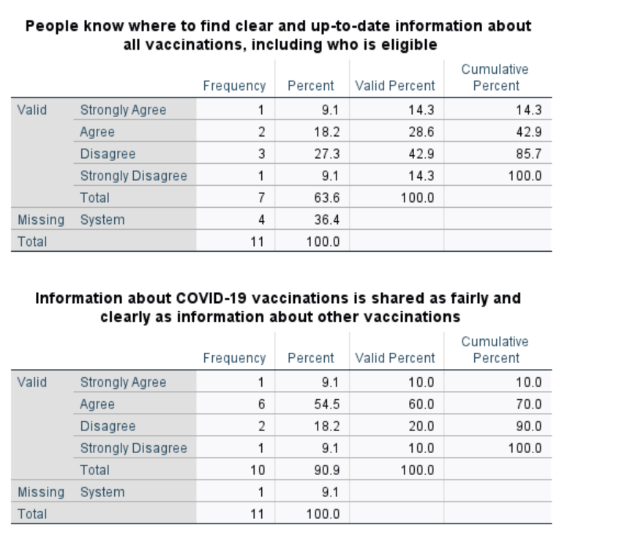
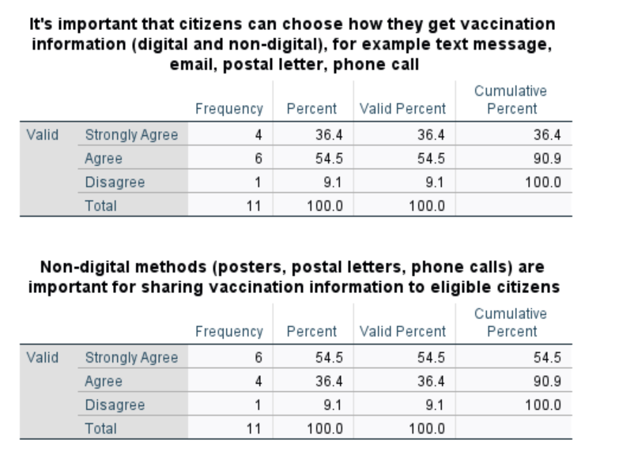
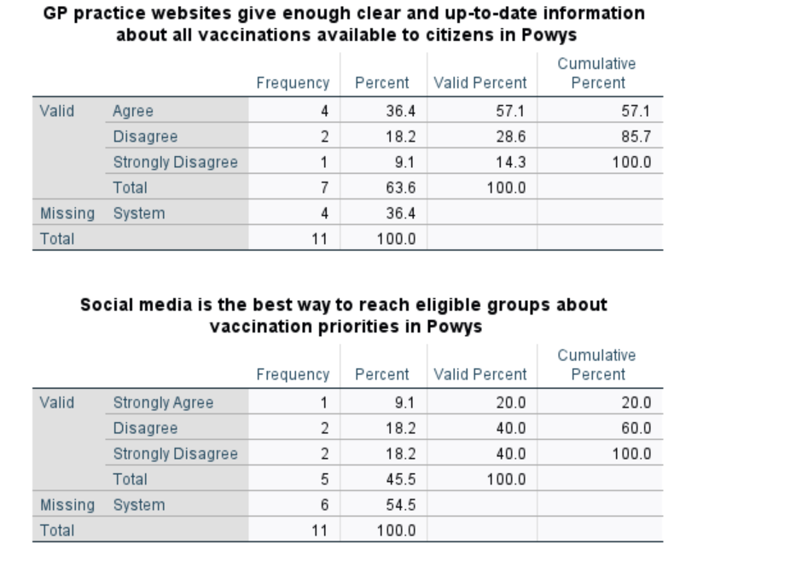
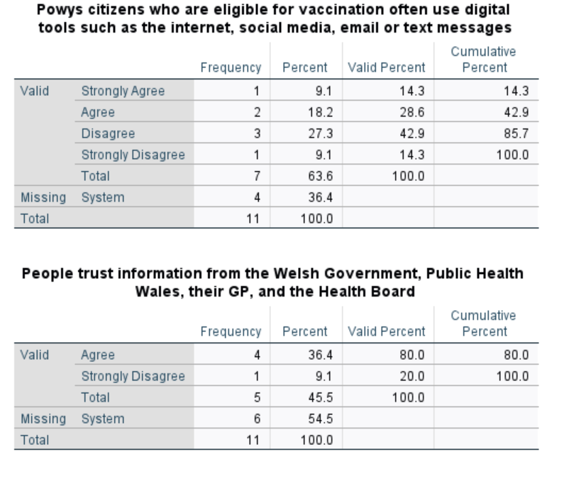
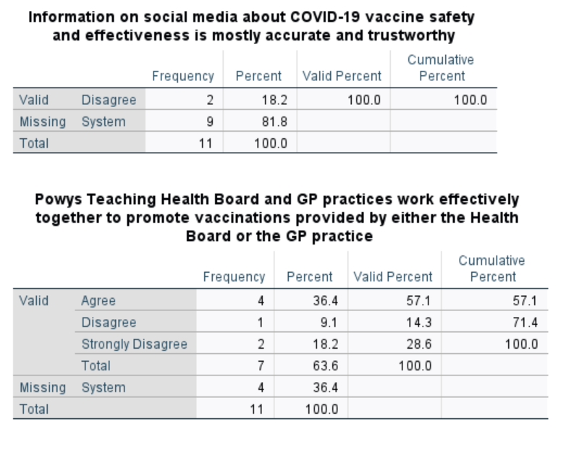
For each criterion, the overall percentage meeting the “applies” definition was calculated by collecting the number of responses classified as “applies” across the eight associated survey items. This total was divided by the sum of valid applicable responses (excluding Neutral and “Not applicable to my role”) and multiplied by 100. The resulting percentage provided a single score for comparison against the predefined 80% threshold. The results have been summarised within Table 15 below:
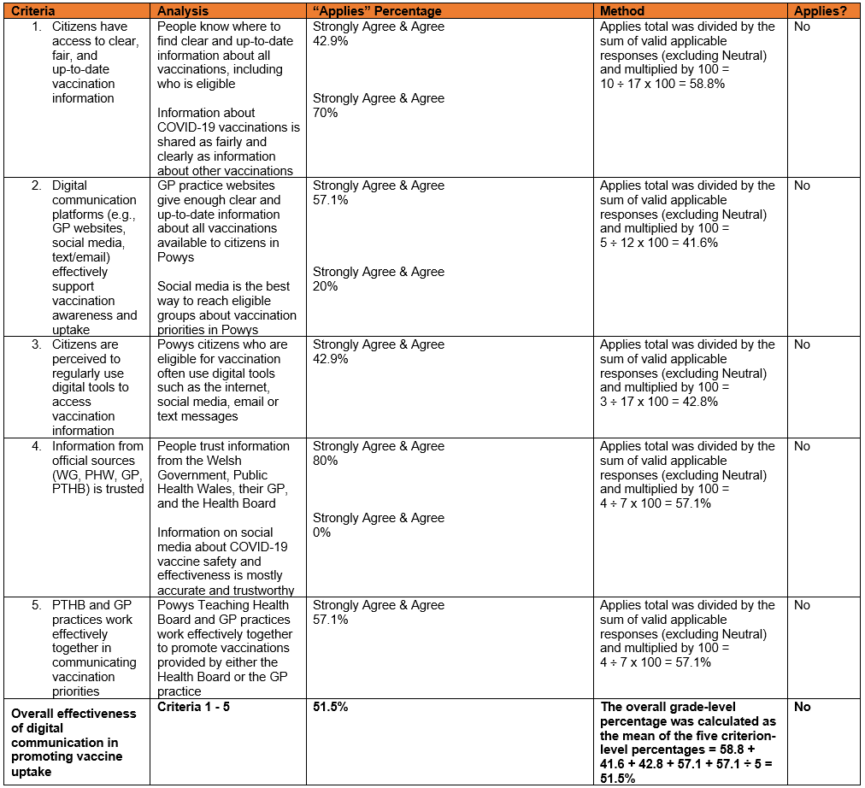
Table 15
These results are represented within the below bar chart:

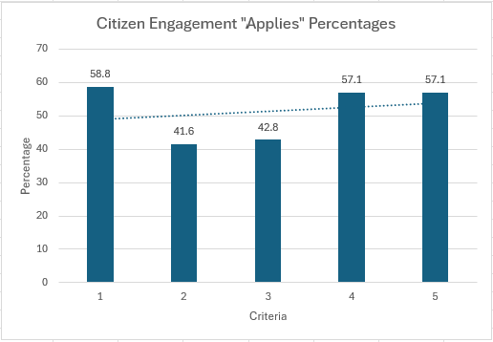
Figure 8
The results show information about COVID-19 vaccinations is perceived as being communicated just as clearly and fairly as information about other vaccinations. Respondents reported high levels of trust in information provided through official sources, including the Welsh Government, Public Health Wales, general practices, and the Health Board. In contrast, no respondents regarded social media as an accurate or trustworthy source of information on COVID-19 vaccine safety or effectiveness. Only 20% felt social media was an effective way to reach eligible groups about vaccination priorities in Powys, with most highlighting the continued importance of non-digital methods such as posters, printed letters, and telephone contact. Criteria two and three, which focused specifically on digital engagement, received the lowest scores, and this is clearly reflected in the bar chart, where there is a noticeable dip compared with the stronger performance in other areas.
When evaluated against the overall maturity criteria, the findings suggest although clear and trusted information is being delivered through formal channels, digital communication platforms, particularly social media, are not effectively engaging citizens. This substantially reduces the overall maturity score for this dimension, despite strong performance in traditional, non-digital communication methods.
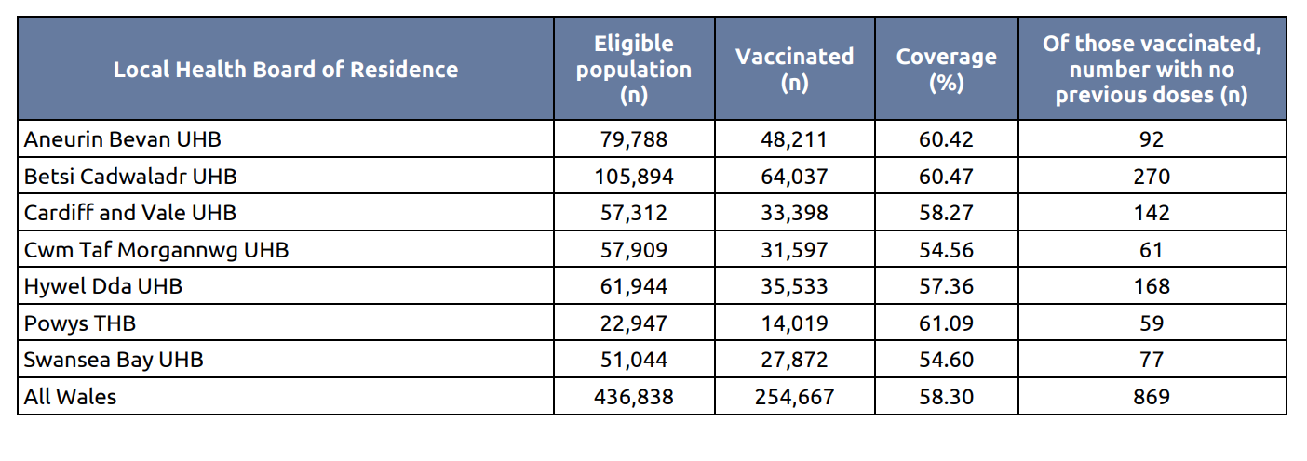
Despite limitations in digital engagement, vaccination uptake in Powys remains relatively high. Data from the latest Public Health Wales vaccination summary indicates that 61% of eligible Powys residents received the most recent COVID-19 autumn booster (Public Health Wales, 2026). Notably, Powys achieved the highest uptake rate of all Welsh health boards during the 2025–26 autumn campaign, falling short of the 75% target by 14%:
Table 16 - (Public Health Wales, 2026)
This outcome is likely influenced by the demographic profile of Powys, which has one of the highest proportions of residents aged 60 and over in Wales (The Older People’s Commissioner for Wales, 2024). This population group is more likely to engage with and trust traditional and non-digital communication methods, such as letters, posters, and direct contact with general practices. The survey findings support this, demonstrating strong trust in information delivered via official healthcare and government channels, despite limited confidence in social media as a source of vaccine information.
However, the failure to reach the 75% uptake target reflects a broader and persistent challenge rather than a local shortcoming. International evidence from 2021 demonstrated that willingness to receive a COVID-19 vaccine was below 70% in most countries studied (Honora, Wang and Chih, 2022), indicating barriers to achieving herd immunity. The uptake levels observed in Powys during the 2025–26 campaign are therefore consistent with patterns identified earlier in the pandemic.
Process digitisation findings stated WIS automatically sends appointment communications, such as letters, to eligible individuals. This reliance on non-digital communication appears to be well aligned with the strong preference for offline channels in Powys as identified within findings. Taken together, these results suggest the continued use of traditional communication methods, particularly letter-based correspondence, may play a key role in supporting positive vaccine engagement and uptake within Powys overall.

  - Qualitative results:
Similarly to Research Objective One, qualitative data collected through free-text questions embedded into the survey. These were analysed using thematic analysis:

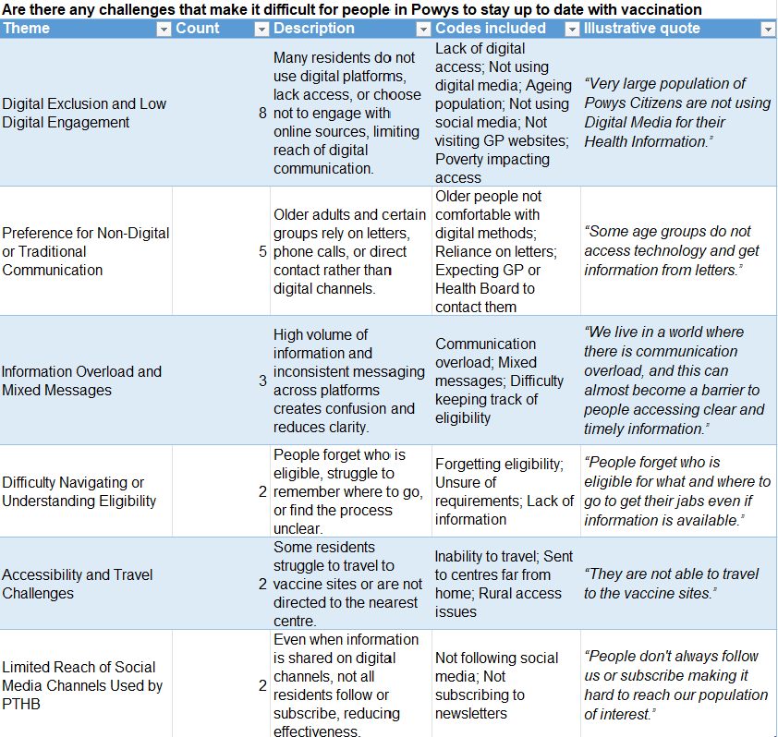

The most frequently reported challenge making it difficult for people in Powys to stay up to date with vaccination priorities was digital exclusion and low digital engagement. This qualitative theme closely aligns with the quantitative findings, which showed less than half of respondents strongly agreed or agreed eligible citizens in Powys routinely use digital tools such as the internet, social media, email, or text messages to access vaccination information. Qualitative responses further indicated almost half of participants believed residents prefer non-digital or traditional communication methods, including letters and phone calls. However, several respondents also noted information overload can act as an additional barrier, making it challenging for citizens to identify clear and timely vaccination messages.

A clear pattern emerging from the qualitative findings is the extent to which respondents emphasised the need for non-digital communication to support meaningful engagement with vaccination priorities. More than half of participants proposed solutions which rely on non-digital methods, reinforcing the earlier finding that digital exclusion and limited digital engagement remain significant barriers within the Powys population. To further support this, administrative data received from Powys Digital Services in 2025 indicated of 23,662 individuals registered with a Powys GP practice, only 13,531 (57.2%) had a mobile number recorded in the ‘Mobile’ field followed a recognisable UK mobile pattern.
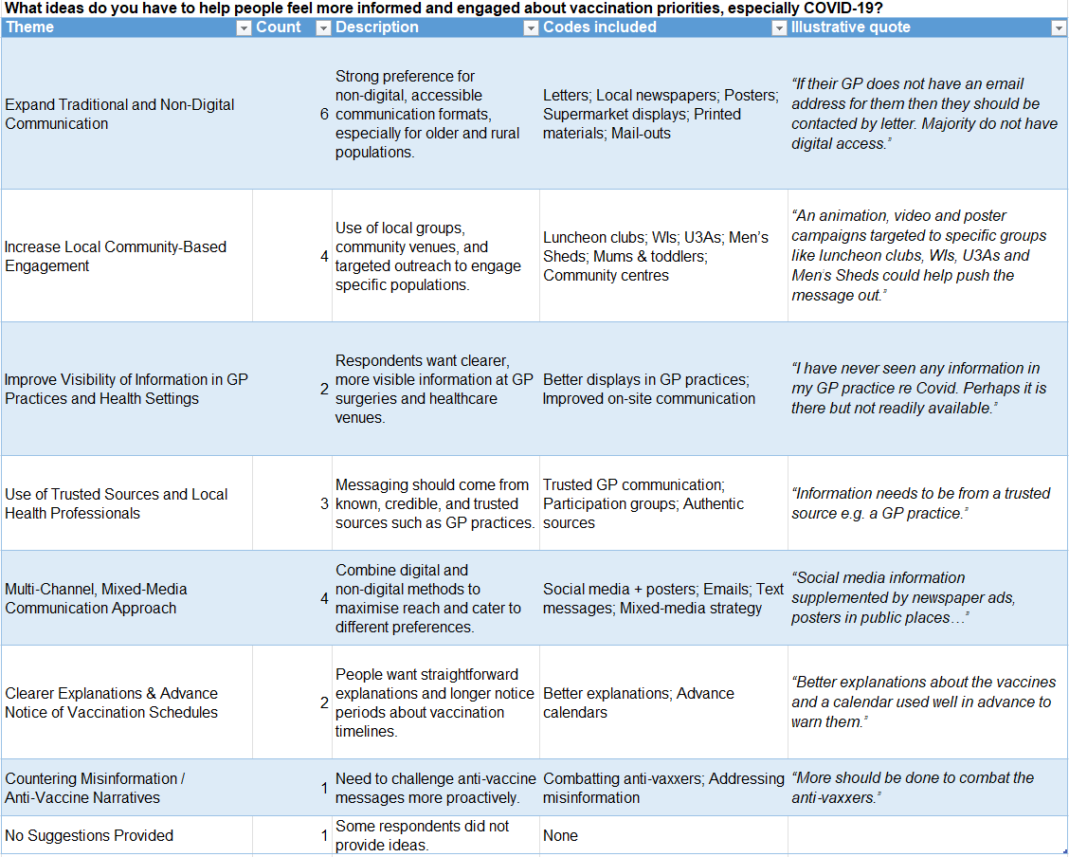
This strong preference for traditional communication aligns with the quantitative results, which indicated fewer than half of respondents believed eligible citizens routinely use digital tools to access vaccination information.

In addition to the broader non-digital communication theme, four respondents highlighted community-based engagement, such as outreach through local groups, community venues, and familiar social settings, as a practical means of increasing reach and improving trust. Community-based engagement represents another form of non-digital communication resonates with the rural, dispersed, and ageing demographic profile of Powys and reflects local preferences for personalised, locality-driven information. Three further themes also demonstrated reliance on, or preference for, non-digital approaches:
- Improving the visibility of information in GP practices and other health settings, where residents expect trusted health information to be readily available.
- Using trusted sources and local health professionals, reflecting the continued importance of interpersonal and relationship-based communication within rural health systems.
- Adopting a multi-channel or mixed-media communication strategy, which respondents viewed as necessary to ensure accessibility across a population with varied digital capability and communication preferences.
Taken together, five of the seven qualitative themes, representing most findings, emphasise the continued importance of non-digital forms of communication. This conveys a clear and consistent message: for residents of Powys, effective engagement with vaccination priorities relies on communication strategies that extend beyond digital platforms, incorporating trusted, familiar, and locally accessible channels to ensure inclusivity and reach. This reliance on non-digital communication is reflected in the comparatively lower digital maturity score for this dimension, which was assessed at 51.5%.

4.5 Research Objective 4 Results: Integration

Data for Research Objective Four was generated through informal semi-structured interviews with key DHCW personnel, conducted via Microsoft Teams, and through documentary analysis of the WIS 2.0 User Guide and the SAD. The findings relate to three core areas of digital integration:

- Interoperability with national data platforms
- Real-time data exchange; and
- Access to vaccination information across settings, including patient-facing access.

  - Integration with the National Data Resource (NDR) and Clinical Data Repository (CDR)
Interview data suggest although WIS 2.0 has been designed to support full interoperability with both the NDR and the CDR, this capability has not yet been implemented operationally. According to a colleague from DHCW, the technical functionality is already embedded within WIS. However, integration requires the NDR and CDR teams to “configure their side so they can ingest vaccines by creating a vaccine profile”. Howe reported this work is planned, with integration expected to be enabled “within the next year”.

Howe highlighted the anticipated benefits of this future integration. Once operational, vaccine data captured in WIS would become centrally accessible through the NDR/CDR infrastructure. A DHCW colleague explained this would allow other clinical systems to retrieve vaccine information when required, supporting a unified vaccination record across NHS Wales and improving interoperability across digital services.

Documentary analysis further confirmed WIS continues to operate with its existing suite of integrations. A rich picture, produced using Microsoft Visio using the information in the SAD, illustrates the current and planned integration architecture of WIS in a visual format (Figure 9).

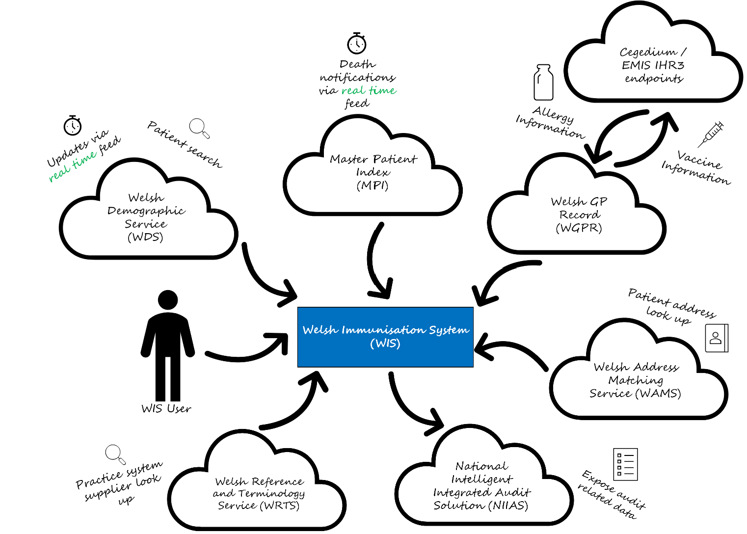
Figure 9

  - Real time updates
The systems-level mapping also confirmed WIS supports real-time data updates with the Welsh Demographic Service (WDS) and the Master Patient Index (MPI), ensuring vaccination events are consistently linked to accurate and up-to-date patient demographic information at the point of care. Interview data provided further clarification regarding the flow of GP record information into WIS. Participants explained GP data do not populate WIS directly. Instead, WIS users can view relevant GP-held information, specifically allergy status and previous vaccinations, through the patient record interface. This information is accessed dynamically and is not stored within WIS itself. Although participants believed this access to operate via a real-time feed, the SAD did not explicitly confirm this mechanism. As such, while the interviews provide useful insight, the real-time nature of this GP data linkage cannot be definitively verified through documentary evidence alone.

  - Access across all care settings
Interview data indicate despite the delayed integration with the NDR/CDR, WIS is already fully accessible across all care settings involved in COVID-19 vaccination delivery.

  - Patient-facing access to vaccination record
Access for patients emerged as a further area of incomplete integration. DHCW personnel reported “there is currently no patient-facing access to vaccination records yet but there are plans to get this into the NHS Wales App. We are looking to start engagement on this towards the end of this year”. This finding aligns with wider organisational plans to expand patient digital services.
Although WIS was described in the literature as the “first national online rebooking service for COVID-19 vaccinations” (Government and Cymru, 2022), interviews clarified the only patient-facing element, a rebooking website, was decommissioned in July of the previous year. According to DHCW staff, the service was discontinued because it was “expensive to maintain” and had low utilisation due to the Welsh “pull” model of vaccine delivery, in which individuals are proactively assigned an appointment and issued an invitation rather than self-booking.
In accordance with the methodology for determining whether the integration dimension meets the 80% “applies” threshold, the findings are summarised in Table 17 below:

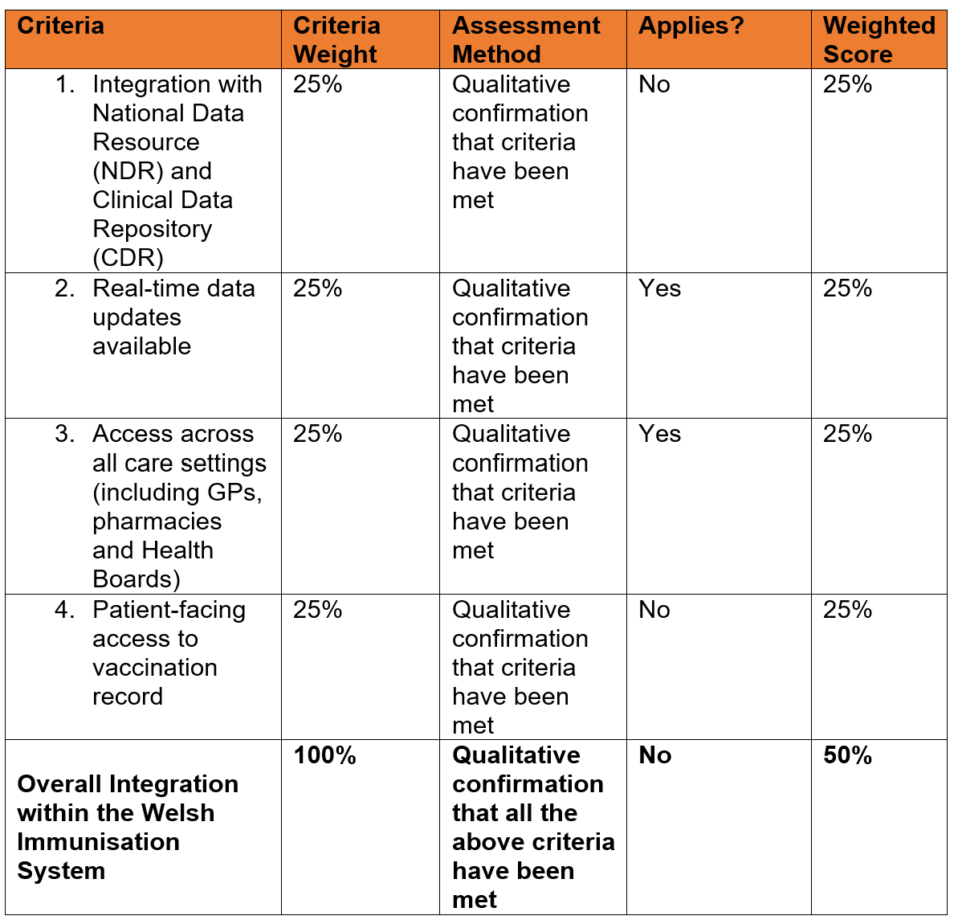

Table 17
Evaluation against the predefined assessment criteria demonstrates 50% of the required integration components are operational within the COVID-19 vaccination pathway using the mean-aggregated approach.

4.6 Conclusion

Overall, the findings indicate only one of the four dimensions met the “applies” maturity criterion of 80%. In line with the benchmark defined earlier in this dissertation, this resulted in the process digitisation dimension achieving the required threshold, meaning the Immunisation and Vaccination Service met one of the four available maturity grades.

5 Discussion

5.1 Introduction

This chapter interprets the findings presented in the previous chapter in relation to the study’s research criteria and the wider literature. It explores the meaning and implications of the results, examines how they align with or differ from existing evidence, and considers the operational and organisational factors which explain the observed patterns. Limitations of the study are also discussed and recommendations for future research and digital development within the service.

5.2 Digital Competency

The findings from the digital competency survey provide insight into employees perceived ability to engage effectively with digital systems and processes. These results align with Ala-Mutka’s definition of digital competence as “having sufficient skills and capability to be efficient with digital processes and devices” (Ala-Mutka, 2011), suggesting respondents generally possess the baseline capability expected within a healthcare environment. Although competency levels varied across demographic groups, survey items relating to access and general use of digital systems showed consistently high levels of self-reported capability. Over 80% of respondents strongly agreed or agreed they could access digital devices and systems and use them either very well or well enough to undertake the duties of their role, with WIS reported as the tool staff felt most competent using, followed by Microsoft Outlook and Word. This suggests, overall, the workforce perceives itself as digitally capable, although, correlation analysis did suggest employees within younger age groups reported higher levels of competency on the three digital tools employees felt most competent using.

However, the final survey item, which explored confidence in using digital tools without additional support or training, demonstrated a notable decline in agreement levels. This indicates competence does not necessarily equate to confidence, highlighting a potential gap between ability to use digital tools effectively and feeling fully assured in doing so without further assistance. Digital tools such as Power BI Dashboards and the Digital Services Portal contributed to this decline, with respondents commonly selecting neutral responses or indicating they would benefit from additional training or support. However, awareness of these specific digital tools also saw a decline, indicating specialist or less frequently used systems may be less visible or less integrated into routine workflows by both clinical and administrative staff. Furthermore, frequency increased for responses of ‘Not applicable to my role’ for these tools, which may suggest limited exposure to these tools. Nevertheless, lower competence scores, among those for whom the tools are applicable, still signals targeted areas for development.

The overall achievement of 80% for this dimension was narrowly missed by just under 2%, suggesting while foundational elements of digital competency appear to be largely in place, there remain gaps in confidence and knowledge preventing the organisation from demonstrating full digital maturity. The final criteria within this dimension had a particularly marked impact on the overall score, with only an average of 50.3% indicating digital maturity in terms of not requiring further support or training, despite higher competency levels for the other items. These findings indicate a consistent pattern in which staff are generally able to use digital tools to meet the demands of their roles, yet a substantial proportion still feel they would benefit from further development. This highlights a clear ongoing need to strengthen training provision to support the workforce in progressing from digitally functional use towards more advanced and confident engagement across a wider range of digital platforms.

5.3 Process Digitisation

The findings relating to the digital maturity of Immunisation and Vaccination Service processes focused on the extent to which key operational functions, such as booking systems, consent processes, communication channels, and data-recording mechanisms, are supported by digital tools. The criteria for this dimension were derived from the NIF, which outlines the components required to deliver a person-centred, digitally enabled vaccination journey.

Observations conducted with the Bookings Team and within Vaccination Centres indicated day-to-day operational workflows are predominantly digital. For COVID-19 appointments specifically, WIS is used to allocate appointment slots and generate SGAs, while digital consent processes and secure, structured data-recording functions are routinely embedded in practice. These findings suggest the core digital mechanisms required to support an efficient and consistent vaccination pathway are well established and functioning effectively.

Although this dimension achieved 100% of the criteria within the digital maturity model, the data-flow maps (figures 4 and 5) reveal areas where digitalisation remains incomplete. Microsoft Excel spreadsheets continue to be used to support several workflow elements, including:
- Waitlist management
- Citizen amendments
- Check-in
- Daily appointment figures

The continued reliance on spreadsheets indicates some processes still operate outside WIS and therefore lack full integration into formal digital workflows. While the service performs strongly against the defined criteria, manual workarounds demonstrate end-to-end digital integration has not yet been fully realised. They present opportunities to further strengthen process digitisation and enhance standardisation, data quality, and operational efficiency.

Furthermore, although a 25% weighted score was allocated because automated communication with citizens is in place, it is important to acknowledge individuals cannot select their preferred method of contact. Patients are proactively assigned an appointment and issued an invitation letter, supplemented by automated SMS reminders. While these mechanisms satisfy the technical requirement for automated communication, the absence of user-selected contact preferences deviates from a fully person-centred approach.

Although the communication processes met the maturity model’s defined threshold for this dimension and therefore received a score of 100%, the findings indicate that these processes are not yet fully aligned with the broader principles of personalised digital care. This suggests that the 100% score may over-represent the true extent of process digitalisation when considered beyond the model’s predefined criteria. However, the maturity assessment was conducted using a consistent methodological approach across all dimensions, based on mean score calculations and strict adherence to the criteria specified within NIF. As all required indicators for this dimension were satisfied, awarding a score below 100% would have required reinterpretation or modification of the framework, which would have compromised consistency and comparability across dimensions.

5.4 Citizen Engagement

The findings from the citizen engagement dimension of the study provided insight into stakeholder views on the mechanisms used in Powys to engage citizens around COVID-19 vaccination appointments. This enabled the dissertation to examine how effective these mechanisms were perceived to be, and the extent to which citizens were appropriately informed, supported and engaged throughout the vaccination process, from the perspective of individuals closely involved in citizen engagement activities. The literature review informed the development of the criteria for this dimension, as well as the description of the citizen-centredness dimension within the digital maturity model, ensuring the assessment framework reflected both established evidence and the principles underpinning person-centred digital engagement.

The survey item generating the highest level of agreement was the statement “non-digital methods (posters, postal letters, phone calls) are important for sharing vaccination information with eligible citizens.” Although literature suggests the pandemic accelerated the use of social media and digital platforms in public health communication (Zang et al., 2023) the survey findings do not support social media as an effective communication channel in this context. Social media has been described as a “double-edged sword,” with potential to facilitate misinformation and undermine trust in vaccination programmes (Honora, Wang and Chih, 2022). This concern was reflected in the findings of this dissertation, as not one respondent strongly agreed or agreed information on social media regarding COVID-19 vaccine safety and effectiveness was accurate, and only one respondent viewed social media as the best way to reach eligible groups. The role of anti-vaccine activists in amplifying mistruths online may help to explain these low levels of trust (Carpiano et al., 2023). Trust in official information sources also appeared fragile. Respondents were largely uncertain about whether people trust information provided by Welsh Government, Public Health Wales, their GP or the Health Board, with only 36.4% agreeing this was the case. This points to wider challenges in public confidence and the effectiveness of official vaccination messaging.

Findings from the literature review further highlighted gaps in the visibility of vaccination information online. Only three of 16 GP practices in Powys (approximately 19%) displayed COVID-19-related information when searched, a pattern mirrored in the survey results. Just 36% of respondents agreed GP websites provided clear and up-to-date vaccination information, and only 27.3% felt citizens knew where to find accurate information. These findings suggest a need for greater clarity, consistency and accessibility in the digital information available to citizens through primary care and health board platforms. However, the strong preference for non-digital communication methods arguably justifies limited utilisation of GP websites as a primary information source, as if citizens predominantly rely on letters, posters or telephone contact, the perceived importance of maintaining comprehensive online content may be reduced.

These findings therefore indicate a clear preference for traditional, non-digital communication channels and highlight significant concerns regarding the trustworthiness of social media and the accessibility of online information. These patterns underscore the importance of maintaining reliable non-digital communication methods alongside improving the quality, consistency and visibility of digital information sources to better support citizen engagement. Consequently, the overall dimension score was 51.5% using the consistent mean-score approach applied across all dimensions. Although the NIF’s ambition is to create a person-centred digital vaccination journey, the results suggest current engagement mechanisms do not yet fully align with this aspiration. Instead, they indicate many citizens may not yet feel ready or confident to engage with a predominantly digital vaccination campaign. This highlights a potential need to strengthen digital literacy, enabling citizens to “use and understand digital technology and information to effectively participate in society” (Digital Health & Care Institute, 2024), and to ensure future digital engagement approaches are inclusive, accessible and responsive to diverse preferences and capabilities. Given only 57.2% of eligible citizens had a mobile phone number recorded in a usable format (according to data retrieved in October 2025), this further strengthens the argument that digital-only engagement approaches would exclude a substantial proportion of the population. These findings together underline the importance of maintaining multi-channel engagement strategies and highlight, at present, a fully digital vaccination journey would not be equitable or person-centred for the Powys population.

5.5 Integration

The findings to support Research Objective 4 supported this study to examine the integration and functionality of WIS in supporting a unified and accessible digital vaccination record. Through qualitative analysis, this study discovered some elements of integration were outstanding, such as interoperability with the NDR and CDR, which would make vaccination data more centrally accessible. The mapping of existing integrations confirmed WIS successfully exchanges real-time updates with core demographic services such as the WDS and the MPI. This represents an important area of digital maturity, ensuring accurate patient identification and demographic consistency. However, the mechanism for accessing GP-held data remains unclear. Although allergy and immunisation history can be viewed through the WIS interface, the SAD did not confirm whether this occurs through a real-time feed or a different technical arrangement. In addition, access across care settings was largely strong, with WIS being used consistently in COVID-19 vaccination delivery.

A notable integration gap relates to patient-facing access. Although plans exist to surface vaccination records through the NHS Wales App, this capability is not yet available. The decommissioning of the previous patient rebooking website, due to low utilisation and high maintenance costs, illustrates the complexity of delivering patient-facing digital services that are both cost-effective and aligned with the operational “pull” model, in which appointments are proactively issued rather than self-booked. While this means patient-initiated rebooking may be less critical, the absence of any digital route for citizens to view their vaccination records restricts opportunities for transparency, autonomy and self-management, and places Powys behind emerging national expectations for personalised digital health access. When considered alongside the findings from the citizen engagement survey, which showed a strong preference for non-digital communication and limited trust in digital information sources, the lack of patient-facing functionality becomes even more understandable. Demand for these services in Powys is likely to be relatively low at present, suggesting citizen digital readiness may be a limiting factor in the realisation of a fully integrated, person-centred digital vaccination journey.

Taken collectively, these findings explain why only 50% of the integration criteria were met using the mean-score approach. Although WIS demonstrates several strong integration features, particularly real-time demographic synchronisation and a system architecture designed for future interoperability, key components such as national data connections, consistent GP data exchange, and patient-facing access remain incomplete. Furthermore, qualitative findings from the employee survey highlight integration challenges are also experienced at the operational level. Respondents reported access to GP records within WIS would benefit their roles, suggesting the current functionality is not perceived as reliable or fully integrated in practice. This discrepancy between the technical capability illustrated within the solution design and the lived experience of end-users reinforces the conclusion integration maturity is only partially realised, and that both technical and organisational factors continue to constrain the achievement of fully integrated vaccination workflows.

Powys’ integration maturity reflects a system that is progressing, but still constrained by national dependencies, only allowing it to reach a 50% digital maturity score.

5.6 Limitations

Several limitations should be considered when interpreting the findings of this dissertation. Firstly, although the digital competency survey aimed to assess employees’ skills and capabilities, it is possible the items measured perceived confidence rather than actual competence. This risk is particularly relevant where respondents indicated they were able to perform digital tasks but lacked confidence in using digital tools independently or without support. The distinction between digital competency and digital literacy is therefore important when interpreting these results. Digital literacy refers to “the ability to use and understand digital technology and information to effectively participate in society” (Digital Health & Care Institute, 2024). and the survey findings suggest the responses may have reflected employees’ ability to use digital technology to participate in workplace activities, rather than competence in using digital processes and devices.

The decision to apply an 80% threshold to determine whether each maturity dimension was met represents another limitation. Although this value was selected as a pragmatic benchmark to support consistency, the use of a different threshold, or an alternative evaluative approach such as a balanced scorecard, could have produced different maturity outcomes. Applying the same threshold across all dimensions ensured each component was judged against an identical criterion. However, the relatively high threshold may have reduced the likelihood that any dimension would be classified as digitally mature, potentially underestimating areas of digital maturity. In addition, neutral responses were excluded from the scoring as they could not be fairly interpreted as either applying or not applying to a given criterion. This decision avoided artificially inflating results where respondents expressed uncertainty or indifference. However, had neutral responses been categorised within the ‘applies’ category, the digital maturity scores for some dimensions, particularly those with high proportions of neutral responses, may have been higher. This further illustrates the sensitivity of the final maturity grading to decisions made during the scoring process.

The study was further constrained by data availability. It was not possible to analyse SMS delivery reports from GOV.UK Notify due to the sensitive personal data they contain, meaning the effectiveness of automated messaging, specifically how many messages were successfully delivered, could not be assessed. Similarly, uptake data by locality was unavailable, preventing exploration of whether geographical variations in uptake were linked to different engagement mechanisms across Powys. A further limitation relates to the scope and representativeness of the citizen engagement data. The survey did not collect respondent locality information, which restricted the ability to conduct spatial comparisons or explore whether engagement patterns differed across Powys. In hindsight, follow-up interviews could have helped address this gap by providing richer qualitative insight into local variations in digital engagement, and their absence represents a missed opportunity to deepen understanding in this area. Additionally, this dissertation highlighted the limited availability of PPI groups across Powys, with only four established groups out of the 26 GP practices in the county. All four groups were in Mid-North Powys, meaning perspectives from South Powys were not represented in the survey responses either. This lack of geographical coverage further limits the generalisability of the findings, particularly in relation to citizen engagement.

Finally, although the integration analysis drew on interviews and system documentation, uncertainties remained. The exact mechanism through which GP record information is accessed within WIS could not be verified from the SAD, limiting the ability to fully confirm the integration pathway. While this dissertation aimed to assess how digitally mature PTHB’s Immunisation and Vaccination Service is in delivering a person-centred digital vaccination journey, the criteria used was constrained by the definitions set out within the NIF. As a result, the overall maturity grading reflects not only PTHB’s digital capabilities, but also the scope, design, and limitations of the national framework in which WIS operates. This means digital maturity outcomes cannot be reliant solely to local efforts, as progress is dependent on national infrastructure, governance, and system development.

5.7 Conclusion

Overall, this chapter has shown while Powys’ Immunisation and Vaccination Service demonstrate strong digital foundations, particularly in the digitalisation of operational processes and the generally high capability of employees, despite narrowly missing the 80% threshold, gaps remain across workforce confidence, citizen engagement, and system integration. Employees typically view themselves as digitally capable, but lower confidence in using more unfamiliar tools highlights the need for continued training and tailored support.

Although core vaccination workflows are highly digitised, the continued reliance on spreadsheets and the limited capacity for personalised communication indicate that fully end-to-end digital pathways are not yet embedded. These findings suggest that elements of the service remain partially digitised, with manual processes persisting alongside digital systems. Comparative analysis with other health boards would have provided valuable contextual insight into whether these workflow patterns are typical across Wales or reflect a relative lag or strength in Powys’ digital maturity within this domain.

Citizen engagement emerged as one of the least digitally mature dimensions, characterised by low trust in online information, a strong preference for traditional communication channels, and limited digital readiness within the population. Integration results revealed a similar picture, with a 50% digital maturity score indicating strong demographic synchronisation but persistent challenges relating to GP data exchange, national interoperability, and the absence of patient-facing digital access.

These findings indicate digital maturity within PTHB’s Immunisation and Vaccination Service is progressing but remains uneven, shaped by both technical constraints and human factors. The limitations outlined earlier emphasise the need for cautious interpretation. Nonetheless, the insights gained provide a clear basis for identifying targeted improvements, although progress will largely depend on developments within the national digital system, WIS, and ongoing collaboration with the partner organisation, DHCW.

6 Conclusion

This dissertation set out to assess the digital maturity of PTHB’s Immunisation and Vaccination Service in delivering a person-centred digital vaccination journey, in line with the ambition outlined by the Welsh Government in the NIF. To achieve this, the research examined four core areas central to a digitally enabled vaccination pathway, as the literature review demonstrated: the digital competence of employees, the extent of process digitisation, the effectiveness of citizen engagement mechanisms, and the integration and functionality of WIS. The decision to focus on these domains was informed by the research objectives of this dissertation and existing literature which identifies these elements as central features of several digital maturity models. In particular, the German Health Authorities’ model aligned closely with the research objectives of this dissertation due to its emphasis on both technological and human factors, unlike models such as HIMSS EMRAM and the DHI, which offered more limited applicability to the public-health vaccination context. This dissertation therefore applied a mixed methods approach to examine each of these areas and assign an overall digital maturity grading for PTHB.

The research undertaken for this dissertation, as evidenced in the Results chapter, indicates each of the four areas exhibits differing levels of digital maturity, reflecting varied progress across the service. Although the digital competency survey did not strictly meet the 80% threshold, it fell short by less than 2%, suggesting employees capability remains relatively strong and is approaching a mature level. In contrast, the process digitisation dimension achieved full compliance with the maturity criteria, highlighting notable strengths in this area.

Citizen engagement demonstrated lower levels of digital maturity within this evaluation. Although information regarding COVID-19 vaccination was perceived as being shared fairly and citizens generally reported high levels of trust in information from the Welsh Government, Public Health Wales, GPs, and PTHB, the effectiveness of digital engagement mechanisms was limited. Low confidence in the accuracy of social media content, alongside perceptions that eligible citizens infrequently use digital tools such as the internet, email, text messaging, or social media, contributed to this outcome. As digital communication was not viewed as effective in promoting vaccine uptake, neither was it perceived that Powys residents engage with digital tools, the digital maturity grading for this dimension was reduced. This finding reflects a continued preference for traditional communication methods, which currently contrasts with the strategic ambition of achieving a fully digital person-centred vaccination journey.

Integration findings presented a similarly mixed picture. While WIS performs strongly in supporting process digitisation, key integration elements remain outstanding, including interoperability with the NDR and the CDR, which WIS 2.0 was designed to support. Patient-facing functionality has also regressed, with the withdrawal of the online rebooking system. Furthermore, Wales appears to be progressing more slowly than England, where citizens can already use the NHS App to book or manage COVID-19 vaccination appointments. Strengthening digital literacy among Powys residents may therefore be necessary to support future digital engagement and ensure citizens can “use and understand digital technology and information to effectively participate in society” (Digital Health & Care Institute, 2024). Nonetheless, despite digital communication challenges, the most recent COVID-19 campaign achieved the highest uptake in Wales, suggesting a solely digital approach may not be essential for maintaining strong vaccination uptake in Powys since the population is relatively compliant already.

One implication of this dissertation is that each digital maturity dimension was assessed against an 80% benchmark to determine whether it met the agreed threshold for maturity. While this approach may be viewed as restrictive, it is consistent with precedents established in existing literature. The German Health Authorities employ a comparable benchmark within their digital maturity assessment framework, and widely used instruments such as the HIMSS EMRAM apply an even more stringent threshold of 90%. The use of an 80% benchmark therefore represents a balanced standard, providing sufficient methodological rigour while remaining appropriate for the public health service context under evaluation. Furthermore, the use of a mean-aggregated, equally weighted scoring approach may have constrained dimension-level scores, particularly where individual criteria within a dimension were unevenly met. However, limitations were encountered in fully assessing the comparability of scoring approaches, as detailed methodological information outlining how the German Health Authorities and HIMSS EMRAM calculate and aggregate percentage scores for their respective maturity stages was not publicly available. Alongside the use of fixed benchmark thresholds and aggregation methods, the decision to exclude “neutral” responses from the analysis likely influenced the final graded outcomes. Given the high number of neutral responses in some survey items, their inclusion within the “applies” category could have increased the digital maturity scores for certain dimensions. However, this dissertation argued a neutral response does not indicate agreement or disagreement and therefore should not be counted towards the attainment of a criterion, ensuring fairness and transparency in the scoring process.

In relation to process digitisation, the criteria were defined directly from the NIF. As a result, although some internal workflows remain “clunky” and reliant on spreadsheets, these issues did not affect the maturity grading because the assessment was anchored to the NIF’s specific definitions rather than broader interpretations of full digital integration. Data availability constraints also meant SMS delivery reports from GOV.UK Notify could not be analysed, preventing assessment of whether citizens were receiving digital reminders as intended. Likewise, uptake data by locality was unavailable, limiting exploration of whether geographical differences in engagement were linked to variations in communication methods across Powys.

Despite these implications and limitations, the study was able to conclude digital maturity within PTHB’s Immunisation and Vaccination Service is evident, with one, and almost two, of the four dimensions meeting the maturity grading:

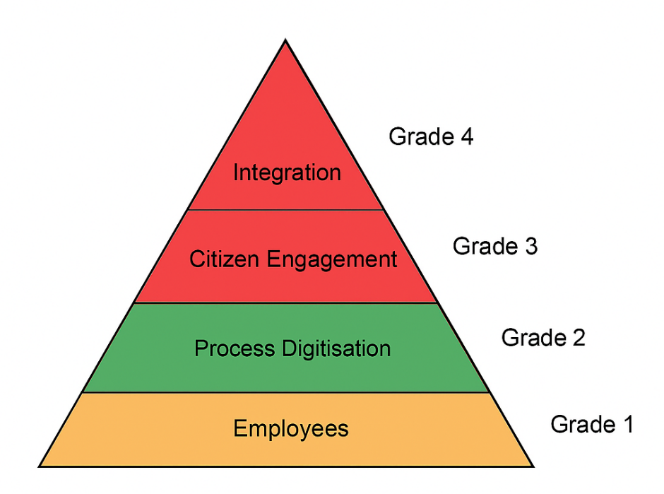

Dimensions that achieved the 80% threshold are highlighted in green, while those that did not meet the threshold are shown in red. The Employees dimension is displayed in amber, indicating that it narrowly fell short of the 80% grading.

This outcome aligns with findings from other digital maturity models, such as HIMSS EMRAM, where many health boards similarly did not progress beyond early stages due to stringent criteria, including the 90% threshold (Table 8). This alignment provides reassurance the results emerging from this dissertation are consistent with patterns observed in wider digital maturity assessments. Although the overall grading suggests PTHB’s Immunisation and Vaccination Service is at a low grading, and relatively early stage of digital maturity, it is important to recognise each dimension contained clear examples of positive digital practice. These pockets of strength are not fully captured within the aggregate grading but nonetheless demonstrate meaningful progress and offer a solid foundation on which to build further digital development.

Taken together, these findings suggest several priorities for future work. Enhancing workforce digital confidence, through targeted training and development, would help address gaps identified in confidence levels. Whilst processes on the surface appear digitised, exploring alternatives to spreadsheet-based workflows, such as developing an internal application or dedicated digital tool, could further advance the service’s digital maturity by reducing manual workarounds and providing staff with an additional, purpose-built digital system to support their roles. Such developments would not only streamline internal processes but also contribute to a more consistent, end-to-end digital pathway for vaccination delivery.

Equally, improving understanding of citizen digital readiness is important. With only four PPI groups established across 16 GP practices in Powys (excluding satellite surgeries), current engagement structures do not fully represent the diversity of local communities, particularly in South Powys. Further research involving direct engagement with citizens would therefore be valuable before implementing new patient-facing systems or integrations. Given perceptions that some eligible citizens may have lower digital literacy, careful consideration should be given to how future digital enhancements might impact vaccination uptake, especially as Powys has historically achieved high coverage rates. Allowing citizens to choose their preferred method of communication would also support a more flexible, inclusive approach to a digital vaccination journey in Powys.

Overall, this dissertation concludes that PTHB’s Immunisation and Vaccination Service demonstrates low to moderate digital maturity, characterised by strong internal digitisation and workforce digital competence, but more limited maturity in digital citizen engagement and system integration when assessed against the requirements of a fully person-centred digital vaccination journey.

References

About Us | Llais (no date). Available at: https://www.llaiswales.org/about-us (Accessed: 13 November 2025).

Ala-Mutka, K. (2011) Mapping Digital Competence: Towards a Conceptual Understanding, Report. Available at: https://www.researchgate.net/publication/340375234_Mapping_Digital_Competence_Towards_a_Conceptual_Understanding (Accessed: 24 November 2025).

Bhatia, R. (2020) ‘Public engagement is key for containing COVID-19 pandemic’, The Indian Journal of Medical Research, 151(2–3), p. 118. doi:10.4103/IJMR.IJMR_780_20.

BPMN Specification - Business Process Model and Notation (no date). Available at: https://www.bpmn.org/ (Accessed: 19 March 2026).

Brooks, D.J. et al. (2024) ‘Developing National Information Systems to Monitor COVID-19 Vaccination: A Global Observational Study’, JMIR Public Health and Surveillance, 10(1), p. e62657. doi:10.2196/62657.

Carpiano, R.M. et al. (2023) ‘Confronting the evolution and expansion of anti-vaccine activism in the USA in the COVID-19 era’, The Lancet, 401(10380), pp. 967–970. doi:10.1016/S0140-6736(23)00136-8.

Creswell, J.W. and Plano Clark, V.L. (2011) Designing and Conducting Mixed Methods Research. SAGE Publications.

Rimpiläinen, S., Bosnic, I. and Savage, J. (2024) ‘How to navigate the digital shift in healthcare? An international review and analysis of frameworks used to support digital working by frontline healthcare staff’. doi:10.17868/strath.00087702.

Digital Health and Care Wales (2022) Welsh Immunisation System reaches 7 million vaccination milestone - Digital Health and Care Wales. Available at: https://dhcw.nhs.wales/news/latest-news/welsh-immunisation-system-reaches-7-million-vaccinations-milestone. (Accessed: 2 April 2025).

Digital Health and Care Wales (2025) Vaccination system frees up time for more patient interactions. Available at: https://dhcw.nhs.wales/news/latest-news/vaccination-system-frees-up-time-for-more-patient-interactions. (Accessed: 12 December 2025).

Digital Health and Care Wales (no date a) The Welsh Immunisation System: Building a Lasting Legacy. Available at: https://dhcw.nhs.wales/news/in-depth/the-welsh-immunisation-system-building-a-lasting-legacy. (Accessed: 15 November 2025).
European Centre for Disease Prevention and Control (2023) COVID-19 Vaccine Tracker | European Centre for Disease Prevention and Control. Available at: https://vaccinetracker.ecdc.europa.eu/public/extensions/COVID-19/vaccine-tracker.html#uptake-tab (Accessed: 12 December 2025).

Eymann, T. et al. (2023) ‘The maturity model for the public health service-a tool for assessing and improving the digital maturity level of German public health agencies’, Bundesgesundheitsblatt, Gesundheitsforschung, Gesundheitsschutz, 66(2), pp. 136–142. doi:10.1007/S00103-022-03643-7.

Friedman, C.P., Wyatt, J. and Ash, J.S. (2022) Evaluation methods in biomedical and health informatics. Springer.

Government, W. (2025) ‘A report from the Ministerial Advisory Group on NHS Wales Performance and Productivity’.

Government, W. and Cymru, L. (2022) ‘National Immunisation Framework for Wales’.
GOV.UK Notify (no date) Performance Data. Available at: https://www.notifications.service.gov.uk/features/performance (Accessed: 25 February 2026).

Health Education and Improvement Wales (2023) Digital Capability Framework. Available at: https://heiw.nhs.wales/files/dcf-2024/ (Accessed: 8 April 2026).

Honora, A., Wang, K.Y. and Chih, W.H. (2022) ‘How does information overload about COVID-19 vaccines influence individuals’ vaccination intentions? The roles of cyberchondria, perceived risk, and vaccine skepticism’, Computers in Human Behavior, 130. doi:10.1016/J.CHB.2021.107176.

Howe, J. (2025) Solution Architecture Document For WIN2WEB.

National Immunisation Office (2024) ‘National Immunisation Office Strategic Plan 2024-2027’.

Leedy, P.D. (2020) ‘Practical research: planning and design / Paul D. Leedy, late of American University and Jeanne Ellis Ormrod, University of Northern Colorado (Emerita); with Laura Ruth Johnson, Northern Illinois University.’, p. 479. Available at: https://students.aiu.edu/submissions/profiles/resources/onlineBook/a2g3B6_Practical%20Research_%20Planning%20And%20Design-2020.pdf (Accessed: 10 April 2025).

Morrison, C. et al. (2022) Emerging Trends in Digital Health and Care: A Refresh post-COVID. doi:10.17868/strath.00082203.

National Audit Office (2020) ‘Report - Value for Money - Digital transformation in the NHS’, p. 57. Available at: https://www.nao.org.uk/reports/the-use-of-digital-technology-in-the-nhs/ (Accessed: 15 November 2025).
NHS 111 Wales (no date) NHS 111 Wales - Services near you. Available at: https://111.wales.nhs.uk/LocalServices/Default.aspx?s=GPSurgeries (Accessed: 24 November 2025).

NHS England (no date) NHS England » Digital maturity assessment. Available at: https://www.england.nhs.uk/digitaltechnology/connecteddigitalsystems/digital-maturity-assessment/ (Accessed: 20 February 2026).

NHS England Digital (2026a) Record a Vaccination Service. Available at: https://digital.nhs.uk/services/vaccinations-point-of-care/record-a-vaccination-service (Accessed: 12 December 2025).

Ofcom (2020) Effects of Covid-19 on TV viewing.

Pavia, G. et al. (2024) ‘Integrating Digital Health Solutions with Immunization Strategies: Improving Immunization Coverage and Monitoring in the Post-COVID-19 Era’, Vaccines 2024, Vol. 12, Page 847, 12(8), p. 847. doi:10.3390/VACCINES12080847.

Pennisi, F., Genovese, C. and Gianfredi, V. (2024) ‘Lessons from the COVID-19 Pandemic: Promoting Vaccination and Public Health Resilience, a Narrative Review.’, Vaccines, 12(8). doi:10.3390/vaccines12080891.

Phiri, P. et al. (2023) ‘Digital Maturity Consulting and Strategizing to Optimize Services: Overview’, Journal of Medical Internet Research, 25. doi:10.2196/37545.

Van Poelgeest, R. et al. (2017) ‘Level of Digitization in Dutch Hospitals and the Lengths of Stay of Patients with Colorectal Cancer’. doi:10.1007/s10916-017-0734-3.
Powys Teaching Health Board (2025b) COVID-19 Vaccination. Available at: https://pthb.nhs.wales/staying-healthy/immunisation-and-vaccines/covid-19-vaccination/ (Accessed: 12 December 2025).

Public Health Scotland (no date) Vaccine Management Tool. Available at: https://www.publichealthscotland.scot/population-health/health-protection/infectious-diseases/covid-19/covid-19-vaccine-delivery-and-workforce-information/vaccine-management-tool/ (Accessed: 12 December 2025).

Public Health Wales (2026) Rapid COVID-19 Surveillance Latest Vaccination Summary. Available at: https://public.tableau.com/app/profile/public.health.wales.health.protection/viz/COVID-19vaccination-Public_17016821876630/Vaccination?publish=yes (Accessed: 19 March 2026).

Public Health Wales (no date a) About Us - Public Health Wales. Available at: https://publichealthwales.nhs.wales/about-us (Accessed: 2 April 2025).
Public Health Wales (no date b) COVID-19 vaccination information - Public Health Wales. Available at: https://phw.nhs.wales/topics/immunisation-and-vaccines/covid-19-vaccination-information/ (Accessed: 24 November 2025).

Public Health Wales (no date c) Immunisation and Vaccines - Public Health Wales. Available at: https://publichealthwales.nhs.wales/topics/immunisation-and-vaccines/ (Accessed: 2 April 2025).

Ratzan, S. et al. (2021) ‘Missing the Point — How Primary Care Can Overcome Covid-19 Vaccine “Hesitancy”’, New England Journal of Medicine, 384(25). doi:10.1056/NEJMp2106137.

Razai, M.S. et al. (2021) ‘Covid-19 vaccination hesitancy’, BMJ, 373. doi:10.1136/BMJ.N1138.

Sarker, R. et al. (2023) ‘The WHO has declared the end of pandemic phase of COVID-19: Way to come back in the normal life’, Health science reports, 6(9). doi:10.1002/HSR2.1544.

Scott, T. et al. (2021) ‘A Community Partnered Approach to Promoting COVID-19 Vaccine Equity’, Health Promotion Practice, 22(6), pp. 758–760. doi: 10.1177/15248399211029954

The Health Foundation (2015) Evaluation: what to consider | The Health Foundation. Available at: https://www.health.org.uk/resources-and-toolkits/quick-guides/evaluation-what-to-consider (Accessed: 15 November 2025).

The Older People’s Commissioner for Wales (2024) ‘Understanding Wales’ Ageing Population: Key Statistics’. Available at: www.olderpeople.wales (Accessed: 19 March 2026).

The Welsh Immunisation System: Building a Lasting Legacy (no date). Available at: https://dhcw.nhs.wales/news/in-depth/the-welsh-immunisation-system-building-a-lasting-legacy/ (Accessed: 2 April 2025).

Welsh Government (2015) A Digital Health and Social Care Strategy for Wales.

Welsh Government (2021) Vaccination saves lives: new toolkit to help employers encourage employees get Covid-19 vaccine | Welsh Government News. Available at: https://media.service.gov.wales/news/vaccination-saves-lives-new-toolkit-to-help-employers-encourage-employees-get-covid-19-vaccine (Accessed: 29 September 2025).

Woods, L., Eden, R., Pearce, A., et al. (2022) ‘Evaluating Digital Health Capability at Scale Using the Digital Health Indicator’, Applied Clinical Informatics, 13(5), pp. 991–1001. doi:10.1055/s-0042-1757554.
Woods, L., Eden, R., Duncan, R., et al. (2022) ‘Which one? A suggested approach for evaluating digital health maturity models’, Frontiers in Digital Health, 4, p. 1045685.
doi:10.3389/FDGTH.2022.1045685/FULL.

World Health Organization (2020) Coronavirus Disease 2019. doi:10.1056/NEJMc2004973.
World Health Organization (2026) A Brief History of Vaccination. Available at: https://www.who.int/news-room/spotlight/history-of-vaccination/a-brief-history-of-vaccination (Accessed: 20 February 2026).

World Health Organization (no date) Coronavirus Disease (COVID-19) Pandemic. Available at: https://www.who.int/europe/emergencies/situations/covid-19 (Accessed: 2 April 2025).
Zang, S. et al. (2023) ‘Applications of Social Media and Digital Technologies in COVID-19 Vaccination: Scoping Review’, Journal of Medical Internet Research, 25. doi:10.2196/40057

Appendices
  - Appendix A

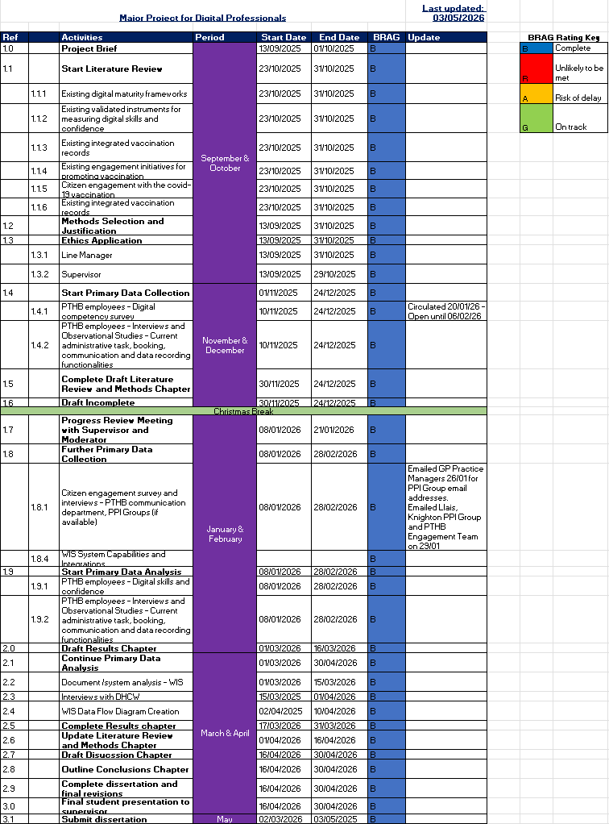

  - Appendix B
Digital Competency Survey

Welcome to the Digital Competency Survey
What does digital competency mean?
It means having the skills and confidence to use digital tools and devices.
Why are we doing this survey?
We want to know how confident staff feel in helping to give people a “person-centred digital vaccination journey.” This is part of the plan for Wales in the NIF.
This survey is part of a Master of Science (MSc) project on Digital Transformation for Health and Care Professions with the University of Wales Trinity Saint David. Your answers are anonymous and very important. They will help us answer the main question: “How ready is PTHB’s Immunisation and Vaccination Service to deliver a person-centred digital vaccination journey?”
This survey should take no more than ten minutes to complete. Most of the questions ask how much you agree or disagree with a certain statement, so please tick the relevant box.
Thank you for taking part.
Section 1: Digital Awareness
I can successfully log into a device (e.g., laptop, tablet, Surface GO/Pro, desktop) to access the required digital systems/applications for my role.
☐ Strongly Agree ☐ Agree ☐ Neutral ☐ Disagree ☐ Strongly Disagree
I am aware of the following digital systems/applications used within PTHB’s Immunisation and Vaccination Service:
WIS (WIS)
☐ Strongly Agree ☐ Agree ☐ Neutral ☐ Disagree ☐ Strongly Disagree
Power BI Dashboards
☐ Strongly Agree ☐ Agree ☐ Neutral ☐ Disagree ☐ Strongly Disagree
Microsoft Teams
☐ Strongly Agree ☐ Agree ☐ Neutral ☐ Disagree ☐ Strongly Disagree
Microsoft Excel
☐ Strongly Agree ☐ Agree ☐ Neutral ☐ Disagree ☐ Strongly Disagree
Microsoft Word
☐ Strongly Agree ☐ Agree ☐ Neutral ☐ Disagree ☐ Strongly Disagree
Microsoft Outlook
☐ Strongly Agree ☐ Agree ☐ Neutral ☐ Disagree ☐ Strongly Disagree
SharePoint
☐ Strongly Agree ☐ Agree ☐ Neutral ☐ Disagree ☐ Strongly Disagree
Digital Services Portal (Halo)
☐ Strongly Agree ☐ Agree ☐ Neutral ☐ Disagree ☐ Strongly Disagree
Section 2: Usage and Knowledge
How often do you engage with the following digital systems/applications in your current role?
WIS
☐ Daily ☐ Several times a week ☐ Weekly ☐ Monthly ☐ Rarely/Never
Power BI Dashboards
☐ Daily ☐ Several times a week ☐ Weekly ☐ Monthly ☐ Rarely/Never
Microsoft Teams
☐ Daily ☐ Several times a week ☐ Weekly ☐ Monthly ☐ Rarely/Never
Microsoft Excel
☐ Daily ☐ Several times a week ☐ Weekly ☐ Monthly ☐ Rarely/Never
Microsoft Word
☐ Daily ☐ Several times a week ☐ Weekly ☐ Monthly ☐ Rarely/Never
Microsoft Outlook
☐ Strongly Agree ☐ Agree ☐ Neutral ☐ Disagree ☐ Strongly Disagree
SharePoint
☐ Daily ☐ Several times a week ☐ Weekly ☐ Monthly ☐ Rarely/Never
Digital Services Portal (Halo)
☐ Daily ☐ Several times a week ☐ Weekly ☐ Monthly ☐ Rarely/Never
Section 3: Rate your level of competence for each system/application:
WIS
☐ I can use this digital tool very well
☐ I can use this digital tool well enough to undertake the duties of my role
☐ I can use this digital tool, but sometimes struggle
☐ I cannot use this digital tool without help
☐ I cannot use this digital tool at all yet
☐ Not applicable to my role
Power BI
☐ I can use this digital tool very well
☐ I can use this digital tool well enough to undertake the duties of my role
☐ I can use this digital tool, but sometimes struggle
☐ I cannot use this digital tool without help
☐ I cannot use this digital tool at all yet
☐ Not applicable to my role
Microsoft Teams
☐ I can use this digital tool very well
☐ I can use this digital tool well enough to undertake the duties of my role
☐ I can use this digital tool, but sometimes struggle
☐ I cannot use this digital tool without help
☐ I cannot use this digital tool at all yet
☐ Not applicable to my role
Microsoft Excel
☐ I can use this digital tool very well
☐ I can use this digital tool well enough to undertake the duties of my role
☐ I can use this digital tool, but sometimes struggle
☐ I cannot use this digital tool without help
☐ I cannot use this digital tool at all yet
☐ Not applicable to my role
Microsoft Word
☐ I can use this digital tool very well
☐ I can use this digital tool well enough to undertake the duties of my role
☐ I can use this digital tool, but sometimes struggle
☐ I cannot use this digital tool without help
☐ I cannot use this digital tool at all yet
☐ Not applicable to my role
Outlook
☐ I can use this digital tool very well
☐ I can use this digital tool well enough to undertake the duties of my role
☐ I can use this digital tool, but sometimes struggle
☐ I cannot use this digital tool without help
☐ I cannot use this digital tool at all yet
☐ Not applicable to my role
SharePoint
☐ I can use this digital tool very well
☐ I can use this digital tool well enough to undertake the duties of my role
☐ I can use this digital tool, but sometimes struggle
☐ I cannot use this digital tool without help
☐ I cannot use this digital tool at all yet
☐ Not applicable to my role
Digital Services Portal (Halo)
☐ I can use this digital tool very well
☐ I can use this digital tool well enough to undertake the duties of my role
☐ I can use this digital tool, but sometimes struggle
☐ I cannot use this digital tool without help
☐ I cannot use this digital tool at all yet
☐ Not applicable to my role
Section 5: Barriers
What problems do you have when using digital tools? (Open-ended)

Section 6: Support Needs
What support would help you feel more skilled and confident when using digital tools?

I would benefit from more training on:
WIS
☐ Strongly Agree ☐ Agree ☐ Neutral ☐ Disagree ☐ Strongly Disagree
☐ Not applicable to my role
Power BI
☐ Strongly Agree ☐ Agree ☐ Neutral ☐ Disagree ☐ Strongly Disagree
☐ Not applicable to my role
Microsoft Teams
☐ Strongly Agree ☐ Agree ☐ Neutral ☐ Disagree ☐ Strongly Disagree
☐ Not applicable to my role
Microsoft Excel
☐ Strongly Agree ☐ Agree ☐ Neutral ☐ Disagree ☐ Strongly Disagree
☐ Not applicable to my role
Microsoft Word
☐ Strongly Agree ☐ Agree ☐ Neutral ☐ Disagree ☐ Strongly Disagree
☐ Not applicable to my role
Microsoft Outlook
☐ Strongly Agree ☐ Agree ☐ Neutral ☐ Disagree ☐ Strongly Disagree
☐ Not applicable to my role
SharePoint
☐ Strongly Agree ☐ Agree ☐ Neutral ☐ Disagree ☐ Strongly Disagree
☐ Not applicable to my role
Other: __________
Section 7: Future Development
Are there any other digital tools or systems would help you in your role?
About You
- Which of the following best describes your role? – Move to end
☐ Clinical – Branching Registered Nursing, Non-Registered nursing
☐ Administrative
- Age Group
Under 25
25–29
30–34
35–39
40–44
45–49
50–54
55–59
60 and above
- Sex
Male
Female
Prefer Not To Say

  - Appendix C
Citizen Engagement Survey
Welcome to the Citizen Engagement Survey

This survey is part of a Master of Science (MSc) project on Digital Transformation for Health and Care Professions with the University of Wales Trinity Saint David.
We are looking at how ready PTHB’s Immunisation and Vaccination Service is to provide a person-centred digital vaccination journey.
We want to understand how people in Powys get information about vaccination priorities and whether digital communication helps more people get vaccinated. Your views on how online tools share information and make communication clear will help us learn if citizens feel well-informed about vaccination priorities.
This survey should take no more than five minutes to complete. Most of the questions ask how much you agree or disagree with a certain statement, so please tick the relevant box.
Thank you for taking part.

Section 1:
People know where to find clear and up-to-date information about all vaccinations, including who is eligible.
☐ Strongly Agree ☐ Agree ☐ Neutral ☐ Disagree ☐ Strongly Disagree
Information about COVID-19 vaccinations is shared as fairly and clearly as information about other vaccinations
☐ Strongly Agree ☐ Agree ☐ Neutral ☐ Disagree ☐ Strongly Disagree

Section 2: Communication Choices
Its important citizens can choose how they get vaccination information (digital and non-digital), for example text message, email, postal letter, phone call.
☐ Strongly Agree ☐ Agree ☐ Neutral ☐ Disagree ☐ Strongly Disagree
Non-digital methods (posters, postal letters, phone calls) are important for sharing vaccination information to eligible citizens.
☐ Strongly Agree ☐ Agree ☐ Neutral ☐ Disagree ☐ Strongly Disagree
Section 3: Effectiveness of Communication
GP practice websites give enough clear and up-to-date information about all vaccinations available to citizens in Powys.
☐ Strongly Agree ☐ Agree ☐ Neutral ☐ Disagree ☐ Strongly Disagree
Social media is the best way to reach eligible groups about vaccination priorities in Powys.
☐ Strongly Agree ☐ Agree ☐ Neutral ☐ Disagree ☐ Strongly Disagree
Powys citizens who are eligible for vaccination often use digital tools like the internet, social media, email or text messages.
☐ Strongly Agree ☐ Agree ☐ Neutral ☐ Disagree ☐ Strongly Disagree
Section 4: Trust
People trust information from the Welsh Government, Public Health Wales, their GP, and the Health Board.
☐ Strongly Agree ☐ Agree ☐ Neutral ☐ Disagree ☐ Strongly Disagree
Information on social media about COVID-19 vaccine safety and effectiveness is mostly accurate and trustworthy.
☐ Strongly Agree ☐ Agree ☐ Neutral ☐ Disagree ☐ Strongly Disagree

Section 6: Working Together
PTHB and GP practices work effectively together to promote vaccinations provided by either the Health Board or the GP practice.
☐ Strongly Agree ☐ Agree ☐ Neutral ☐ Disagree ☐ Strongly Disagree

Open Questions
What do you think makes it hard for Powys citizens to stay informed about vaccination priorities?
What ideas do you have to help people feel more informed and engaged about vaccination priorities, especially COVID-19?
About You
Which best describes your role?
☐ PTHB Staff
☐ GP Practice Staff
☐ Member of PPI Group
Age Group:
☐ Under 25 ☐ 25–29 ☐ 30–34 ☐ 35–39 ☐ 40–44 ☐ 45–49 ☐ 50–54 ☐ 55–59 ☐ 60+
Sex:
☐ Male ☐ Female ☐ Prefer Not to Say

  - Appendix D
APPLICATION FOR ETHICAL APPROVAL
ADAPTED FOR MSC DIGITAL TRANSFORMATION DISSERTATIONS

STUDENTS should submit this form (and receive the outcome) via systems explained to you by the supervisor/module leader.

In order for research to result in benefit and minimise risk of harm, it must be conducted ethically. A researcher may not be covered by the University’s insurance if ethical approval has not been obtained prior to commencement.

The University follows the OECD Frascati manual definition of research activity: “creative work undertaken on a systematic basis in order to increase the stock of knowledge, including knowledge of man, culture and society, and the use of this stock of knowledge to devise new applications”. As such this covers activities undertaken by members of staff, postgraduate research students, and both taught postgraduate and undergraduate students working on dissertations/projects.

The individual undertaking the research activity is known as the “principal researcher”.

Ethical approval is not required for routine audits, performance reviews, quality assurance studies, testing within normal educational requirements, and literary or artistic criticism.

Please read the notes for guidance before completing ALL sections of the form.

This form must be completed and approved prior to undertaking any research activity. Please see Checklist for details of process for different categories of application.

SECTION A: About You (Principal Researcher)
1 | Full Name: |  | Catrin Elizabeth Herdman
2 | Tick all boxes that apply: |  | Member of staff: | ☐ | Honorary research fellow: | ☐
 | Undergraduate Student | ☐ | Taught Postgraduate Student | ☒ | Postgraduate Research Student | ☐

3 | Institute/Academic Discipline/Centre: | IMH
4 | Campus: | Distance learning
5 | E-mail address: | 2312284@student.uwtsd.ac.uk
6 | Contact Telephone Number: | 07983626077
 | For students:
7 | Student Number: | 2312284
8 | Programme of Study: | MSc Digital Transformation for the Health & Care Professions
9 | Director of Studies/Supervisor: | Prof Philip Scott

SECTION B: Approval for Research Activity
1 | Has the research activity received approval in principle?  (please check the Guidance Notes as to the appropriate approval process for different levels of research by different categories of individual) |  | YES | ☒ | NO | ☐
 |  |  |  |  | Date
2 | If Yes, please indicate source of approval (and date where known): Approval in principle must be obtained from the relevant source prior to seeking ethical approval | Research Degrees Committee |  | ☐
2 |  | Institute Research Committee |  | ☐
2 |  | Other  Line Manager |  | ☐ | 24/10/2025

SECTION C: Internal and External Ethical Guidance Materials
 | Please list the core ethical guidance documents that have been referred to during the completion of this form (including any discipline-specific codes of research ethics, location-specific codes of research ethics, and also any specific ethical guidance relating to the proposed methodology). Please tick to confirm that your research proposal adheres to these codes and guidelines. You may add rows to this table if needed.
1 | UWTSD Research Ethics & Integrity Code of Practice | ☒
2 | UWTSD Research Data Management Policy | ☒
3 | [List any other relevant documents here] | ☐

SECTION D: External Collaborative Research Activity
If there are external collaborators then you should gain consent from the contact persons to share their personal data with the university. If there are no external collaborators then leave this section blank and continue to section E.
1 | Institution
2 | Contact person name
3 | Contact person e-mail address
4 | Is your research externally funded? |  | YES | ☐ | NO |  | ☐
5 | Are you in receipt of a KESS scholarship? |  | YES | ☐ | NO |  | ☐
6 | Are you specifically employed to undertake this research in either a paid or voluntary capacity? | Voluntary | YES | ☐ | NO | ☐
7 |  | Employed | YES | ☐ | NO | ☐
8 | Is the research being undertaken within an existing UWTSD Athrofa Professional Learning Partnership (APLP)? | If YES then the permission question below does not need to be answered. | YES | ☐ | NO |  | ☐
9 | Has permission to undertake the research has been provided by the partner organisation? | (If YES attach copy)  If NO the application cannot continue | YES | ☐ | NO |  | ☐

Where research activity is carried out in collaboration with an external organisation
10 | Does this organisation have its own ethics approval system? | YES | ☐ | NO | ☐
 | If Yes, please attach a copy of any final approval (or interim approval) from the organisation (this may be a copy of an email if appropriate).

SECTION E: Details of Research Activity
1 | Indicative title: | Evaluate the Digital Maturity PTHB’s Immunisation and Vaccination Service
2 | Proposed start date: | 01/11/2025 | Proposed end date: | 03/05/2026
Introduction to the Research (maximum 300 words per section)
Ensure that you write for a Non-Specialist Audience when outlining your response to the points below:
- Purpose of Research Activity
- Proposed Research Question
- Aims of Research Activity
- Objectives of Research Activity
Demonstrate, briefly, how Existing Research has informed the proposed activity and explain
- What the research activity will add to the body of knowledge
- How it addresses an area of importance.
3 | Purpose of Research Activity  The research aims to evaluate the digital maturity of the Immunisation and Vaccination Service within Powys Teaching Health Board (PTHB). It seeks to determine whether PTHB is progressing towards a "person-centred digital vaccination journey" as outlined by Welsh Government.
4 | Research Question  How digitally mature is PTHB’s Immunisation and Vaccination Service in delivering a person-centred digital vaccination journey?
5 | Aims of Research Activity  This dissertation aims to assess the digital maturity of Powys Teaching Health Board’s Immunisation and Vaccination Service. The evaluation will focus on four key areas:  - Digitally ready employees  - Process digitisation  - Citizen engagement and consent  - Vaccination record integration  By examining these components, the study will determine the extent to which PTHB has achieved a “digital vaccination journey,” as defined by the National Immunisation Framework “an integrated vaccination record, digital consent processes, and enhanced functionality for booking, communication, and data recording.”
6 | Objectives of Research Activity  - To assess the digital readiness of staff within PTHB’s Immunisation and Vaccination Service, including their confidence and competence in using digital tools.  - To evaluate the extent of process digitisation, focusing on booking systems, communication channels, and data recording functionalities.  - To explore citizen engagement and consent mechanisms, particularly the effectiveness of digital communication in promoting vaccine uptake and how well citizens are engaged with around vaccination priorities.  - To examine the integration and functionality of the Welsh Immunisation System (WIS) in supporting a unified and accessible digital vaccination record.  - To determine whether PTHB’s Immunisation and Vaccination Service aligns with the National Immunisation Framework’s definition of a “digital vaccination journey” to support giving the service an overall digital maturity score.  These objectives not only somewhat align with the criteria of the Maturity Model for the Public Health Service developed by German Health Authorities but also incorporate the Welsh Government's key elements for a person-centred digital vaccination journey.
Proposed methods (maximum 600 words)
Provide a brief summary of all the methods that may be used in the research activity, making it clear what specific techniques may be used. If methods other than those listed in this section are deemed appropriate later, additional ethical approval for those methods will be needed. You do not need to justify the methods here, but should instead describe how you intend to collect the data necessary for you to complete your project.
7 | To evaluate the digital maturity of the Immunisation and Vaccination Service within Powys Teaching Health Board (PTHB), the following methods will be employed:  Quantitative Methods  - Descriptive Statistics: Vaccination uptake figures.  Mixed methods  - Surveys: Employee digital awareness, understanding and confidence, views on how well citizens are engaged with around vaccination priorities & whether Public and Patient Involvement (PPI) groups, Practice Participation Groups, Powys Association of Voluntary Organisations, Powys councillors, and the PTHB Communication and Engagement department think citizens are informed about vaccination priorities  - Interviews: To gain deeper insights into current administrative processes, booking, communication, and recording functionalities and employee views, views on citizen engagement regarding vaccination priorities and understanding of Welsh Immunisation System (WIS) integration capabilities.  Qualitative Methods  - Document Reviews and Analysis: Internal documents and Welsh Immunisation System (WIS).  - Data Maps: To better explain and administrative processes.  - Rich Picture: To better explain integration capabilities of WIS.  - Observational studies: Current administrative processes.  Data Collection Tools  - Microsoft Forms, Teams: For conducting surveys and collecting qualitative data.  Data Analysis Tools  - SPSS, Excel, Power BI: For quantitative data and thematic analysis.  - Microsoft Visio: For process mapping and data flow visualisation.  These methods will ensure a comprehensive evaluation of the digital maturity of PTHB's Immunisation and Vaccination Service, providing valuable insights for future improvements. If additional methods are deemed necessary during the research, further ethical approval will be sought.  (this box should expand as you type)
Location of research activity
Identify all locations where research activity will take place.
8 | PTHB.  (this box should expand as you type)
Research activity outside of the UK
If research activity will take place overseas, you are responsible for ensuring that local ethical considerations are complied with and that the relevant permissions are sought. Specify any local guidelines (e.g. from local professional associations/learned societies/universities) that exist and whether these involve any ethical stipulations beyond those usual in the UK (provide details of any licenses or permissions required). Also specify whether there are any specific ethical issues raised by the local context in which the research activity is taking place, for example, particular cultural and/or legal sensitivities or vulnerabilities of participants. If you live in the country where you will do the research then please state this.
9 | (this box should expand as you type)

10 | Use of documentation not in the public domain: Are any documents NOT publicly available? | NO | ☐
10 |  | YES | ☒
11 | If Yes, please provide details here of how you will gain access to specific documentation that is not in the public domain and that this is in accordance with the current data protection law of the country in question and that of England and Wales.  Internal documents in relation to administrative processes accessible via my NADEX and password for my current role.  Welsh Immunisation System (WIS) Solution Architecture Document  Survey results from Public and Patient Involvement (PPI) groups, Practice Participation Groups, Powys Association of Voluntary Organisations, Powys councillors and the PTHB Communication and Engagement regarding views on how well citizens are informed about vaccination priorities.  (this box should expand as you type)

 | Does your research relate to one or more of the seven aims of the Well-being of Future Generations (Wales) Act 2015? | YES | NO
12 | A prosperous Wales | ☐ | ☐
13 | A resilient Wales | ☒ | ☐
14 | A healthier Wales | ☒ | ☐
15 | A more equal Wales | ☒ | ☐
16 | A Wales of cohesive communities | ☐ | ☐
17 | A Wales of vibrant culture and thriving Welsh language | ☐ | ☐
18 | A globally responsible Wales | ☐ | ☐
19 | If YES to any of the above, please give details:
A Healthier Wales: By evaluating and enhancing the digital maturity of the Immunisation and Vaccination Service, the research contributes to improving public health outcomes.

A Resilient Wales: Ensures PTHB’s Immunisation and Vaccination service is digitally ready for future challenges and a digitally enabled future.

A More Equal Wales: The research will explore barriers within the current service and how the service can be more accessible to those patients who are currently not attending their vaccination appointments.

SECTION F: Scope of Research Activity
 | Will the research activity include: | YES | NO
1 | Use of a questionnaire or similar research instrument? | ☒ | ☐
2 | Use of interviews? | ☒ | ☐
3 | Use of focus groups? | ☒ | ☐
4 | Use of participant diaries? | ☐ | ☒
5 | Use of video or audio recording? | ☐ | ☒
6 | Use of computer-generated log files? | ☐ | ☒
7 | Participant observation with their knowledge? | ☒ | ☐
8 | Participant observation without their knowledge? | ☐ | ☒
9 | Access to personal or confidential information without the participants’ specific consent? | ☐ | ☒
10 | Administration of any questions, test stimuli, presentation that may be experienced as physically, mentally or emotionally harmful / offensive? | ☐ | ☒
11 | Performance of any acts which may cause embarrassment or affect self-esteem? | ☐ | ☒
12 | Investigation of participants involved in illegal activities? | ☐ | ☒
13 | Use of procedures that involve deception? | ☐ | ☒
14 | Administration of any substance, agent or placebo? | ☐ | ☒
15 | Working with live vertebrate animals? | ☐ | ☒
16 | Procedures that may have a negative impact on the environment? | ☐ | ☒
17 | Other primary data collection methods. Please indicate the type of data collection method(s) below. | ☐ | ☒
 | Details of any other primary data collection method:  (this box should expand as you type) | ☐ | ☒
If NO to every question, then the research activity is (ethically) low risk and may be exempt from some of the following sections (please refer to Guidance Notes).

If YES to any question, then no research activity should be undertaken until full ethical approval has been obtained.

SECTION G: Intended Participants
If there are no participants then do not complete this section, but go directly to section H.

 | Who are the intended participants: | YES | NO
1 | Students or staff at the University? | ☐ | ☒
2 | Adults (over the age of 18 and competent to give consent)? | ☒ | ☐
3 | Vulnerable adults? | ☐ | ☒
4 | Children and Young People under the age of 18? (Consent from Parent, Carer or Guardian will be required) | ☐ | ☒
5 | Prisoners? | ☐ | ☒
6 | Young offenders? | ☐ | ☒
7 | Those who could be considered to have a particularly dependent relationship with the investigator or a gatekeeper? | ☐ | ☒
8 | People engaged in illegal activities? | ☐ | ☒
9 | Others. Please indicate the participants below, and specifically any group who may be unable to give consent. | ☐ | ☒
 | Details of any other participant groups:  (this box should expand as you type) | ☐ | ☒

Participant numbers and source
Provide an estimate of the expected number of participants. How will you identify participants and how will they be recruited?
10 | How many participants are expected? | Roughly 52 staff members of the Immunisation and Vaccination Service (this is subject to change depending on any new starters or leavers).  Three Patient Involvement (PPI) groups.  Three PTHB Communication and Engagement Department colleagues.  One Practice Participation Groups.  Powys Association of Voluntary Organisations.  Powys councillors.  Digital Health and Care Wales Welsh Immunisation System Product Owner and Head of Agile Delivery.  (this box should expand as you type)
11 | Who will the participants be? | 52 PTHB Immunisation and Vaccination service employees.  Knighton, Montgomery and Rhayader GP Practice Public and Patient Involvement (PPI) groups, Montgomery Practice Participation Groups, Powys Association of Voluntary Organisations, Powys councillors, PTHB Communication and Engagement Department, colleagues within Digital Health and Care Wales (DHCW).  (this box should expand as you type)
12 | How will you identify the participants? | Eligibility criteria using patient demographics accessible in WIS.  Staff organisational chart.  (this box should expand as you type)

 | Information for participants: | YES | NO | N/A
13 | Will you describe the main research procedures to participants in advance, so that they are informed about what to expect? | ☒ | ☐ | ☐
14 | Will you tell participants that their participation is voluntary? | ☒ | ☐ | ☐
15 | Will you obtain written consent for participation? | ☒ | ☐ | ☐
16 | Will you explain to participants that refusal to participate in the research will not affect their treatment or education (if relevant)? | ☒ | ☐ | ☐
17 | If the research is observational, will you ask participants for their consent to being observed? | ☒ | ☐ | ☐
18 | Will you tell participants that they may withdraw from the research at any time and for any reason? | ☒ | ☐ | ☐
19 | With questionnaires, will you give participants the option of omitting questions they do not want to answer? | ☒ | ☐ | ☐
20 | Will you tell participants that their data will be treated with full confidentiality and that, if published, it will not be identifiable as theirs? | ☒ | ☐ | ☐
21 | Will you debrief participants at the end of their participation, in a way appropriate to the type of research undertaken? | ☒ | ☐ | ☐
22 | If NO to any of above questions, please give an explanation
 | (this box should expand as you type)
24 | Will participants be paid? | ☐ | ☒ | ☐
25 | Is specialist electrical or other equipment to be used with participants? | ☐ | ☒ | ☐
26 | Are there any financial or other interests to the investigator or University arising from this study? | ☐ | ☒ | ☐
27 | Will the research activity involve deliberately misleading participants in any way, or the partial or full concealment of the specific study aims? | ☐ | ☒ | ☐
28 | If YES to any question, please provide full details
 | (this box should expand as you type)

SECTION H: Anticipated Risks

Outline any anticipated risks that may adversely affect any of the participants, the researchers and/or the University, and the steps that will be taken to address them.

If you have completed a full risk assessment (for example as required by a laboratory, or external research collaborator) you may append that to this form.
1 | Full risk assessment completed and appended? |  | Yes | ☐
1 |  |  | No | ☒
2 | Risks to participants  For example: sector-specific health & safety, emotional distress, financial disclosure, physical harm, transfer of personal data, sensitive organisational information
 | Risk to participants:  Increased stress due to added tasks on top of existing responsibilities.  (this box should expand as you type) | How you will mitigate the risk to participants:  Schedule participation during quieter periods or allow flexible completion windows and give plenty of notice.  Clearly communicate the value of the study.  Emphasise that participation is voluntary.  Provide contact details for support.  (this box should expand as you type)
3 | If research activity may include sensitive, embarrassing or upsetting topics (e.g. sexual activity, drug use) or issues likely to disclose information requiring further action (e.g. criminal activity), give details of the procedures to deal with these issues, including any support/advice (e.g. helpline numbers) to be offered to participants. Note that where applicable, consent procedures should make it clear that if something potentially or actually illegal is discovered in the course of a project, it may need to be disclosed to the proper authorities
 | (this box should expand as you type)
4 | Risks to the investigator  For example: personal health & safety, physical harm, emotional distress, risk of accusation of harm/impropriety, conflict of interest
 | Risk to the investigator:  N/A  (this box should expand as you type) | How you will mitigate the risk to the investigator:  N/A  (this box should expand as you type)
5 | University/institutional risks  For example: adverse publicity, financial loss, data protection
 | Risk to the University:  N/A  (this box should expand as you type) | How you will mitigate the risk to the University:  N/A  (this box should expand as you type)
6 | Environmental risks  For example: accidental spillage of pollutants, damage to local ecosystems
 | Risk to the environment:  N/A  (this box should expand as you type) | How you will mitigate the risk to environment:  N/A  (this box should expand as you type)

 | Disclosure and Barring Service
 | If the research activity involves children or vulnerable adults, a Disclosure and Barring Service (DBS) certificate must be obtained before any contact with such participants. | YES | NO | N/A
7 | Does your research require you to hold a current DBS Certificate? | ☐ | ☒ | ☐
8 | If YES, please give the certificate number. If the certificate number is not available please write “Pending”; in this case any ethical approval will be subject to providing the appropriate certificate number.

SECTION I: Feedback, Consent and Confidentiality

1 | Feedback  What de-briefing and feedback will be provided to participants, how will this be done and when?
As data will be anonymised, and untraceable to staff member, unique identification numbers could be provided should employees/colleagues ask for feedback in relation to the information they provided.
(this box should expand as you type)
2 | Informed consent  Describe the arrangements to inform potential participants, before providing consent, of what is involved in participating. Describe the arrangements for participants to provide full consent before data collection begins. If gaining consent in this way is inappropriate, explain how consent will be obtained and recorded in accordance with prevailing data protection legislation.
Consent will be sought via the MS Form before participants submit their responses.

(this box should expand as you type)
3 | Confidentiality / Anonymity  Set out how anonymity of participants and confidentiality will be ensured in any outputs. If anonymity is not being offered, explain why this is the case.
Anonymised survey forms – Data will be masked so that it cannot be traced back to the individual, or unique codes will be used.

Data will only be kept for a suitable timeframe and deleted once no longer required for the purpose of this project.

GDPR policies will be followed.

(this box should expand as you type)

SECTION J: Data Protection and Storage

 | Does the research activity involve personal data (as defined by the General Data Protection Regulation 2016 “GDPR” and the Data Protection Act 2018 “DPA”)? | YES | NO
1 | “Personal data” means any information relating to an identified or identifiable natural person (‘data subject’). An identifiable natural person is one who can be identified, directly or indirectly, in particular by reference to an identifier such as a name, an identification number, location data, an online identifier or to one or more factors specific to the physical, physiological, genetic, mental, economic, cultural or social identity of that natural person. Any video or audio recordings of participants is considered to be personal data. | ☒ | ☐
 | If YES, provide a description of the data and explain why this data needs to be collected:
2 | Participant email addresses will be used, however, they will not be disclosed or linked to analysis.  (this box should expand as you type)
 | Does it involve special category data (as defined by the GDPR)? | YES | NO
3 | “Special category data” means sensitive personal data consisting of information as to the data subjects’ –  (a) racial or ethnic origin,  (b) political opinions,  (c ) religious beliefs or other beliefs of a similar nature,  (d) membership of a trade union (within the meaning of the Trade Union and Labour Relations (Consolidation) Act 1992),  (e) physical or mental health or condition,  (f) sexual life,  (g) genetics,  (h) biometric data (as used for ID purposes), | ☐ | ☒
 | If YES, provide a description of the special category data and explain why this data needs to be collected:
4 | (this box should expand as you type)

 | Will data from the research activity (collected data, drafts of the thesis, or materials for publication) be stored in any of the following ways? | YES | NO
5 | Manual files (i.e. in paper form)? | ☒ | ☐
6 | University computers? | ☐ | ☒
7 | Private company computers? | ☒ | ☐
8 | Home or other personal computers? | ☒ | ☐
9 | Laptop computers/ CDs/ Portable disk-drives/ memory sticks? | ☐ | ☒
10 | “Cloud” storage or websites? | ☒ | ☐
11 | Other – specify: | ☐ | ☐
12 | For all stored data, explain the measures in place to ensure the security of the data collected, data confidentiality, including details of backup procedures, password protection, encryption, anonymisation and pseudonymisation:
 | (this box should expand as you type)

 | Data Protection
 | Will the research activity involve any of the following activities: | YES | NO
13 | Electronic transfer of data in any form? | ☒ | ☐
14 | Sharing of data with others at the University outside of the immediate research team? | ☐ | ☒
15 | Sharing of data with other organisations? | ☐ | ☒
16 | Export of data outside the UK or importing of data from outside the UK? | ☐ | ☒
17 | Use of personal addresses, postcodes, faxes, emails or telephone numbers? | ☒ | ☒
18 | Publication of data that might allow identification of individuals? | ☐ | ☒
19 | Use of data management system? | ☒ | ☐
20 | Data archiving? | ☐ | ☒
21 | If YES to any question, please provide full details, explaining how this will be conducted in accordance with the GDPR and Data Protection Act (2018) (and any international equivalents, where appropriate):
Ensure data used for the project complies with the Welsh Immunisation System (WIS) Privacy Notice for use of personal addresses, postcodes, faxes, emails or telephone numbers:
dhcw.nhs.wales/use-of-site/privacy-policy/welsh-immunisation-system-and-vaccine-booking-service-privacy-notice-bilingual/
I will ensure there is a Data Protection Impact Assessment in place, or conduced, if required.
Only collect data that is necessary for the research purpose.
When transferring data electronically, I will ensure that I utilise encrypted channels such as Multi Factor Authentication (MFA).
I will liaise with the Head of Information Governance for advice when needed.

(this box should expand as you type)
22 | List all who will have access to the data generated by the research activity:
Myself
Powys Teaching Health Board
University of Wales Trinity Saint David
Digital Health and Care Wales
Vaccination Programme Wales (Public Health)

(this box should expand as you type)
23 | List who will have control of, and act as custodian(s) for, data generated by the research activity:
Myself
Powys Teaching Health Board
University of Wales Trinity Saint David

(this box should expand as you type)
24 | Give details of data storage arrangements, including security measures in place to protect the data, where data will be stored, how long for, and in what form. Will data be archived – if so how and if not why not.
Data collected for the purposes of this project will be stored securely and only retained for as long as necessary. Once it is no longer required, it will be permanently deleted in line with data protection principles.
- Personal Data Storage:
Addresses, postcodes, emails, and telephone numbers of eligible citizens for the COVID-19 vaccination in Powys will be securely stored on the Welsh Immunisation System (WIS).
Employee email addresses are stored within PTHB Outlook, which is accessible only via the secure NHS network.
- File Storage:
Project-related documents, such as Excel spreadsheets, will be stored on a UWTSD OneDrive account, which is protected by Multi-Factor Authentication (MFA) and accessible only by myself.
- Data Retention:
Data will be retained only for the duration necessary to fulfil the objectives of this project. Once the data is no longer needed, it will be securely deleted.
(this box should expand as you type)
25 | Please indicate if your data will be stored in the UWTSD Research Data Repository (see https://researchdata.uwtsd.ac.uk/ ). If so please explain. (Most relevant to academic staff)
 | (this box should expand as you type)
26 | Confirm that you have read the UWTSD guidance on data management (see https://www.uwtsd.ac.uk/library/research-data-management/) | YES | ☒
27 | Confirm that you are aware that you need to keep all data until after your research has completed or the end of your funding | YES | ☒

SECTION K: Declaration
The information which I have provided is correct and complete to the best of my knowledge. I have attempted to identify any risks and issues related to the research activity and acknowledge my obligations and the rights of the participants.

In submitting this application I hereby confirm that I undertake to ensure that the above named research activity will meet the University’s Research Ethics and Integrity Code of Practice which is published on the website: https://www.uwtsd.ac.uk/research/research-ethics/
1 | Signature of applicant: | C Herdman | Date:  17/10/2025  Updated 05/02/2026

For STUDENT Submissions:
2 | Director of Studies/Supervisor: |  | Date:
3 | Signature: |  | Date:

For STAFF Submissions:
4 | Academic Director/ Assistant Dean: |  | Date:
5 | Signature: |  | Date:

Checklist: Please complete the checklist below to ensure that you have completed the form according to the guidelines and attached any required documentation:
☒ | I have read the guidance notes supplied before completing the form.
☒ | I have completed ALL RELEVANT sections of the form in full.
☒ | I confirm that the research activity has received approval in principle
☐ | I have attached a copy of final/interim approval from external organisation (where appropriate)
☐ | I have attached a full risk assessment (where appropriate) ONLY TICK IF YOU HAVE ATTACHED A FULL RISK ASSESSMENT
☒ | I understand that it is my responsibility to ensure that the above named research activity will meet the University’s Research Ethics and Integrity Code of Practice.
☒ | I understand that before commencing data collection all documents aimed at respondents (including information sheets, consent forms, questionnaires, interview schedules etc.) must be approved by the Supervisor and the Programme Director.

STUDENTS ON UNDERGRADUATE OR TAUGHT MASTERS PROGRAMMES should submit this form (and receive the outcome) via systems explained to you by the supervisor/module leader.

  - Appendix E
Descriptive Statistics
 | N | Minimum | Maximum | Mean | Std. Deviation
I am aware how to log into a device, such as laptops, tablet devices and/or desktop computers, to access the required digital tools for my role | 34 | 1 | 5 | 1.26 | .963
I am aware of the following digital tools used within PTHB’s Immunisation and Vaccination Service - WIS | 34 | 1 | 5 | 1.15 | .702
I am aware of the following digital tools used within PTHB’s Immunisation and Vaccination Service - Power BI Dashboards | 34 | 1 | 5 | 3.15 | 1.617
I am aware of the following digital tools used within PTHB’s Immunisation and Vaccination Service - Microsoft Teams | 34 | 1 | 5 | 1.26 | .751
I am aware of the following digital tools used within PTHB’s Immunisation and Vaccination Service - Microsoft Excel | 34 | 1 | 5 | 1.47 | 1.022
I am aware of the following digital tools used within PTHB’s Immunisation and Vaccination Service - Microsoft Word | 34 | 1 | 5 | 1.32 | .843
I am aware of the following digital tools used within PTHB’s Immunisation and Vaccination Service - Microsoft Outlook | 34 | 1 | 5 | 1.26 | .751
I am aware of the following digital tools used within PTHB’s Immunisation and Vaccination Service - SharePoint | 34 | 1 | 5 | 1.44 | .927
I am aware of the following digital tools used within PTHB’s Immunisation and Vaccination Service - Digital Services Portal (Halo) | 34 | 1 | 5 | 2.71 | 1.528
How often do you use the WIS in your current role? | 34 | 1 | 5 | 1.56 | 1.307
How often do you use Power BI Dashboards in your current role? | 34 | 1 | 5 | 4.18 | 1.424
How often do you use Microsoft Teams in your current role? | 34 | 1 | 3 | 1.44 | .746
How often do you use Microsoft Excel in your current role? | 34 | 1 | 5 | 2.00 | 1.326
How often do you use Microsoft Word in your current role? | 34 | 1 | 5 | 1.82 | 1.193
How often do you use Microsoft Outlook in your current role? | 34 | 1 | 2 | 1.06 | .239
How often do you use SharePoint in your current role? | 34 | 1 | 5 | 1.62 | 1.129
How often do you use Digital Services Portal (Halo) in your current role? | 34 | 1 | 5 | 4.18 | 1.193
Rate your level of competence for each digital tool - WIS | 32 | 1 | 2 | 1.34 | .483
Rate your level of competence for each digital tool - Power BI Dashboards | 21 | 1 | 5 | 3.19 | 1.692
Rate your level of competence for each digital tool - Microsoft Teams | 34 | 1 | 3 | 1.47 | .662
Rate your level of competence for each digital tool - Microsoft Excel | 34 | 1 | 3 | 1.82 | .758
Rate your level of competence for each digital tool - Microsoft Word | 34 | 1 | 3 | 1.44 | .660
Rate your level of competence for each digital tool - SharePoint | 33 | 1 | 3 | 1.67 | .777
Rate your level of competence for each digital tool - Microsoft Outlook | 34 | 1 | 2 | 1.29 | .462
Rate your level of competence for each digital tool - Digital Services Portal (Halo) | 22 | 1 | 5 | 2.32 | 1.524
I would benefit from more training on the WIS | 32 | 2 | 5 | 3.78 | .906
I would benefit from more training on Power BI Dashboards | 25 | 1 | 4 | 1.84 | .987
I would benefit from more training on Microsoft Teams | 34 | 1 | 5 | 3.12 | 1.365
I would benefit from more training on Microsoft Excel | 34 | 1 | 5 | 2.59 | 1.328
I would benefit from more training on Microsoft Word | 33 | 1 | 5 | 3.18 | 1.236
I would benefit from more training on Microsoft Outlook | 33 | 1 | 5 | 3.45 | 1.121
I would benefit from more training on SharePoint | 34 | 1 | 5 | 2.79 | 1.250
I would benefit from more training on Digital Services Portal (Halo) | 26 | 1 | 4 | 2.42 | .945
Valid N (listwise) | 15

  - Appendix F
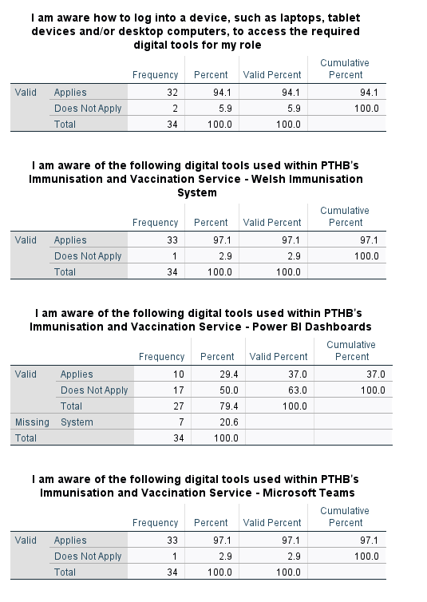

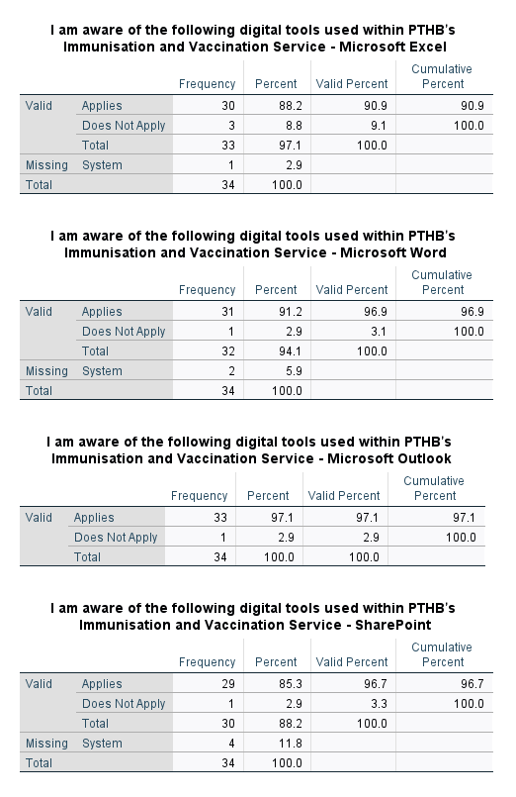

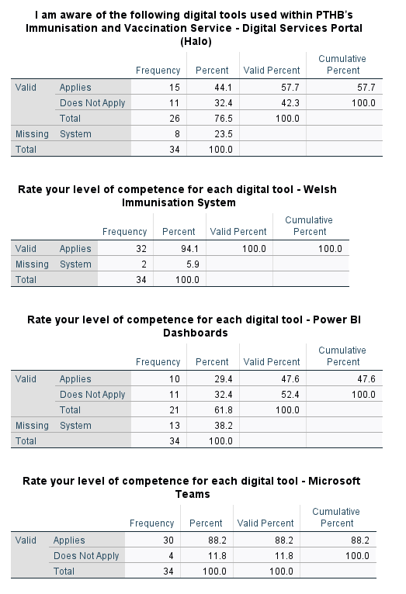
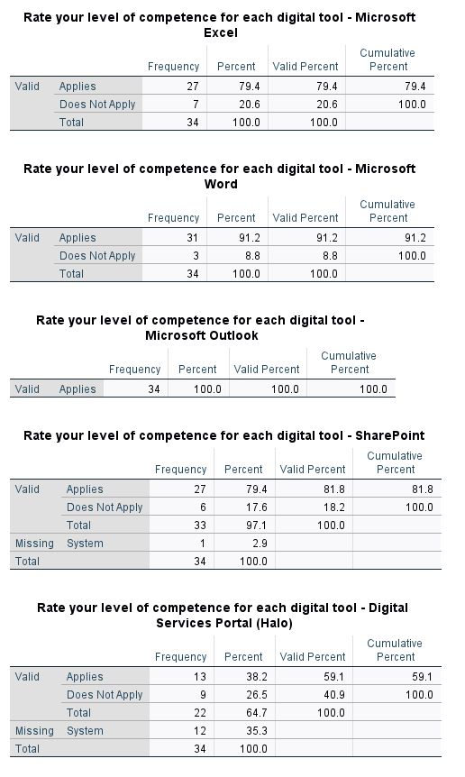

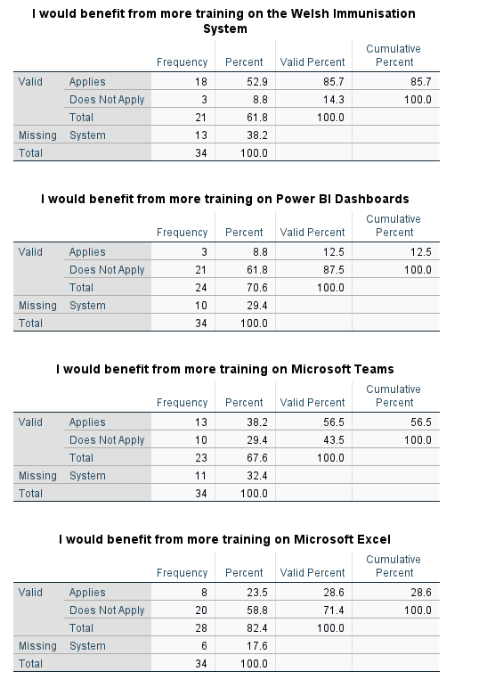

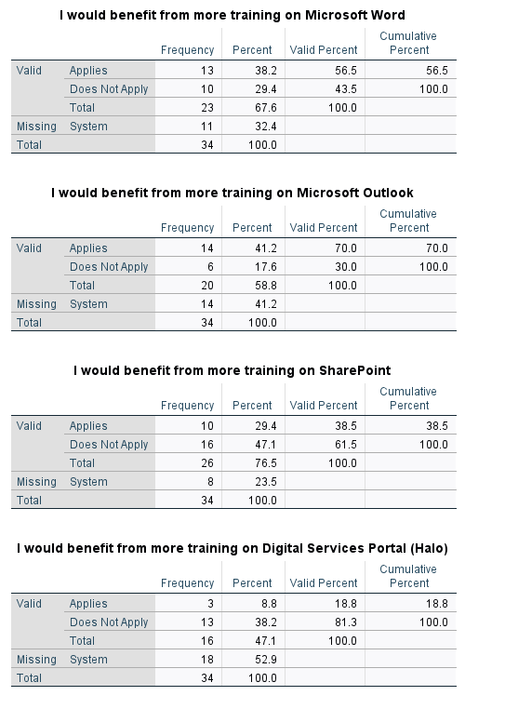

  - Appendix G

  - 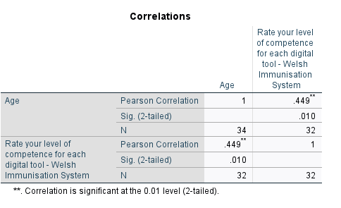
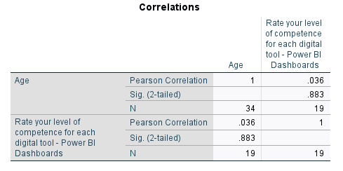
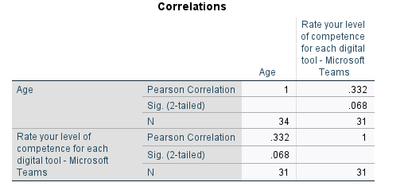
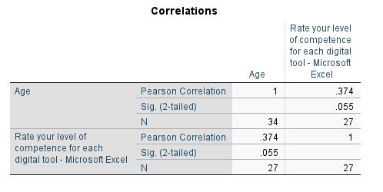
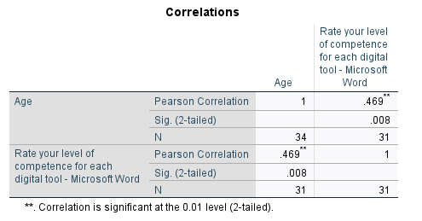
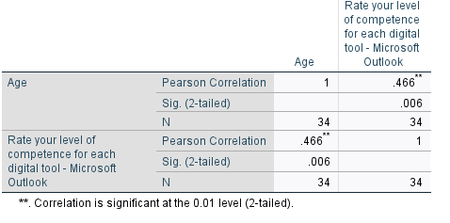
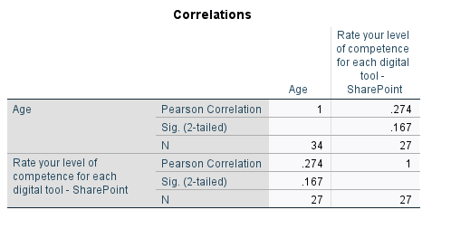
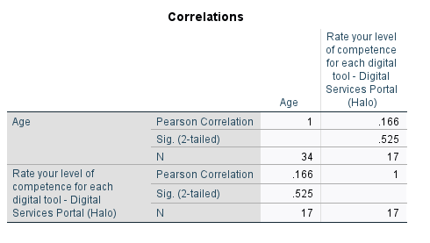

  - Appendix H

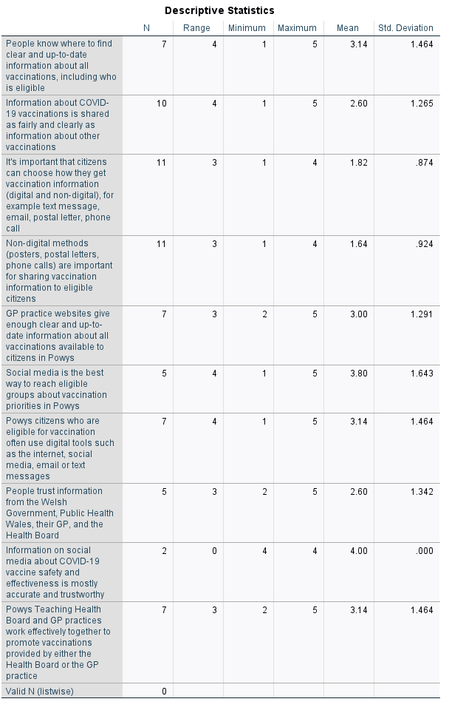

  - Appendix I



