Assignment 2: Project Management & Innovation.
L5 - Changemakers: Creativity and Value Creation (ACCA5033 Apprentices - Sem 3 2025)
George Quick (2315899)
2025

Table of Contents
Introduction 2
Task 1: Project Management 2
Q1. Project Management & Planning 2
Q2. Project Design 3
Task 2: Enterprise & Innovation 5
Q1. Example PEST & SWOT Analysis for a ISRA VISION / Parsytec 5
PEST Analysis 5
SWOT Analysis 6
Legal Considerations 6
Ethical Considerations 7
Q2. Related to Project Idea – Potential Tech Start-up 7
Task 3: Project Reflection 8
Using the Opportunity to Develop New Skills 8
Positive Impact and Contribution to Society 8
Risks and Challenges, and How to Reduce Them 9
Conclusion 9
Appendices 10
References 10

Introduction
This report outlines the planning, design, and reflection for developing a centralised web platform to monitor manufacturing line performance. The system aims to provide real-time and historical data on key data, helping managers and operators improve efficiency, quality, and decision-making.

Task 1: Project Management

Q1. Project Management & Planning
Project Overview
The project aims to create a central web platform that makes it easy to monitor and understand the performance of our manufacturing lines. This platform will track key metrics like yield, line speed, downtime, production output, and inspection details for individual coils. By providing clear, real-time and historical data, the platform will help managers and operators quickly spot issues, make informed decisions, and ultimately improve productivity and product quality.
Proposed Solution
I plan to build a secure, browser-based application connected to a central database. It will pull live data from production line sensors as well as detailed information about each coil. The system will organise and store this data so users can view both current and historical performance. Users will also be able to apply custom filters, generate charts, and export data, making it simple to analyse and act on the information.
Required Technologies/Resources
- Frontend: HTML, CSS, JavaScript, Bootstrap, Chart.js or AMCharts for data visualisation.
- Backend: PHP for server-side logic and C# for collecting data for the databases.
- Database: MySQL or MSSQL.
- Hosting & Infrastructure: On-sight servers.

Constraints
- Time: Must be delivered within 6 months.
- Budget: Limited to current resources available due to no funding.
- Integration: Compatibility with existing manufacturing line control systems.
- Security: Data encryption and role-based access control required.
Timeline & Schedule
Below is the Gantt chart showing the planned project stages:
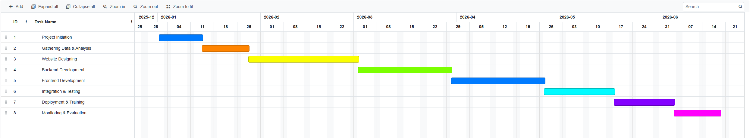
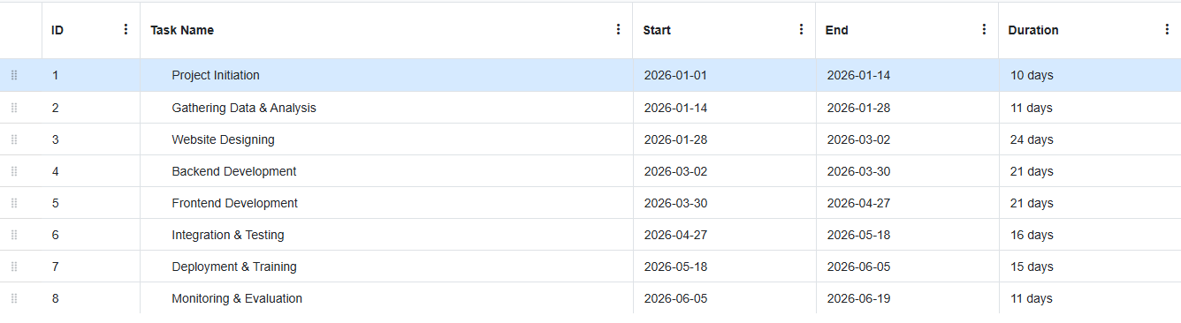
[1]
Development Methodology
The project will follow the Agile Scrum methodology to allow flexibility in adapting to evolving requirements. [2]
- Sprints: Set time periods to complete provided tasks.
- Daily DSUM Reviews: Daily morning meetings to discuss the work plan.
- End-of-day Review: Providing work completed in the day and gathering feedback.
- Workload managing: Writing progress reports, updating progress made on the page each week.

Q2. Project Design

Design Work 1: Requirements Specification
Here are some function and non-functional requirements that I would use to create the website. [3]
Functional Requirements
- Display real-time metrics (line speed, yield, downtime).
- Generate historical performance reports.
- Support multiple user roles (management, operator, basic access).
- Export data to CSV/PDF/XLSX.
- Provide drill-down view for further information about coil data.
Non-Functional Requirements
- Must be responsive for desktop and laptop.
- Data refresh rate: immediately.
- Website uptime target: 100%
- Secure authentication and HTTPS encryption.

Design Work 2: Entity Relationship Diagram (ERD)
Below is a simplified ERD for the websites databases:
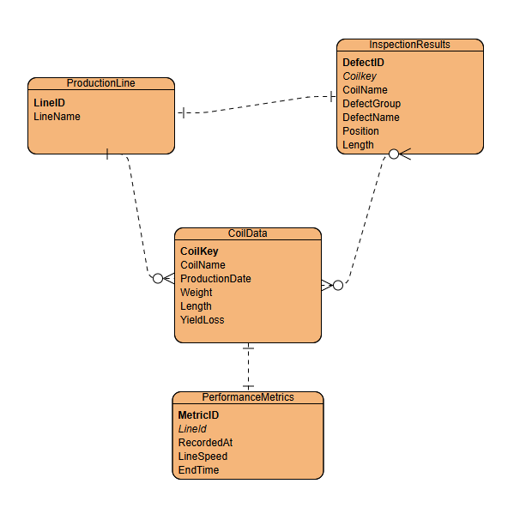
Entities
- ProductionLine: PK LineID, LineName
- CoilData: PK CoilKey, CoilName, ProductionDate, Weight, Length, YieldLoss
- InspectionResults: PK DefectID, FK Coilkey, DefectGroup, DefectName, Position, Length
- PerformanceMetrics: PK MetricId, FK LineID, RecordedAt, LineSpeed, EndTime

Design Work 3: UI Wireframe (Dashboard)
A simple wireframe layout:
- Header: Page title, login info, date/time.
- Left Sidebar: Navigation links to different production lines.
- Main Panel: Real-time charts and tables.
- Footer: System status and last update time.

Task 2: Enterprise & Innovation

Q1. Example PEST & SWOT Analysis for a ISRA VISION / Parsytec

PEST Analysis
Political
ISRA VISION / Parsytec gains from government incentives that promote automation, smart factories and digital quality control [4]. At the same time, trade restrictions and tariffs can make it harder to export inspection equipment. The company also must stay on top of different manufacturing regulations in regions like the EU, North America, and Asia. [5].
Economic
The economic climate has a big impact on demand. More and more industries are focused on cutting costs and achieving zero-defect production, which works in ISRA’s favour. But challenges remain, shifting exchange rates can affect global buying and selling, and downturns in industries like steel, automotive, and glass. This often leads to reduced investment in inspection technologies.
Social
Increasing focus from both consumers and regulators on product quality and safety is pushing demand for automated inspection systems. Workers are becoming more open to AI-based inspection tools, seeing them as helpful rather than threatening. Still, there’s a challenge with finding people with the knowledge required, particularly in areas like computer vision, machine learning, and IoT.
Technological
Advances in IIoT, imaging, and automation allow ISRA to deliver faster, more accurate defect detection and easier integration with factory systems. Cloud platforms and predictive analytics also enables manufacturers to track long-term performance trends and carry out analysis on data.

SWOT Analysis
ISRA VISION / Parsytec is widely recognised as a leader in surface inspection systems, representing industries like steel, glass, paper, and plastics. Its strong reputation for AI-powered machine learning, combined with a well-established global customer base, gives the company a solid competitive advantage.
However, there are challenges. The high cost of advanced inspection systems can discourage clients with less of a budget. The company’s dependence on industries that are highly exposed to economic cycles also creates revenue risks. On top of that, integrating inspection systems into existing manufacturing setups can be complex, often leading to longer adoption times.
Looking ahead, ISRA has room to grow. Expanding into new markets offers multiple opportunities as demand for automated quality systems rise. The momentum behind Industry 4.0 initiatives also plays to ISRA’s strengths, creating opportunities for deeper technology integration.
At the same time, there are risks to manage. Low-cost competitors are putting pressure on both prices and market share. As inspection systems become more connected, cybersecurity is an increasing concern. And with technology advancing quickly, ISRA must keep investing heavily into new technology to maintain its leadership position.

Legal Considerations
ISRA must navigate a variety of legal challenges. Compliance with GDPR (General data protection regulations) and other data privacy regulations is needed when handling sensitive data. Protecting intellectual property, including advanced AI algorithms, imaging techniques, and sensor technologies is also crucial to maintaining a competitive edge. Additionally, the company must ensure that its products meet industrial safety standards and do not disrupt critical production processes, which ties into product liability considerations. Export licensing requirements for dual-use goods, including imaging systems, are an additional consideration in regions such as the UK and EU [5]. Exporting to Israel may require permits and documentation, especially during global affairs. [6]

Ethical Considerations
ISRA must place a strong emphasis on transparency, ensuring that defect detection data is reported honestly rather than used to fit business targets. The introduction of AI-driven inspection also brings questions about its effect on workers. To address this, the company should focus on retraining and upskilling employees so that automation enhances jobs instead of replacing them. Environmental responsibility is another key factor. By developing energy-efficient systems and helping manufacturers cut material waste through early defect detection, ISRA can both support sustainability goals and strengthen its reputation.

Q2. Related to Project Idea – Potential Tech Start-up
If I was going to create a centralised website to help other companies have a way to monitor and make quick decisions on their coil inspection data, this is how I would create that start-up company:
Proposed Start-up Name:
Web Inspection & Analysis Services Ltd
The name reflects the company’s focus on inspecting data and providing an easy way for customers to make decisions on the data provided.
Proposed Logo:
A modern, polished logo that combines an eye or magnifying glass with a data chart, using Arial font with the text being blue and green hues to communicate insight and data-driven decision-making.
Business Type (Legal Classification):
- Private Limited Company (Ltd) registered in the UK, allowing limited liability for shareholders and easier access to funding. [7]
Business Strategy
- Market Focus: Target medium to large manufacturing firms seeking to improve operational efficiency.
- Value Proposition: Offer an affordable, customisable web-based platform integrating real-time production data, historical trends and analysis.
Potential Funding Initiatives
- Government Grants: Apply for UK government’s funding. [8]
- Crowdfunding: Use platforms like Crowdcube to raise community support. [8]

Task 3: Project Reflection

Using the Opportunity to Develop New Skills
Developing a centralised, web-based platform to track manufacturing performance both historically and in real time can offer an opportunity for me to advance my professional, technical and analytical abilities.
On the technical side, I’ll strengthen my skills in web development, working with PHP for backend logic, JavaScript and Chart.js/AMCharts for data visualisation, and MySQL/MSSQL for managing data. I’ll also gain hands-on experience integrating Industrial Internet of Things (IIoT) technologies like Parsytec to collect data to our SQL Ssrvers, which will help me work confidently with live data streams and build similar websites to this in the future.
On the project management side, I’ll gain a stronger understanding of Agile methodologies, sprint planning, and development. Managing this project will also help me build practical skills in communicating with management, documenting processes, and handling changes, which are all essential for a career in professional software development.
Additionally, I’ll develop data analytics and visualisation skills by turning raw data into clear graphs with drilldowns to further information using Chart.js/AMCharts. This will strengthen my ability to build and design future analytic projects that I might need to develop, which is a skill that is very valuable in many industries, not just manufacturing.

Positive Impact and Contribution to Society
The project’s impact can go beyond the workplace. Real time performance monitoring systems can:
- Improve efficiency by spotting issues and reducing downtime, which leads to higher productivity and less time waste.
- Support sustainability by using resources more efficiently, lowering energy use, and reducing defects found on customers coils, helping meet environmental goals.
- Enhance safety and transparency by giving operators clear and accurate information so they can make informed decisions and carry out production as normal.
- Boost competitiveness by helping manufacturers respond quickly to market demands through better planning.
By creating a platform that gives managers and engineers real-time, reliable data, this project supports the Industry 4.0 transformation, encouraging smarter, more sustainable production that benefits both the economy and the environment. [9]

Risks and Challenges, and How to Reduce Them
One of the main challenges will be data integration. Many of the production lines still use outdated data systems, which can make integration difficult. To reduce this risk, it’s important to run early system compatibility checks to ensure everything connects to our systems smoothly.
Another key concern is cybersecurity. Industrial systems are especially vulnerable to cyberattacks once they’re connected to external networks. To mitigate this, the project will use strong security measures such as firewalls, encrypted communication, role-based access controls, and regular security audits to keep systems secure.
There’s also the risk of user resistance. Operators and managers might prefer sticking to familiar methods instead of adopting to the new system. To overcome this, end-users should be involved early in the design process, the interface should be kept simple and user-friendly and proper training sessions should be provided to build trust and confidence in the system. [10]
Data accuracy and reliability is another challenge. Faulty sensors or data collection methods can cause issues that might lead to misleading analytics and poor decision-making. To manage this, the system will include validation checks, use redundant data collection methods and allow testing of the data collection for a period of time with feedback from line operators to confirm the data is accurate.
Finally, there is the risk of the projects timeline to overrun. Scope creep or technical delays could push delivery dates back. To stop this, the project will stick to a well-defined scope, follow Agile sprint cycles to manage progress in smaller chunks, and hold frequent progress reviews with managers to keep everything on track.

Conclusion
In summary, the project provides both a technical challenge and an opportunity for growth. By improving data visibility and supporting smarter production, the platform can deliver real value to manufacturing while also contributing to sustainability, efficiency and workplace production.

Appendices

References
[1] “Free online gantt chart software.” https://www.onlinegantt.com/#/gantt
[2] “What is Agile Scrum Methodology? | Inflectra.” https://www.inflectra.com/Solutions/Methodologies/Scrum.aspx
[3] GeeksforGeeks, “Functional vs. Non Functional Requirements,” GeeksforGeeks, Jul. 12, 2025. https://www.geeksforgeeks.org/software-engineering/functional-vs-non-functional-requirements/
[4] Wikipedia contributors, “Parsytec,” Wikipedia, Dec. 19, 2024. https://en.wikipedia.org/wiki/Parsytec
[5] “UK Trade Tariff: export prohibitions and restrictions,” GOV.UK, Jul. 02, 2018. https://www.gov.uk/government/publications/uk-trade-tariff-export-prohibitions-and-restrictions/uk-trade-tariff-export-prohibitions-and-restrictions
[6] “Exporting goods to Israel amid current restrictions and conflict.” https://www.chamber-international.com/news/latest-news/exporting-goods-to-israel-amid-current-restrictions-and-conflict/
[7] Xact+ Accountants, “Private Limited Company: Advantages, liability & credibility,” Xact+ Accountant, Jan. 01, 2025. https://xactaccountants.co.uk/blog/private-limited-company-advantages-liability/#:~:text=A%20private%20limited%20company%20(Ltd)%20offers%20limited%20liability%2C%20meaning,through%20shareholding%2C%20boosting%20capital%20opportunities.
[8] Unit 3 Topic 2. (Find notes made on this topic in assignment 1)
[9] “Understanding the adoption of Industry 4.0 technologies in improving environmental sustainability,” 2022. https://www.sciencedirect.com/science/article/pii/S2666412722000071
[10] T. Lugosi and T. Lugosi, “How to overcome user resistance to new technology,” Sogeti Labs, Feb. 26, 2025. https://labs.sogeti.com/how-to-overcome-user-resistance-to-new-technology/.

