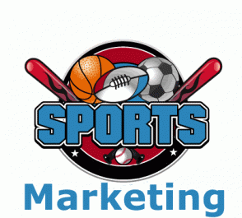

An introduction to sports marketing  [Document subtitle] | Christopher Briggs (1903008)  [Course title]

Contents

- Introduction-

- Main section –
There will be a clear explanation of sports organisations and events in public, for both private and non-private sectors.

- Conclusion
- References

Sports Marketing
During this essay there will be a definition and a discussion as to why sports marketing is a big influence within the sporting industry. Also, how sports marketing will have a huge influence on and within small sporting organisations events within the public. Private and non-profits sectors, this will also come in importance when discussing how sports marketing can help grow and develop organisations. During this essay there will also be backed up by many theatrical concepts.
"What you need to know about sports marketing in 2017 and beyond". campaignlive.co.uk. Retrieved 19 April 2018.
Sports marketing is an introduction within how many sports organisations and industries market their own sport and how they help entice their products such as football, how they sell and promote their balls for young users and even adults to purchase kits and football boots, This is the same for any sport like cricket with their bats, tennis with their rackets they all have a specific selling point and in this essay there will be a discussion into how they do it and what helps them become more successful. Not only within their sporting industry but how clubs around the world as big as Bayern Munich help market and keep their club running compared to a smaller club with insufficient funds. Lovelock, Christopher; Reynoso, Javier; D'Andrea, Guillermo; Huete, Luis (2004). Lovelock, Christopher; Reynoso, Javier; D'Andrea, Guillermo; et al. (eds.). Administración de Servicios [Service's Administration] (in Spanish). Pearson Educación Times. p. 760
Sport marketing
Sports marketing is a promotional element within the world of sport, which includes a large variety of sports sectors within the industry. These elements include broadcasting, advertising, social media, digital platforms for example iPads, phones and laptops, ticket sales, and community events and promotions. Mullin, B. J., Hardy, S., & Sutton, W. (2014). Sport Marketing, 4th Edition. Human Kinetics
There are actually 3 sectors that sport marketing splits into these are the first is sport advertising, this includes many high-profile players and athletes producing ads to help promote big tournaments or matches that will be coming soon such as Olympics, world cup finals and derby day matches most well known the Manchester derby. A well-known scheme or advertisement that the euro 2016 tournament used to help promote their event was to put their tournament name on the bottle of the coca cola bottle as this is a well-known brand and this will help promote and help get their name out there before the tournament starts. The way they helped promote it was to use a campaign name which was euro 2106 places the fans at the heart of the tournament they have used this phrase to say that the tournament is nothing without the fans from all over the world. P., Coke, S. and Us, C., 2020. Coca-Cola UEFA EURO 2016 Campaign Places Fans At The Heart Of The Tournament. [online] Coca-cola.co.uk. Available at: <https://www.coca-cola.co.uk/newsroom/press-releases/coca-cola-uefa-euro-2016-campaign-places-fans-at-the-heart-of-the-tournament> [Accessed 12 March 2020].
One organisation/company that helps showcase and advertise these upcoming events are BT sport they make small documentaries to help entice why these games are so important and show how big the matches are. If we look at the Deontay wilder and Tyson fury’s second match. They made a short clip with other huge boxing icons to see how big and amazing the first fight was and how this will help promote the second fight as this is to determine who will remain undefeated and become world heavyweight champion.
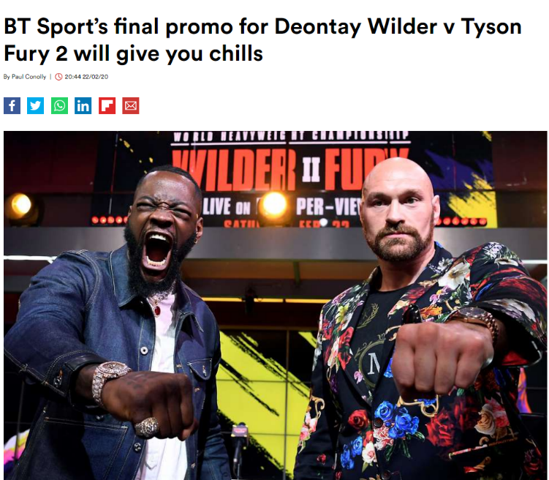

Looking at the top headlines like these were made from huge newspaper and news companies as they show how important and big this small documentary was to show from BT sports point of view as this will help promote and persuade more people to by pay for view.

The second sector within sports marketing is the use of sporting events, this includes a various amount of sporting high profile athletes and teams promoting products with it be their own or someone else’s for example mobile phone contracts or airlines such as Qatar airways or Etihad.
Finally, the third sector is the promoting sports to the public and communities to help raise the participation rate. An example of this is the premier league sending out sports management officers out to schools and various leisure centres to help motivate participation in football.
With the 3 sectors that many companies and organisations use there is another marketing strategy they use are the 4 ps of marketing what the 4 ps are these are guidelines that these companies and organisations follow to see if their product or brand can sell and work. This term is normally known as marketing mix an example of this is a spider diagram graph showing the importance of each P. Milne, G. R., & McDonald, M. A. (1999). Sport marketing: Managing the exchange process. Jones & Bartlett Learning.
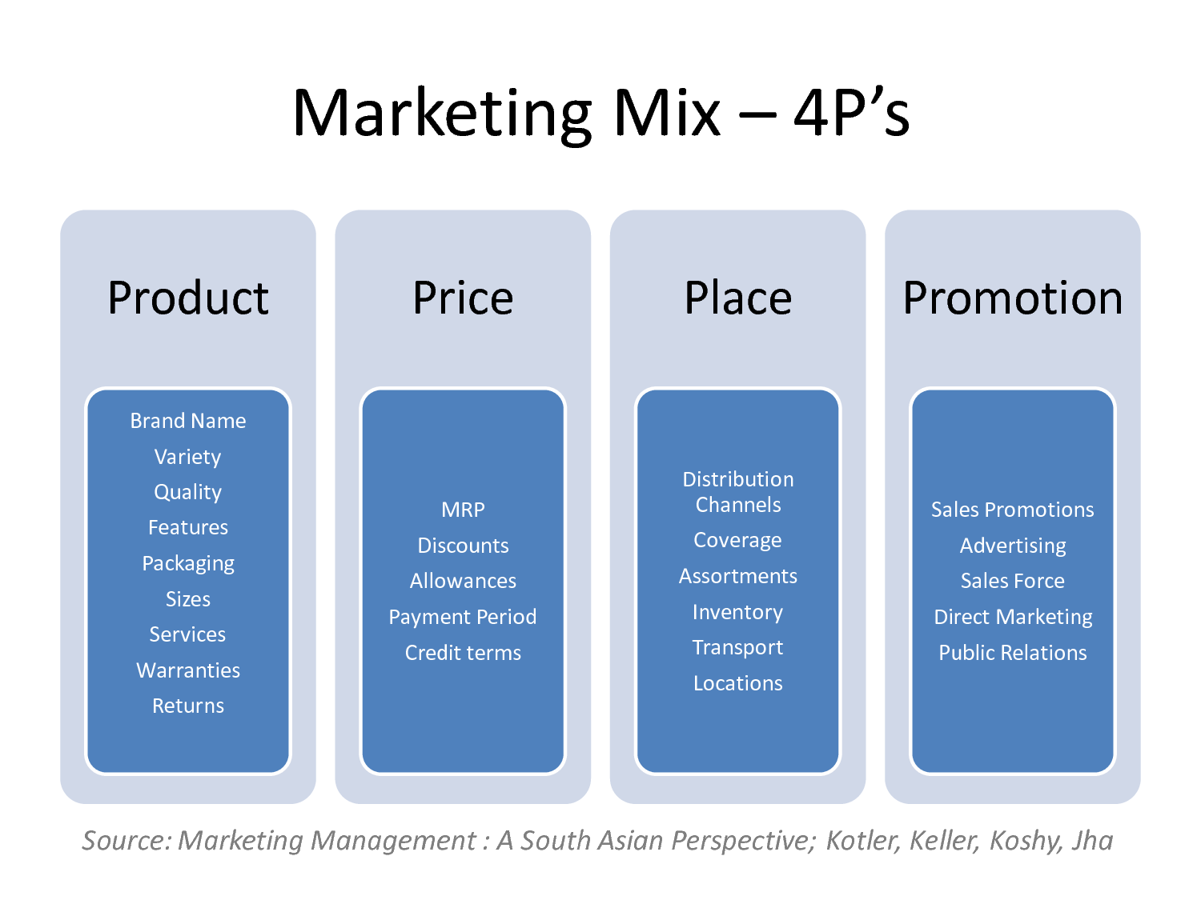
Kotler,Keller,Keshy, Jha.A south Asian perspective. : source Marketing Management

The aims and objectives of the 3 sectors
Firstly, let’s look at the private sector, this sector aims for profit this is owned by the government and voluntary sector, when a newly built business is set up and running the first objective is to survive. Once, a business survives and is in a stable and good condition they will then expand their aims and objectives to help maximise and make profit. An example of a private sector is a gym sort of business as these are paying big money up front and then they are trying to make profits once they are in a good and stable condition. The gym has made a revenue of £73.5m and on a yearly rate they are getting and sustaining a member joining them +20.8%. Tggplc.com. 2020. [online] Available at: <https://www.tggplc.com/media/82712/TGG-Plc-FY-Results-2016-Presentation1403.pdf> [Accessed 13 March 2020].
However, looking into the public sector this serves the taxpayers so they cannot afford to take these risks. Many things cannot be trusted with the private sector one being the law, so the government the takes charge and takes care of this. The voluntary sector is a special one as this investigates the community and looks for devoted and selfless people to help serve good and have no financial gain and these are called volunteers. A well-known public sector is sport England this organisation helps organise and increases the rate of participation within sports in grass roots and school PE. here, W., 2020. Why We're Here | Sport England. [online] Sportengland.org. Available at: <https://www.sportengland.org/why-were-here> [Accessed 13 March 2020].

However, if one individual decides to help and give some financial support to the club or organisation out of their own pocket then they will be able to get compensation. An example of this could be when a medic wants to do a world of good and travels abroad to help with injured refugees or victims of a tragedy, they will then use the SMART process for their objectives.

Why do objectives have to be SMART
Bogue, Robert. "Use S.M.A.R.T. goals to launch management by objectives plan". TechRepublic. Retrieved 10 February 2018
S- Well any objective will have to investigate something specific and to be able to help you look to improve on a certain aspect of the business such as financials.
M- Once a business has their specific objective, they will then need to find out if it is measurable. Because if you can’t find it to be measurable this can result in a downfall in financials than what you started out with in the beginning.
- This part in any businesses is important as you need to find out if your objective can be achieved with it being short term or long term the importance is that can it be achieved, if not then it would be a waste of time and money if found unrealistic.
R- If an objective or idea is unrealistic then it is inevitable that that idea is going to fail so when making an idea you need to make sure if you can see it working and see it being realistic and not day dream and hope for the best.
T- Time-management, if your idea ticks all the first 4 boxes you will need to be able to find a time on when to publish it and if you use the same excuse of we’ve got time or there’s always tomorrow there will be a big shock when there isn’t and your left stranded on the final hurdle. Doran, G. T. (1981). "There's a S.M.A.R.T. way to write management's goals and objectives". Management Review. 70 (11): 35–36
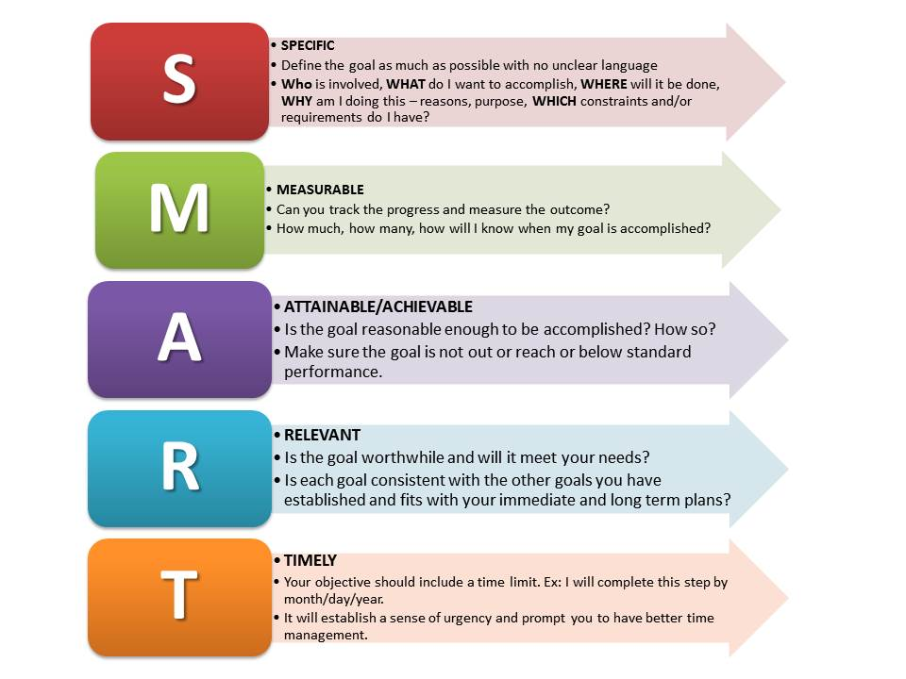

Sports marketing can help develop and grow organisations in many ways, many organisations and companies have been using the use of marketing through sport since the 1980s and has since been growing over the past 40 years. This is because it works, and it really does help grow and develop the companies and organisations that have been using this technique.
Drury, Glen (4 January 2008). "Opinion piece: Social media: Should marketers engage and how can it be done effectively?". Journal of Direct, Data and Digital Marketing Practice. 9 (3): 274–277
Sports marketing isn’t the same as it was 2 decades ago this is because there are now different ways and techniques how companies and organisations can now promote their brands or events due to technology expanding and many electronical devices are around not only can adults see the brands, but so can millennials can as well, due to iPhone, iPad, laptops and even when you go to a football match they have advertising electronical boards changing from one company to another so there’s a large amount advertisements wherever you go rather than just your tv in between your favourite programme. Milne, G. R., & McDonald, M. A. (1999). Sport marketing: Managing the exchange process. Jones & Bartlett Learning
They way many companies and organisations jump straight into the bandwagon when using famous and influential players/athletes to help promote events, clothing brands, and even jewellery as people see these inspirational people and want to have the same thing as they are because it’s cool and their inspiration have it so why can’t they. Business dictionary.com (5 November 2010). "Event marketing" [Definicion de marketing de un evento]. Bisnessdictionary.com. Retrieved November 5, 2010
Not only do they use players but they also use huge famous teams such as Real Madrid many people see this team and badge and they instantly suggest that if a big team is helping promote this brand then it must be good. As Real Madrid help promote Audi and Nivea men, and this is just a short this list.
Not only do organisations and companies use famous teams but they also help sponsor and become official partners within an event. Back in 2016 the UEFA euro 2016 tournament was beginning and the way they helped sponsor that event is that they used another such as coca cola which is very famous soft drink and they used their tournament name of the label of the coca cola bottle to help promote their event.
However, not only do big tournaments and brands help each other by promoting each other many sports organisations use the power of grass roots football and other sports through tv ads and also by using famous sports stars this is to help promote the lack of children and especially females continuing sport pass the ages between 14 and over the way that Nike helped grassroots football was to make an ad with a female mascot and her looking through all the match possibilities with all famous sports role models mostly women but there was a short clip with male stars as well .
With Nike doing this it shows that are numerous of female sports stars and it’s not only a man’s game it shows how women sport has become more famous and out there than it was a few years ago and with this ad this will help promote and inspire young girls as herself to play football and want to play for the sake of having fun because they enjoy it.
Not only are Nike trying to help encourage and bring more girls to play football, but the government and organisations within sport are also trying to promote many other sport and younger generations for both sexes play more grass root sport. Mullin, B. J., Hardy, S., & Sutton, W. (2014). Sport Marketing, 4th Edition. Human Kinetics

Conclusion
In conclusion, having looked at this academic essay there are a lot of finding that back up the points and views that are in it. Having said this there is a lot of points that tick all of the checklist in which defines the discussion as to why sports marketing has a big influence in todays day in sport and why it also has a big influence for small organisations and businesses and how they manage to use the techniques like the SMART technique and the marketing mix. Not only have w found out the techniques in which companies and organisations use to help boost their product but how the 3 sectors manage to function and work.

Reference list
1."What you need to know about sports marketing in 2017 and beyond". campaignlive.co.uk. Retrieved 19 April 2018.
2. Drury, Glen (4 January 2008). "Opinion piece: Social media: Should marketers engage and how can it be done effectively?". Journal of Direct, Data and Digital Marketing Practice. 9 (3): 274–277
3. Business dictionary.com (5 November 2010). "Event marketing" [Definicion de marketing de un evento]. Bisnessdictionary.com. Retrieved November 5, 2010
4. Doran, G. T. (1981). "There's a S.M.A.R.T. way to write management's goals and objectives". Management Review. 70 (11): 35–36
5. Bogue, Robert. "Use S.M.A.R.T. goals to launch management by objectives plan". TechRepublic. Retrieved 10 February 2018
6. Milne, G. R., & McDonald, M. A. (1999). Sport marketing: Managing the exchange process. Jones & Bartlett Learning
7. Kotler,Keller,Keshy, Jha.A south Asian perspective. : source Marketing Management
8. P., Coke, S. and Us, C., 2020. Coca-Cola UEFA EURO 2016 Campaign Places Fans At The Heart Of The Tournament. [online] Coca-cola.co.uk. Available at: <https://www.coca-cola.co.uk/newsroom/press-releases/coca-cola-uefa-euro-2016-campaign-places-fans-at-the-heart-of-the-tournament> [Accessed 12 March 2020].
9. Mullin, B. J., Hardy, S., & Sutton, W. (2014). Sport Marketing, 4th Edition. Human Kinetics
10. Lovelock, Christopher; Reynoso, Javier; D'Andrea, Guillermo; Huete, Luis (2004). Lovelock, Christopher; Reynoso, Javier; D'Andrea, Guillermo; et al. (eds.). Administración de Servicios [Service's Administration] (in Spanish). Pearson Educación Times. p. 760
11. Tggplc.com. 2020. [online] Available at: <https://www.tggplc.com/media/82712/TGG-Plc-FY-Results-2016-Presentation1403.pdf> [Accessed 13 March 2020].
12. here, W., 2020. Why We're Here | Sport England. [online] Sportengland.org. Available at: <https://www.sportengland.org/why-were-here> [Accessed 13 March 2020].

