Student Name: Latifa Ali

Student Number: 1809325

Lecturer Name: Sylvia Hoffmann

Module Title: Academic and Employability Skills

Module Code: BMSK4001

Table of Contents

1. Introduction…………………………………………. Page 3
2. Reflection using Gibbs Reflective Cycle
2.1 Description……………………………………… Page 3
2.2 Feelings…………………………………………. Page 4
2.3 Evaluation………………………………………. Page 4
2.4 Conclusion……………………………………… Page 5
2.5 Action plan……………………………………… Page 6
3. Conclusion………………………………………….. Page 6
4. Reference List ……………………………………… Page 7

Introduction

This study is aiming to highlight the impact of the learning module on academic and employability skills. It also focuses on the description of Gibbs reflective cycle and its importance on learning. Gibbs cycle of reflective learning provides a framework to learning acquired from experiences. The structure focuses on experience and provides a cycle that encourages people to think in a systematic way regarding the specific experiences during a course of situation. Focusing on this cycle in this study I have highlighted the six specific stages on which the reflective cycle works on.
The study provides description on different elements that the reflective cycle deals with. It focuses on the personal assessment and skill development scenario through the course of the discussion. During this study I have also focused on the presentation skills, note taking skills and CV writing to improve my academic skills. It will also highlight the impact of this module on employability skills including positive attitude, teamwork, communication, resilience and self-management. The study focuses on an action plan with plans for future development. I have also mentioned an evaluation process that has improved my ability to learn and handle research work during the study of the module.

2 Reflection using Gibbs Reflective Cycle
2.1 Description
Whilst studying this module I have learnt specific skills including academic writing, communication skills, team working, time management, paraphrasing and referencing. These skills are very important for academic purposes as this addresses the requirements of academic papers. During my university days I have gone through these skills to improve my efficiency. Academic writing needs proper research to present information based on valid data and information. Thus, I have considered this module to ensure that I will be capable in future to research accordingly while preparing an academic paper. In terms of this module I have learned everything in the class during my class at university. All the theoretical lessons have been learned through lectures and study materials.
Along with research methods, academic writing is also depended on referencing techniques. In order to improve my skills and to write proper academic papers, I have gone through this module. As mentioned by Sekarwinahyu et al.(2019), different research methods allows an academic writer to collect the appropriate data through researching wider data sources in minimum time which also offers time management skills. Another prime reason for me to choose this module was related to referencing. As opined by Pianpeng and Koraneekij (2016), it is essential to prepare reference list in terms of academic writing.
I also learned about employability skills and how they can be used in employment. The CV and cover letter writing lecture was extremely useful as this will help me in future employment. There are some things to include on a CV which I already knew however it is always good to know more. I was able to update my CV with the relevant information required for employment.
I have given special focus on the learning skill and observation skills that were needed to develop during my lectures. Our qualified teachers were there to guide me in different activities that were required to learn writing in academic sessions and in gathering knowledge regarding techniques of referencing.
This module has improved my note taking skills and communication to a great extent. I have acquired knowledge in writing and improved my ability to observe and listen more attentively. My communication skill has also improved during my engagement with other students through conversation.
2.2 Feelings
When I started this course, I was very scared whether I could improve my skills through the structure of this module. My communication with others were very poor and my observation skills were very weak during the early days of the course. I felt that this course would not be able to rectify my skills that I required to develop to improve my writing in terms of note taking and CV writing. As I started to familiarise myself with different approaches my confidence started to grow. I felt that I would be able to utilize this new learned technique in the outer world so that my chances of acceptance will get increased over time. As opined by Straktova and Cimermanova (2018), communicating effectively regarding your problem improves the ability to solve problems to a great extent. During the course I have realised that I would work on these skills to improve my abilities. Some of my classmates forwarded their steps to help me in removing my fear.
As I got through the first term, I found myself as a different kind of person. My skills of communication were increased. I could handle situations better than the early days and I was gaining confidence. My writing skills had improved. I think that this module can prove effective for the future. As opined by Lerkkanen et al. (2016), acceptance and appearance in the outer world is necessary to increase the chance of getting employed with ease. I enjoyed this term as it was focused on academic and CV writing. I had been out of school for a long time and lectures have helped me a lot. The lecture on language and grammar were exceptionally helpful. This module has improved my vision to a great extent and I strongly believe this can help others in the same way. As my confidence increases, I am discovering myself as a different person and I believe that the world is providing me with opportunities that are required to develop a better lifestyle and future.

2.3 Evaluation
This module has provided me with great opportunity to take advantage in terms of academic writing, process of research and techniques of academic referencing. The module has provided all these facilities in a structured way. This process of integration has helped to acquire knowledge in that specific region with ease (Pang et al. 2016).
The module covered techniques on academic writing, referencing and employability skills. In order to cope with the course, I faced many challenges to manage time and gain knowledge. So, the limited time schedule of the course bears negativity in this respect.
During the module I attended all my classes on a regular basis, this has improved my interaction with lecturer and classmates. My note taking skill has increased gradually, and I have developed a skill to assess my writing with quick succession.
I found the CV and cover letter writing very interesting and informational as this will help me when I am applying for a job in the future.
During this module I could not manage my time effectively. Effective time management helps a person to develop principles according to the need of the learned society. As there was a lack of communication among the classmates, it has affected our group work with the course of time (Morton et al. 2016). I applied my learned techniques in referencing that I had acquired during the class in my academic writing.

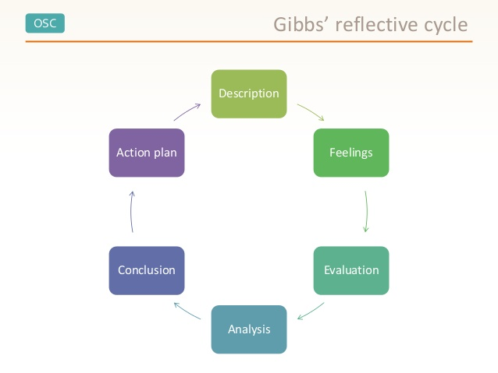

Figure 1: Gibbs Reflective Cycle

2.4 Conclusion
It can be concluded that the module could bring positivity in the case of gathering experience in many ways. The module could have focused on more outer world exposure to make the students acquainted with employability skills. In the case of theory learning the module could’ve focused on practical base teaching, this could help students to develop practical skills.
In order to improve my learning in academic writing I would opt for more practical exposure than theoretical learning. Practical exposure is more important to deal with real life conditions than theoretical analysis within a classroom situation.
I need to improve my skills of writing effectively. I also need to increase my ability in accessing different research methods so that I can improve my research work accordingly. In the case of referencing, I need to focus on practise on a regular basis in order to apply it in a more effective way. In order to improve my employability skills, I need to develop my time management, communication skills and self-management through increasing practical exposure in the future.

2.5 Action Plan
Skill | Strategy to develop | Resources | Time
Time Management | - Develop schedules for each activity.  - Develop short term goals.  - Participate in practical scenario | - Learning materials.  - Case study materials as evidence | 25 days
Communication | - Listen to other members carefully.  - Convey message clearly. | - Learning resources | 20 days
Knowledge Share | - Participate in group discussion.  - Go through learning courses  - Development of inter-communication. | - Course materials.  - Technological support. | 20 days

Table 1: Action Plan
(Source: as influenced by Takey et al. 2015).
Through the preparation of an action plan schedule I have managed to perform my activity according to my plan within a framework. I have manged time by adopting strategies such as preparing short term goals and preparing a specific time schedule for different activities. I have also improved my communication skills by listening to others with utmost care and conversing with people on different subjects and participating in group discussions. I have also improved my knowledge sharing skills by gathering resources from technological support and going through different learning courses.

Reference List
Lerkkanen, M.K., Kiuru, N., Pakarinen, E., Poikkeus, A.M., Rasku-Puttonen, H., Siekkinen, M. and Nurmi, J.E., (2016). Child-centered versus teacher-directed teaching practises: Associations with the development of academic skills in the first grade at school. Early childhood research quarterly, 36, pp.145-156.
Morton, K.L., Atkin, A.J., Corder, K., Suhrcke, M. and Van Sluijs, E.M.F., (2016). The school environment and adolescent physical activity and sedentary behaviour: a mixed-studies systematic review. Obesity reviews, 17(2), pp.142-158.
Pang, P. and Wu, C.Y.N.T.H.I.A., (2016). Learning through reflection: students’ service-learning experiences in Cambodia. 17(3), pp.125-347
Pianpeng, T and Koraneekij ,P., (2016). Development of a Model of Reflection Using Video Based on Gibb’s Cycle in Electronic Portfolio to Enhance Level of Reflective Thinking of Teacher Students. International Journal of Social Science and Humanity, 6(1), pp.26-50.
Sekarwinahyu, M., Rustaman, N.Y., Widodo, A. and Riandi, R., (2019). Development of problem-based learning for online tutorial program in plant development using Gibb’s reflective cycle and e-portfolio to enhance reflective thinking skills. In Journal of Physics: Conference Series (Vol.1157, no.2, pp.2209-2304). IOP Publishing.
Strakova, Z. and Cimermanova, I., (2018). Developing Reflective Skills of Student Teachers in the Virtual Learning Environment. Electronic Journal of e-learning, 16(2), pp.107-121.
Takey, S.M. and de Carvalho, M.M., (2015). Competency mapping in project management: An action research study in an engineering company. International Journal of Project Management, 33(4), pp.784-796.

