EFFECTIVE TEAM WORKING AND COMMUNICATIONS (BMSW 4002)

NATALIE ELLIOTT (1814476)

TUTOR: ERIC OSEI

PAGE

INTRODUCTION

In today’s modern world, communication plays a key role to running a successful business.

The world is forever challenging, constantly changing and growing, so for an individual who can put across effectively and skillfully would be noticed and taken.

So it very important that all the staff have good communication skill this will enable its employees to perform at their best and creating a good work environment to work

Having good communication skills such as speaking, listening, reading and writing make your work come across clearly and makes it easy to understand.

Efficient communication is very important this helps us to understand the position better, it also develops trust and respect and also problem solving skills.

A lot of companies are going global these days and in able to enhance the international sales and earnings good communication skills are mandatory.

.

How communication plays an important role in running a successful organization

Having good communication within an organization plays a key role in making your organization successful as within the organization they will be many interactions with different people in the business – clients, employees and managers. It is very important that the flow of communication is clear and correct between all parties this will reduce the chances of information been misunderstood and lessen the chances of anybody been dissatisfied and lessen the chance of anybody losing trust in the organization.

There are many forms of communication within an organization from oral communication to written communication via email/letters/instant messages even body language can play an important role in today’s workplace. So it is very important that all communication is always clear and consistent across all sectors of the organization.

Good communication starts right at the top of an organization, the way a manger communicates and directs their employees shows how good the communication is within the workplace, helping build a good work relationship with it employees and other team members.

An interesting survey of 46 CEOs/ Senior Leaders in the UK by the Marketing Society (2013), revealed what they considered essential leadership skills for senior management:
- Giving a clear sense of direction
- Bringing the customer into the boardroom
- Communicating clearly – both inside and out
- Being flexible but not floppy
- Taking risks but not ‘betting’ the company
- Building the team around you
- Listening with humility, acting with courage
- Earning your reward through building
Good communication is the basic function of a good manager a good manager will be able to use some of the above skills ensuring that they have employees working to their best.
Good and effective communication skills will result in:
- good workplace relationships
- a nice work environment
- more staff commitment
- increase in work productivity
- higher quality of services
- higher quality of products
- higher creativity levels from its employees
- higher quality of services and products
- better work satisfaction
- lowers the risk of recruiting
- reduces cost
- reduces employees taking time off work

Regular communication from all employees, from management all the way to entry-level staff making sure everyone know what is expected from the organization, what is the company’s goals as well as how to present the company to customers and future clients. Also it is important that staff and customers know where to leave feedback as this will help strengthen your organization, this could be asked face to face or even through a survey.

What is two-way communication and why it is important in an organization between management and employees

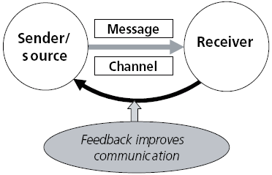
Two-way communication process is the method of which a sender reaches a receiver with a message or information, then the receiver then sends back a response back to the sender enabling the sender to see how the receiver interpreted the message/information and will show the sender what to do next. Having this feedback will enable the sender to measure the effectiveness of the message/information that was sent. So, the importance of two-way communication in an organization is key to help grow a successful organization.

The different types of communication and the different effects
Downward Communication
Downward communication is the communication where information or messages flows from the top of the organizational structure from the bottom of the organizational structure. Downward communication occurs when information flows down the hierarch form superiors to subordinates. This type of communication may forms such as staff meetings, company newsletter, company policy statement, information memos, e-mail, face-to-face contact, orders, instruction etc. some important definitions of downward communications are given below:

Upward Communication
When the flow of information in an organisation, is from lower levels of the corporate ladder to the upper levels, is named as upward communication. This form of communication, helps employees, to express their views, ideas or grievances with the top management. It is possible only in a democratic environment, wherein employees have a say in management.
Upward communication flows from subordinate to superior, which helps in the increase in acceptance of management decision by the subordinates. However, it suffers from various limitations like the long chain of command, lack of confidence in superiors, fear of criticism, lack of common sharing, etc.
In this type of communication, the message can be transmitted either through oral media – employer-employee meeting, grievance procedure, open door policy, etc. and written media – reports, letters, complaints, suggestions, etc.

THE GRAPHICAL PRESENTATION OF DOWNWARD COMMUNICATION IS AS FOLLOWS:
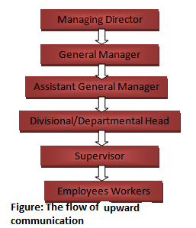
So, downward communication is the communication where information or messages flows from the top level of the organizational structure form the bottom level of the organizational structure.

OBJECTIVES OR PURPOSE OF DOWNWARD COMMUNICATION
- Supply information:
- Assigning work:.
- Explaining policies and plan:
- Responsibility and duty:
- Directing subordinates:
- Evaluation of performance:
- Explain the change environment
- Coordination and cooperation
- Delegate authority
- Establish discipline

Role of Internal Communications
Internal communication happens when a business shares information within itself to its staff. Companies can internally communicate in writing through emails and memos or verbally at meetings and conferences. The main purpose of internal communication is to identify and share company goals. It’s vital for employees to know what they are working toward. Goals can be company-wide, departmental or individual. Regardless, knowing what their purpose is at work helps employees to stay on track.
Creating a better work environment is another reason why internal communication is so important. By communicating within the company about organizational changes, sales numbers and human resources issues, businesses can create transparent and effective work environments where employees thrive. This helps to reduce turnover rates, attract new talent and increase employee satisfaction. Businesses can also stop company rumors before they start by ensuring they communicate openly and routinely with their employees.

Purpose of External Communications
External communication happens when a business exchanges information with customers, prospects, partners, suppliers, investors and other stakeholders outside of the company. It’s integral that the organization implement polices that guide employees on what kind of information to share outside the company, who to share it with and how to share it.
Having guidelines on what kind of information to share with which party is important so that certain information doesn’t fall into the wrong hands or create problems for the company. For example, if a company is developing a new product that will revolutionize the market, it’s critical not to share specific details of that product with competitors before its release. However, the company may want to tell their valued customers, investors and partners about the product before anyone else.
Controlling negative information about the company is one of the reasons effective external communication is so important. By having a strategy in place, organizations can reach out to external stakeholders and discuss the issues at hand. If a company is dealing with a PR disaster, for example, having a plan to speak with the media and customers is an important part of handling the situation.

The importance of two-way communication comes in different angles and below is briefly discussed:
Job Satisfaction:
in the workplace two-way communication enables employees to share their complaints, Ideas, opinions, suggestions and problems to their superiors, enabling management to make better decisions and to make changes to any complaints given from the employee’s feedback. This will therefor increase job satisfaction and make employees feel that they are important.
Democratic Environment:
Two-way communication can help give an organization a democratic environment as this shows all staff that their voice and opinion matter and makes employees feel free to share opinions without any hesitation. This will enable managers to make better decisions from the feedback their employees give.
Dynamic Process:
Two-way communication is a dynamic process of which messages are exchanged. The way that information flows from the sender to the receiver and receiver back to the sender this helps build an interactive relationship between the sender and the receiver.
Increasing the Efficiency of Management:
A good two-way communication system enables a supervisor and workmates to have good close contact with each other which will strengthen work relationships and help remove any problems within the team, this will increase work efficiency within the team.

Accuracy of understanding:
Two-way communication will help remove any information been misunderstood and lessen the chances of any confusion within the organization. Two-way communication enables any problems to be solved and increases the chance of the information been correctly understood.

Providing suggestions:
By giving regular briefs supervisors can give employees instructions on what tasks/targets need to be reached for that day this will enable staff to plan timing and help for the team to make the correct decisions to enable to complete tasks in time and to reach targets set.

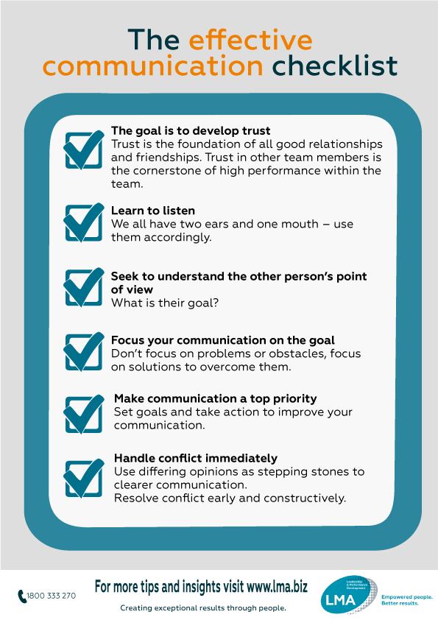

Effective communication helps us better understand a person or situation and enables us to resolve differences.
It also allows us to build trust and respect, and create environments where creative ideas, problem solving, affection, and caring can flourish according to (LMA, 2019)

The significance of non-verbal communication when communicating to employees

Nonverbal communication comprises of your overall body language, including your appearance and posture as a form of communication with others. Rather than using words, people can communicate using nonverbal gestures, such as facial expressions and eye contact. Also, an individual’s voice tone may communicate nonverbal messages to others. In the workplace, people interact with each other throughout the workday using verbal and nonverbal communication. In essence, the way individuals deliver nonverbal messages can be just as important as verbal dialogue.

Definition of Nonverbal Cues
Examples of nonverbal communication include what you wear, how you wear your clothes, facial expressions, body gestures, eye contact, voice, posture, and the distance between you and your audience. Nonverbal cues affect how people understand what you are attempting to communicate, and their reaction corresponds to how you delivered your message. If you are expecting a certain response by the receiver of your message, your nonverbal communication affects their response.

Using Non-Verbal Cues to Enhance Communication
Depending on your occupation, you may be required to communicate messages to others on a regular basis; certain occupations —such as teachers, salespeople, journalists, doctors, lawyers and corporate executives— spend a great deal of their workday communicating with others. Using nonverbal cues can enhance how people receive your communication. Nonverbal communication indicates how a person is feeling in relation to what they are saying, and it also reflects how people react to the message. Communicating an important message to your colleagues with excitement and enthusiasm may have a greater impact on your audience in regards to the importance of the message versus delivering the message with a monotonous tone and facial expression.

Impacting Workplace Relationships
Having a conscious awareness of your nonverbal communication when you are also communicating verbal messages allows others to receive the message the way you intended to deliver your message. Positive nonverbal communication helps colleagues in the workplace build positive business relationships, whereas negative nonverbal communication can cause conflicts and other negative disturbances in the workplace. Many people build positive business relationships by consistently delivering positive nonverbal communication to others.

Improving Workplace Performance
Effective communication is important to managers in business organizations because their communication with employees affects how employees perform their duties. Managers may provide information to employees in regards to various job-related matters, such as employee policies, job performance objectives, work schedules and deadlines. Employees must make adjustments to any changes communicated by managers in regards to workplace matters. The manager’s attitude, which is mostly communicated by nonverbal messages, can produce either positive or negative attitudes by the employees; this can affect their attitude and emotions when performing job duties and either raise or lower employee morale. In other words, communicating positive nonverbal cues when speaking with employees can increase employee morale and job performances.

CONCLUSION

Always remember that in an organization it is important to have two way communications in order to have smooth work environment. The workplace communication is focused on the betterment of the job. It is better to have transparency in the workplace since this will improve the job performance of the employees.

REFERENCES

Hargie, O. (2016) The importance of communication for organisational effectiveness. In
Lobo, F. (ed.) Psicologia do Trabalho e das Organizações. Braga, Portugal: Axioma. pp.
15-32.

LMA. (2019). The effective communication checklist. [online] Available at: https://leadershipmanagement.com.au/the-effective-communication-checklist/ [Accessed 8 Aug. 2019].

