
Integrated Group Project: ACBA 6003
Project Title: UWTSD Leisure Complex – Feasibility Study

Location: SA1, Swansea.


Prepared by:
Chris Atkinson (CA)
Jon Langstone (JL)
Tobias Adamson (TA)
Cameron Evans (CE)
Jenny Stroud (JS)

Dated: Wednesday 25th of January 2023

Feasibility Report |  |  |  |  |  |  |  |  |  | 
Project: | UWTSD Leisure Complex |  |  |  |  |  | Report No: |  |  | 001
Prepared By: | CA/JL/TA/CE/JS |  | Validated: |  |  |  |  | Date: | 25/01/2023
Reporting Period From: |  | October 2022 |  | To: |  | January 2023

- Introduction. | Status
Commentary: | Green

- Background Information. | Status
Commentary: | Green

- Outline Brief. | Status
Commentary: | Green

- Site/Location | Status
Commentary: | Green
  - Location Description
The proposed site sits closely East of the Swansea city boundary and is situated inland between the King’s Dock and the Prince of Wales Dock being the end portion of that peninsular. The site sits South of the St Thomas district and Southwest of the Port Tennant district. From Swansea City centre the proposed site is a 1.7-mile drive. The site coordinates include a latitude of 51.617857 and a longitude of -3.920298.

  - Ownership/tenancies, covenants, terms of lease, legal boundaries, easements, rights of way, wayleaves
We are informed by the Client team that they have legal ownership of the proposed site, we are also informed that the surrounding sites are not in the client’s ownership. Because of this ownership there shouldn’t be any terms of lease relating to the site. The produced site and location plan depict the site boundary, adjacent to the site is a road and public foot path along the Prince of Wales Dock which will be the responsibility of the Swansea City Town Council. From our desktop and site visit we could not identify any rights of way through the site. The client and legal team did not inform us of any existing covenants, wayleaves or easements. Potential wayleaves and easements may need to be established for the proposed project.

  - Location of existing statutory services
We obtained service maps from West and Wales utilities, the National Grid and ESP Utilities. ESP utilities showed no existing services around the proposed site. The National Grid show high voltage (11kV) underground lines running in parallel with the site along the existing road, they also show an underground low voltage cable which terminates at the Northwest existing junction to the site. It also shows a fourth high voltage (11kV) line which crosses the road at the Northeast junction and runs in parallel with itself. They also show an underground service line only being around the Northeast junction, further investigations into this are required as no real details were provided. West and Wales utilities show a low pressure 21-75mbar water line running alongside the low voltage cable and terminating in the same place. Shown in plans obtained through the council we can see an underground 150mm PVC pipe running under and in line with the existing road with multiple manholes being situated in the adjacent brownfield site, this line is shown to terminate at the same Northeast junction to the site. Currently we do not have any further plans or information regarding potential other services.

  - Services adequacy
To date there are no known services which are already on the site; we identified 4 high voltage underground electrical cabling, a single low voltage underground cable, 150mm PVC foul water pipe and a low-pressure water line all in close proximity to the site. At this early stage we believe the electrical supply to the site has adequate capabilities for the proposed project. In regard to the low-pressure water line, we envisage the site requiring a high-pressure line as well. The single 150mm PVC foul water pipe will not suffice for the proposed occupancy of the leisure complex.

  - Access
The access onto the proposed site is provided by an existing tarmac road running in parallel with the Prince of Wales dock and currently provides 2 existing access junctions with the most West junction accessing directly into the site. During our site visit no vehicle access was permitted to either the North of East junction which leads to the site. This Access Road has a split in it at the East end of the Prince of Wales dock and leads to two different points on Langdon Road, both being in close vicinity to each other. The most East junction of the currently unused road leads in front of several small industrial units and in front of one of the ABP (Associated British Ports) secure access points, this way of access may be least suited due to the potential for heavy goods vehicles along this small section of road. Langdon Road can either provide quick access to the dual carriage way of Fabian Way or lead directly around The Prince of Wales dock granting access to residential, commercial and educational buildings. The existing split road access leading onto the site from Langdon Road has wide pedestrian paths, is well light and with correct railings around the dock.

Also running in parallel with the site to the South elevation is another road which is part of the ABP (Associated British Ports).
This road access link from an adjacent road by Fabian Way dual carriage way and leads alongside the Kings Dock providing access to a number of facilities within the port. By following this road, it will lead you to a bridge access point over the mouth between the Kings Dock and the Prince of Wales dock providing access to the rear of the UWTSD waterfront camps and subsequently onto Kings Road. This road is not accessible by non-authorised people as it is the property of the ABP. Talks can be put in place to upgrade the small bridge to provide pedestrian access to the proposed site as this bridge is in close vicinity to the scheme.

Langdon Road leading to Fabian Way we envisage being the main incoming access to the site with very few restrictions identified. The roundabout prior to accessing Fabian Way could pose as a bottle neck during mass flow of traffic as it does experience this now however, these low flow/high surge times will be uncommon and subsequent changes to this area can be made if highways see fit during the planning application. In the event of this, time traffic can be allowed to build up along Langdon Road and subsequently there is another way into the site from Fabian Way.

  - Archaeological status
Cadw and National Resources Wales (NRW) state no special interest in the site in regard to the stated points.

  - SSI/SSSI/SNCI/AONB status
Cadw and National Resources Wales (NRW) state no special interest in the site in regard to the stated points.

  - Condition survey
No existing building remains on site. Specialist surveys will be required for the site, namely an ecologist survey to determine the presence of any protected species or plants. During our walk over visit we identified areas of Japanese knotweed to the adjacent site, because of this a specialist survey must be carried out to uncover any potential areas on the proposed site. From our site visit it appeared that action has already been taken. A contamination survey will be required due to the nature of the brown filed site and its historic use. To accompany, bore hole/soil sampling surveying will be undertaken to conclude the substrate make-up of the ground.

  - Visual survey
The visual/walk over survey concluded to be a relatively flat brownfield site with an adjacent business to the South, bridge and dock mouth to the West, dock to the North and a similar brownfield site to the East.
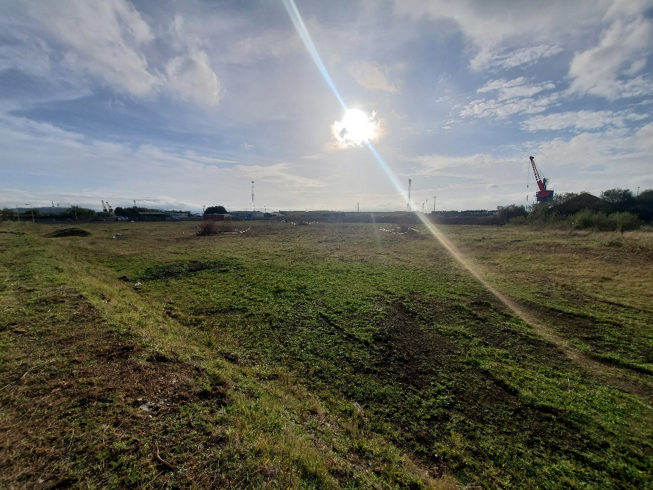

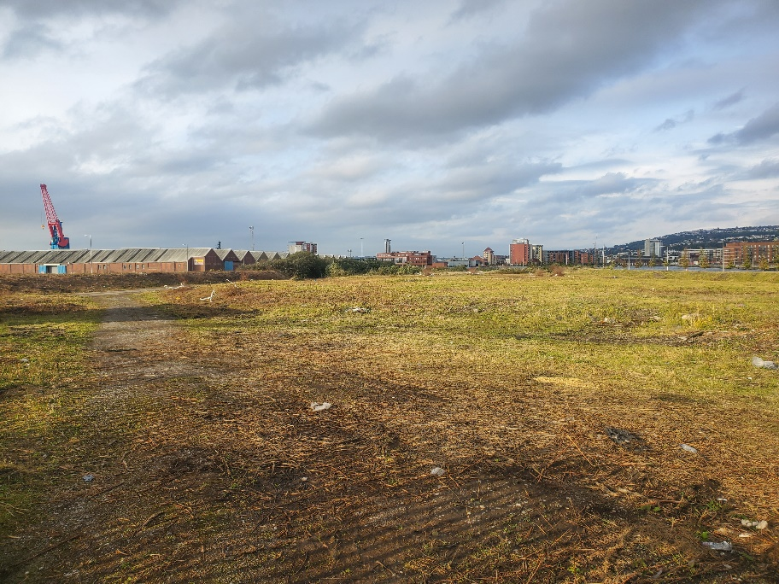

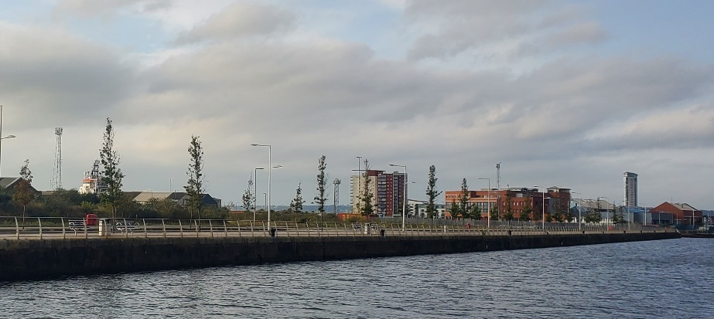

  - Alternative site
This proposed site is the only stated land around this area which the client team own. If site constraints warrant it the adjacent brownfield area to this site can be investigates further as to whether it can be used to replace or in conjunction with the already used site to create a larger space. This would create a much more open space creating more scenery and campus feel for not only the building users but for the community as more green spaces would be available.

  - Site Location Plans
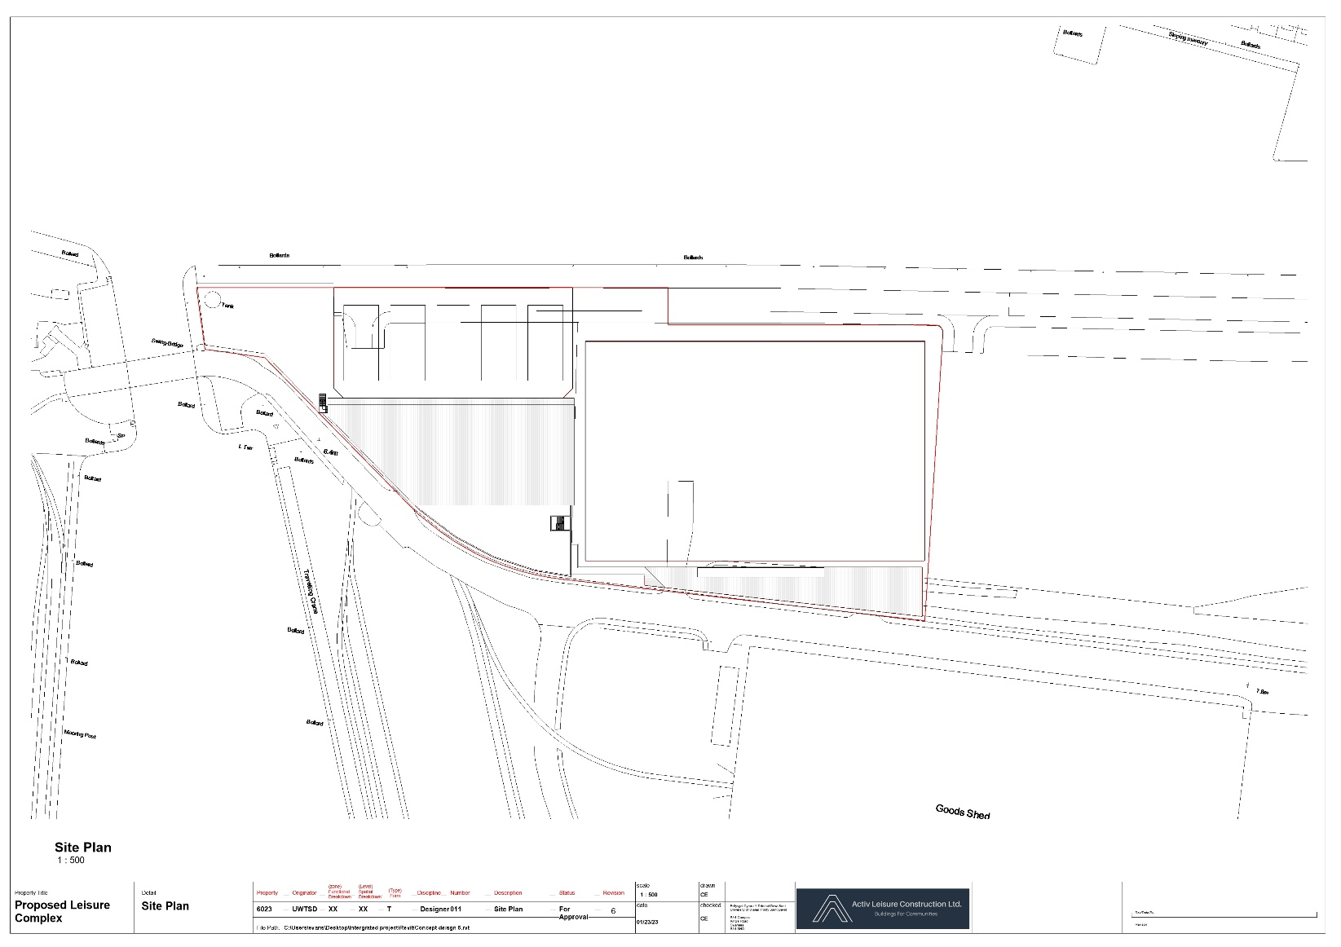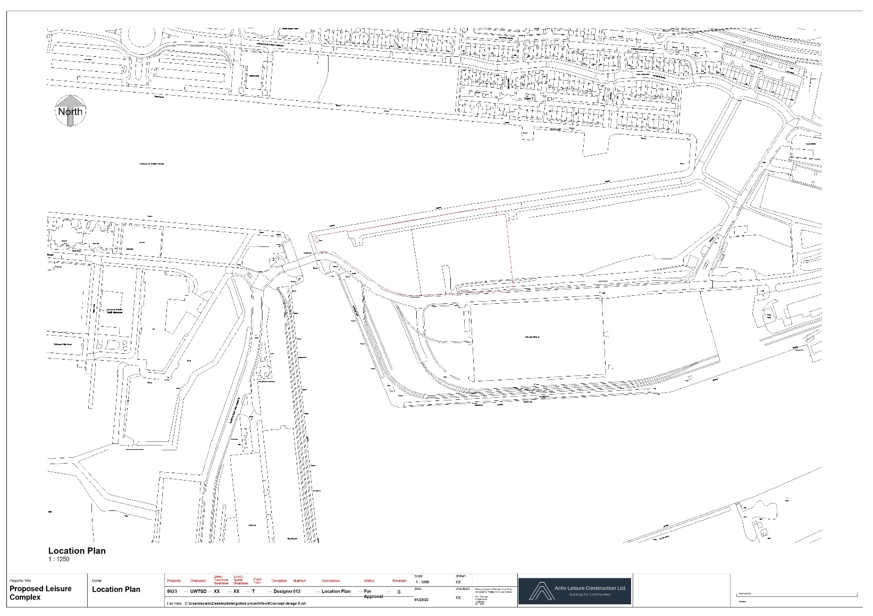

  - Surrounding development
The site has the prince of Wales dock bordering it to the North with the small supply channel to the West between this dock and the Kings dock. This small channel has an existing bridge present which was not accessible during our site survey; this area over the bridge houses the UWTSD waterfront campus as well as residential flats, commercial premises (restaurant, café etc) and industrial units. To the opposite side of The Prince of Wales dock directly adjacent to the site is a relatively new residential development constructed in brick looking over the dock. To the East of this site is the main access road into the proposed site which also accesses a range of commercial business, like car dealerships and fast-food outlets. To the West of the residential development is the HMT Sancta Maria hospital and a Premier Inn hotel. By following this road around, it will lead you either to Fabian way dual carriage way or to the University of Wales Trinity St David campus and other development areas. The Premier Inn Hotel will support the large competitions held in the Leisure Centre and the Hospital can be linked to the scheme through a rehabilitation centre. Lastly to the East and South of the site are a range of industrial zones all being part of the ABP (Associated British Ports). Access to the site has already been detailed in the above. This main access road to the site does have adequate foot paths either side however we would wish to include pedestrian access to the bridge to connect the two portions of land and create a link with the adjacent university. There is no current parking available. From our investigations we do not believe the adjacent industrial units are high noise areas, moderate levels of noise may be produced by incoming ships. Likewise, during the construction, noise will have to be considered due to the relatively adjacent residential development and university to the North and West.

  - Ecological survey
Due to the lack of existing structure, brownfield nature of the site and lack of freshwater courses we do not envisage there being any bats or reptiles to the site, nor do we envisage there being any protected species of birds due to the limited presence of trees. Due to the shrubbery onsite however, this could give the potential to nesting birds. The site will require a preliminary ecology survey and, depending on the findings, potentially more detailed surveys.

  - Tree assessment
There were no significant trees on site, the brownfield site was accompanied by shrubbery and few very small trees. A specialist assessment may be required to identify the species of the small trees and to make appropriate recommendations as to if they are protected. We do not envisage them being protected.

- Development Constraints | Status
Commentary: | Green
  - Flood consequence assessment
The NRW flood risk map shows a low to high risk from surface water flooding to isolated areas, because of this the planning application will need to be accompanied by an FCA (Flood Consequence Assessment).

  - Services adequacy
To date, there are no known services on the site; identified are 4 high voltage underground electrical cabling, a single low-voltage underground cable, a 150mm PVC foul water pipe and a low-pressure water line all near the site. At this early stage, we believe the electrical supply to the site has adequate capabilities for the proposed project. Regarding the low-pressure water line, we envisage the site requiring a high-pressure line as well. The single 150mm PVC foul water pipe will not suffice for the proposed occupancy of the leisure complex.

- Accommodation Requirements | Status
Commentary: | Green
  - Space requirements
The client brief states use for an Olympic size swimming pool to hold national events, a rugby/football pitch and subsequent facilities, and 5 tennis courts as well as sufficient facilities to accommodate community use provisions. All design and cost guidance are set out by sport England.

  - Services requirements
Swimming pool services for heating filtration and circulation.
Sufficient extraction is required due to the high humidity areas. Potential for technology machinery/equipment due to the potential rehabilitation link with the neighbouring hospital. Following on from these points sport England guidance states:

Pool halls (main and secondary) HVAC
• Heating via a dedicated ventilation system
• Mixing air circulation for pool (ductwork at high level designed for modulation)
• Dehumidification via fresh air
• Plate heat exchanger.
• Lighting - Corrosion resistant IP65+, Metal Halide floodlights, Up and down lighting.

Changing rooms HVAC
• Heating via a dedicated ventilation system
• Plate heat exchanger
• Openable high-level windows for natural ventilation in summer where possible.
Lighting
• Corrosion resistant IP65+
• LED * bulkhead fittings or high efficiency fluorescent fittings.

Fitness suite and studios HVAC
• Heating and cooling provided via dedicated ventilation system
• Comfort cooling provided by chilled water or VRF system.
Lighting
• Recessed modular LED or high efficiency fluorescent fittings.

Offices, staff room and circulation HVAC
• LST radiators
• Natural ventilation via manual openable windows where possible, mechanical ventilation for internal spaces.
Lighting
• LED recessed downlighters or high efficiency fluorescent fittings

- Design/Specification | Status
Commentary: | Green
  - Fixed and loose equipment, furniture and furnishings
As stated in the sport England guidance -
Reception desk, automatic turnstiles, Fixed seats suitable for pool hall, white boards / notice boards, external guard rails to automatic doors, benching and clothes hooks, hand dryers, baby changing facility, first aid room, fit-out WC, changing, shower cubicles, fitness studio mirrors, dance studio rail, mirrors to WC and changing, vanity units, hairdryers, lockers, shelving to stores and cleaner’s cupboards, hooks for equipment storage Internal signage, external signage, disabled access hoist, pool access ladders, pool clock, access handrails, pool lane ropes and anchor points, lane rope trolleys.

Club house requires Showers, curtains, tables, mirrors, WC provisions, raised platforms, storage cupboard.

  - Provision for future expansion/alteration
The design can be such that it is incorporated into the site with it in mind that the adjacent brownfield site is to be purchased and used in the future. Likewise, the use of a steel frame and other specifically chosen building details can make for future extensions/alterations to be easier due to the relatively simple tie in process involved with steel frames.

  - Energy efficiency, BREEAM, EPC requirements, sustainability measures
There has been a similar scheme completed in recent years - the Exeter new leisure centre is the first Passivhaus leisure centre which provides a good template in achieving similar or exact goals. BREEAM signifies the efforts of the building to low carbon footprint and sustainability measures, it should strive to be achieved as one of the main considerations from the client team is sustainability. Sport England's guidance for BREEAM states: If a BREEAM assessment method is used to raise the sustainability standards, the indicative designs will fall within New Construction Non-Domestic 2014 assessment criteria (from 30th June 2014). See the BRE published manual for full details.

Sport England design guidance set out considerations and requirements for a 50m length pool leisure centre, these are listed in brief within the document as:

Energy conservation measures
- Air handling units with heat recovery
- Modulation of the fresh air provided by the ventilation system to meet varying loads in all occupied spaces
- Variable speed drives on all pumps, both for heating, domestic services and water treatment
- Sizing of ductwork to achieve low specific fan power
- Daylight linked dimming control on lighting in all well daylit areas
- Lighting control based on presence or absence detection (as appropriate) in all ancillary rooms and stores.

Renewable technologies
- Solar thermal collectors (100m2 array).

Water conservation: sanitaryware specific cation to include:
- Sensor or percussion taps and showers • Dual flush WC’s • Water efficient shower heads • Flow regulators to taps

Metering and monitoring
- Meter 90% of annual energy consumption by use (Part L2 requirement)
- Output from any renewable energy generation (Part L2 requirement)
- Heat meter on LTHW branch serving pool water heating
- Temperature and RH sensors in the pool hall at pool level and in spectators seating
- Visitor numbers monitored via tills.

- Estimates | Status
Commentary: | Green

- Programme | Status
Commentary: | Green

- Conclusions/Recommendations | Status
Commentary: | Green
  - -

- Drawings and Associated Information | Status
Commentary: | Green
  - Site Location.
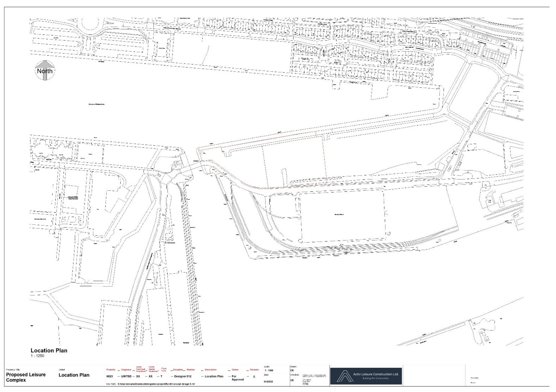
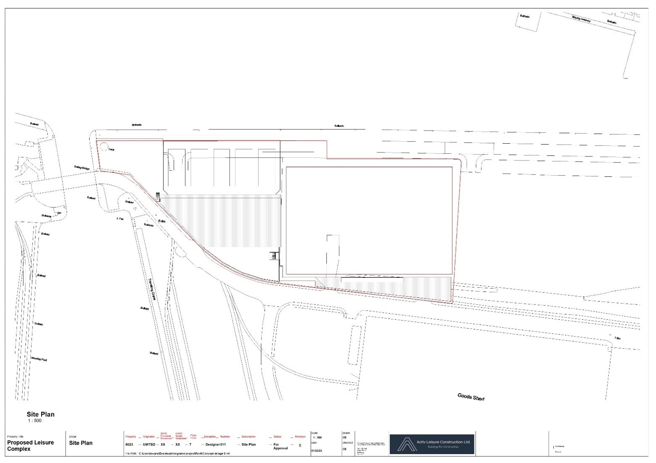

11.2. Sketch schemes and options
To date 6 concept designs have been produced with the 6th design being the current preliminary design; the other concepts were superseded due to their inefficient use of space on the constricted site or their lack of practicality. This preliminary design is currently at revision 3.

  - Schedule for accommodation
This is set out in Sport England design guidance and in the brief from the client team; all will be followed and presented in a later stage of the project.

  - Schedule for furniture and equipment
This is set out in Sport England guidance and will be incorporated with the design at a later stage of the project. Simple estimates of this are currently produced to aid in producing an initial cost.

  - Preliminary design


