ASSIGNMENT NO 1 MANAGING PEOPLE
LECTURER ZE ZOOK
UWTSD OCTOBER 2020
BUSINESS MANAGEMENT
IZABELA CRISTINA ANTONESCU – STUDENT NUMBER 1817787

ASSIGNMENT NO 1

TABLE OF CONTENTS

- INTRODUCTION……………………………………………………..3
- DISCUSSION………………………………………………………….3
  - TASK 1…………………………………………………………….3
  - TASK 2…………………………………………………………….5
- CONCLUSION…………………………………………….…………..9
- REFERENCES……………………………………………………..…10

- Introduction

I will start by pointing that the HR (human resources) department is crucial in any business, the human factor is the most important element in a company. The major challenge of HR is that it needs to prove the critical status and the vital role in any business in order to become successful in the future.
Human Resources can be defined as the people who work for a company and the department responsible for managing resources associated to employees. (Humanresourcesedu.org,2018) The HR department is responsible for hiring, finding, and developing new relationships with the new talent and making sure they are offering the best they can for the organization.

- Discussion

Task 1

According to Rijnetu(2018) the HR department plays an important role in a organization, but this department is not recognized to its fully potential. A study by CIPD (The Chartered Institute of Personnel and Development) gathered information from the leaders of HR and from the business environment regarding the contribution of HR in the business performance. The study’s result has brought to the attention that the HR department role is undervalued and there are also many talented and capable people that are not recognized enough.
The HR professional must own some important qualities such as curiosity, collaborator, credible, decisive thinker, driven to deliver etc. (CIPD, 2013) The current CIPD profession map helps to set standards for organizations worldwide in the HR department.

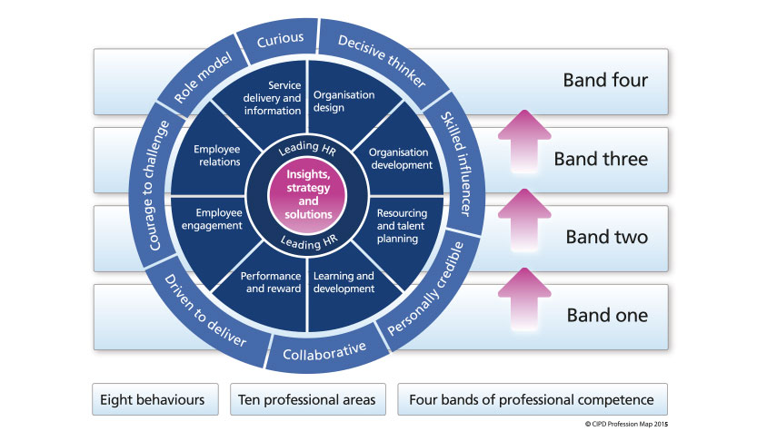
Fig. 1 CIPD Profession Map 2013.
A HR professional could be defined as someone who is communicative, knows how to use the words in order to make connections with people and develop relationships regardless if the people are eventual employees or colleagues, the HR professional needs to be curious and willing to learn new things; learning should be a priority because intelligence is gathered in ordered for the individual to grow and for the company to have success, also credibility is an important skill that the HR professional needs to have, furthermore being a role model and a skilled influencer goes hand in hand with the credibility skill where people respect and believes that the HR professional has good intentions. The HR professional should be a decisive thinker a skill that helps with the recruitment and resourcing talent as well as meeting expected deadlines, improving performances and delivering expectations.
According to Cosbuc(2018) a CEO expectations of a HR professional are the first and most important responsibility is to bring the vision of the company to the employees, secondly the HR professional needs to properly analyze and interpret the data in order to work with the best people and create the most performant teams, third expectation that needs to be met is that the HR professional will take into account the performance and the talents of the people in order to bring more success for the company, a HR professional needs to be an expert in recruitment and decision making when hiring new people regardless if they are temporary or permanent.
In other words, the HR professional or the talent manager is no doubt the most important element of the business, besides the business vision and money. Without the best employees, not money and not even the best business vision will help a company on its way to success. The HR department has an important impact on the organization and the impact will be good or bad depending if the company is willing to really invest in the HR.

Task 2

The objectives of the HR professional are as follows exemplifications of the issues within the hiring process, deliberation of the role of planning of HR and the way the organization is covering their need of employees, evaluation of the results from the job interviews, description of the successful methods for integrating the new employees in the company, providing new methods for the employees future growth and development, explaining the objectives of the performance reviews, discussion of the aspects that needs to be considered in the decision making in rewarding the employees, discussion of the methods of developing productive relationships with the employees. (Cornescu, 2004)
Cornescu (2004) argues that the HR professional is creating a plan in attraction and retention of the people to which qualities benefits the company. Implementing the plan requires recruiting, selection, integrating, training, rewarding and continuous monitoring of performance in order to identify if the organizational objectives are met.
The planning process is used in order to determine the needs, strategies and philosophies regarding the human resources of the organization, the HR professional needs to find out how many people and what skills the firm needs in present as well in the future. The planning objectives are finding the right people in the right number with the required talents, knowledge, and skills for the right jobs at the perfect time at a reasonable cost.
Recruitment and selection are complementary activities within the hiring process. Research shows that recruitment is the process of confirmation the need of hiring new staff, localization and attracting the interested people to apply for the jobs available. The selection is the final stage of decision making within the recruitment process, this represents the process where people are chosen because they own the necessary skills, knowledge, and qualities in order to finish the tasks given at the job. (Cornescu, 2004)
The stages of the recruitment and selection progress are as follows : defining the job where the recruiter presents the job requirements and the skills needed for it, attraction of the candidates where the job is advertised in mass media, word of mouth or newspapers and the last stage, selection where the recruiter asks the candidates to send a CV (curriculum vitae), cover letter or recommendation.
The company chosen for investigation is going to be Nando’s. Nando’s is a fast-food style restaurant that has been founded in 1987 in South Africa, they are famous for their peri-peri chicken, garlic bread, corn on the cob, spicy and different sauces, and bottomless fizzy drinks. According to their website Nando’s can be found in many countries around the world including UK, Australia, Canada, Fiji, Pakistan, Qatar, Singapore, USA etc.
According to much research Nando’s became more and more popular, now it is on the 14th spot for the most popular restaurant in UK and the 10th most famous dining brand. (YouGov, 2020)
Nando’s motto is “Nando’s is not just about the chicken. It’s never been just about the chicken. It’s about the people who make the chicken.” , according to their website, this quote brings to the attention of people that their employees are not just there for work but they are there to be valued and cherished. The people who work at Nando’s are satisfied with their jobs there, according to Indeed.co.uk, Nando’s has four stars from over 2.500 votes regarding satisfaction.
The interview at Nando’s is easy, straightforward, and fun, people tend to be stressed and nervous when they attend a job interview but Nando’s makes the process less stressful. Nando’s is using social media to help with the recruitment process, they are posting the job openings on Indeed, Facebook, newspapers etc. When the author attended the job interview, the HR made it better than any other interview she had before with other companies. The author found about the job opening from a friend, she sent Nando’s the CV and they called her for an interview. The questions that have been asked were,, What do you know about this company? What is your current job? What skills do you have? Do you work well under stress? Do you realize cleaning will be involved in your role? If you were a superhero, who would you chose to be?’’ The HR made clear everything during the interview, they made clear the payment, the requirements, hours on the contract, possibility to grow and evolve within the company, company benefits also after she was offered the role she started work the next day.
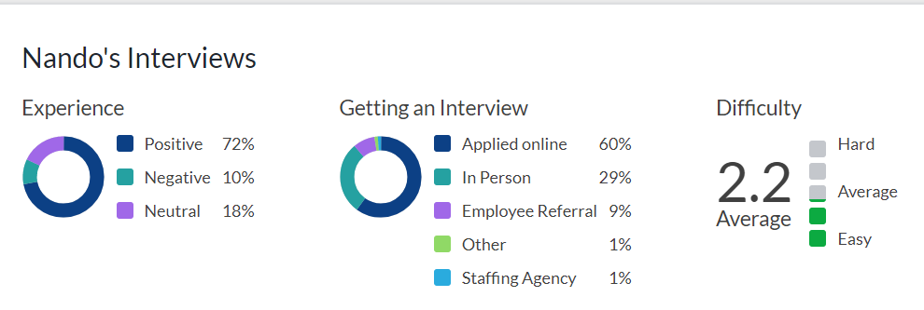
Fig. 2 Nando’s interviews .2020
The motivation at Nando’s was done correctly by the HR team and the management, for example the shifts were done in advance, breaks were taken regardless if the restaurant was very busy or not, training is provided for all new employees and even for old employees if they need to learn new things or if they are struggling, food was provided by the company for free for shifts longer than 5 hours, weekly payments were always on time and paid straight to the bank account, holiday was paid, opportunities were presented to the team at the monthly staff meeting and news about products and future events, company benefits and staff discounts and so on. People were valued at Nando’s and there were no differences made between people, everybody was working hard, and they were motivated to do better within the company, not long after the author started my job there as front of house member she felt like she was part of a team and she was valued as a human being. As proof of the employee motivation, the branch in Colchester where she used to work there were people working there for more than 5-7 years and they were happy with their jobs, motivated and always with a smile on their faces.
According to research, 21% of the managers had been promoted from within in 2001. (Performancesonsultants,2017) Nando’s objectives are to maintain the value of pride, passion, courage, integrity, and the family ‘feeling’. Nando’s is not just a place for a job, it is a feeling where you feel included, driven to grow, a passion to help others and just do better.
Usually, Nando’s recruitment is pretty straightforward and they accept basically people from 14 to 60 or more, they accept people with disabilities, people with different cultures from different countries, the company offers equal opportunities for everybody regardless of their background and this is a big motivation factor to work for them.
Even though Nando’s was offering opportunities to all kinds of people, most of the employees were youngsters, their business was based on younger people that are willing to work on minimum wage, longer hours or on short notice. One reason why younger people were keen on working for Nando’s was the busy environment and the excitement that comes with it, for older people or more mature ones working in a very active environment everyday might not be their first choice, the skills needed in the company were patience, integrity, common sense, honesty and most importantly working hard. The management was well trained and not as young as the rest of employees and they prove that they can be motivational, helpful without being rude or insistent in different matters overall they were creating a positive environment.
According to research the staff surveys at Nando’s have shown that 91% of the staff have fun at work, 96% of the staff are proud to be working for the company and 87% reveal that their manager ensures that they are trained for the job.(Personneltoday,2006)
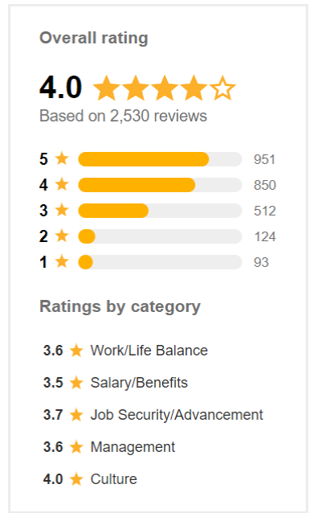
Fig. 3 Nando’s overall rating .2020
Overall, the planning, recruitment, and selection at Nando’s needs to be done by the HR team in a fun and interesting way. The current Nando’s employees found their jobs online where is easy and accessible, young people tend to check the internet for jobs and by advertising online the openings at Nando’s could bring many candidates. The author’s opinion about the planning, recruitment and selection is done great by the HR because they take quick decisions about the candidates, they offer interviews and trial shifts which helps the employer to make an idea about the candidate and the candidate to have an idea about the job where they applied. In this company the targeted people for the job are young people who they do not mind working on minimum wage in a busy and fast environment where stress is present, and the customer needs to be treated with respect and helped with any queries.

- Conclusion

In conclusion being a HR professional is a lot of hard work, dealing with colleagues and employees. The HR department is crucial in any company and needs to be treated with respect. The right people at the HR can make a huge difference within the firm, it can make the firm successful and great or not. Regarding the planning, recruitment and selection, the HR is responsible for finding the right people for the right role at the right time in order keep the company going with the best people out there.

References:

Akakabota P. (2014) How Nando’s can manage and lead their team successfully. [Online] Available at : https://www.academia.edu/17073621/How_Nandos_can_manage_and_lead_their_team_successfully (Accessed on 13/11/2020)
Cosbuc E. (2018) Rolul strategic al managerului de HR si ce asteptari are un CEO de la el. [Online] Available at : https://www.colorful.hr/rolul-strategic-al-managerului-de-hr-si-ce-asteptari-are-un-ceo-de-la-el/ (Accessed on 13/11/2020)
Cornescu V. (2004) Managementul resurselor umane. [Online] Available at : https://ebooks.unibuc.ro/StiinteADM/cornescu/cap12.htm (Accessed on 18/11/2020)
CIPD (2013) HR Outlook. Views of our profession. [Online] Available at : https://www.cipd.co.uk/Images/hr-outlook_2012-13-winter-profession-views_tcm18-11011.pdf (Accessed on 13/11/2020)
CIPD (2013) CIPD HR Profession map. [Online] Available at : https://www.cipd.co.uk/cipd-hr-profession/cipd-hr-profession-map/default.html (Accessed on 13/11/2020)
CIPD (2018) The CIPD profession map: a guide. [Online] Available at : https://www.cipd.co.uk/Images/the-cipd-profession-map-accessible-format_tcm18-33362.pdf (Accessed on 13/11/2020)
CIPD (2017) HR Professionalism: what do we stand for ? [Online] Available at: https://www.cipd.co.uk/Images/professional-identity-research-report-updatedPFFMay20_tcm18-17960.pdf (Accessed on 18/11/2020)
Fig. 1 CIPD Profession Map. (2013)
Fig. 2 Nando’s interviews (2020) Nando’s [Online] Available at : https://www.glassdoor.com/Overview/Working-at-Nando-s-EI_IE574195.11,18.htm (Accessed on 22/11/2020)
Fig. 3 Nando’s overall rating (2020) Nando’s [Online] Available at : https://nz.indeed.com/cmp/Nando's/reviews?fcountry=ALL (Accessed on 22/11/2020)
Humanresourcesedu.org, (2018) What is Human Resource. [Online] Available at : https://www.humanresourcesedu.org/what-is-human-resources/ (Accessed on 13/11/2020)
Indeed (2020) Questions and answers about Nando’s [Online] Available at : https://au.indeed.com/cmp/Nando's/faq (Accessed on 13/11/2020)
Indeed (2020) Hiring process at Nando’s [Online] Available at : https://www.indeed.co.uk/cmp/Nando%27s/faq/hiring-process (Accessed on 13/11/2020)
Performanceconsultants (2017) Talent management Nando’s case study [Online] Available at : https://www.performanceconsultants.com/talent-management-nandos-case-study (Accessed on 13/11/2020)
Personneltoday (2006) Nando’s spices up it’s leadership style. [Online] Available at : https://www.personneltoday.com/hr/nandos-spices-up-its-leadership-style/ (Accessed on 13/11/2020)
Rijnetu I., (2013) Ce cred liderii din HR despre rolul HR-ului in dezvoltarea business-ului. [Online] Available at : https://portalhr.ro/ce-cred-liderii-din-hr-despre-rolul-hr-ului-in-dezvoltarea-business-ului/ (Accessed on 13/11/2020)
Nando’s Co. (2020) Explore the Nando’s world. [Online] Available at : https://www.nandos.com/worldwide/ (Accessed on 13/11/2020)
Nando’s Co. (2020) People. [Online] Available at : https://www.nandos.com/people/ (Accessed on 13/11/2020)
YouGov (2020) The most popular dining brands in the UK. [Online] Available at : https://yougov.co.uk/ratings/food/popularity/dining-brands/all (Accessed on 13/11/2020)

