ACCA4023_Sem1_Database_Assignment.

Ossian De’Ath
2520279
Computing
ACCA4023_Sem1 Databases.
05/01/2026

Table of Contents
Summary of the report. 3
Requirements 4
Database attributes and their relationships. 5
Entity Relationship diagram. 5
Data structure development. 6
Rider Table 6
Bike Table 6
Bike Type Table 7
Bike Condition Table 7
Condition Table 7
Status Table 7
Rental Table 8
Maintenance Table 8
Maintenance Type Table 8
Staff Table 9
Job Role Table 9
Station Table 9
Tarrif Table 10
Normalisation compliance. 10
Sample Data. 10
Database Queries. 10
Validation and testing. 10
Evaluation 11
References 12
References for the Written assignment: 12
Appendices 13

Summary of the report.
Give a summary of the assignment.

Requirements

The local authorities have introduced the Eco Ride scheme. This is a green transport scheme which offers different types of bikes on rental for people to use to get back and fourth work in a sustainable and economical way.
The current service relies on paper form and basic spreadsheets to manage rider information, bike availability, maintenance, and rental transactions. This approach will cause inefficiencies, including double bookings, unreturned bikes, and poor visibility of bike status. This will make it difficult for us to generate accurate reports on users, bikes, and rentals.
To helps resolve these challenges, I will look to implement a structured Database system for Access. This operation will streamline operations by allowing the team to do:
- Register riders and store essential information.
- Maintain comprehensive records of all bikes, which will include condition, location, and maintenance history.
- Record rental transactions with dates, duration, and costs.
- Track the staffs involvement within servicing and inspections.
This database will provide a centralised efficient and user-friendly system which will improve data accuracy and operational control, and reporting capabilities.

Database attributes and their relationships.

Entity Relationship diagram.

I have created an entity Relationship Diagram using Draw.io. This diagram displays the entities and their relationships. I have clearly listed the Primary Key, Foreign Key and Candidate key. Each keys are displayed like this:
- Primary Key: PK
- Foreign Key: FK
- Candidate Key: CK
These Keys are listed to the left of each attribute. The diagram below displays each table clearly with it’s attributes. You can clearly identify the relationships between each table as you can see the crows foot notation from each tables.
My ERD also displays proper Normalisation as tables like Tarrif Table, Status Table, and Job Role table are separated. This allows us to reduce redundancy and improves Scalability. 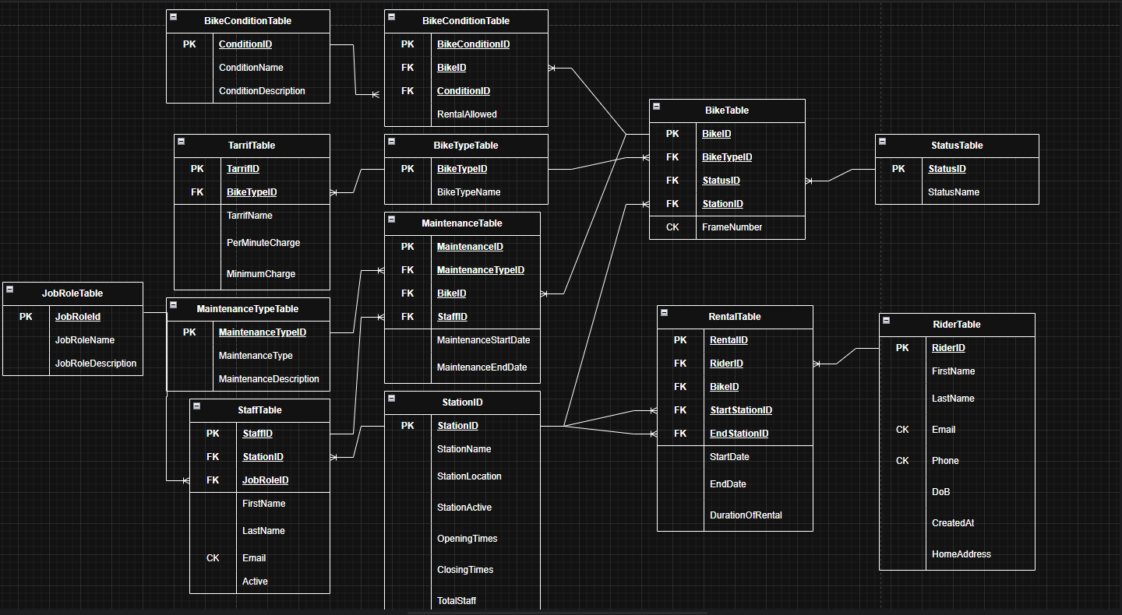

Data structure development.
The structure of my Data will follow as below and every field which isn’t a relationship will be set to “Is Not Null” with appropriate validation text so we do not have any null data entries.

Rider Table
These are the date entries for this table:
- RiderID (PK): AutoNumber.
- FirstName: Short Text
- LastName: Short Text
- Email (CK): Short text
- Phone (CK): Short text.
- DoB: Time and Date
- CreatedAt: Time and Date
- HomeAddress: Long Text

Constraints
- RiderID is the primary Key
- Email must contain “@” and is unique
- Phone must be a valid number.

Bike Table
These are the date entries for this table:
- BikeID (PK): AutoNumber.
- BikeTypeID (FK): Number
- StatusID (FK): Number
- StationID (FK): Number
- FrameNumber (CK): Short Text

Constraints
- BikeID is the primary Key
- Foreign Keys reference respective lookup tables.
- FrameNumber is Unique.

Bike Type Table
These are the date entries for this table:
- BikeTypeID (PK): AutoNumber.
- BikeTypeName: Short Text

Constraints
- BikeTypeID is the primary Key
.

Bike Condition Table
These are the date entries for this table:
- BikeConditionID (PK): AutoNumber.
- BikeID (FK): Number
- ConditionID (FK): Number
- RentalAllowed: Yes/No

Constraints
- BikeConditionID is the primary Key
- Foreign keys will reference representative tables.

Condition Table
These are the date entries for this table:
- ConditionID (PK): AutoNumber.
- ConditionName: Short Text
- ConditionDescription: Short Text

Constraints
- ConditionID is the primary Key

Status Table
These are the date entries for this table:
- StatusID (PK): AutoNumber.
- StatusName: Short Text

Constraints
- StatusID is the primary Key

Rental Table
These are the date entries for this table:
- RentalID (PK): AutoNumber
- BikeID (FK): Number
- RiderID (FK): Number
- StartStationID (FK): Number
- EndStationID (FK): Number
- StartDate: Date and Time
- EndDate: Date and Time
- DurationOfRental: Calculated

Constraints
- RentalID is the primary Key
- Foreign keys will reference representative lookup tables.
- Start Date/End Date need to have exact Start Time.
- Duration of rental calculates time in minutes.

Maintenance Table
These are the date entries for this table:
- MaintenanceID (PK): AutoNumber
- MaintenanceTypeID (FK): Number
- BikeID (FK): Number
- StaffID (FK): Number
- MaintenanceStartDate: Date and Time
- MaintenanceEndDate: Date and Time

Constraints
- MaintenanceID is the primary Key
- Foreign keys will reference representative lookup tables.
- Start Date/End Date need to have exact Start Time.

Maintenance Type Table
These are the date entries for this table:
- MaintenanceTypeID (PK): AutoNumber.
- MaintenanceType: Short Text
- MaintenanceDescription: Long Text

Constraints
- MaintenanceTypeID is the primary Key

Staff Table
These are the date entries for this table:
- StaffID (PK): AutoNumber
- StationID (FK): Number
- JobRoleID (FK): Number
- FirstName: Short Text
- LastName: Short Text
- Email (CK): Short Text
- Active: Yes/No

Constraints
- StaffID is the primary Key
- Foreign keys will reference representative lookup tables.
- Email must contain “@” and auto populated with domain.

Job Role Table
These are the date entries for this table:
- JobRoleID (PK): AutoNumber.
- JobRoleName: Short Text
- JobRoleDescription: Long Text

Constraints
- JobRoleID is the primary Key

Station Table
These are the date entries for this table:
- StationID (PK): AutoNumber.
- Station: Short Text
- StationActive: Yes/No
- OpeningTimes: Short Text
- ClosingTimes: Short Text
- TotalStaff: Number

Constraints
- StationID is the primary Key
- Total Staff will be calculated via a query or Macro.

Tarrif Table
These are the date entries for this table:
- TarrifID (PK): AutoNumber.
- BikeTypeID (FK): Number
- TarrifName: Short Text
- PerMinuteCharge: Currency
- MinimumCharge: Currency

Constraints
- TarrifID is the primary Key
- Foreign keys will reference representative lookup tables.

Normalisation compliance.
Based on the above ERD. I believe my Table will meet the 3NF compliance. The tables themselves have clear primary keys in each table, with the foreign keys properly established in other tables. Attributes like First Name, Last name, are atomic, meaning there are no multivalued or composite attributes. There are no repeating groups as data has been structured so that the repeating groups are avoided, for example maintenance types are in a separate table from the maintenance table.

However, there may be a few issues with this structure as attributes like total staff in the Station Table are derived from the staff table and storing it here introduces redundancy. Also Tables like the rider table which contain the home address may need more normalisation to be split down into things like street name postcode etc.

Overall I would say that this ERD is mostly compliant with normalisation due to the above factors.

Sample Data.
I have created and entered the sample data for the Database and all it’s tables. Currently we have two ways of viewing this sample data. We can use the Database or the forms. Here are all the Tables:

Rider Table
Data View: 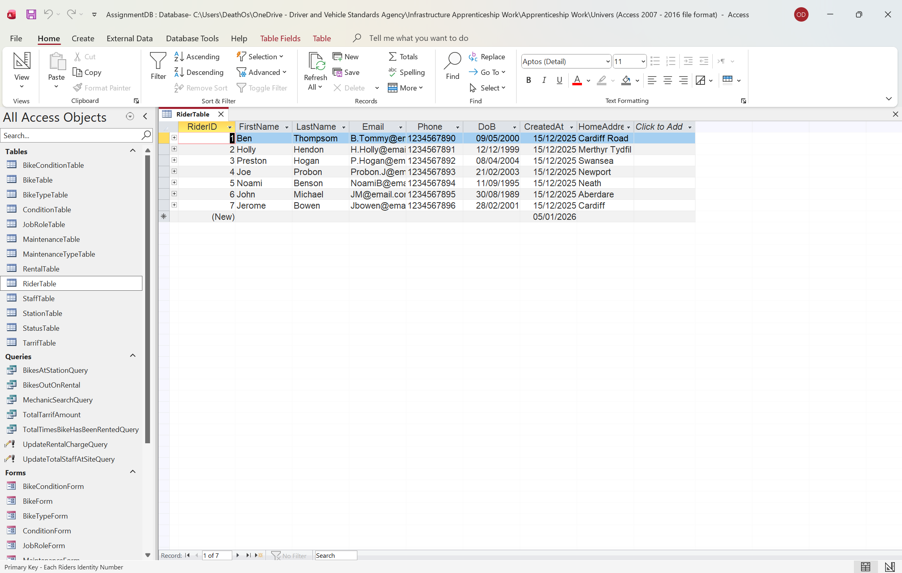
Design View:
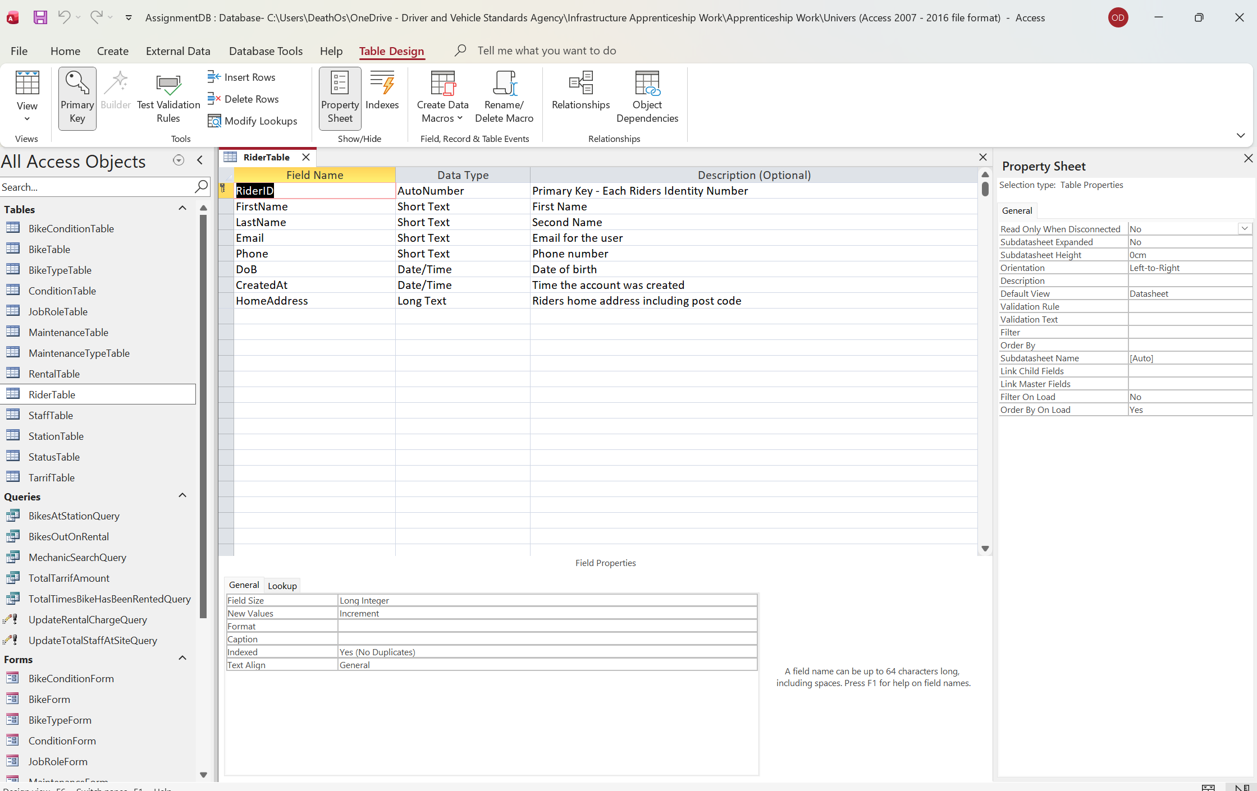
Form View:
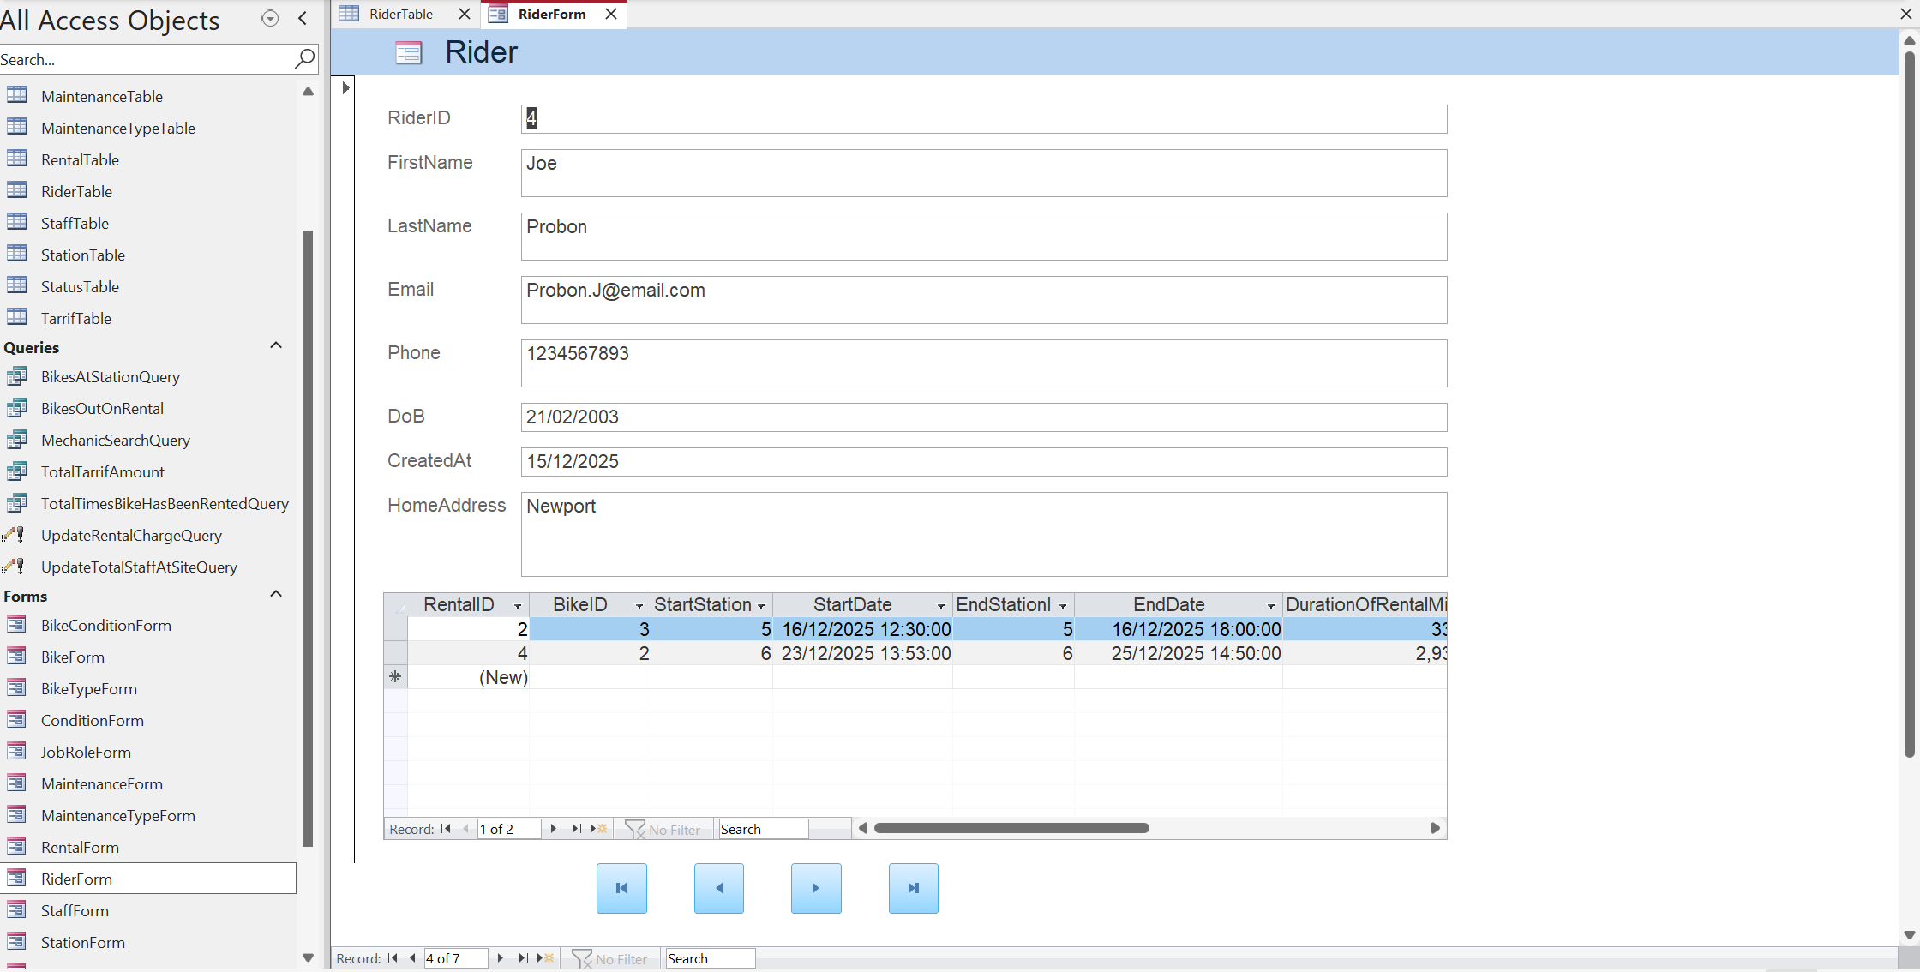

Bike Table
Data View:
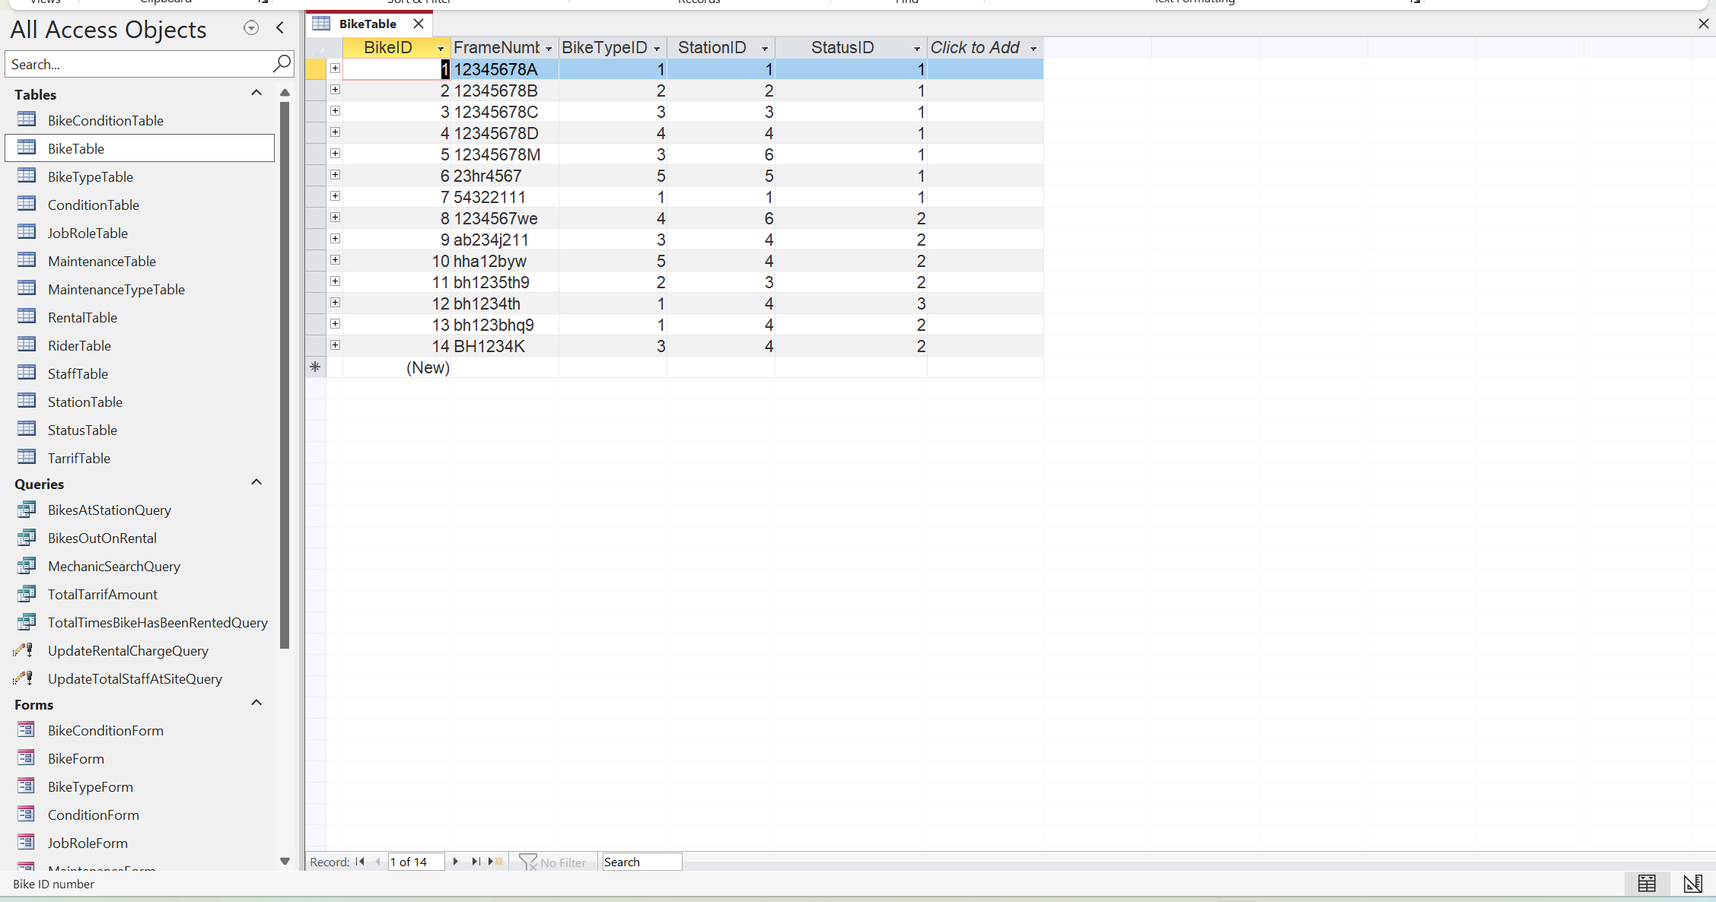
Design View:
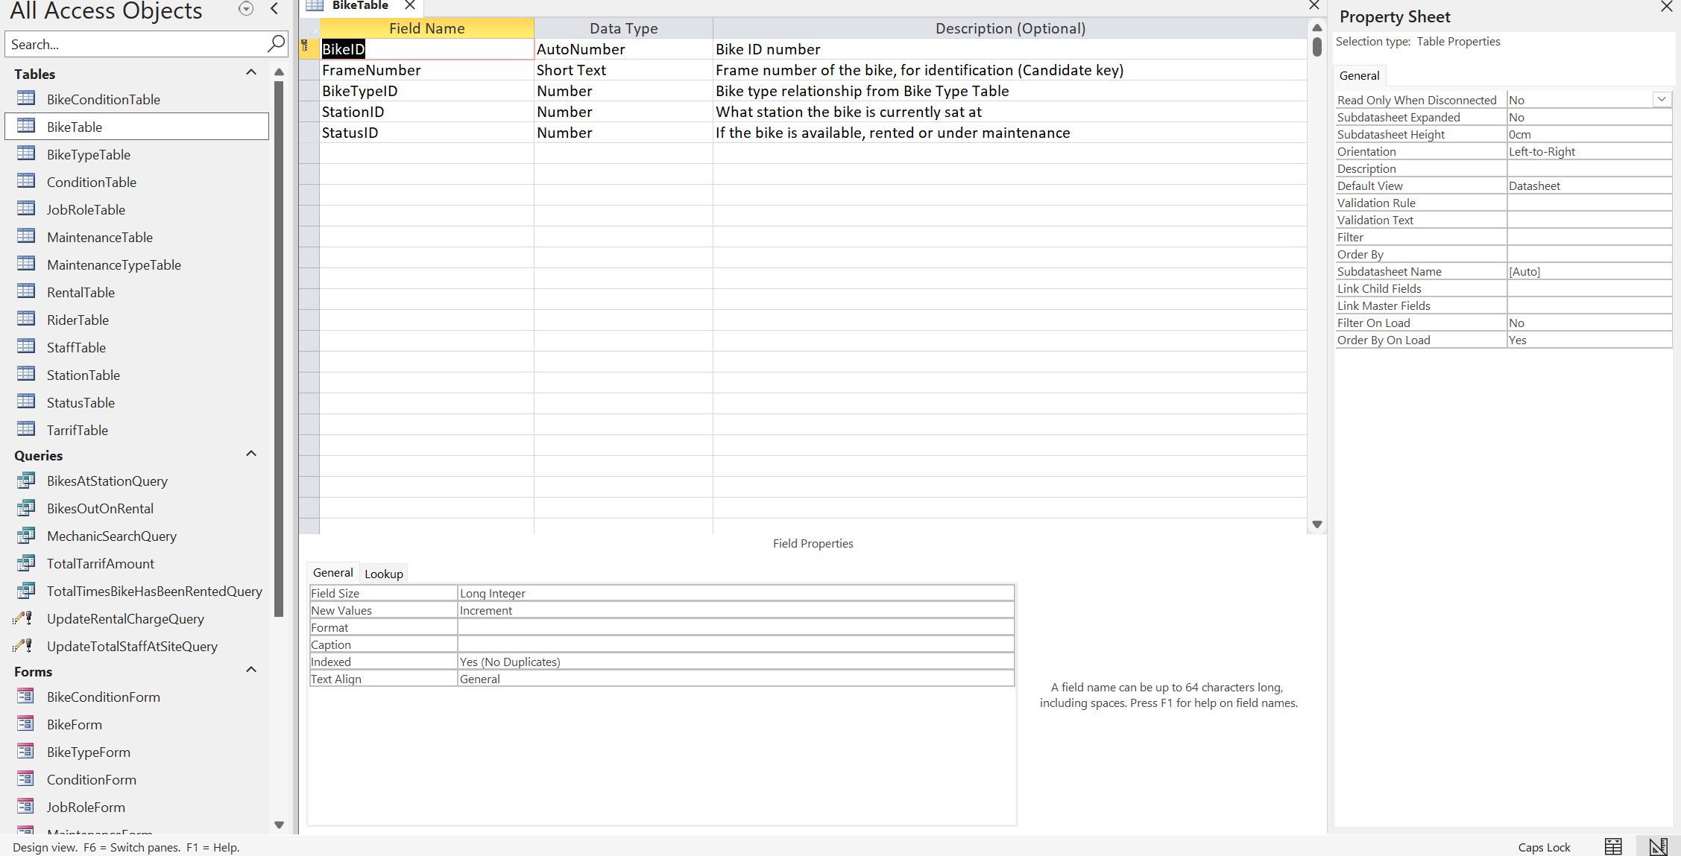
Form View:
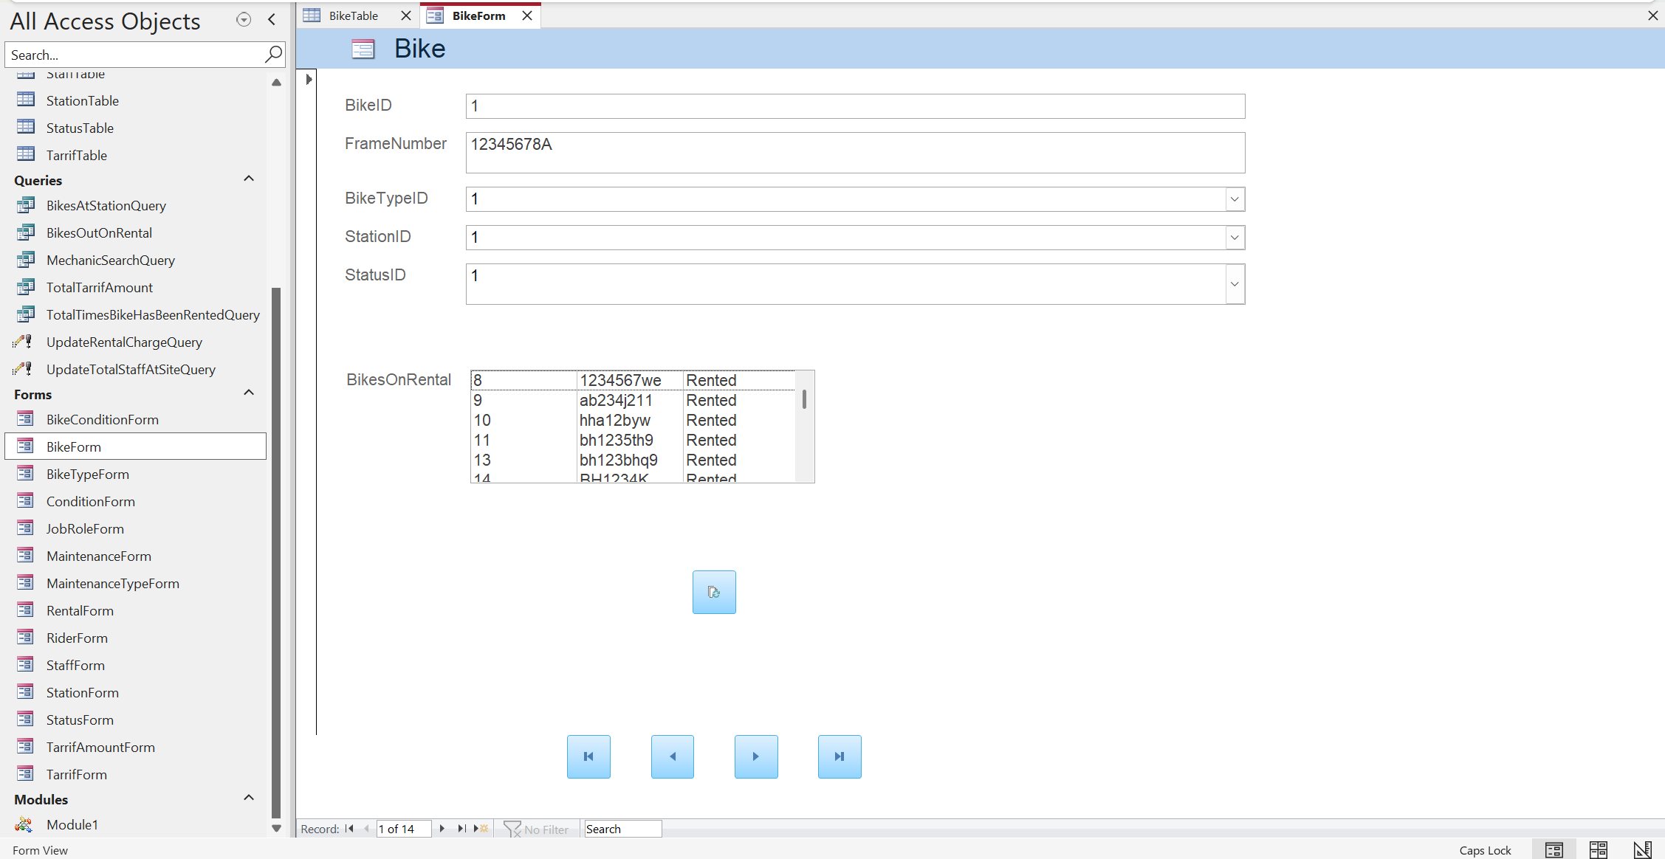

Bike Type Table
Data View:
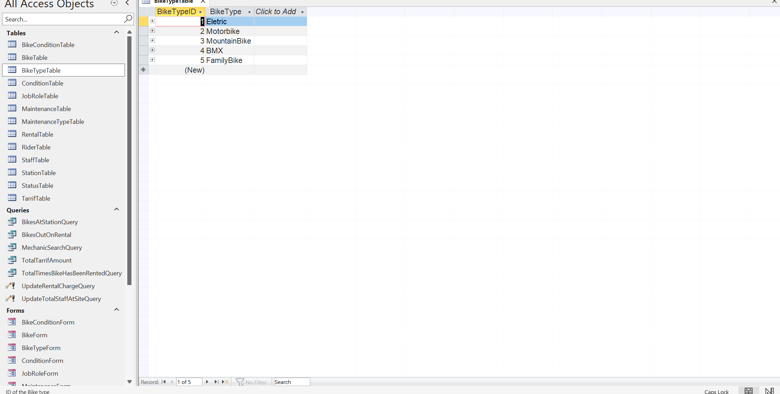
Design View:
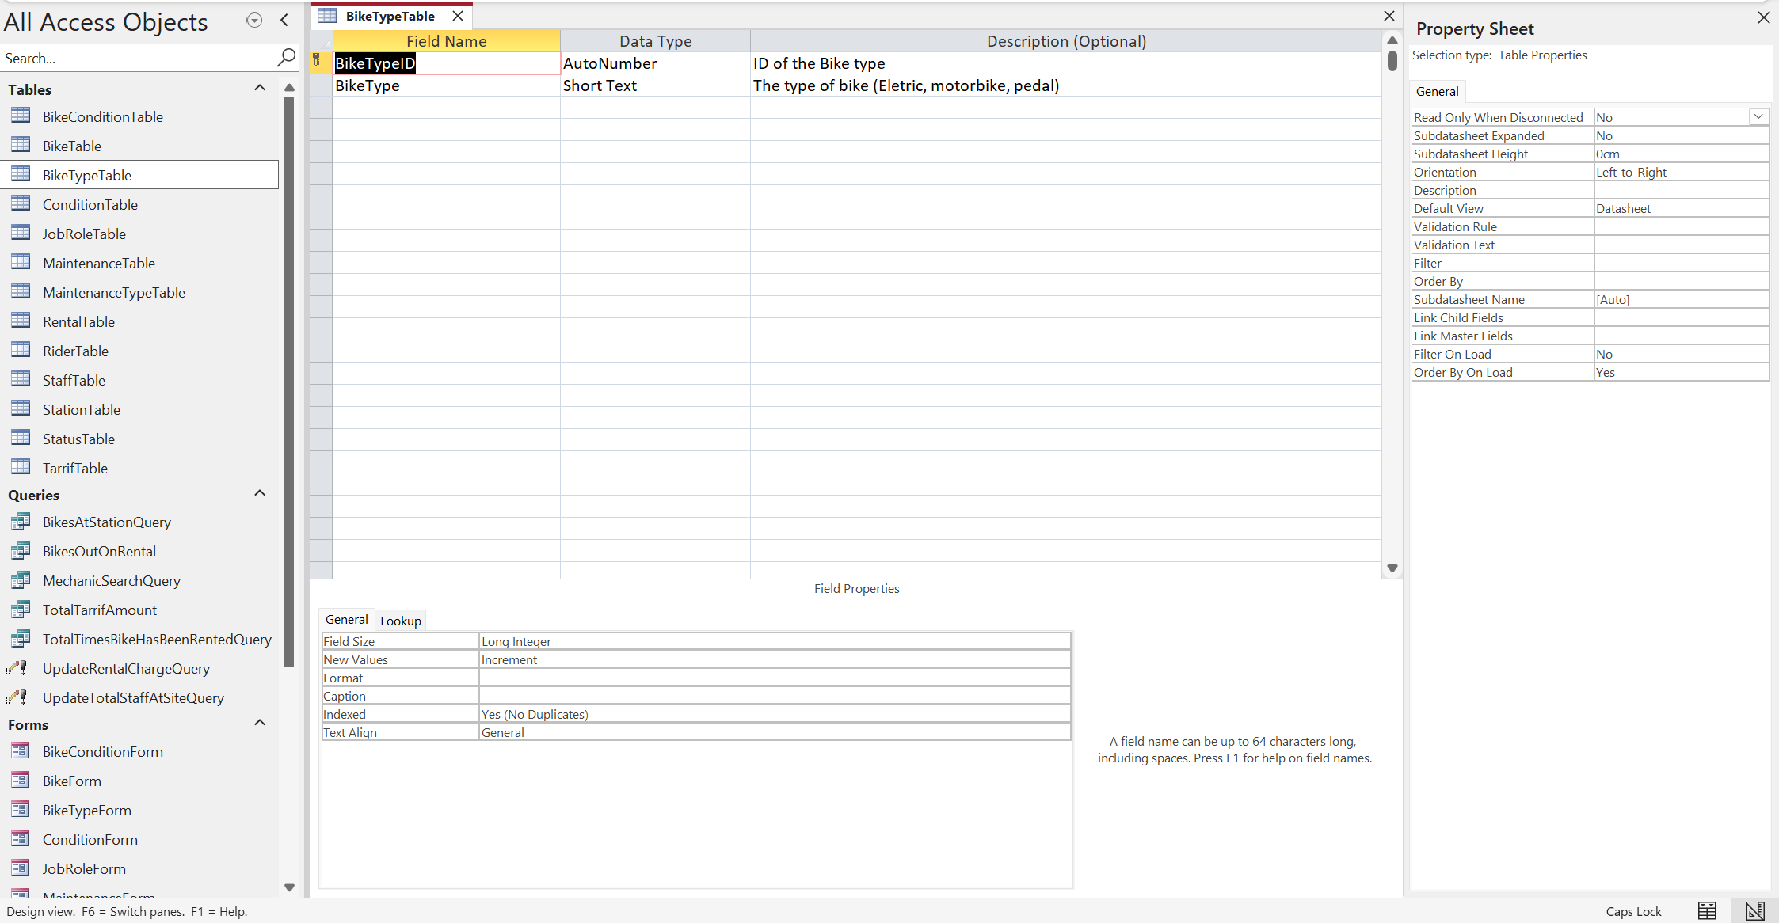
Form View:
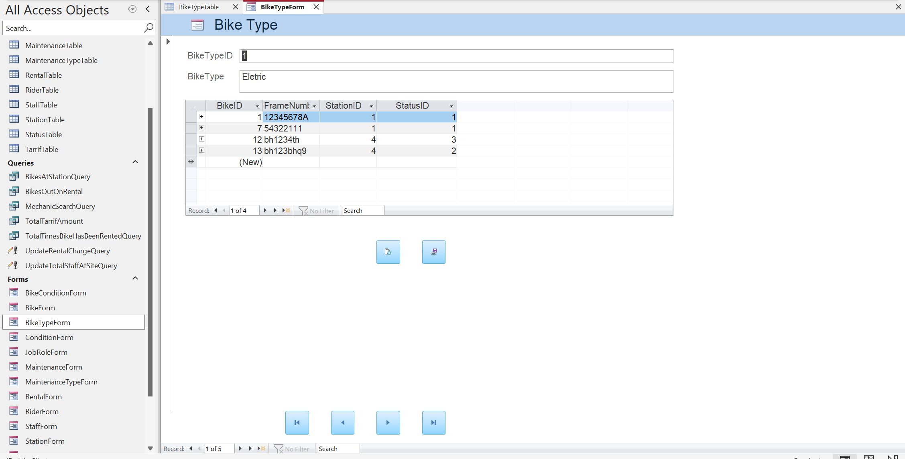

Bike Condition Table
Data View:
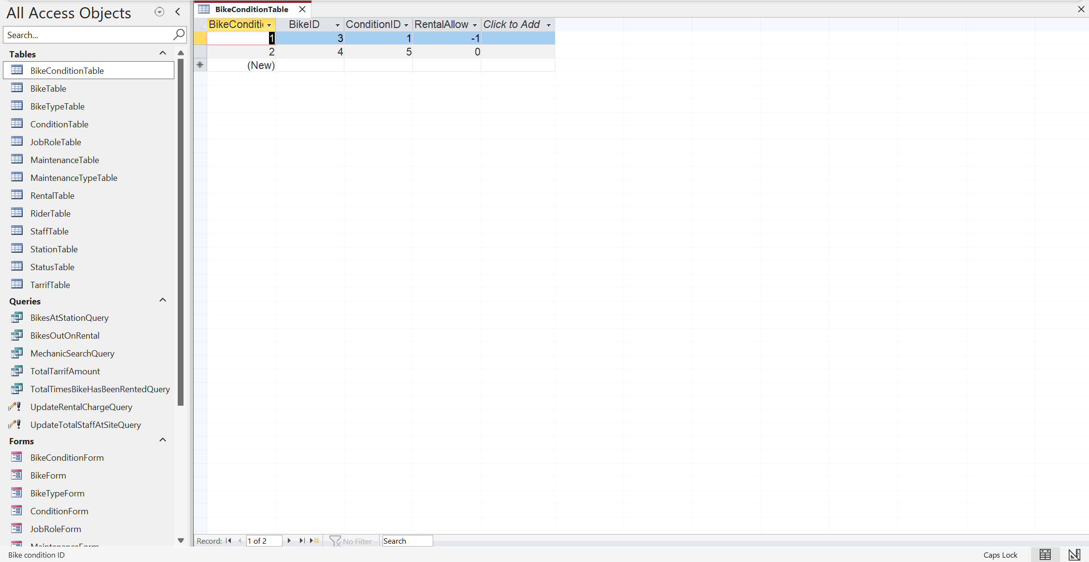
Design View:
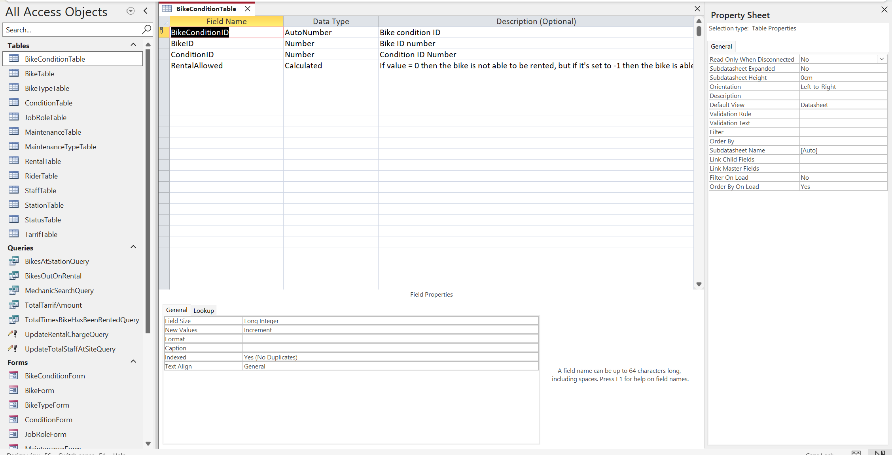
Form View:
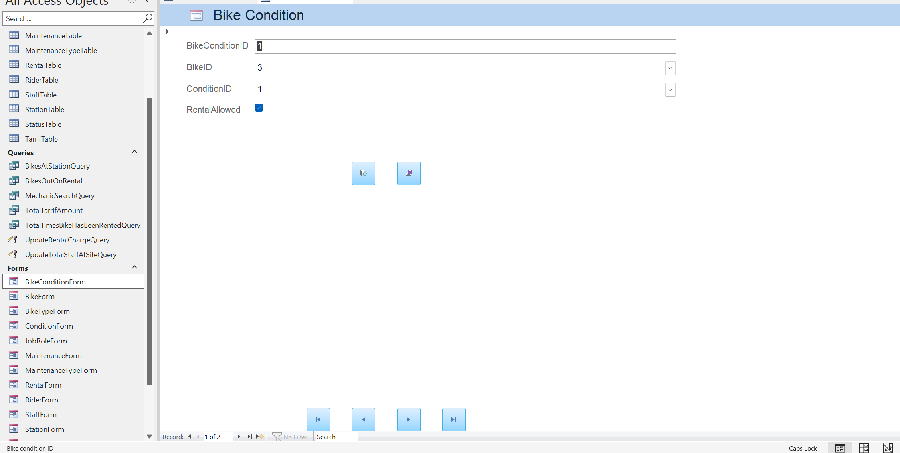

Condition Table
Data View:
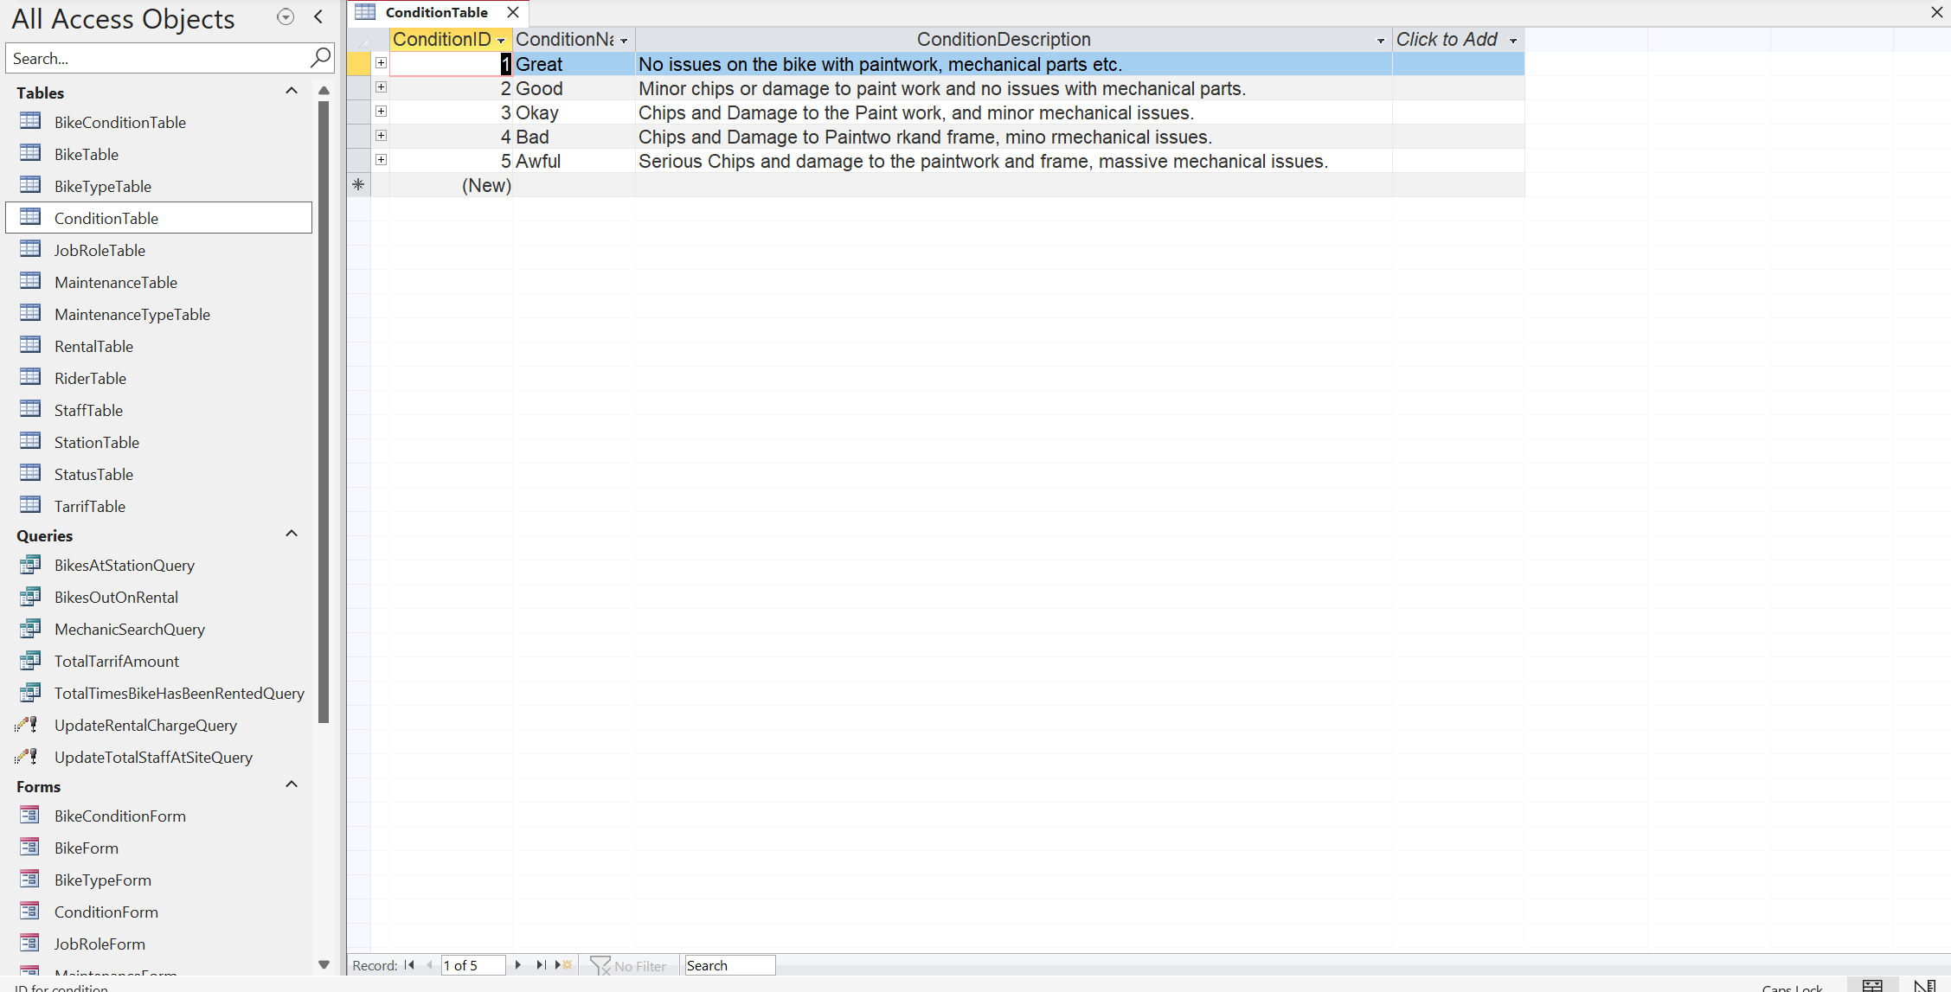
Design View:
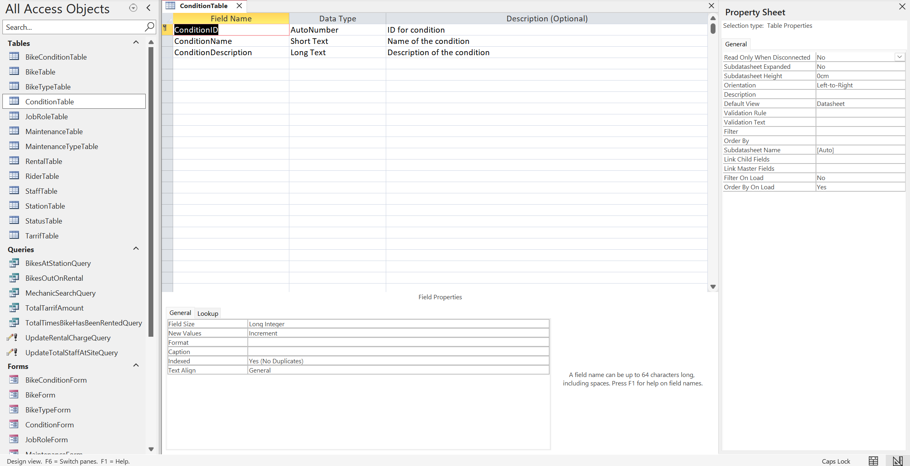
Form View:
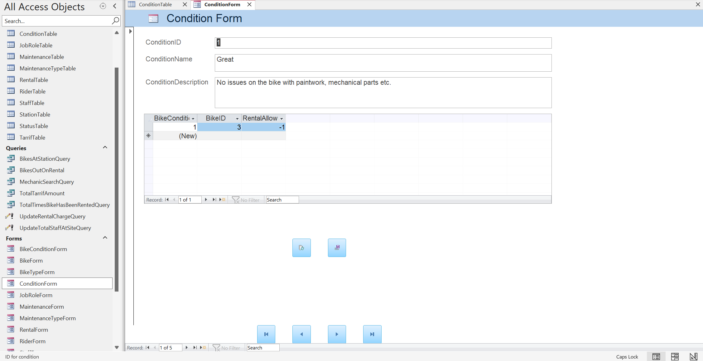

Status Table
Data View:
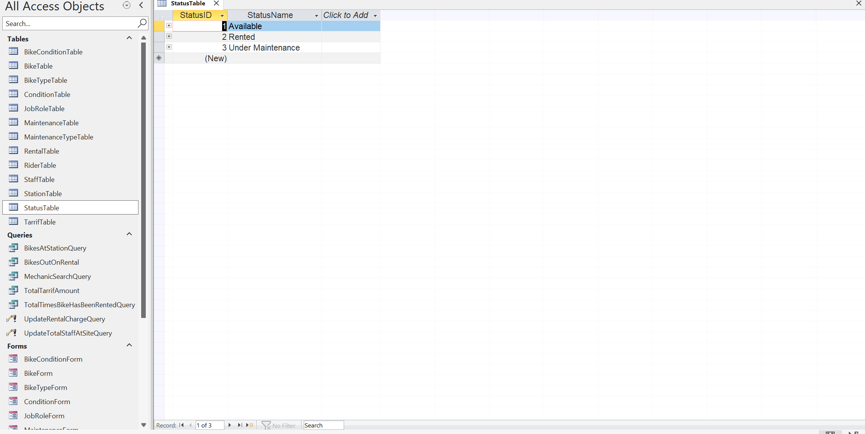
Design View:
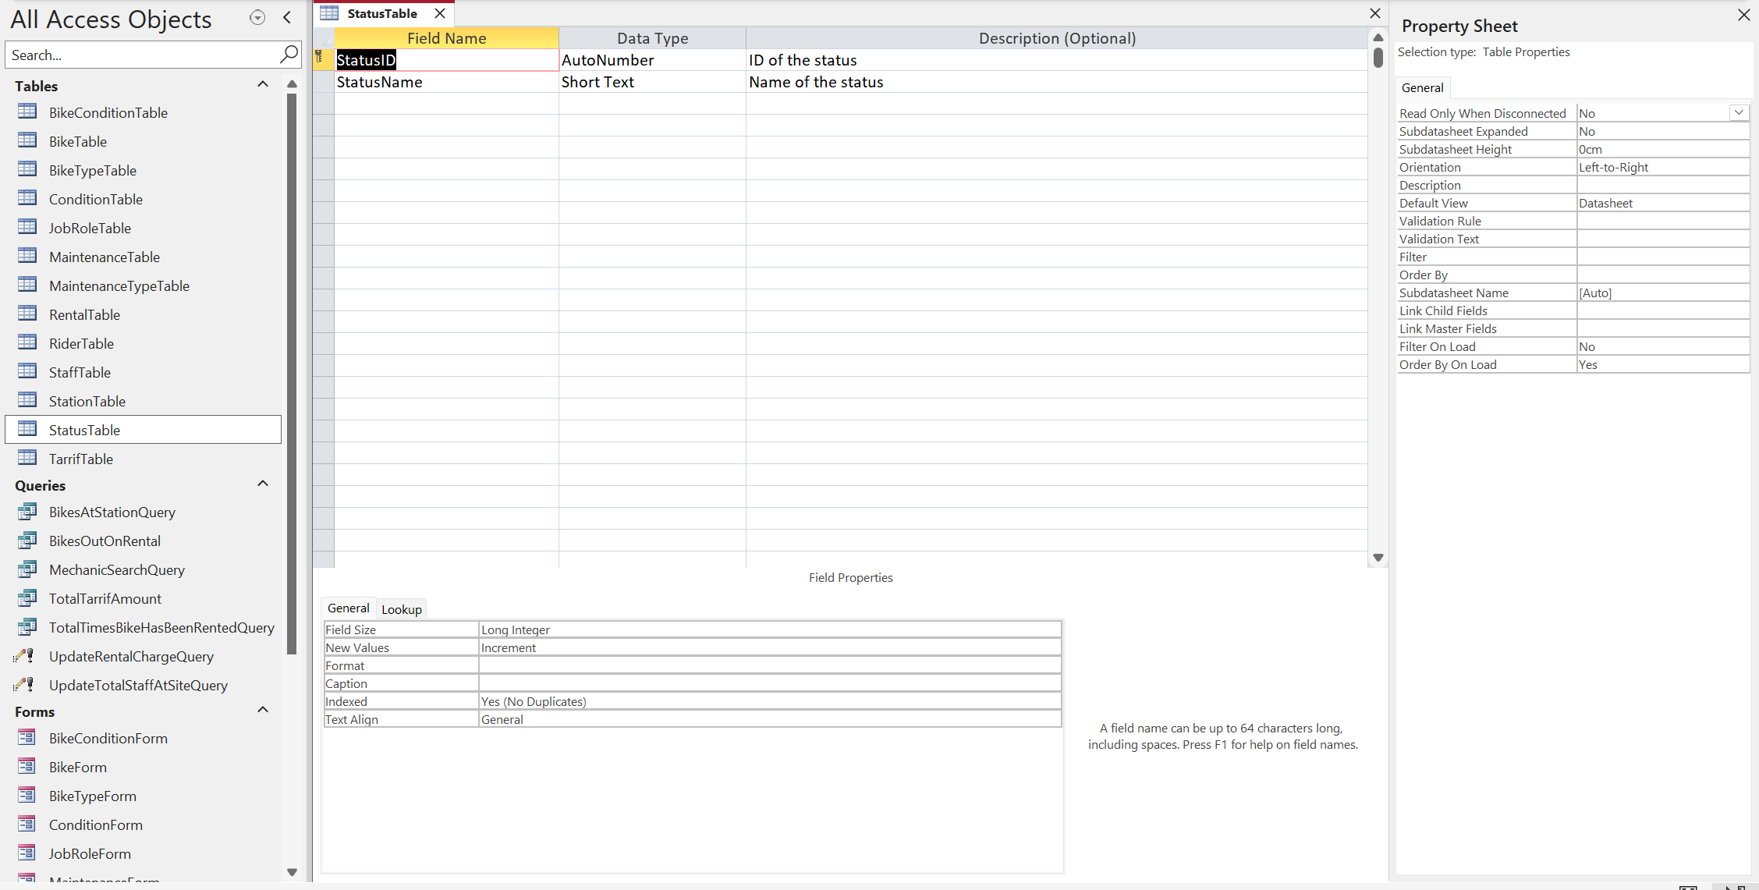
Form View:
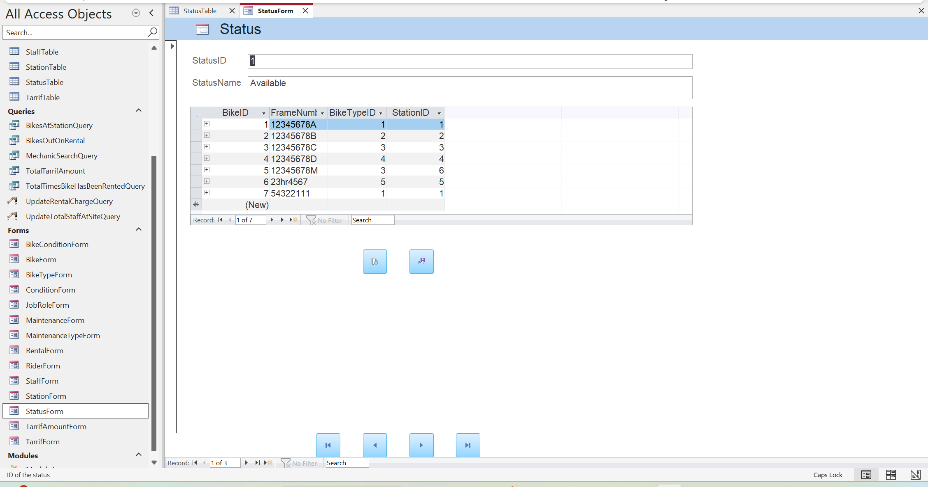

Rental Table
Data View:
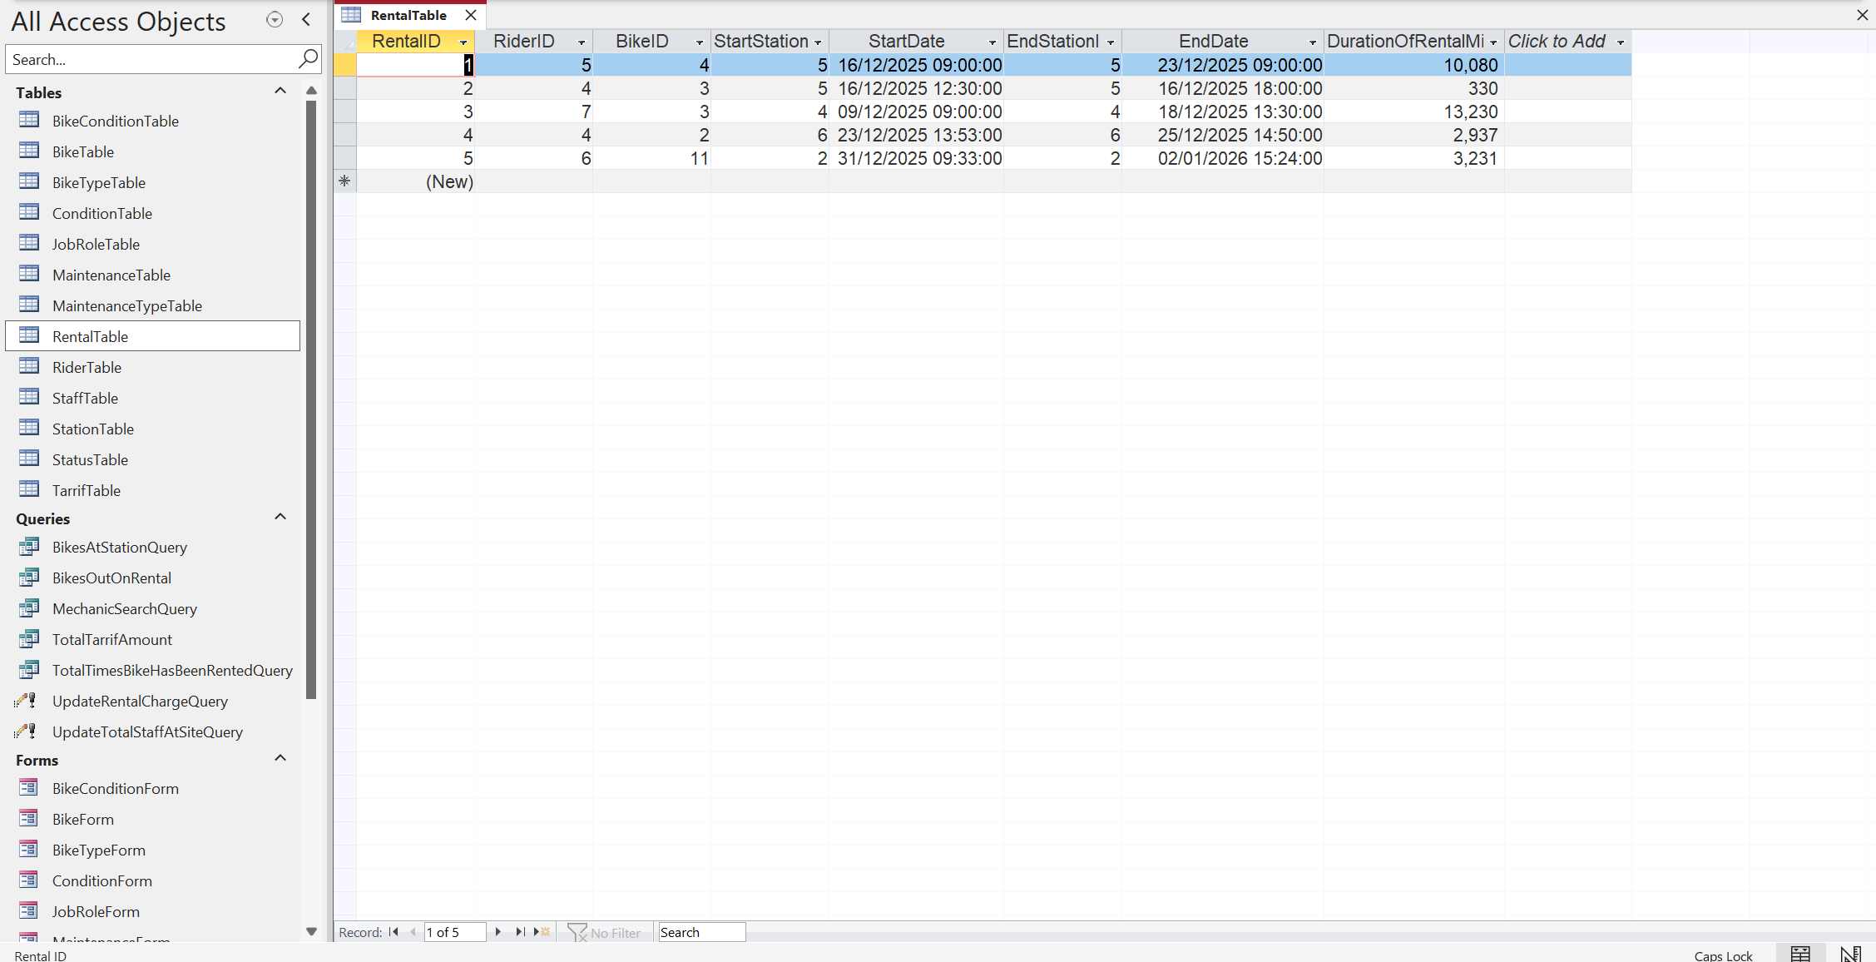
Design View:
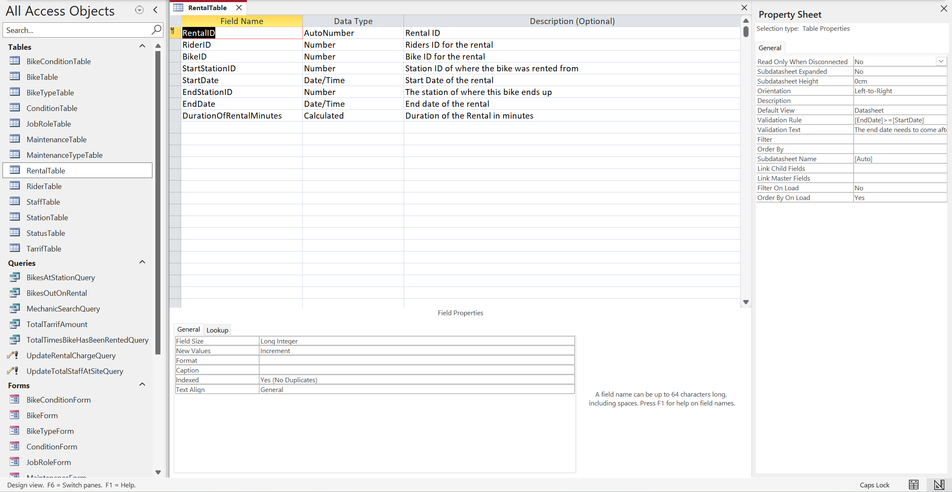
Form View:
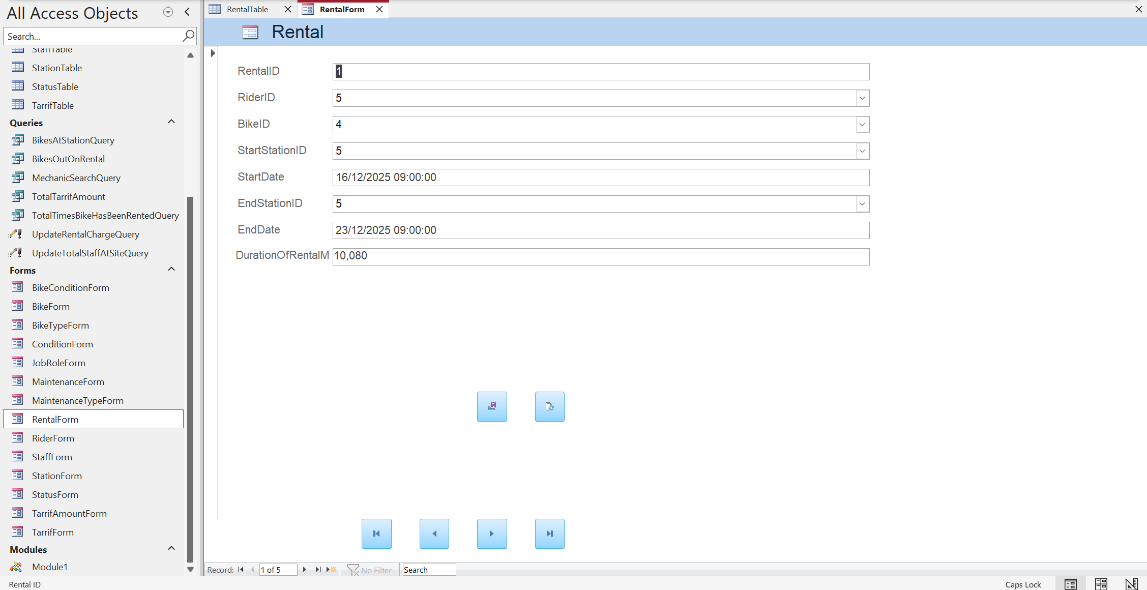

Maintenance Table
Data View:
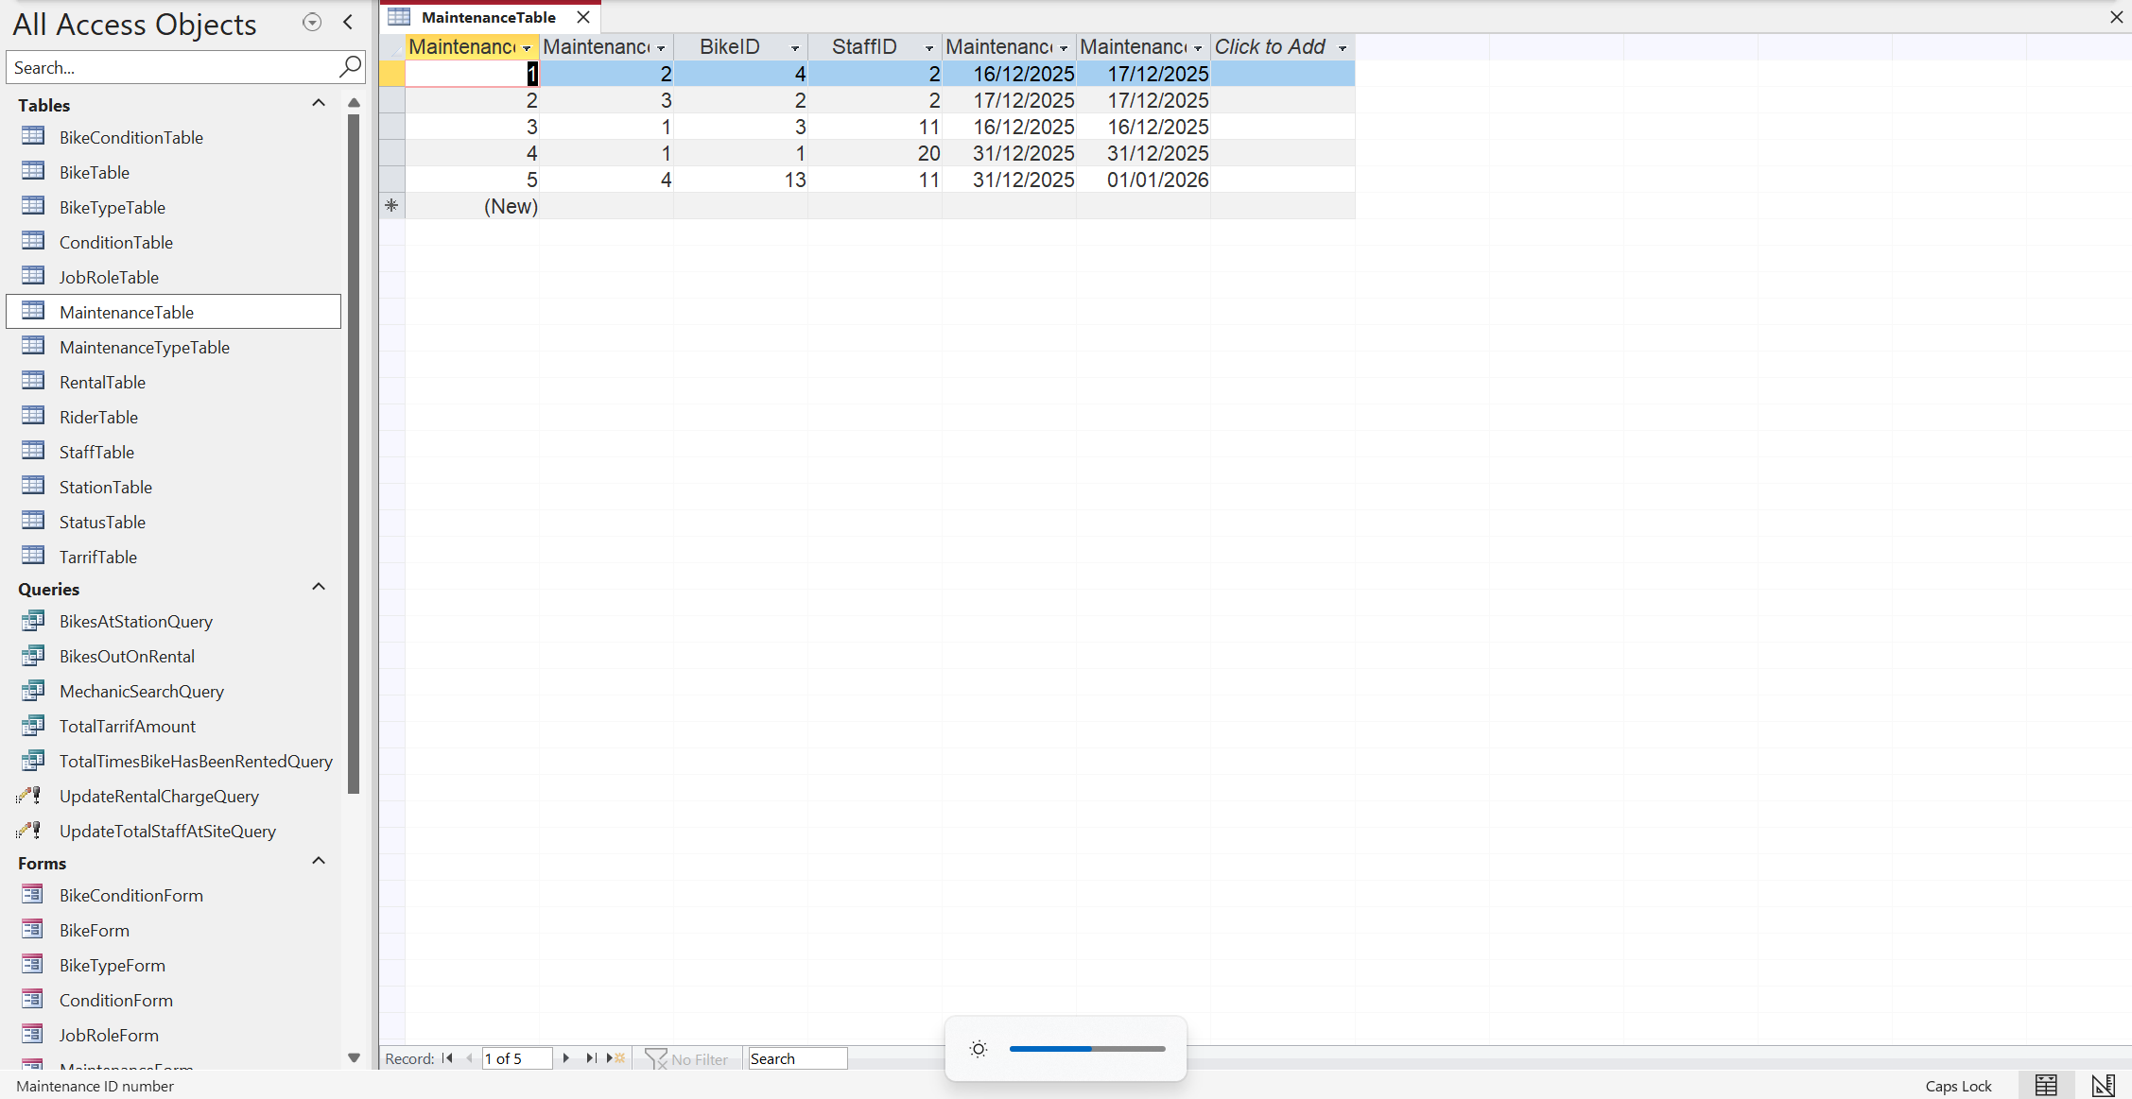
Design View:
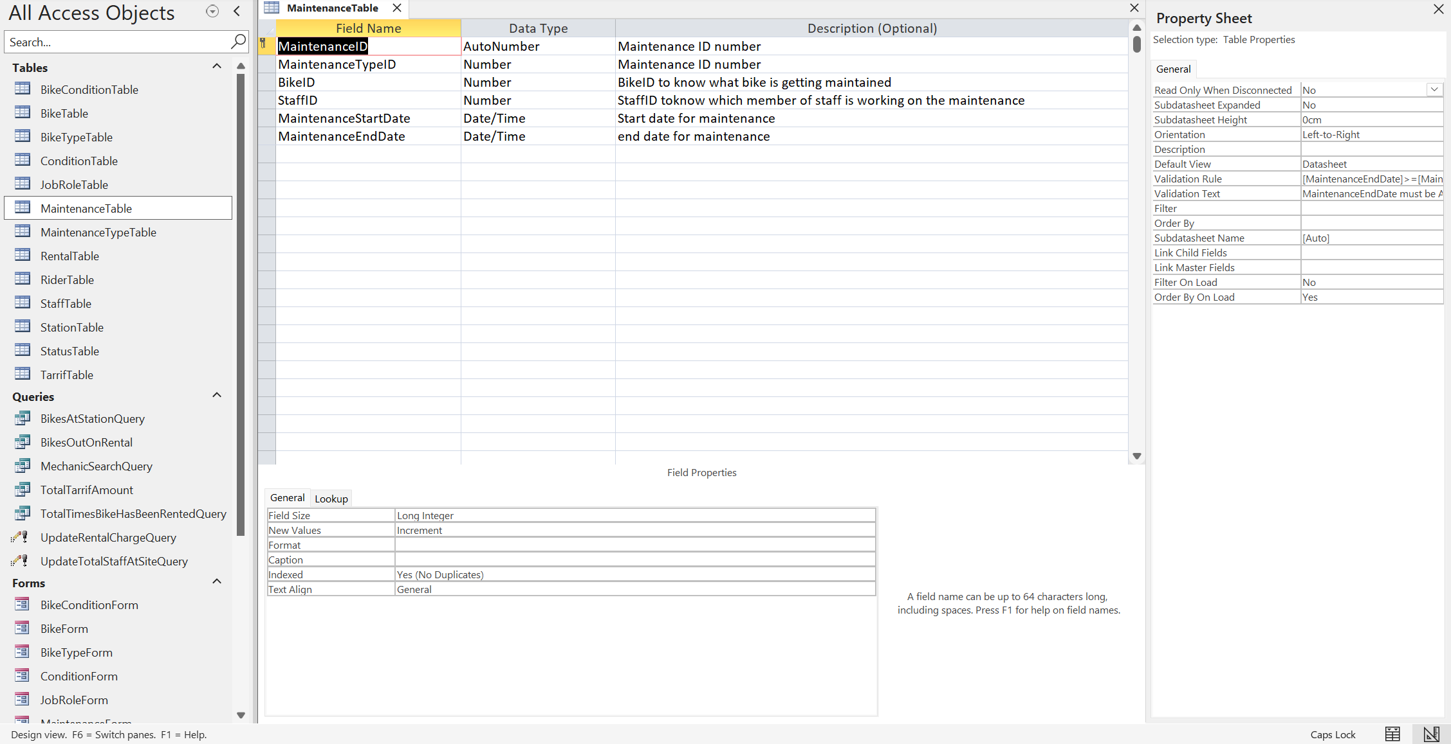
Form View:
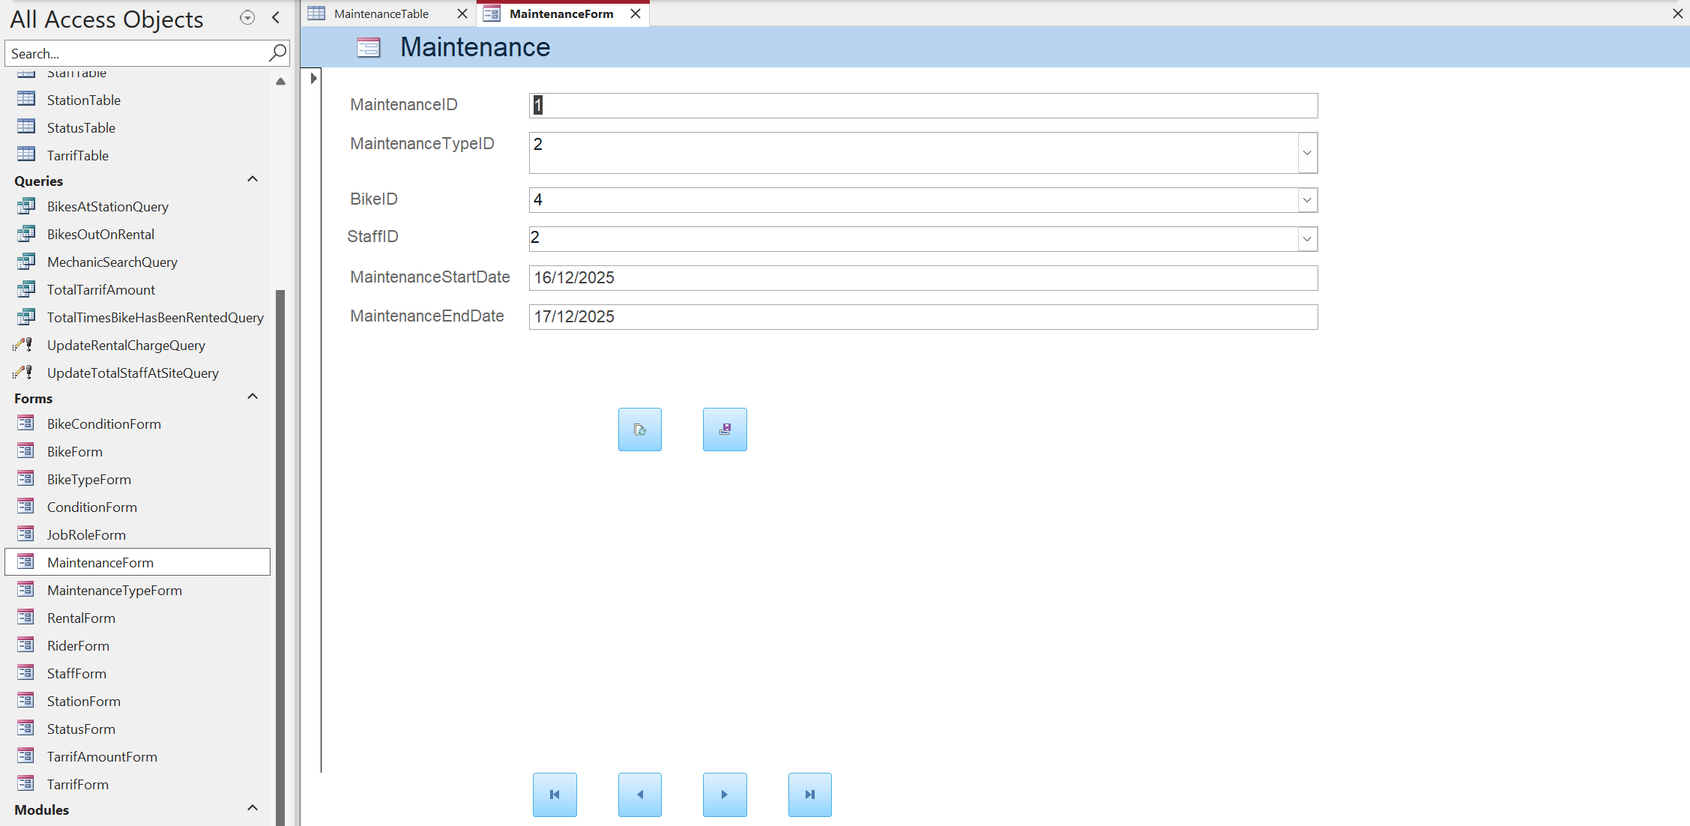

Maintenance Type Table
Data View:
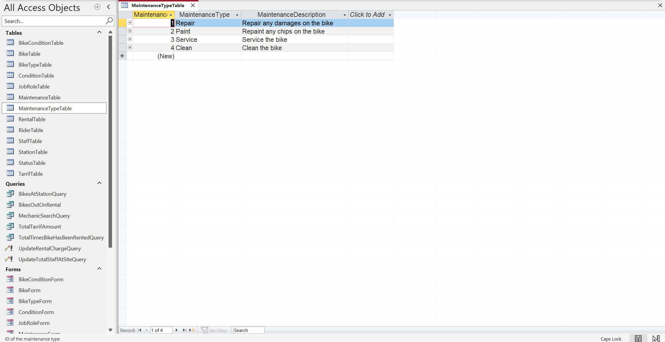
Design View:
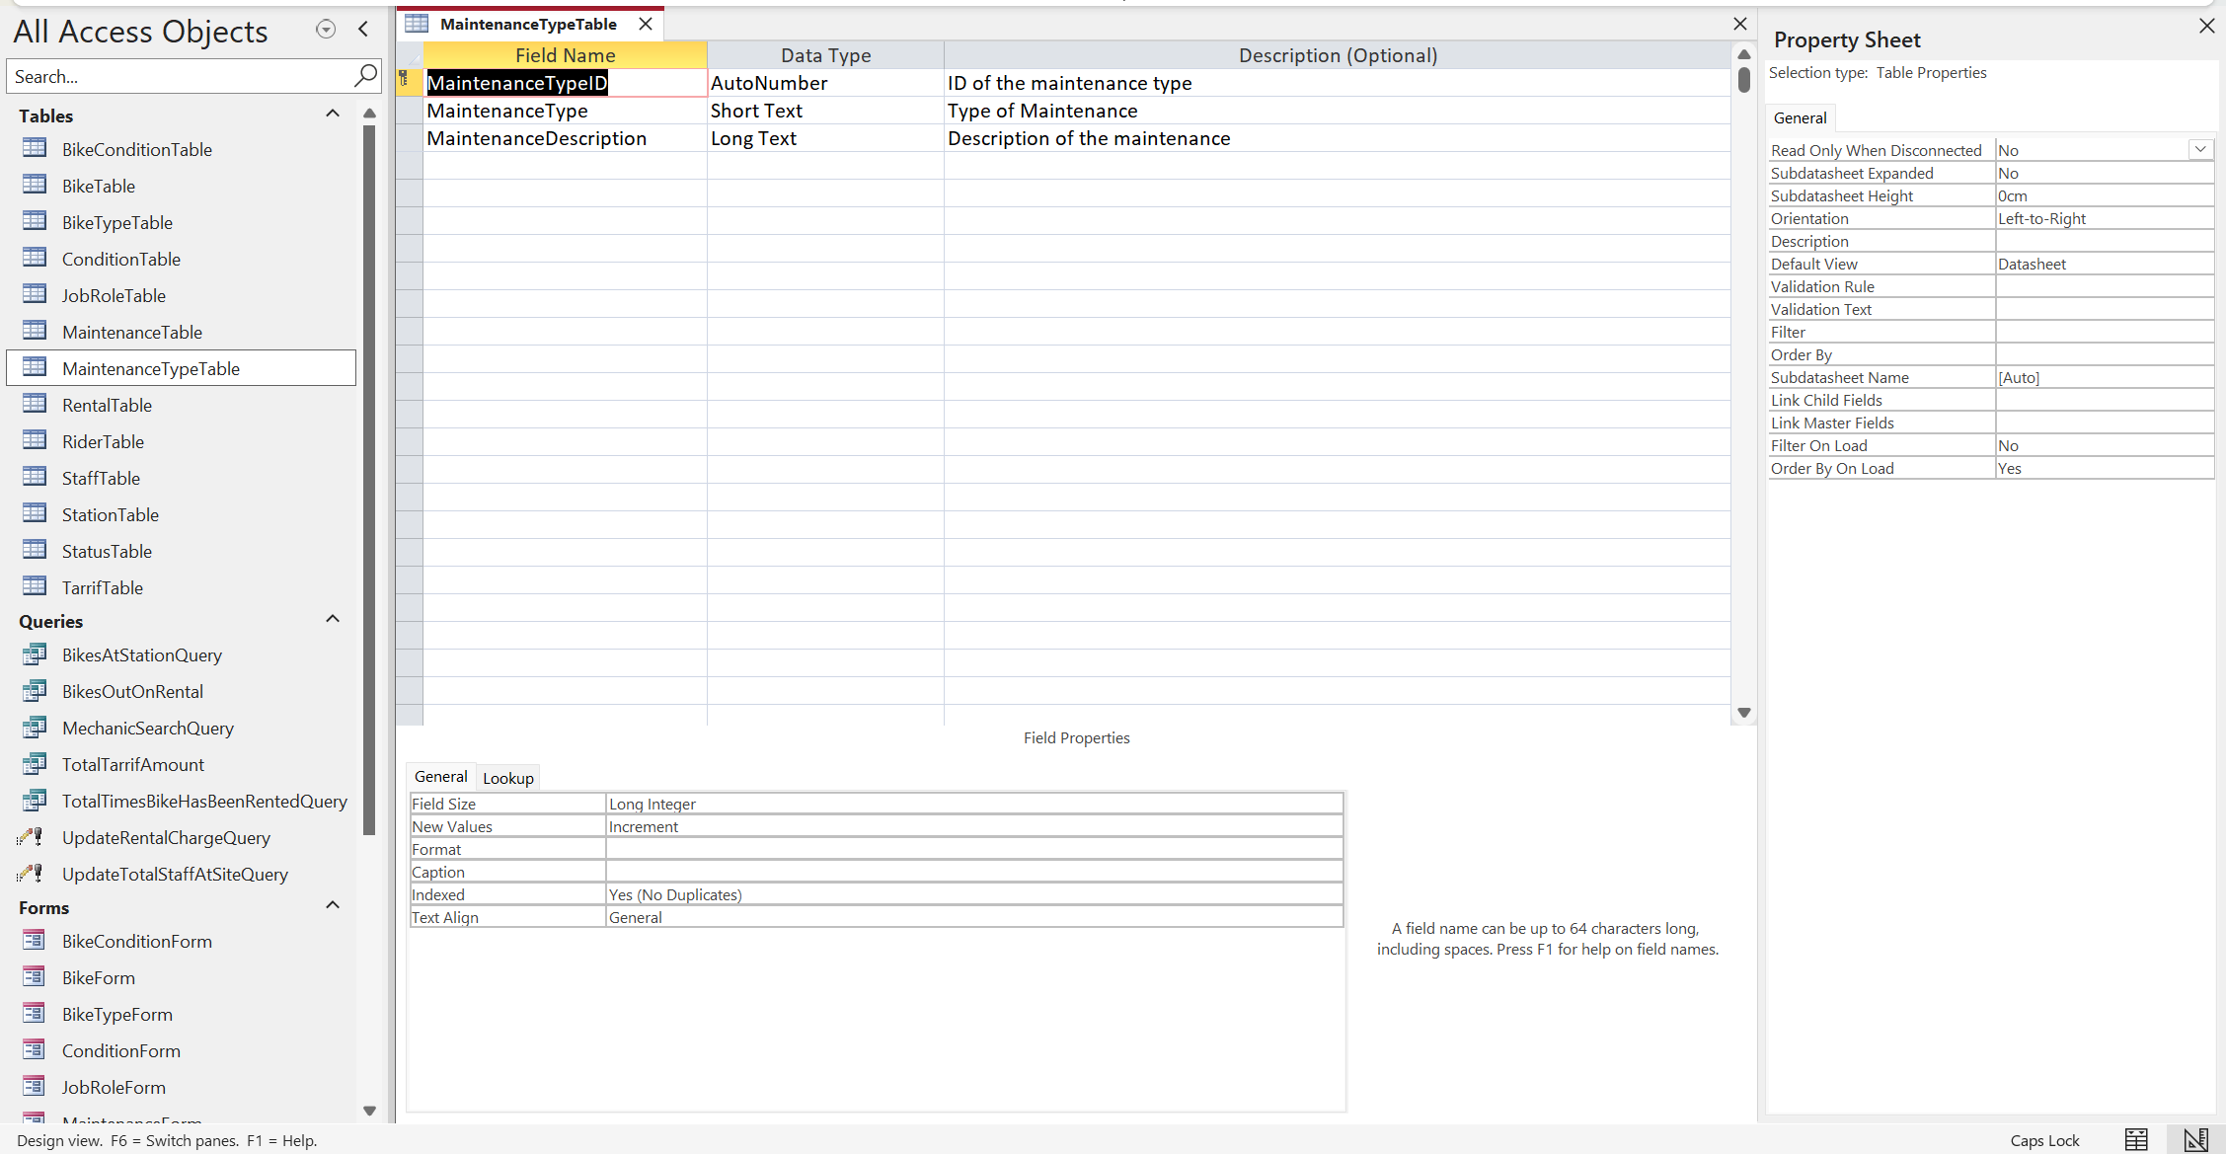
Form View:
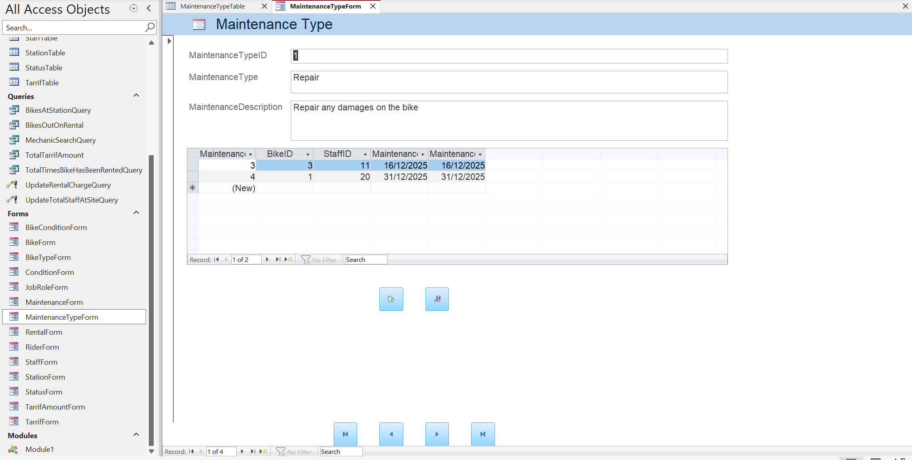

Staff Table
Data View:
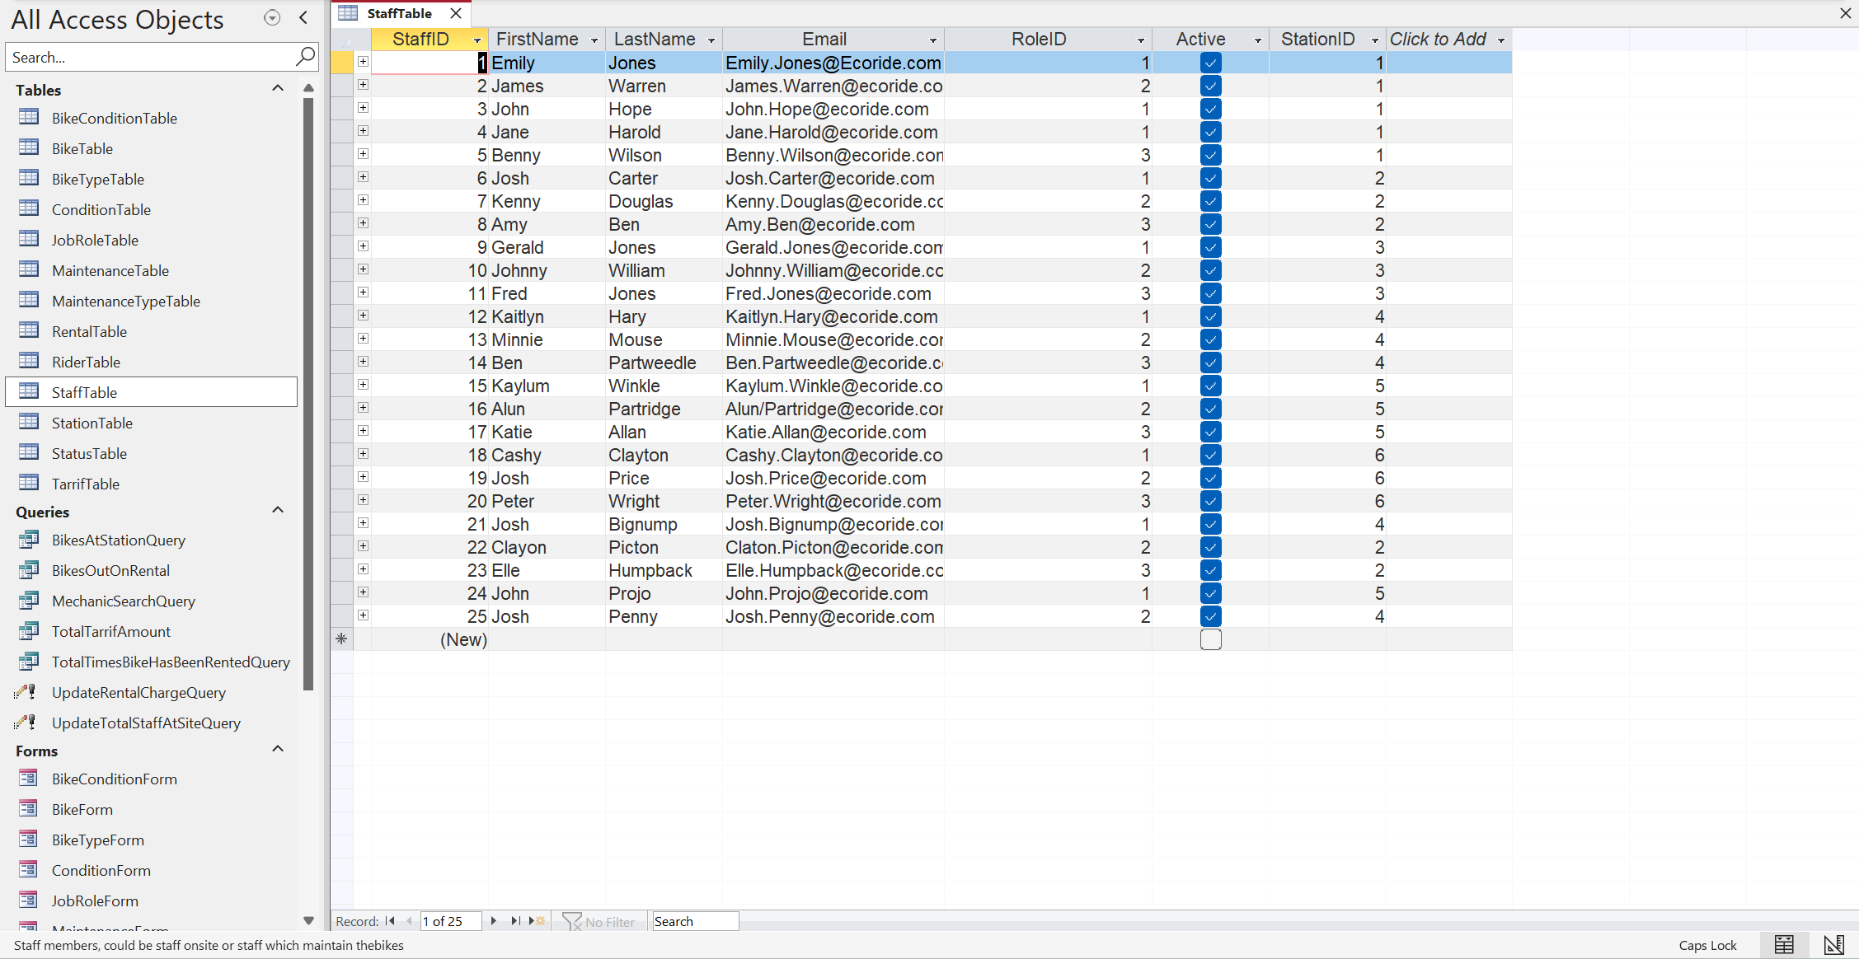
Design View:
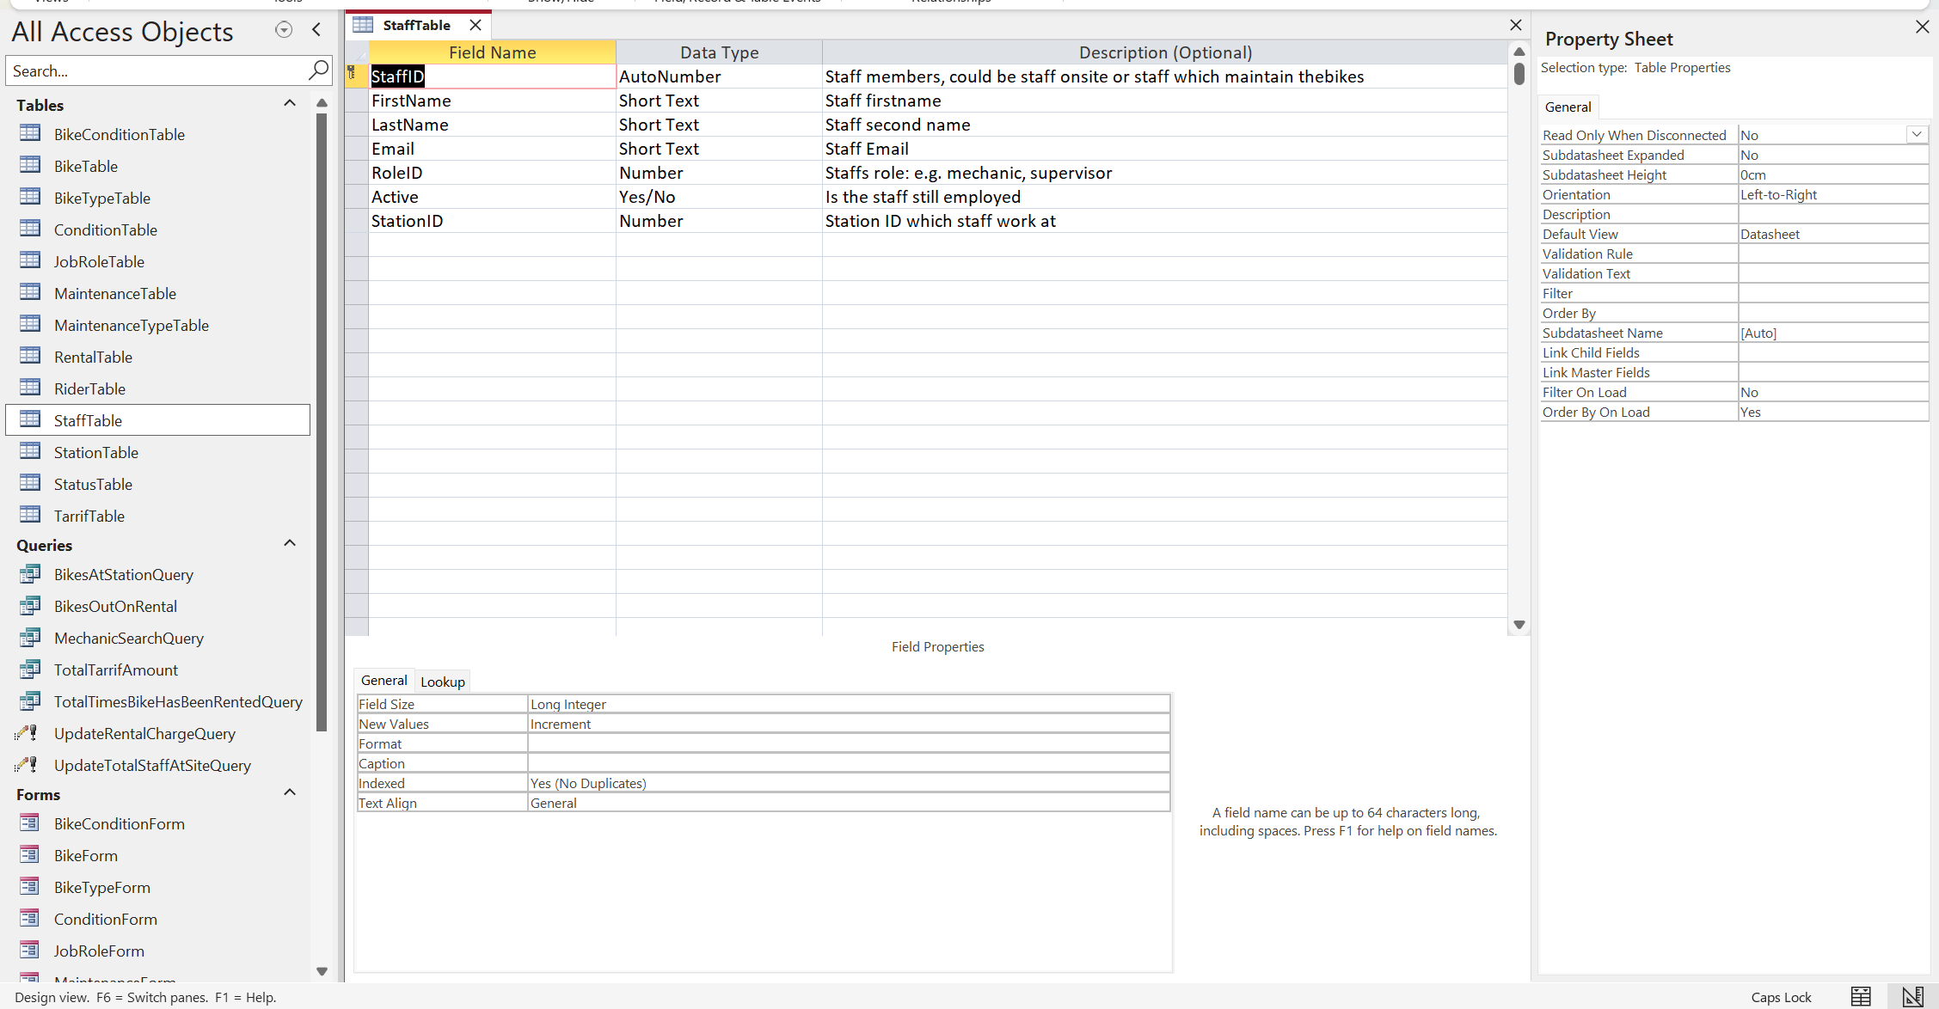
Form View:
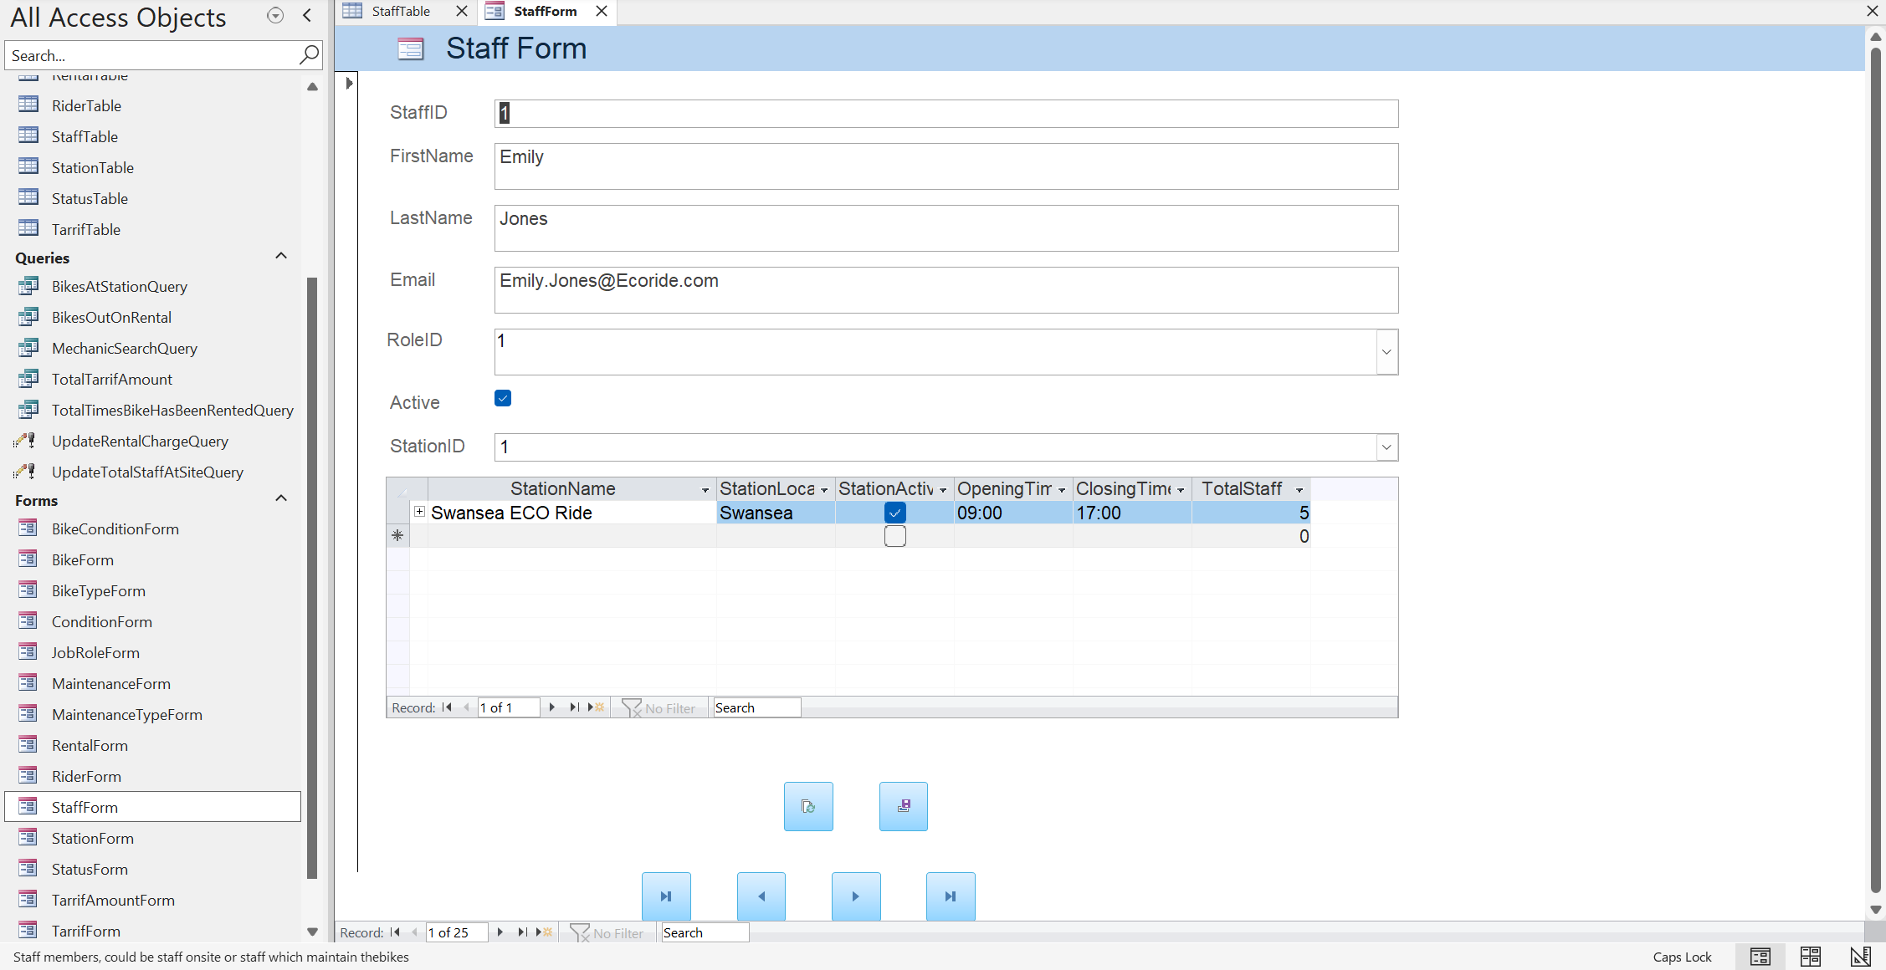

Job Role Table
Data View:
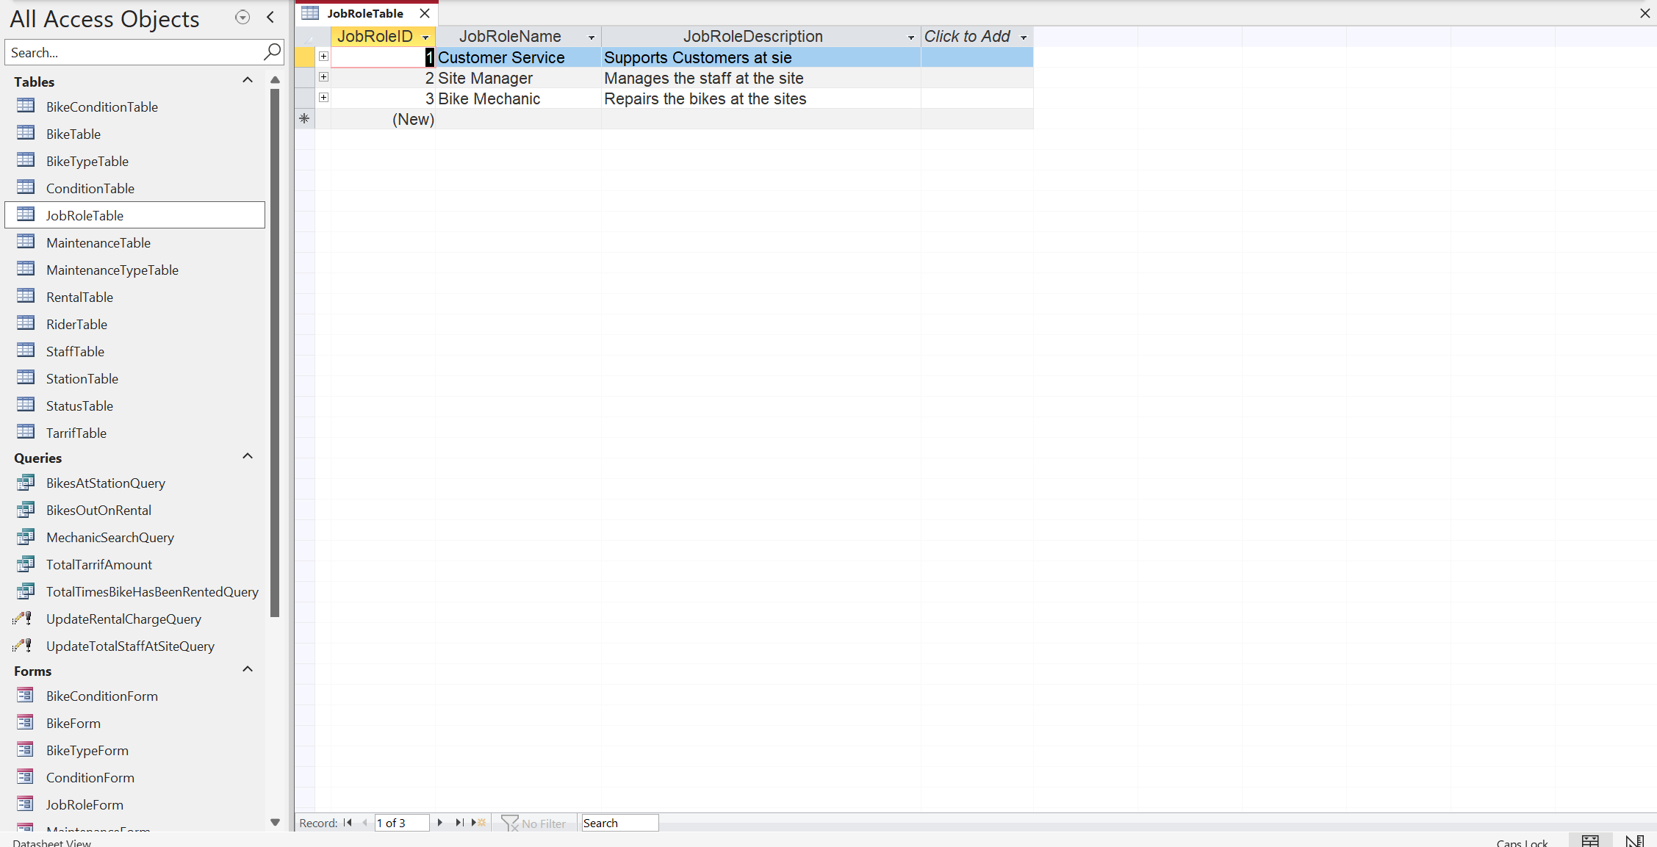
Design View:
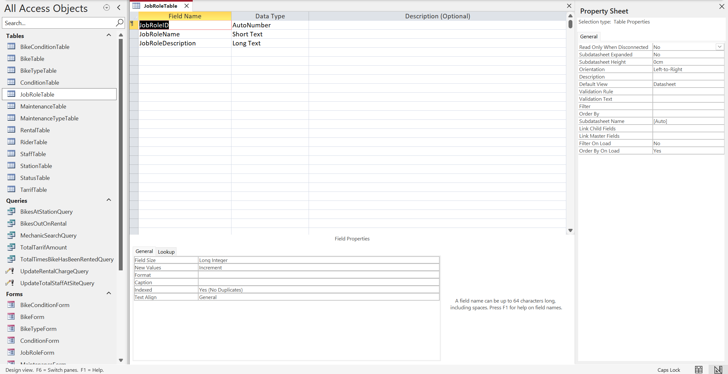
Form View:
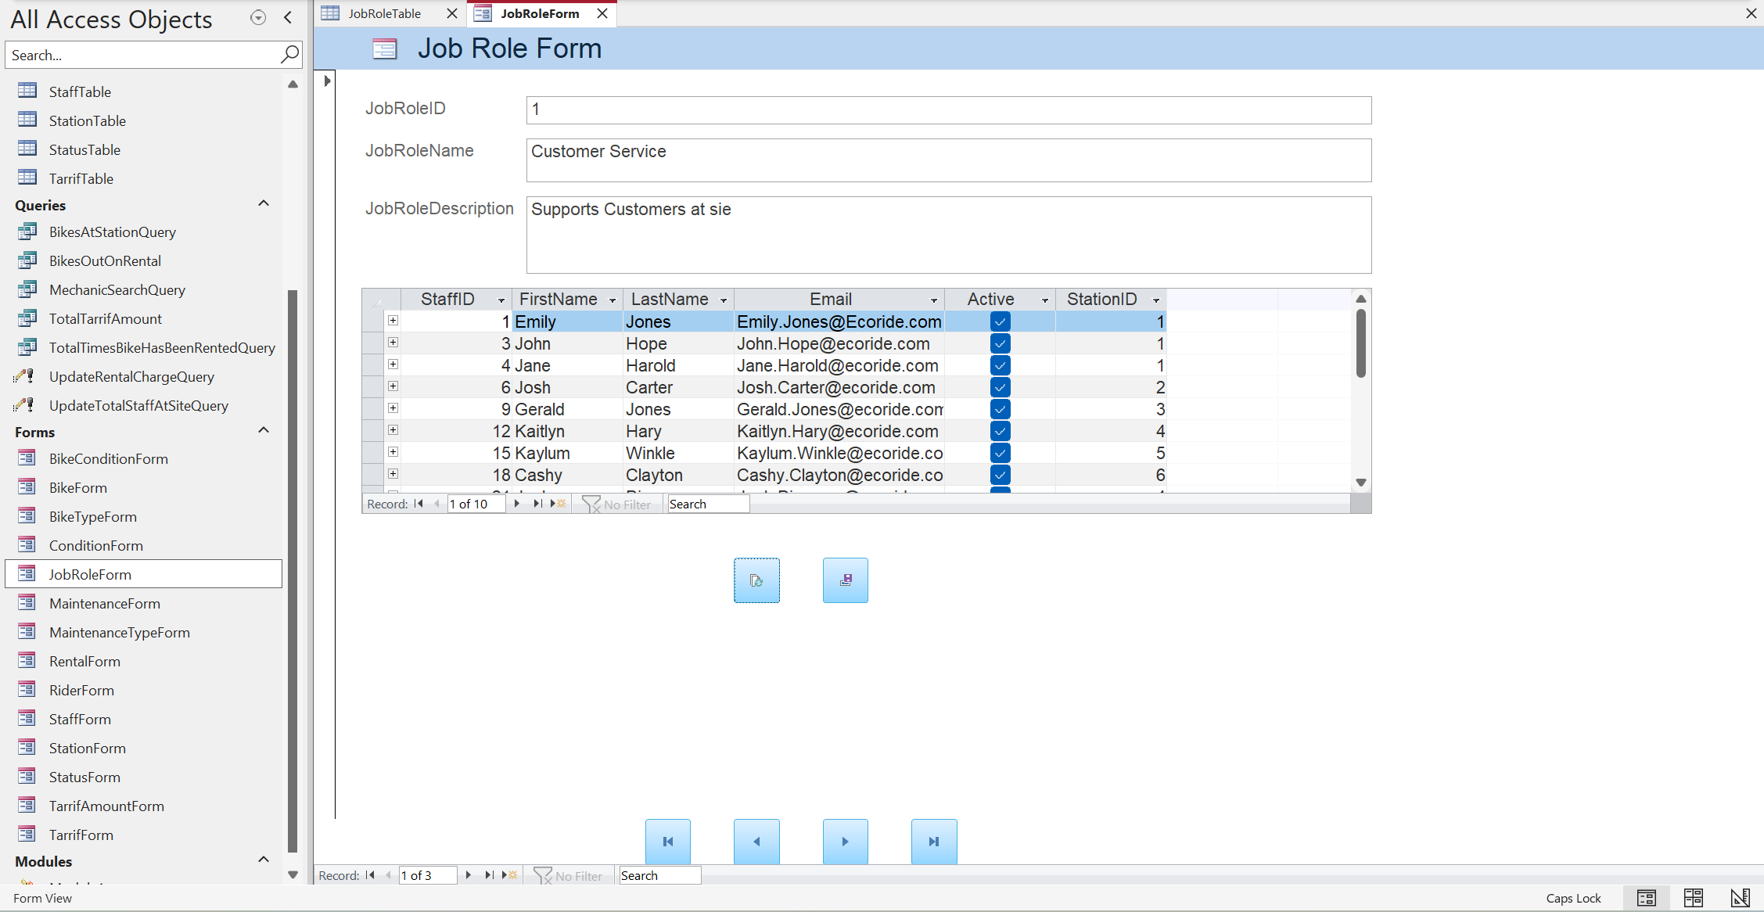

Station Table
Data View:
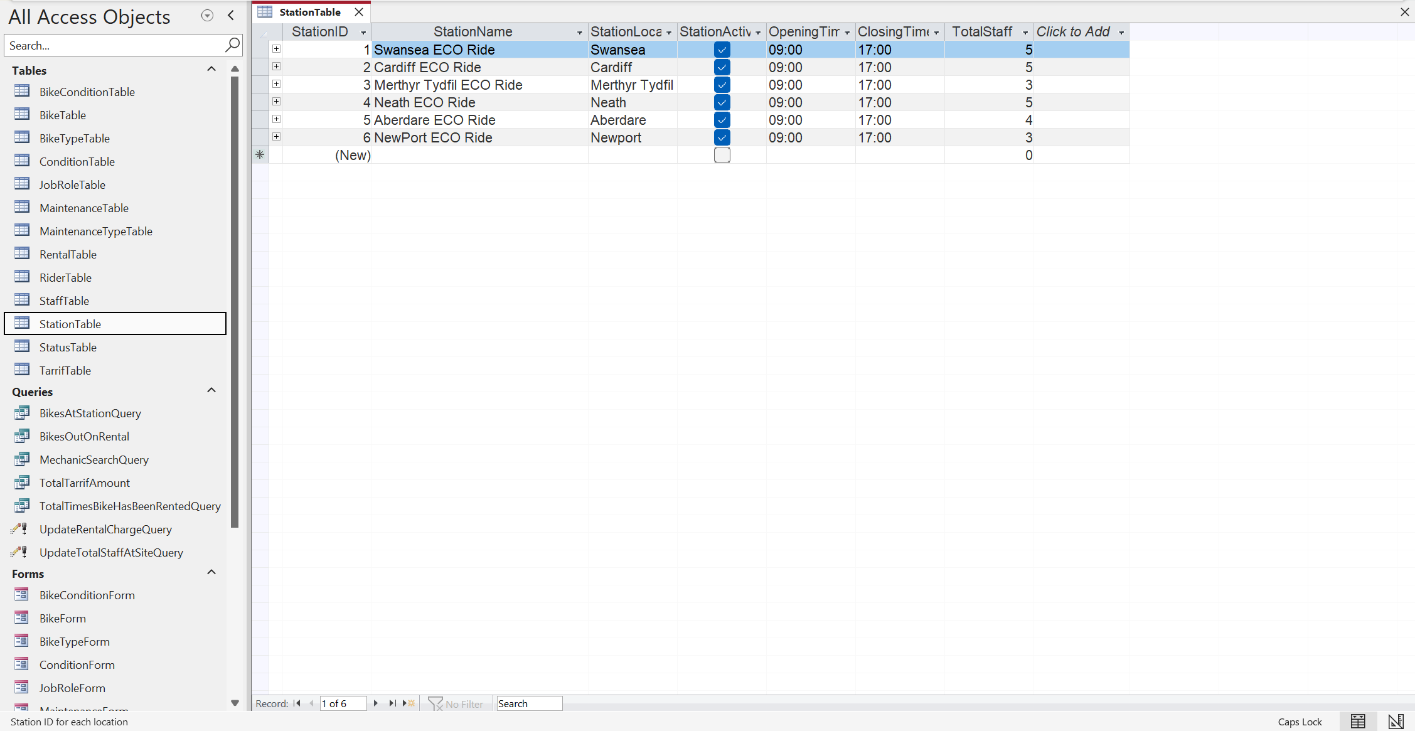
Design View:
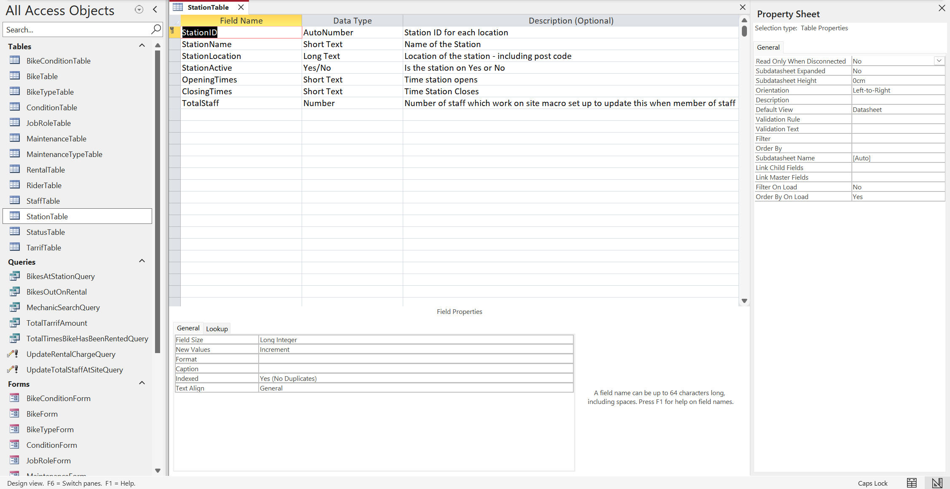
Form View:
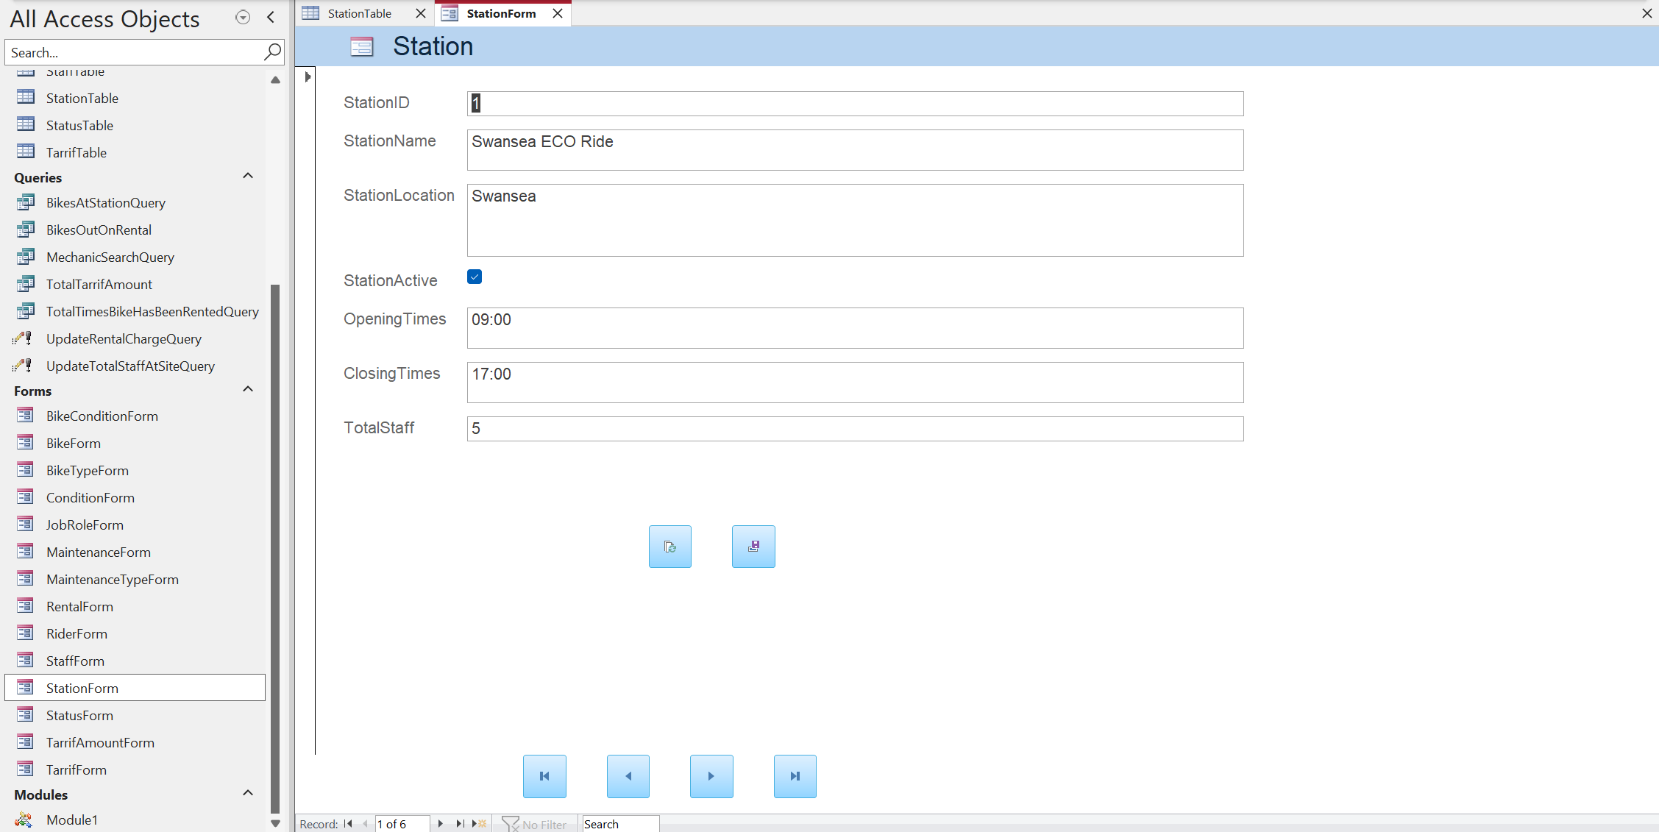

Tarrif Table
Data View:
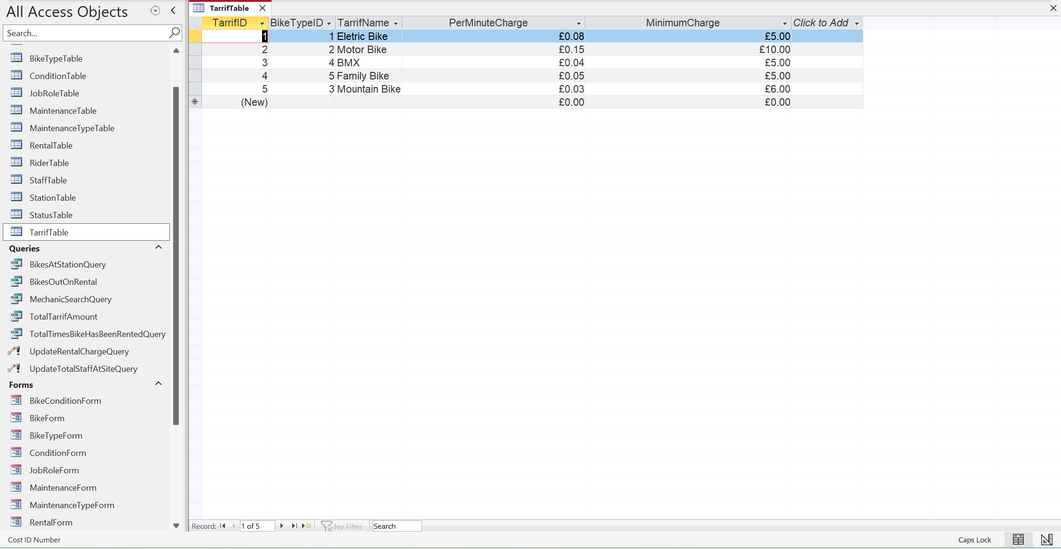
Design View:
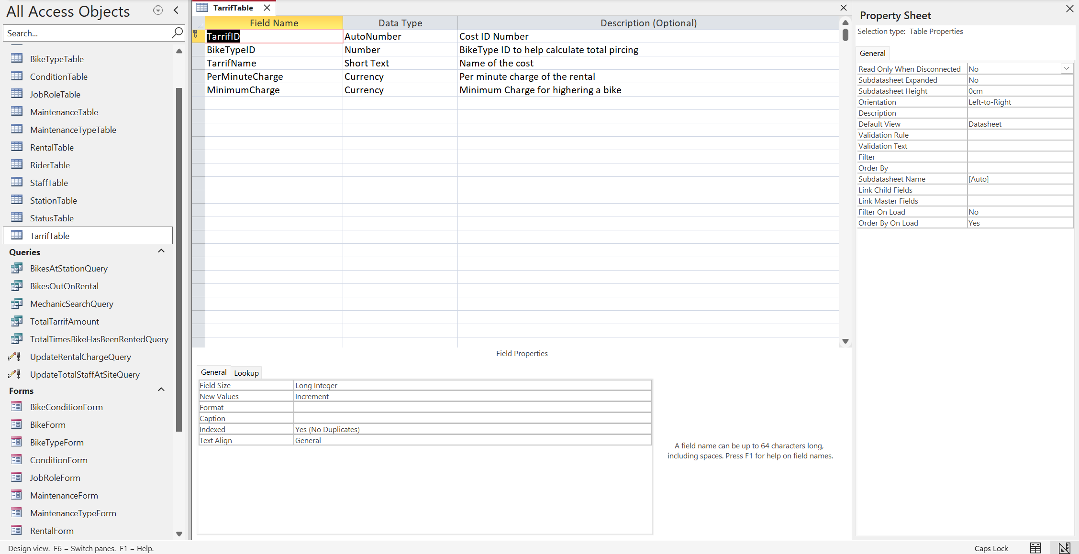
Form View:
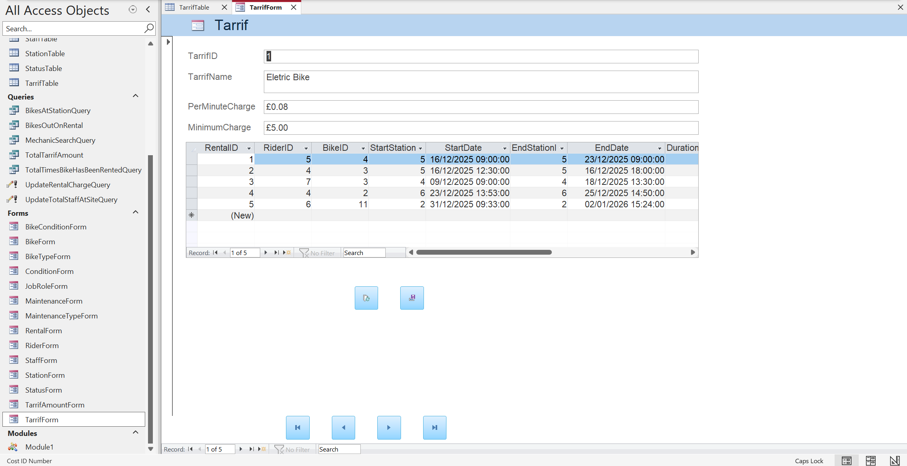
TarrifAmountForm: This form is a form related to the tarrifTable and it uses the RiderTable and TarrifTable to calculate the total price of a rental, using a query and a macro.

Database Queries.

Validation and testing.

Evaluation

Written Evaluation here……

References

References for the Written assignment:

Appendices (copy and paste of code if required.)

