Research proposal: The EXTENDED USE OF COMPUTER SOFTWARE IN MOTORCYCLE RACING

Research Methods & Professional Development (ACFA7004)
Kyle Cummings (1700852)


University of Wales Trinity St David: School of Engineering
MSc Motorcycle Engineering
List of Figures, Tables & Equations
Figure 1 – Results from Massaro’s Non-Linear Simulation 9
Figure 2 – Comparison Between New and Previous Model for Roll Angle Error 10
Figure 3 – Comparison Between New & Previous Models and Real Data for Roll Angle 10
Figure 4 – Comparison of Real and Simulated Motorcycle Data 14
Figure 5 – Front & Rear Suspension Position Data Gathered from Moto2 Motorcycle 15
Figure 6 – Wheel Force & Rate Graphs (Motorcycle Under Braking) in Zero One Chassis Software 15
Figure 7 – Planned Questionnaire Questions 1 & 2 20
Figure 8 – Planned Questionnaire Question 3 21
Figure 9 – Planned Questionnaire Questions 4 & 5 22
Figure 10 – Planned Questionnaire Question 6 22
Figure 11 – Planned Questionnaire Questions 7 & 8 23
Figure 12 – Planned Questionnaire Question 9 23
Figure 13 – Project Timing Plan 24

Table 1 – List of Professional Computer Software Available to Motorcycle Racing Engineers 6
Table 2 – Comparison of Motorcycle Chassis Setup Software 7

Table of Contents
List of Figures, Tables & Equations 1
1. Introduction 3
1.1 The Connection Between Technological Innovation & Racing 3
1.2 The Evolution of Computer Software Within Motorcycle Racing 3
1.3 Project Relevance, Aims & Limitations 4
2. Literature Review 6
2.1 Currently Available Software 6
2.2 Published Knowledge Within Dynamic Motorcycle Simulation 8
3. Methodology 11
3.1 Database Creation 11
3.2 Chassis Program Development 11
3.3 Qualifying Lap Simulation Software 12
3.4 Software Validation 12
4. Results Collection & Analysis 14
5. Evaluation 16
6. Bibliography 17
Appendix 1 – Questionnaire Plan 20
Appendix 2 – Project Timing Plan 24

- Introduction
  - The Connection Between Technological Innovation & Racing
The pinnacle of racing series, whether it be in cars or motorcycles, have always been at the forefront of the greatest innovations in technology – with the Repsol Honda team describing MotoGP as “the laboratory for innovation” (MotoGP 2.0: Future technologies applied to MotoGP - Box Repsol, 2019). These revolutions are created and developed within racing before reaching the wider world; such examples as Formula 1’s kinetic energy recovery (KERS) was first used in the 2009 world championship as an overtaking aid (Formula for Success – KERS and DRS, 2012), however the technology is now reaching road vehicles with Volvo adding the technology to its XC90 model (Potts, 2019).

  - The Evolution of Computer Software Within Motorcycle Racing
The key to driving these technological advancements is the will to win by all within racing and team personnel will look at all areas for any possible advantage they can gain. As mechanical technology throughout motorcycle racing has evolved throughout the decades since the inception of the Isle of Man Tourist Trophy in 1906 (History of Motorcycle Racing, n.d.), so has technology in the wider world. The introduction and advancement of computer technology throughout the world has no doubt changed the way a lot of the world works, and it was not long before this produced ideas in the minds of engineers throughout the motorcycle racing world too. The increase in understanding led to increasingly complex computer software being used to essentially part-control the machines, as the systems grew further and further in complexity the rule markers finally decided enough was enough with the MotoGP rulebook for 2016 stating all teams would use the same electronic control unit (ECU) (Spalding, 2019). Despite the limitations in controlling the motorcycles there was another way in which computer software was being used to improve performance from the pit box – chassis setup and data analysis software.

Data analysis software has been used since the mid-1990s in MotoGP with the Kenny Roberts team the first to use limited sensors and the on-board computer system to record the outputs from different areas of the motorcycle such as suspension travel and lean angle (MotoGP, 2018). In the present time this technology has evolved a lot to include almost every area of the motorcycle with hundreds of data logging channels available from wheel speeds to steering torque on the handlebars and engine speed, the MotoGP race paddock is currently using data analysis programmes such as 2D Data Recording, Motec and Magneti Marelli which also allow you to calculate your own channels within the software to create data traces for areas that are not being logged at that time (Cummings, 2021).

The use of chassis set-up software is a much newer concept with very little written regarding the subject. A limited number of options in regard to this software are available on the market for teams outside of the MotoGP paddock to buy, with some of the biggest manufacturers providing their factory-backed teams with an in-house developed software (Cummings, 2021). While the data analysis software is used with the purpose of analysing data gained after on-track sessions, chassis setup software is used before these sessions in order to visualise the motorcycle’s geometry and predict in some areas how the motorcycle may react using graphs of functions such as wheel force or wheel rate. The software is powered by a database of highly-accurately measured motorcycle geometry and will show motorcycles in various states such as when they are braking or accelerating. However, despite these features there has been very little in the way of ground-breaking improvements within this type of software, something somewhat of a surprise when this type of software is hailed as “just as valuable as tyre warmers or a stopwatch” for all teams by MotoGP chassis engineer Mark Taylor (TESTIMONIALS, n.d.).

  - Project Relevance, Aims & Limitations
The interest and undeniable valuableness in this area certainly makes it a topic worthy of a masters-level research project, however the key is not just to add any features – they must be useful to those engineers using the software every day. In order to confirm the relevance of the project’s idea with engineers it will be important to connect with them and understand if they feel the ideas are of use to their everyday work and also if they have any other requests for improvements. If the engineers within the various motorcycle racing paddocks decide that they find the software ideas to be of use, then the project will continue with the production of a chassis set-up software combined with a highly accurate lap simulation software.

The idea behind the combination of these two types of software is to give engineers something they are familiar with (the chassis software) and use it to drive a complex tool that would give them an edge on their competitors, all while pushing the boundaries of knowledge and innovation. The exceptional accuracy of the simulation software would save teams both time and money in test sessions and timed sessions on race weekends, predicting whether a change to the bike’s geometry within the setup software would give a faster lap time on the track. This prediction would then save the team from sending both bike and rider out onto the track to test a new setup idea and potentially risk a crash and damage to the bike and/or rider if the wrong call was made. It is increasingly clear software such as this within the hands of extremely talented MotoGP engineers could change motorcycle racing – should it be as accurate as intended.

However, there are some limitations to the idea that may cause issues and will need further investigation. The software must be exceptionally accurate as if it is not it will be of no use to engineers, an error in prediction of half a second can be the difference between second and twelfth position - in the 2020 French MotoGP qualifying session was 0.472 seconds (Barstow, 2020). Due to the software needing to be accurate to thousands of a second it will be extremely important to understand the intricacies of software development when coding this lap simulation. It is important that the motorcycle dynamics are modelled perfectly within the simulation and that the rider is also correctly modelled. Each rider will also need their own model with a data log of their riding style and techniques, such as braking styles, physical attributes, and lean angles, in order to make the simulation as personable to each rider-engineer combination and increase the accuracy. It is expected that combining the rider model with the motorcycle model to alter the dynamics will be difficult and this will need further investigation throughout the project in order to allow the simulation to remain fluid and fine tune the model in different areas as and when required.

With the research’s ideas and limitations laid out, the aims and intended areas of study can now be detailed as follows with further information on how these will be undertaken in section 3.

- Analyse various data sources to compile a data log of riders, motorcycles, and racetracks in order to be used within the simulation software.
- Develop a geometrically accurate and easy to use chassis setup software that would be useful to high-level motorcycle racing engineers.
- Determine the correct method for developing a highly accurate and complex lap simulation software for both the rider and the motorcycle, combining their dynamics.
- Develop the lap simulation software and validate its accuracy.
- Literature Review
  - Currently Available Software
There are multiple options for computer software currently available to motorcycle race teams, they are predominantly split into two categories – data logging and chassis setup software. Table 1 shows the current variations of the software available including their country of origin and the year they were developed; however, some information was unavailable as it was not published on the author’s websites.
Software Name | Software Type | Author | Country of Origin | Year of Creation
SuspAct | Chassis Setup | Boudewijn Evenhuis | Netherlands | Unknown
MotoSPEC | Chassis Setup | Jeff Laidman | Canada | Unknown
ZeroChassis | Chassis Setup | Aaron Hunt | UK | 2015
MotoChassis | Chassis Setup | Tony Foale | UK | 2004
Motec i2 | Data Logging | Motec | Australia | Late 1980s
Wintax 4 PRO | Data Logging | Magneti Marelli | Italy | Unknown
2D Data Recording | Data Logging | 2D | Germany | 1993

Table 1 – List of Professional Computer Software Available to Motorcycle Racing Engineers

Without direct access to all of this software it is very difficult to explain the differences between them as they all complete the same task when compared to the other options in their relative field. It is understood that all of these setup software complete their respective tasks with the same basic geometry equations as there are only specific equations that will give the correct geometry for the motorcycle. The four chassis setup software however do have their own traits as shown in table 2, ZeroChassis for example does allow for the exportation of information to Microsoft Excel (ZeroChassis, n.d.) where it can be stored externally from the software perhaps allowing for more personalised analysis. MotoSPEC is slightly different again in that it allows for analysis of calculated data channels inside its software making it compatible with all of the data acquisition software in table 1 (DATA AQ, n.d.). When considering the information in table 2 it is clear that MotoSPEC and Zero One definitely have the most benefits in their software out of all of the current setup software on the market, this means that they are also the most likely ones to be used by the race engineers due to their large number of upsides such as their modern interface as well as the compatibility with other types of software they are using.

Software Name | Advantages | Disadvantages
SuspAct | - 5 setups can be compared at once | - Can only compare bike in braking and acceleration situations  - More basic, less detailed user interface
MotoSPEC | - Can conduct analysis at various lean angles  - Modern user interface  - Allows for extra calculation of mathematical data channels | - Only 3 setups can be compared at once
ZeroChassis | - Ability to export data to Excel  - Modern, clear user interface  - Allows for analysis of bike in four situations | - Only 4 setups can be compared at once
MotoChassis | - Includes features for calculations of various motorcycle dynamics  - Lots of customisation of various motorcycle technology | - Dated user interface

Table 2 – Comparison of Motorcycle Chassis Setup Software

  - Published Knowledge Within Dynamic Motorcycle Simulation
Studies into the dynamics of single-track vehicles, whether they have been bicycles or motorcycles have long been a source of intrigue, a paper was published in 1899 describing a mathematical model developed to describe the stability of one of these vehicles (Sharp, n.d.). There are now multiple papers that exist in the realm of motorcycle dynamics due to the investigations that have taken place to better understand how a motorcycle works from authors such as Vittore Cossalter, and as time has passed more and more investigations are taking place regarding motorcycle and rider simulations. While it is important to create an accurate model to simulate motorcycle dynamics it is also considered to be equally important to develop an accurate rider model to accurately model the entire system (Massaro, Lot and Cossalter, 2012). This is due to the fact that motorcycles cannot perform set manoeuvres without considering the varying position of the rider and their input, this is especially different to a four-wheeled vehicle where the driver remains in one position and do not contribute to the dynamics of the vehicle over than their limited inputs such as steering and acceleration or braking. A motorcycle rider’s body position contributes greatly to the handling of the motorcycle due to the change in mass distribution and torque inputs in various areas such as the handlebars (Cossalter et al., 2011). This is a main reason as to why the area of motorcycle rider modelling is such an important subject with multiple investigations taking place to better understand the influence of a rider on the whole system combining motorcycle and rider dynamics.

Over the past few years there have been multiple different rider models developed to simulate the actions of a motorcycle rider for various different situations, such as Massaro’s non-linear model (Massaro, 2011). In the studies undertaken within this paper the model is used to simulate three different scenarios – entering a turn while braking, entering a curve at constant speed, and exiting a turn while accelerating. The results produced by these simulations are shown in figure 1. The model accurately simulates the steering torque applied by the rider in order to begin the cornering process and causing the motorcycle to roll. The virtual rider also has two other inputs into the motorcycle model which are the rear wheel driving/braking torque as well as the front wheel braking torque, these are then used to control the accelerating and braking simulation scenarios. This model also brings attention to an important parameter required when developing this type of model - the preview horizon. The preview horizon is in theory the factor of the rider’s view of what they can see in front of them and their movements on the motorcycle to prepare them for the next section of the track. This allows the model to be a specified number of steps ahead of the current piece of track that the motorcycle model is currently operating on, it is also important to consider the changes in this function dependant on speed and the scenario being simulated such as cornering. It is visible from the results shown in figure 1 that this method of rider modelling is effective, with the simulation line being relatively indistinguishable from the target line in most areas. The model was such a success that it was used in a combined study with Lot and Cossalter (Massaro, Lot and Cossalter, 2012) in which a more realistic motorcycle model was used to produce further results to improve the knowledge within this subject.

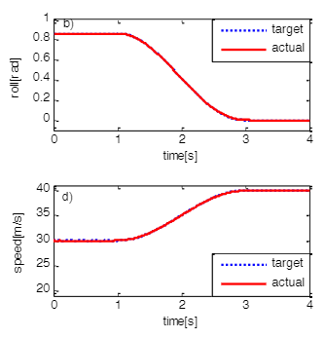
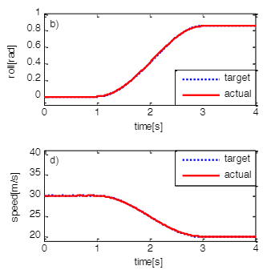
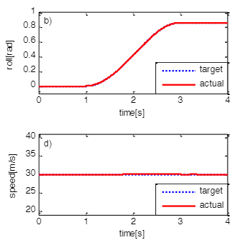
Fig.1 – Results from Massaro’s Non-Linear Simulation
(L-R: Constant Speed, Braking & Acceleration) (Massaro, 2011)

Despite Massaro’s non-linear model being a success, this was not quite what was required for a motorcycle racing model and so a new model was constructed as part of a study in 2020 undertaken in connection with Honda Racing Corporation (Nishimura et al., 2020). The study undertakes areas of simulation which have not been previously considered where a motorcycle is pushed to it’s limits in conditions where the front or rear wheels may be in the air, something not seen in road-going production motorcycles. This would then be used to better simulate hard-braking situations where the rider is controlling the motorcycle with the rear wheel off the floor at some points during the braking phase. It is also understood that each rider’s style of riding the motorcycle greatly effects the motorcycle’s performance (Nishimura et al., 2020) and so in this study the decision was made to ensure the motorcycle was constantly pushed to its limits. The model also used some other control inputs to Massaro’s non-linear model such as changing the rider’s centre of gravity position to alter the motorcycle’s handling in situations such as cornering, these inputs are however determined using the preview horizon theory from Massaro’s model. The results from the study in terms of roll rate are shown in figures 2 and 3. Figure 2 proves that this new form of rider model is much more efficient than the conventional models when simulating the actions of a motorcycle racer compared to a standard road rider, with less errors being seen in the new model. Figure 3 also proves that the new model is an improvement, however it is still not as close to the real-world data measurements as it perhaps could be despite the model being considered as ‘effective’ for conducting a race simulation. This information provides proof that conducting further research into this area is viable in order to provide the much-wanted accuracy which these race teams and engineers require.

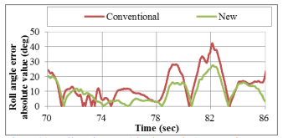

Fig.2 – Comparison Between New and Previous Model for Roll Angle Error
(Nishimura et al., 2020)
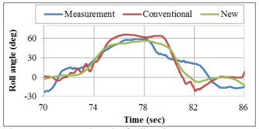

Fig.3 – Comparison Between New & Previous Models and Real Data for Roll Angle
(Nishimura et al., 2020)

- Methodology
The methodology of this proposed research project is split into four distinct sections, as seen below. This methodology also links to the aims in section 1.3, with each section linking to each aim in numerical order.

  - Database Creation
The first step in the project methodology is to create a database in Microsoft Excel that will be used to store various information on specific motorcycles, riders, and racetracks. In order to create this database, the information will need to be gathered in various different ways. Due to the limitations in the opportunities to collect accurately scanned data on racetrack geometry, this information will likely need to be measured manually using software such as Google Earth. The data on road-based motorcycles such as those seen in the British Superbike championship will be much easier to gather than data of prototype motorcycles in the MotoGP world championship, and so it may be better to create this iteration of the software based on these road-going motorcycles. Finally, the rider research will likely have to be gained by analysing data in order to understand their riding traits such as braking styles and lean angles as not all riders are the same. Although, physical attributes for the riders such as heights and masses may be more difficult to obtain as they cannot be found within the data traces.

  - Chassis Program Development
The chassis program will be created using Excel and will be driven by the database created in the first section of the methodology. This software will be developed with the idea of using all of the geometry of the motorcycle from the database in order to create a geometric diagram of the different points of the motorcycle to be used for direct visual comparison without even using the lap simulator software. This software will also produce some information in graphs, for data such as suspension, based on the geometric setup as to create further visual comparison between the two setups. In connection with this section of the project, a questionnaire will also be developed in order to better understand the requirements of what is preferred by motorcycle racing engineers in their current computer software including what features they would find useful. A plan of this questionnaire can be found in appendix 1.

  - Qualifying Lap Simulation Software
This third section of the methodology will be the main body of work for the project and will be the most difficult section to complete. The first step in the creation of the lap simulation software will be to ensure the motorcycle is operating around the track as expected on a base level, with values such as accelerations, lean angles and braking forces seeming accurate. Once the base level is created it is then important to develop the simulation dependent on the riders’ behaviour and how this will dynamically affect the motorcycle’s response over the course of the entire lap in different scenarios such as under braking and acceleration. Developing this model will allow for fine tuning of the results that will work closer in line with what is seen from real data collected at a race event, as in order for this tool to be usable within the industry it needs to be as accurate as possible due to the fine margins of change it will be used to predict. As previously explained, there is limited information on the understanding of a rider’s effects on a dynamic motorcycle model and so this section of the model will need to be continuously tuned as more issues are found throughout the development stage. At this stage it is unknown as to whether Excel or MATLAB will be used to create the simulation, it is likely following the literature review in section 2.2 that MATLAB will likely be used in some facility due to the expected requirement to use matrix mathematics. However, both pieces of software will be evaluated for their limitations in order to determine which is the best option as both can be driven via the Excel database.

  - Software Validation
The final step of the project will be validating the results produced by the lap time simulation software. The overarching idea for the validation process will be to use as good a level of rider as possible to do as fast a lap as possible of a specific racetrack on a real motorcycle, then a set up change will be made to the motorcycle and the same rider will be sent back onto the racetrack to go as fast as possible. All of the data from the rider, motorcycle and racetrack will be implemented into the database and then both motorcycle setups used at the track day are ran through the simulation. The results from the simulation can then be compared to the real data gathered on the real racetrack in order to determine the accuracy of the lap simulation. If there are some areas of the simulation that are not accurate enough when compared to the real data traces, then the software can be developed and tweaked further as discussed in section 3.3. It is likely that this is going to be the case as more knowledge will be gained through analysing as much real data as possible to find areas which the model has not considered, for example a certain phenomenon that may only be seen by some rider’s techniques in specific scenarios. Alternatively, if it is not possible to collect real world data due to impossible situations, such as the coronavirus, then it may be possible to collect some data in some accurate computerised geometric simulations. Below is a list of requirements that would be needed to conduct a trackside validation:

- Motorcycle Racer
- Motorcycle (As Close to Race Specification as Possible)
- Data Logging Software
- Laptop Capable of Running Data Analysis Software
- Data Logging Equipment to Be Installed on Motorcycle
- Mechanic/Assistant (To Assist with Motorcycle Setup Alterations)
- Renting of Racetrack (Likely as Part of Motorcycle Track Day)

- Results Collection & Analysis
The results collection procedure will be fairly simple for this research project as the simulation software will be built to automatically output its data into graphs ready for analysis. An example of this can be seen in figure 4, taken from a previously completed lap simulation software in Microsoft Excel, where a comparison of the simulated motorcycle’s speed was outputted and compared against the data from a sensor gathered over a real lap of the same circuit by the same motorcycle. These data traces will allow for large numbers of comparison between real data and simulation data in areas such as velocity, suspension data (seen in figure 5), gear position, engine speeds and more including calculated channels for areas that were not gathered directly by sensors in the real measured data. One of the most important parameters for comparison will certainly be the overall lap time determined by the simulation as the accuracy to this will in many ways determine how accurate the simulation is overall when compared to a real motorcycle. However, it will definitely be important to analyse all areas of the data due to the fact that if the simulation states that the motorcycle is quicker than the real data in some situations and slower in others the solution is clearly incorrect even if it looks as though the lap time is very accurate.

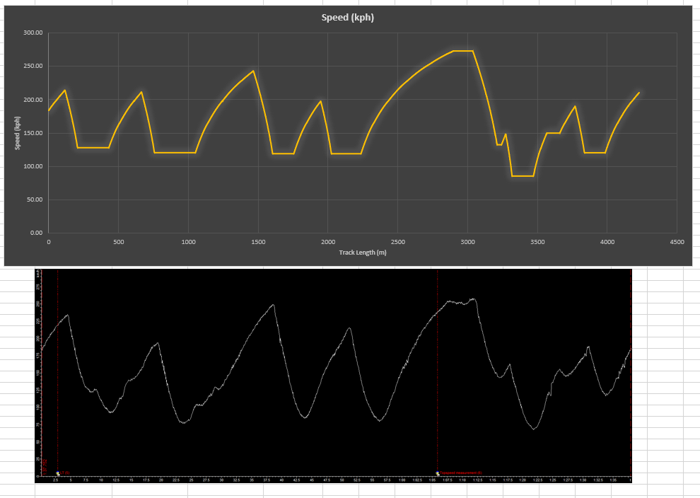

Fig.4 – Comparison of Real and Simulated Motorcycle Data
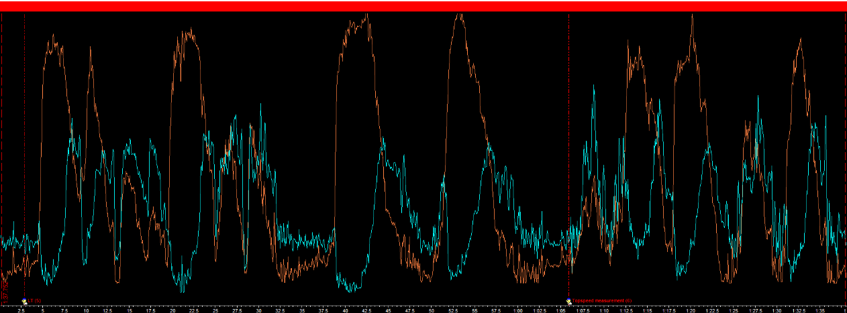
Fig.5 – Front & Rear Suspension Position Data Gathered from Moto2 Motorcycle

It will also be important to analyse the results produced by the geometric equations from the chassis set-up software and not just the simulation aspect of the created software. The chassis program’s geometry is the driving force for the simulation software and so any errors in the geometric formulae can cause greater issues for the software as a whole. The chassis setup program will also produce its own graphs for the bike based on the geometry inputted by the user, as well as bike diagrams driven by the geometry acting as a visual aid for the engineer – as shown in figure 6. These diagrams and graphs will then be available at various motorcycle positions such as under acceleration and braking should the engineer not want to use the simulation software at that time.
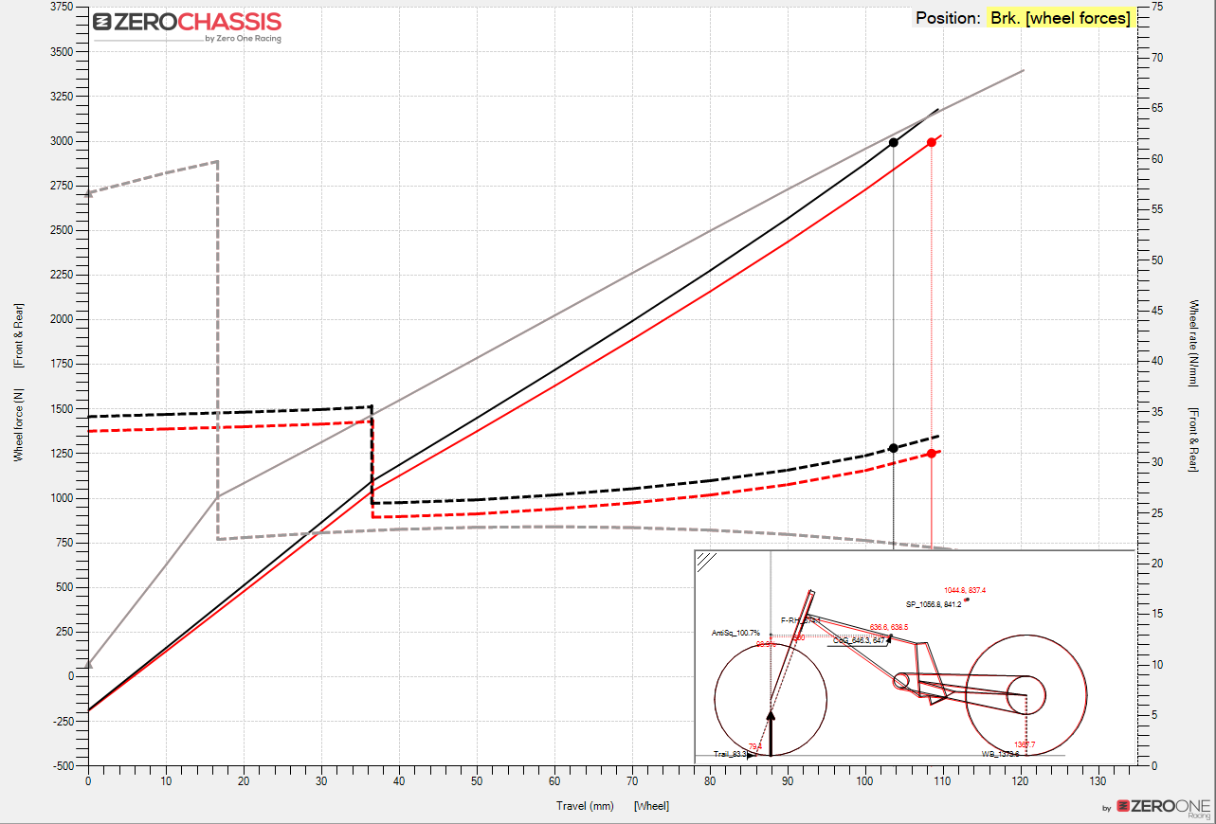

Fig.6 – Wheel Force & Rate Graphs (Motorcycle Under Braking) in Zero One Chassis Software
- Evaluation
It’s understood that the proposed research project will be of significant use to the wider motorcycle racing and motorcycle engineering sector. It is extremely important when undertaking work that may be of so much importance to be thorough and a perfectionist throughout the process of creating and developing this software. This software has the potential to be used or wanted by the large majority of motorcycle racing teams should it be able to provide an advantage to its first user, hence it will need to be perfect in order to impress and live up to the expectations of highly intelligent engineers working at the pinnacle of their field. By using the geometric equations that are most likely used in all motorcycle chassis setup software it is hoped that the engineers will trust in the effectiveness and familiarity of this aspect of the software despite the lap simulation area being much more experimental and brand new. It is hoped that this innovative idea however will catch the eye of teams and engineers looking to improve their on-track performance and get the edge over their competitors, furthering the knowledge of these engineers and opening their eyes further to the possibilities of expanding their computer software usage.

There are some limitations to the proposed study however in that it will be difficult to implement the accuracy of the rider model due to its complexity. This issue is compounded by the limited published information on accurate motorcycle rider simulation, meaning a lot of time will be taken tuning the model in achieving as perfect a match as possible to some of the actions undertaken by the best motorcycle racers in the world. Another limiting factor is the privacy and secrecy within the MotoGP paddock and hence lack of availability in gathering accurate enough information to produce this software for motorcycles and riders operating at world championship level. It is understandable that all manufacturers and teams will want to keep their prototype motorcycles secret and will hence not allow them to be scanned for use in the development of the software, however this may be possible to do if some engineers or teams want to use the software near its completion. If this remains an impossibility many road motorcycles are used in various championships such as British Superbikes are available to be scanned in order to prove the viability of the software during its development and validation. The technology for scanning these machines however is not cheap and although the university has various technologies available this area of the process may be hindered by the ongoing coronavirus pandemic in terms of access to workshops within the university campus.

- Bibliography
2016. Wintax 4 PRO. [ebook] Magneti Marelli. Available at: <https://www.magnetimarelli.com/sites/default/files/2_SF_Wintax_PRO_rev8.0_0.pdf> [Accessed 19 March 2021].

2D Debus & Diebold Meßsysteme GmbH. n.d. The Company - 2D Debus & Diebold Meßsysteme GmbH. [online] Available at: <http://2d-datarecording.com/en/unternehmen/> [Accessed 19 March 2021].

Barstow, O., 2020. French MotoGP Qualifying Results: Quartararo grabs home pole in Miller fight. [online] Visordown. Available at: <https://www.visordown.com/news/racing/motogp/french-motogp-qualifying-results-quartararo-grabs-home-pole-miller-fight> [Accessed 7 March 2021].

BBC Sport. 2012. Formula for Success – KERS and DRS. [online] Available at: <https://www.bbc.co.uk/sport/formula1/20496330> [Accessed 6 March 2021].

Box Repsol. 2019. MotoGP 2.0: Future technologies applied to MotoGP - Box Repsol. [online] Available at: <https://www.boxrepsol.com/en/motogp-en/motogp-2-0-future-technologies-applied-to-motogp/> [Accessed 6 March 2021].

Cossalter, V., Lot, R., Massaro, M., Peretto, M. and Korsunsky, A., 2011. Investigation of Motorcycle Steering Torque Components. AIP Conference Proceedings, [online] 1394(1), pp.35-46. Available at: <https://www.researchgate.net/publication/234960085_Investigation_of_Motorcycle_Steering_Torque_Components> [Accessed 21 March 2021].

Cummings, C., 2021. Discussion on MotoGP software.

Foale, T., 2019. Motochassis Software User's Manual. [ebook] Available at: <https://motochassis.com/DocumentFiles/SetupManual.pdf> [Accessed 19 March 2021].

Honda Racing Corporation. n.d. History of Motorcycle Racing. [online] Available at: <https://motogp.hondaracingcorporation.com/history/> [Accessed 6 March 2021].
Massaro, M., 2011. A nonlinear virtual rider for motorcycles. Vehicle System Dynamics, [online] 49(9), pp.1477-1496. Available at: <https://www.researchgate.net/publication/233144358_A_nonlinear_virtual_rider_for_motorcycles> [Accessed 22 March 2021].

Massaro, M., Lot, R. and Cossalter, V., 2012. A virtual motorcycle driver to simulate real manoeuvres from experimental data. Proceedings of the Institution of Mechanical Engineers, Part D: Journal of Automobile Engineering, [online] 226(9), pp.1211-1219. Available at: <https://www.researchgate.net/publication/258177655> [Accessed 21 March 2021].

Motec.com.au. n.d. MoTeC > 25 Years of Driving Success. [online] Available at: <https://www.motec.com.au/Success/> [Accessed 19 March 2021].

MotoGP, 2018. The evolution of data analysis for riders in MotoGP. [video] Available at: <https://www.motogp.com/en/video_update/2017/09/22/the-evolution-of-data-analysis-for-riders-in-motogp/240351> [Accessed 6 March 2021].

MotoSPEC CHASSIS PROGRAM. n.d. DATA AQ. [online] Available at: <https://www.motospec.ca/data-aq.html> [Accessed 19 March 2021].

MotoSPEC CHASSIS PROGRAM. n.d. TESTIMONIALS. [online] Available at: <https://www.motospec.ca/testimonials.html> [Accessed 6 March 2021].

Nishimura, M., Tezuka, Y., Picotti, E., Bruschetta, M., Ambrogi, F. and Yoshii, T., 2020. Study of Rider Model for Motorcycle Racing Simulation. [online] Available at: <https://www.sae.org/publications/technical-papers/content/2019-32-0572/> [Accessed 22 March 2021].

Potts, G., 2019. The Volvo XC90 now comes with actual KERS. [online] Top Gear. Available at: <https://www.topgear.com/car-news/volvo-xc90-now-comes-actual-kers> [Accessed 6 March 2021].

Sarkar, A., 2016. Kinetic Energy Recovery Systems in Formula 1. [online] Stanford University. Available at: <http://large.stanford.edu/courses/2015/ph240/sarkar1/> [Accessed 6 March 2021].

Sharp, R., n.d. Dynamics of Motorcycles: Stability and Control. London.

Spalding, N., 2019. MotoGP Technology. 3rd ed. Kent, UK: Phoebus Apollo Ltd.

SuspAct. n.d. About SuspAct. [online] Available at: <https://www.suspact.com/about-suspact/> [Accessed 19 March 2021].

Zero One Racing. n.d. ZeroChassis. [online] Available at: <https://www.zerooneracing.com/zerochassis/> [Accessed 19 March 2021].

Appendix 1 – Questionnaire Plan
Seen below is a plan of the questionnaire that will be sent out to motorcycle racing engineers as part of the data collection area of section 3.2. The feedback via this survey will allow for understanding on what engineers currently use and what they prefer in their current software. It will also provide information on how familiar they are in regard to any existing simulation software and finally whether they would find the tool being created in connection with this project useful as part of their own trackside work.



Fig.7 – Planned Questionnaire Questions 1 & 2

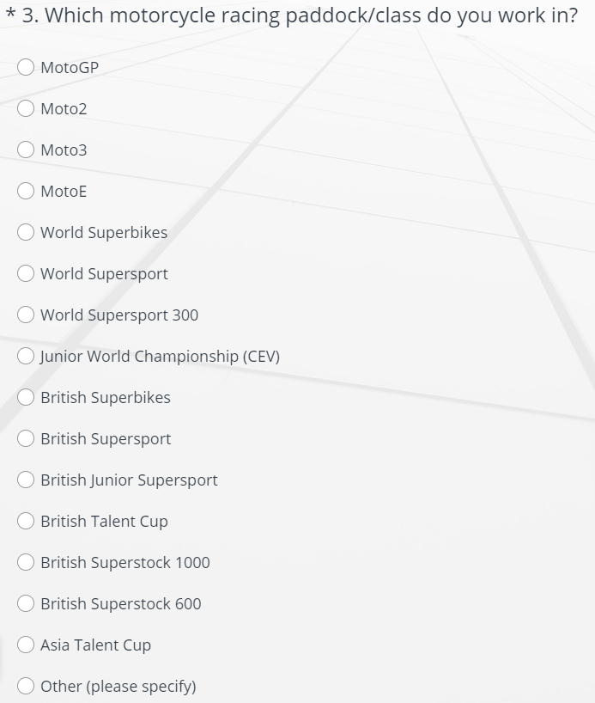

Fig.8 – Planned Questionnaire Question 3

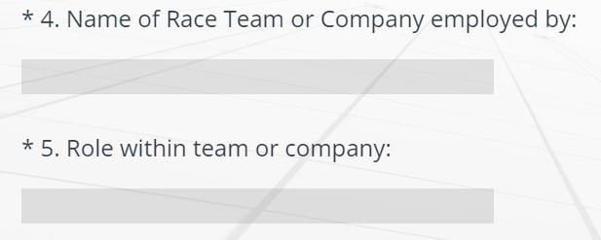

Fig.9 – Planned Questionnaire Questions 4 & 5

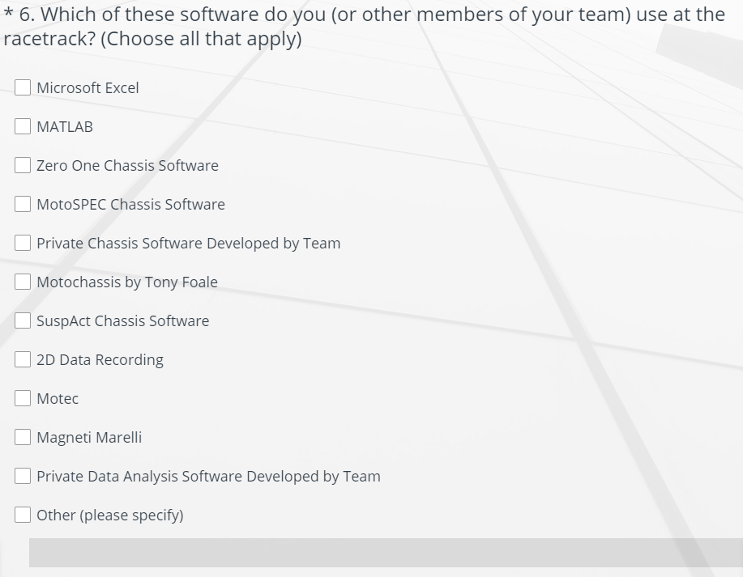
Fig.10 – Planned Questionnaire Question 6

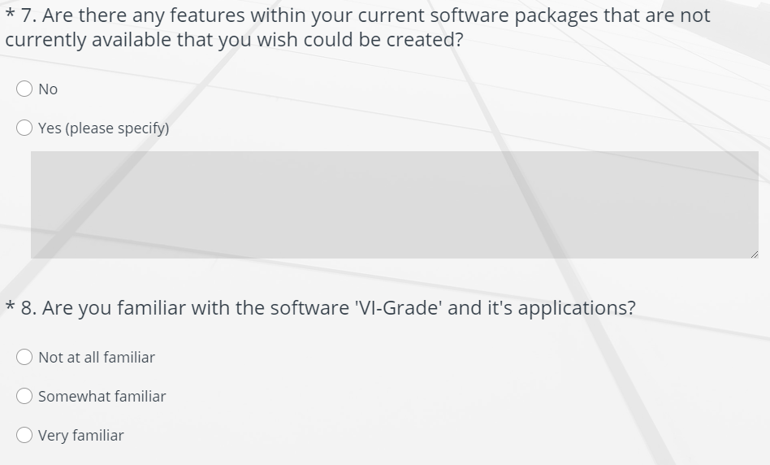

Fig.11 – Planned Questionnaire Questions 7 & 8

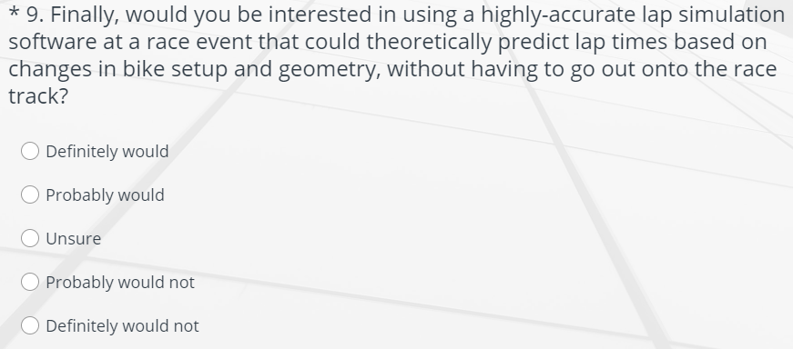

Fig.12 – Planned Questionnaire Question 9

Appendix 2 – Project Timing Plan
Seen below is the timing plan for the research project, the project will run from the week commencing April 19th once approved. The plan shows the steps of the project that will be undertaken from the beginning until full completion and submission by the end of week 20 (September 6th).
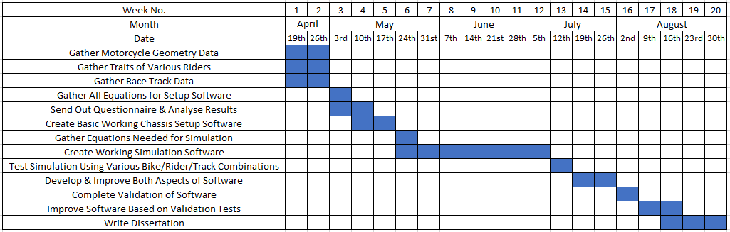

Fig.13 – Project Timing Plan

