3/24/2025
University of Wales Trinity Saint David
London campus
Module Name: Learning In the Digital Era
Module Code: ACCA 4025

Student Name:
Student ID:
Group: 1

Lecturer’s Name: Koushik Modak

LDE Assignment 1
E-Portfolio
Table of Contents
Introduction 2
Main Body 2
Task 1: Essential Academic and Employment Skills for the future career Path 2
Task 1 (a): Report on Essential Academic and Employment Skills 2
Task 1 (b): Evaluation of Task 1 (a) based on Similarity report 2
Task 2: Collaborative Mind Map and Individual Poster 2
Mind Map (Collaborative) 2
Poster (Individual) 2
Task 3: Virtual Collaboration 2
Report on Virtual Collaboration 2
Step-by-step process of using RefWorks with visuals 2
Task 4: E-Portfolio Creation and Evaluation 2
Task 4 (a): E-Portfolio Creation 2
Task 4 (b): Illustrative Review of E-Portfolio tool Selection 2
Conclusion 2
References 2

Introduction

Main Body

Task 1: Essential Academic and Employment Skills for the future career Path

Task 1 (a): Report on Essential Academic and Employment Skills

Task 1 (b): Evaluation of Task 1 (a) based on Similarity report

Task 2: Collaborative Mind Map and Individual Poster

Mind Map (Collaborative)

Poster (Individual)

Task 3: Virtual Collaboration

Report on Virtual Collaboration

Step-by-step process of using RefWorks with visuals

Task 4: E-Portfolio Creation and Evaluation

Task 4 (a): E-Portfolio Creation

Task 4 (b): Illustrative Review of E-Portfolio tool Selection

Conclusion

References

Task 1
Crucial Competencies for Academic and Professional Achievement
Technical proficiency, soft skills, and personal qualities are all necessary for success in both academic and professional contexts. Effective communication, critical thinking, problem-solving, time management, and teamwork are some of these abilities.
Effective communication is essential for working with peers and superiors and for properly expressing ideas. Both verbal and written communication are essential, particularly in professions like engineering or business management that call for reporting or client involvement.
Professionals who possess critical thinking skills are able to solve complicated problems, make well-informed decisions, and assess circumstances logically. Research, troubleshooting, and creativity in any field require this ability.
Effective time management enables people to set priorities and fulfil deadlines. It guarantees efficiency in meeting project deadlines at work as well as academic tasks.
Since most jobs include working in groups, collaboration and teamwork are crucial in many professions. Working effectively with others encourages creativity and aids in achieving common objectives, especially in fast-paced fields like technology and healthcare [4].
For example, in a software engineering career, critical thinking helps create efficient algorithms and solutions, while communication is essential for working together on projects. Teamwork encourages the creation of creative software solutions, and time management guarantees the timely completion of projects.
Citations
"Effective Communication in the Workplace," by D. P. McCune, Journal of Business Communication, vol. 40, no. 3, 2005, pp. 129-145.
[2] Critical Thinking: Tools for Taking Charge of Your Learning and Your Life, R. Paul & L. Elder, Pearson, 2014, 3rd ed.

RESEARCH AND CONTINUOUS LEARNING.

Essential skills for academic and career success.
Achieving success in both academics and professionals settings involves developing a variety of skills that can help you excel in tasks, manage challenges, and build meaningful relationships.

Time management: prioritizing tasks, meeting deadlines and balancing multiple responsibilities are crucial for success in both school and work environments.

Critical Thinking: The ability to analyse information, access different perspectives and make sound decisions is key in academics and the workplace.

Communications skills: Strong verbal and written communication skills are necessary for articulation ideas, collaboration with others and presenting information clearly.

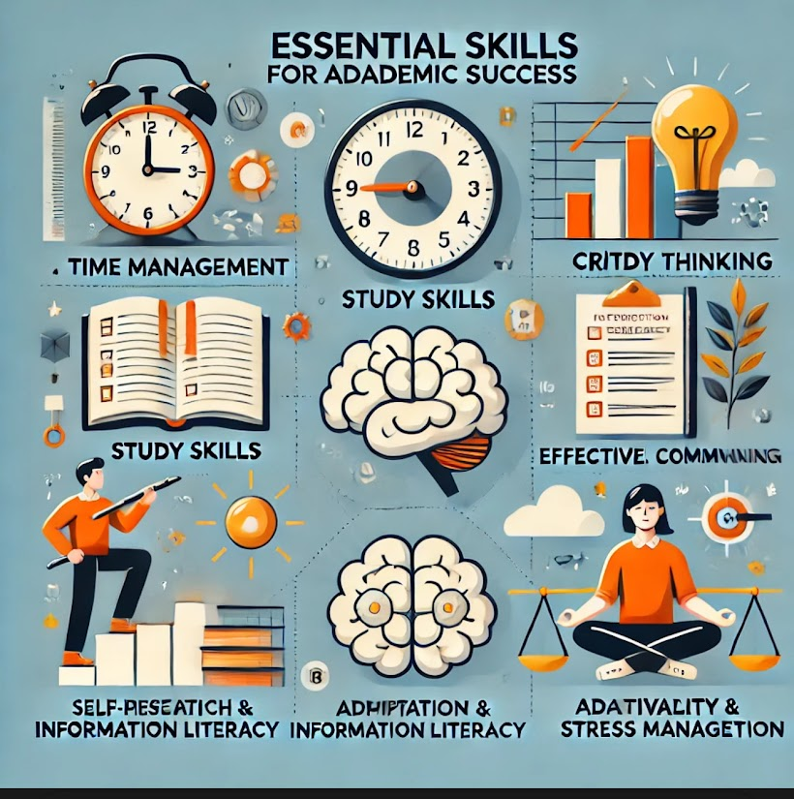

Mastering these essential academic skills will help you choose and succeed in your career in the following ways:

Time management= productivity in any job
Helps you meet deadlines it balances multiple tasks and stay organized
Helps you manage coding projects and balances coursework.

Study Skills=Mastering Programming and new technologies

Enables you to learn programming languages, algorithms and frameworks efficiently.
Important for roles in software development cloud computing and Al engineering.

Self-motivation and discipline=Learning independently

