Name: Anisa Tollia
Student Number: 2021941
Module Title: Marketing Fundamentals
Assignment Title: Marketing Fundamentals Analysis and Evaluation – Assessment 2
Module Lecture’s Name: Tushara Balendran

The role of marketing in creating value
for customers at Louis Vuitton

The impact of Stakeholders on the LVMH group’s
marketing activities

Essay

Introduction
The purpose of this essay is to review the various ways of creating value for the customers with the help of different marketing activities. It also examines the role of stakeholders and their impact on Louis Vuitton's marketing activities. The essay uses the company, Louis Vuitton, as an object of research.
The first part of the work is focused on the marketing concept and how marketing creates value for customers. Special attention is paid to branding as an element of the marketing mix strategy. It is also a very powerful tool used by LVMH for attracting customers and increasing organisational performance. The first part ends with a presentation of the Ansoff Matrix model and the way it can be used for creating value.
The second part of the essay deals with the stakeholders of LVMH. It presents some definitions and differentiation of the various stakeholders. In the end, it is the way LVMH communicates with their stakeholder and how stakeholders shape the marketing activities of LVMH.
Part 1. The role of marketing in creating value for customers at Louis Vuitton

Definition of marketing concept
The marketing concept represents a particular point of view on the process of achieving high revenue by production and sales. This concept puts customers’ needs and satisfaction at the center of the marketers’ attention.(8) The organization decides what products to be produced after examination of customers’ needs. It is an opposite approach to the sales concept, which assumes that profits are achieved by sales and promotion of existing products. The two concepts are shown in Figure 1 below.

Figure 1 Selling and Marketing concepts contrasting, Source: (8)
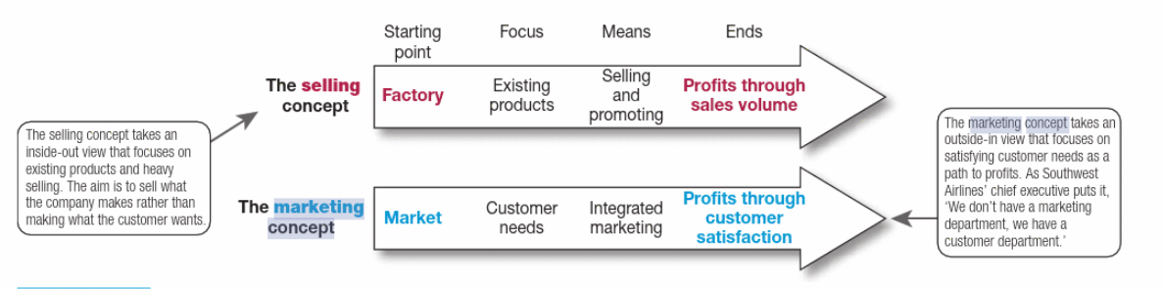
According to Kotler et al., 2019 the idea of marketing concept is to find the right product that satisfies best the customers’ needs. This means that the organisation needs to know well their customers and their needs. It is achieved by researches, investigation and continuous contact with the customers.

How Louis Vuitton practices the marketing concept
LVMH group is a parent company of Louis Vuitton, created after its merger with Moet Hennessy, a champaign-and-cognac producer. (3) The LVMH group is one of the biggest players in the luxury business in the world. It has a variety of customers due to the large number of products and brands it represents and offers. All of their houses and brands that constitute the group put customers in the centre of their attention and efforts. The nature of luxury goods makes customers’ experience the most important think of the producer’s success. Often, a luxury brand gives the customer more satisfaction than the physical characteristics of the product. It is the reason why customer experience is so important for the LVMH’s success. A piece of evidence showing that this fact is well understand by the LVMH’s management is their Code of Conduct. It states that ‘understanding customer needs and expectations is important in order to provide them with the products they seek and deliver a personalized customer experience’. (11)

Advantages of marketing to consumers
Marketing concerns companies relationships with their customers. According to Kotler et al., (2019) marketing is ‘the process by which companies engage customers, build strong customer relationships, and create customer value in order to capture value from customers in return.’ The definition itself highlights the advantages for consumers. The first advantage is that the producers need to keep their customers well informed about their products and brands in order to achieve their goals. In recent years producers need to report their social and environmental policies and activities, as well. Secondly, the producers investigate customers’ needs and preferences to design and build their products. The consumers are getting goods that mostly cover their needs. In the third place consumers are getting high-level services. For example, LVMH group sells their products by individual boutiques in the centres of the cities where customers receive personal service. Also, the company uses social media to help their customers make buying decisions by uploading information and videos giving them professional advices. (4)

Branding
Definition of Branding
The brand name helps both the consumers and producers. It helps the first one to buy and the second one to sell easier a product or service. According to Kotler and Armstrong (2008) brand names incorporate everything that the product or service means to customers.’ The brand is usually a name or a symbol ‘that distinguishes one product from another in the eyes of the customer. (2)
Advantages of Branding
Kotler and Armstrong (2008) distinguish the following advantages of branding. Firstly, the brand helps the customers in their buying decisions. Usually, the brand is associated with a particular level of quality and customers know what to expect from a product of the brand. Secondly, brands work as means of legal protection, preventing unique product features to be copied by competitors. Thirdly, branding stimulates innovation by pushing producers to think about new features that cannot be imitated by competitors. The branding brings to increased product variety for the customers.
How branding of LVMH’s group provides value for customers
Each of the above-mentioned brands’ advantages provides value for the consumers. Brands can save customers’ time by informing the customers in a very short time about the quality and the specific characteristics of a product. In the case of Louis Vuitton, their brands work as a guarantee for product quality.
The brand itself brings value for customers. For example, when a customer buys a luxury watch or a Louis Vuitton’s bag, they do not only acquire a tool for measuring the time, but a symbol of their social status. Practically, the branded luxury goods give customers more than the economic value of the product. They provide a feeling of exclusiveness. This means that brands, especially when they are powerful and well-recognisable, create value for customers. It is the reason why the LVMH group invests in its brands.

How Ansoff Matrix can create value for customers
The Ansoff Matrix
The Ansoff Matrix helps companies to develop their product and market strategy. (14) The matrix model determines four different approaches for the development of sales and growth with the help of new or existing products, and in new or existing markets. The Ansoff matrix is shown in Figure 2 below.

Figure 2 The product/market expansion grid, Source: (8)
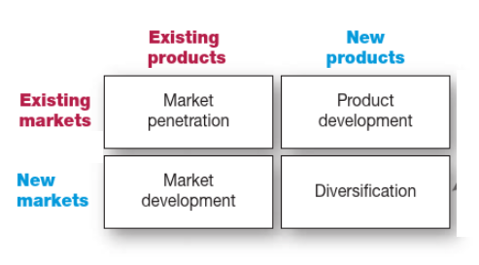

Each approach is related to a particular market strategy. For example, market penetration is a strategy that assumes selling the same product in the same market.
Creating value for customers
The Ansoff Matrix allows organisations to design their marketing strategies and create value for customers by developing both products and markets. For example, product development strategy, the right upper square in Figure 2, concerns creating new products and innovating the existing ones to sell them to different markets. This leads to an increased variety of products and many more useful characteristics that are of benefit for the customers. Customers will have more choice and their needs will be more fully satisfied. This is the value for them better covered needs and a more positive buying experience.
The concept is similar when it comes to product diversification strategy. In this case, new products are developed in order to be sold to new markets. Both products and markets are developed and this brings value to customers. Practically, this strategy is materialised by ‘starting up or buying businesses beyond companies’ current products and markets’ Kotler et al. (2019) LVMH widely use this strategy by acquiring companies in their field of activity e.g. luxury bags and accessories, spirits and wines, cosmetics, perfumes, watches, etc. For example one of their recent acquisitions is the one of the American brand Tiffany. (1). By this act, LVMH acquires both new products and new markets.

Part 2. Stakeholder engagement and their impact on the marketing activities of Louis Vuitton

Definition of a stakeholder
According to Freeman et al. (2007, p. 48), ‘stakeholders are the groups that can affect or be affected by the achievement of a business’s core purpose.’ These include individuals or organisations that have some relationship with the company. They can be dependent on the company’s activity and the company, in turn can, depend on them. It is a kind of two-way relation. The list of stakeholders includes the shareholders, the employees, any volunteers, any consulting or supporting partners, suppliers, customers, competitors, a variety of external organisations such as the government, banks, other financial institutions, communities, and different organisations from the third sector.
All these groups and individuals have their impact on organisational performance. Some of them play a crucial role, e.g. employees, managers, customers, suppliers, financial, and society. Others are quite in the periphery, but none could be neglected.(5) Each group has its own interests and often they may be in conflict with the interests of the company. It is the reason why managing the stakeholders interests is a key function of every organisation. An example of the different stakeholders’ interests is given in Table 1.

Table 1. Organisational stakeholders and their interests, Source: (15)
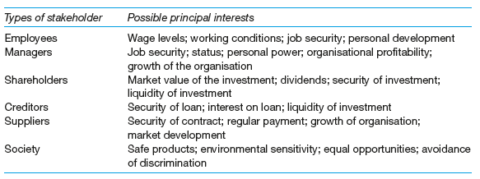

Definition of internal and external stakeholder
Internal Stakeholders
The internal stakeholders are a part of an organisation or a project. These are the employees and their managers. They are important because often the success of the business or project depends on the perceived satisfaction of the internal stakeholders. (6) Different internal stakeholders are shown in Figure 3 below.

Figure 3: Mind Map of Internal Stakeholders, Source: (12)

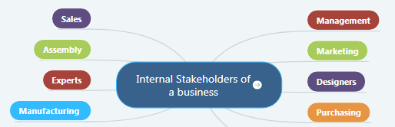

Using the mind-map above, we can descry the following internal stakeholders of the LVMH group.
Examples of internal stakeholders of Louis Vuitton
The first group of internal stakeholders of LVMH is their employees. The company has more than 150 thousand employees in more than 80 countries. (7) The employees play a crucial role in the development and growth of Louis Vuitton. They contribute to the preservation of knowledge in the production of Louis Vuitton’s unique products. Each company of the LVMH group has its own creators, designers, experts, and manufacturing resources.
The second big group of internal stakeholders includes the LVMH management. Here are included the board of directors of the group plus the management of each brand within LVMH. As mentioned above each brand keeps its independence management.

External stakeholders
The external stakeholders are individuals or organisations that are outside of the business or project but are able to affect their processes or be affected by them.(13) Some of the most important external stakeholders are the suppliers, customers, communities, and financiers. They are vital to the continued growth and survival of any business.(5) A mind map of the external stakeholders is given in Figure 4.

Figure 4: Mind Map of external Stakeholders, Source: (13)

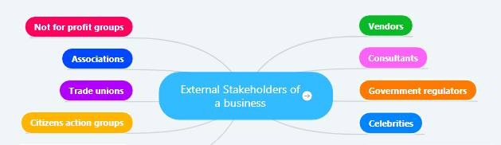

Examples of external stakeholders of Louis Vuitton
Using the above-given map we can descry the external stakeholders of the LVMH group. In the first place are Louis Vuitton’s customers. Their attitude and satisfaction are critical for the business. It is the reason why the customers receive very special attention from the company. Another important factor of the internal stakeholders is the group of suppliers. They are necessary for the success of the business since the quality and prices of the resources they deliver to LVMH became a part of Louis Vuitton’s products. Banks and other financial institutions pay also a significant role since they ensure financially the LVMH’s activities. The other external stakeholders of Louis Vuitton are the government, different non-profit organisations, environmental associations, trade unions, communities, etc.

How Louis Vuitton communicates with their stakeholders
Louis Vuitton uses different methods of communication with the stakeholders. Companies need to understand that their various ‘stakeholders are complex beings and that they cannot be managed with a ‘one size fits all point of view. (5)
Regarding the employees, LVMH supports their development and growth knowing that it is critical for the organization's growth as a whole. Evidence for that is the LVMH management's statement in their Annual Report 2020 that they are ‘encouraging all their employees to reach their full career potential and achieve their aspirations. (7). What is more, Louis Vuitton creates an atmosphere of support that helps people be creative and engaged.
LVMH’s relationships with its suppliers are necessary for the sound production process within the organisation as a whole. It is because a good relationship with suppliers ensures sustainable supply chains. LVMH maintains on-site supplier audits. The group has also implemented a responsible sourcing policy that provides suppliers with support and training.(7) LVHM has stated a number of requirements to their suppliers to ensure that they are comply with the same values as LVHM is. The requirements are stated in a document called the LVMH Supplier Code of Conduct (10) and include legal requirements of corruption , respect of competition, protection of personal information, confidentiality, etc.
LVMH is also a socially responsible company that maintains close contact with communities and different non-profit organisations working to protect the environment and supporting various social causes. For example, in 2019 they launched an initiative called A Day All Your Own addressed to more than 400 women. They were invited in the Palace of Versailles to spend one ‘day focused on their own well-being’. (7)
How stakeholders impact the marketing activities of Louis Vuitton
According to Freeman et. all (2007) companies need to ‘overspend’ on understanding stakeholder needs, using marketing techniques to segment stakeholders to provide a better understanding of their individual needs and using marketing research tools to understand the nature of most stakeholder groups.’
Louis Vuitton has a variety of internal and external stakeholders and needs to adapt its marketing activities so that to be able to maintain the best relationships with its stakeholders.
Customers are one of the primary external stakeholders of every organisation. It is totally true for Louis Vuitton, as well. They put their customers in the centre of all their attention and efforts, knowing that satisfied customers are the most precious value for every business. According to Kotler et. all, (2019, p. 199) companies ‘must design customer-driven marketing strategies that build the right relationships with the right customers.’ It is the way in which customers impact the marketing activities of LVMH. They motivate the management of LVMH to build specific customer-driven marketing strategies. Some of these strategies include segmentation and targeting that have already been discussed in assignment one.
Another group of stakeholders that impacts LVMH’s marketing activities includes the various communities in the different countries in which LVMH operates. Communities shape the LVMH’s marketing activities by their expectation for socially responsible behaviour of the business. The reason for these expectations is the increased people’s awareness of environmental and social problems. LVMH has introduced a variety of social incentives related to gender equity, women’s voices to be heard, inclusion, diversity, child labour prohibition etc. The marketing character of all these activities is related to the fact that they build the image of the organisation as a socially responsible company. This adds further value to the LVMH name and brands.

Conclusions and recommendations
The essay examines various marketing tools such as branding, product development, diversification, and stakeholders’ management and comes to the conclusion that they can be used for creating value for customers. So is realised the main purpose of marketing, to create value for customers in order to gain value in return under the form of sales and revenue.(8) After reviewing how LVMH in particular uses marketing for creating value for its customers a couple of recommendations can be made. Firstly, they can put more effort into developing new products. Practically, the companies of the LVMH group are quite conservative. Their products are of high quality but rather traditional. They can include more technology in their products and make them suitable for young people, for example. Secondly, The LVMH group is focused on a very close market segment. They can achieve higher sales and higher profit by addressing larger audiences. In the third place, they can introduce initiatives for protecting some endangered species of the world’s flora or fauna. This will balance the fact that they use animal leather for the production of some of their luxury products. This will also highlight their image of a socially responsible company.

References
1)BBC News. (2021). LVMH seals purchase of Tiffany after takeover fight. [online] Available at: <https://www.bbc.com/news/business-55578195> [Accessed 3 April 2021].
2)Brassington, F., Pettitt, S. (2013), Essentials of Marketing, Pearson Education
3)eu.louisvuitton.com (2021) The Legendary Story [online] Available at: <https://eu.louisvuitton.com/eng-e1/magazine/articles/a-legendary-history> [Accessed 30 March 2021].
4)DeAcetis, J., 2020. Relationship Goals: Luxury Retail And Technology Make A Perfect Combo For Customer. [online] Forbes. Available at: <https://www.forbes.com/sites/josephdeacetis/2020/08/15/relationship-goals-luxury-retail-and-technology-make-a-perfect-combo-for-customer/?sh=365a81012754> [Accessed 5 April 2021].
5)Freeman, R. E., et al. (2007) Managing for Stakeholders: Survival, Reputation, and Success, Yale University Press, ProQuest Ebook Central
6)Heerkens, G (2013). Project Management, 2nd Edition, [e-book] McGraw-Hill Education
7)Hosting.fluidbook.com. 2021. LVMH 2020 Annual Report. [online] Available at: <https://hosting.fluidbook.com/LVMH/2020interactiveannualreport/en/#/page/22> [Accessed 3 April 2021].
8)Kotler, P. T., et al. (2019) Principles of Marketing, Pearson Education Limited, ProQuest Ebook Central
9)Kotler, P., Armstrong, G., (2008) Principles of marketing, 5th European ed., Harlow: Financial Times Prentice Hall
10)LVMH. 2021. LVMH Supplier Code of Conduct - LVMH. [online] Available at: <https://www.lvmh.com/news-documents/lvmh-supplier-code-of-conduct/> [Accessed 13 April 2021].
11)R.lvmh-static.com. (2017) LVMH Code of Conduct [online] Available at: <https://r.lvmh-static.com/uploads/2017/12/lvmh-code-of-conduct-2017_122017.pdf> [Accessed 5 April 2021].
12)Stakeholdermap.com (2021) 1. External Stakeholders | Who are External Stakeholders?. [online]. Available at: <https://www.stakeholdermap.com/external-stakeholders.html> [Accessed 12 April 2021].
13)Stakeholdermap.com. (2021) 2. Internal Stakeholders | Who are Internal Stakeholders?. [online] Available at: <https://www.stakeholdermap.com/internal-stakeholders.html#download> [Accessed 10 April 2021].
14)tutor2u. 2021. Ansoff Matrix | tutor2u. [online] Available at: <https://www.tutor2u.net/business/reference/ansoffs-matrix> [Accessed 6 April 2021].
15)Worthington, I., Britton, C. (2014) The Business Environment. 7th Ed. Harlow Pearson.

