Evidence of e-learning portfolio

BMSM4003
  - Cody Peacey (2404220)

Contents page.
Unit 1 Notes and Comments 2
Unit 2 Notes and Comments 6
Unit 3 Notes and Comments 8
Unit 4 Notes and Comments 10
Unit 0 Notes and Comments 13
Summary of Essential skills for Study and Employment 15
Reference List 17
Mind map of the main themes in all units 18
Artificial Intelligence Units 19

Unit 1 Notes and Comments

Notes
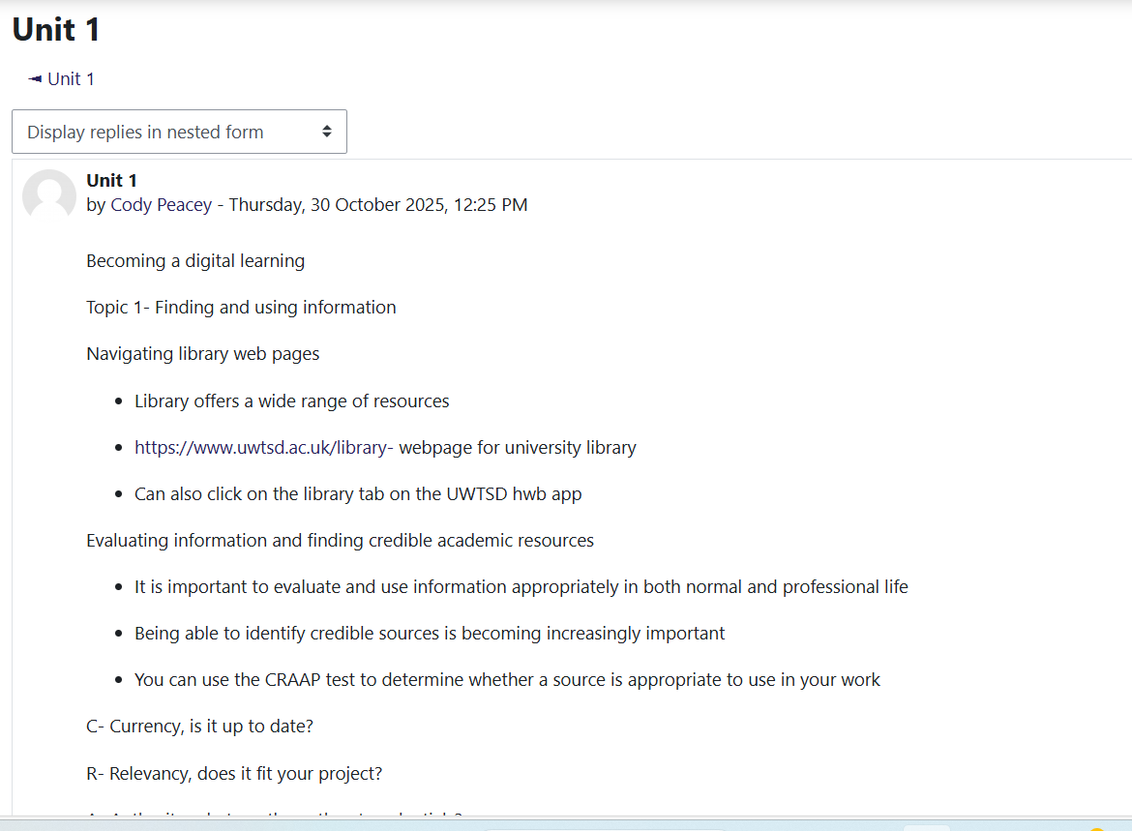
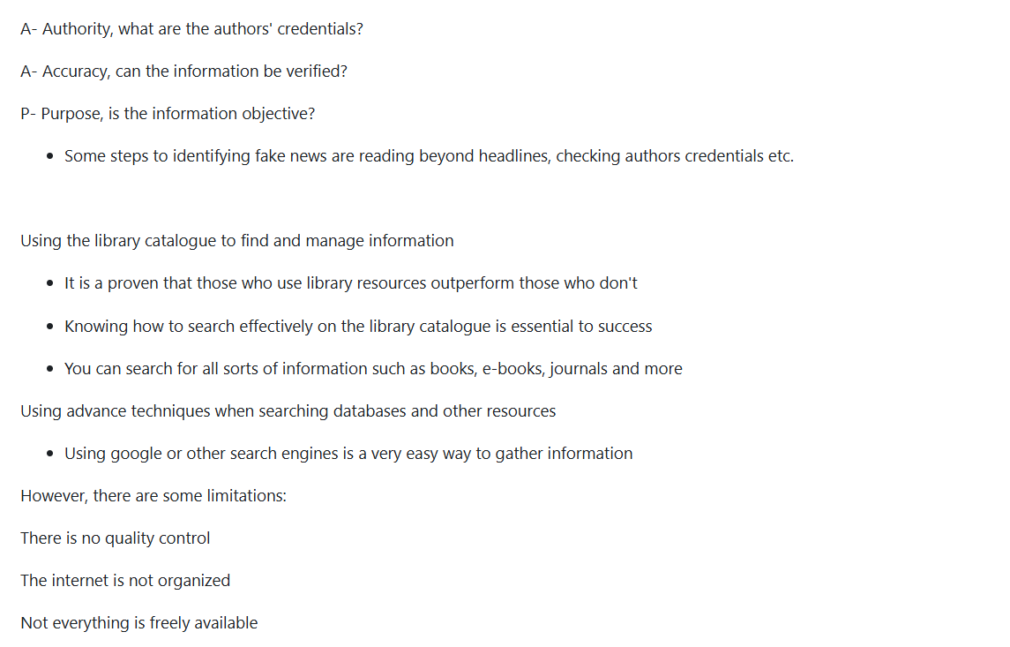
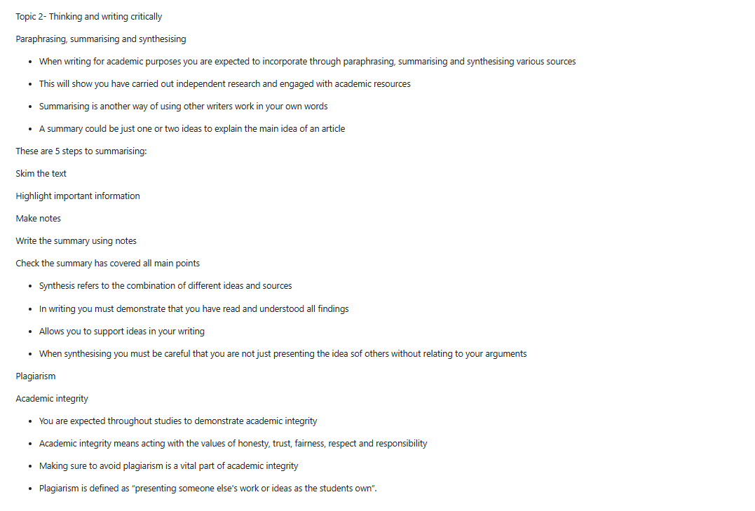
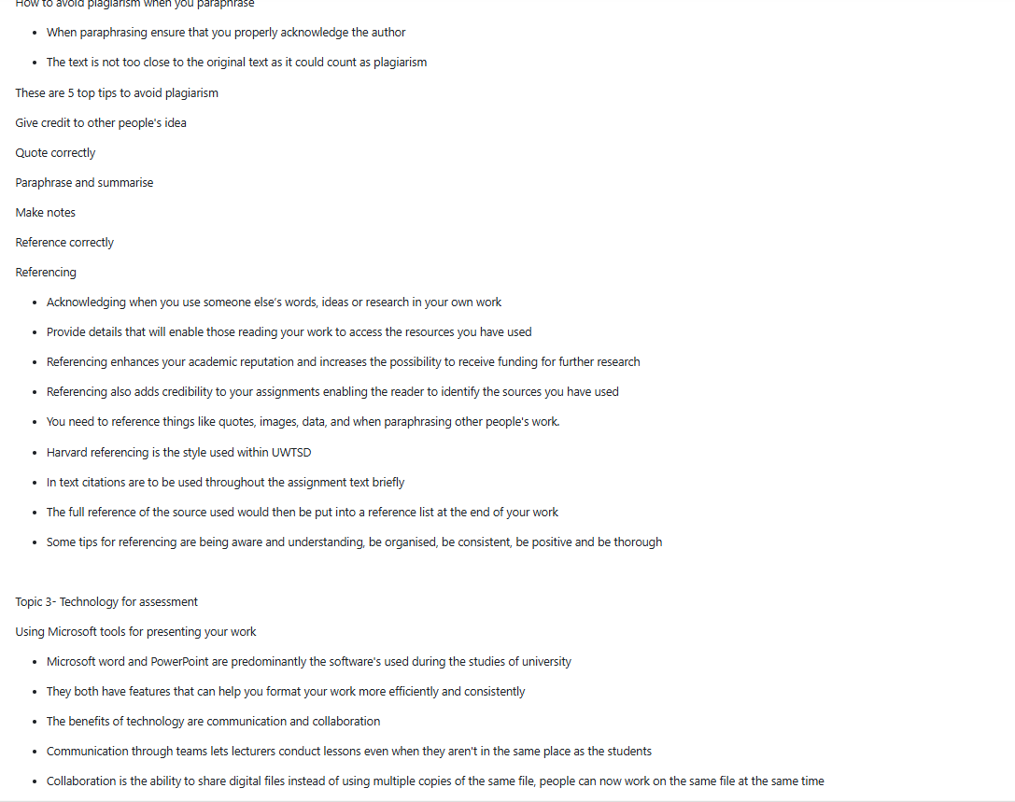
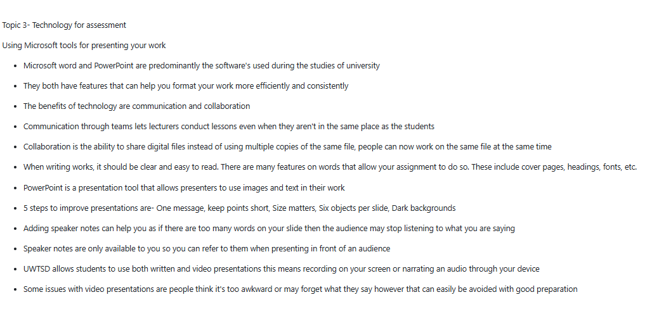

Comments


Unit 2 Notes and Comments

Notes
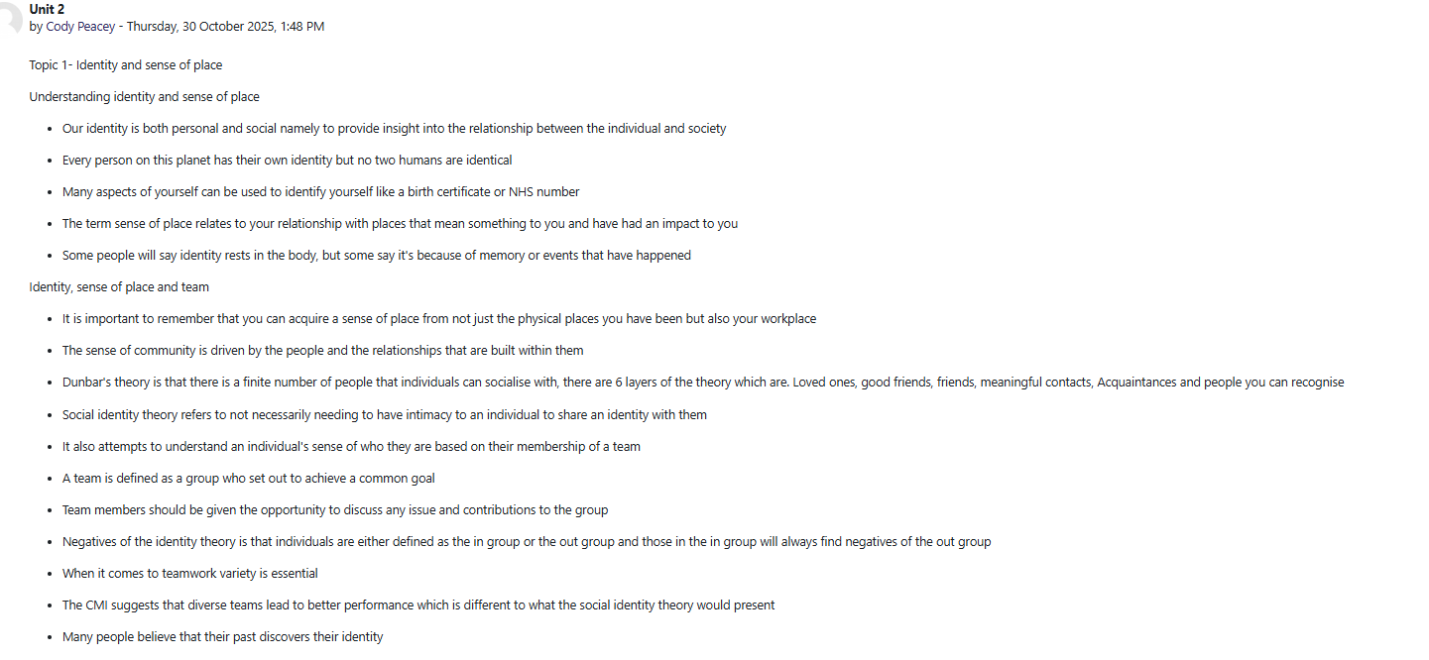
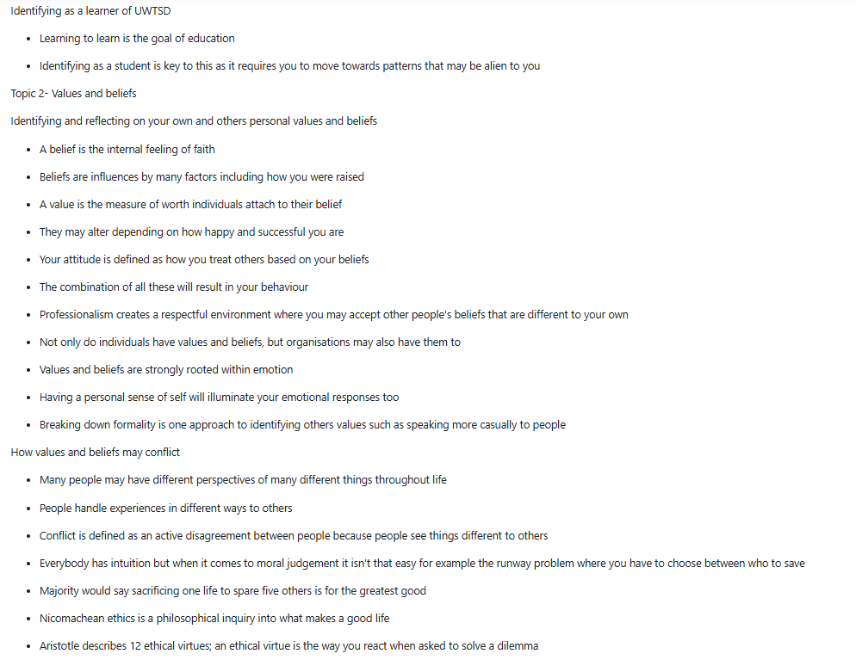
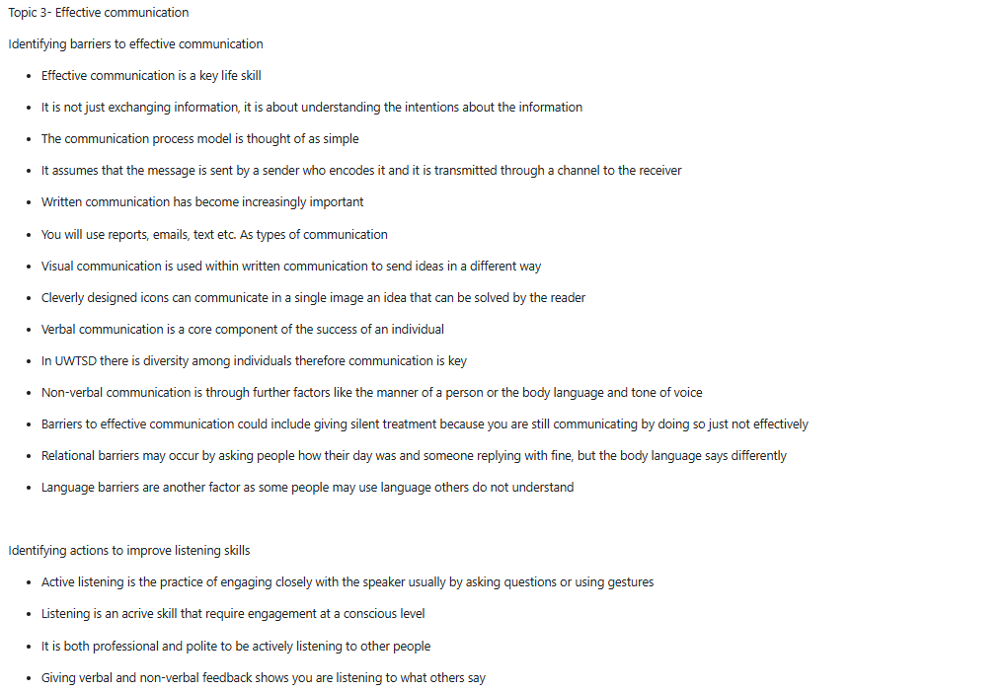
Comments


Unit 3 Notes and Comments
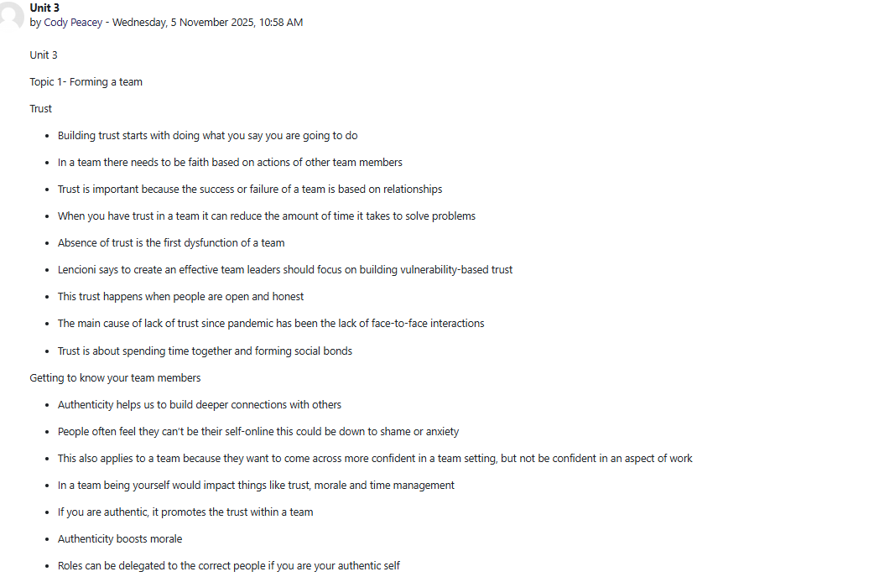
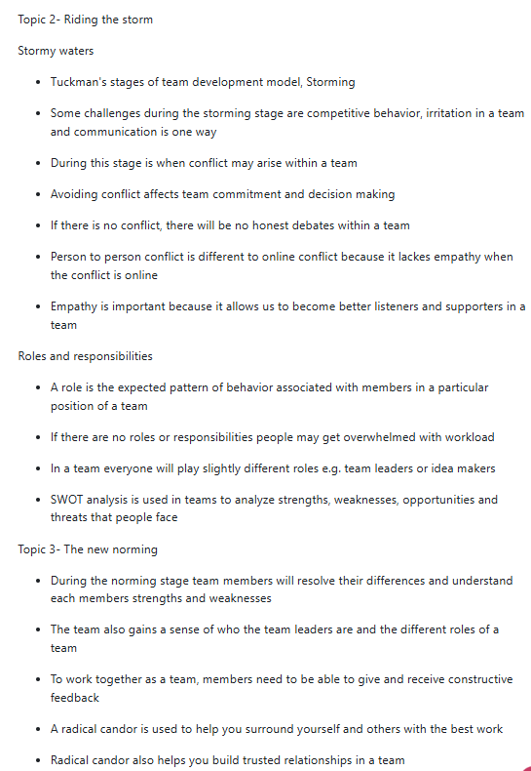
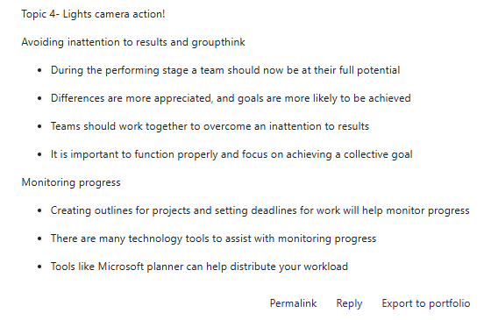

Comments


Unit 4 Notes and Comments

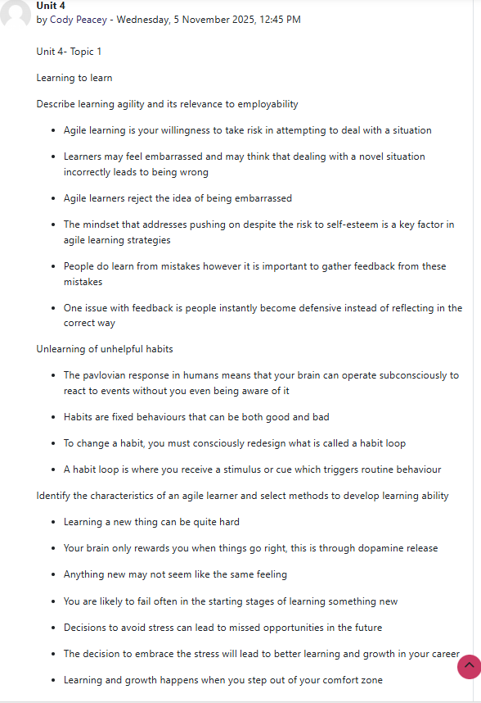
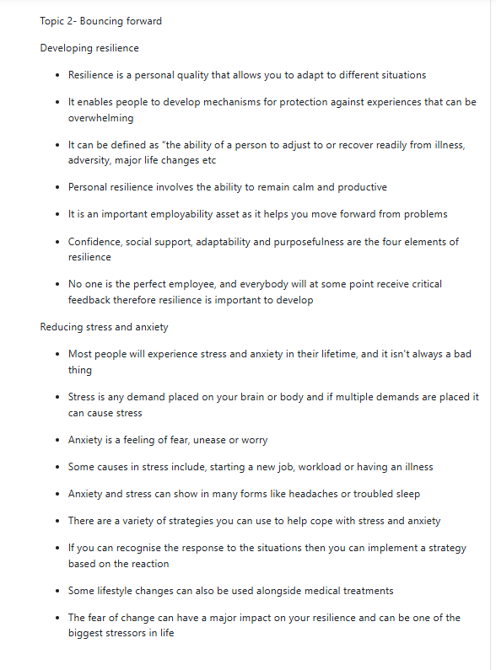
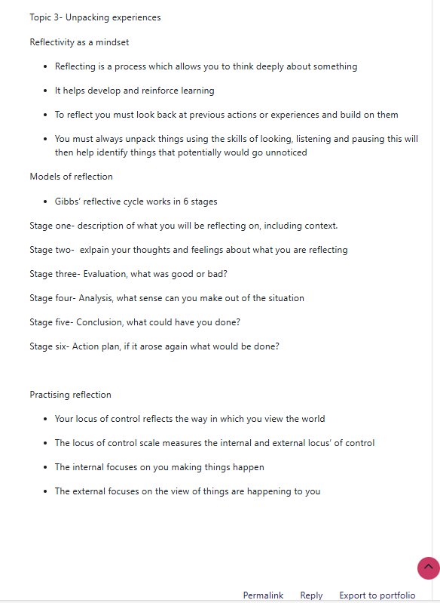

Comments


Unit 0 Notes and Comments

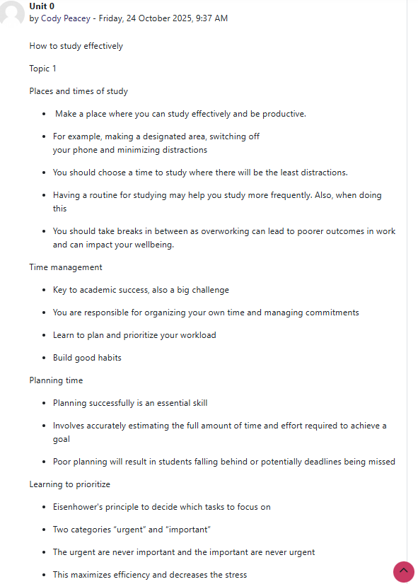

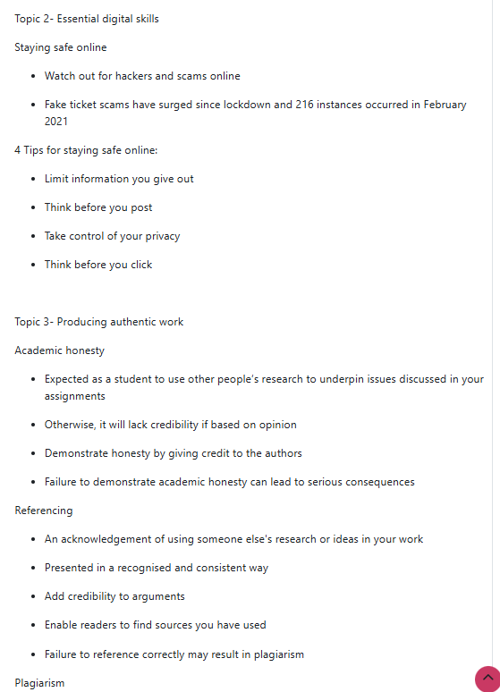
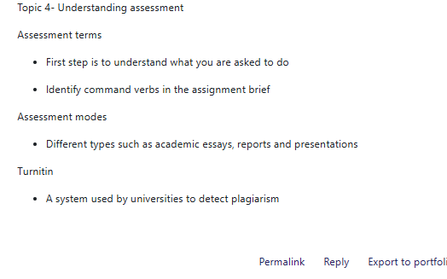

Comments


Summary of Essential skills for Study and Employment

A wide range of essential skills that allow people to adapt, communicate clearly, think critically, and manage their personal and professional growth are necessary for success in both studies and professional work. These abilities, also known as employability or transferable skills, are essential for succeeding academically and are also becoming increasingly valued by employers in a global workforce that is changing quickly (Andrews and Higson, 2008).
Effective communication continues to be crucial for both work and education. Students must be able to participate in discussions, express themselves clearly verbally as well as through writing, and provide arguments that are backed up by facts in classroom environments (Cottrell, 2019). Collaboration, negotiation, and professional networking are all aspects of communication in the workplace. One of the most popular graduate qualities, according to employers, is communication (Jackson, 2016). Additionally, in diverse teams, interpersonal skills like empathy, teamwork, and cultural sensitivity promote productive relationships and successful collaboration (Robles, 2012).
Successful education and employment ability depend strongly on critical thinking, meaning the capacity to evaluate information impartially and form well-reasoned conclusions. Facione (2015) claims that self-control, interpretation, analysis, and inference are all components of critical thinking. Students can apply their understanding to real-world situations and engage deeply with academic material because of these abilities. Problem solving skills enable people to innovate in their roles and handle difficult scenarios in the workplace (Kivunja, 2015). Today's workplace is dominated by developments in technology, and the constant change requires employees who can think critically and adapt to solutions independently.
Efficient time management is essential for managing multiple deadlines in the workplace and in university. Productivity and stress reduction are enhanced by effective goal setting, prioritisation, and scheduling (Claessens et al., 2007). Students who effectively manage their time in the classroom are more likely to achieve their deadlines and perform better academically (Macan et al., 1990). Also, self-management in the workplace, that involves emotional intelligence, resilience, and adaptability, encourages steady performance and wellbeing (Goleman, 1998).
Digital literacy has emerged as an essential ability as digital technologies continue to transform education and the workforce. It includes having the ability to efficiently use, assess, and produce digital information (Ng, 2012). Professionals need these abilities to interact with changing technological tools and platforms, while students need them for research, teamwork, and presentation. Additionally, lifelong learning is the continuous quest for knowledge which guarantees that people will continue to be competitive and flexible in ever-changing work settings (Candy, 2002).
To conclude, study and employment related skills have strong connections and support one another. Academic success and professional success are based on communication, critical thinking, time management, and digital literacy. Gaining these skills enables people to succeed in challenging and changing environments by promoting adaptability, employability, and personal development. Therefore, to prepare students for successful careers in the future, schools, universities and employers must continue to work together to develop and evaluate these critical and essential skills.

Reference List

Andrews, J. and Higson, H. (2008) ‘Graduate employability, “soft skills” versus “hard” business knowledge: A European study’, Higher Education in Europe, 33(4), pp. 411–422.
Candy, P.C. (2002) Lifelong learning and information literacy. White Plains, NY: Elsevier
Claessens, B.J.C., Van Eerde, W., Rutte, C.G. and Roe, R.A. (2007) ‘A review of the time management literature’, Personnel Review, 36(2), pp. 255–276.
Cottrell, S. (2019) The study skills handbook. 5th ed. London: Red Globe Press.
Facione, P.A. (2015) Critical thinking: What it is and why it counts. Millbrae, CA: Measured Reasons LLC.
Goleman, D. (1998) Working with emotional intelligence. London: Bloomsbury.
Jackson, D. (2016) ‘Re-conceptualising graduate employability: The importance of pre-professional identity’, Higher Education Research & Development, 35(5), p. 925–939.
Kivunja, C. (2015) ‘Exploring the pedagogical meaning and implications of the 4Cs “super skills” for the 21st century through Bruner’s 5E lenses of knowledge construction to improve pedagogies of the new learning paradigm’, Creative Education, 6(2), p. 224–239.
Ng, W. (2012) ‘Can we teach digital natives’ digital literacy?’, Computers & Education, 59(3), p. 1065–1078.
Robles, M.M. (2012) ‘Executive perceptions of the top 10 soft skills needed in today’s workplace’, Business Communication Quarterly, 75(4), p. 453–465.

Mind map of the main themes in all units

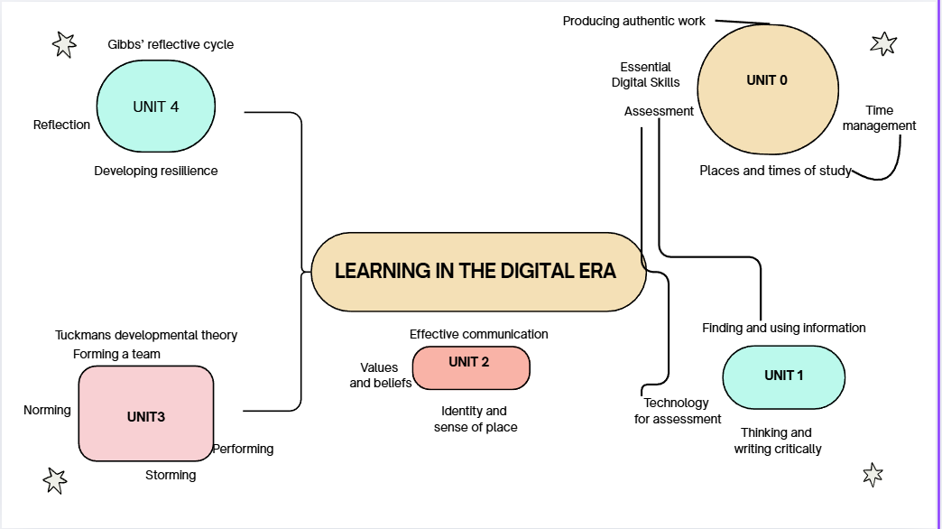

Artificial Intelligence Units
Review of Generative Ai in Sport
Generative Ai is used in various ways within the sporting world. Generative Ai uses machine models to produce content based on patterns of existing data such as text, images and video. In the sport industry this is used through creating online content to engage with fans, also to analyse the performance of a team. Coaches will use generative ai to simulate in game scenarios and gather insights through data of game footage to assist in improving a player's performance. Regarding engagement with the fans, generative ai can produce matchday content like programs or social media content tailored to what the fans want to see such as highlight reels or statistics from a game. Broadcasting is also another factor within sport that generative ai is used within, commentary can be heard in many different languages through the use of ai as it can provide different voiceovers in multiple languages. However, even with the positives of using generative ai there are some drawbacks with the process. These drawbacks could include not having a reliable outcome due to ineffective data being collected and put into a generative ai tool. Aswell as this there are some ethical problems because some Ai feature may go against sports players rights therefore the user of generative ai would need to be responsible for ensuring that ethics have been checked before producing any broadcasting or social media about any players.
How to use Generative Ai
A new addition as such to the sporting world is generative ai and how it is used effectively within different sports. Many sports teams would use generative ai to gather analysis on either their own sports team or other opposition teams. These tools are an enhancement of the modern game and how players can develop. Sports teams will create different simulations of matches and the scenarios within them for example a football team may simulate a corner through ai and gather data on where the players should be attacking the corner from. This then will allow teams to better prepare for a real match due to the data insights they have received through generative ai analysis. Aswell as on the field analysis generative ai can provide off the field insight into factors such as injuries. This is done through biomechanical data analysis to delve into risk factors of potential injuries a player could sustain and how training can be developed to reduce the risk of injury to certain players. Aswell as this rehabilitation programs have been generated through generative ai to make recovery plans for players currently going through the injury process. Scouts and recruitment officers will also be using generative ai data to find future players for professional clubs. This can be done by studying the career trajectory of a player through the data provided by clubs or comparing players from other clubs to how professionals were at that age to have a conclusion on how that player may develop in the future.

