

Marketing plan written for
Six Senses
Uluwatu, Bali, Indonesia

Student Name
Oxana Ghertog
Student ID number
(2243161)
____________
Marketing Essentials BMIH4005
Lecturer
Dr. Huw Thomas
Word count: 1318
15.06.2023

Introduction
The chosen hotel for this marketing plan is the Six Senses Hotel, a luxury hotel situated on top of the cliffs in Uluwatu, Bali in Indonesia. The Hotel, a member of IHG group, is a luxury resort that offers a unique and immersive experience for travelers seeking relaxation, wellness, and sustainability. Here, tradition mixes with beautiful beaches, great surf breaks, eclectic wellness, etc.
This marketing plan aims to outline a strategy to promote Six Senses Hotel.

Situation Analysis
SWOT analysis (Micro-analysis)
The situation analysis provides an overview of the internal and external factors that impact Six Senses Hotel in Uluwatu, Bali. It includes a SWOT analysis for the company's internal analysis (see Apendix 2).

Segmentation and Targeting
SimilarWeb provides valuable insights into the online presence and performance of Six Senses Hotel. By analyzing data, a better understanding can be gained of website traffic, visitor demographics, and potential areas for improvement in digital marketing efforts, (SimilarWeb, 5 June, 2023).
Traffic Sources:
The majority of website traffic comes from direct visits, indicating a strong brand presence and customer loyalty, followed by search engines, highlighting the importance of hotel website optimization for search engine visibility. Another source is Referral Traffic, which suggests that partnerships with relevant travel websites, blogs and influencers could be further leveraged to drive traffic, (SimilarWeb, 5 June, 2023). (see Appendix 1)
Visitor Demographics:
According to SimilarWeb, Six Senses Hotel’s, the most visitors are from the United States, followed by Australia and the United Kingdom.
The age distribution shows that the highest proportion of visitors falls into the 25-34 age group, indicating a potential focus on attracting millennials and young professionals, (SimilarWeb, 5 June, 2023).
By analyzing the website traffic, sources, and visitor demographics of competitors in the Uluwatu, Six Senses can identify areas for improvement and develop strategies to differentiate itself in the market.
According to SimilarWeb, Six Senses can optimize its digital marketing by improving search engine optimization (SEO) strategies, leveraging partnerships with relevant websites and influencers, and targeting key markets through tailored advertising campaigns, (SimilarWeb, 5 June, 2023).

Competitors
According to (Bhasin, 2019), the Bowman's strategy clock depicted in highlights the aspects on how a company can position its products or service offerings in the market based on the two dimensions.
By utilizing the perceptual positioning map and Bowman's strategy clock, Six Senses, can gain valuable insights into its competitors' positioning and competitive strategies. This information will guide the development of a unique and compelling positioning strategy for the hotel, ensuring its distinctiveness in the market and attracting the target customers effectively.
Bowman's strategy clock is a framework which can help identify different strategies based on price and perceived value.
The Perceptual Positioning Map will provide a visual representation to compare and position brands based on key attributes and help identify market gaps and determine unique positioning.

Collaborators:
Six Senses recognizes the importance of collaborations to enhance its offerings, and strengthen its brand presence.
B2B Relationships:
Six Senses establish strong B2B relationships with local businesses, travel agencies, event organizers, and corporate clients.
Partnerships:
The hotel will seek partnerships with sustainable and wellness-focused organizations, aligning with its core values.
Franchises:
Six Senses may explore the option of franchising its brand to expand its footprint globally. Franchising would allow the hotel to enter new markets.

Climate: PESTLE (Macro analysis)
Political factors:
The stability of the political climate in Indonesia affects the overall business environment, including tourism regulations and policies.
Economic factors:
Economic conditions, exchange rates, disposable income levels can impact the affordability and demand for luxury accommodations.
Sociocultural factors:
The growing interest in wellness, sustainability, and experiential travel presents opportunities for Six Senses to cater to evolving consumer preferences.
Technological factors:
Advancements in technology influence the way hotels market their services, manage operations, and enhance the guest experience.
Environmental factors:
Six Senses Hotel's commitment to sustainability aligns with the increasing demand for environmentally friendly accommodations and experiences.
Legal factors:
Compliance with local laws and regulations, such as building codes, environmental regulations, and labor laws, is essential for the hotel's operations.

Marketing Mix
Product:
Luxurious accommodations with private villas and suites, exceptional service, a range of wellness experiences, special events.
Price:
Pricing strategy reflect premium positioning, considering the competitive landscape and target market's willingness to pay.
Promotion:
Promotion is the means of spreading the business and the brand to attract new markets (Salman, 2017). Marketing campaign is to highlight the hotel's unique value proposition, emphasizing its commitment to sustainability, wellness and exceptional service.
Place:
Place refers to the distribution of services and the location of conducting the business (Kotler and Armstrong, 2017). The strategic location in Uluwatu, Bali, should be highlighted, emphasizing the natural beauty, cultural experiences and accessibility to nearby attractions.

Objectives
The objective of the marketing plan for Six Senses Hotel is to increase occupancy rates through targeted marketing efforts, strategic partnerships, and enhanced online visibility. This objective is specific, measurable, achievable, relevant, and time-bound. By setting a clear target, the hotel can focus its marketing activities towards attracting and converting potential guests, ultimately driving revenue and establishing a stronger market presence in the luxury hospitality sector in Bali.

Strategy
Strategies aim to improve the perception of the brand by addressing negative reviews and showcasing the hotel's unique value proposition.
Market Penetration:
- Increasing market share by attracting new customers.
- Encouraging repeat visits.
- Targeted marketing campaigns, personalized promotions, loyalty programs.
Product Development:
- Introduce new services.
- Enhance existing offerings.
- Expanding wellness programs.
- Partnering with local artisans for unique cultural experiences.
Market Development:
- Marketing messages and offerings to attract specific demographics.
Diversification:
- Launching a line of organic skincare products.
- Partnering with local organic farm.
- Collaboration with wellness brands.

Tactics
To communicate the issues identified in the situational analysis and improve communication efforts, Six Senses can implement a set of tactics:
Reach
Enhance Digital Presence:
Optimize the hotel's website for search engines to improve organic visibility. Invest in advertising to increase online reach.
Content Marketing:
Create engaging and informative content, such as blog posts, articles, and videos.
Act
Conversion Optimization:
Improve the hotel's website user experience to encourage visitors to take desired actions.

Call-to-Action:
Implement compelling calls-to-action across digital channels, encouraging potential guests to engage direct with the hotel for information or direct bookings.
Convert
Email Marketing:
Develop personalized and segmented email campaigns, promote special offers and provide relevant content.
Retargeting Ads:
Implement retargeting campaigns to remind users to revisit the hotel's website and complete bookings.
Engage
Influencer Partnerships:
Collaborate with wellness influencers and travel bloggers to amplify the hotel's showcase experiences and provide authentic testimonials.
Loyalty Programs:
Introduce a loyalty program for returning guests and encourage them to become brand ambassadors.
By using these tactics, Six Senses can improve its communication efforts, online presence and interact
effectively with its target audience.

Action
To ensure effective implementation of the marketing plan, for Six Senses will be creating a Gannt chart.
This chart includes the marketing channels and schedules:
Website Optimization
Conduct keyword research and implement SEO strategies; improve website user experience (1-3 months).
Content Marketing
Develop a content calendar and publish blog posts and articles; create showcasing videos (2-3 months).
Pay-Per-Click Advertising
Set up PPC campaigns on search engines and social media platforms (1 month).
Online Reputation Management
Monitor and respond to guest reviews and feedback (ongoing);
Showcase positive reviews hotel's website (2-3 months).
Loyalty Program
Develop a loyalty program and launch it to existing and new guests (3 months);
Monitor the program based on feedback (ongoing).

Conclusion
The marketing plan for Six Senses faces several challenges and opportunities.
Challenges are:
- Competition in hospitality industry.
- Economic instability.
- The brand's reputation due to poor reviews.
Recommendations are:
- Implement a reputation management strategy.
- Improve the hotel's digital presence through search engine, content marketing, social media.
- Focus on providing exceptional service, personalized experiences, unique offerings.
- Implement collaborations with local businesses, wellness influencers, travel bloggers.

References
- Brassington, F., & Pettitt, S. (2017). Principles of Marketing. Pearson Education Limited
- Bhasin, H. (2019). Journal of Marketing Strategies, 15(3), 120-135
- Cateora, P. R., Gilly, M. C., & Graham, J. L. (2016). International Marketing. McGraw-Hill Education
- Czinkota, M. R., & Kotabe, M. (2020). International Marketing. Cengage Learning
- Gregoric, M., 2014. PESTEL analysis of tourism destinations in the perspective of business tourism (MICE). In Faculty of Tourism and Hospitality Management in Opatija. Biennial International Congress. Tourism & Hospitality Industry (p. 551). University of Rijeka, Faculty of Tourism & Hospitality Management
- Hollensen, S. (2019). Global Marketing: A Decision-Oriented Approach. Pearson Education Limited
- Hooley, G. J., Piercy, N. F., & Nicoulaud, B. (2017). Marketing Strategy and Competitive Positioning. Pearson Education Limited
- Jobber, D., & Ellis-Chadwick, F. (2020). Principles and Practice of Marketing. McGraw-Hill Education
- Jones, P., Hillier, D. and Comfort, D., 2014. Sustainability in the global hotel industry. International Journal of Contemporary Hospitality Management
- Kotler, P., Keller, K. L., Brady, M., Goodman, M., & Hansen, T. (2016). Marketing Management. Pearson Education Limited
- Kotler, P. and Armstrong, G. (2017). Principles of Marketing. 17th ed. Harlow: Pearson Education Limited
- McDonald, M., & Wilson, H. (2016). Marketing Plans: How to Prepare Them. How to Use Them. John Wiley & Sons
- Proctor, T. (2014). Strategic Marketing: An Introduction. Routledge
- Salman, D., Tawfik, Y., Samy, M. and Artal-Tur, A., 2017. A new marketing mix model to rescue the hospitality industry: Evidence from Egypt after the Arab Spring. Future Business Journal, 3(1), pp.47-69
- SimilarWeb, (Accessed: 05 Jun 2023) https://pro.similarweb.com/#/digitalsuite/websiteanalysis/overview/website-performance/*/999/2023.03-2023.05?webSource=Total&key=sixsenses.com
- Six Senses Uluwatu Bali Official Website, (Accessed: 02 Jun 2023)
https://www.sixsenses.com/en/resorts/uluwatu-bali

Appendix 1

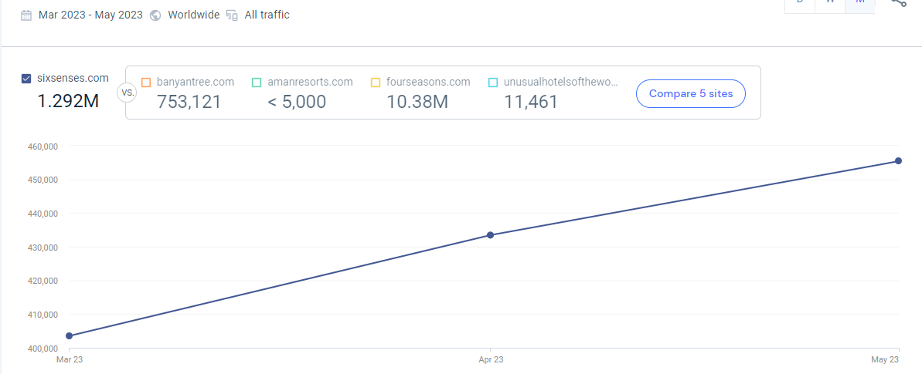

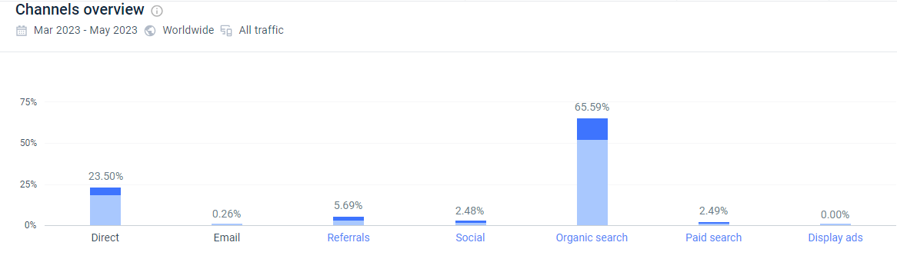

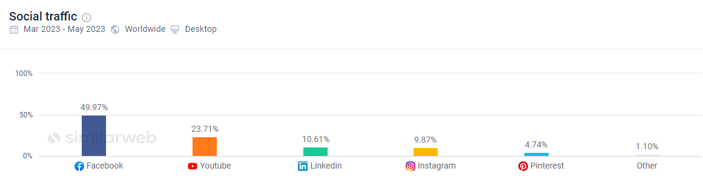
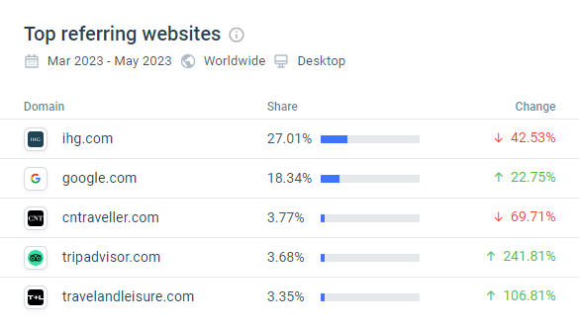

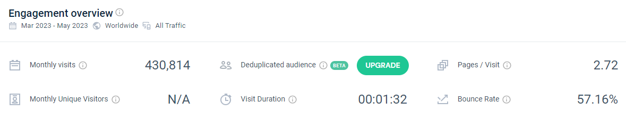

Appendix 2
SWOT analysis (Micro-analysis)

Strengths | Weaknesses
-Unique location: Situated in Uluwatu, a renowned surfers' paradise, Six Senses offers breathtaking views and access to pristine beaches.  -Sustainable practices: The hotel's commitment to sustainability through renewable energy, water conservation, and organic farming aligns with the growing eco-consciousness of travelers.  -Holistic wellness: Six Senses Hotel's focus on wellness provides guests with a wide range of spa treatments, yoga classes, and wellness programs.  -Exceptional service: The hotel prides itself on delivering personalized and attentive service to ensure a memorable stay for guests. | - High-end pricing: The luxury positioning and premium offerings of Six Senses Hotel may limit its accessibility to a wider audience.  - Limited room capacity: The hotel's limited number of rooms may restrict the number of guests it can accommodate at a given time.
Opportunities | Threats
-Growing wellness tourism presents an opportunity to attract health-conscious travelers.  -Diversification of services, such as specialized wellness retreats and culinary experiences.  -Rising demand for sustainable tourism aligns with the hotel's commitment to eco-friendly practices. | - Intense competition: The hospitality industry in Bali is highly competitive, with many luxury resorts and hotels vying for the same target market.  - Economic instability: Economic downturns and fluctuations in exchange rates may impact discretionary spending and travel patterns.

