


Process Safety Systems

Assignment 1: Process Safety Management

HNC Process Operations Engineering

Student name: Jessica Journeaux

Student ID number: 1203218

Student Email: 120124@pembrokeshire.ac.uk

Lecturer: Rhys Hutton

Date: 16.01.24

Table of Contents
Introduction 1
Task 1 2
Task 2 8
Task 3 10
References 12
Bibliography 14

Table of Figures
Figure 1: Origin of Process Safety 2
Figure 2: Four accident prevention pillars 3
Figure 3: Pillars proposed by the Energy Institute 3
Figure 4: Pillar one – Commitment to process safety 4
Figure 5: Pillar two – Understand hazards and risk 4
Figure 6: Potential ignition source map 4
Figure 7: Pillar three - Manage risk 5
Figure 8: Pillar four - Learn from experience 5
Figure 9: Loss of containment protocol 6
Figure 10: HazOp study 7
Figure 11: Safe Operating Limits 8
Figure 12: Merox reactors 10
Figure 13: Caustic and Kerosene SDS 10

Introduction

This assignment will be looking into Process Safety Management and how it has directly impacted the development of systems used in the petrochemical industry. The elements from the four pillars will be directly linked to documentation used on-site, including methodologies that have shaped the safety culture.

Task 1
Process Safety Management has evolved since it was first introduced by the European Federation of Chemical Engineering in 1971. According to ‘A comparative analysis of process safety management (PSM) systems in the process industry’ (Nwankwo, 2020) in figure 1, PSM for chemicals relating to loss of containment incidents, were established in 1992. The PSM program under Occupational Safety and Health Administration (OSHA) and the Operations Integrity Management System (OIMS) laid out a standard for industries, specifically the petroleum industry, using Highly Hazardous Chemicals (HHC). Several catastrophic chemical releases had implemented this change, with guidelines and procedures later rolled out in 1994 to minimise catastrophic incidents and create a safer workplace. (Ross, 2013).
In an online blog ‘Process Safety in Oil & Gas Industry (ASK-EHS, 2022)’ they state that “There were 56 process safety events between 2007 and 2017 that led to 128 deaths.”
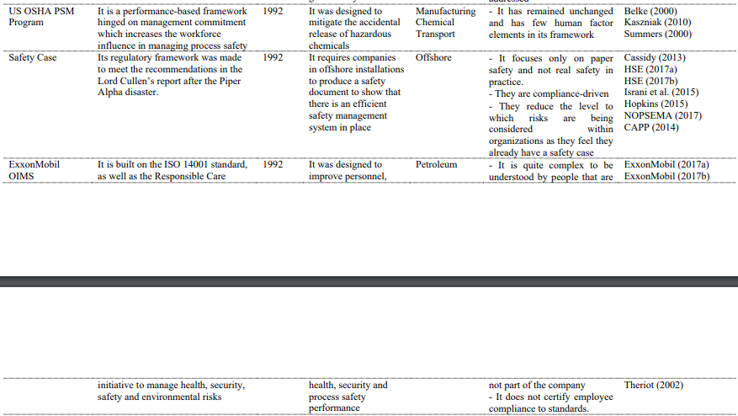
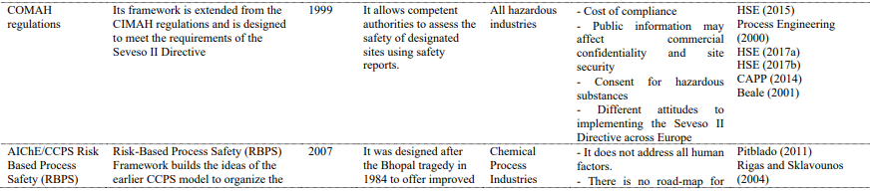
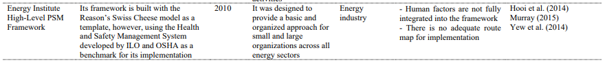
Figure 1: Origin of Process Safety

The Control of Major Accident Hazards Regulations (COMAH) 1999 Regulations was later introduced under the UK’s Health and Safety Executive (HSE) to meet the Seveso II Directive active in Europe. To better understand and overcome these incidents, the management scheme was categorised into four functional pillows. These four pillars which the Risk Based Process Safety Management (RBPS) were built on are:
- Process safety leadership / commitment to process safety
- Understand hazards and risks / Risk identification and assessment
- Manage risk / Risk management
- Learn from experience / Review and improvement

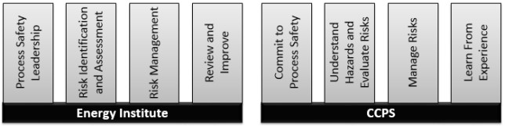
US and UK framework Canadian Association of Petroleum Producers (CAPP) and the Energy Institute identify these four pillars in their framework shown in the image taken from a training document from the University of Hull, ‘Process Safety Management’ (Reynolds Training Services Ltd, 2022) in figure 2. Other framework is available which uses five or more pillars.
Figure 2: Four accident prevention pillars

“The four prevention pillars described by the Energy Institute provide a well-structured system with clear direction on all elements covering Plant, Processes, and People. The aim is to ensure safe operations when handling hazardous chemicals.” (Fat Finger, 2021)
The idea is that failure can occur where there are weaknesses in one step of the system, demonstrated in the figure below. Common definitions of the management style include it being a proactive approach to hazards by preventing, preparing, mitigating and responding where a release incident has occurred. The underlying goal is to reduce or eliminate loss of containment or other energy sources. (Elbanhawi, 2022)

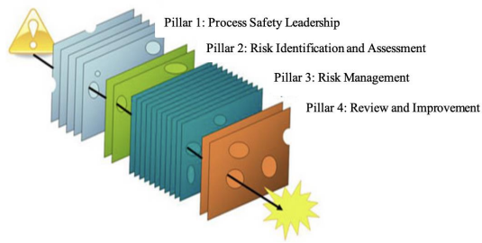
Figure 3: Pillars proposed by the Energy Institute


PSM is the safety umbrella with each pillar being made up of elements shown in the figures below, taken from Process Safety Integrity (Process Safety Integrity , 2023).
Figure 4: Pillar one – Commitment to process safety

In the first pillar, commitment to process safety is for the organisation to provide resources to withstand good safety culture, comply with legal legislation and standards, have members within who are competent through training, involvement with different groups within the workplace as well as stakeholder engagement. Under the commitment and culture, workplaces such as Valero have management which implements and enforces safety rules concerning safe working practices in compliance with the UK law. With this they must supply adequate training to those with exposure to a potential loss of containment i.e the Unit Operators, along with workers complying with rules such as wearing PPE and following procedures.
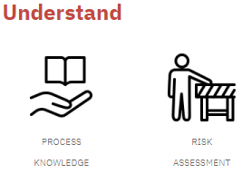
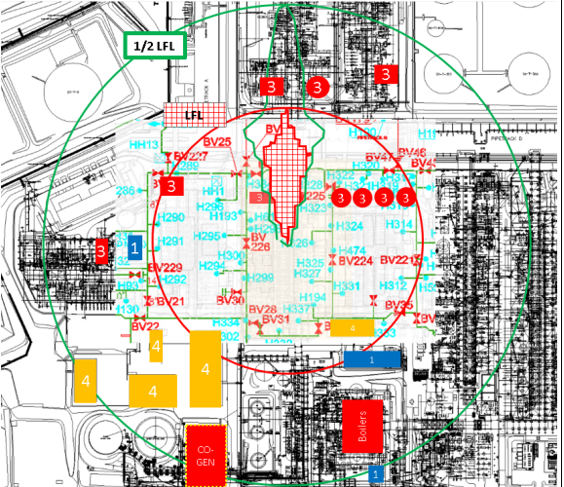
Figure 5: Pillar two – Understand hazards and risk
Figure 6: Potential ignition source map

For the second pillar, understanding the hazards and risks can be done using methodologies such as a Hazard and Operability Study (HazOP), Process Hazard Analysis (PHA) and Failure Mode and Effects Analysis (FMEA). This looks at what could go wrong, how bad could it be and how likely is it to happen. An example of this worst-case scenario is demonstrated in the Emergency Fire Plan (Valero, 2020) in the event of an unignited release of pre-flashed crude shown in figure 6.

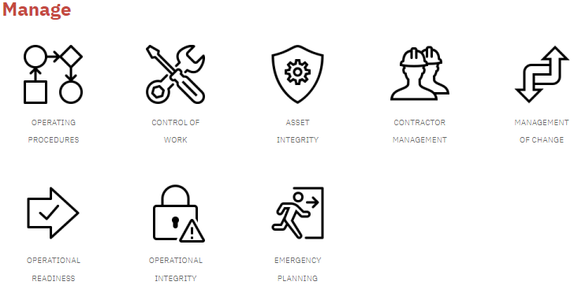
Process knowledge is collected from various documentation such as Safety Data Sheets (SDS), the design limitations of equipment such as vessels and pumps and engineering drawings such as Piping and Instrumentation Diagrams (P&ID’s). Calculations are done based on the information to analyse the risk of loss of containment and implement measures to prevent an incident from occurring.
Figure 7: Pillar three - Manage risk

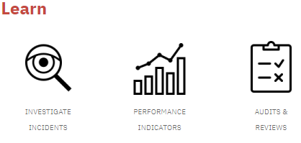
This leads to the third pillar, risk management. In conclusion to the findings based on the process knowledge and risk assessments done, safe working procedures, Risk-Assessed Method Statements (RAMS), permits to work, inspections, Pre-Startup Safety Review (PSSR) and emergency planning can be tailored to the specific process. This allows for multiple steps to be put in place to reduce the likelihood of loss of containment occurring and supplies the best way to respond in the event of a leak. An example of this on the Crude Unit would be procedure PP-OPS-POI-0035 (Valero, 2020) which is to monitor and control the pH in crude using chemical injections to prevent corrosion of equipment which can lead to loss of containment through material failure.
Figure 8: Pillar four - Learn from experience

The final pillar number four is to learn on previous incidents or ‘near misses’ and use the findings to further improve the PSM system. It highlights where the weaknesses are, trends or where information was missed.

In the event of loss of containment in a refinery environment, the four pillars are applied as follows:
Process safety leadership → Existing safety department, committee and safety representatives from each company to highlight and communicate any concerns. All equipment, designs and safety measures such as PPE or shutdown systems are compliant with UK standards. All Operators in charge of the units have completed competency packs, Basic Operators Training and passed tests to qualify in their position, with refresher training and various other training provided. An in-house fire squad with regular fire training exercises, as well as engagement with the local fire department and other forces in the event of larger potentially disastrous incident.
Understand hazards and risks → Different departments such as Process Engineers and Inspection Teams with Subject Matter Experts (SME) to calculate the severity of the situation and come up with fast solutions. Various safety documentation such as emergency procedures to follow in the event of an incident.
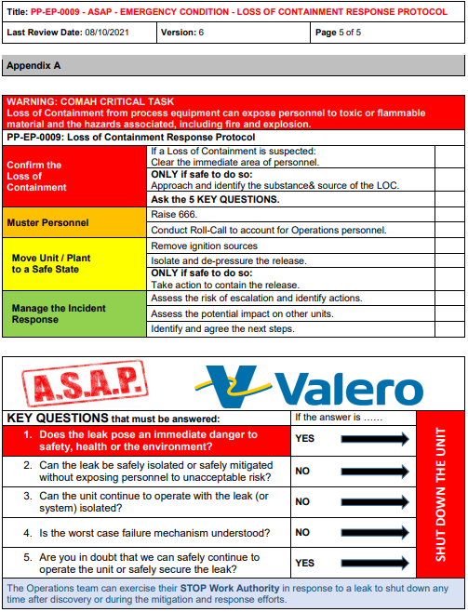
Manage risk → Protocols to follow in the event of loss of containment such as PP-EP-0009 “ASAP – Emergency Condition – Loss of Containment Response Protocol” (Valero, 2021) shown in figure 9. Safety equipment such as fire hydrants, BA sets, spill kits and emergency showers on the units. Emergency HXV valves in the system with remote operation available to isolate sections of the process. Alarm systems to evacuate the area and radios to communicate with the fire technicians.
Figure 9: Loss of containment protocol

Learn from experience → An Environmental Health and Safety Management (EHSM) system to communicate and document incidents alongside meetings to discuss root causes or factors that led to the loss of containment using methods shown in figure 10.

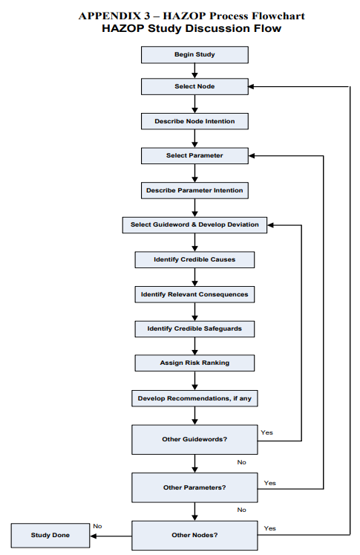
Figure 10: HazOp study

Task 2
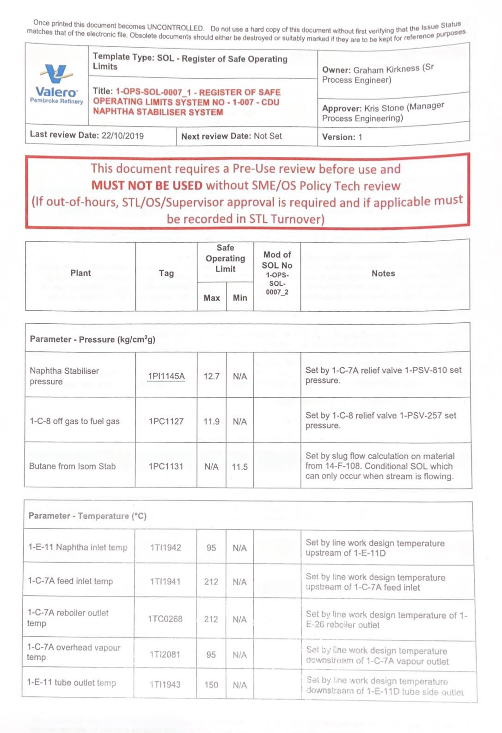
Across the refinery a Distributed Control System (DCS) is used to keep the process within the designed Safe Operating Limits (SOL) demonstrated in document 1-OPS-SOL-0007_1 in figure 11 (Valero, 2019).
Figure 11: Safe Operating Limits

DCS works by using control valves which have a pneumatically operated actuator that moves with the air sent from the positioner. The positioner works on signals sent from a transmitter or switch that is collecting level, flow, temperature or pressure readings. Depending on the service of these instrumentations, some can be set-up so they cause equipment to trip if the conditions becomes unsafe. PHA’s have influenced the failure action of a valve which when calibrated dictates if the valve should fail open or closed dependant on what system it is in. Pressure Relief Systems have also been designed into the process from PHA’s to prevent equipment like a vessel from over pressuring by venting to the flare header or to atmosphere through Pressure Safety Valves (PSV’s). On Sunday 24th July 1994 at Pembroke Refinery, a valve on the outlet of a flare drum failed, which led to a build-up of liquid that reached a line it wasn’t designed for. That line then ruptured, the material found a source of ignition and exploded. The findings from the event highlighted how the process control measures were not adequate to manage the incident.

“The direct cause of the explosion that occurred some five hours later was a combination of failures in management, equipment and control systems during the plant upset.” (HSE, 1997)

On the Crude Unit these shut-down systems can be used in many ways such as if the flow to the heaters is too low which can cause the heater tubes to overheat, the HXV’s on the fuel gas will automatically shut to remove the fuel source and allow the heater to purge with air. If the pressure in the atmospheric distillation column gets too high, the HXV on the stripping steams will close to prevent more light ends from lifting out of the feed. In the event of a fire, a pumps HXV’s can be closed to isolate flow through a pump and stop the pump by tripping the turbine or motor. A fire can be detected using a fire ring which sends an alarm signal to the control or remote panel in the event the fire ring has melted, dropping the air pressure inside.

“Protective tripping systems provide a defence against excursions beyond the safe operating limits by detecting a excursions beyond set points related to the safe operating limits (ie the onset of a hazard)” (HSE, 2021)

The unit has its own water-cooling system used for cooling the reduced crude oil fraction taken from the bottom of the distillation column which in normal operations is cooled through the even numbered 1-E-20 motors for the fin fans. A temperature transmitter reads the run-down temperature of the oil and once a temperature is reached, the odd numbered motors with automatically switch on to aid with cooling.
Electric grids are used in the four unit desalters, as well as in two vessels on the Kerosene Merox Unit (KMU). The vessels use higher pressure with the electric grids to knock water out of the process. If the pressure drops, space is created in the vessel which could allow air into the vessel, creating the fire triangle. Before this can happen, the electric grids will trip to prevent the risk of an incident from occurring.

“Process Control is very common in refineries and chemical plants. It was used for the first time in 1920-1930s and today is essential to respect product quality, safety and reliability of the processes.” (Oil & Gas Portal, 2018)

Task 3
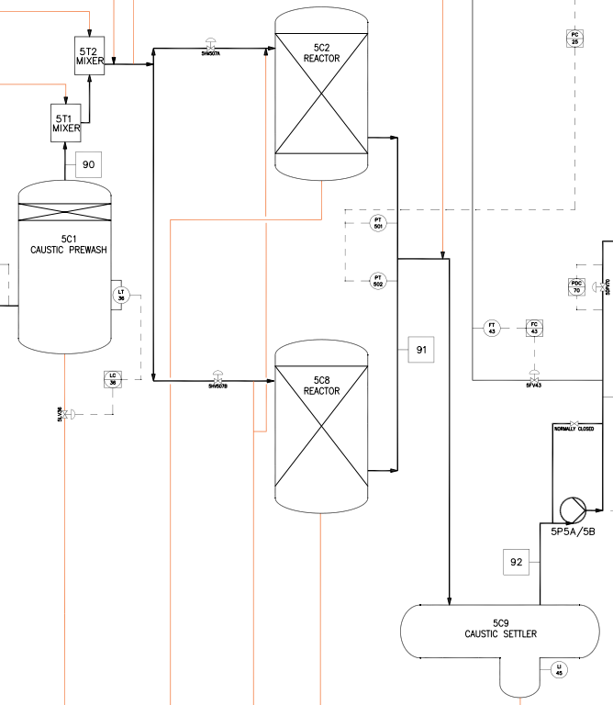
Figure 12: Merox reactors
The Merox Unit is used for mercaptan oxidation and is the only final product made on the Crude Unit from the distillation column. As part of the routine duties for the Merox, every weekend the two reactors (shown in figure 12) have to have a 7% caustic mix circulated through them. These reactors are made up of fixed beds of charcoal granules used to remove the mercaptans from the kerosene feed.

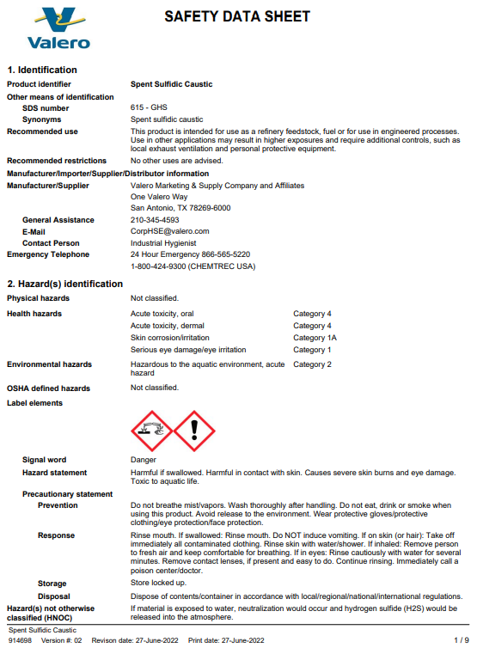
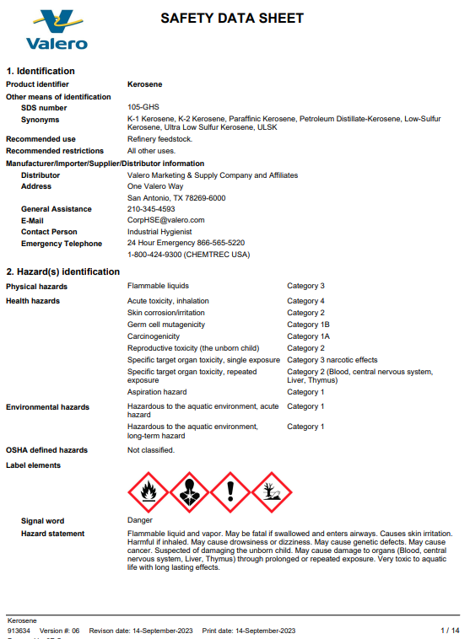
The Merox and caustic areas have additional safety requirements in the procedures such as chemical gloves and goggles. The Safety Data Sheets for Kerosene and Caustic seen in figure 13 should be read and understood prior to working. The neat caustic is a 50% mix which is extremely harmful if exposed to as it causes burns on the skin.
Figure 13: Caustic and Kerosene SDS

When operating valves, a valve movement Job Hazard Analysis (JHA) must be completed and signed off by the Shift Team Leader (STL) as it comes under a High Consequence Activity (HCA). This is to be completed prior to starting the task to highlight any hazards and implement the correct safety measures.
The reactors procedure 5-OPS-PRO-0008 (Valero, 2022) must be followed which describes the line up required to transfer the pre-mixed 7% caustic from tank 25-D-58 via pump 25-G-4 and over to either pumps 5-G-1 or 5-G-4. If the line up is not correctly followed it is possible for caustic to get into different parts of the system. All vents and drains need to be closed and plugged/capped beforehand to prevent the caustic spilling out. The vessels all connect to a common piped drainage system to allow the product to get routed to ‘slop’ to be re-processed in the event that the kerosene is off-spec due to process upset. This will risk the caustic leaving the controlled chemical areas into another area with less safety measures. The other vessels in the system also undergo routine water drawing to an open drainage system which could mean caustic potentially splashes out onto the operator. Once the transfer is near the end, the pump must be stopped to prevent it running dry and cavitating. Cavitation is one of the most common causes of pumps failing and can often lead to the seals failing, meaning loss of containment. All the valves opened for the caustic circulation need to be shut, and when the 7% caustic mix is made, the pipeline needs to be flushed through with water. Leaving neat caustic settle in a line can cause rapid corrosions, creating more hazards. The Handheld Device (HHD) is then updated to communicate the transfer as well as the caustic level readings for the operator on the next shift.
When completed the unit draining afterwards, the area needs to be free from maintenance activities, especially hot work as there is a risk that traces of kerosene in the water. Anyone working in the Merox area must have a valid Permit to Work with the signed Joint Job Site Visit (JJSV).

References
- ASK-EHS, 2022. Process Safety in Oil & Gas Industry. [Online]
Available at: https://www.ask-ehs.com/blog/process-safety-in-oil-gas-industry/
[Accessed 5th January 2024].
- Elbanhawi, H., 2022. Process Safety Management - PSM. [Online]
Available at: http://hassanelbanhawi.com/psm/
[Accessed 15th December 2023].
- Fat Finger, 2021. Process Safety Management: Your Ultimate Guide and How To Be OSHA Compliant. [Online]
Available at: https://fatfinger.io/process-safety-management/
[Accessed 14th December 2023].
- HSE, 1997. The explosion and fires at the Texaco Refinery, Milford Haven. 24th July 1994. [Online]
Available at: https://www.hse.gov.uk/comah/sragtech/casetexaco94.htm
[Accessed 5th January 2024].
- HSE, 2021. Control Systems. [Online]
Available at: https://www.hse.gov.uk/comah/sragtech/techmeascontsyst.htm#fivec9e3df
[Accessed 5th January 2024].
- Nwankwo, C. T. S. A. A., 2020. A comparative analysis of process safety management (PSM) systems in the process industry, Coventry: Coventry University.
- Oil & Gas Portal, 2018. Latest Advancements in Process Control in Refineries and Chemical Plants. [Online]
Available at: “Process Control is very common in refineries and chemical plants. It was used for the first time in 1920-1930s and today is essential to respect product quality, safety and reliability of the processes.”
[Accessed 5th January 2024].
- Process Safety Integrity , 2023. Process Safety Integrity. [Online]
Available at: https://processsafetyintegrity.com/lessons/
[Accessed 16th December 2023].
- Reynolds Training Services Ltd, 2022. Process Safety Management. [Online]
Available at: http://www.firstclients.net/UniversityOfHull/EPSM-V2/assets/documents/Process_Safety_Management.pdf
[Accessed 14th December 2023].
- Ross, J. L., 2013. The history and purpose of PSM-NEP. [Online]
Available at: https://www.plantengineering.com/articles/the-history-and-purpose-of-psm-nep/#:~:text=Process%20Safety%20Management%20was%20initiated,highly%20hazardous%20chemicals%20(HHCs).
[Accessed 14th December 2023].
- Valero, 2019. Register of Safe Operating Limit System No 1-007 - CDU Naphtha Stabiliser System, Pembroke: N/A.
- Valero, 2020. CDU - Unignited Release of Pre-flashed Liquid Crude from 1g7 Pumps to Crude Heaters, Pembroke: N/A.
- Valero, 2020. Control and Monitoring of Acid Crudes Through Crude Processing, Pembroke: N/A.
- Valero, 2021. ASAP – Emergency Condition – Loss of Containment Response Protocol, Pembroke: N/A.
- Valero, 2022. Caustic circulation to 5-C-2/5-C-8, Pembroke: N/A.

Bibliography
- Guss, D. (2019, May 9th). The Four Pillars of Risk Based Process Safety (RBPS). Retrieved from Education.aiche.org: https://education.aiche.org/topclass/media/bd452f3c-1e1f-4799-94fa-2e6021da112f/story_content/external_files/The%20Four%20Pillars%20of%20Risk%20Based%20Process%20Safety.pdf
- Louvar, D. A. (2019, June 4th). An Introduction to Chemical Process Safety. Retrieved from Inform It: https://www.informit.com/articles/article.aspx?p=2979062&seqNum=12#:~:text=These%20elements%20are%20organized%20in,(4)%20learn%20from%20experience
- Reynolds, J. (2023, September 13th). The Energy Institute's Four Pillars of Process Safety Management. Retrieved from Reynolds Training Services: https://reynoldstraining.com/rts/the-energy-institutes-four-pillars-of-process-safety-management

