
University Of Wales Trinity Saint David

Reflective Report

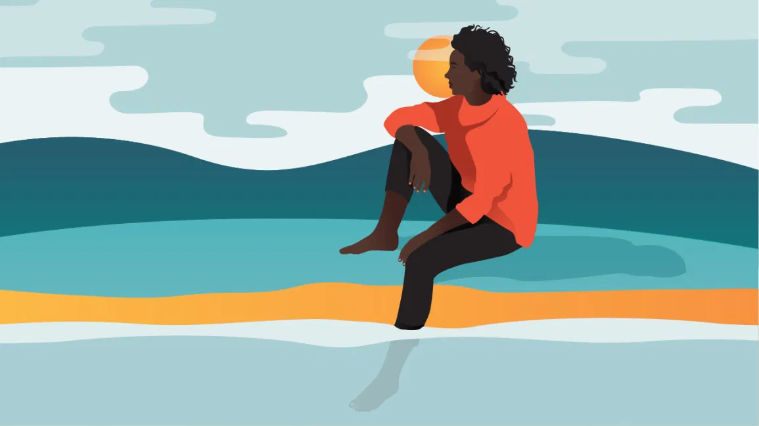
Module: Academic and Employability Skills
Module code: BMSW4001
Professor: Muhammad Hossain
Student: Keila Costa (2021935)

Contents

Introduction ……………………………………………………………………………………….…. 3
Reflective Writing ……………………………………………….………………………..……..……4
Different approaches to reflecting ……….……………………………….…………………..…… 5
ERA Model …..…………..........................………………………….. 5
Briscoll’s Model …….……………………………………..……….……5
Experiential Learning Cycle ………………..……….……………………………..………………. 6
Different approaches to reflecting ………………………………………..…………………..…… 7
Description Feelings and Evaluation ……………………..…………8
Analysis .…..………………………………………………………..…..9
Conclusion ……………………...…………………………………………………………………. 10
Personal Development Plan ………………………………………………………………………11
References……………………………………..……………………………………………………12

Introduction

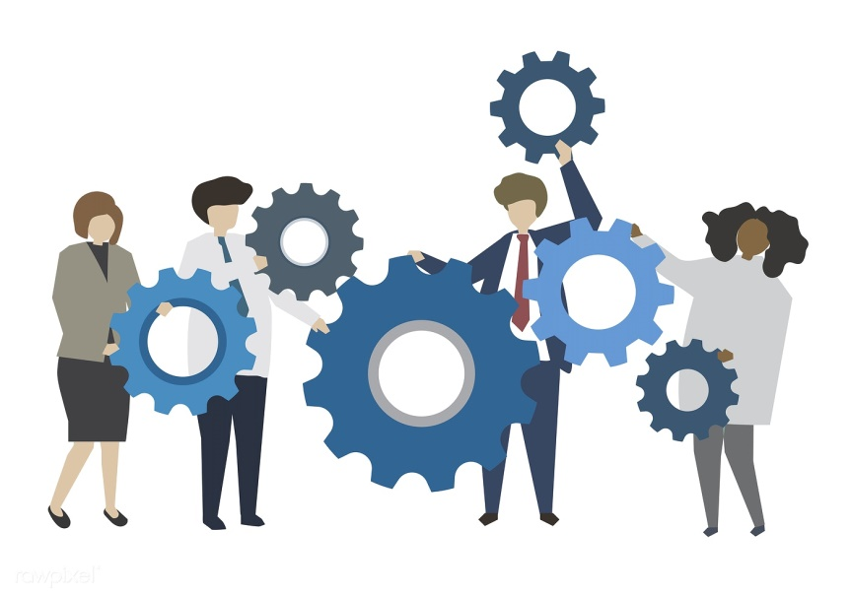

This report is being written for the class Academic and Employability Skills using the Gibbs method, which is based on the fact that we learn from experiences, with the aim of reflecting and transmitting the challenges I faced when carrying out two academic works, because during the class period, both my colleagues and I had to carry out two academic assignments, the first being individual "What is the most effective way to motivate staff?" regarding task 2 for this class and a group assignment "How do students use technology to collaborate at UWTSD" in the Digital Skills and Research Methods class. I intend to explain the difficulties of carrying out an academic work while we have a busy life and how I reconciled the little time I had with my group colleagues and of course, I will also explain in detail what it is and how the Gibs method works and without forgetting I also want to clarify how this method was important for me to carry out this report.

Reflective Writing

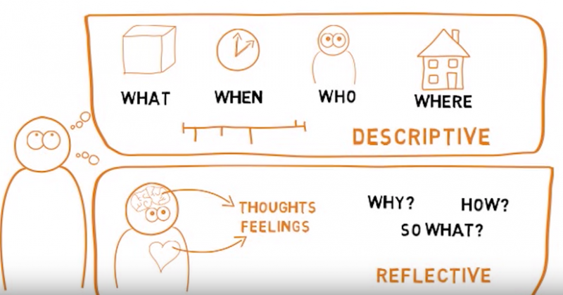

Reflected writing is the type of writing that can be presented formally or informally about one subject presented (in this case will be the assignments carried out in the class) using our emotions, thoughts, memories and this type of writing class is usually used as a reaction to something we have read or to extract knowledge from a specific moment, literary work or reading a lesson that was presented to us. In this way, this writing can be used both to determine the key points or form new ideas about certain subjects, so we can say that this is an accurate and brilliant strategy that can help to improve our writing, develop thoughts and without doubt, help improve critical thinking.

Different approaches to reflecting

There are several ways to reflect, and that is why reflection models were created, and a reflection model is an organized structure for the reflective process through personal emotions and situations experienced. In Bassot (2020) we can see three models of reflection.

- ERA Model
Experience: It can be any recent or past event that has meaning or has come to our attention.
Reflection: It is the stage where we reflect on what we have learned from the experience and how we can act in the future in a similar situation.
Action: At this stage, based on what we learned, the lessons learned from this situation will be reflected in the future, more precisely in the decisions we will make regarding other experiences.

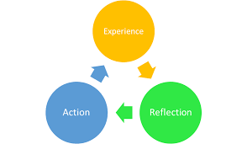

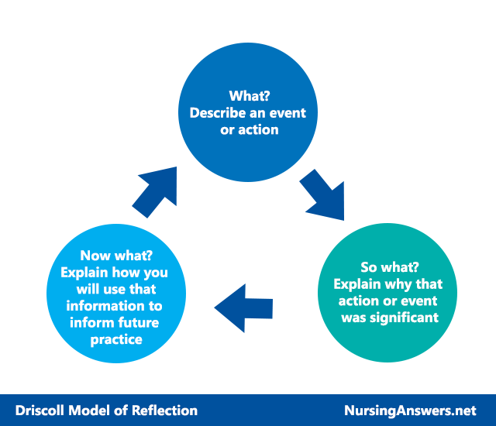
- Driscoll’s Model

Driscoll (2007) created this model based on three simple questions: What?, So what? and Now What?

- Experiential Learning Cycle

Learning is based on reflection and understanding of lived experiences. With lessons learned from each situation, we can apply new insights to similar situations in the future.
Concrete Experience – moment when we are part of an experience.
Reflective observation – reflecting on the experience without judgment.
Abstract conceptualization – making sense of experience. What worked and what didn't?
Active experimentation – planning what to do next time, setting goals and determining success criteria.

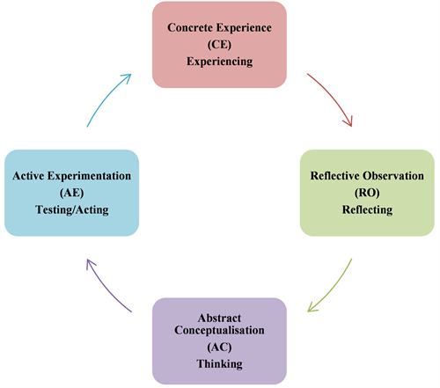

Gibbs Reflective Cycle

Another reflection model is the "Gibbs Reflective Cycle" which was created by Dr. Graham Gibbs in 1988 and that will be used in this report.
This reflective cycle it is a method that organizes the process of learning through experience using a six-step structure: description, feelings, evaluation, analysis, conclusions, and action plan.
In one of his works, Learning by Doing, Gibbs observed that we do not learn only from experience, but through the reflection that we do about the experience, because if we don't stop to reflect we will easily forget it.
Therefore, learning will come through the feelings and thoughts that arise from reflection, and they are what allow us to learn from everything that has been experienced and give us new mechanisms to face future situations.
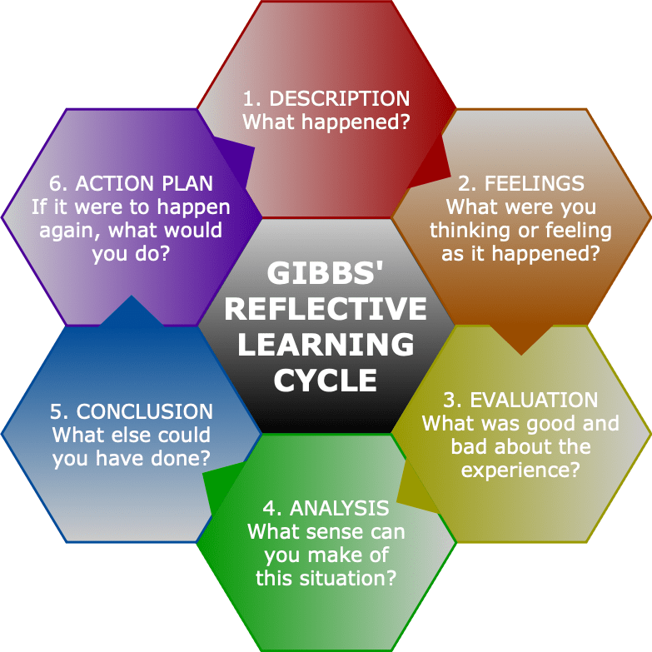
Description Feelings and Evaluation

Regarding task 2, about "What is the effective way to motivate staff" I first started to think about the subject and made an outline about what I knew about the subject, in order to better understand what I really know about the subject . After sketching what I knew, or thought I knew, I started my research work, using Google Scholar a lot, and reading literary works about the subject. I analysed different points of view and in the end I compared my initial draft with what I had learned from the research and so I jumped to my final draft where I concluded that what I knew about the subject was a very small percentage of all the information that I found it, because I didn't even know that there were so many methods of encouraging staff, that so many companies have already started to implement these methods and especially that encouraging staff gives so many advantages to both the employee and the employer. After all this process I started to structure the final report.
Regarding the other report that was presented in the Digital Skills and Academic Methods course to discuss the topic of how students use technology to collaborate with the UWTSD, this work was carried out and presented in a group, which gave rise to several challenges. First it was difficult to know who were the right people to work with me, and who I could trust and also to know if these people would want to work in a team with me. After finding the right people, the challenge of sharing tasks arises, but luckily it wasn't a very difficult thing to decide. We created a whatsap group where we could always be in contact in order to help each other in a mutual way, and in this way each of us would say what part of their task was. It was difficult for all of us because we all work and the other two elements of my group have children, but with effort we managed to organize ourselves and reconcile everything, because we tried to be very communicative and when each one finally did their part, we sent them to the group so that everyone had access and could say whether or not they agree with what was done, in the end we chose a person to assemble all the work and of course we all also participated in this process in order to choose the structure and effects of each slide. Finally, with the presentation assembled, each of us studied his part and we agreed on how the presentation would be and in which part each of us entered. It can be said that it was a challenging process but it was very good to remind me of what it is like to work in a team the fear of failing in front of others or failing because of others, it was also good to realize that with organization and communication anything can be done without forgetting that it was also good to feel the nervousness again, the butterflies in my belly moments before the presentation, and even better was the end where I realized that I am still able to speak in front of other people keeping my nervousness inconspicuous, the sensation in the end it was incredible, a feeling of long work and that both me and my team were happy because we gave our best and in the end the connection between us remained.

Analysis

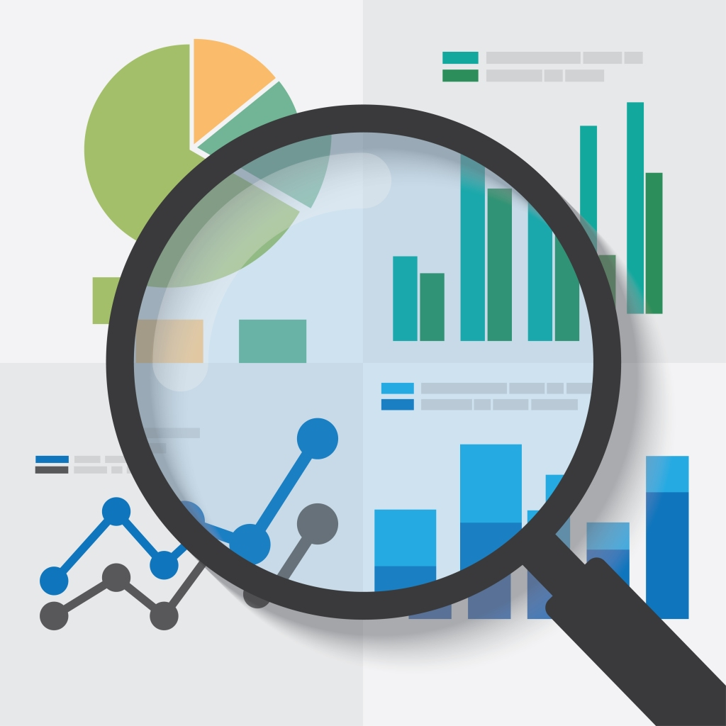

Now I see that, at first, my biggest fear was trusting people, but the same fear I had was the same fear that my group mates had in relation to each of us.
I also realized that communication and organization were very important for the good outcome of everything, these elements were essential.

Conclusion



To conclude, I think it was an enriching experience, in which I overcame my fears and proved to myself that I am capable of doing things that I doubted I could still do, such as making a good group presentation. If I could go back, I would change certain things, for example, I would see the initial situation differently and I would not be so afraid to approach my colleagues and ask if they want to be part of my group, I would trust my colleagues more, but above all, I would have organized my time in a different way, I would have started the work earlier and I would have organized a well-structured plan on how to write the report because, mainly in task 2, I think that if I had organized my time better, I would have made a better report , and I would have had time to make some final changes, which I didn't have because I left it to do at the last minute and when I realized I didn't have time.

Personal Development Plan
Personal Target | How will I achieve this? | How will this improve my academic or employability prospects? | How will I know that I have achieved this? | When will I achieve this by?
Organize a work structure. | I must create a table with all the steps that I must follow during this report. | It will help me to be an organized student and professional. | When I make the table and start following the steps. | At the end of the report.
Believing in people and teamwork | I must communicate more with my colleagues. | I will feel more comfortable in the work environment. | When I start to feel more comfortable discussing my opinions with others. | After doing some group work at the university.



References

Holly, M.L., 1989. Reflective writing and the spirit of inquiry. Cambridge Journal of Education, 19(1), pp.71-80.
Hinett, K. and Varnava, T., 2002. Developing reflective practice in legal education (Vol. 5). Coventry: UK Centre for Legal Education.
Bassot, B., 2020. The reflective journal. Bloomsbury Publishing.
Stice, J.E., 1987. Using Kolb's Learning Cycle to Improve Student Learning. Engineering education, 77(5), pp.291-96.
Kolb, D (1984) Experiential Learning: Experience as the source of Learning and development, Englewood Cliffs, NJ: Prentice Hall.
Abdulwahed, M. and Nagy, Z.K., 2009. Applying Kolb's experiential learning cycle for laboratory education. Journal of engineering education, 98(3), pp.283-294.
Allan, E.G. and Driscoll, D.L., 2014. The three-fold benefit of reflective writing: Improving program assessment, student learning, and faculty professional development. Assessing Writing, 21, pp.37-55.
Plack, M.M., Dunfee, H., Rindflesch, A. and Driscoll, M., 2008. Virtual action learning sets: a model for facilitating reflection in the clinical setting. Journal of Physical Therapy Education, 22(3), pp.33-42.
Gibbs, G., 1988. Learning by doing: A guide to teaching and learning methods. Further Education Unit.

