

Student name:Ignat Andreea Madalina
Student ID:2411704

Module name: Introduction to Physiology (BMHP5023_LON)
Module code:BMHP5023
Lecturer name:Soban Sadiq

Assessment: Case study report asthma

Introduction
Asthma is a chronic respiratory condition that affects millions of people worldwide and is particularly common among children and adolescents. It is characterised by inflammation and narrowing of the airways, which can make breathing difficult and lead to symptoms such as wheezing, coughing, chest tightness and shortness of breath (NHS, 2023). For many individuals, asthma can be controlled with appropriate medication and lifestyle management; however, certain environmental and behavioural factors can trigger exacerbations.
The scenario describes a practice nurse working in a GP surgery who runs a regular asthma clinic for adolescents. The clinical team has noticed that many young people who previously had mild asthma during childhood are now presenting with more severe symptoms. This change appears to be linked to lifestyle behaviours that often develop during adolescence, such as smoking, vaping and spending time in crowded environments where respiratory infections can spread easily. These factors may increase irritation in the airways and worsen asthma symptoms.
The purpose of this report is to provide information that can help adolescent patients better understand their respiratory health and improve the management of their asthma. The report will explain the structure and function of the respiratory system, including the process of breathing and gas exchange in the lungs. It will also explore how irritants such as smoking, vaping and respiratory infections can cause inflammation and affect lung function. In addition, the importance of monitoring respiratory health through tools such as peak flow readings will be discussed. Finally, evidence-based lifestyle recommendations will be presented to support adolescents in managing their asthma safely and effectively.
Asthma is influenced by a combination of genetic, environmental and lifestyle factors. Common risk factors include exposure to allergens such as pollen, dust mites and animal dander, air pollution, respiratory infections and tobacco smoke (Global Initiative for Asthma, 2023). Smoking and vaping are particularly concerning for young people with asthma because they irritate the airways and may increase inflammation, which can lead to more frequent asthma attacks. Therefore, improving awareness and understanding of these risks is essential in helping adolescents take greater control of their condition and reduce the likelihood of severe exacerbations.

2. Structure of the respiratory system
The respiratory system is responsible for supplying oxygen to the body and removing carbon dioxide, which is a waste product produced by cellular metabolism. This system is made up of several organs and structures that work together to allow breathing and gas exchange to occur efficiently (Tortora and Derrickson, 2021).
Air enters the respiratory system through the nose or mouth. The nasal cavity plays an important role in filtering, warming and moistening the air before it reaches the lungs. Small hairs and mucus inside the nose trap dust particles and microorganisms, helping to protect the respiratory tract from infection. From the nasal cavity, air passes through the pharynx, which is a shared passageway for both air and food.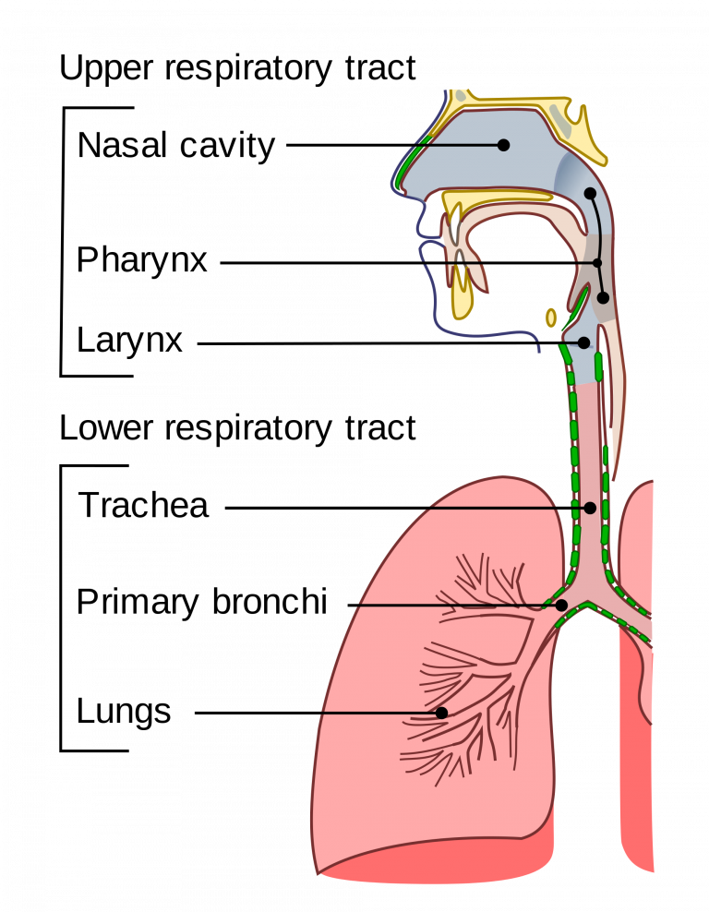
This Photo by Unknown Author is licensed under CC BY-ND
Next, the air moves through the larynx, often referred to as the voice box, which also helps prevent food from entering the airway during swallowing. From there, air travels down the trachea, also known as the windpipe. The trachea is supported by rings of cartilage that keep the airway open and allow air to move freely into the lungs.
The trachea then divides into two bronchi, one leading to each lung. Inside the lungs, these bronchi branch into smaller tubes called bronchioles. These progressively smaller airways allow air to be distributed throughout the lungs. At the end of the bronchioles are tiny air sacs known as alveoli, which are responsible for gas exchange between the lungs and the bloodstream (Hall, 2021).
Mechanical respiration refers to the physical process of breathing, which involves inhalation and exhalation. This process is controlled by the diaphragm and the intercostal muscles located between the ribs. During inhalation, the diaphragm contracts and moves downward, while the intercostal muscles contract to lift the rib cage. This action increases the volume of the chest cavity and creates a negative pressure inside the lungs. As a result, air flows into the lungs.
During exhalation, the diaphragm relaxes and moves upward while the intercostal muscles relax, causing the chest cavity to decrease in size. This increases the pressure inside the lungs and pushes air out of the respiratory system. In normal breathing, this process occurs automatically without conscious effort.
However, in individuals with asthma, inflammation and narrowing of the airways can restrict airflow and make breathing more difficult. This can interfere with normal mechanical respiration and cause symptoms such as wheezing and shortness of breath.

3. Gas exchange in lungs
Gas exchange is a vital process that occurs in the lungs and allows the body to obtain oxygen while removing carbon dioxide, a waste product produced during cellular metabolism. This process takes place in the alveoli, which are tiny air sacs located at the ends of the bronchioles within the lungs. The alveoli are surrounded by a dense network of capillaries, creating a large surface area that enables efficient exchange of gases between the air and the bloodstream (Hall, 2021).
When a person inhales, air containing oxygen enters the lungs and reaches the alveoli. The walls of the alveoli are extremely thin, allowing oxygen to diffuse across the alveolar membrane into the surrounding capillaries. Diffusion occurs because oxygen moves from an area of higher concentration in the alveoli to an area of lower concentration in the blood. Once oxygen enters the bloodstream, it binds to haemoglobin in red blood cells and is transported throughout the body to supply tissues and organs with the oxygen required for energy production (West, 2012).
At the same time, carbon dioxide produced by cells during metabolism travels through the bloodstream back to the lungs. Since carbon dioxide concentration is higher in the blood than in the alveoli, it diffuses in the opposite direction—from the capillaries into the alveoli. During exhalation, this carbon dioxide is expelled from the body. This continuous exchange of gases is essential for maintaining normal physiological function and supporting cellular activity.
However, exposure to irritants such as cigarette smoke, vaping aerosols, air pollution and respiratory infections can negatively affect this process. These substances irritate the lining of the airways and trigger inflammation within the respiratory system. Inflammation causes the airway walls to swell and stimulates the production of excess mucus. As a result, the airways become narrower, restricting airflow to the lungs (Barnes, 2015).
In individuals with asthma, the airways are already sensitive and prone to inflammation. When irritants enter the respiratory system, the immune response may become exaggerated, leading to increased swelling of lung tissue and tightening of the surrounding airway muscles. This condition is often referred to as bronchoconstriction. The narrowing of the airways reduces the amount of air that can reach the alveoli, which may limit oxygen intake and make breathing more difficult.
Over time, repeated exposure to irritants can worsen respiratory symptoms and increase the risk of asthma exacerbations. In severe cases, prolonged inflammation may contribute to structural changes in the airways, reducing lung function and affecting the efficiency of gas exchange. For this reason, reducing exposure to irritants is an important part of asthma management and maintaining respiratory health (GINA, 2023).

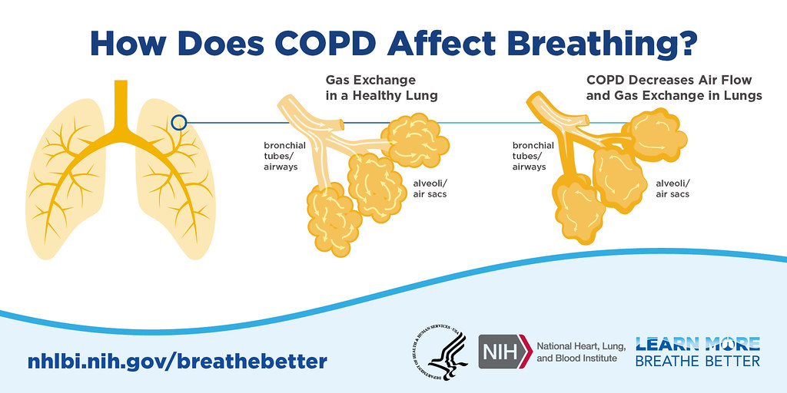

4. Recording and tracking respiratory functions
Monitoring respiratory function is an important part of managing asthma effectively. One of the most used tools for this purpose is the peak flow meter, which measures the peak expiratory flow (PEF). This measurement shows the fastest speed at which a person can exhale air from their lungs after taking a deep breath. Peak flow readings provide valuable information about how well the airways are functioning and whether they are becoming narrower (Asthma UK, 2022).
For individuals with asthma, the airways can become inflamed and constricted, which reduces airflow and makes breathing more difficult. Regularly recording peak flow readings allows patients and healthcare professionals to detect early changes in lung function. In many cases, peak flow values may decrease before symptoms such as wheezing or shortness of breath become noticeable. By identifying these changes early, individuals can take appropriate action, such as using reliever medication or seeking medical advice (GINA, 2023).
Tracking peak flow readings over time also helps patients understand patterns in their asthma symptoms. For example, they may notice that their peak flow levels decrease after exposure to certain triggers such as cold air, smoke, dust or respiratory infections. Identifying these triggers can help individuals avoid situations that may worsen their condition and allow them to better manage their asthma.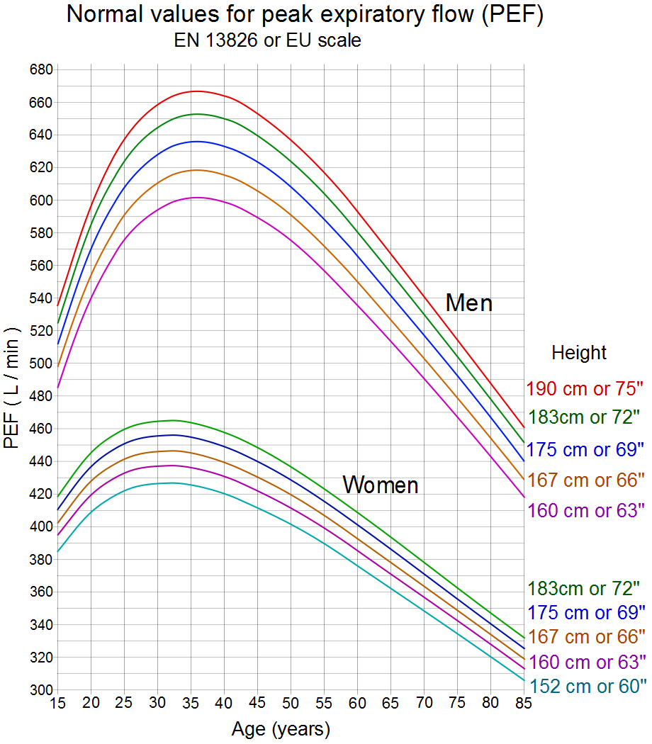
This Photo by Unknown Author is licensed under CC BY-SA
Another important benefit of peak flow monitoring is that it supports the use of personalised asthma action plans. Many healthcare professionals use a traffic-light system that divides peak flow readings into three zones: green, amber and red. The green zone indicates that asthma is well controlled and peak flow readings are close to the patient’s normal level. The amber zone suggests that the airways may be starting to narrow and that additional medication or caution may be needed. The red zone indicates a significant reduction in airflow and signals that urgent medical attention may be required (NHS, 2023).
Regular monitoring also encourages patients to take a more active role in their own health management. Adolescents who understand how to measure and record their peak flow readings may become more aware of how lifestyle factors affect their breathing. This awareness can improve treatment adherence and promote healthier behaviours.
Overall, recording and tracking respiratory data provides important clinical information that helps both patients and healthcare professionals monitor asthma control, prevent severe exacerbations and support safe long-term management of the condition.

5. Recommendations
Managing asthma effectively requires a combination of medical treatment, lifestyle adjustments and health promotion strategies. Evidence suggests that individuals with asthma can improve their respiratory health and overall wellbeing by adopting behaviours that reduce exposure to triggers and support healthy lung function. Healthcare professionals, including nurses working in primary care settings, play an important role in educating patients about these strategies and supporting them in managing their condition safely (GINA, 2023).
One of the most important recommendations for individuals with asthma is to avoid smoking and vaping. Tobacco smoke contains thousands of chemicals that irritate the airways and increase inflammation in lung tissue. Research shows that smoking can worsen asthma symptoms, reduce lung function and increase the risk of asthma attacks. Similarly, vaping has been linked to airway irritation and respiratory problems in young people. Therefore, smoking cessation support and education about the risks of vaping should be part of asthma management programmes (WHO, 2023).
Another key recommendation is to reduce exposure to environmental triggers that may worsen asthma symptoms. Common triggers include dust mites, pollen, animal dander, air pollution and strong chemical fumes. Patients should be encouraged to maintain a clean indoor environment, ensure good ventilation and minimise exposure to allergens where possible. For example, regularly cleaning bedding, reducing indoor dust and avoiding smoke-filled environments can help reduce airway irritation (Asthma UK, 2022).
Regular physical activity can also contribute to improved lung function and overall health. Exercise strengthens the cardiovascular and respiratory systems and supports general wellbeing. While some individuals with asthma may experience exercise-induced symptoms, these can often be managed with appropriate medication and by warming up before physical activity. Healthcare professionals should encourage patients to remain active while following their personalised asthma action plans (NHS, 2023).
Another important intervention is ensuring that patients use their prescribed medication correctly. Many individuals with asthma are prescribed inhaled corticosteroids to reduce airway inflammation and bronchodilators to relieve symptoms. However, incorrect inhaler technique or poor adherence to treatment may reduce the effectiveness of these medications. Providing education and regular reviews of inhaler technique can significantly improve asthma control and reduce the risk of exacerbations (GINA, 2023).
In addition, vaccination against respiratory infections, such as the annual influenza vaccine, is recommended for individuals with asthma. Respiratory infections can trigger asthma attacks and worsen breathing difficulties. Preventative measures such as good hand hygiene, avoiding contact with individuals who are ill and receiving recommended vaccinations can reduce this risk.
Health promotion strategies also include improving patients’ knowledge and self-management skills. Adolescents may benefit from education programmes that explain asthma triggers, medication use and monitoring techniques such as peak flow measurement. When individuals understand their condition better, they are more likely to follow treatment plans and adopt behaviours that support long-term health.
Overall, evidence-based interventions such as smoking cessation, trigger avoidance, physical activity, correct medication use and health education can significantly improve asthma control. These strategies help reduce asthma symptoms, prevent exacerbations and enhance the overall quality of life for individuals living with this condition.

6. Conclusion
. Asthma is a common chronic respiratory condition that can significantly affect adolescents, particularly when lifestyle factors such as smoking, vaping and exposure to infections are present. Understanding how the respiratory system functions is essential for patients to manage their condition effectively. The respiratory system allows oxygen to enter the body and carbon dioxide to be removed through a complex process involving mechanical respiration and gas exchange within the alveoli. In asthma, inflammation and airway narrowing interfere with these processes, leading to breathing difficulties.
Exposure to irritants can worsen inflammation and trigger asthma attacks, highlighting the importance of avoiding harmful substances such as tobacco smoke and vaping products. Monitoring respiratory function using tools such as peak flow meters enables individuals to detect early changes in lung function and manage symptoms proactively.
By combining education, monitoring and healthy lifestyle choices, adolescents with asthma can improve their respiratory health and reduce the risk of severe exacerbations. Healthcare professionals play a key role in supporting patients to understand their condition and develop effective self-management strategies.

References

Asthma UK (2022) Asthma facts and statistics. Available at: https://www.asthma.org.uk (Accessed: 8 March 2026).
Global Initiative for Asthma (2023) Global strategy for asthma management and prevention. Available at: https://ginasthma.org (Accessed: 8 March 2026).
NHS (2023) Asthma overview. Available at: https://www.nhs.uk/conditions/asthma/ (Accessed: 8 March 2026).
World Health Organization (2023) Asthma. Available at: https://www.who.int/news-room/fact-sheets/detail/asthma(Accessed: 8 March 2026).
Hall, J. (2021) Guyton and Hall Textbook of Medical Physiology. 14th ed. Philadelphia: Elsevier.
Tortora, G. and Derrickson, B. (2021) Principles of Anatomy and Physiology. 16th ed. Hoboken: Wiley.
Barnes, P. (2015) Asthma mechanisms and management. London: Academic Press.
Global Initiative for Asthma (GINA) (2023) Global strategy for asthma management and prevention. Available at: https://ginasthma.org (Accessed: 8 March 2026).
Hall, J. (2021) Guyton and Hall Textbook of Medical Physiology. 14th ed. Philadelphia: Elsevier.
West, J. (2012) Respiratory Physiology: The Essentials. 9th ed. Philadelphia: Lippincott Williams & Wilkins.
Asthma UK (2022) Peak flow and asthma monitoring. Available at: https://www.asthma.org.uk (Accessed: 8 March 2026).
Global Initiative for Asthma (GINA) (2023) Global strategy for asthma management and prevention. Available at: https://ginasthma.org (Accessed: 8 March 2026).
NHS (2023) Peak flow test. Available at: https://www.nhs.uk/conditions/peak-flow/ (Accessed: 8 March 2026).
Asthma UK (2022) Asthma triggers and prevention. Available at: https://www.asthma.org.uk (Accessed: 8 March 2026).
Global Initiative for Asthma (GINA) (2023) Global strategy for asthma management and prevention. Available at: https://ginasthma.org (Accessed: 8 March 2026).
NHS (2023) Living with asthma. Available at: https://www.nhs.uk/conditions/asthma/ (Accessed: 8 March 2026).
World Health Organization (2023) Tobacco and lung health. Available at: https://www.who.int (Accessed: 8 March 2026).

