

Assessment Component 1

Case study - Written Report

Student name: Mutiat Shobajo
Student ID: 1910057

Module name: Children, Young People and Families
Module code: (BMHP5004_LON)
Lecturer name: Dr. Rachael Adebayo
Word count: 3500

Table of Contents
Introduction 2
Presentation of the Case Study 2
Factors Contributing to the Risk of Vulnerability of Children 3
War 3
Child Labour 3
Child Marriages 4
Right to Identity 5
Professional Interventions of the Health care and Social Agencies Involved 5
Current Policy and Roles of Multi-disciplinary Agencies 6
Evaluation 7
Maslow's hierarchy of needs 9
Conclusion 9
Bronfenbrenner's ecological systems theory 10
References 11

Children, Young People and Adults

Introduction

Presentation of the Case Study
The phrase "vulnerable children" refers to children who are more likely than other children to suffer mental or physical harm or experience poor outcomes as a consequence of one or more circumstances in their life ("No Child Left Behind A Public Health Informed Approach to Improving Outcomes for Vulnerable Children, n.d"). Child vulnerability has been prevalent globally, but many cases have been reported in Afghanistan in the past few years. With recent political and economic changes in Afghanistan, the humanitarian situation has worsened substantially. Essential services are on the verge of collapsing, thus aggravating the requirements of already vulnerable people, where children account for almost 12 million of the 24 million vulnerable people (UNICEF.org, n.d). Even before COVID-19, the ongoing political conflict characterized by conflict led to displacement, inadequate access to facilities such as schools, and lasting impacts on children (Neto et al., 2022). Together with the socioeconomic crises, these repercussions have practically obliterated coping mechanisms and given rise to child labour and early marriage. With the economy and several public service sectors bordering on collapse owing to non-payment of wages and empty government coffers, Afghanistan's children face an uncertain future (Neto et al., 2022).
This essay presents an analysis of children vulnerability in Afghanistan. The essay will analyse the factors that contribute to vulnerability, available professional interventions, current policies and the role of multidisciplinary agencies, an evaluation and conclusion.

Factors Contributing to the Risk of Vulnerability of Children

War
According to a recent new analysis by UNICEF, Afghanistan is among the countries with the highest percentage of children residing near an armed group or force that recruit children leaving at significantly high recruitment risks (UNICEF.org, n.d). Also, within the last year, approximately 3.5 individuals have been displaced within the country due to conflict, and every day, about 1000 children are forced to flee due to acts of war (NRC, n.d). Most of these children end up in concentration camps where they cannot go outside the camp or even to schools. Schools that are supposed to be safe spaces for children's growth and development and development have been converted to battlefields (NRC, n.d). The acts of war within the last year led to the closure of 250 schools, and about 120 000 children lost the opportunity to go to school and humanitarian aid workers sent to help children in these camps are usually killed in Afghanistan (NRC, n.d).

Child Labour
With reference to recent UN statistics, Afghan is among the poorest country in the world almost half (47%) of the Afghan population is living below the poverty line, with children not receiving adequate nutrition, healthcare services, and education(O'Leary et al., 2018; Children of Afghanistan - Humanium, 2017). These poverty levels drive most Afghan vulnerable families to sell their children to feed other family members (Children of Afghanistan - Humanium, 2017). Those not sold are forced into child labour to help feed their families. Recent figures indicate that around 20% of children are required to work in order to support themselves and their families (Children of Afghanistan - Humanium, 2017). It is common for Afghan children to be employed in odd occupations such as selling trinkets on the street or at home or as domestic help or shop employees. In the Afghan family structure, children play a vital economic role since their parents' wages are insufficient to support their big households (Children of Afghanistan - Humanium, 2017). Additionally, because of their cultural norms, the majority of Afghan mothers opt not to seek employment, forcing such families to depend on the economic contribution of the child, even if this means the child must beg on the streets (Children of Afghanistan - Humanium, 2017). The consequences associated with the obligation to work are deleterious, and these include police violence, absence of education, increased risk of illnesses linked to pollution and the effects of drastic climate change during summer and winter (Children of Afghanistan - Humanium, 2017).

Child Marriages
Young girls are now at higher danger of child marriages in Afghanistan. Even before the present political upheaval, UNICEF and partners reported roughly 180 child marriages and 10 incidents of selling young girls between 6 months to 17 years old between 2018 and 2019 in Baghdis and Herat provinces alone (UNICEF, n.d). Due to the ongoing food crisis, almost half of the Afghan population is poor and lacking the basic necessities. Increasing numbers of families are being forced into poverty as a result of this very severe economic condition, and they are being forced to make desperate decisions such as marrying off their children at a young age in exchange for money (UNICEF, n.d). Additionally, currently, due to the ongoing political conflict which has not allowed children back to school, the risk of child marriages is even higher(UNICEF, n.d). The consequences of these early marriages are that apart from denying a child their right to education, these children could expose them to physical abuse, domestic violence, and adverse health conditions in terms of pregnancy complications.

Right to Identity
In Afghanistan, only around 6% of births are legally registered. Since most Afghan children lack official identity and nationality, they are virtually invisible to the rest of society. This is particularly difficult for Afghan youngsters who have been forced to flee their homes as a consequence of the war. Up to 1.5 million children may be housed in refugee camps in Pakistan or Iran. Their legal position as children is illegitimate; therefore, they have no civil rights as citizens of the country and are therefore at a greater danger of being exploited than other children with legal status.

Professional Interventions of the Health care and Social Agencies Involved
The need for urgent humanitarian actions led to the development and growth of social intervention agencies to help in eliminating children's vulnerability in Afghanistan. To ensure the safety of the most vulnerable children, UNICEF and other organizations are working together to improve the child protection system, which includes the legal framework (UNICEF, 2019). As part of UNICEF's efforts to safeguard children from harmful practices, including child marriage, cruel corporal punishment, domestic abuse, and the exploitation of children in the labour market, UNICEF works with traditional and religious leaders in communities, government and civil society (UNICEF, 2019). They also engage with the Agency of Hajj, Afghanistan's most significant ministry for dealing with religious matters, to train religious leaders on the role of Islam in ensuring child safety (UNICEF, 2019; Edward et al., 2015). (UNICEF, 2019; Edward et al., 2015).
Additionally, the Afghan government and UNICEF joined forces to form the "Child Protection Action Network" (CPAN), a coalition of government institutions, non-profit organizations, and community and religious leaders devoted to protecting children's rights and giving aid to those in need (UNICEF, 2019). About 5,000 cases of child abuse and neglect were addressed by the Child Protection Action Network (CPAN) in 2017. (UNICEF, 2019).
Afghan children endure significant trauma as a result of the country's conflict. War, relocation, exposure to violence, and natural catastrophes may all have a detrimental effect on their psychological development and well-being ( Betancourt et al., 2013; UNICEF, 2019). UNICEF and its partners assist children in humanitarian catastrophes by establishing child-friendly settings (UNICEF, 2019). These safe havens give a place for children to play, study, and interact and aid in re-establishing a feeling of childhood after a crisis or prolonged emergency.

Current Policy and Roles of Multi-disciplinary Agencies
Afghanistan's children are at risk of psychological and physical vulnerability as a result of abuse, violence, exploitation, and neglect, which is exacerbated by insecurity, insecurity, conflict, and natural disasters, in addition to the limited capacity and knowledge of immediate caregivers and duty bearers (Monico et al., 2019). To combat child recruitment into armed groups, UNICEF works closely with the "United Nations Assistance Mission in Afghanistan and the Afghanistan Independent Human Rights Commission (AIHRC)" to monitor and report on the majority of problems impacting children in armed conflict (Monico et al., 2014). Another technique undertaken by the UN in conjunction with the Afghan government is the prevention of recruitment of minors into the "Afghan National Security Forces (ANSF)." This collaboration and assistance for the AIHRC Children Rights Unit have resulted in an increase in the detection and monitoring of child rights violations in armed conflict, particularly in dangerous and isolated places. Weak age verification procedures commonly conceal child recruitment; hence UNICEF encourages the establishment of "Child Protection Centres" (CPC) inside law enforcement and recruitment organizations. Through this, over 1,410 children were prevented from being recruited in 2017 owing to the establishment of eleven "Child Protection Units" (CPU) throughout 32 provinces.
Eliminating juvenile detention and assuring access to child protection measures and sufficient health care is complicated by the fact that just 6 percent of Afghan children have birth certificates. To boost birth registration, UNICEF and partners are now supporting the "Ministry of Interior Vital Statistics" in improving the rate of registration. Also, collaborating with families and communities has helped the public to appreciate the vital link between child registration and protection. Using a common data bank, parents in 28 of the 34 provinces can now document their children's births online.
Additionally, in collaboration with the Afghan government, the UN has established the "Orphan Reunification Project" which is currently aimed at reuniting children and families (Fober-Pratt et al., 2020). Trained social workers are used to identify children appropriate for reintegration and then focus on the child deinstitutionalization and family support, and despite several challenges and barriers, there have been successful cases of family-child reunifications. This deinstitutionalization initiative is one of many across the globe that concentrate on reintegrating children into family and community life using the "Guidelines for Alternative Care of Children" (Monico et al., 2019).

Evaluation
Many organizations' engagement in Afghanistan to provide humanitarian assistance to children has resulted in beneficial outcomes in terms of minimizing the negative consequences. Children have gained access to their basic needs as a result of these efforts, which has the potential to help them reach their full potential. If these needs are addressed in a hierarchical manner, they might lead to self-realization. Air, water, clothes, shelter, food, sleep, and good health are all examples of physiological needs. Security needs such as emotional security, i.e., being safeguarded from any psychological or mental trauma, are important. Financial security is defined as protection against anything that affects socioeconomic activity, whereas personal security is defined as protection against bodily harm. For a person to feel love and belonging, they must have a healthy relationship with their family and friends. This is feasible for Afghan's most vulnerable children since UNICEF provides victim aid to these children in the impacted regions and reunification services to reunite them with their families. Topping the list of esteem needs is the desire to be respected in order to get greater status recognition, framing, attention, self-confidence, and respect for others. The last item on the list in the hierarchy of needs is self-actualization. Self-actualization and creativity are achieved when all of the hierarchical needs identified by Maslow's hierarchy of needs are achieved.

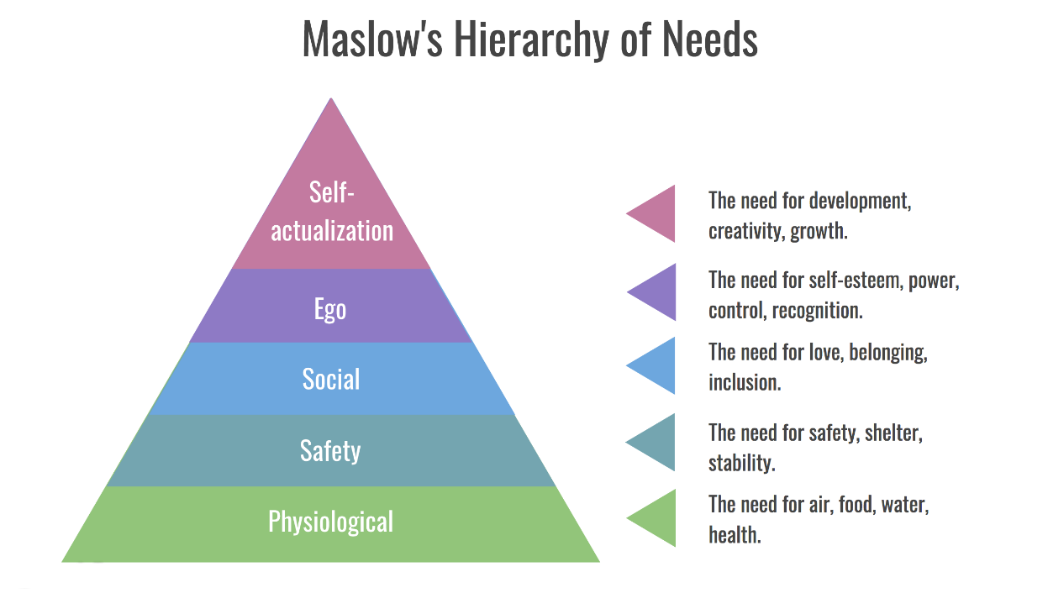
Maslow's hierarchy of needs

Conclusion
There is an urgent need to improve universal services for vulnerable children across all sectors in order to avoid challenges and give assistance to families who have been negatively impacted. It is especially critical that children get sufficient assistance since the fragility of their environment disproportionately impacts them. Referencing Bronfenbrenner's ecological systems theory, which describes how everything in a child and the child's surroundings has an effect on how a child grows and develops, it can be concluded that this theory is built on the foundation of five separate systems. The child is the microsystem, and they have direct interaction with this system that is capable of performing cognitive functions. Family, nursery, teachers, play-ground, and religion are all examples of mesosystem structures that link the structures inside the microsystem. The exosystem is the society, community, and culture in which the child participates indirectly via the microsystem. The outermost system of cultural values, practices, and laws is the macrosystem, which is the globe. In the Chronosystem, the time spent with a child's growth is taken into account. Insight into a child's biological development may be gained by studying the interrelationships and interactions between these systems.

Bronfenbrenner's ecological systems theory

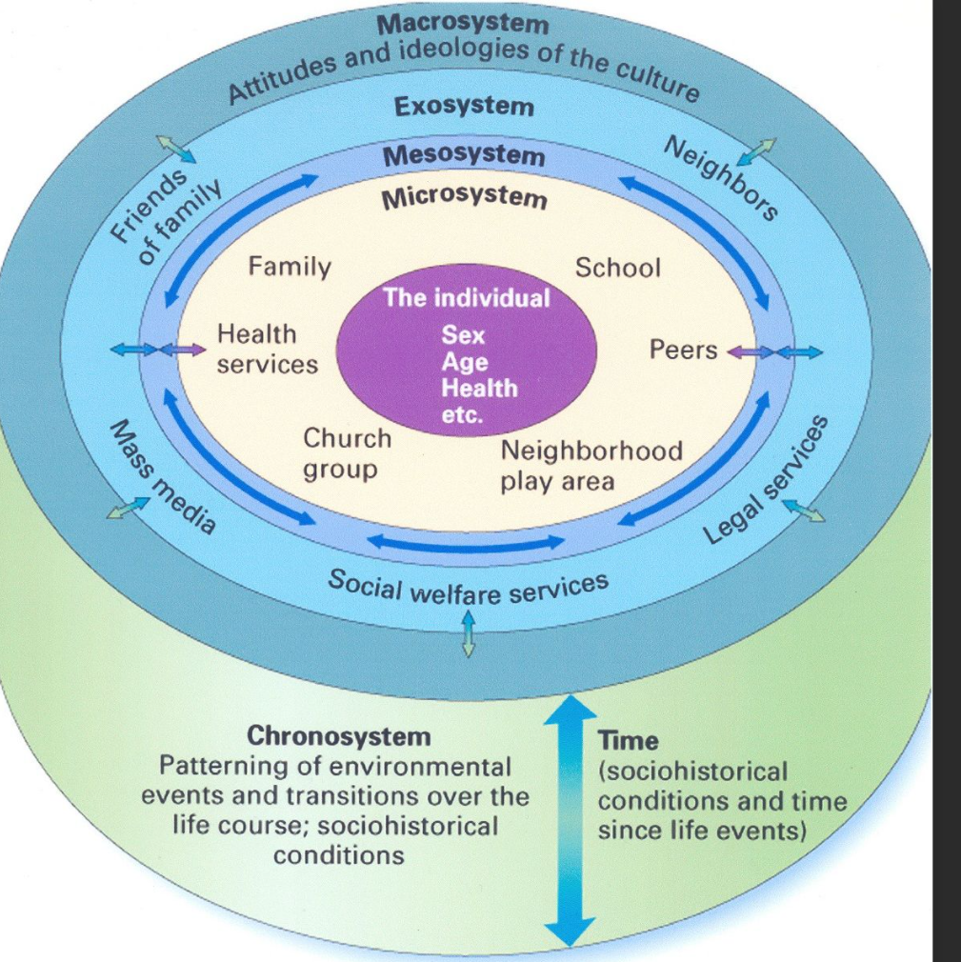

References
‌Betancourt, T.S., Meyers-Ohki, M.S.E., Charrow, M.A.P. and Tol, W.A., 2013. Interventions for children affected by war: an ecological perspective on psychosocial support and mental health care. Harvard review of psychiatry, 21(2), p.70. Available at: https://pubmed.ncbi.nlm.nih.gov/23656831/
‌Edward, A., Osei-Bonsu, K., Branchini, C., shah Yarghal, T., Arwal, S.H. and Naeem, A.J., 2015. Enhancing governance and health system accountability for people centered healthcare: an exploratory study of community scorecards in Afghanistan. BMC health services research, 15(1), pp.1-15. Available at: https://bmchealthservres.biomedcentral.com/articles/10.1186/s12913-015-0946-5
‌Unicef.org. (2019). Child protection. [online] Available at: https://www.unicef.org/afghanistan/child-protection.
Children of Afghanistan - Humanium. (2017). Humanium. https://www.humanium.org/en/afghanistan/
Forber-Pratt, I., Li, Q., Wang, Z. and Belciug, C., 2020. A Review of the Literature on Deinstitutionalisation and Child Protection Reform in South Asia. Institutionalised Children Explorations and Beyond, 7(2), pp.215-228. https://journals.sagepub.com/doi/abs/10.1177/2349300320931603
Monico, C., Rotabi, K.S. and Sarhan, T.A., 2019. International aid, relief, and humanitarian assistance. In Encyclopedia of Social Work. https://oxfordre.com/socialwork/view/10.1093/acrefore/9780199975839.001.0001/acrefore-9780199975839-e-957?mediaType=Article#acrefore-9780199975839-e-957-div1-7
Neto, M.L.R., Lima, N.N.R., Machado, S.S.F., Vasconcelos, J.P.M., de Carvalho, S.M.F., Junior, J.G., de Oliveira, C.R.T., de Paula, J.D.A. and Pedro, U.N.S.F., 2022. Children are in need of humanitarian aid in Afghanistan. Child Abuse & Neglect, 123, p.105421.
No child left behind A public health informed approach to improving outcomes for vulnerable children. (n.d.). [online] Available at: https://assets.publishing.service.gov.uk/government/uploads/system/uploads/attachment_data/file/913764/Public_health_approach_to_vulnerability_in_childhood.pdf.
NRC. (n.d.). Afghanistan: Children are the biggest victims of the war. [online] Available at: https://www.nrc.no/perspectives/2021/children-are-the-biggest-victims-of-the-war/ [Accessed 9 Jan. 2022].
O’Leary, P., Cameron, C.M., Lakhani, A., Osborne, J.M., de Souza, L., Hope, K., Naimi, M.S., Khan, H., Jawad, Q.S. and Majidi, S., 2018. Violence against children in Afghanistan: Concerns and opportunities for positive change. Child abuse & neglect, 76, pp.95-105.
‌www.unicef.org. (n.d.). Children in Afghanistan. [online] Available at: https://www.unicef.org/afghanistan/children-afghanistan [Accessed 9 Jan. 2022].
www.unicef.org. (n.d.). Girls increasingly at risk of child marriage in Afghanistan. [online] Available at: https://www.unicef.org/press-releases/girls-increasingly-risk-child-marriage-afghanistan.

