n.kaliyamurthy@uwtsd.ac.uk
Advanced Networking (ACCA5024)
Lab 2: Analyse Network Packets
Applied Computing
Wales Institute of Science and Art (WISA)

Part 1 - Capture and Analyse Local ICMP Data in Wireshark

Record your reflection:

Does the source MAC address match your PC interface?
Yes, the ipconfig showed the following (18:31:bf:51:1b:15):
€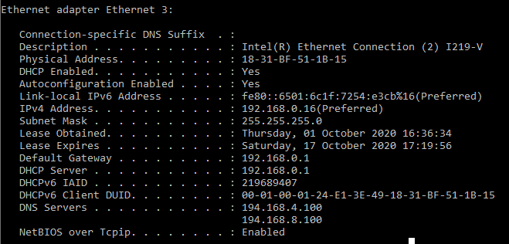

And the Wireshark packets showed the same:
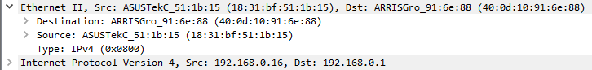

Does the destination MAC address in Wireshark match your team member MAC address?
As I am working from home, I pinged my default gateway.
Wireshark (40:0d:10:91:6e:88):

Physical Router (note the SSID and password have been changed from the defaults already!):
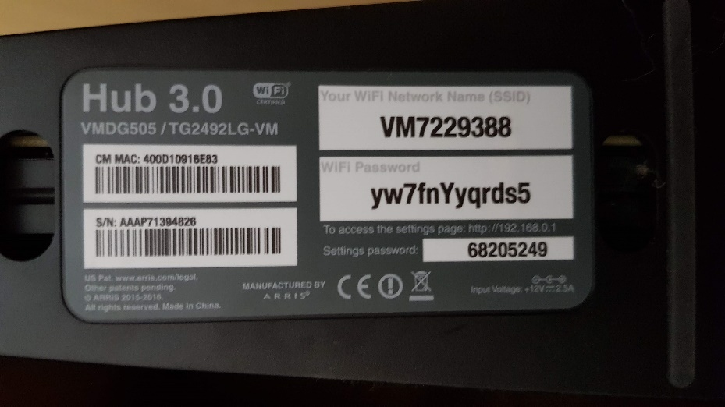

How is the MAC address of the pinged PC obtained by your PC?
Through Address Resolution Protocol (ARP), as the device pinged was my default gateway, my local machine already had the IP & MAC addresses of my router in the ARP Table.
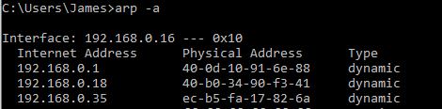

The ARP Table correlates the layer 3 IP addresses used in a ping request to the layer 2 MAC addresses used for local communications.

Part 2 - Capture and Analyse Remote ICMP Data in Wireshark
In Part 2, you will ping remote hosts (hosts not on the LAN) and examine the generated data from those pings. You will then determine what is different about this data from the data examined in Part 1

Start capturing data on the interface.
- Start the data capture again
- A window prompts you to save the previously captured data before starting another capture. It is not necessary to save this data. Click Continue without Saving.
- With the capture active, ping the following three website URLs from a Windows command prompt.
  - www.yahoo.com
  - www.cisco.com
  - www.google.com

Note: When you ping the URLs listed, notice that the Domain Name Server (DNS) translates the URL to an IP address. Note the IP address received for each URL.

- You can stop capturing data by clicking the Stop Capture icon.

Examining and analysing the data from the remote hosts
Review the captured data in Wireshark and examine the IP and MAC addresses of the three locations that you pinged. List the destination IP and MAC addresses for all three locations in the space provided.

Record your reflection:

IP address for www.yahoo.com:
87.248.100.215

MAC address for www.yahoo.com:
40:0d:10:91:6e:88

IP address for www.cisco.com:
104.82.234.236

MAC address for www.cisco.com:
40:0d:10:91:6e:88

IP address for www.google.com:
216.58.212.196

MAC address for www.google.com:
40:0d:10:91:6e:88

What is significant about this information?
The MAC address for all of the remote servers are shown as the default gateways MAC address, not the MAC address of the actual server

How does this information differ from the local ping information you received in Part 1?
The local ping shows the actual device MAC address

Why does Wireshark show the actual MAC address of the local hosts, but not the actual MAC address for the remote hosts?
MAC addresses are only used for traffic within a local network, any traffic that passes a gateway such as a router uses layer 3 IP addresses to set the source and destination of packets.

Part 3 - Examine the Header Fields in an Ethernet II Frame

Record your reflection

What is significant about the contents of the destination address field?
The destination IP address is related to the IP that was pinged, but the destination MAC address is 00:00:00:00:00:00 because it’s sent as a layer 2 broadcast

Why does the PC send out a broadcast ARP prior to sending the first ping request?
The PC sends out a broadcast ARP before the first ping request if the ARP table doesn’t contain a record for that IP. This means that the PC doesn’t know what MAC address correlates to that IP address. It sends out an ARP request to all of the machines in the local network, asking if any of the machines have a NIC that matches the IP in the ping request. It then either gets a reply from the machine with that IP, or if it doesn’t it will then ask the default gateway if it has a record for that IP.

What is the MAC address of the source in the first frame?
40:0d:10:91:6e:88 – the MAC address of the default gateway

What is the Vendor ID (OUI) of the Source NIC in the ARP reply?
40:0d:10 – owned by Arris group inc. because the virgin media 3.0 hub is just a rebranded Arris device.

What portion of the MAC address is the OUI?
The first 3 binary octets which means the first 6 Hex numbers

What is the NIC serial number of the source?
91:6e:88 – the last 3 octets

Part 4 – Use Wireshark to Capture and Analyse Ethernet Frames

What is the IP address of the PC default gateway?
192.168.0.1

Local ping requests:

What is the MAC address of the PC NIC?
18:31:bf:51:1b:15

What is the default gateway’s MAC address?
40:0d:10:91:6e:88

What type of frame is displayed?
IPv4

What is the source IP address?
192.168.0.16

What is the destination IP address?
192.168.0.1

What do the last two highlighted octets spell?
“hi”

What device and MAC address is displayed as the destination address?
My PC (192.168.0.16 and 18:31:bf:51:1b:15)

Remote ping requests:

In the first echo (ping) request frame, what are the source and destination MAC addresses?
Source: 18:31:bf:51:1b:15
Destination: 40:0d:10:91:6e:88
What are the source and destination IP addresses contained in the datafield of the frame?
Source: 192.168.0.16
Destination: 104.82.234.236

Compare these addresses to the addresses you received already. The only address that changed is the destination IP address. Why has the destination IP address changed, while the destination MAC address remained the same?
MAC addresses are only used for traffic within a local network, any traffic that passes a gateway such as a router uses layer 3 IP addresses to set the source and destination of packets.

Wireshark does not display the preamble field of a frame header. What does the preamble contain?
The preamble consists of 7 bytes of alternating 1 and 0 bits, which helps devices on the network to synch their receiver clocks. It is followed by a 1-byte SFD value that marks the end of the preamble, which is the first field of an Ethernet packet, and indicates the beginning of the Ethernet frame.

